Additional files

Additional file 1 (Word document)

Text S1. Semi-structured ethnobotanical questionnaire for date palm (Phoenix dactylifera L.) surveys in the Taghit oasis.
Part A: General survey and Farmer Information
Date of interview: _________________
Location (Locality / Palm grove): _________________
Farmer code: _________________
Farmer’s gender: □ Male □ Female
Age: _________________
Educational level: _________________
Experience in date palm farming (number of years): _________________
Status: □ Owner □ Sharecropper □ Farm worker □ Other (specify): __________

Part B: Palm Grove Characteristics and Varieties
Approximate area of your palm grove (hectares): _________________
Total number of female palms: _________________
Do you have male palms (ḏakar)? How many? _________________
What varieties (cultivars) of date palms do you grow in this palm grove (free-list)?
________________________________________________________________________________________________________________________________________________________________________________________________________________________________________________________________________________________________

Part C: Cultivation practices
Propagation techniques and nomenclature of male and seed-grown palms:
How do you propagate your female varieties? By transplanting offshoots? ___________
Where do these offshoots come from (your garden, a neighbour’s garden, elsewhere)? _________________
Do you ever plant date seeds (pits)? □ Yes □ No
Why? _________________
In your palm grove, do you have spontaneous palms that germinated naturally from seeds?
_________________
How do you call palms that grew from seeds (ḫalṭ or other names)? _________________
Do you propagate male palms from offshoots, or do they all come from seeds? _________
How do you know that a particular palm is called by its specific name? ________________

Irrigation Techniques:
Main water source (Well, foggara, spring, etc.): _________________
Irrigation method (Flood, drip, etc.): _________________
Irrigation frequency (Summer / Winter): _________________

Maintenance:
How often do you carry out maintenance operations on your palms? What does maintenance include? _________________

Pollination:
Method (Manual, natural by wind): _________________
If manual, what period and technique (number of male flower clusters per female palm, etc.)? _________________
How do you select the ḏakar for pollinating each palm (does each palm have a preferred pollen)? _________________
Where does the pollen you use come from?
□ From my own male palms □ Purchased from a market or shop
□ Obtained from other growers □ Other (specify): _________________

Part D: Uses of the date palm products
Processed Products:
Do you prepare products from dates?
Syrup (Rob or another local name)? □ Yes □ No
Preservation methods (storage in jars, freezing, etc.): _________________
At what stage are dates typically consumed (fresh or dried)?

Crafts:
Objects made (baskets [quffa], mats, ropes, brooms, doors, etc.): _________________

Construction:
Is the wood (trunk/stipe) used in construction (beams, ceilings)? □ Yes □ No
Are the leaves used for roofs (ksour) or fences? □ Yes □ No

Medicine and Cosmetics:
Do you use the date palm or its products to treat health conditions?
Parts used (pollen [ṭalʿ], seeds, dates, sap): _________________
Preparation (decoction, poultice, powder): _________________
Conditions treated (e.g., digestive problems, fever, etc.): _________________
Cosmetic uses (oil, skin care): _________________

Other Uses:
Animal feed (dates or by-products)? □ Yes □ No

Part E: Challenges, Constraints, and Knowledge transmission
Observed Diseases and Pests:
□ None □ Bayoud □ Red palm weevil □ Scale insects (cochineal)
□ Other(s): _________________

Do you notice that some varieties are more resistant to Bayoud than others? Which ones?
_________________

Management Methods Used:
Please indicate, if applicable, the methods you use to manage diseases and pests.
A. Traditional Methods (e.g., plant-based preparations, ash, manual removal, ancestral knowledge, etc.): _________________
B. Modern Methods (e.g., synthetic pesticides, pheromone traps, biological control, surveillance drones, etc.): _________________

Climatic issues (drought, sandstorms, frost): _________________
Economic issues (selling price, market access, labour costs): _________________

Knowledge Transmission:
From whom did you learn (father, mother, community)? _________________
Do you transmit this knowledge to the younger generation? □ Yes □ No
Why? _________________

Text S2. Glossary of key terms in date palm cultivation in the oasis of Taghit, Algeria.
English Term | Definition | Arabic | Transliteration
Bayoud | A lethal fungal disease caused by Fusarium oxysporum f. sp. albedinis, responsible for widespread mortality of date palms across North Africa and the primary biotic threat to oasis palm diversity. | البيوض | al-bayūḍ
Date palm mite | The most damaging mite pest of the date palm, caused by Oligonychus afrasiaticus. Active during peak summer heat, it spins a fine web around developing fruits to feed on their sap, causing desiccation and hardening of the fruit, which becomes unfit for human consumption. | بوفروة | būfarwah
Date palm scale / white scale | A sap-sucking insect pest (most commonly Parlatoria blanchardi) that feeds on the fronds, midribs, and fruit of date palms. Protected by a hard, waxy, greyish-white covering, it weakens trees by draining plant fluids and causing premature tissue necrosis or yellowing of fronds. | الجَرَب | al-jarab
Red palm weevil | A highly destructive invasive snout beetle (Rhynchophorus ferrugineus), native to Southeast Asia and considered one of the world’s most dangerous agricultural pests. Larvae bore into and hollow out the trunk of date palms from the inside, causing structural collapse and tree death. | سوسة الحمراء | sūsa al-Ḥamrā
Brown Blotch | A common fungal leaf spot disease of date palms, characterised by the appearance of distinct dark brown to black circular or elongated lesions on the fronds and rachis. In severe cases, lesions coalesce and cause premature desiccation of affected fronds, reducing photosynthetic capacity and overall tree vigour. | بوقرقور | būqarqūr
Named type | A palm name selected and maintained by farmers, identifiable by a locally recognised name and associated with a distinct set of morphological or agronomic traits. | صنف | ṣinf
Date palm | Phoenix dactylifera L.; the dominant crop of arid oasis agroecosystems, cultivated for its fruit (dates) and a wide range of secondary products. | نخلة | naḫlah
Male palm | An unproductive male date palm, cultivated solely for the production of pollen used in hand-pollination of female palms. | دكر دكّار/ | Ḏakkār / ḏakar
Female palm | A productive date palm tree bearing fruit, which requires hand-pollination with pollen from a male (ḏakar) palm. | نخلة أنثى | naḫlat unthā
Foggara | A traditional underground gravity-fed irrigation channel used to convey groundwater from aquifers to oasis palm groves, characteristic of the Saharan agricultural system. | فقارة | fuqqārah
Genetic erosion | The loss of genetic diversity within a cultivated species over time, resulting from the abandonment of traditional varieties, monoculture expansion, disease pressure, or environmental change. | التآكل الوراثي | al-taʾākul al-wirāthī
Inflorescence / Spathe | The enclosed flower cluster of the date palm, emerging from the leaf axil and split open for pollination. The spathe contains either male or female flowers. | طلع | ṭalʿ
In situ conservation | The conservation of plant genetic diversity within the farming systems and environments where it has developed, relying on farmers' continued cultivation and management of traditional varieties. | الحفظ في الموقع | al-ḥifẓ fī al-mawqiʿ
palm frond | The complete leaf of the date palm, comprising the central rachis and all attached leaflets (hasfas). Jridas are used in construction, shade structures, and as raw material for traditional crafts; the dried rachis also serves as a lightweight building material. | جريدة | jrīdah
khalal | The third ripening stage of the date fruit, characterised by full size attainment and a change from green to yellow, orange, or red coloration; the fruit is still firm at this stage. | خلال | khalāl
leaflet | An individual leaflet (pinnule) of the date palm frond, arranged pinnately along the rachis of the leaf. They are harvested for basketry, mat weaving, and other traditional crafts. | حسفة | hasfah
khchaf | Low-quality dates, typically small, dry, or poorly developed, unfit for human consumption and used as fodder for livestock, particularly sheep and donkeys. Khchaf may result from poor pollination, water stress, or inherently low-yielding named types. | خشف | khchaf
kimri | The first ripening stage of the date fruit, during which the fruit is green, hard, and high in tannins; not yet suitable for consumption. | كمري | kimrī
Oasis | A fertile area in an arid or desert environment sustained by a water source, typically supporting a multi-strata agroecosystem dominated by date palms. | واحة | wāḥah
Offshoot | A vegetative shoot produced at the base of a date palm, used for clonal propagation; the primary method by which farmer-recognised named types are reproduced and maintained true-to-type. | فسيلة | fasīlah
Palm grove | A cultivated stand of date palms managed by one or more farmers within the oasis landscape, typically organised in a multi-strata system with intercropped fruit trees and seasonal crops. | نخيل | naḫīl
Pollination | The manual transfer of pollen from a male (ḏakar) inflorescence to a female inflorescence, performed annually by farmers at the Khalal stage to ensure fruit set. | تلقيح | talqīḥ
Rachis | The central woody axis of the date fruit bunch, bearing the spikelets and fruit. | عرجون | ʿurjūn
Rob (date syrup) | A traditional food product prepared by cooking and concentrating date pulp into a thick, sweet syrup; a common method of date preservation and processing in Saharan oases. | رُب | rub/rob
Rutab | The fourth ripening stage of the date fruit, characterised by partial or full softening and browning of the flesh and a reduction in tannin content; sweet and partially moist. | رطب | ruṭab
Tamr | The final and fully ripe stage of the date fruit, characterised by low moisture content, concentrated sugars, and long shelf life; the primary commercially traded form. | تمر | tamr
Basket | A traditional woven basket, made from palm leaves (fronds) | قُفَّة | quffa

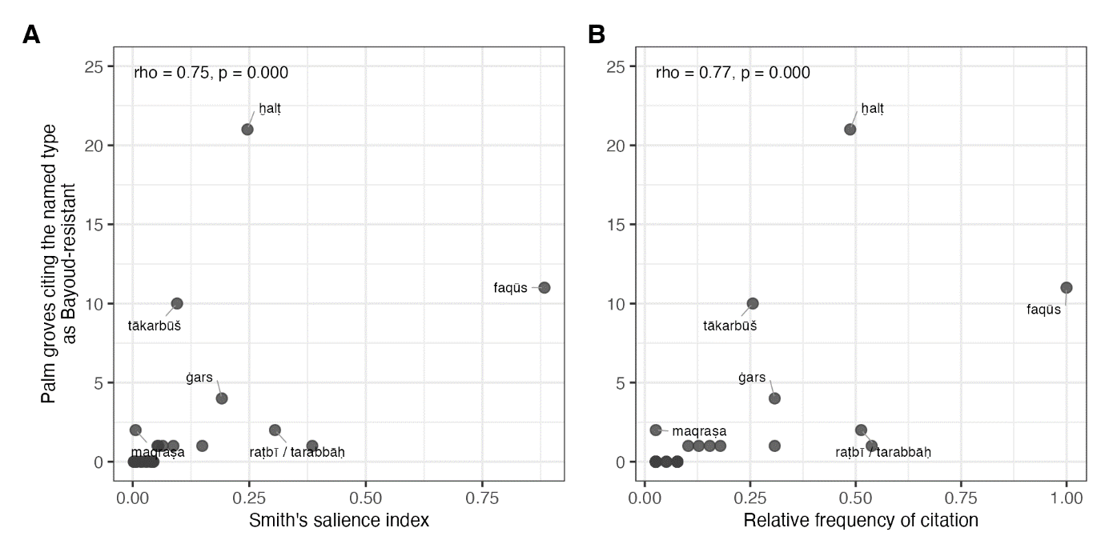
Figure S1. Relationship between the cultural prominence of a date palm variety and the number of palm groves where it was cited as resistant to Bayoud. Each point is one of the 30 varieties recorded in the free lists. Cultural prominence is measured against Smith’s salience index (A) and against the relative frequency of citation, that is the proportion of the 39 palm groves in which the varietywas reported (B). The y axis gives the number of palm groves in which farmers cited the named type as resistant to Bayoud, among the 35 palm groves where at least one resistant type was named. Varieties never cited as resistant are retained with a count of zero. Spearman rank correlation coefficients and their p values are given in each panel.
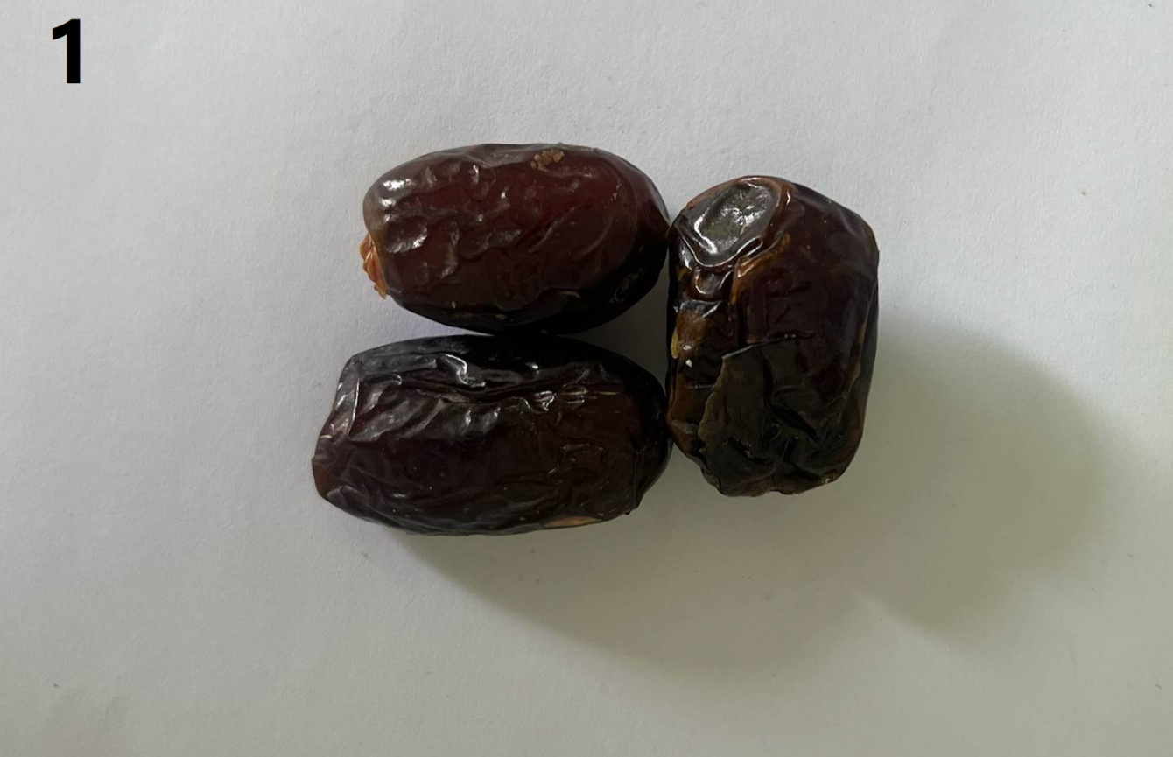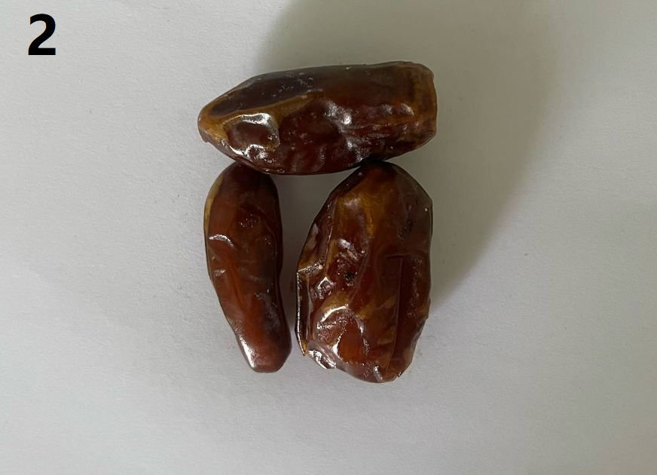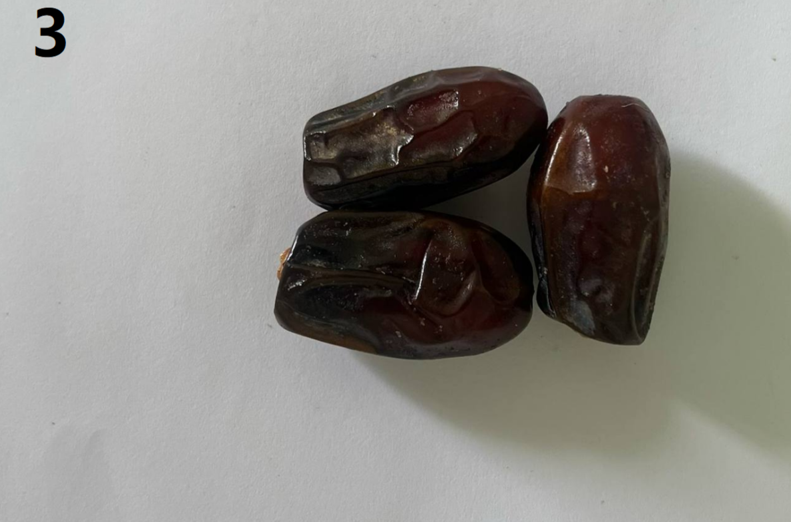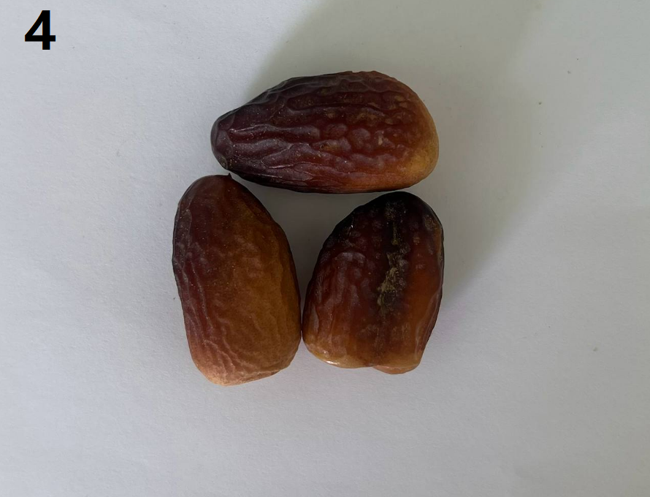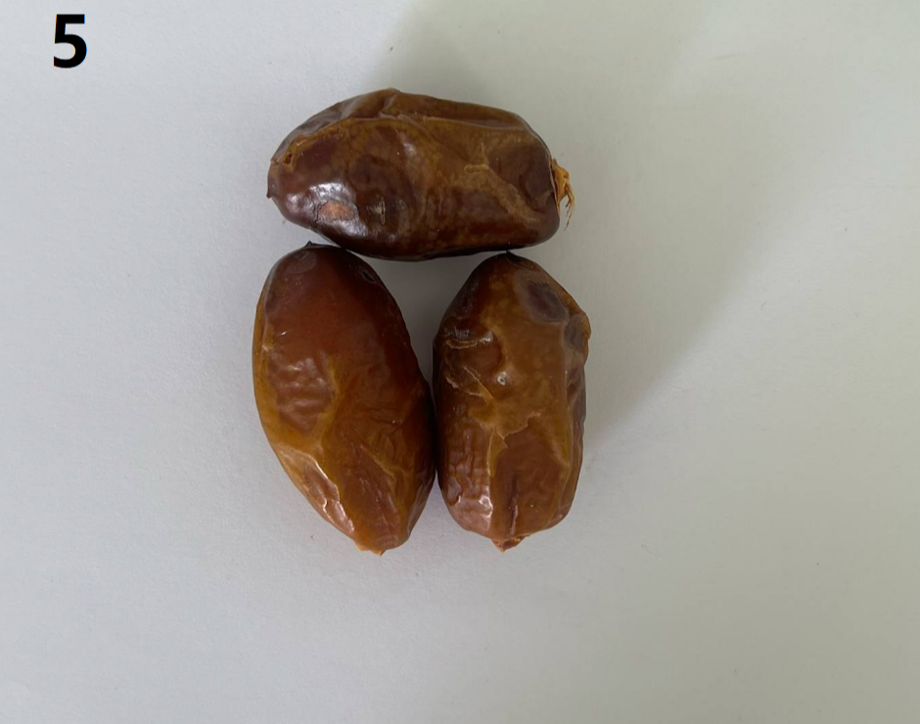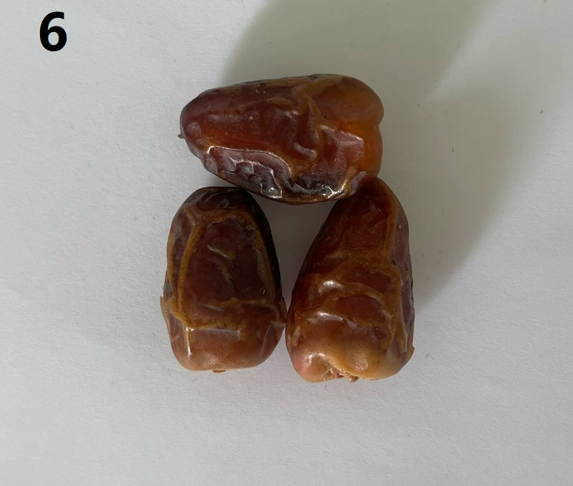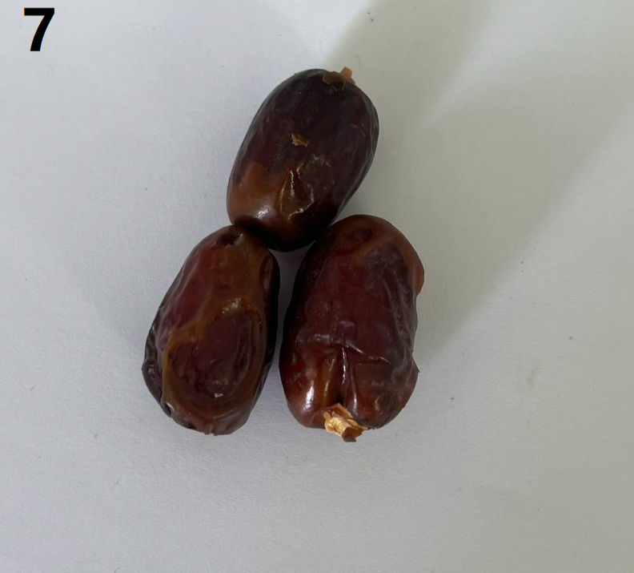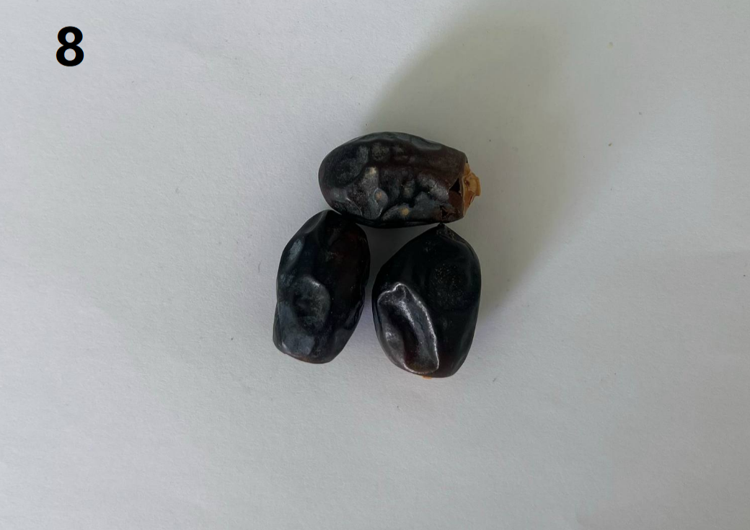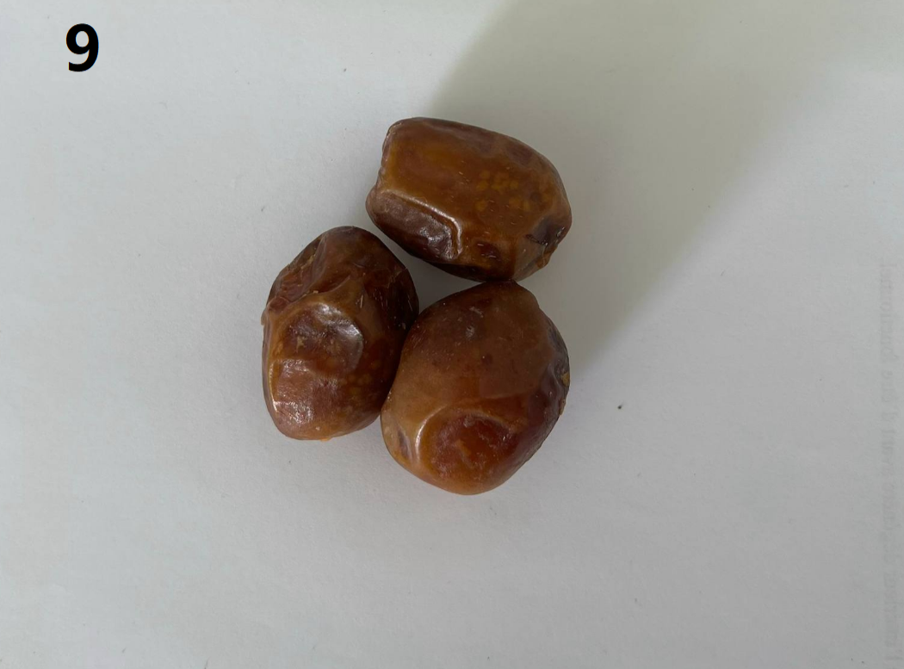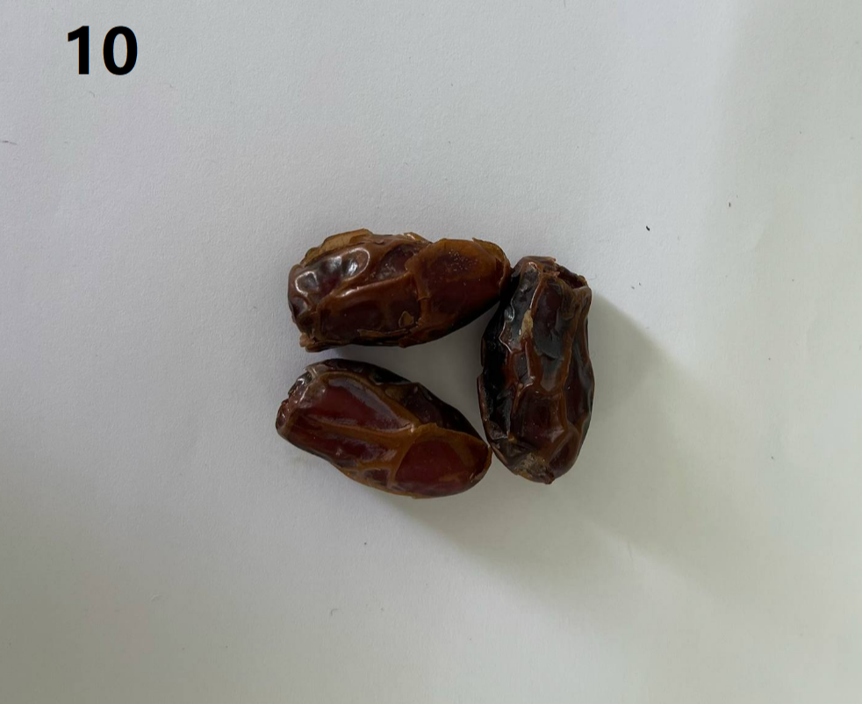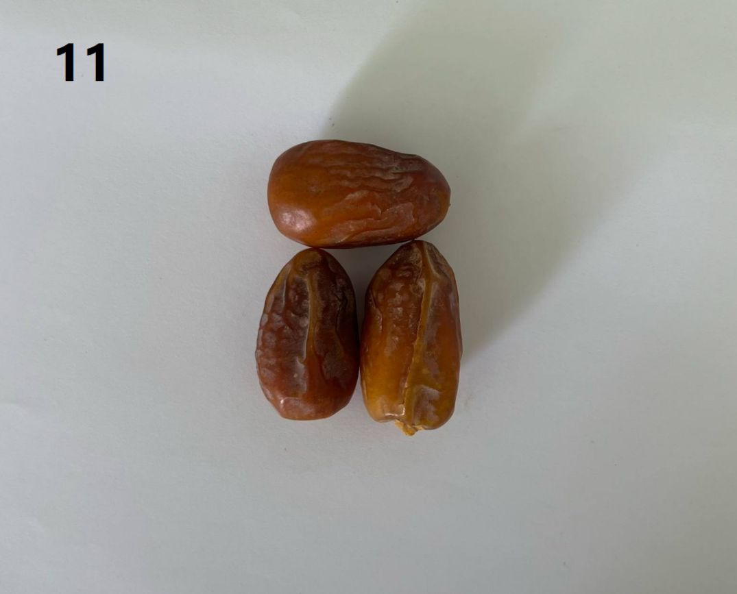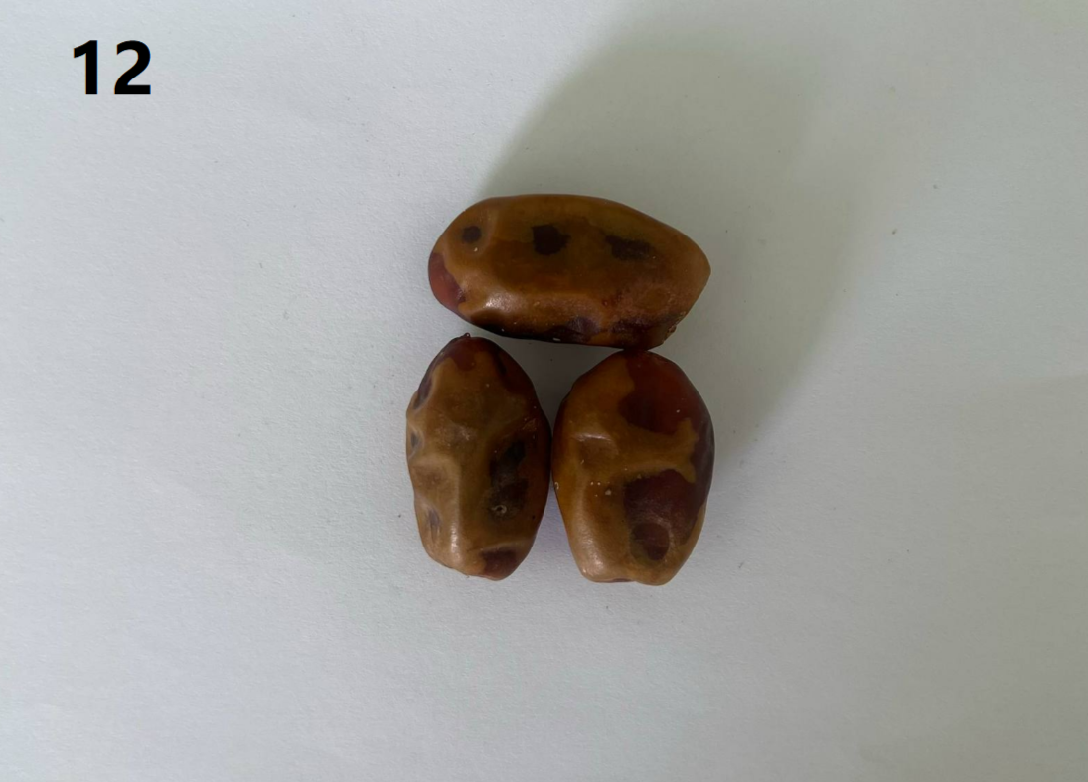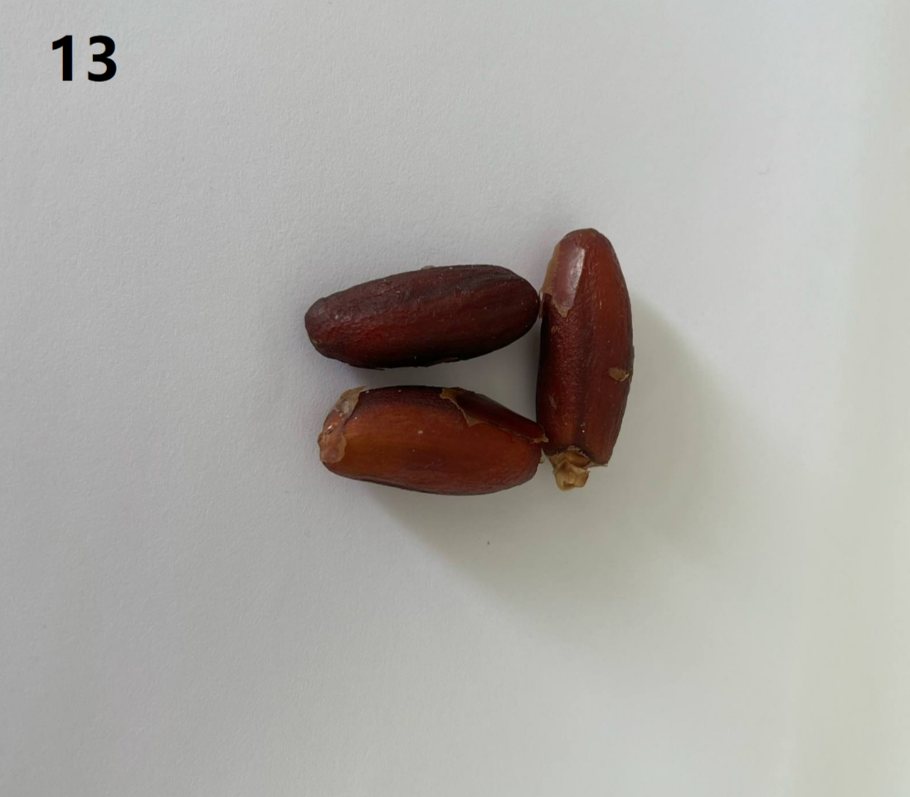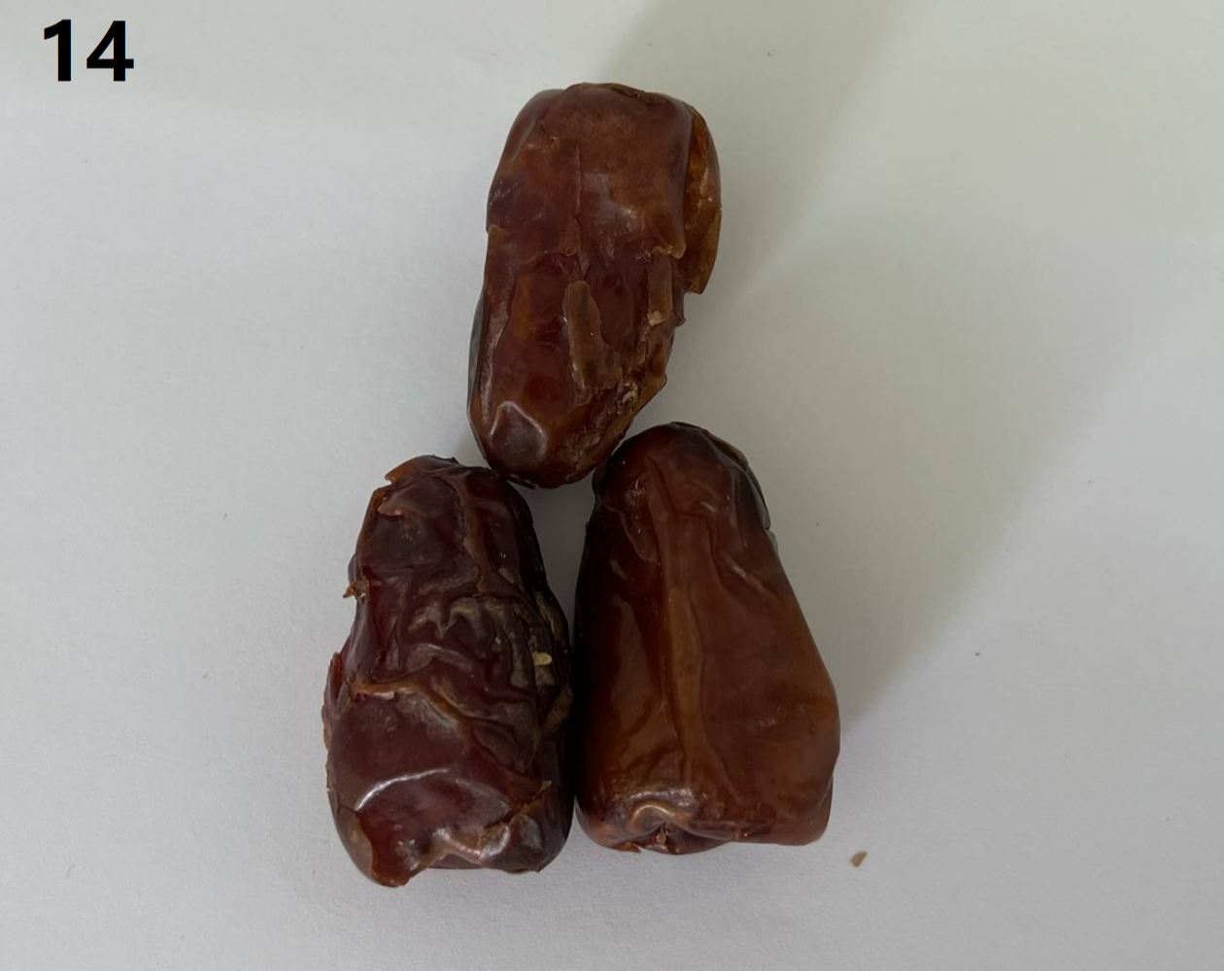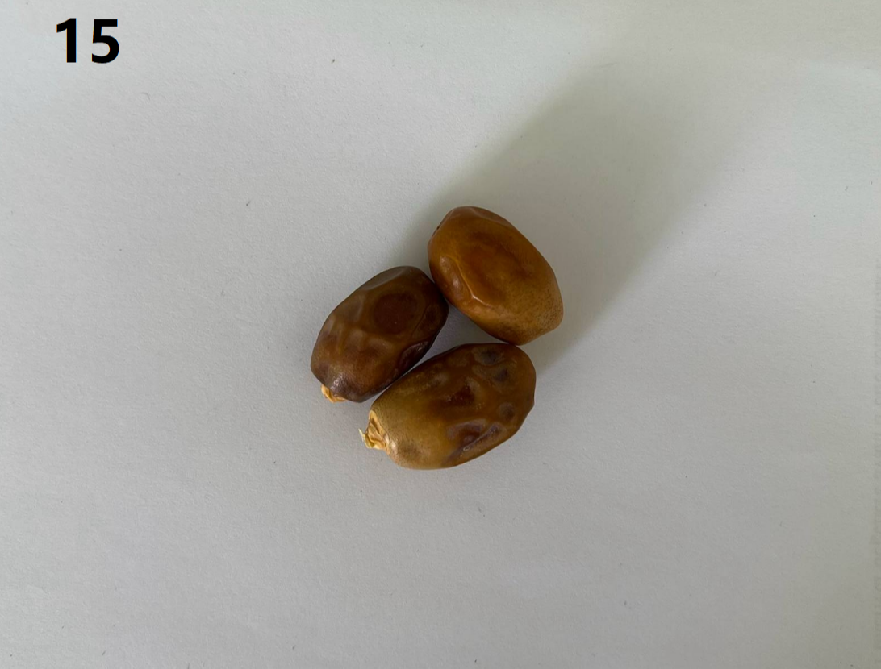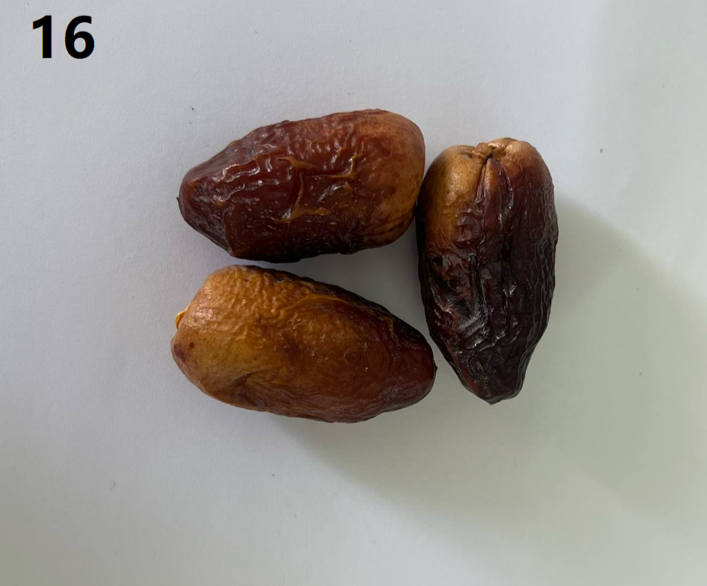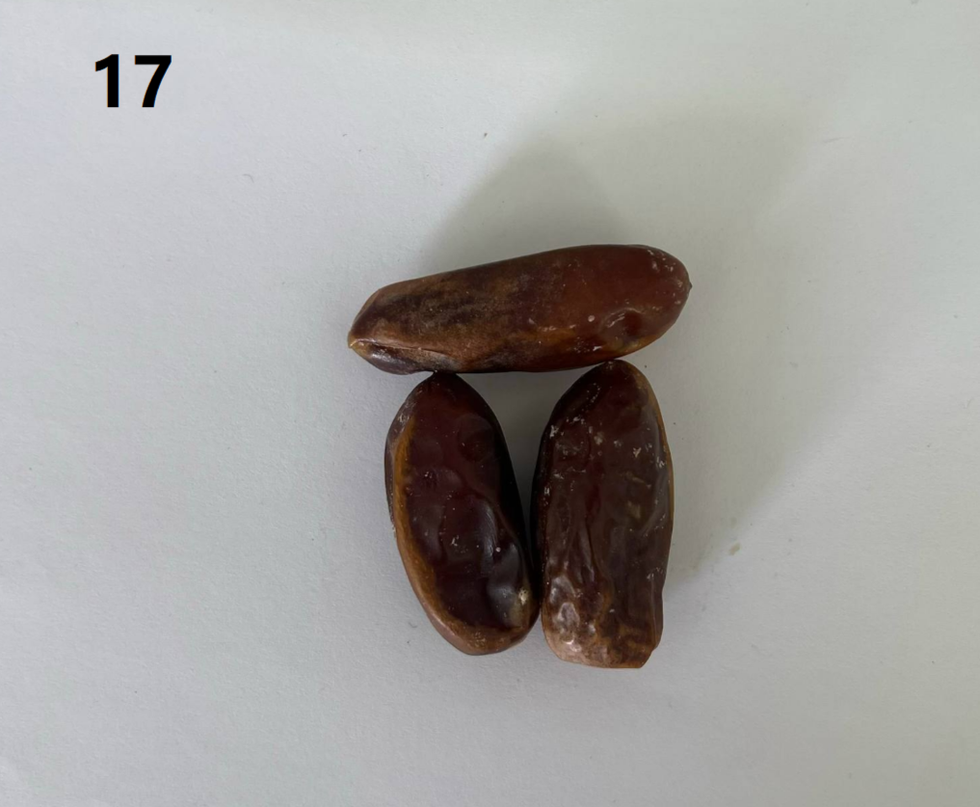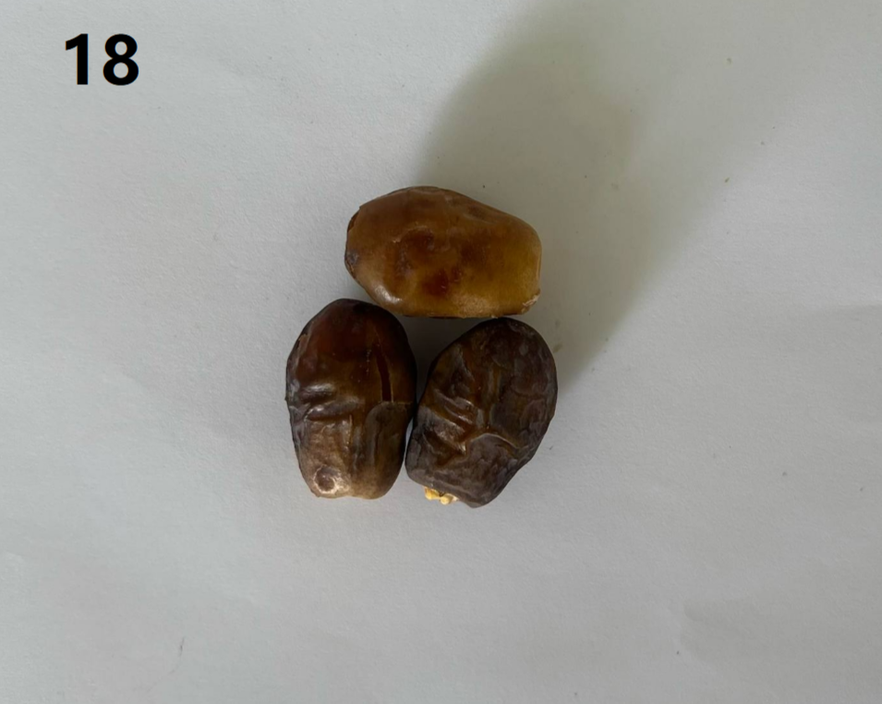

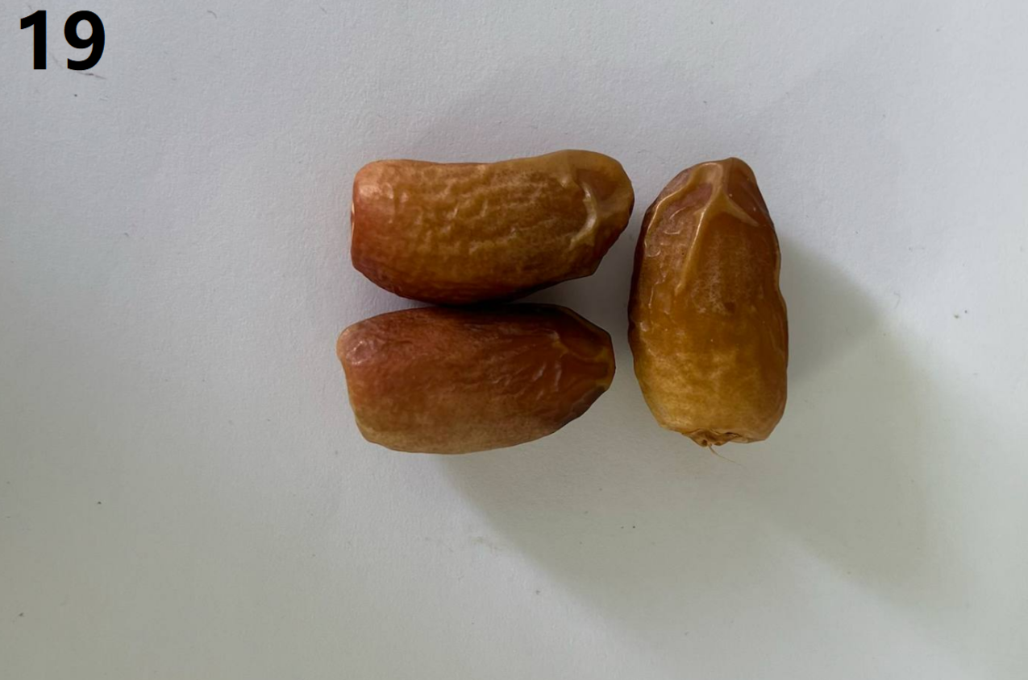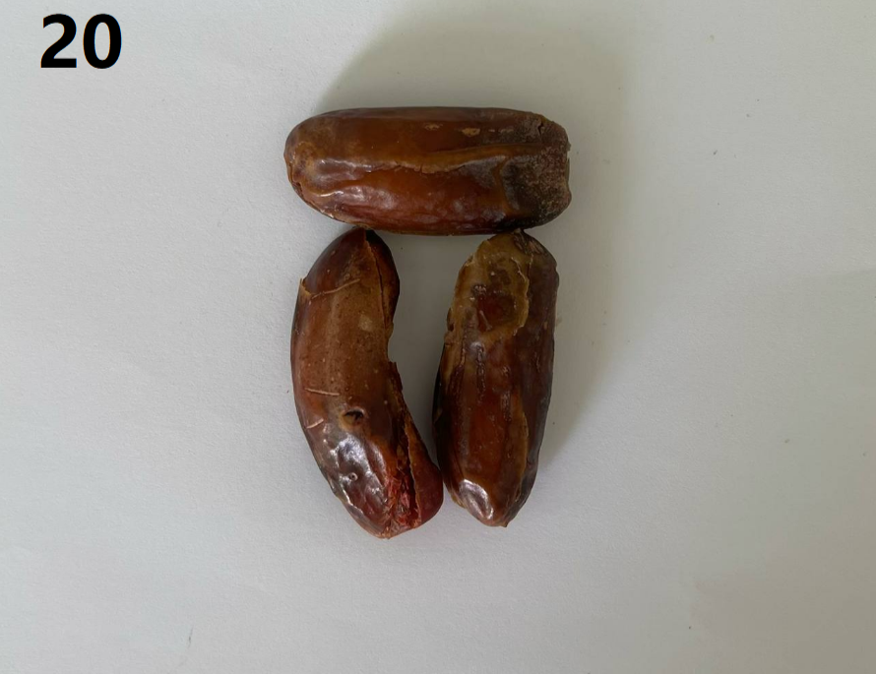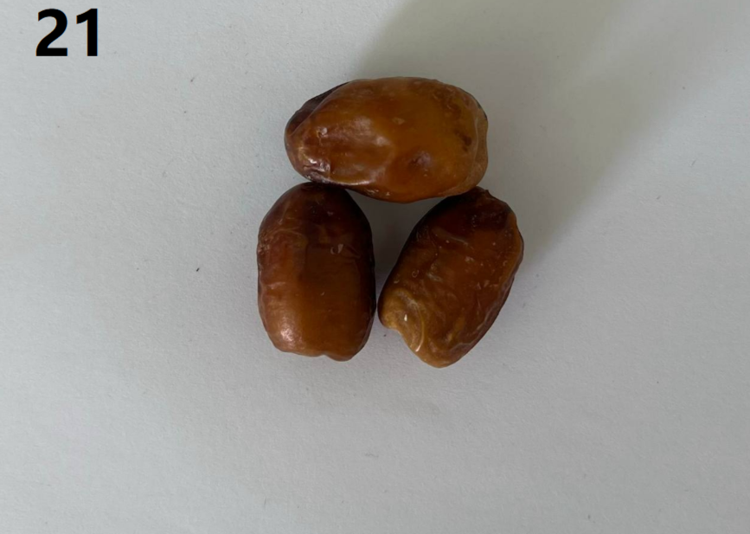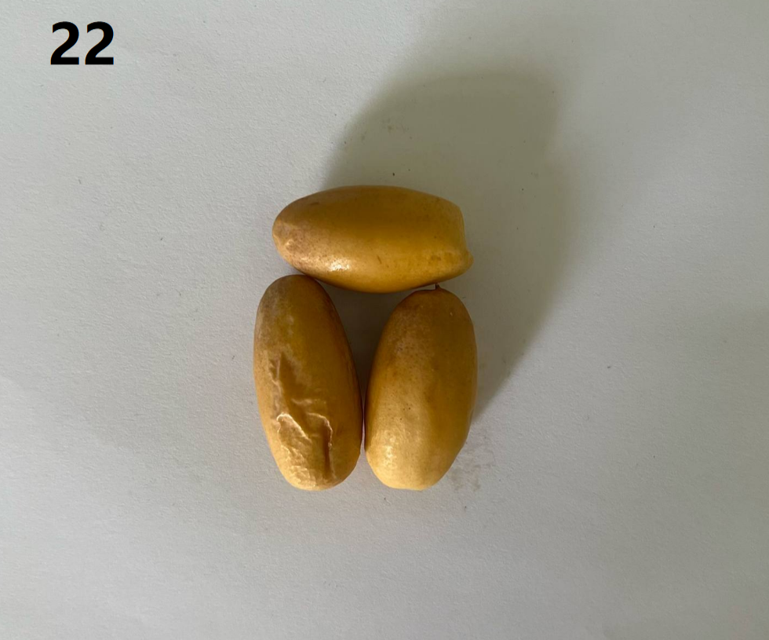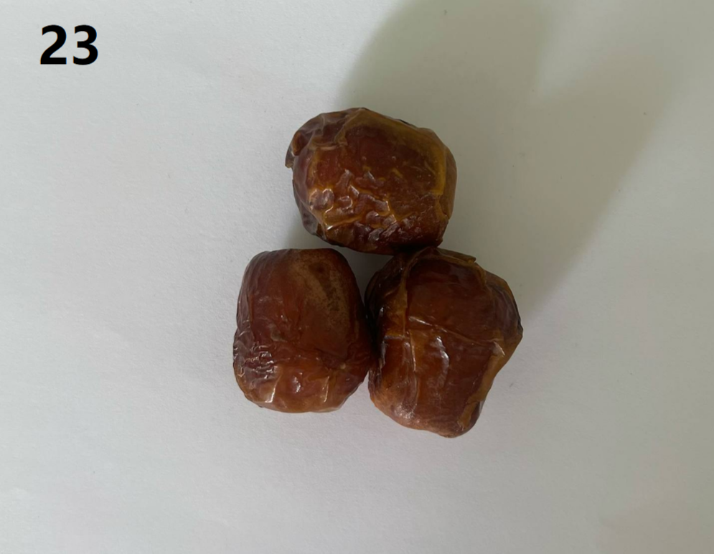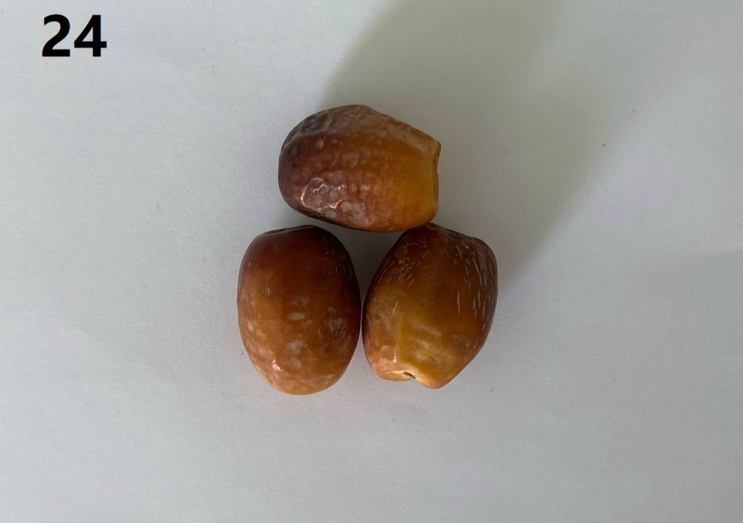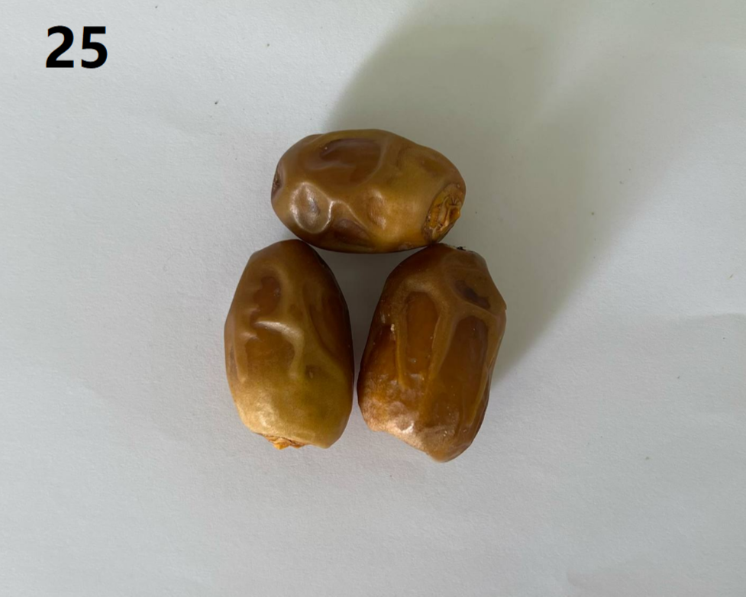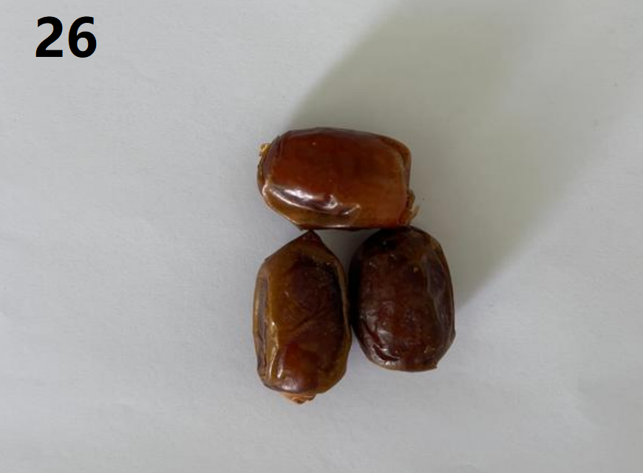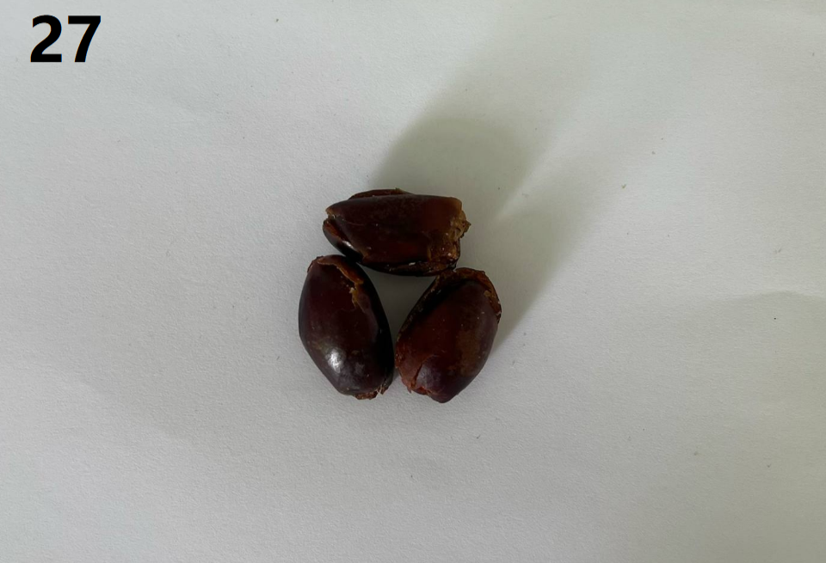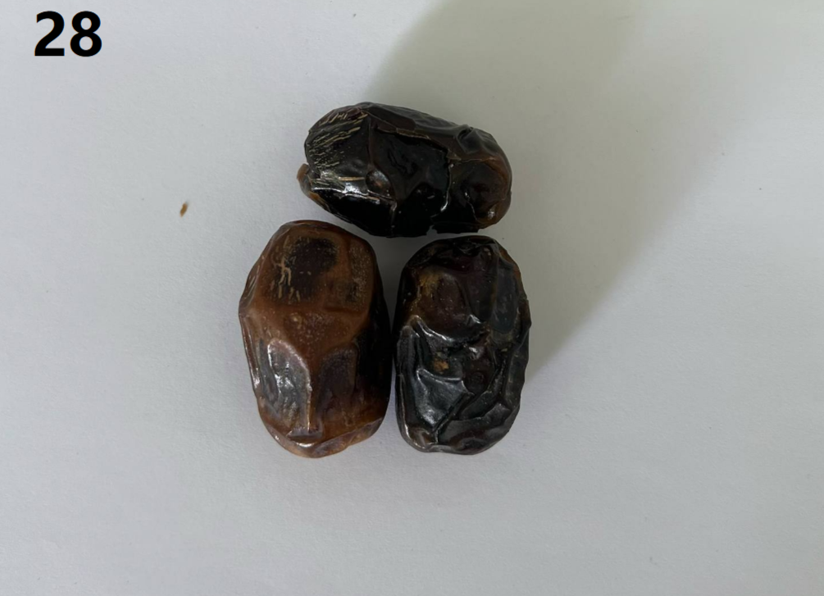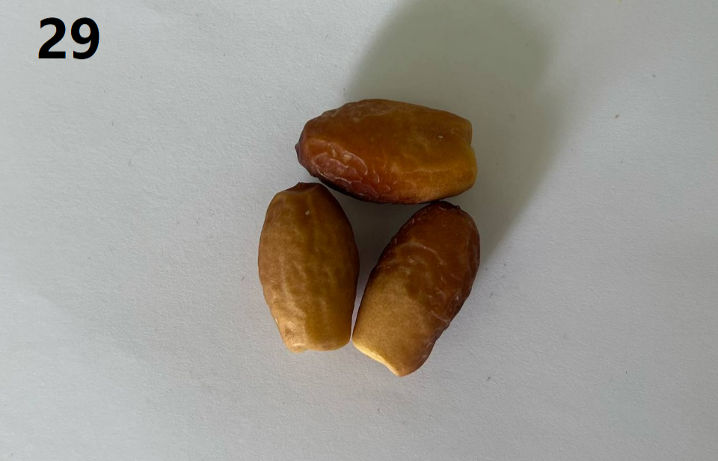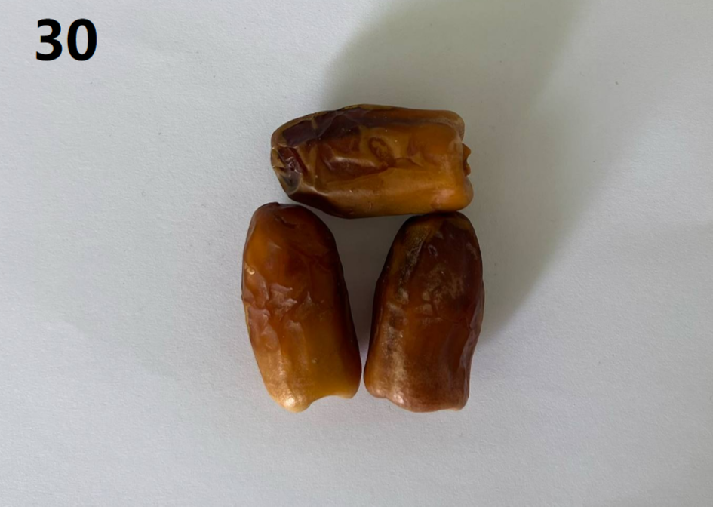
Figure S2. Fruits of the 30 date palm varieties recorded in the Taghit oasis. 1: faqūs; 2: ḥarṭān; 3: raṭbī / tarabbāḥ; 4: ḫalṭ; 5: ġars; 6: šarkah; 7: ḥumayrah; 8: kuḥaylah / kuḥayliyyah; 9: tākarbūš; 10: bayḍ ad-dajāj; 11: tīwrīġīn; 12: šatwiyyah; 13: tīn yūnis; 14: bint aš-šark; 15: tīḥajāmīn; 16: al-ḥarṭān al-ḥurrah; 17: ʿaẓm būlah; 18: būgallū; 19: kssabah; 20: ṣbaʿ sulṭān; 21: būmlāl; 22: tināḍrār; 23: tīmkūr; 24: mgarṣah; 25: ʿazīzah; 26: ʿušš al-ḥummā; 27: ġbaybū; 28: šayḫ an-naḫl; 29: amʿā allāh; 30: tīksks.

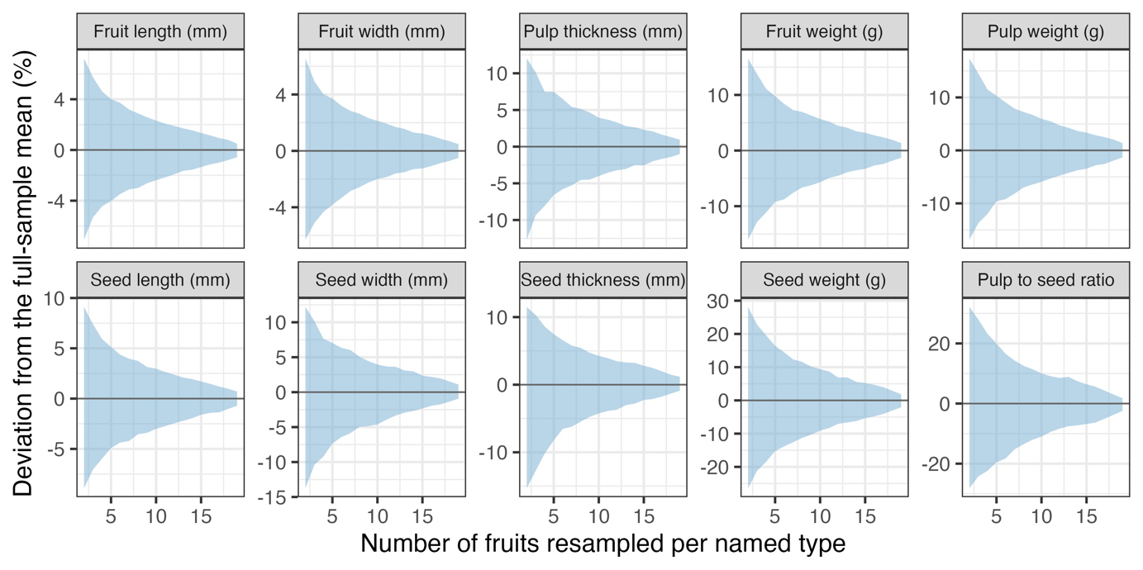
Figure S3. Stability of fruit and seed trait means as a function of the number of fruits sampled per variety. For each variety and each subsample size, fruits were drawn at random without replacement and the mean of each trait was compared with the mean computed on the full set of 20 fruits, expressed as a relative deviation. The shaded envelope encloses 95 % of the resampled estimates across the 100 iterations and the 30 varieties. Deviations decreased steadily with sample size and remained below 2.5 % for all traits at 19 fruits, indicating that 20 fruits per variety are sufficient to estimate trait means with a precision adequate for comparison among varieties.

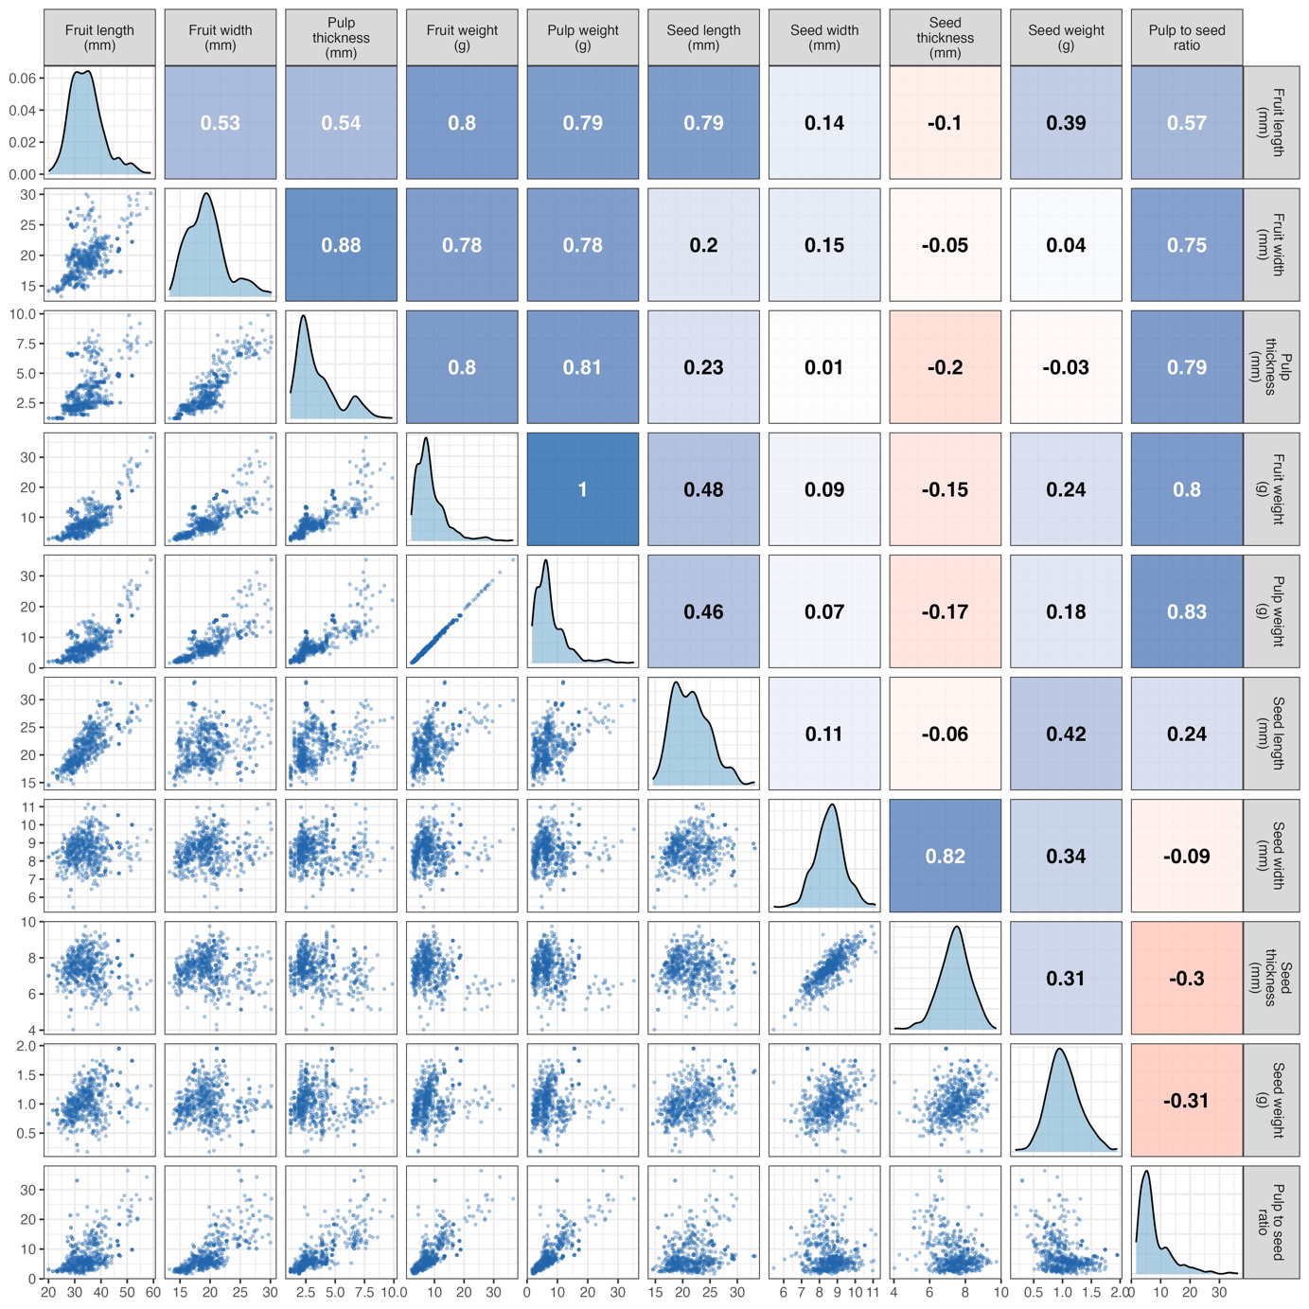
Figure S4. Pairwise correlations among fruit and seed morphological traits across the 28 seeded varieties. Scatterplots of all trait pairs are shown below the diagonal, trait distributions on the diagonal, and Pearson correlation coefficients above the diagonal, with the colour scale running from negative in red to positive in blue.

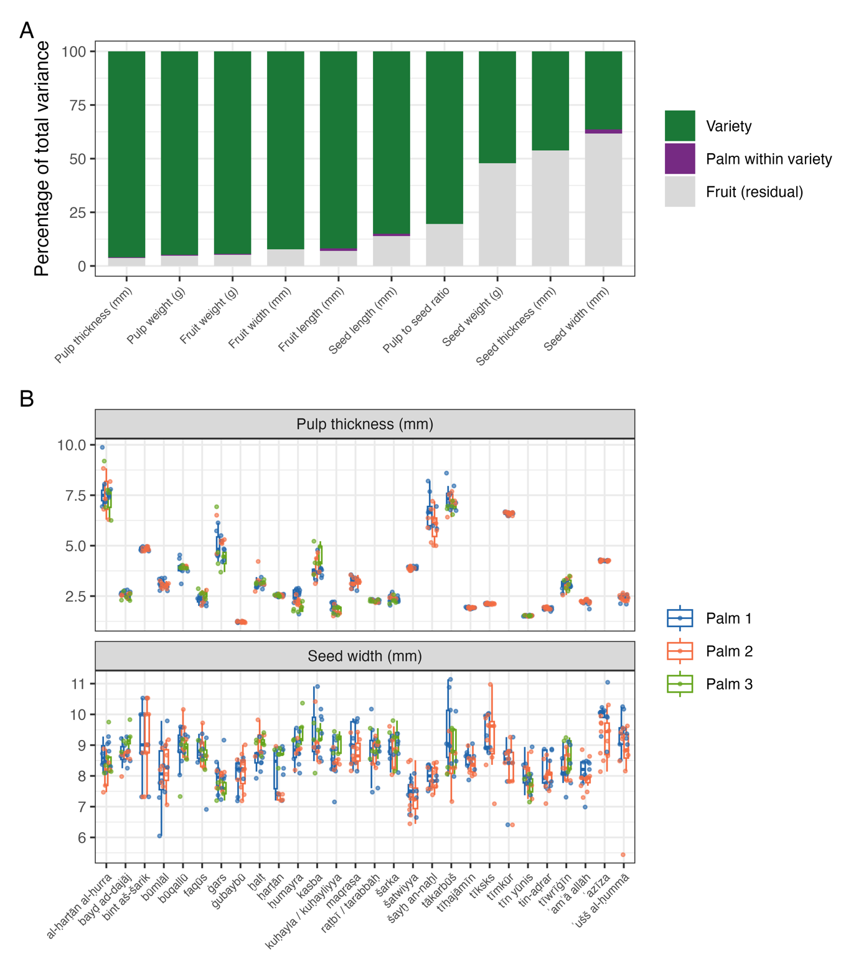
Figure S5. Partitioning of morphological variation between varieties, palms and fruits. A. Percentage of the total variance of each descriptor attributable to the variety, to the palm within variety, and to the fruit, estimated by linear mixed models with variety and palm nested within variety as random effects. Descriptors are ordered by decreasing variety component. The palm component was estimated at zero for seed thickness, seed weight and the pulp to seed ratio. B. Raw values for the two descriptors at the extremes of that gradient, pulp thickness above and seed width below, with boxplots and points coloured by palm within each variety. Palms bearing the same name overlap almost completely, whereas varieties separate clearly for pulp thickness and broadly overlap for seed width.

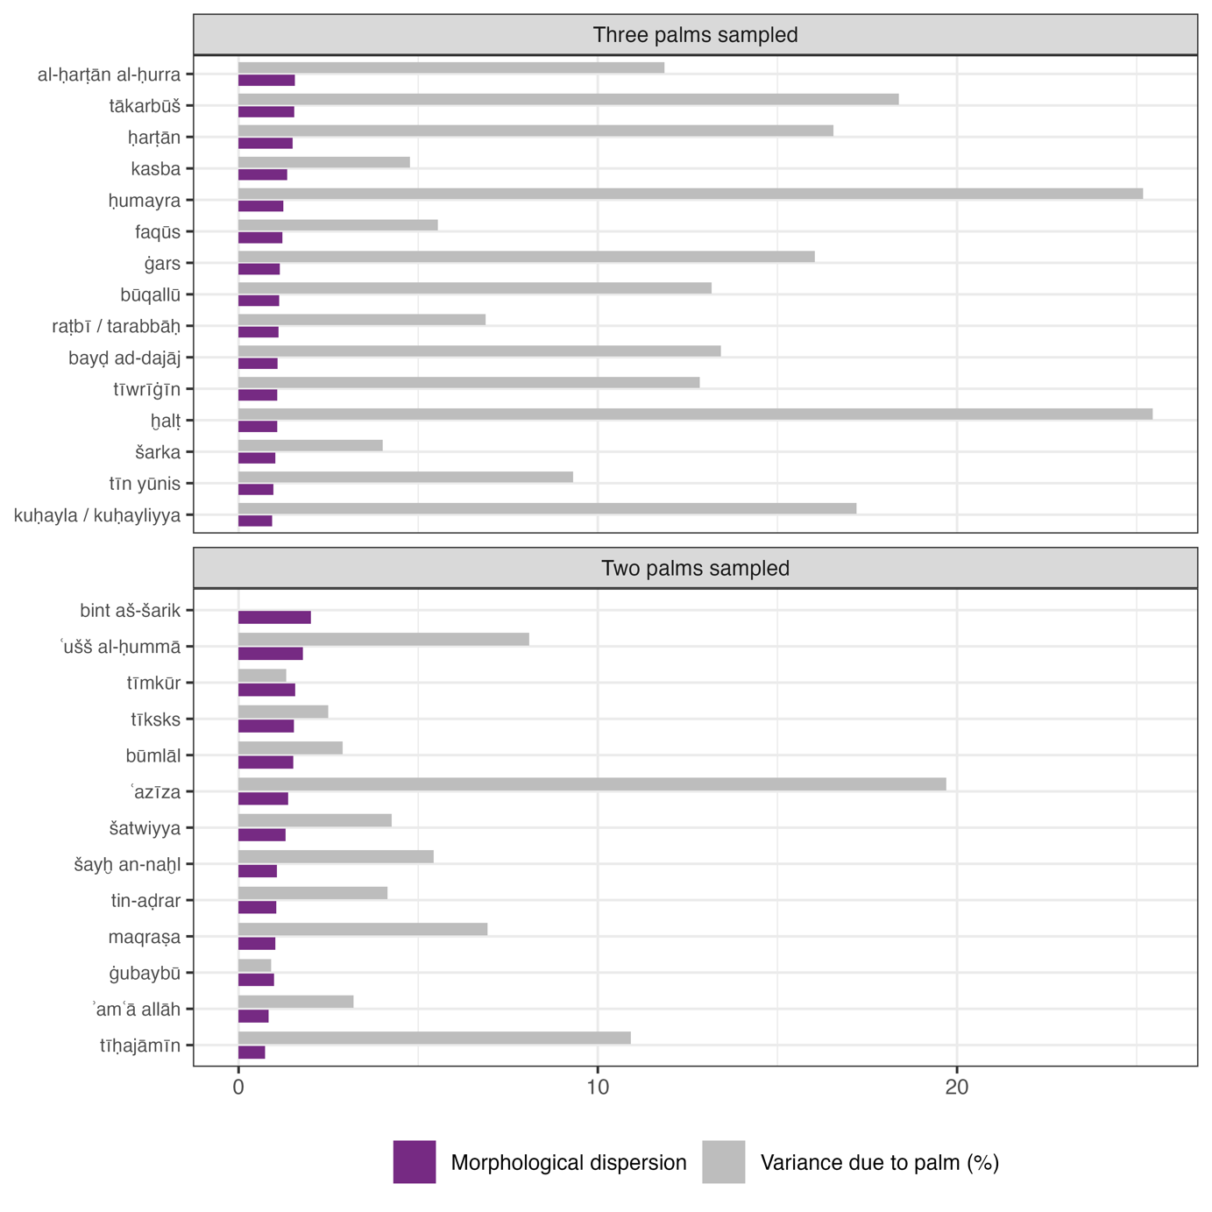
Figure S6. Internal morphological structure of each variety. Varieties are ordered by decreasing morphological dispersion, measured as the mean Euclidean distance of their fruits to their own centroid in the standardised eight-trait space. The second bar gives the share of that internal variation attributable to palm identity, estimated by a PERMANOVA fitted within each variety. The two descriptors are shown side by side rather than stacked because one is not a component of the other. Varieties sampled from two and from three palms are shown in separate panels, since the palm share is not comparable across the two designs, whereas dispersion is comparable throughout. No variety showed a significant palm effect after correction for multiple testing across the 28 tests.

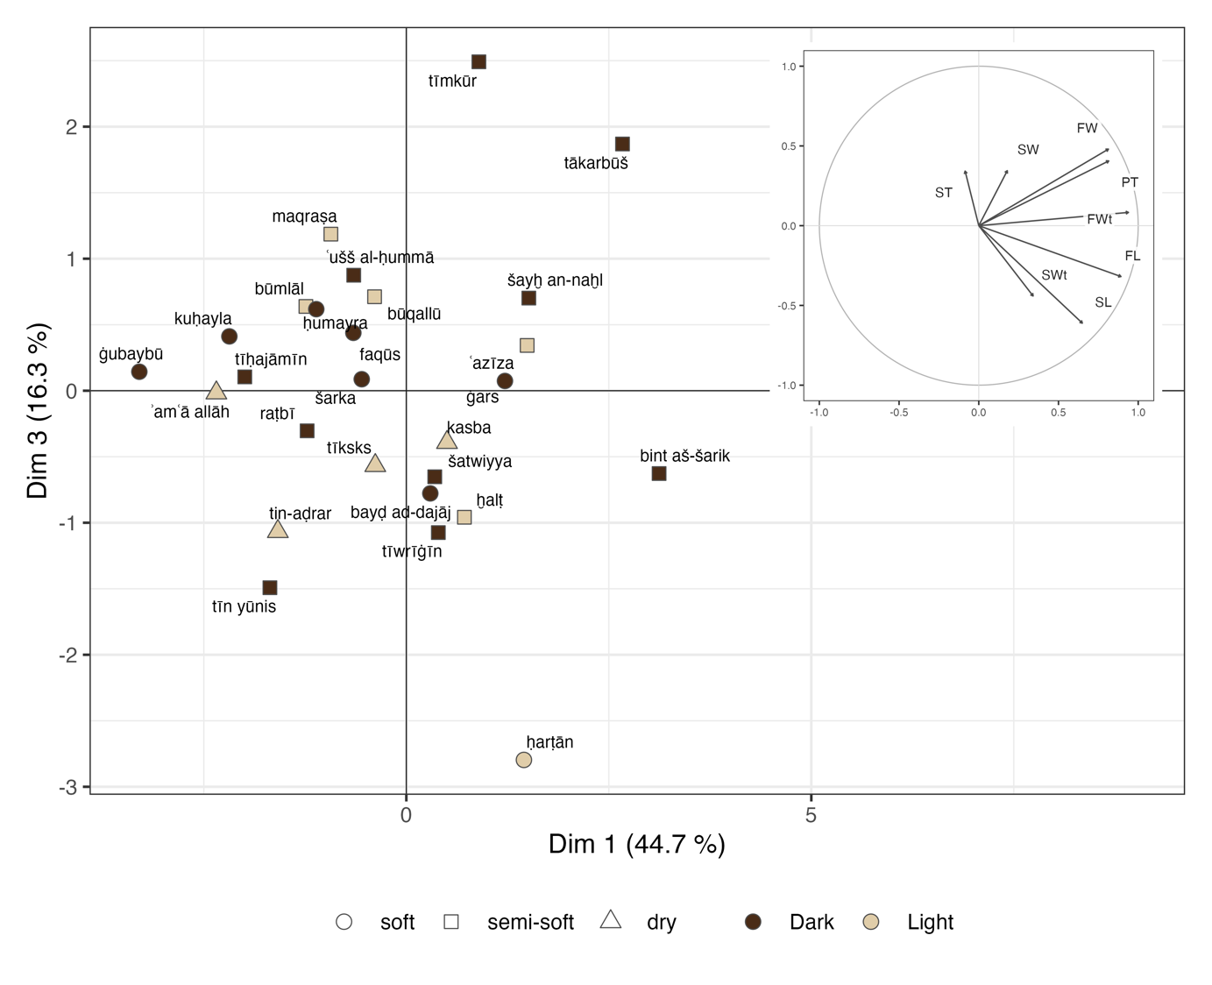 Figure S7. Fruit and seed shape variation among the Taghit varieties, shown on the first and third principal components. Each point is the centroid of a variety on the first and third principal components, computed on the eight non-redundant morphometric descriptors measured on 560 fruits. Whereas the first component describes overall fruit size, the third opposes seed length to fruit width and pulp thickness, and therefore distinguishes elongated fruits from broader, fleshier ones at a given size. Point fill indicates the colour group of the fruit and point shape its texture, both scored at the variety level. The inset shows the correlation circle of the descriptors, with trait codes as in Fig. 8.

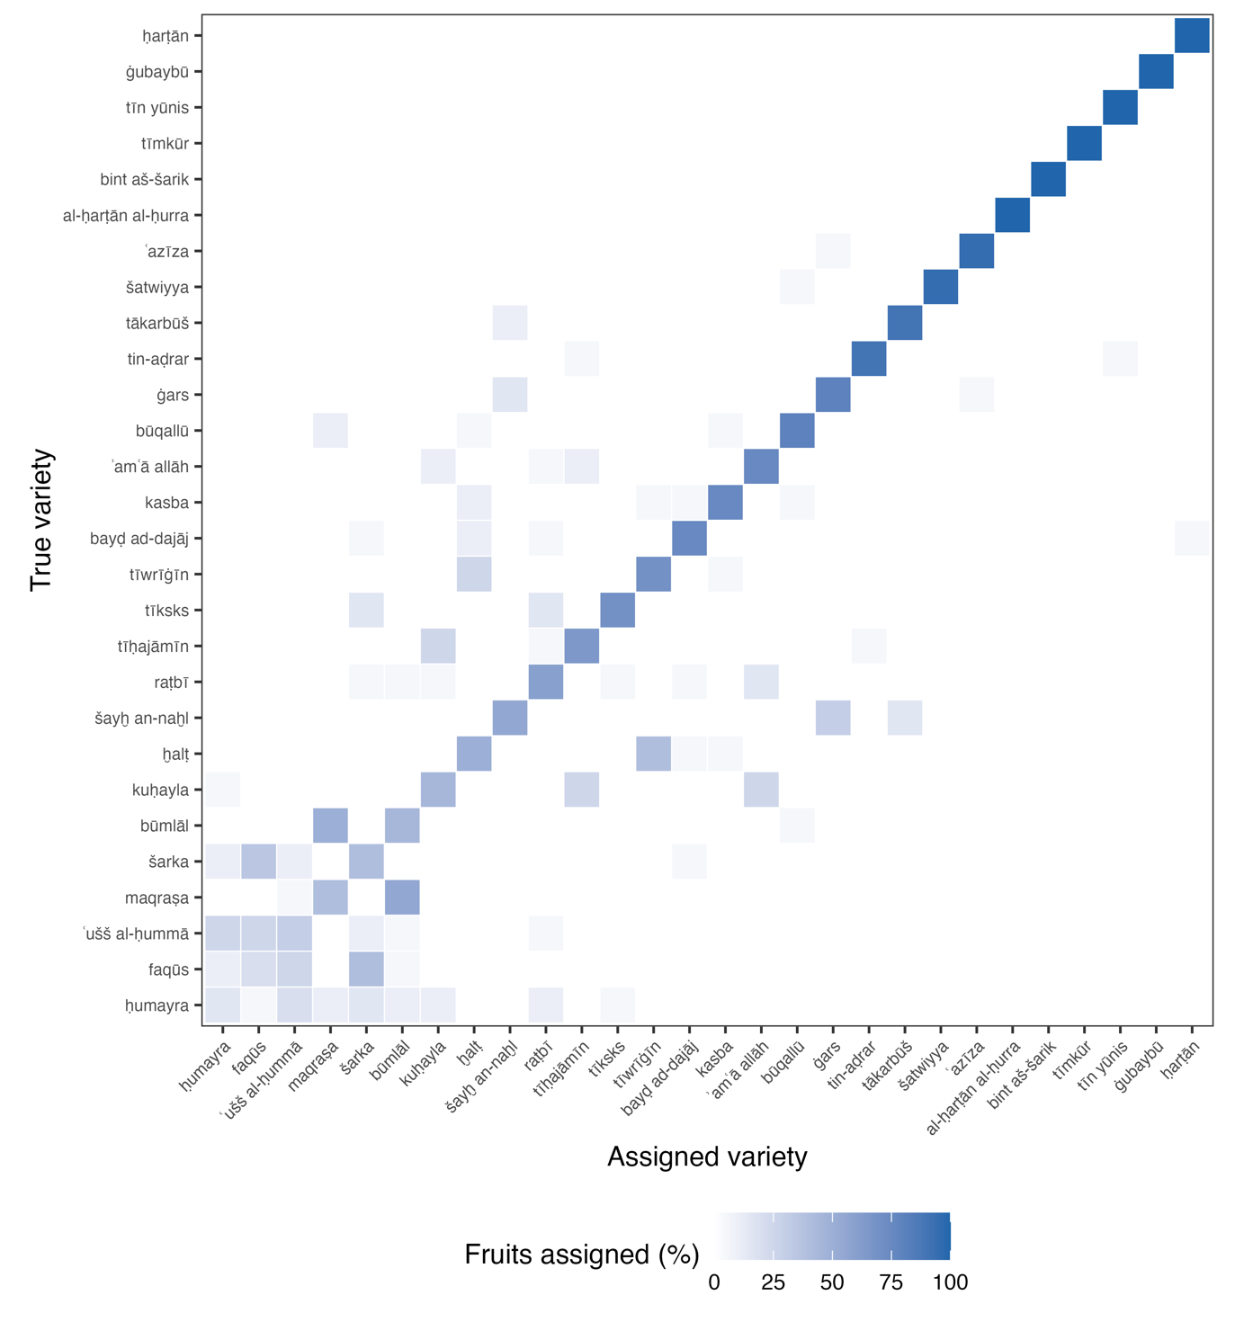
Figure S8. Confusion matrix of the random forest classification of individual fruits among the 28 seeded varieties. Rows give the variety a fruit actually came from and columns the variety it was assigned to, each row being expressed as a percentage of the 20 fruits of that variety. Assignments were obtained by leave-one-palm-out cross-validation, all fruits of a palm being set aside and classified by a forest trained on the remaining palms, so that no fruit was assigned by a classifier that had seen another fruit of the same palm. Classification rested on the eight non-redundant morphometric descriptors, standardised. Varieties are ordered by increasing classification accuracy along both axes, so that the diagonal darkens from bottom left to top right, and off-diagonal cells identify the varieties a given one is mistaken for.

