SUPPLEMENTARY MATERIAL D
Study 2 prosociality measurements

Competitiveness & Self-Credit Questionnaire (ad-hoc measure)
Based on the scenario described before, what do you think Alex would prefer in this moment/right now?
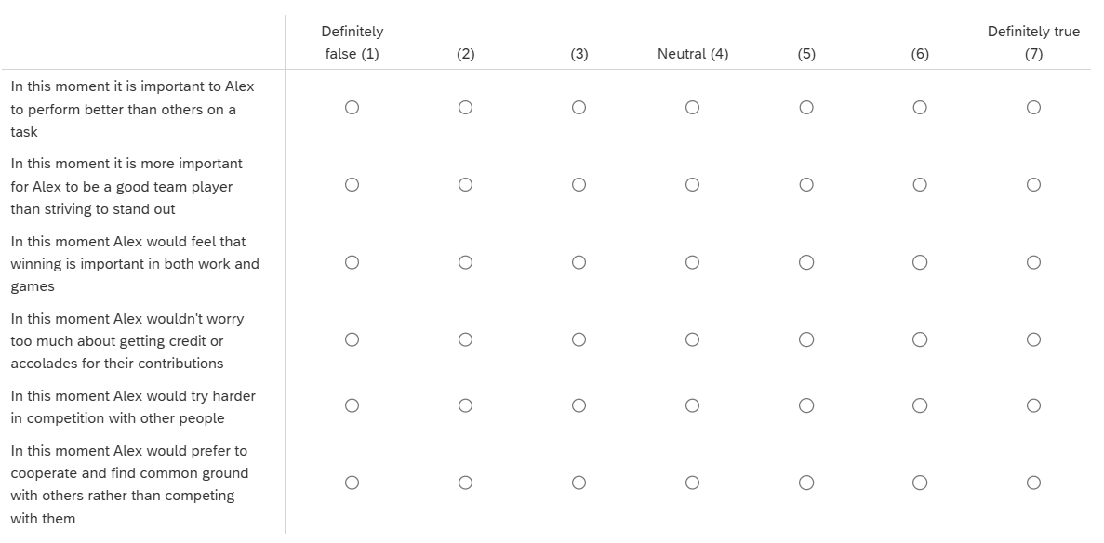

Social Dilemma (Alex)
Now consider a different situation:
Alex and Jordan are working on a major client presentation, which could lead to promotion.
Both have access to useful data and strategic insights that would improve the final presentation.
Each must choose:
- Cooperate: Share their best ideas and resources so the team presentation is excellent, even though this may help the other person and not themselves get promoted.
- Compete: Keep their strongest ideas to themselves and focus on making their own contribution look better, increasing their personal chances of being promoted.
They decide independently.
Outcomes Advisory:
- Both cooperate → excellent presentation, both are valued, slightly increased chances of either being promoted
- Alex competes, Jordan cooperates → Alex gains individual advantage
- Alex cooperates, Jordan competes → Jordan gains individual advantage
- Both compete → weaker presentation, damaged trust, poorer overall chances of either being promoted
Please review the table below for more clarity:
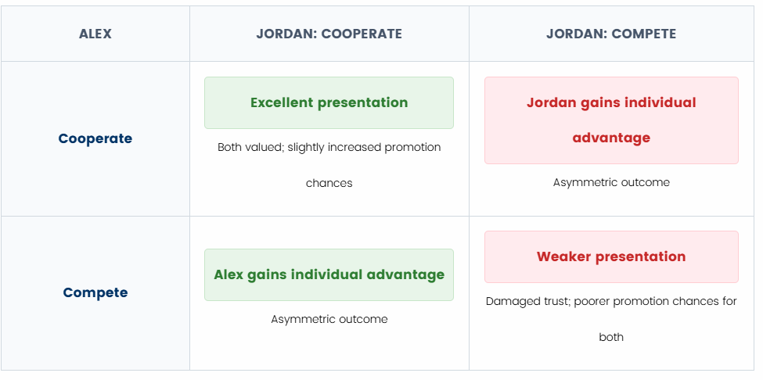
What should Alex do?
- Compete for promotion
- Defer promotion

Table D.1.
Means, Standard Deviations, and One-Way ANOVA Results for Self-Credit - Study 2
Measure | Condition | M (SD) | F(2, 376) | p | η² | 95% CI [η²]
Primary measures (prosociality)
Self-credit | Smallness | 12.48 (3.30) | 2.750 | .065 | .014 | [.000, .043]
Self-credit | Neutral | 13.32 (3.11)
Self-credit | Bigness | 13.22 (2.90)

