SUPPLEMENTARY MATERIAL C
Study 1 measurements

Bigness/Smallness motivation 3rd person

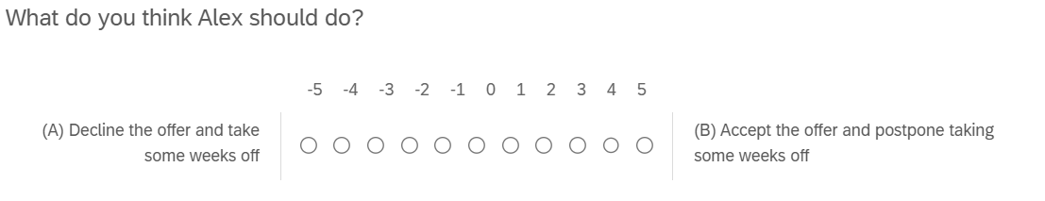
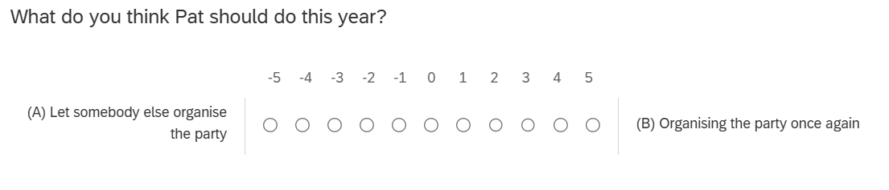
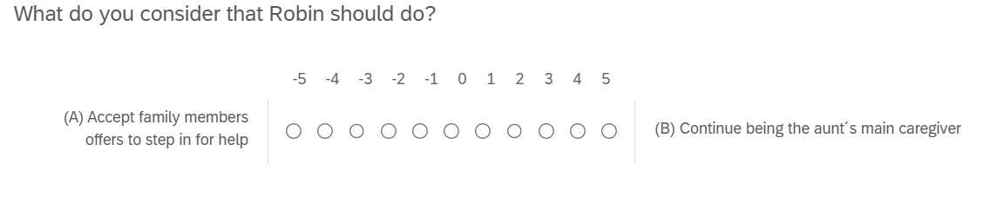

Bigness/Smallness motivation 1st person

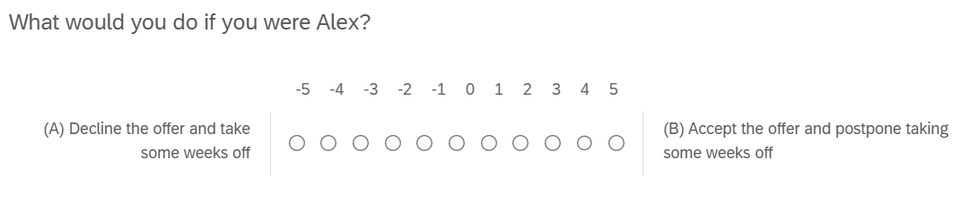
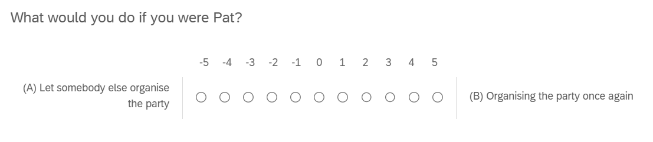
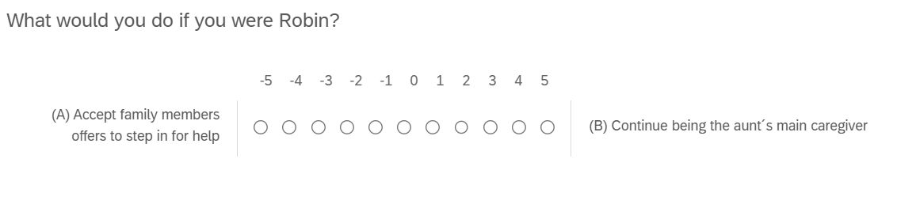

Affect (3rd person) – Adapted from PANAS (Watson et al., 1998)

At this moment, to what extent do you think Alex/Pat/Robin would feel the following:
