SUPPLEMENTARY FILE
Cannabis sativa phytoligands as potential EGFR inhibitors for lung cancer treatment
*Afolabi Owoloye^{1,2}, Samuel O. Olubode³, Precious A. Akinnusi³, Evans Asamoah Adu^{4,5}, Natalia Shakela⁶, David O. Oyerinde⁷, Olamide L. Onawola⁸, Kolapo M. Oyebola^{1,2}
EGFR-ligand interactions
Grossamide interacted with the kinase by forming an H-bond with Thr854. The binding of the pyrrolopyrimidine compound AEE788 to the target kinase was found to extend into the hydrophobic pocket defined by Thr790, Leu788, Lys745, and Met766 via its 4-phenylethylamine moiety, as well as Leu718 and Gly796 below via the 6-phenyl substituent. In addition, the ethylpiperazine group extended towards Asp800 and Glu804 at the edge of the active site. In that order, Luteolin 7-O-glucoside, isovitexin, and quercetin established hydrophobic contacts with Lys745, while grossamide made hydrophobic interactions with Met766.
Luteolin 7-O-glucoside, grossamide, quercetin, orientin, and gefitinib made contact with Leu718 via hydrophobic interactions. Luteolin 7-O-glucoside, isovitexin, and orientin contacted Asp800. Also, Luteolin 7-Oglucoside interacted with the target receptors by forming H-bonds with Arg841, Asp855, and Cys797, as well as hydrophobic interactions with Val726, Ala743, and Leu844. Grossamide made additional contacts with Phe856, Cys797, Asn842, Phe997, Leu1001, Leu792, Arg841, and Val726 via hydrogen and hydrophobic interactions. A pi-pi stacking interaction with the amino acid residue Phe856 was also observed. Quercetin formed additional H-bond contacts with Gln791 and Asp855, and hydrophobic interactions with Val726, Leu844, and Ala743. Isovitexin made additional contacts with Cys797, Ala743, Leu844, and Val726.
Pharmacophore hypothesis
The results of the pharmacophore hypothesis, as depicted in Figure S1, identified five features for Luteolin 7-O-glucoside and quercetin (ADDRR): one H-bond acceptor (A), two H-bond donors (D), and two aromatic rings (R). Four features were observed in isovitexin (ADRR): one hydrogen-bond acceptor, one donor, and two aromatic rings. In addition, Orientin returned a six-feature hypothesis (ADDDRR) that included one hydrogen-bond acceptor, two hydrogen-bond donors, and two aromatic rings. Meanwhile, grossamide exhibited a seven-feature hypothesis (ADDRRRR) comprising one hydrogen-bond acceptor, two donors, and four aromatic rings. The common pharmacophoric signature was a four-feature hypothesis (ADRR), comprising one hydrogen-bond acceptor, one donor, and two aromatic rings. This could be explored by screening large compound libraries to identify ligands that interact strongly with the EGFR binding domain.
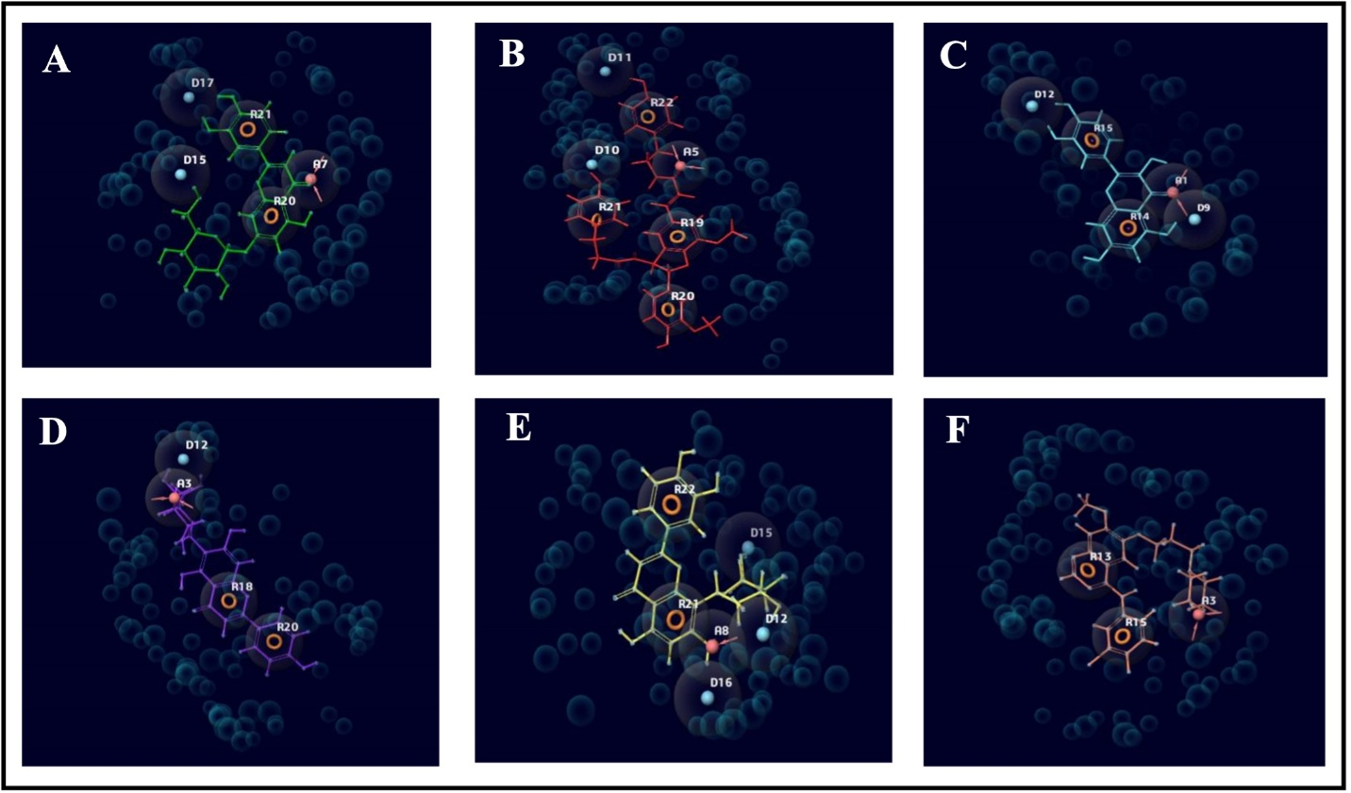
Figure S1: Pharmacophore hypothesis (A = Luteolin 7-O-glucoside, B = Grossamide, C = Quercetin, D = Isovitexin, E = Orientin, F = Gefitinib)

Structure-based pharmacokinetics
Modern drug discovery and development depend heavily on drug metabolism and pharmacokinetics, often known as Absorption, Distribution, Metabolism, Elimination, and Toxicity (ADMET). A high-quality drug candidate should exhibit appropriate ADMET characteristics at the therapeutic dose, in addition to sufficient activity against the therapeutic target. Early drug development uses in silico ADMET servers to model a range of pharmacokinetic and physicochemical endpoints. Table S1 presents the predicted physicochemical properties from the SwissADME server. The pharmacokinetic profile of the selected compounds is summarized in Tables S2 and S3.

Table S1: Physicochemical properties of the lead and standard compounds
Compounds | MW (g/mol) | Con. Log P | ESOL Log S | ESOL Class | Bio. score | Lip. vio.
Luteolin 7-O-glucoside | 448.38 | 0.15 | -3.65 | Soluble | 0.17 | 2
Grossamide | 624.68 | 4.19 | -6.29 | Poorly soluble | 0.55 | 1
Quercetin | 302.24 | 1.23 | -3.16 | Soluble | 0.55 | 0
Isovitexin | 432.38 | -0.02 | -2.84 | Soluble | 0.55 | 1
Orientin | 448.38 | -0.47 | -2.7 | Soluble | 0.17 | 2
Gefitinib | 446.9 | 3.92 | -5.05 | Moderately soluble | 0.55 | 0
MW = molecular weight, Cons. Log P = Consensus Log P, Bio. Score = Bioavailability score, Lip. Vio. = Lipinski violation

Table S2: SwissADME pharmacokinetic profile of the lead and standard compounds
Compounds | GI absorption | BBB permeant | Pgp Substrate | CYP1A2 inhibitor | CYP2C19 inhibitor | CYP2C9 inhibitor | CYP2D6 inhibitor | CYP3A4 inhibitor
Luteolin 7-O-glucoside | Low | No | Yes | No | No | No | No | No
Grossamide | Low | No | Yes | No | Yes | Yes | No | No
Quercetin | High | No | No | Yes | No | No | Yes | Yes
Isovitexin | Low | No | No | No | No | No | No | No
Orientin | Low | No | No | No | No | No | No | No
Gefitinib | High | Yes | No | No | Yes | Yes | Yes | Yes
GI = gastrointestinal, BBB =blood brain barrier, Pgp =P-glycoprotein

Table S3: ProToxII server toxicology profile of the lead and standard compounds
Compounds | Predicted  LD50 (mg/kg) | Predicted toxicity class | Carcino | Hepato | Neuro | Cardio | immuno
Luteolin 7-  O-glucoside | 5000 | 5 | - | - | - | - | -
Grossamide | 500 | 4 | - | - | + | - | -
Quercetin | 159 | 3 | + | - | - | - | -
Isovitexin | 159 | 3 | - | - | - | - | -
Orientin | 1213 | 4 | - | - | - | - | +
Gefitinib | 2935 | 5 | - | + | + | - | +
Carcino = carcinogenicity, Hepato = hepatoxicity, Neuro = neurotoxicity, Cardio = cardiotoxicity, Immuno = immunotoxicity.

Using the SwissADME server, Table S3 presents the predicted physicochemical properties. These findings showed that all the compounds investigated, except Luteolin-7-O-glucoside and orientin, obeyed the Lipinski rules. For greater accuracy, this investigation used the consensus log P to value the arithmetic mean of the five lipophilicity models. Grossamide demonstrated the highest lipophilicity among the test chemicals, with a score of 4.19, compared to 3.92 for gefitinib.
Orientin was the most soluble of all the chemicals examined, according to the ESOL Log S model of water solubility, with a value of -2.7. Except for grossamide, which was poorly soluble (-6.29), all the reported lead compounds demonstrated ideal solubility values and were categorized as soluble. Gefitinib, on the other hand, was regarded as moderately soluble and had a value of -5.05. Quercetin displayed excellent physicochemical characteristics, including a low molecular weight, high bioavailability, and solubility, despite relatively poor absorption. Based on physicochemical profiling, this compound is the most drug-like among the test compounds, including the standard drug (gefitinib).
Table S2 shows the compounds’ pharmacokinetic profiles. The test ligands’ low gastrointestinal absorption rate indicates relatively low lipophilicity. By contrast, quercetin and gefitinib showed high gastrointestinal absorption. All tested substances failed to cross the blood-brain barrier.
Quercetin, isovitexin, orientin, and the standard compound were not P-glycoprotein substrates, whereas grossamide and luteolin 7-O-glucoside were predicted to be P-glycoprotein substrates (Table S2). Luteolin 7-O-glucoside, isovitexin, and orientin were predicted not to inhibit the isoform of CYP. Conversely, grossamide and quercetin, together with the standard drugs, inhibit these enzymes and could result in a drug-drug interaction. Table 5 shows the estimated toxicity profile of the hits, as determined by the Pro-tox II web server.
The lead compounds ranged in LD₅₀ from 159 mg/kg to 5000 mg/kg, with luteolin 7-O-glucoside having the highest values and quercetin and isovitexin the lowest (Table S3). Gefitinib's LD50 was predicted to be 2935 mg/kg. The toxicity class for the lead compounds ranged from class 3 to class 5, with luteolin 7-O-glucoside having the same rank (class 5) as gefitinib. However, gefitinib and grossamide were predicted to be neurotoxic, quercetin carcinogenic, and the standard compound hepatotoxic. The remaining lead compounds showed no toxicity.
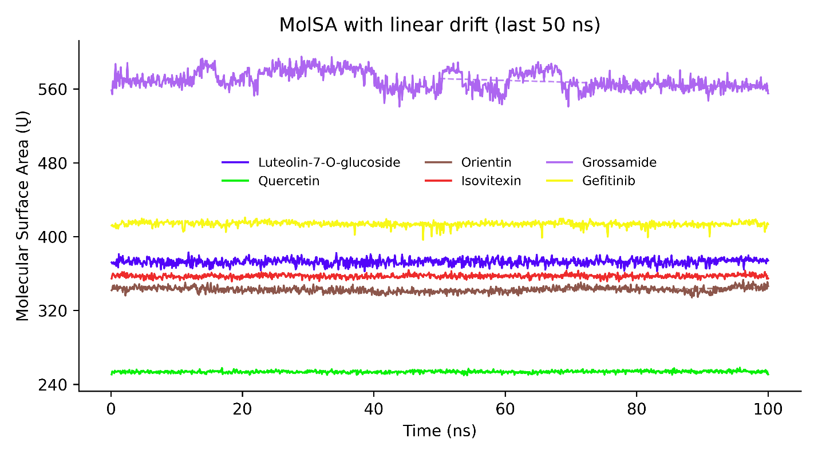
Figure S2. Time evolution of ligand molecular surface area (MolSA) during 100 ns MD simulations with EGFR.
Molecular surface area (MolSA, in Å²) trajectories of five Cannabis sativa phytoligands (grossamide, luteolin-7-O-glucoside, orientin, isovitexin, and quercetin) alongside the reference inhibitor gefitinib, bound to the epidermal growth factor receptor (EGFR), over a 100 ns production run. Linear drift analysis (applied to the final 50 ns) highlights structural compaction and conformational stability of each ligand within the EGFR binding cavity.

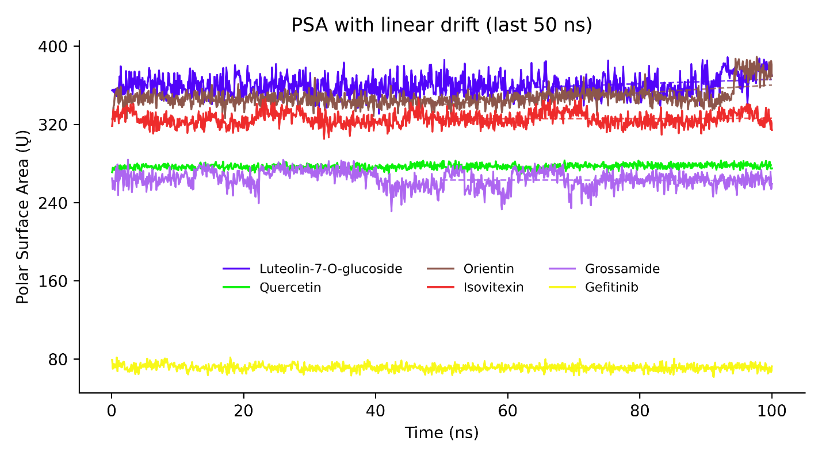
Figure S3: Dynamic polar surface area (PSA) profiles of candidate ligands complexed with EGFR over 100 ns.
Time-dependent fluctuations in ligand polar surface area (PSA, in Å²) across 100 ns molecular dynamics simulations for five Cannabis sativa phytoligands (grossamide, luteolin-7-O-glucoside, orientin, isovitexin, and quercetin) alongside the standard inhibitor gefitinib. Dashed horizontal lines show linear drift over the final 50 ns, indicating stable polar interaction networks and conformational equilibrium within the EGFR binding pocket.

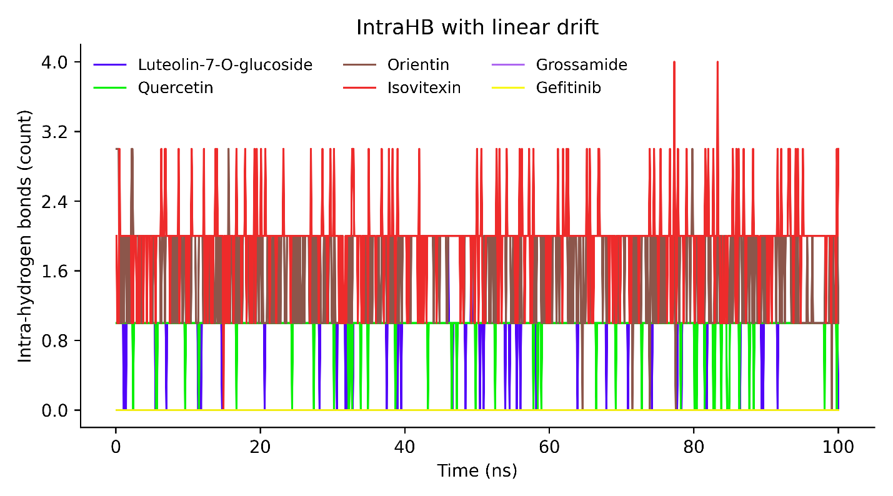
Figure S4: Time-course profiles of intramolecular hydrogen bonding (IntraHB) within EGFR-bound ligands across 100 ns MD simulations.
Intramolecular hydrogen-bond counts are plotted over a 100 ns trajectory for five Cannabis sativa phytoligands (isovitexin, orientin, luteolin-7-O-glucoside, grossamide, and quercetin), alongside the reference inhibitor gefitinib complexed with the epidermal growth factor receptor (EGFR). Linear drift analysis reveals sustained internal hydrogen-bonding networks, most prominently in the C-glycosylflavones (isovitexin and orientin), which contribute to ligand conformational rigidity within the EGFR binding site.

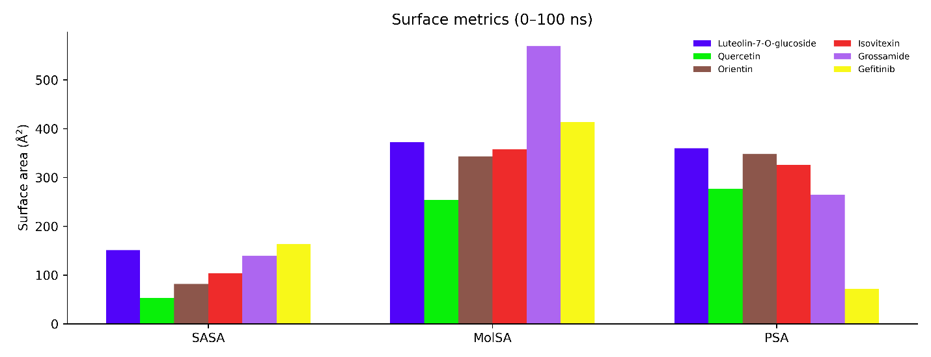
Figure S5: Comparative ligand surface metrics across 100 ns MD simulations of EGFR-bound complexes.
Bar plots compare the average solvent-accessible surface area (SASA), molecular surface area (MolSA), and dynamic polar surface area (PSA), measured in Å², for five Cannabis sativa phytoligands (luteolin-7-O-glucoside, quercetin, orientin, isovitexin, and grossamide) alongside the reference inhibitor gefitinib over a 100 ns simulation. The profiles show low solvent exposure (SASA) and stable steric (MolSA) and polar (PSA) footprints within the EGFR kinase domain, highlighting consistent active-site burial and pocket occupancy.

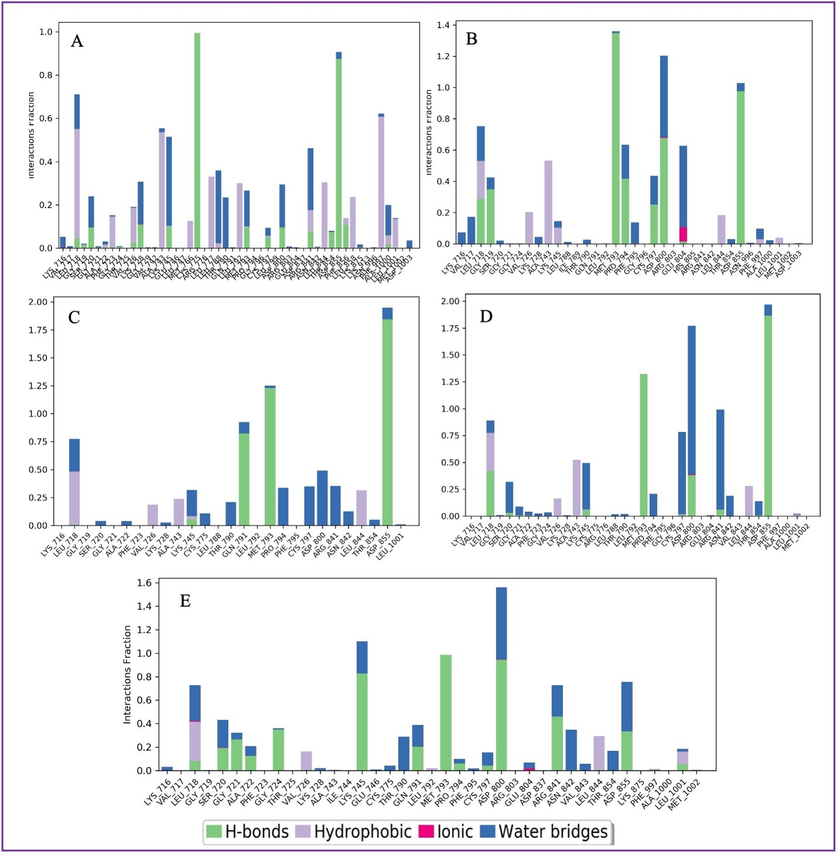
Figure S6: Protein-ligand contacts monitored throughout the 100 ns simulation run time of the EGFR (3POZ) complex with the lead compounds.
Normalized interaction fraction diagrams showing the contacts between EGFR kinase residues and bound ligands throughout the simulation trajectory: (A) Luteolin-7-O-glucoside, (B) Quercetin, (C) Orientin, (D) Isovitexin, and (E) Grossamide [or Gefitinib control; verify compound mapping for panels A–E]. Stacked bar colours categorise interaction modes: hydrogen bonds (green), hydrophobic contacts (light purple), ionic interactions (pink), and water-mediated bridges (blue). Values exceeding 1.0 indicate residues forming multiple simultaneous contacts or multi-pathway interactions with the ligand across the trajecto

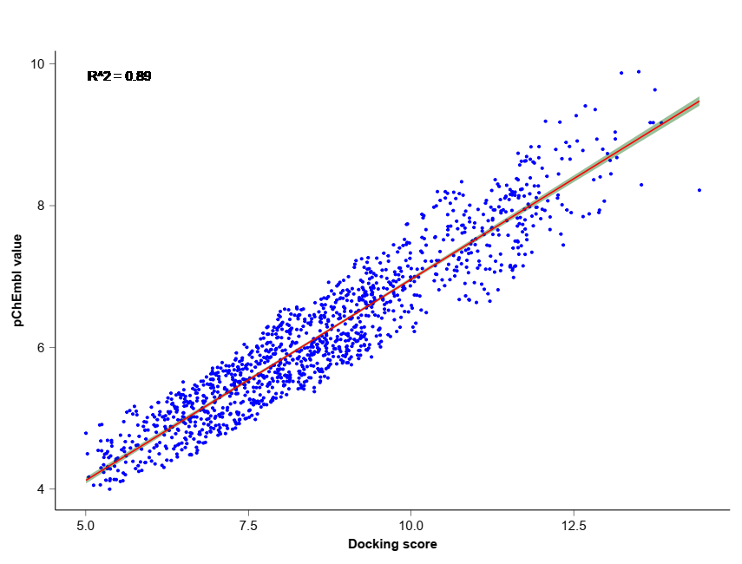
Figure S7: The regression plot between the ChEMBL experimentally determined inhibition of EGFR and the docking scores of the EGFR (R² = 0.89, p-value =0.03).

