Supplementary Information
Article title: Factors Associated With 3-Month Visual Outcomes in Patients With Pituitary Tumors: The Impact of Functional Status and Transsphenoidal Surgery
Journal: Pituitary
Authors: Yeo Jin Lee, Suk-Gyu Ha
Corresponding author affiliation and e-mail address:
Suk-Gyu, Ha
Sukgyu.ha@gmail.com
Korea University College of Medicine Department of Ophthalmology Ansan Hospital

Supplementary Table S1. Baseline characteristics according to transsphenoidal surgery status
Characteristic | Non-TSA (n=38) | TSA (n=37) | P value
Age, years | 63.9 ± 10.6 | 66.2 ± 13.4 | 0.420
Male sex, n (%) | 25 (65.8) | 20 (54.1) | 0.423
Functioning tumor, n (%) | 24 (63.2) | 11 (29.7) | 0.008
Tumor maximum diameter, mm | 23.2 ± 6.3 | 30.0 ± 6.8 | <0.001
Chiasmal compression grade | 1.2 ± 0.9 | 2.0 ± 0.9 | <0.001
Temporal RNFL, μm | 67.5 ± 7.9 | 63.8 ± 6.4 | 0.027
GCIPL, μm | 72.5 ± 6.1 | 67.3 ± 5.8 | <0.001
Baseline visual-field MD, dB | -4.9 ± 3.0 | -7.2 ± 3.1 | 0.002
VFODI | -0.3 ± 0.8 | 0.3 ± 1.1 | 0.025
Data are presented as mean ± standard deviation or number (%). GCIPL, ganglion cell–inner plexiform layer; MD, mean deviation; RNFL, retinal nerve fiber layer; TSA, transsphenoidal surgery; VFODI, visual field–OCT discordance index.

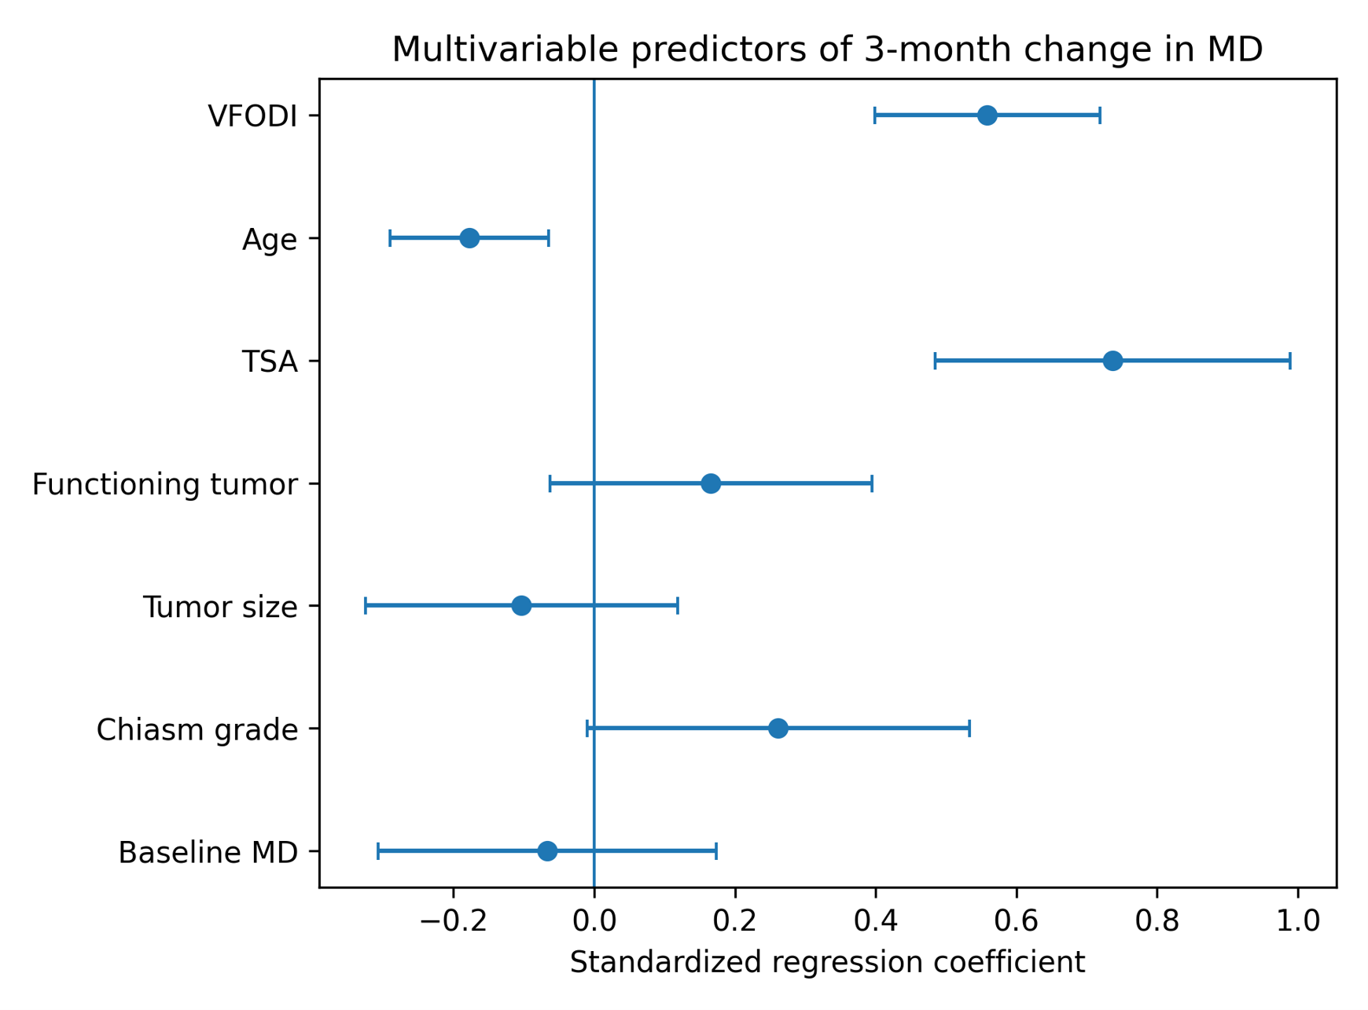
Supplementary Fig. S1 Standardized coefficients from the exploratory multivariable linear regression model for 3-month change in visual-field MD. Error bars represent 95% confidence intervals.

