Supplementary Materials

Supplementary Figure 1
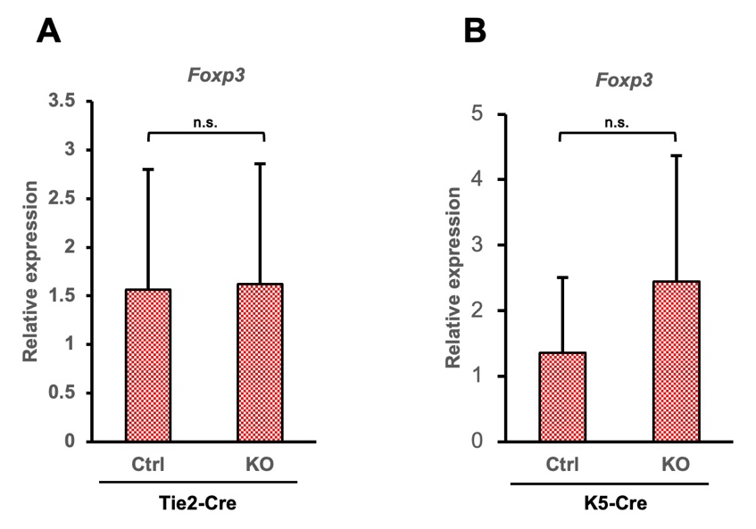

The expression of Foxp3 as the regulatory T cell marker in hematopoietic cell-specific and keratinocyte-specific Nfkbiz-deficient mice.
Quantitative real-time qPCR analysis of Foxp3 expression in dorsal skins after six days of imiquimod treatment. The number of mice was as follows: Ctrl and K5-Cre mice (n = 10 per group), and Ctrl and Tie2-Cre mice (n = 15 per group).
n.s.: not significant

Supplementary Table 1. List of antibodies
Antibody | Application | Host Animal | Dilution | Distributor | Product, Cat. No., RRID
Anti-F4/80 | IHC-F | rabbit,  monoclonal | 1:500 | Cell Signaling Technology,  Danvers, MA | #70076,  RRID: AB_2799771
Anti-Ly-6G | IHC-F | rat,  polyclonal | 1:400 | Biolegend,  San Diego, CA, USA | #127601,  RRID: AB_1089179
Anti-CD8 | IHC-P | rat, monoclonal | 1:80 | Thermo Fisher Scientific,  Waltham, MA | #14-0808-82,  RRID: AB_2572861
Anti-CD4 | IHC-P | rabbit,  monoclonal | 1:1000 | Abcam, Cambridge, UK | #ab183685,  RRID: AB_2686917
Alexa Fluor 488-  anti-Rabbit IgG | IHC-P, F | donkey,  polyclonal | 1:400 | Thermo Fisher Scientific,  Waltham, MA | #A-21206,  RRID: AB_2535792
Alexa Fluor 568-  anti-Rat IgG | IHC-F | donkey,  polyclonal | 1:400 | Thermo Fisher Scientific,  Waltham, MA | #A78946  RRID: AB_2910653
Anti-TNFα antibody | Therapy | Rat IgG1,  monoclonal |  | Bio X Cell, Lebanon, NH | InVivoMAb anti-mouse TNFα (XT3.11), #BE0058  RRID: AB_1107764
Isotype control  (TNFα) | Therapy | Rat IgG1,  monoclonal |  | Bio X Cell, Lebanon, NH | InVivoMAb rat IgG1 isotype control (HRPN), #BE0088  RRID: AB_1107775
Anti-IL1β antibody | Therapy | Armenian Hamster IgG1,  monoclonal |  | Bio X Cell, Lebanon, NH | InVivoMAb anti-mouse/rat IL1β  (B122), #BE0246  RRID: AB_2687727
Control  antibody  (IL1β) | Therapy | Armenian  Hamster IgG,  polyclonal |  | Bio X Cell, Lebanon, NH | InVivoMAb polyclonal Armenian hamster IgG  #BE0091  RRID: AB_1107773
IHC-P: Immunohistochemistry-Paraffin, IHC-F: Immunohistochemistry-Frozen

