Supplementary Information
NISAR offsets measure pre-failure motion but do not single out the Bhote Koshi avalanche source
Sansar Raj Meena
Geophysics Department, SpatioAI Lab, National Institute of Oceanography and Applied Geophysics – OGS, Borgo Grotta Gigante 42/C, 34010 Sgonico, Trieste, Italy
This file contains Supplementary Figs. 1–3 and Supplementary Tables 1–6. Supplementary Fig. 1 and Supplementary Table 5 derive from third-party data licensed CC BY-NC 4.0 (© Geopera / Vantor) and are excluded from the article licence; all other items are CC BY 4.0.
Supplementary figures
Supplementary Fig. 1 | Independent stable-ground check of the third-party Geopera v1.1 elevation-change product. a, Density of elevation change (dh, clipped to ±15 m) on ground outside the release’s own erosion and deposition polygons, for reach A, Rasuwagadhi–Timure (orange), and reach B, Syabrubesi (blue); dashed lines mark the medians and the solid black line zero. A well co-registered product centres on zero. Median and normalised median absolute deviation are −2.33 m and 4.50 m (stated 1σ 3.10 m) for reach A and −0.33 m and 2.19 m (stated 1σ 1.45 m) for reach B. b, Optical cross-check over reach B: the release’s erosion (red) and deposition (yellow) polygons on pre-event PlanetScope imagery of 27 May 2026 (left) and post-event Pelican imagery of 27 August 2026 (right); scale bar 1 km. c, Percentage of pixels whose |dh| exceeds 1σ, 2σ and 3σ of the stated uncertainty, inside the change polygons (solid bars) and on stable ground (hatched, pale bars), for both reaches; the stable-ground fraction is the false-positive rate and the legend gives the signal-to-noise ratio (|median change| / σ). Elevation change is from WorldView-3 stereo (© Vantor, CC BY-NC 4.0) differenced against pre-event NASA HMA terrain, as released by Geopera (Weedman 2026); stable ground includes vegetated slopes against a decade-old reference, so the check is conservative. This is not our measurement and no result in the main text depends on it. Imagery in b © Planet Labs PBC.
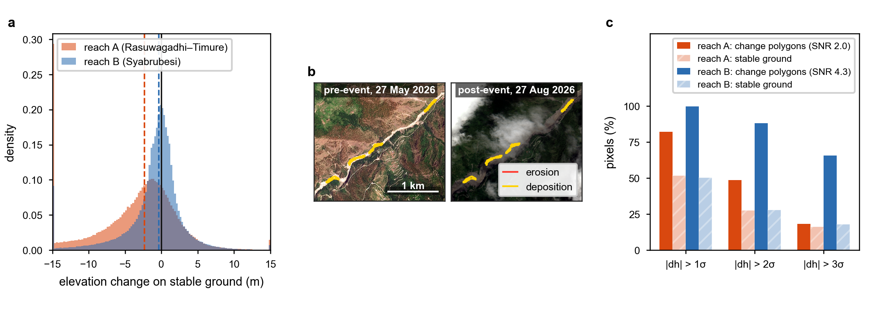

Supplementary Fig. 2 | The source area before and after failure in optical imagery. PlanetScope visual scenes (3 m) over the crown, all three reprojected to one grid and stretched jointly (2–98 %): a, 28 December 2025 (pre-event, winter); b, 17 June 2026 (pre-event, three days before the first NISAR acquisition analysed); c, 28 August 2026 (two days after failure). Window 85.516–85.543° E, 28.277–28.304° N, about 2.6 × 3.0 km; yellow circle and cross, detachment at 85.530° E / 28.290° N; white dashed rectangle, the crown analysis polygon of Figs 1b–3 (85.5245–85.5400° E, 28.2847–28.2970° N); grey, no data (scene edge); scale bar 1 km in every panel; north arrow in c. The post-event scene shows the detachment scar and fresh debris. No displacement is measured from optical data in this study, and the imagery is used under a research licence and not redistributed. Imagery © Planet Labs PBC. Fraction of bright (snow/cloud) pixels: a 39 %, b 68 %, c 30 %; 13 % of c is outside the scene (grey).
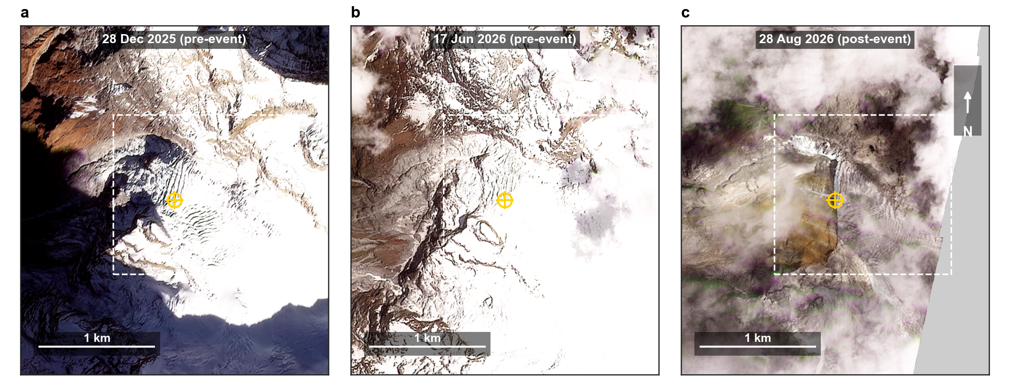

Supplementary Fig. 3 | Coverage of the five GOFF pairs across the footprint. Statistics computed at the native 80 m posting over the 345 × 339 km footprint and reduced to 640 m cells by block median for display; the projection here uses scene-centre geometry, adequate for coverage but not for the magnitudes of the main analysis. a, Number of pairs (of five) with SNR ≥ 5 at each cell; the screenable area used as denominator in the text is where at least two pairs are valid. b, Median over valid pairs of the displacement-magnitude anomaly after removing a 41-pixel (3.28 km) running mean, in metres. c, Median over valid pairs of directional coherence R in a 5 × 5 window computed on the raw direction field, before the bulk offset is removed; it saturates near 1 almost everywhere, which is why the screen computes R on the residual field (Methods). Red box, the 6 km reference box of the site series (about 1 mm at this scale, beneath the star); yellow star, the Bhote Koshi detachment.
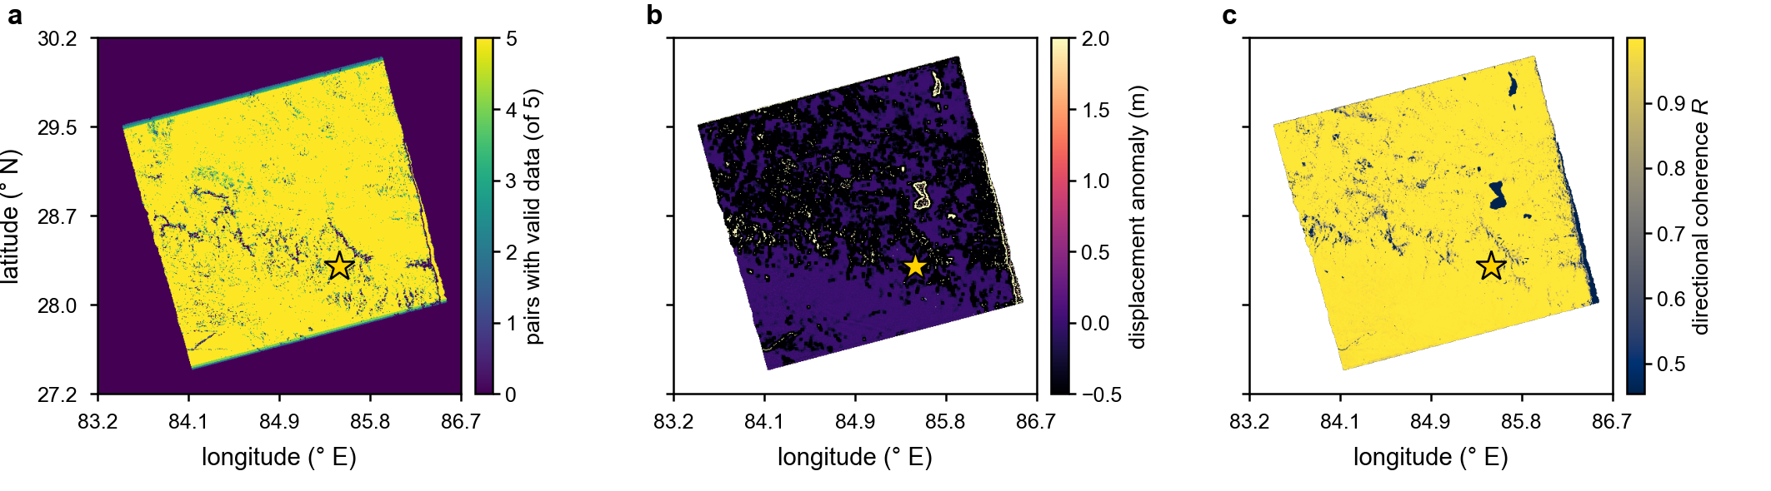

Supplementary tables
Supplementary Table 1 | The five NISAR Level-2 GOFF granules (track T098 ascending, L-SAR frequency A, HH) analysed in this study, as distributed by the Alaska Satellite Facility DAAC. Flag is the processing-flag field of the identifier.
# | Interval (2026) | Days | Flag | Granule identifier
1 | 20 Jun–2 Jul | 12 | N_F | NISAR_L2_PR_GOFF_023_098_A_016_024_4000_SH_20260620T233921_20260620T233956_20260702T233920_20260702T233955_P05023_N_F_J_001
2 | 2–14 Jul | 12 | F_F | NISAR_L2_PR_GOFF_024_098_A_016_025_4000_SH_20260702T233920_20260702T233955_20260714T233920_20260714T233954_P05023_F_F_J_001
3 | 14–26 Jul | 12 | N_F | NISAR_L2_PR_GOFF_025_098_A_016_026_4000_SH_20260714T233920_20260714T233954_20260726T233919_20260726T233954_P05023_N_F_J_001
4 | 26 Jul–19 Aug | 24 | N_F | NISAR_L2_PR_GOFF_026_098_A_016_028_4000_SH_20260726T233919_20260726T233954_20260819T233918_20260819T233953_P05023_N_F_J_001
5 | 19–31 Aug | 12 | N_F | NISAR_L2_PR_GOFF_028_098_A_016_029_4000_SH_20260819T233918_20260819T233953_20260831T233918_20260831T233952_P05023_N_F_J_001

Supplementary Table 2 | Sensitivity of the footprint screen to each threshold, varied one at a time about the default. The zone count varies by a factor of 25; the directional result does not move.
Parameter | Value | Zones | Validated (< 45°) | Median misfit (°) | % < 45°
Minimum anomaly z-score | 3 | 165 | 151 | 17.2 | 91.5
Minimum anomaly z-score | 3.5 | 132 | 123 | 20.1 | 93.2
Minimum anomaly z-score | 4 (default) | 106 | 101 | 19.0 | 95.3
Minimum anomaly z-score | 5 | 68 | 66 | 18.4 | 97.1
Minimum anomaly z-score | 6 | 33 | 30 | 15.4 | 90.9
Minimum anomaly (m) | 0.25 | 109 | 103 | 19.1 | 94.5
Minimum anomaly (m) | 0.5 (default) | 106 | 101 | 19.0 | 95.3
Minimum anomaly (m) | 0.75 | 100 | 96 | 19.0 | 96.0
Minimum anomaly (m) | 1 | 96 | 93 | 18.7 | 96.9
Minimum residual coherence R | 0.65 | 136 | 123 | 20.5 | 90.4
Minimum residual coherence R | 0.7 | 119 | 111 | 18.6 | 93.3
Minimum residual coherence R | 0.75 (default) | 106 | 101 | 19.0 | 95.3
Minimum residual coherence R | 0.8 | 93 | 88 | 18.5 | 94.6
Minimum residual coherence R | 0.85 | 77 | 75 | 17.4 | 97.4
Minimum epochs (of five) | 2 (default) | 106 | 101 | 19.0 | 95.3
Minimum epochs (of five) | 3 | 46 | 44 | 14.3 | 95.7
Minimum epochs (of five) | 4 | 12 | 12 | 15.8 | 100.0
Minimum zone size (px) | 5 | 198 | 170 | 20.2 | 86.3
Minimum zone size (px) | 10 (default) | 106 | 101 | 19.0 | 95.3
Minimum zone size (px) | 20 | 47 | 46 | 17.4 | 97.9
Minimum zone size (px) | 40 | 8 | 8 | 18.9 | 100.0

Supplementary Table 3 | The 8 validated zones that do not intersect an RGI 6.0 glacier polygon, ordered by score. d_glac is the distance to the nearest inventoried glacier; zones within a few hundred metres are more plausibly unmapped debris-covered ice than non-glacial ground.
Lon (°E) | Lat (°N) | Area (km²) | Pairs | Residual disp. (m) | Elev. (m) | Slope (°) | Misfit (°) | d_glac (m) | Score
85.1056 | 28.3911 | 0.141 | 4 | 5.81 | 4983 | 37.0 | 9.4 | 1384 | 19.2
85.7318 | 28.3142 | 0.070 | 4 | 4.38 | 5753 | 31.3 | 35.6 | 349 | 11.1
84.0482 | 28.5571 | 0.166 | 4 | 4.04 | 5257 | 29.5 | 6.5 | 985 | 10.7
84.7145 | 28.6129 | 0.179 | 4 | 3.46 | 5259 | 22.3 | 31.1 | 1202 | 9.8
85.1388 | 28.4971 | 0.122 | 4 | 3.60 | 5406 | 25.2 | 0.5 | 1192 | 9.2
83.9929 | 28.5233 | 0.211 | 4 | 2.39 | 3731 | 13.4 | 25.7 | 1001 | 6.0
84.6697 | 28.6460 | 0.064 | 3 | 2.49 | 4667 | 23.7 | 5.4 | 966 | 5.1
85.1082 | 28.4267 | 0.083 | 3 | 2.56 | 5271 | 13.8 | 27.1 | 904 | 4.5

Supplementary Table 4 | Per-pair site statistics under every criterion described in Methods. Columns are the five consecutive NISAR pairs. R is the 5 × 5 directional coherence (mean resultant length of unit displacement vectors). Criterion 1 removes the 6 km box vector mean before computing R; criterion 2 removes the 3.28 km local vector mean; the single-field recomputation applies criterion 1 with the crown excluded from the reference. Percentiles place the crown value among size-matched random samples drawn from the box (polygon scale, 857–996 draws) or from the 6 km box at the 30-pixel core scale (388–395 draws; the tail of this null is over-dispersed and the percentile is descriptive). The GAMMA cross-check is available for the co-event pair only and is not commensurate with the NISAR values (cross-correlation floor 0.05; see Methods).
Statistic | 20 Jun–2 Jul | 2–14 Jul | 14–26 Jul | 26 Jul–19 Aug | 19–31 Aug
Interval (days) | 12 | 12 | 12 | 24 | 12
GOFF processing flag | N_F | F_F | N_F | N_F | N_F
Crown polygon pixels with valid offsets (after 10 m discard) | 302 | 299 | 302 | 298 | 202
Median crown displacement (m) | 0.99 | 0.54 | 0.30 | 0.96 | 0.33
Median crown rate (cm d⁻¹) | 8.3 | 4.5 | 2.5 | 4.0 | 2.7
Displacement-null: crown median displacement percentile among size-matched box samples | 94.9 | 87.5 | 81.0 | 94.7 | 81.3
Displacement-null: median of null samples (m) | 0.17 | 0.21 | 0.14 | 0.14 | 0.09
Criterion 1 (bulk-reference): crown R | 0.750 | 0.612 | 0.611 | 0.871 | 0.551
Criterion 1: background R (box, crown excluded) | 0.641 | 0.719 | 0.757 | 0.687 | 0.592
Criterion 1: crown − background | 0.109 | −0.107 | −0.146 | 0.185 | −0.041
Criterion 1: crown exceeds background | yes | no | no | yes | no
Single-field, crown-excluded recomputation: crown R | 0.739 | 0.583 | 0.594 | 0.848 | 0.511
Single-field recomputation: background R | 0.636 | 0.726 | 0.764 | 0.680 | 0.595
Single-field recomputation: crown exceeds background | yes | no | no | yes | no
Criterion 2 (local-mean reference): crown R | 0.669 | 0.679 | 0.726 | 0.775 | 0.666
Criterion 2: background R | 0.678 | 0.667 | 0.697 | 0.795 | 0.661
Criterion 2: crown − background | −0.009 | 0.012 | 0.029 | −0.020 | 0.005
Criterion 2: crown exceeds background | no | yes | yes | no | yes
Polygon-scale null: crown R percentile | 77.2 | 23.3 | 39.8 | 85.2 | 29.1
Polygon-scale null: samples beating the box mean (%) | 47.5 | 37.7 | 37.2 | 46.7 | 50.2
Polygon-scale null: 5th percentile of null R | 0.460 | 0.485 | 0.481 | 0.413 | 0.412
Polygon-scale null: 95th percentile of null R | 0.863 | 0.891 | 0.965 | 0.896 | 0.814
Polygon-scale null: number of draws | 857 | 887 | 920 | 916 | 996
Core-scale test: core pixels | 30 | 30 | 30 | 30 | 30
Core-scale test: core R | 0.969 | 0.978 | 0.962 | 0.973 | 0.867
Core-scale null: median R | 0.628 | 0.718 | 0.732 | 0.679 | 0.566
Core-scale null: 90th percentile | 0.888 | 0.936 | 0.964 | 0.912 | 0.844
Core-scale null: 99th percentile | 0.969 | 0.989 | 0.998 | 0.981 | 0.931
Core-scale test: core R percentile | 99.0 | 97.0 | 89.2 | 97.7 | 92.6
Core-scale null: number of draws | 389 | 395 | 389 | 388 | 394
GAMMA cross-check: crown R | — | — | — | — | 0.659
GAMMA cross-check: 6 km box R | — | — | — | — | 0.686
GAMMA cross-check: scene R | — | — | — | — | 0.654
GAMMA cross-check: crown / box pixels | — | — | — | — | 1,398 / 31,703

Supplementary Table 5 | Stable-ground check of the Geopera stereo elevation-difference product (Weedman 2026, v1.1) used only in Supplementary Fig. 1. For each reach the elevation difference between the pre-event NASA HMA terrain and the post-event stereo surface is evaluated outside (stable ground) and inside (change mask) the mapped change polygons. NMAD, normalised median absolute deviation. Fractions are pixels whose |difference| exceeds the producer-stated uncertainty σ. The product is third-party data (CC BY-NC 4.0) and no NISAR result depends on it.
Statistic | Reach A (Rasuwagadhi–Timure) | Reach B (Syabrubesi)
Stated vertical uncertainty σ (m) | 3.10 | 1.45
Stable-ground pixels | 2,689,425 | 5,755,766
Change-mask pixels | 43,435 | 26,373
Stable-ground median elevation difference (m) | −2.33 | −0.33
Stable-ground mean elevation difference (m) | −3.68 | −1.11
Stable-ground NMAD (m) | 4.50 | 2.19
Change-mask median elevation difference (m) | −6.05 | −3.61
Change-mask median |difference| (m) | 6.05 | 6.29
Stable-ground fraction beyond 1σ (%) | 52 | 50
Change-mask fraction beyond 1σ (%) | 82 | 100
Stable-ground fraction beyond 2σ (%) | 27 | 28
Change-mask fraction beyond 2σ (%) | 49 | 88
Stable-ground fraction beyond 3σ (%) | 16 | 18
Change-mask fraction beyond 3σ (%) | 18 | 66
Change-mask median |difference| / stated σ | 1.95 | 4.33

Supplementary Table 6 | Footprint-screen parameters. All thresholds are fixed before the topographic comparison; their one-at-a-time sensitivity is in Supplementary Table 2.
Parameter | Value
Signal-to-noise threshold | ≥ 5
Displacement magnitude discard | > 10 m (applied before referencing)
Local window (ramp removal, scatter) | 41 px, 3.28 km
Coherence window | 5 px, 400 m; ≥ 50 % valid
Coherence computed on | residual field (local vector mean removed)
Minimum anomaly | 0.5 m
Minimum anomaly z-score | 4.0
Minimum residual coherence R | 0.75
Minimum epochs of five | 2
Minimum zone size | 10 px, 0.064 km²
Validation: misfit to downslope | < 45°

