Supplementary Material
Predicting the Inspector, Not the Plant: Regulatory Targeting and Explanation Instability in Pharmaceutical Inspection-Outcome Models
Phani Kumar Balagam, Independent Researcher, United States

S1. Prior-outcome availability: bounding the exposure
Features are computed as of the inspection’s end date, not the date on which a record became knowable. A prior classification is recorded against the date the prior inspection ended, but it does not become visible until FDA closes it out: the median interval to a recorded closure is 314 days for OAI against 91 days for non-OAI, and only 20.2% of OAI records ever carry a closure date at all.
We do not gate on closure date, because only a fifth of OAI records have one and gating would remove most prior-OAI signal for reasons of data coverage rather than of science. Instead the exposure is bounded directly.
Table S1. Rows whose prior-outcome features may encode a classification that had not yet posted.
Prior OAI more recent than | Rows | % of prior-OAI rows | % of panel | OAI rate
91 days | 43 | 1.4% | 0.11% | 53.5%
180 days | 91 | 3.0% | 0.23% | 55.0%
314 days (median OAI latency) | 212 | 7.0% | 0.54% | 44.8%
365 days | 293 | 9.7% | 0.75% | 40.6%
540 days | 647 | 21.3% | 1.65% | 35.6%
The affected rows are strongly outcome-enriched (44.8% OAI at the median-latency window against a 7.42% base), which is why the exposure is worth bounding rather than waving away; but at 0.54% of the panel they cannot move a block whose whole unique contribution is +0.006 AUROC. Rows whose last prior inspection of any kind is under 314 days old — the corresponding bound on citation-feature exposure, since citations post with the classification — number 2,803, or 7.16% of the panel.
The honest statement is therefore: every feature is dated strictly before the inspection it predicts, no feature is dated after it, and a small and identifiable minority of rows carry prior-outcome information that a deployed system would not have had in hand on the day.

S2. Panel construction details
Of the 39,147 drug inspections, 752 appeared in the source under two project areas each. Keeping both rows would attach one outcome to both sides of the project-area contrast the paper turns on, so rows are collapsed to one per inspection, the alphabetically first area is kept as primary, and the row is flagged. After that collapse, 0.75% of rows (294) still share a facility and end date with another inspection; the strict inequality in the history construction means such rows do not see each other, which is conservative.
The sister-facility feature counts facilities sharing a normalized legal name whose own first recorded inspection strictly precedes this row’s date. An earlier version counted them over the whole 2008–2026 corpus, which told a 2010 row how many sister sites the firm would eventually have; that was look-ahead, and it inflated a non-conduct feature in the direction of this paper’s conclusion. Two residual caveats remain: the count is left-truncated at the export’s start, so it ramps mechanically through the early years, and the name-to-facility linkage is still built over the whole corpus even though the dates are as of the prediction date.
Four fields are excluded by construction because they are consequences of the inspection being predicted rather than inputs to it: the classification itself, the posted-citations field, the FMD-145 date, and the citations attached to the row’s own inspection. Fiscal year is excluded as a numeric feature so that the model cannot read the era off the row.
Absent history is encoded as −1 rather than as missing: 45.9% of rows for days since last inspection, 92% for days since last OAI. Tree models split on that sentinel cleanly; the standardized logistic model treats it as a numeric value adjacent to “one day ago,” which is a plausible part of why it responds differently to the conduct ablation.

S3. Leave-one-feature-out reliability
Leave-one-feature-out refitting is stochastic, because the model subsamples rows and columns. The entire 96-feature pass was run 10 times, changing nothing but the seed, giving 45 pairwise comparisons. Their Spearman correlations have median 0.17, interquartile range 0.08 to 0.27 and full range −0.18 to 0.42. A pair of passes shares a median of 3 of 10 top features (range 1 to 5), and a median of 46 of 96 features change the sign of their estimated contribution between passes (range 4 to 82). The anchor is stable: AUROC 0.810, standard deviation 0.0016 over five seeds. It is the per-feature differences, of order 0.001 to 0.005, that are swamped by refit noise.
An earlier version of this work ran two passes, obtained Spearman 0.27, and quoted it to two decimals. That is the same single-run-number-as-finding pattern this analysis criticizes, applied to the criticism itself: 0.27 was one draw from the distribution above, and it sat well above its median. An earlier version also reported a SHAP-versus-incremental rank correlation of 0.30 as a finding about SHAP; the same quantity here is −0.13, and neither number means anything, because the reference cannot reproduce itself.
On counting features that survive every resample. The number of features appearing in the top 10 of every bootstrap resample is not a fixed quantity: it falls mechanically as the number of resamples rises. Two features survive all 200 resamples here; an earlier version reported five from 20 resamples, and the two figures are not comparable. The interval-bearing statistic is the mean overlap, 8.2 of 10 (7 to 10). Eighteen distinct features appear in some resample’s top 10.
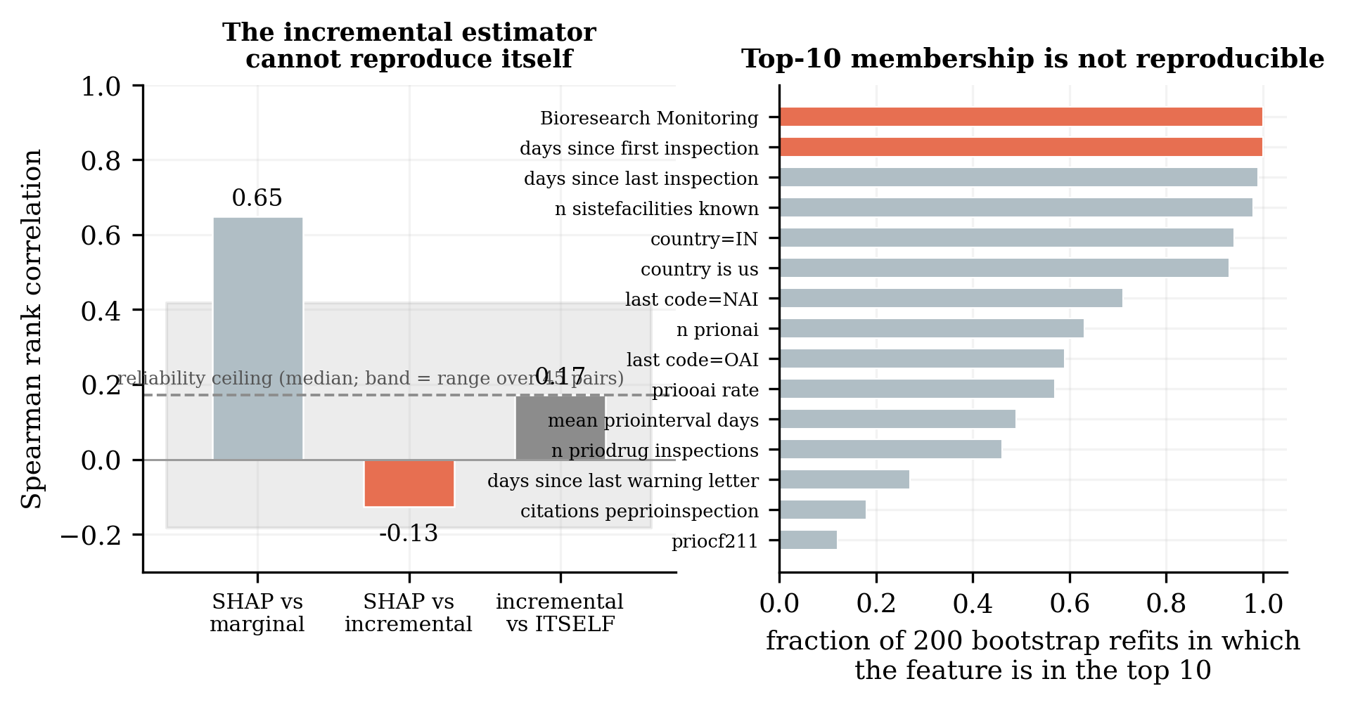
Figure S1. Left, rank correlations between the three notions of importance, with the incremental estimator’s agreement with an independent replicate of itself shown as the ceiling any such correlation could reach. Right, how often each feature enters the top 10 across bootstrap refits.

S4. Operating a frozen model, year by year
Table S2. A model frozen before the disruption, against annual retraining.
Test year | Frozen ≤2019 AUROC | Retrained annually | Frozen observed/predicted
2021 | 0.825 | n/a | 1.62
2022 | 0.807 | n/a | 1.55
2023 | 0.782 | 0.826 | 1.43
2024 | 0.761 | 0.809 | 1.61
2025 | 0.762 | 0.822 | 1.97
The within-era control, trained on data up to 2018 and tested on 2019 where no shift exists, reads AUROC 0.797 and observed/predicted 1.32, and every figure in this table should be read against it rather than against 1.0. Measured from that control the frozen model loses 0.035 AUROC by 2025; measured from its own 2021 peak the figure is 0.063, and the former is quoted because 2021 is the highest value in the series.
A confound that was removed. The first pass fitted these models with a class-imbalance weight, which rescales predicted probabilities away from the base rate. It produced an observed/predicted of 0.26 on the 2019 within-era control, where no regime shift exists. The apparent miscalibration was the weighting, not the world. All probability-level results use unweighted fits, and the within-era control is retained precisely because it is what exposed the error. Rank metrics are invariant to that rescaling and were never affected.
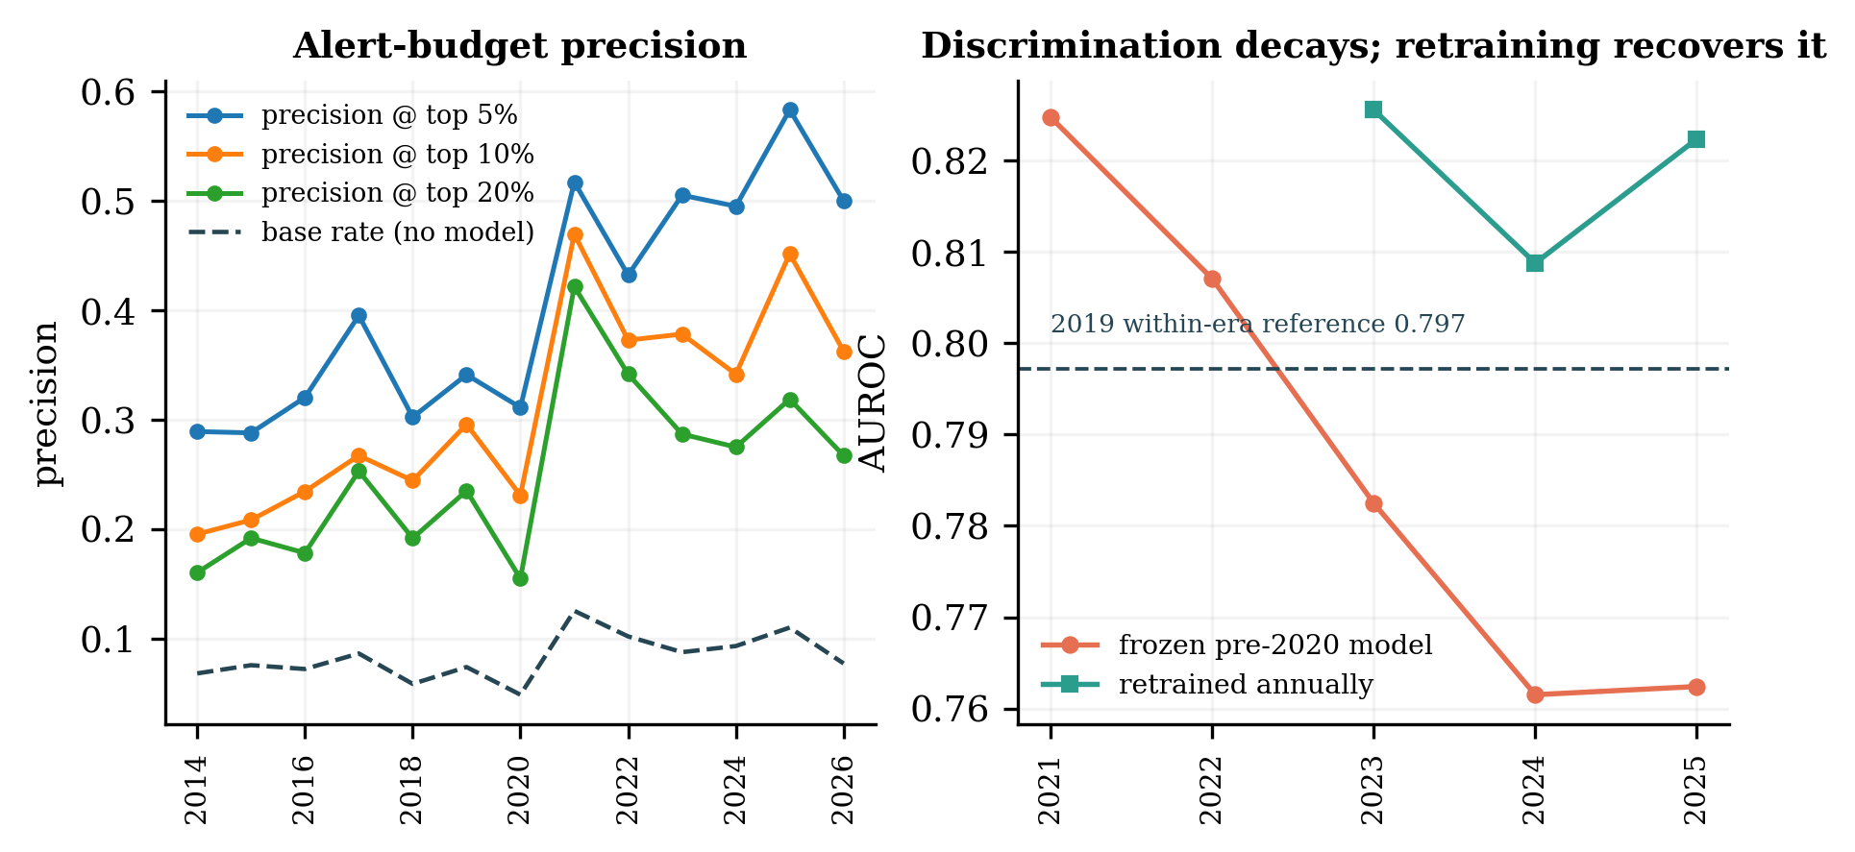
Figure S2. Left, alert-budget precision by test year against the base rate. Right, discrimination of a frozen versus an annually retrained model.

S5. Regime shift: further qualifications
The foreign series is noisy rather than genuinely flat, and its 2017 value of 14.3% exceeds every pre-2021 US value, so the 1.01 pre/post agreement is a coincidence of two imprecise estimates. The 2022–2025 window excludes 2026, where the asymmetry reverses (foreign 19.1%, US 12.8% on partial-year counts of 110 and 321).
Two specification points matter in the interrupted time series. The interaction term is centered at the cut, so the level shift is the discontinuity there rather than an offset extrapolated to the start of the window; that distinction is worth 2.3-fold on the US row, and an earlier version of this analysis got it wrong. And the estimator is unpenalized maximum likelihood. An earlier version used a default L2 penalty, which shrinks every odds ratio toward 1 — under which a positive finding is merely conservative but a null is produced by an estimator biased toward exactly that null. The foreign-stratum null had to be re-earned, and it survives: 0.833 unpenalized against 0.838 penalized. All 400 resamples converged in every stratum; none was dropped.

S6. Extended limitations
Alternative explanations for the US–foreign asymmetry that cannot be excluded. FDA’s Mutual Recognition Agreement with EU authorities reached full drug capability in July 2019, allowing reliance on EU inspectorate reports for routine surveillance, which would remove precisely the lowest-OAI foreign inspections and inflate the foreign rate rather than hold it flat. More importantly, the panel has no field distinguishing pre-approval, for-cause and routine surveillance inspections within a project area, and foreign post-2020 work was heavily application-driven. “Drug Quality Assurance” is therefore not a fixed stratum across the disruption, and that is the single largest confound in the regime-shift analysis. Inspection-assignment records, which are not public, would settle it.
Facility composition inside the strata also moved, in the US only. Within US drug-quality inspections the share of rows at facilities with a prior OAI rose from 14.6% to 21.2% and the share of first-ever inspections fell from 26.5% to 16.3%, while foreign composition barely moved. Part of the doubling is therefore a facility-level composition effect rather than a change in the conditional, and the program × country stratification does not remove it.
Compliance actions are dominated by another center, and they are not filtered by one. Of 176,603 compliance actions, the overwhelming majority are tobacco records; only 2,941 are CDER. Warning-letter features for drug facilities are therefore thin, so their small unique contribution partly reflects sparsity. And the prior-warning-letter and prior-compliance-action counts count actions at the FEI number from any center: a tobacco warning letter issued to a facility that also makes drugs enters that facility’s drug-inspection enforcement features. This is reported as a defect rather than a design choice.
Recalls are weak features by construction. Of 4,652 recall events, 1,835 matched a unique facility and 1,702 were refused as ambiguous. The enforcement block’s small contribution partly reflects that sparsity rather than a true absence of signal.
Classification lag right-censors the recent years. The Data Dashboard publishes classified inspections only, and OAI classifications take longest to finalize. The 2026 partial year runs to August 4 at 807 inspections against roughly 2,100 in a full year, and 2025 may not be final either.
Two protocol details that favor the model slightly. Categorical levels are chosen by frequency over the whole panel including test years, and prior-history features count inspections of any product type, so a food or device OAI can enter a drug inspection’s history. Neither is a temporal leak, but both depart from the strict reading of the protocol. The analysis set itself is drugs only: the product-type filter is applied when rows are built, so the reported N = 39,147 contains no non-drug inspection; the 341,046 figure is the source corpus, not the analysis set.

S7. Reproducibility
All source data are public. The derived analysis panel, the code that builds it and every result file are released at https://github.com/phanibalagam/fda-inspection-outcomes and archived at Zenodo under DOI 10.5281/zenodo.22730734.
Script | Purpose
01_build_panel.py | 39,147-row inspection panel
02_model.py | rolling-origin model fits
03_block_ablation.py | feature-block decomposition
04_regime_shift.py | the 2020 natural experiment
05_explanation_audit.py | importance and stability
08_verify_manuscript.py | re-checks every number in the manuscript
gen_figures.py | figures, from result files only
12_release_package.py | the repository release
Scripts 02 to 05, the figures and the verifier run end to end from the shipped analysis panel, whose SHA-256 digest is recorded in the repository’s data card; they are deterministic at a single seed. Script 01 is not runnable as shipped: it reads the FDA Data Dashboard, whose API is credentialed, and the raw exports are too large to redistribute. A manifest ships in their place and records every endpoint, request body, page count, row count, byte size, SHA-256 digest and fetch timestamp, so that a reader with their own FDA key can re-fetch and confirm the same corpus. The API key is read from the environment and appears nowhere in the repository. This is an artifact a reader can verify and partly re-run, not an end-to-end reproducible one, and it is described as such.
Dependencies: numpy, scipy, scikit-learn, xgboost, shap, matplotlib. Input data are the FDA Data Dashboard API (inspections classifications, inspection citations, compliance actions; fetched September 6, 2026) and the openFDA drug enforcement bulk export (August 27, 2026). Total runtime is approximately 15 minutes on one machine, dominated by the leave-one-feature-out pass.
Every number in the manuscript is emitted by the analysis scripts into result files, and the verifier re-reads each one from those files and fails on any disagreement with the manuscript text.

