Supplementary information

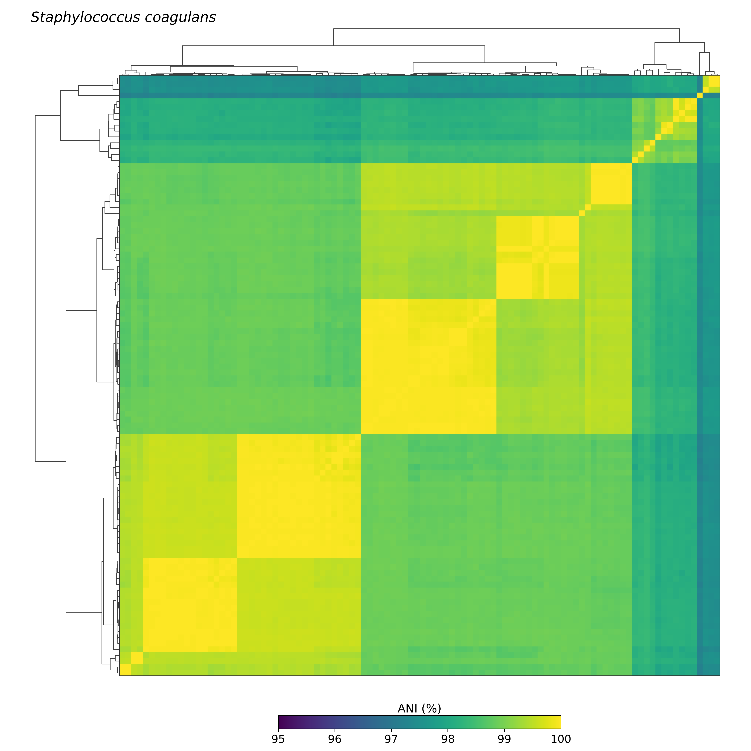

Supplementary Figure S1 (.pdf). Pairwise average nucleotide identity among Staphylococcus coagulans genomes. Pairwise average nucleotide identity (ANI) values were calculated using FastANI v1.34 for the 102 S. coagulans genomes retained following quality control and taxonomic validation. The heatmap represents pairwise ANI values on a 95–100% colour scale. Genome order was determined by hierarchical clustering of the ANI matrix. The resulting dendrogram is provided solely to facilitate visual interpretation of the similarity matrix and should not be interpreted as a phylogenetic reconstruction.

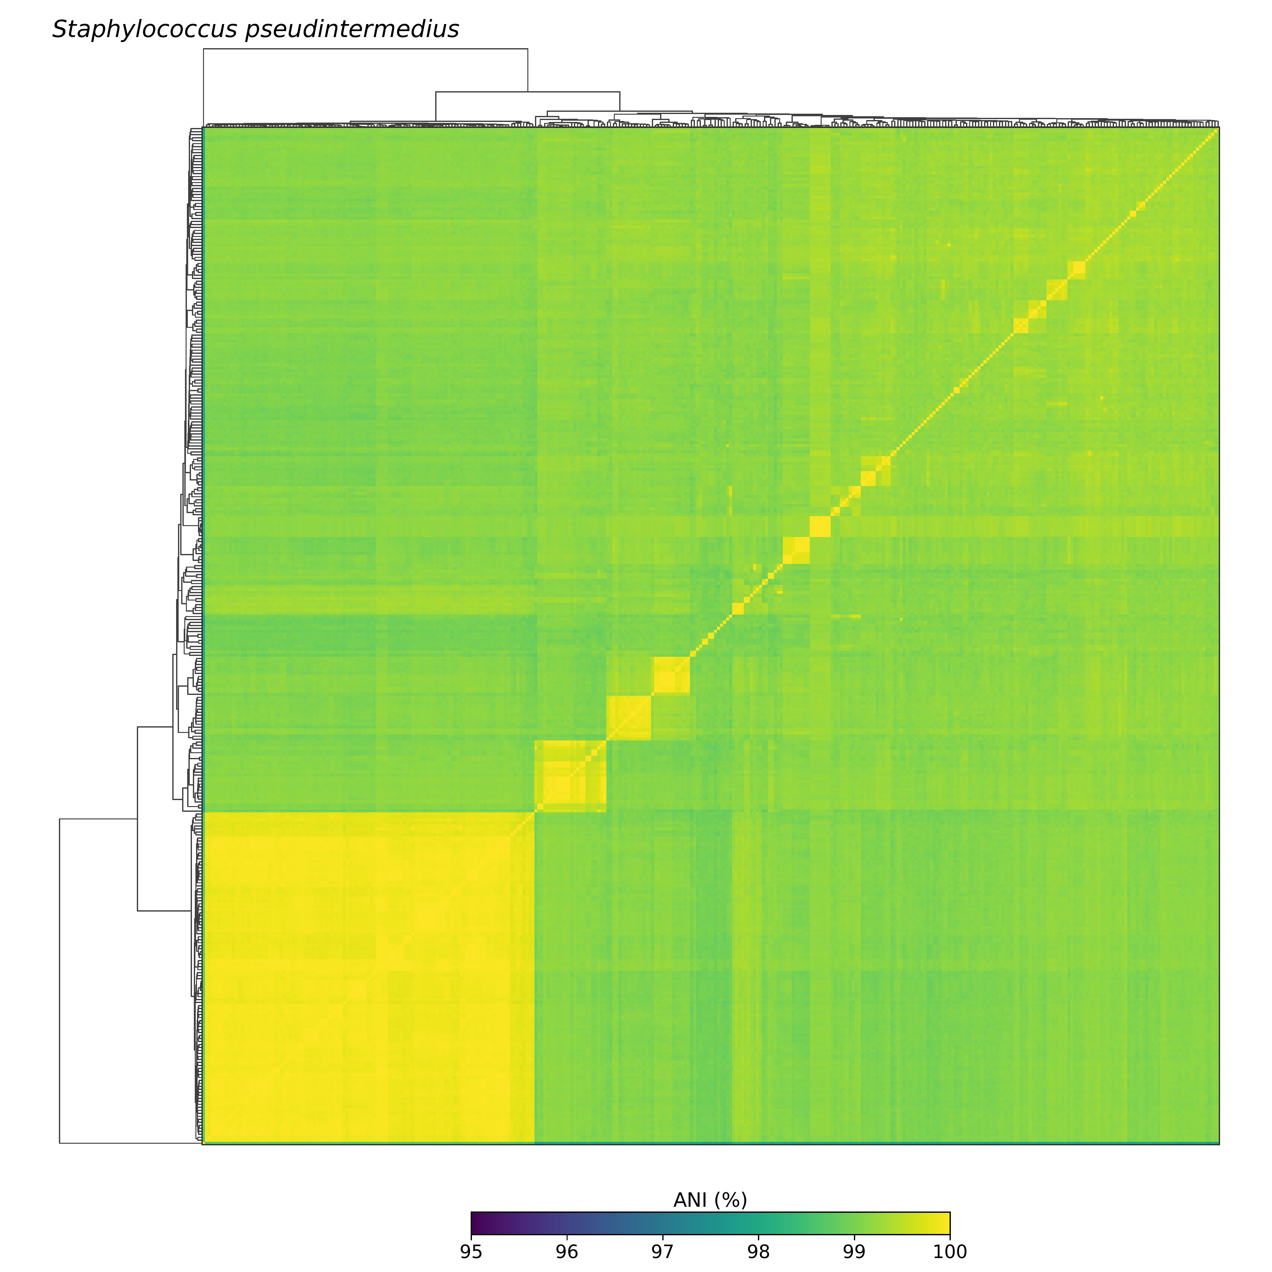

Supplementary Figure S2 (.pdf). Pairwise average nucleotide identity among Staphylococcus pseudintermedius genomes. Pairwise ANI values were calculated using FastANI v1.34 for the 340 S. pseudintermedius genomes retained following quality control and taxonomic validation. The heatmap represents pairwise ANI values on a 95–100% colour scale. Genome order was determined by hierarchical clustering of the ANI matrix. The resulting dendrogram is provided solely to facilitate visual interpretation of the similarity matrix and should not be interpreted as a phylogenetic reconstruction.

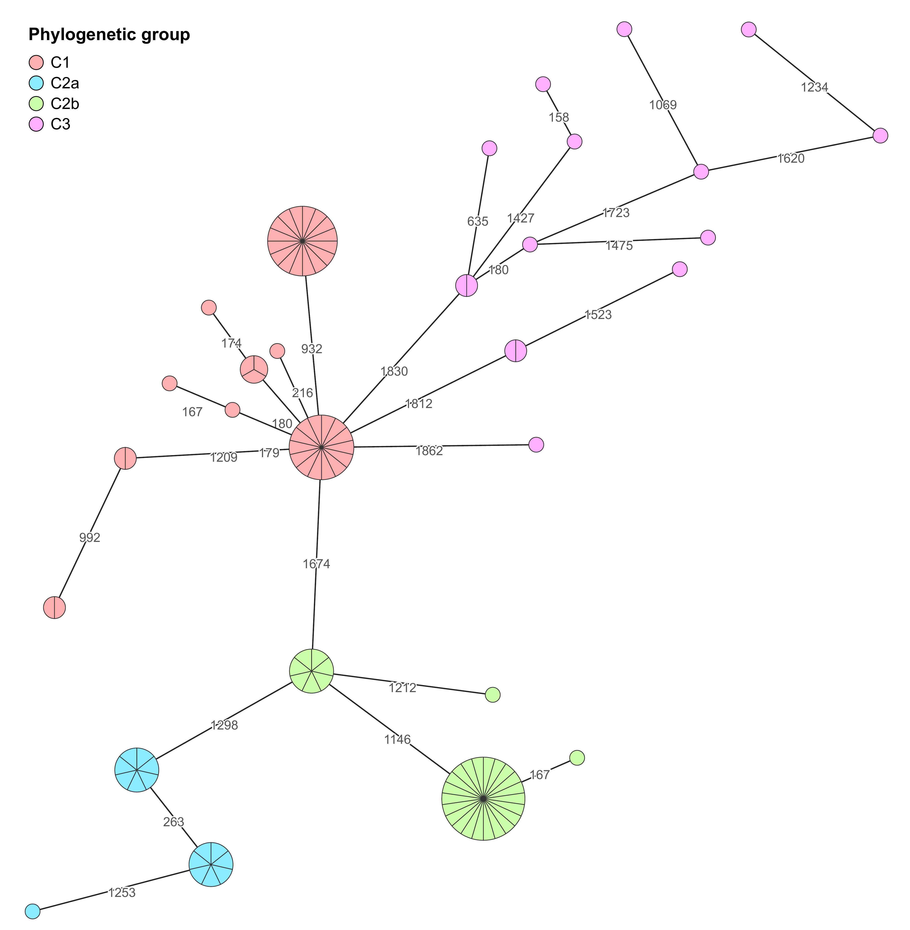

Supplementary Figure S3 (.pdf). Minimum-spanning tree of 102 Staphylococcus coagulans genomes based on the 95% cgMLST schema. The network was constructed in GrapeTree from allelic profiles across 1,932 loci. Each node represents a distinct cgMLST allelic profile; node area and radial sectors indicate the number of genomes sharing that profile. Nodes are coloured according to groups C1 (n = 41), C2a (n = 15), C2b (n = 31), and C3 (n = 15), as defined from the recombination-filtered core-genome SNP tree. Numeric edge labels give the untransformed numbers of allelic differences, whereas edge lengths were logarithmically scaled solely for visualisation.

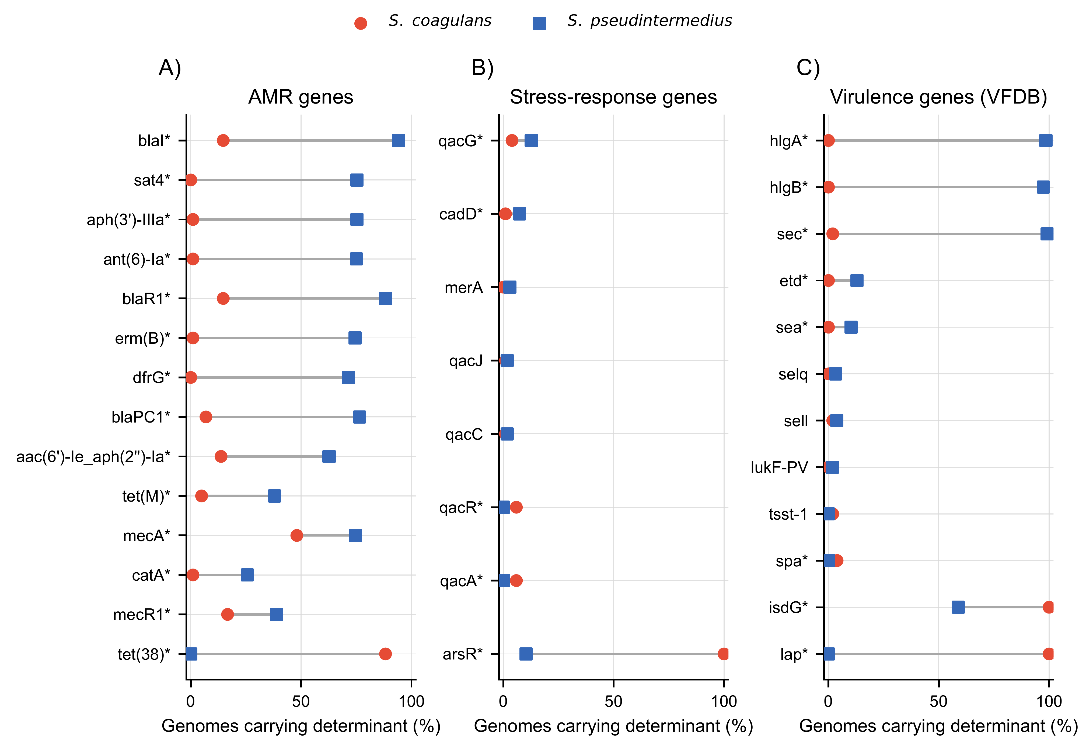
Supplementary Figure S4 (.pdf). Between-species differences in the frequency of detected determinants. Panels show selected AMR-associated genes (A), stress-response genes (B), and virulence-associated genes detected using VFDB (C) in 102 S. coagulansand 340 S. pseudintermediusgenomes. Circles and squares denote species-specific detection percentages; connecting lines indicate the between-species difference. Asterisks indicate Benjamini–Hochberg-adjusted q < 0.05 within the corresponding determinant family. Features were selected by the largest absolute frequency differences, not by statistical significance alone. Frequencies describe the analysed collections and are not population-prevalence estimates.

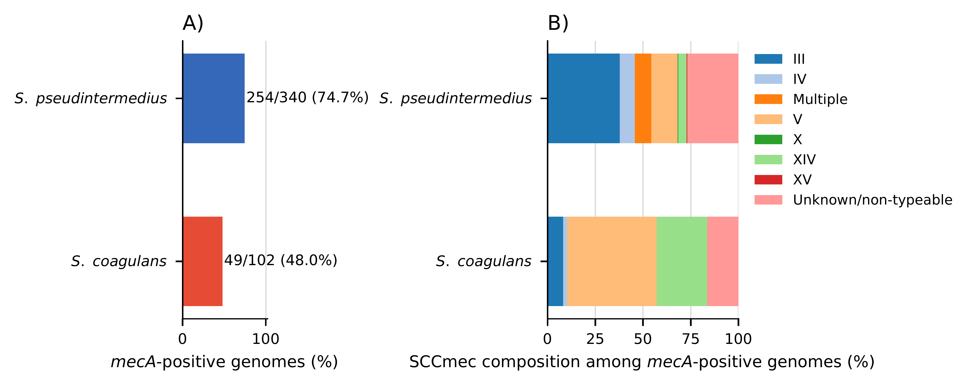
Supplementary Figure S5 (.pdf). Descriptive mecA detection and computational SCCmec assignments. (A) Number and percentage of mecA-positive genomes in each species. (B) SCCmec composition among the 49 mecA-positive S. coagulans and 254 mecA-positive S. pseudintermedius genomes. These counts provide the respective denominators for panel B. “Multiple” indicates multiple SCCmec-associated signatures, not independently confirmed complete cassettes. Genomes without an assigned type are grouped as unknown/non-typeable, including unavailable assignments. Frequencies describe the selected datasets; PCR-informed selection of Peruvian isolates precludes interpreting them as population or geographic prevalence estimates.

