Resolving preferential transport and leakage in a fractured carbonate aquifer using hydraulic testing and electrical resistivity imaging.
Valentina I. Ita¹, James M. Martin-Hayden¹, Kennedy O. Doro^{1,*}
1. Department of Environmental Sciences, The University of Toledo, Toledo OH 43606
* kennedy.doro@utoledo.edu

Suplimentary Information
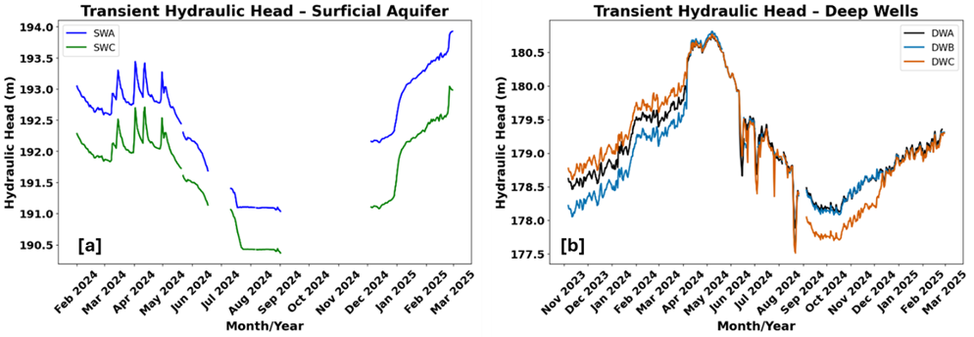
Figure S1: Transient Hydraulic Heads at Wells in the STAR site showing variabilities in [a] Surficial Aquifer and; [b] Bedrock Aquifer
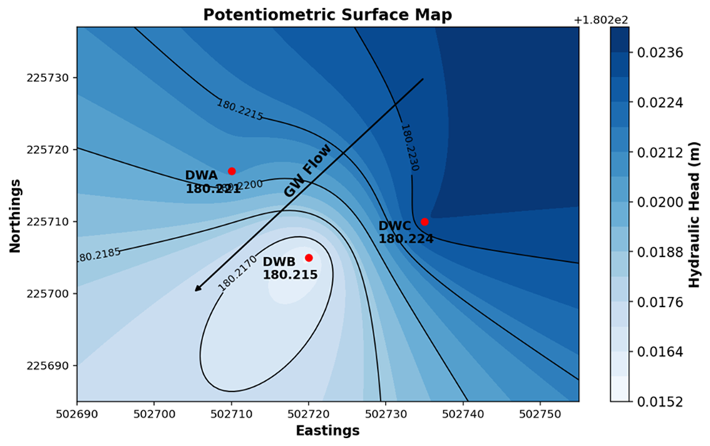
Figure S2: Potentiometric surface map of bedrock aquifer showing hydraulic gradient across the STAR site.
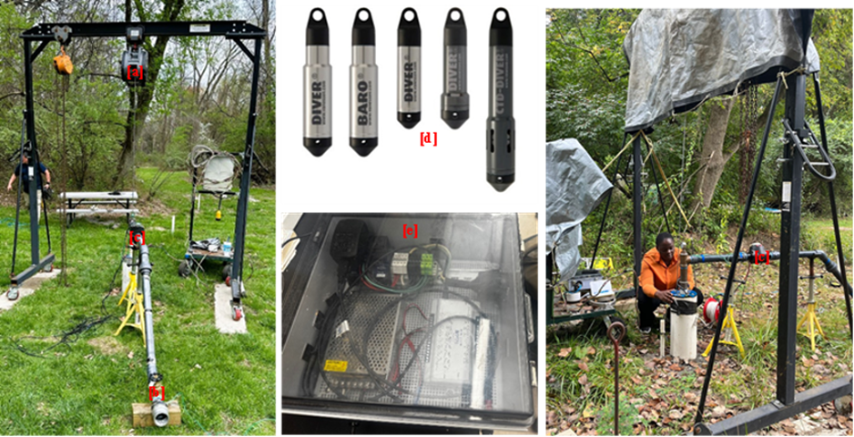
Figure S3: Pump tests field setup and equipment: [a] Gantry crane hoisted to submersible pump, [b] flow control valve, [c] electric flow meter, [d]DIVER pressure transducers, [e] flowrate datalogger
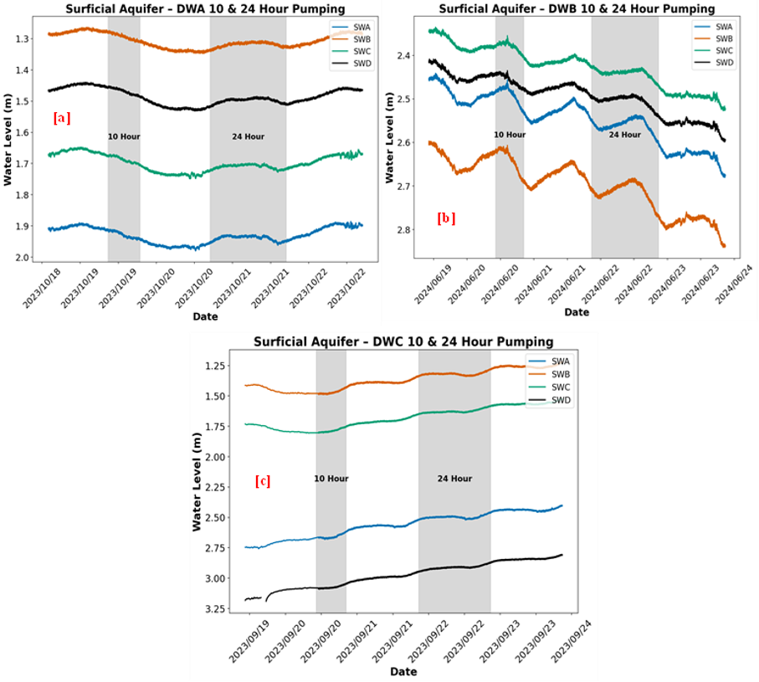
Figure S4: Hydrograph responses in four shallow piezometers (SWA, SWB, SWC, and SWD) during the 10-hour and 24-hour pumping events.

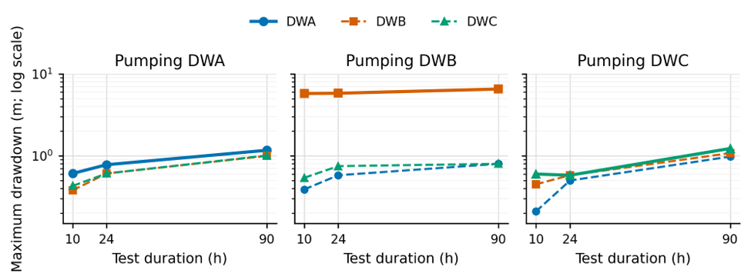
Figure S5: Maximum drawdown during the 10-, 24-, and 90-h constant-rate tests. Solid lines identify the pumping well in each panel; dashed lines identify observation wells. The common logarithmic axis highlights the anomalously large drawdown when DWB was pumped.
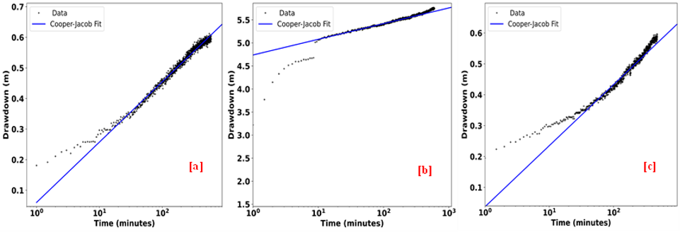
Figure S6: Selected time drawdown plots of 10 constant rate pump tests from pumping wells [labelled a = DWA, b = DWB, c = DWC] using Cooper Jacob straight line solution.
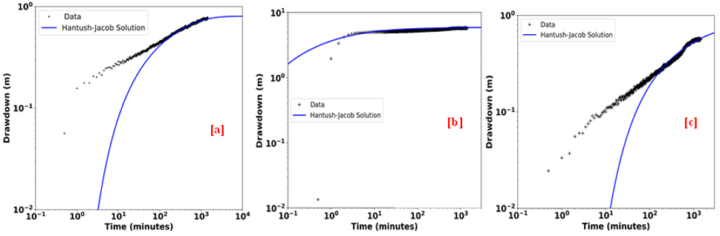
Figure S7: Selected time drawdown plots of 10 hours constant rate pump tests from pumping wells [labelled a = DWA, b = DWB, c = DWC] using Hantush – Jacob Leaky Aquifer Solution.
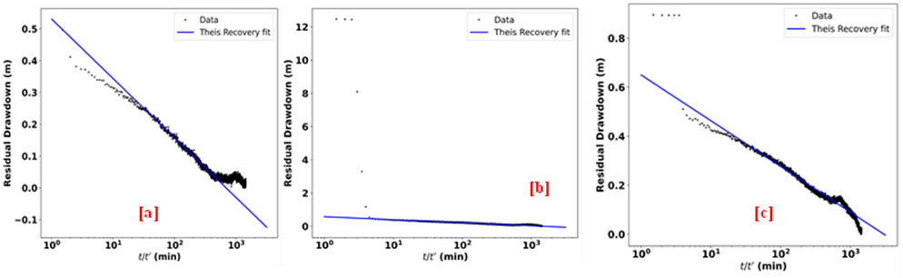
Figure S8: Selected 24 hours recovery plots from pumping wells [labelled a = DWA, b = DWB, c = DWC] using Theis Recovery Solution.
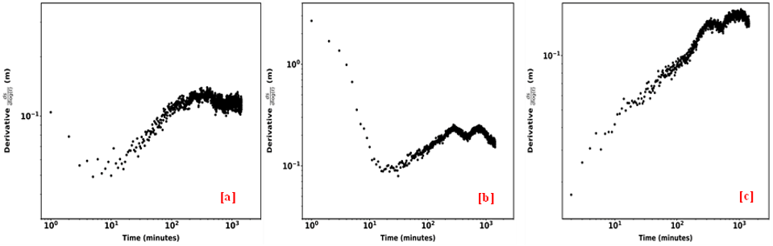
Figure S9: Log–log derivative plots [ds/dlog(t)] from 24-hour constant-rate pumping at wells [a] DWA, [b] DWB, and [c] DWC.
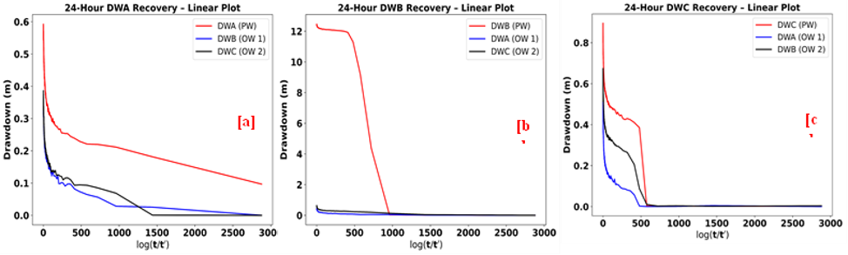
Figure S10: 24 hour linear recovery plots across pumping and observation wells. Pumping wells in red and observation wells simultaneously in black and blue.
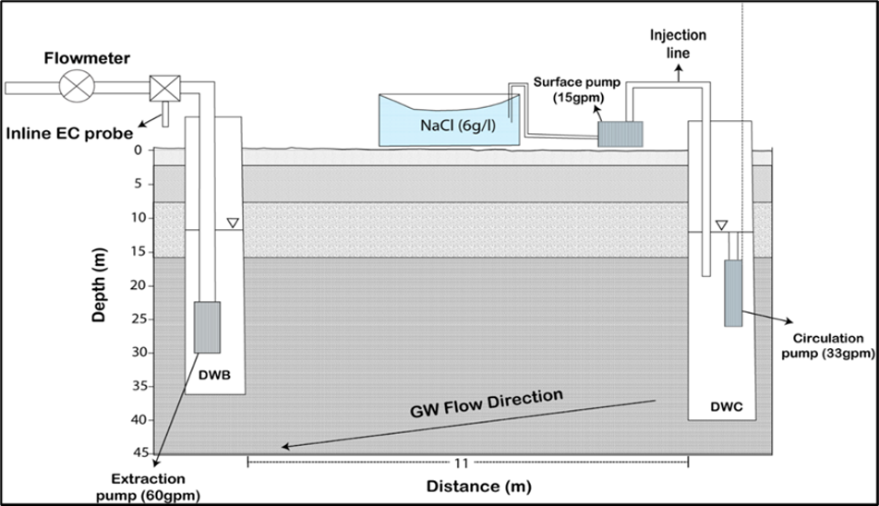
Figure S11: Conceptual Tracer Experimental Design showing flow from DWC to DWB under a forced gradient. NaCl was injected at DWC and monitored at DWB using an inline EC probe.

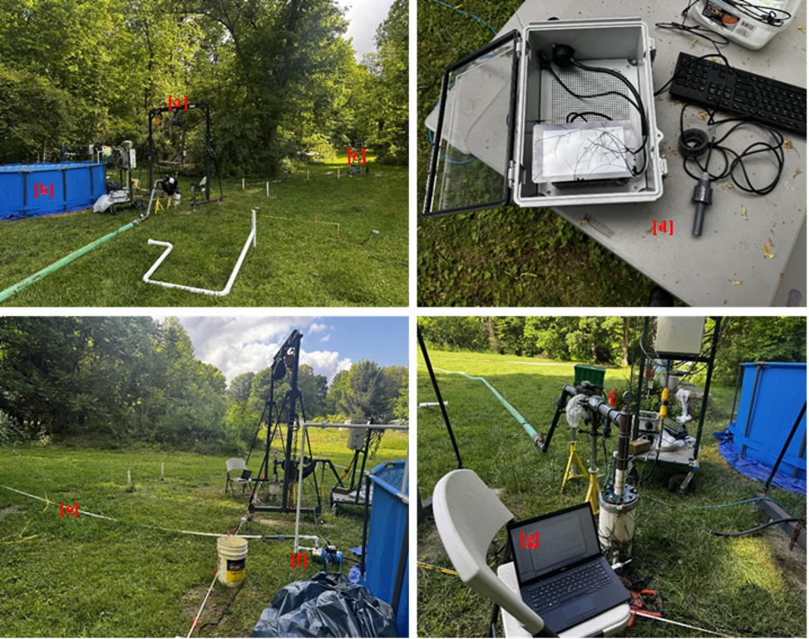
Figure S12: Tracer test experimental setup showing: [a] pump test setup at extraction well, [b] tracer pool, [c] injection well with circulation pump and injection feedline, [d] inline EC probe and monitoring system, [e] tracer injection feedline, [f] surface pump and; [g] real time monitoring of water levels using DIVER office.

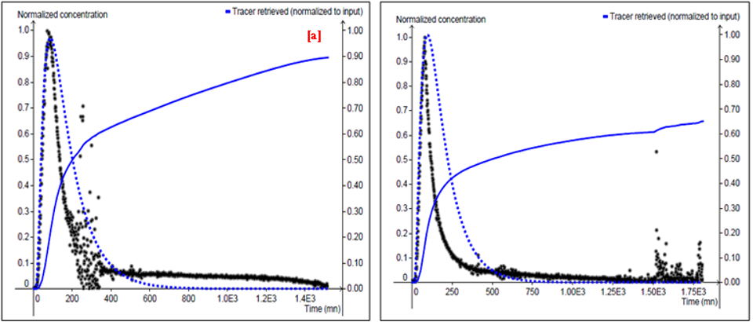
Figure S13: Model Fitting of normalized breakthrough curves on TRAC

