Supplementary Information

Ultrasensitive infrared-to-visible artificial vision via self-evolving projection guided by single-pixel detection

Yao Wang¹, Baolei Liu^{2,3*}, Muchen Zhu¹, Linjun Zhai¹, Dajing Wang¹, Zhaohua Yang^{2,3}, and Fan Wang^{1*}

¹School of Physics, Beihang University, Beijing, 100191, China
²School of Instrumentation and Optoelectronics Engineering, Beihang University, Beijing, 100191, China
³ Hangzhou International Innovation Institute, Beihang University, Hangzhou, 311115, China
These authors contributed equally to this work: Yao Wang and Baolei Liu
*Correspondence: liubaolei@buaa.edu.cn; fanwang@buaa.edu.cn

Keywords: infrared-to-visible upconversion, ultra-low photon sensing, single-pixel detection, adaptive illumination

This file includes:
Section S1. The optimization algorithm in SIVIS.
Section S2. Experimental setup.
Section S3. SIVIS at single-photon conditions.
Section S4. Irradiation power of different upconversion approaches.

Section S1. The optimization algorithm in SIVIS
The adaptive optimization is driven by the genetic algorithm (GA), which iteratively enhances a cost function (CF), which is defined as the ratio of the detected IR SPD intensity and the number of “on” pixels in the corresponding DMD pattern:
$CF\left\{I\left(x,y\right)\right\}=$ $\frac{\int{I\left(x,y\right)·O(x,y)dxdy}}{\int{I\left(x,y\right)dxdy}},$ (1)
where $I\left(x,y\right)$ is the DMD pattern, while x, and y denote the coordinates of the pixel in the pattern, and $O(x,y)$ is the IR target. We can also get the spatial complementarity/ inverted illumination patterns of the IR target by directly taking the reciprocal of CF, defined as:
${CF}^{'}\left\{I\left(x,y\right)\right\}=$ $\frac{\int{I\left(x,y\right)dxdy}}{\int{I\left(x,y\right)·O(x,y)dxdy}}$. (2)
The CF effectively measures the signal-to-pattern correlation and increases as the illumination becomes more concentrated on the target. Initially, a population of random DMD patterns is generated, denoted as:
$g^{(0)}=I_{0,…k}^{0}\left(x,y\right)=\left\{I_{0}^{0}\left(x,y\right),I_{1}^{0}\left(x,y\right),…,I_{k}^{0}\left(x,y\right)\right\},$ (3)
where the superscript represents the generation index, and the subscript represents the population, here is k. Each pattern is evaluated and ranked based on its CF score. Offspring patterns are then generated by crossover, in which pixels are randomly inherited from two selected parent patterns, with higher-ranked patterns having a higher probability of being chosen. Mutation is applied by randomly flipping at partial pixels. The offspring patterns will replace the lower-ranked half of the population in the next generation. As shown in Fig. S1a, the optimization process comprises three phases: (i) random initialization $g^{(0)}$, (ii) intermediate generations $g^{(i)}$where blurred features emerge, and (iii) final patterns $g^{(N)}$with a clear contour. The corresponding CF values increase monotonically throughout the process. Figure S1b shows the IR SPD intensity (photon counts) as a function of generation, exhibiting a similar growth trend to that of the CF. The inset displays the sorted photon counts of DMD patterns from two consecutive generations (i=25), demonstrating that the new generation consistently yields higher average photon detection. Figure S1c presents selected frames extracted from the visualization video throughout the evolution process. The frames correspond to generation indices of 1, 500, 1000, 2000, and 5000 (left to right), where the initially random pattern gradually evolves into a well-defined simulation target in the shape of a clover.
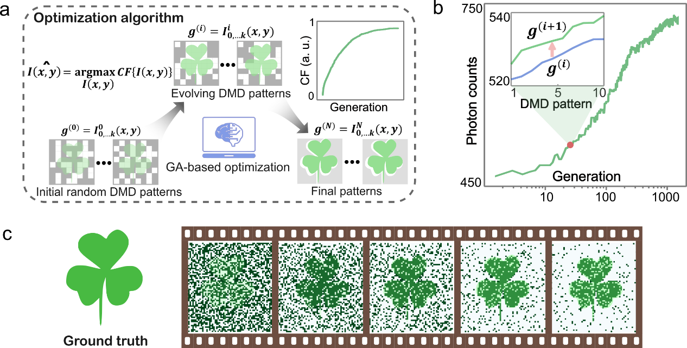
Figure S1. Optimization process of the self-evolving spatial modulation patterns in SIVIS.

Section S2. Experimental setup
The detailed schematic for the SIVIS experimental setup is illustrated in Supplementary Fig. S2. All experiments in the manuscript were conducted with the purpose-built SIVIS. IR light from a polarization-maintaining single-mode continuous-wave laser source (~150 mW power, 850 nm wavelength, MDL-III-852L, CNI) is first collimated by a collimator (L1) and then expanded by a 4f telescope (L2 and L3, f = 30 mm and 200 mm), inducing a beam diameter of ~10 mm. A free-space output 532 nm laser (MGL-FN-532-500 mW, CNI) is expanded by lenses L4 and L5 (f = 200 mm and 20 mm) with a beam diameter of ~20 mm. A long-pass dichroic mirror with a cutoff wavelength of 550 nm is used to combine the two laser beams and then co-modulated by a DMD (GmbH V-7001, ViALUX). Only the central pixels of the DMD micromirror array are activated to accelerate the loading process, as shown in the upper right of Fig. S2, in which the region is highlighted in red. Then the patterns are projected by a f = 50 mm projection lens with a magnification of ~23×, as shown in Fig. S3. The left panel is the loaded chessboard picture, and the right side is the projected pattern of 48×48 pixels captured by a commercial camera (acA1920-150 μm, Basler), in which the individual element represents a single micromirror of the DMD. Then a beam splitter (BS) is used to split the visible light to the display screen.
We have demonstrated SIVIS in both reflection and transmission modes, as shown in Fig. S2, marked by dashed boxes. A f = 100 mm convex lens is used to collect the interaction reflection/transmission light, and a bandpass filter with a peak of 850 nm is used to extract the signal photons before the SPD. Two types of SPD have been adopted in the experiments, in which one is an analog detector (Thorlabs, PDA100A2) and the other is a digital photon counter (Excelitas, SPCM- AQRH-14). The system is synchronized by using a data acquisition device (USB-6353, National Instruments) and a purpose-built Python program.

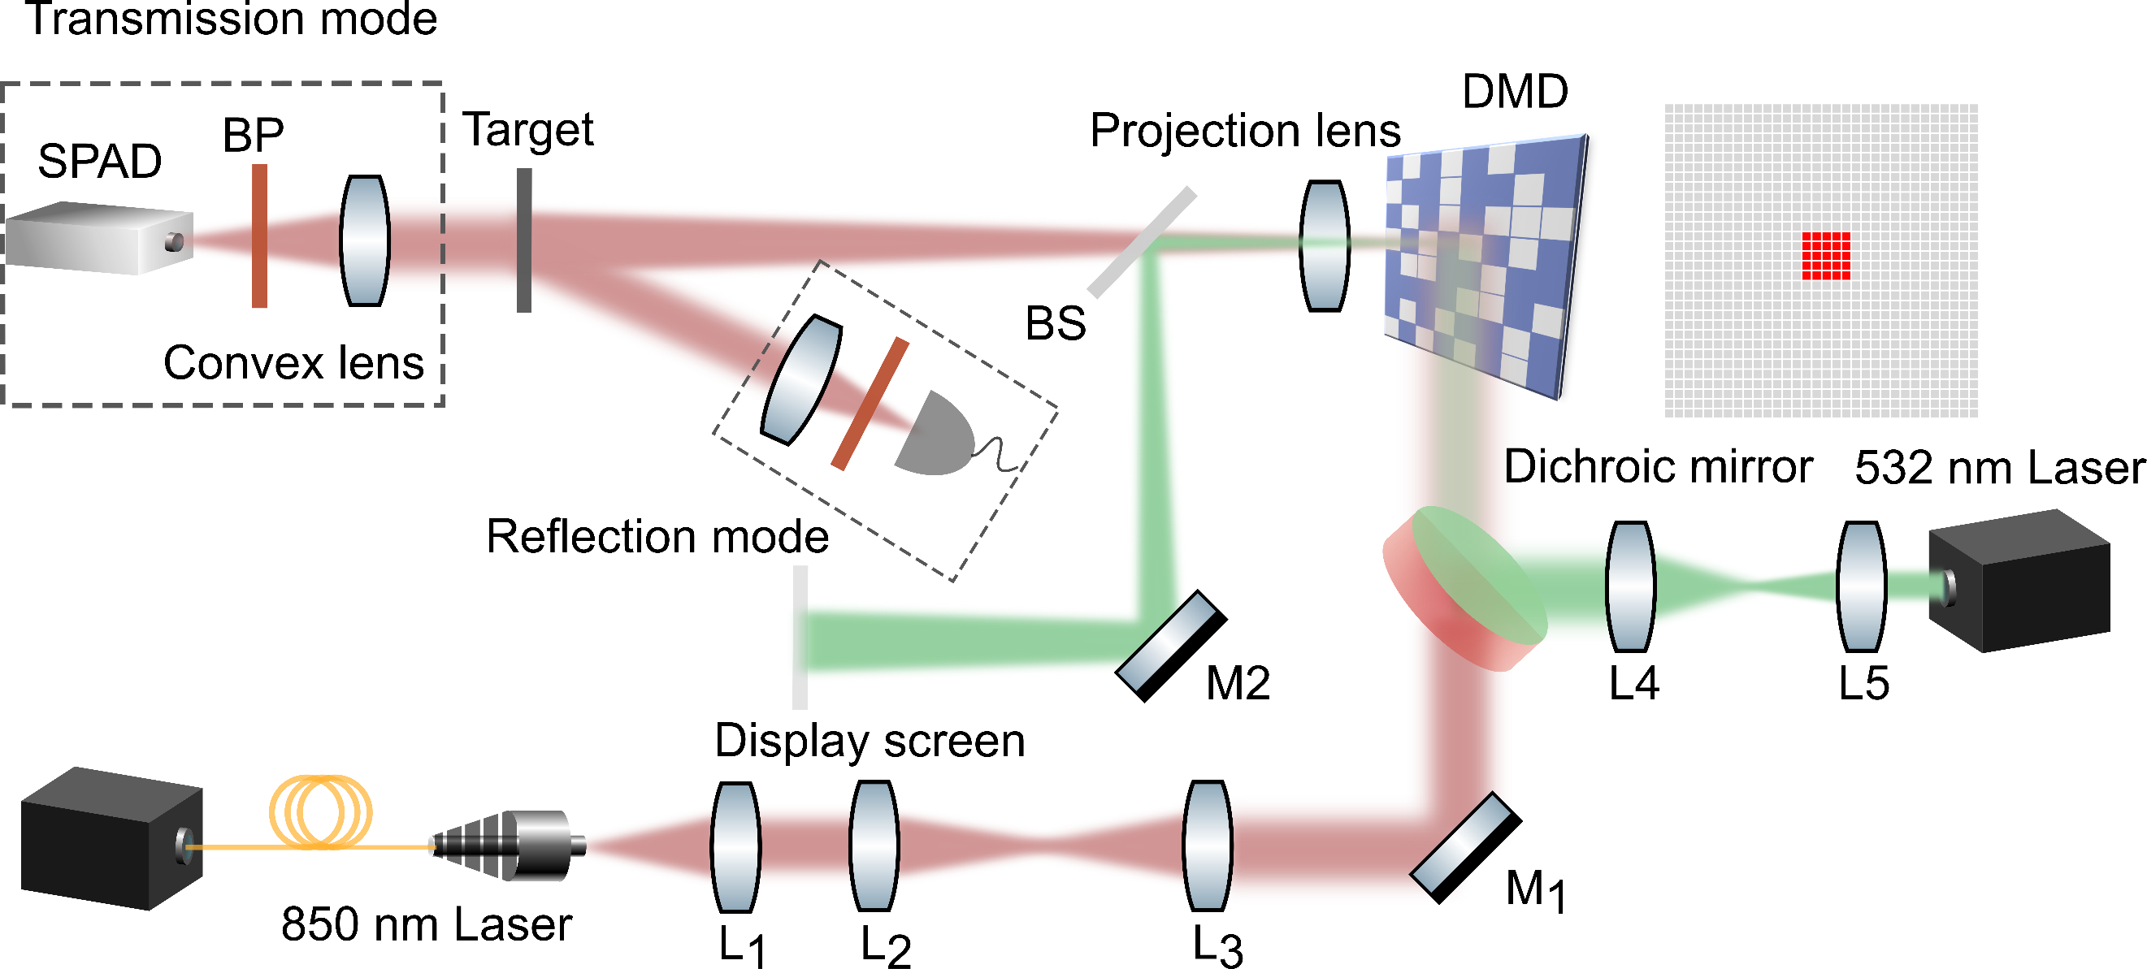
Figure S2. Schematic setup of SIVIS.

The illuminated FOV is approximately 20 mm × 20 mm, corresponding to a 64 × 64-pixel illumination pattern. To accelerate the DMD loading process, only the central 64 rows of DMD are utilized, and the DMD operates at a 20 kHz refresh rate, enabling a generation time interval of ~5 ms (with 10 loaded patterns per generation), corresponding to 200 generations per second. The DMD patterns (Fig. S2) are magnified and projected onto the object using a single projection lens (focal length: 50 mm), achieving a total magnification of ~23×.

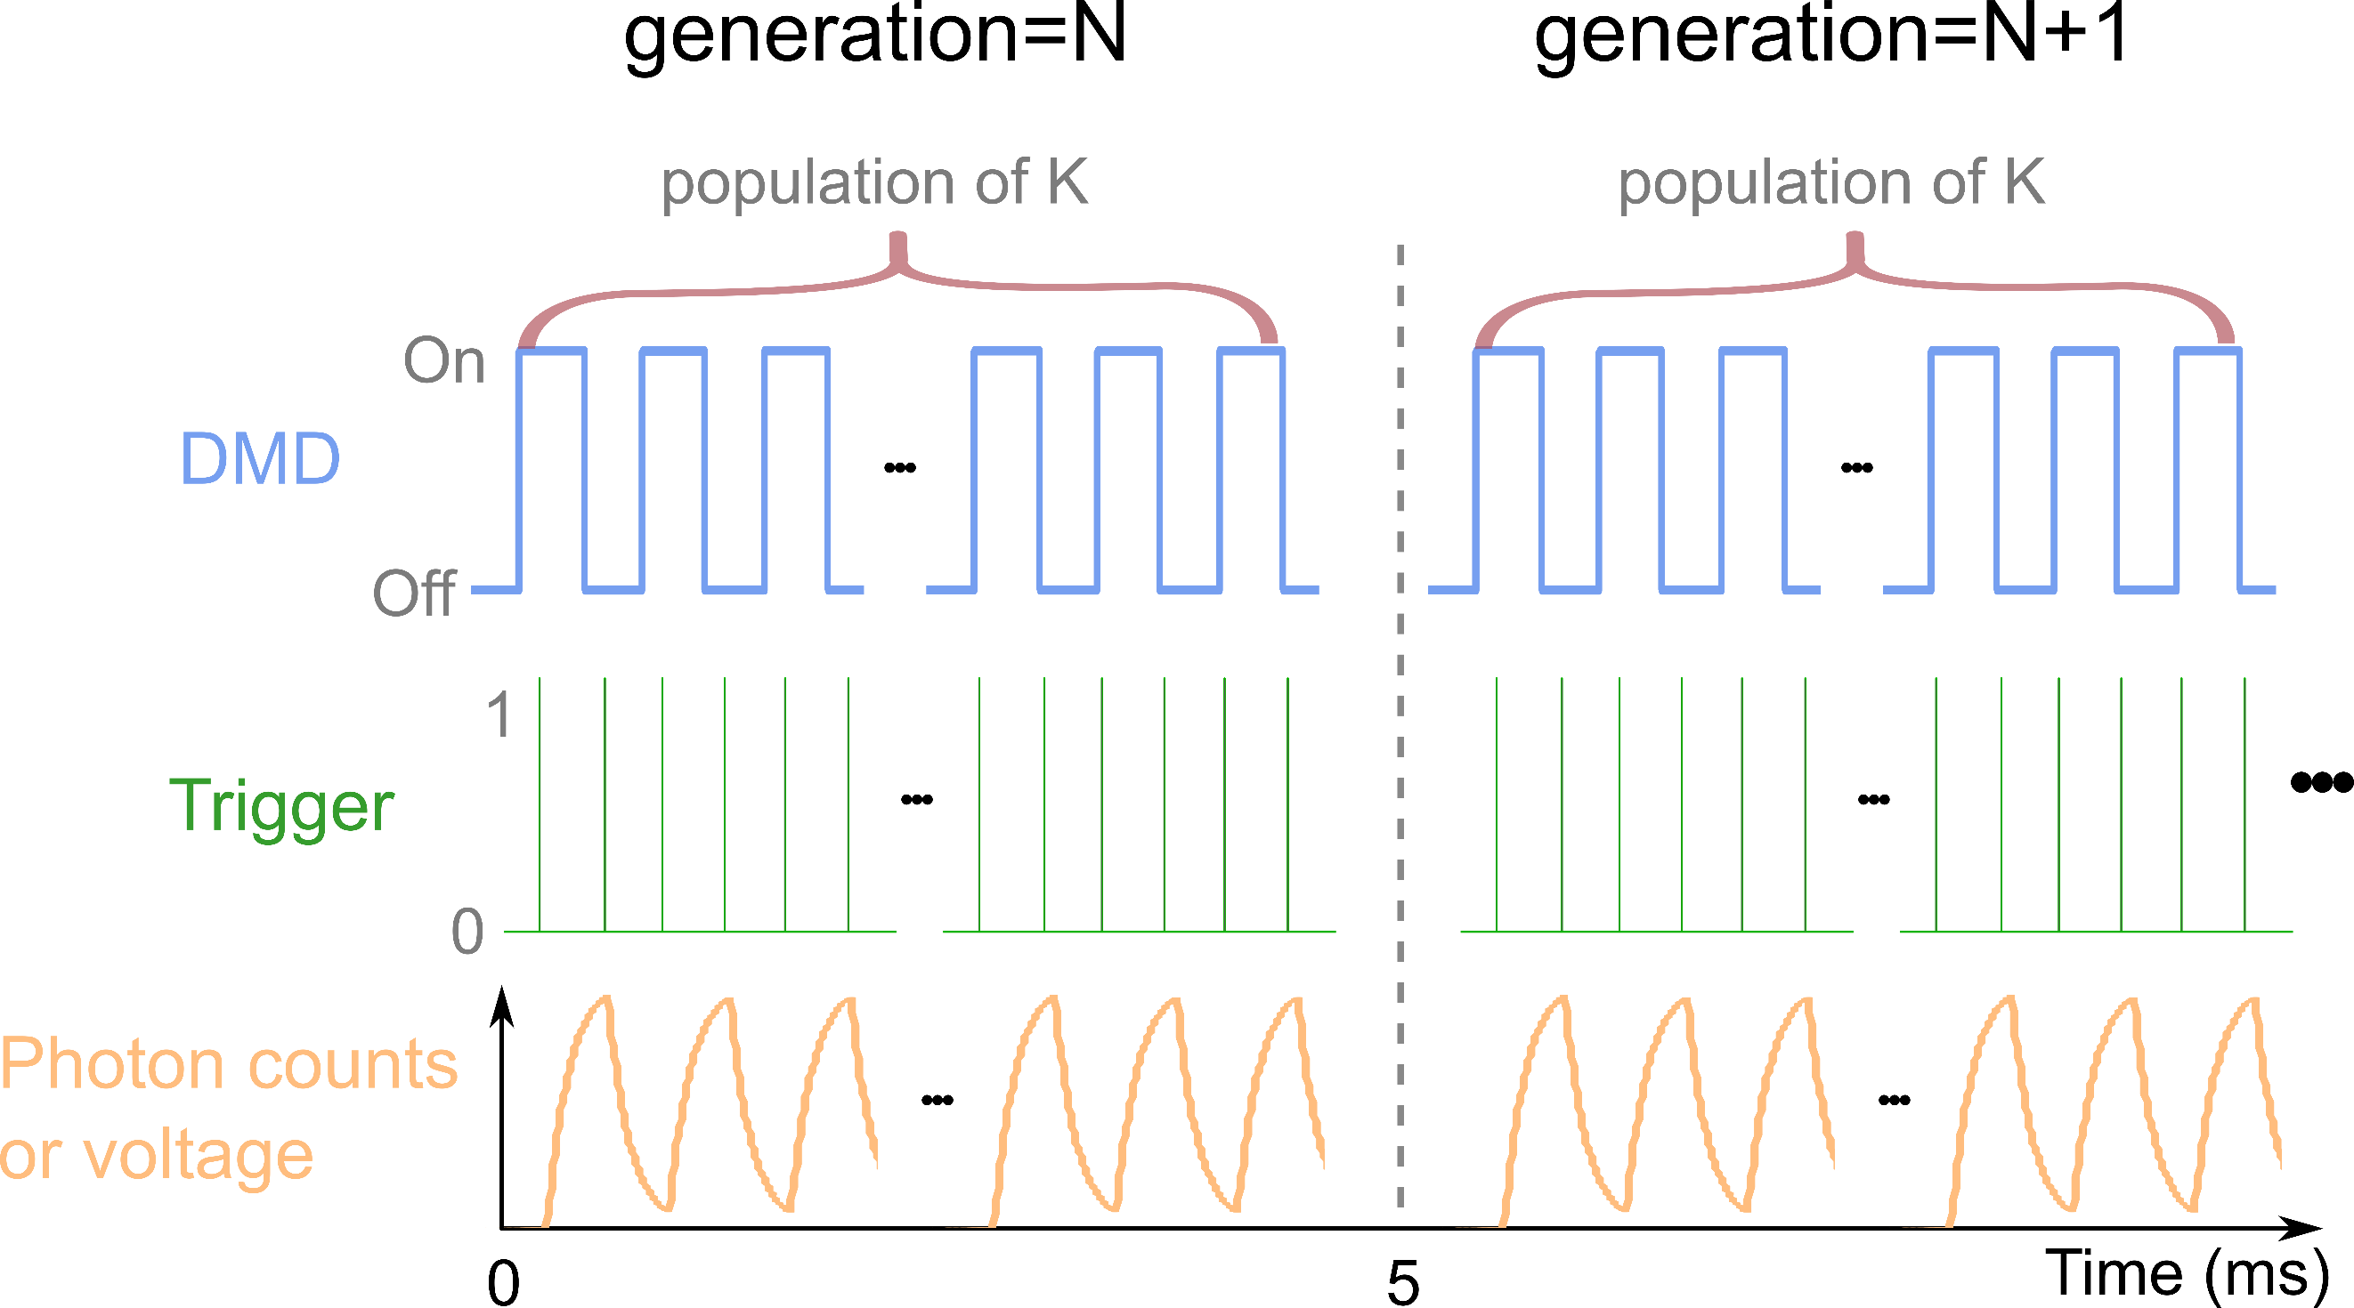
Figure S3. Timing diagram for SIVIS experiments. The switch of DMD from the “off” to the “on” state triggers the acquisition of photon counts or signal voltage. The time interval between the neighboring generations from generation N to N+1 during the evolution is ~5 ms, with a population of K=10 in each generation. This indicates that SIVIS has a refresh generation number of ~0.2 kHz, enabling SIVIS to capture dynamic scenarios.

Section S3. SIVIS at single-photon conditions
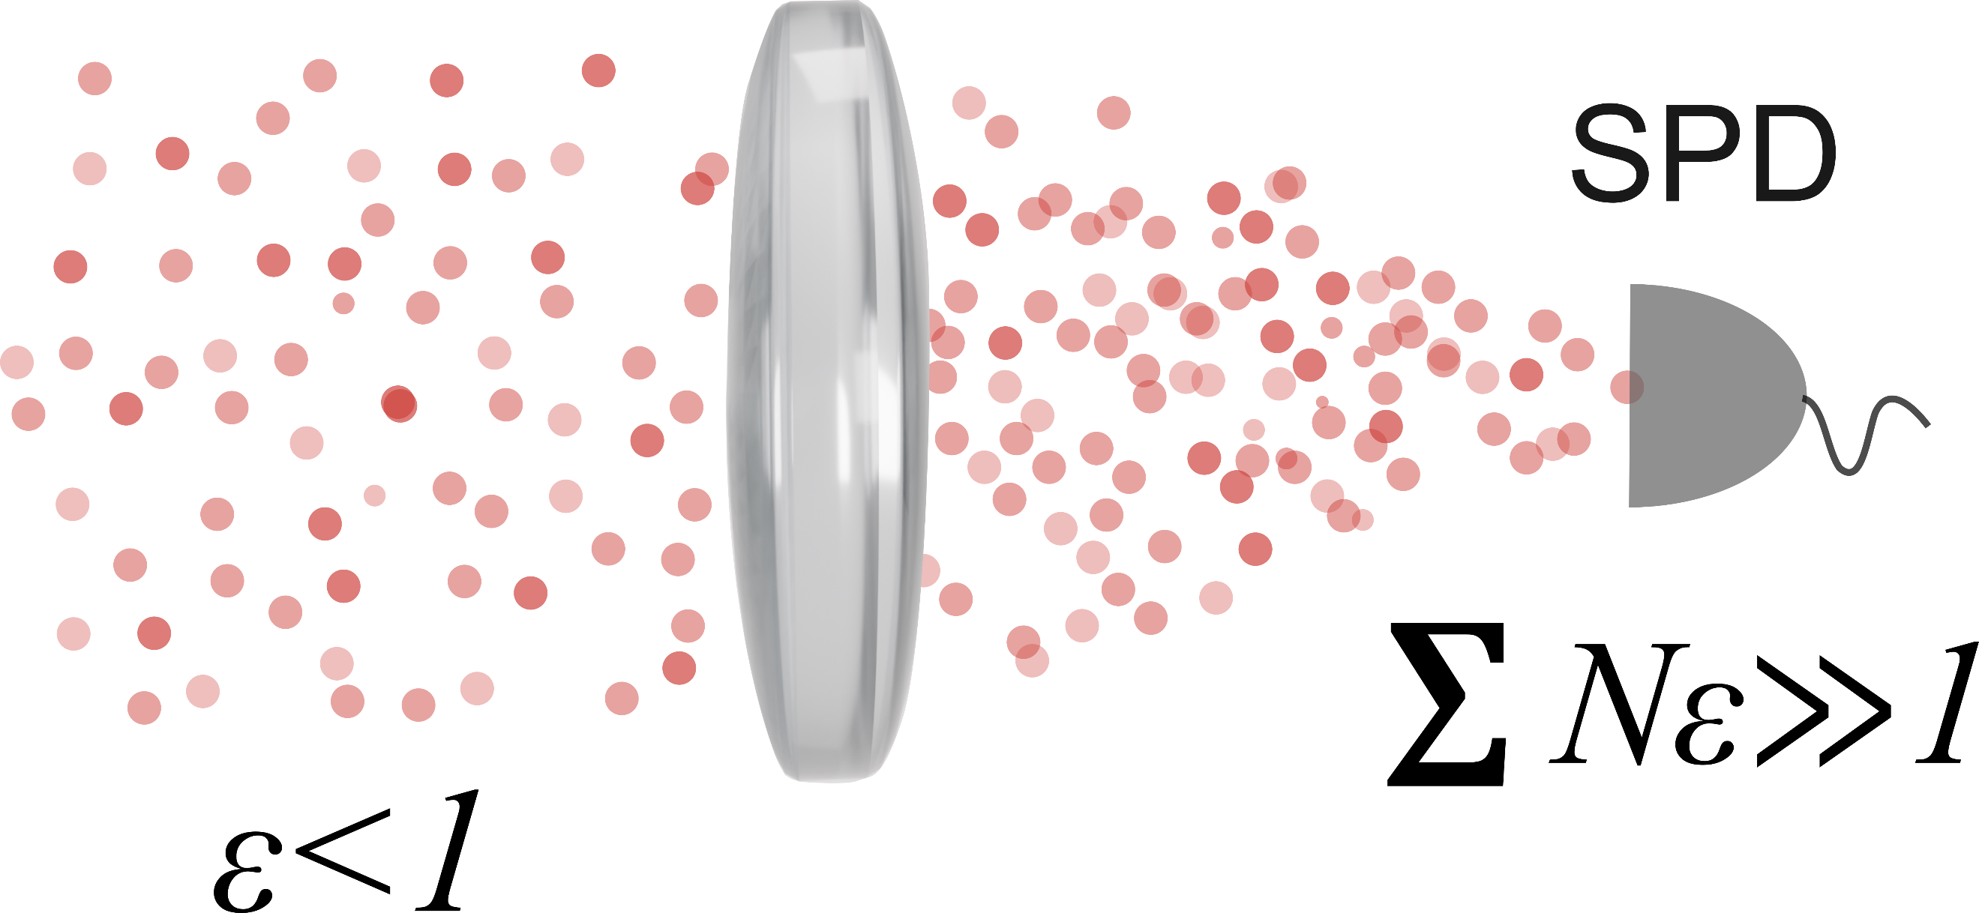
Figure S4. Illustration of how SIVIS enables sub-photon-per-pixel detection. The single-photon detector captures all incident signal photons, with a total photon flux of εN >>1. Since the illumination patterns (upconverted images) have a sufficiently large number of pixels (N), the average photon occupancy per pixel is far below unity (ε << 1). ^{[1]}

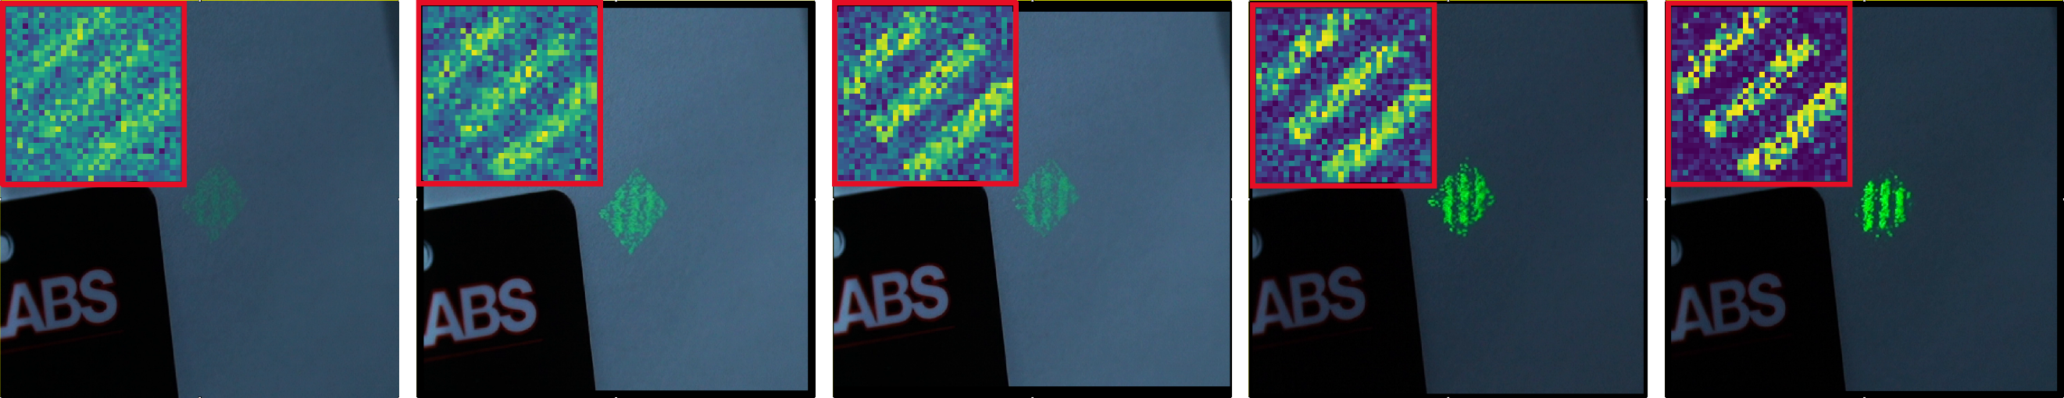
Figure S5. Enlarged views of Fig. 5e under different illumination conditions.

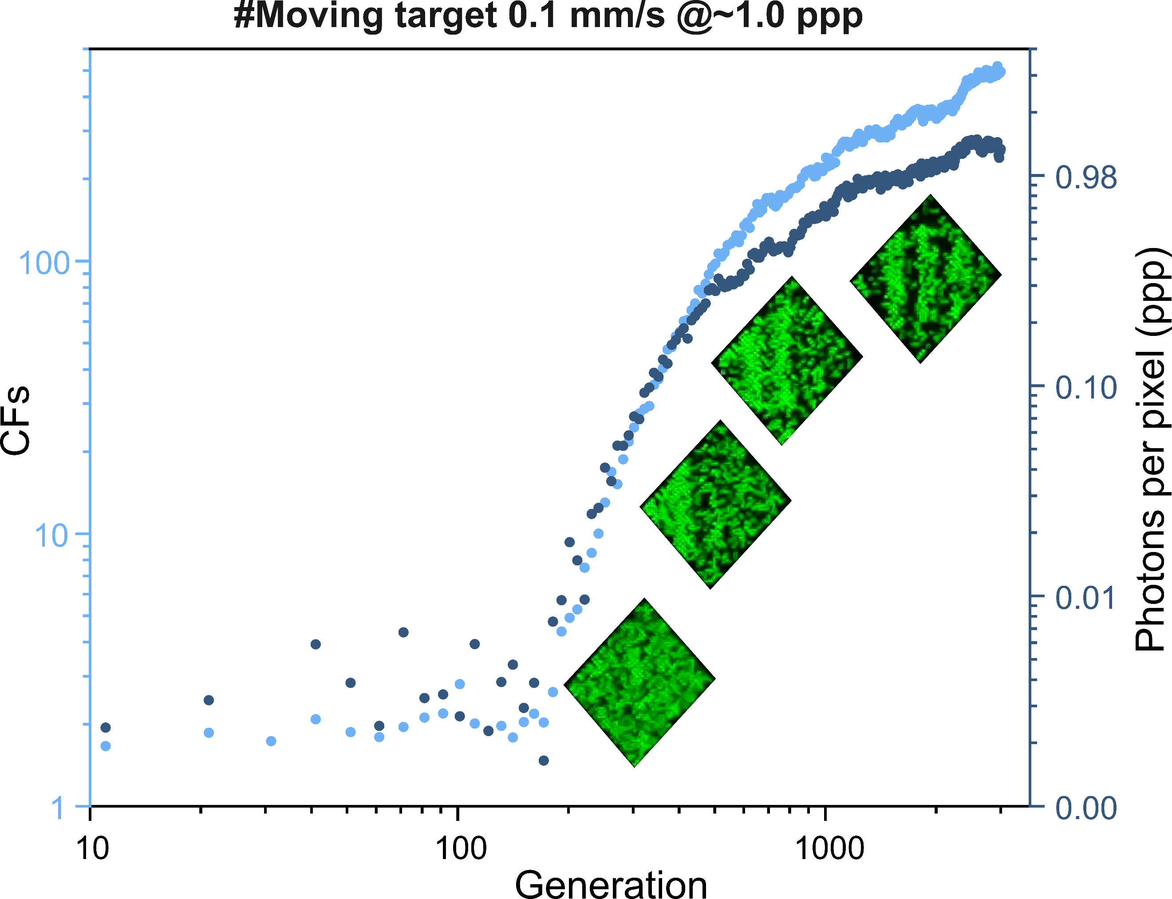
Figure S6. Cost function and photons per pixel vs. generation during the evolution with a 0.1 mm/s moving target, recorded at an illumination level of ~1.0 photon per pixel.

Section S4. Irradiation power of different upconversion approaches
Table S1. List of the IR illumination power on the state-of-the-art upconversion methods.
Ref. | [2] | [3] | [4] | [5] | [6] | [7] | [8] | [9] | [10] | Ours
IR wavelength (nm) | 980 | 780 | 980 | 1042 | 940 | 1500 | 1530 | 850 | 780 | 850
Illumination power (μW/cm⁻²) | 1.62×10³ | 34 | 1.3×10⁴ | 240 | 1×10⁴ | 6×10³ | 1.83×10⁸ | 1.2×10⁴ | 1.5×10⁴ | 5.3×10⁻⁷

For SIVIS, the infrared (IR) illumination power is estimated based on the detected photon flux. For an IR wavelength of 852 nm, the energy of a single photon is given by $E=hc/λ$, where $h$ is Planck’s constant and $c$ is the speed of light, yielding $E≈2.33×{10}^{-19}\text{ J}$. At the lowest photon flux level (0.11 photons per pixel per detection frame), with an illumination pattern of $32×32$ pixels, the total number of photons per frame is estimated to be $N≈112.64$. Given an acquisition time of 0.05 ms, the corresponding total energy per frame is $E_{\text{total}}=N⋅E≈2.63×{10}^{-17}\text{ J}$. The incident optical power is therefore estimated as:
$P=\frac{E_{\text{total}}}{t}≈5.3×{10}^{-13}\text{ W}.$ (4)
Assuming a uniform illumination over an area of 1 cm² of the FOV, the corresponding irradiance is on the order of ${10}^{-13} {\text{W}\text{/}\text{cm}}^{2}$.

Refence
1. T. Wang, S. Y. Ma, L. G. Wright, T. Onodera, B. C. Richard, and P. L. McMahon, "An optical neural network using less than 1 photon per multiplication," Nat. Commun. 13(1), 123 (2022).
2. Y. Ma, J. Bao, Y. Zhang, Z. Li, X. Zhou, C. Wan, L. Huang, Y. Zhao, G. Han, and T. Xue, "Mammalian near-infrared image vision through injectable and self-powered retinal nanoantennae," Cell 177(2), 243–255 (2019).
3. C. J. Shih, Y. Z. Li, M. Z. Li, S. Biring, B. C. Huang, C. W. Liu, T. H. Yeh, D. Luo, J. H. Lee, Y. H. Huang, K. T. Wong, and S. W. Liu, "Transparent organic upconversion device targeting high- grade infrared visual image," Nano Energy 86, 106043 (2021).
4. M. Wu, T. A. Lin, J. O. Tiepelt, V. Bulović, and M. A. Baldo, "Nanocrystal-sensitized infrared-to-visible upconversion in a microcavity under subsolar flux," Nano Lett. 21(2), 1011–1016 (2021).
5. H. Yu, D. Kim, J. Lee, S. Baek, J. Lee, R. Singh, and F. So, "High-gain infrared-to-visible upconversion light-emitting phototransistors," Nat. Photonics 10(2), 129–134 (2016).
6. W. Zhou, Y. Shang, F. P. García de Arquer, K. Xu, R. Wang, S. Luo, X. Xiao, X. Zhou, R. Huang, E. H. Sargent, and Z. Ning, "Solution-processed upconversion photodetectors based on quantum dots," Nat. Electron. 3(5), 251–258 (2020).
7. J. Chen, J. Tao, D. Ban, M. G. Helander, Z. Wang, J. Qiu, and Z. Lu, "Hybrid organic/inorganic optical up-converter for pixel-less near-infrared imaging," Adv. Mater. 24(23), 3138–3142 (2012).
8. R. Camacho-Morales, D. Rocco, L. Xu, V. F. Gili, N. Dimitrov, L. Stoyanov, Z. Ma, A. Komar, M. Lysevych, F. Karouta, A. Dreischuh, H. H. Tan, G. Leo, C. De Angelis, C. Jagadish, A. E. Miroshnichenko, M. Rahmani, and D. N. Neshev, "Infrared upconversion imaging in nonlinear metasurfaces," Adv. Photonics 3(3), 36002 (2021).
9. M. Wu, D. N. Congreve, M. W. B. Wilson, J. Jean, N. Geva, M. Welborn, T. Van Voorhis, V. Bulovic, M. G. Bawendi, and M. A. Baldo, "Solid-state infrared-to-visible upconversion sensitized by colloidal nanocrystals," Nat. Photonics 10(1), 31–34 (2016).
10. S. W. Liu, C. C. Lee, C. H. Yuan, W. C. Su, S. Y. Lin, W. C. Chang, B. Y. Huang, C. F. Lin, Y. Z. Lee, T. H. Su, and K. T. Chen, "Transparent organic upconversion devices for near-infrared sensing," Adv. Mater. 27(7), 1217–1222 (2015).

