Supplementary Information

A modified ¹⁸F-FDG PET/CT diagnostic criterion for regional lymph node metastasis in gastric cancer: a multicenter retrospective study

Table S1. Comparison of CT acquisition parameters and PET reconstruction protocols among the three PET/CT systems (United Imaging uMI 780, GE Discovery MI, and Philips Gemini TP 64).
Parameter |  | United Imaging uMI 780 | GE Discovery MI | Philips Gemini TF 64
CT acquisition parameters | Tube voltage (kVp) | 120 | 120 | 120
CT acquisition parameters | Tube current | Fixed 140 mAs | Auto mA (100–200 mA) | Automatic mA modulation
CT acquisition parameters | Gantry rotation time (s) | 0.5 | 0.6 | 0.75
CT acquisition parameters | Pitch | 1.25 | 1.375 | 1.172
CT acquisition parameters | Collimation width (mm) | 5.0 | 0.625 | 0.625
CT acquisition parameters | Reconstructed CT slice thickness (mm) | 0.6 | 0.625 | 0.67
PET reconstruction specifications | Reconstruction algorithm | TOF-OSEM + PSF | TOF-OSEM + PSF | TOF-BLOB-OSEM + PSF
PET reconstruction specifications | Iterations / subsets | 2 / 20 | 4 / 16 | 3 / 33
PET reconstruction specifications | Post-filter Gaussian FWHM (mm) | 4.0 | 4.0 | 4.0
PET reconstruction specifications | Reconstructed PET voxel size (mm³) | 4.0 × 4.0 × 4.0 | 4.7 × 4.7 × 3.27 | 4.0 × 4.0 × 4.0
PET reconstruction specifications | Mandatory corrections | Attenuation, scatter, random coincidence, dead time, radioactive decay, normalization | Attenuation, scatter, random coincidence, dead time, radioactive decay, normalization | Attenuation, scatter, random coincidence, dead time, radioactive decay, normalization
Note: Data are presented as the fixed or automatically modulated values used in clinical routine scans.
Abbreviations: CT, computed tomography; PET, positron emission tomography; kVp, kilovolt peak; mA, milliampere; s, second; mm, millimeter; TOF-OSEM, time-of-flight ordered subset expectation maximization; PSF, point spread function; FWHM, full width at half maximum; BLOB, basis function using blob basis functions.
Table S2. Comparison of CT acquisition parameters and contrast injection protocols among three centers.
Parameter | Center 1  United Imaging uMI 780 (integrated PET/CT) | Center 2  GE Revolution CT (standalone abdominal CT) | Center3  Philips Brilliance ICT (standalone abdominal CT)
Tube voltage (kVp) | 120 | 120 | 120
Tube current | Auto-modulated mA | Auto-modulated mA | Auto-modulated mA
Gantry rotation time (s) | 0.5 | 0.6 | 0.75
Pitch | 1.25 | 1.375 | 1.172
Collimation width (mm) | 5.0 | 0.625 | 0.625
Reconstructed slice thickness (mm) | 1.25 | 1.25 | 1.25
Contrast medium (300 mg I/mL) | Non-ionic iodinated | Non-ionic iodinated | Non-ionic iodinated
Injection rate (mL/s) | 3.0 | 3.0 | 3.0
Contrast dosage (mL/kg) | 1.5 | 1.5 | 1.5
Saline flush volume (mL) | 20 | 20 | 20
Venous phase delay (s) | 70 | 70 | 70
ª kVp = kilovolt peak; mA = milliampere; s = second; mm = millimeter; mL = milliliter; mg I/mL = milligram iodine per milliliter.
^{b} All centers used the same contrast medium (300 mg I/mL) and the same delay time.
^{c} Auto‑modulation of tube current was applied in all scans.
^{d} CT = computed tomography; PET = positron emission tomography.
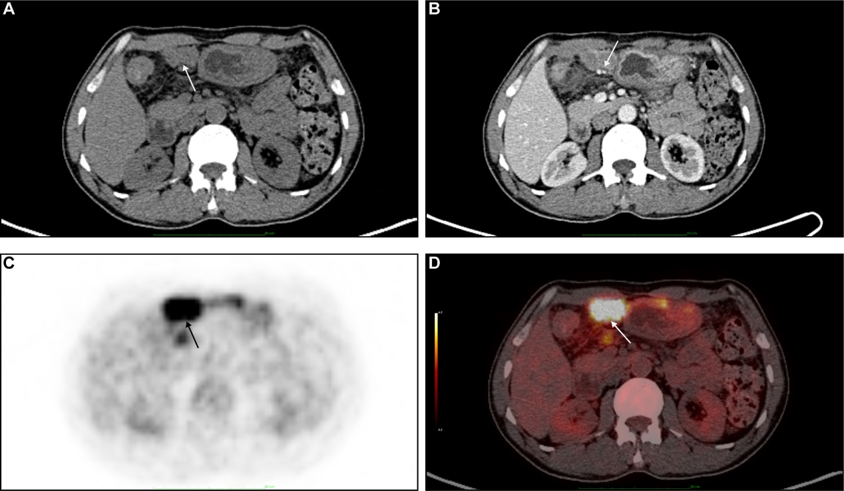
Figure S1. 50-year-old male, poorly differentiated adenocarcinoma; Pathological confirmed lymphatic metastasis in group 4D. (a) Unenhanced CT; (b) venous-phase contrast-enhanced CT with obvious inhomogeneous enhancement inside obviously enlarged lymph nodes with size of 3.6 cm×1.9 cm; (c) ¹⁸F-FDG PET showing highly elevated metabolic uptake with SUVmax of 14.28; (d) fused PET/CT image. These lymph nodes were accurately diagnosed by both C1 and C2. Images acquired on United Imaging uMI 780 PET/CT scanner.

Figure S2: 59-year-old male, mucinous adenocarcinoma; Pathological confirmed lymphatic metastasis in group 7. (a) Unenhanced CT; (b) venous-phase contrast-enhanced CT with mildly enlarged nodule in size of 0.6 cm×0.4 cm; (c) ¹⁸F-FDG PET showing no increase of FDG uptake; (d) fused PET/CT image. The lymph node was falsely diagnosed as benign by C1 due to its low metabolism and correctly malignant by C2 due to uneven reinforcement. Images acquired on Philips Gemini TF 64 PET/CT scanner and Philips Brilliance ICT.

Figure S3: 62-year-old male, moderately differentiated adenocarcinoma; Pathological confirmed benign lymph node in group 9. (a) Unenhanced CT; (b) venous-phase contrast-enhanced CT showing intact fatty nodal hilum (white arrow) in a mildly enlarged node with size of 0.8 cm×0.6 cm; (c) ¹⁸F-FDG PET showing mildly elevated metabolic uptake with SUVmax of 2.5 (on the background of SUVmax of 1.7 in abdominal aortic blood pool); (d) fused PET/CT image. This lymph node was falsely classified as metastasis by C1, while the stratified C2 judged it benign based on preserved hilum morphology. Images acquired on United Imaging uMI 780 PET/CT scanner.

Figure S4: 74-year-old male, moderately differentiated with partially poorly differentiated adenocarcinoma; Pathological confirmed benign node (ectopic pancreas) in group 3B. (a) Unenhanced CT; (b) venous-phase contrast-enhanced CT with enlarged nodule closely attached to the stomach wall in size of 1.3 cm×1.0 cm; (c) ¹⁸F-FDG PET showing no increase of FDG uptake; (d) fused PET/CT image. The lymph node was diagnosed as benign by C1 due to its low metabolism and benign by C2 due to low metabolism as well as short diameter greater than 0.8cm. Images acquired on GE Discovery MI PET/CT scanner and GE Revolution CT.

Figure S5: 62-year-old female, poorly differentiated adenocarcinoma; Pathological confirmed lymphatic metastasis in group 4D. (a) plain CT; (b) venous-phase contrast-enhanced CT with mildly enlarged nodule in size of 0.5 cm×0.4 cm, with cortical nodular thickening; (c) ¹⁸F-FDG PET showing no increase of FDG uptake; (d) fused PET/CT image. The lymph node was falsely diagnosed as benign by C1 due to its low metabolism and correctly malignant by C2 due to its modularly thickened cortex. Images acquired on United Imaging uMI 780 PET/CT scanner.
