Supplementary Information
Longitudinal Topic Mapping of a National-Language Research Field: Korean Balanced Regional Development Studies in the Korea Citation Index, 2004–2025
This Supplementary Information corresponds to the 15-front BERTopic specification used in the main analysis. Machine-readable versions of the tables and stable record-ID assignments are included in the reproducibility materials.

S1. KCI retrieval terms, filters, and provenance
Every analytical record stores the row-level KCI export date of 14 February 2026. Publications dated 2025 are records indexed by that date and may remain subject to late indexing. The original account-level KCI query history was not retained; the archived 16-term query is a reconstruction from retained project evidence.
Table S1. Sixteen reconstructed KCI keyword terms and interface filters
No. | Korean term | English gloss | Field / operator
1 | 지역균형발전 | regional balanced development | KW (author keyword) / OR
2 | 국가균형발전 | national balanced development | KW (author keyword) / OR
3 | 지방분권 | local decentralization | KW (author keyword) / OR
4 | 자치분권 | autonomous decentralization | KW (author keyword) / OR
5 | 지방소멸 | local extinction / depopulation | KW (author keyword) / OR
6 | 인구감소지역 | depopulation area | KW (author keyword) / OR
7 | 지역혁신 | regional innovation | KW (author keyword) / OR
8 | 혁신도시 | innovation city | KW (author keyword) / OR
9 | 수도권집중 | capital-region concentration | KW (author keyword) / OR
10 | 특별지방자치단체 | special local authority | KW (author keyword) / OR
11 | 초광역권 | mega-regional zone | KW (author keyword) / OR
12 | 초광역협력 | mega-regional cooperation | KW (author keyword) / OR
13 | 메가시티 | mega-city | KW (author keyword) / OR
14 | 광역경제권 | broad economic region | KW (author keyword) / OR
15 | 행정통합 | administrative integration | KW (author keyword) / OR
16 | 광역행정 | wide-area administration | KW (author keyword) / OR
Note. Boolean structure: OR across the sixteen keyword terms. Retained interface filters: KCI journal articles; publication years 2004–2025; all relevant KCI subject areas; metadata export with KCI record IDs. The exact account-level interface syntax cannot be recovered because the original platform query history was not retained.

S2. Screening rules and corpus-boundary sensitivity
The main manuscript summarizes the overall corpus-construction flow; this section documents the screening decisions and corpus-boundary checks in greater detail.
The 2,910-to-1,939 preliminary relevance screen was led by one author, with contributions from the other authors, using titles, KCI subject categories, keywords, and abstracts; no formal independent dual-coding protocol was used. Inclusion required a direct territorial-policy relationship to balanced development, decentralization/local autonomy, regional innovation or disparity, metropolitan concentration, inter-local governance, administrative integration, or population decline/local extinction. Records were excluded when a retrieval term denoted only psychological concentration, corporate decentralization, school innovation, non-territorial consolidation, or another homonym. This manual stage is a provenance limitation.
The 1,939-to-1,127 semantic relevance screen stored one primary first-trigger exclusion reason per record. Diagnostic categories could overlap before first-trigger assignment. Of 812 exclusions, 246 contained strong regional-governance terms and were treated as potential false negatives. The targeted 1,373-record sensitivity corpus adds those 246 flagged records only. The full 1,939 corpus supplies a broader upper-bound sensitivity.
Table S2. Screening documentation and corpus-boundary sensitivity
Item | Value
Preliminary screening | 2,910→1,939 relevance screen led by one author with contributions from the other authors; no formal independent dual-coding protocol
Inter-coder reliability | Not estimated and not claimed
Targeted boundary check | 1,373 records after adding 246 flagged records
Upper-bound boundary check | Independent refit of all 1,939 preliminarily screened records
Interpretation | Sensitivity refits address corpus-boundary uncertainty, not screening reliability
Note. Because no formal independent dual-coding protocol was implemented, no inter-coder agreement or reliability statistic is reported for the preliminary screen. The targeted 1,373-record and broad 1,939-record refits test the main trajectory under alternative corpus boundaries; they quantify boundary dependence but do not replace independent dual coding.

S3. Full period shares and temporal slopes
Table S3. BERTopic research fronts by period, n (% of classified documents)
ID | Research front | I | II | III | IV | Slope
T0 | Decentralization and Comparative Local Governance | 20 (18.7%) | 43 (21.3%) | 42 (17.6%) | 41 (12.3%) | -2.27
T1 | Regional Innovation Systems and Industrial Clusters | 19 (17.8%) | 21 (10.4%) | 46 (19.3%) | 37 (11.1%) | -1.09
T2 | Fiscal Decentralization and Local Public Finance | 14 (13.1%) | 35 (17.3%) | 34 (14.3%) | 33 (9.9%) | -1.25
T3 | Constitutional and Legal Reform for Local Autonomy | 9 (8.4%) | 32 (15.8%) | 36 (15.1%) | 29 (8.7%) | +0.03
T4 | Population Decline, Local Extinction, and Regional Vitality | 2 (1.9%) | 10 (5.0%) | 18 (7.6%) | 71 (21.4%) | +6.12
T5 | Firms, Manufacturing Location, and Regional Economies | 11 (10.3%) | 24 (11.9%) | 8 (3.4%) | 17 (5.1%) | -2.40
T6 | Comparative Population Decline and Ageing | 2 (1.9%) | 3 (1.5%) | 10 (4.2%) | 22 (6.6%) | +1.70
T7 | Metropolitan Governance, Urban Regeneration, and Entrepreneurship | 6 (5.6%) | 4 (2.0%) | 7 (2.9%) | 10 (3.0%) | -0.68
T8 | Chinese Central-Local Relations and Decentralization | 2 (1.9%) | 12 (5.9%) | 5 (2.1%) | 8 (2.4%) | -0.22
T9 | Regional Development Policy and Mega-Regional Economies | 10 (9.3%) | 2 (1.0%) | 1 (0.4%) | 12 (3.6%) | -1.78
T10 | Inter-Local Cooperation and Administrative Integration | 3 (2.8%) | 5 (2.5%) | 7 (2.9%) | 10 (3.0%) | +0.11
T11 | Youth Migration, Employment, and Regional Settlement | 0 (0.0%) | 0 (0.0%) | 4 (1.7%) | 19 (5.7%) | +1.88
T12 | Evaluation of Balanced Development Programs and Indicators | 2 (1.9%) | 3 (1.5%) | 4 (1.7%) | 13 (3.9%) | +0.63
T13 | Local Autonomy Institutions and Decentralization Perceptions | 3 (2.8%) | 2 (1.0%) | 9 (3.8%) | 7 (2.1%) | +0.07
T14 | Administrative Organization, Functional Assignment, and Performance | 4 (3.7%) | 6 (3.0%) | 7 (2.9%) | 3 (0.9%) | -0.85
Note. Classified denominators are 107, 202, 238, and 332. Slopes summarize the change in front share, in percentage points per ordered period step, not an annual rate; the four periods span six, six, five, and five years, respectively. Document-bootstrap confidence intervals are reported in Table S17.

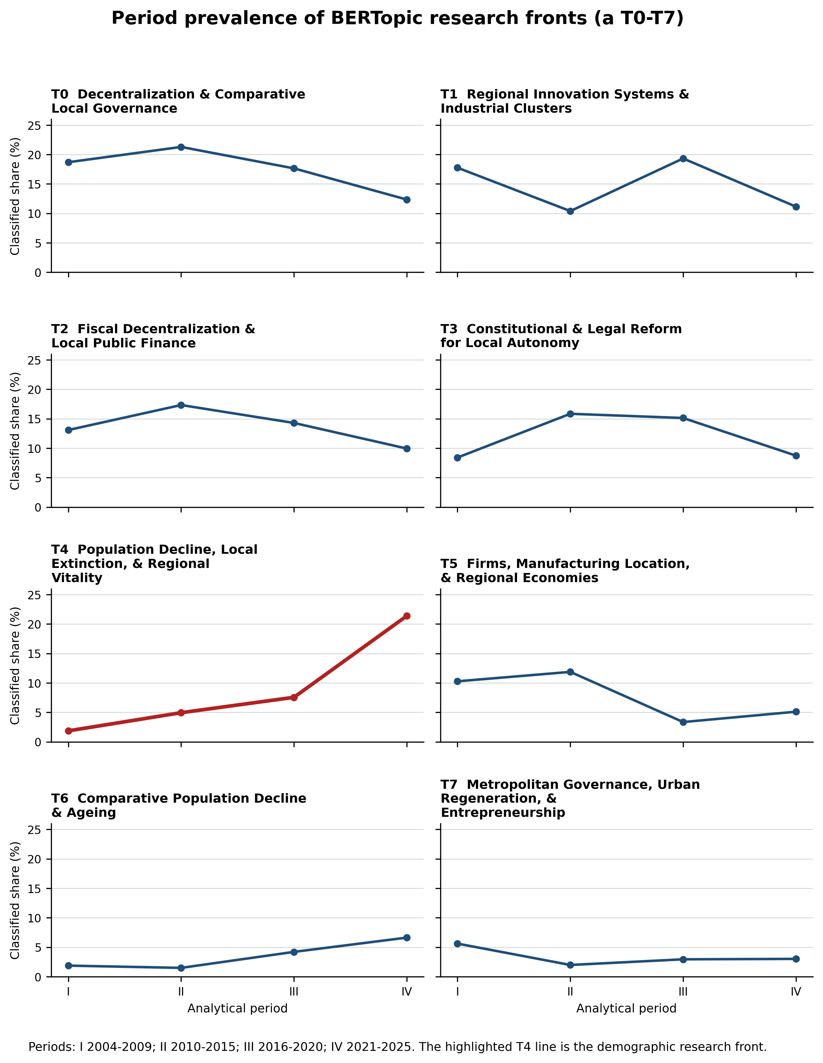
Figure S1. Period prevalence of all 15 BERTopic research fronts: (a) T0–T7. The vertical axis is each front's percentage of classified documents. T4 is highlighted; the panels are descriptive and do not constitute separate significance tests.

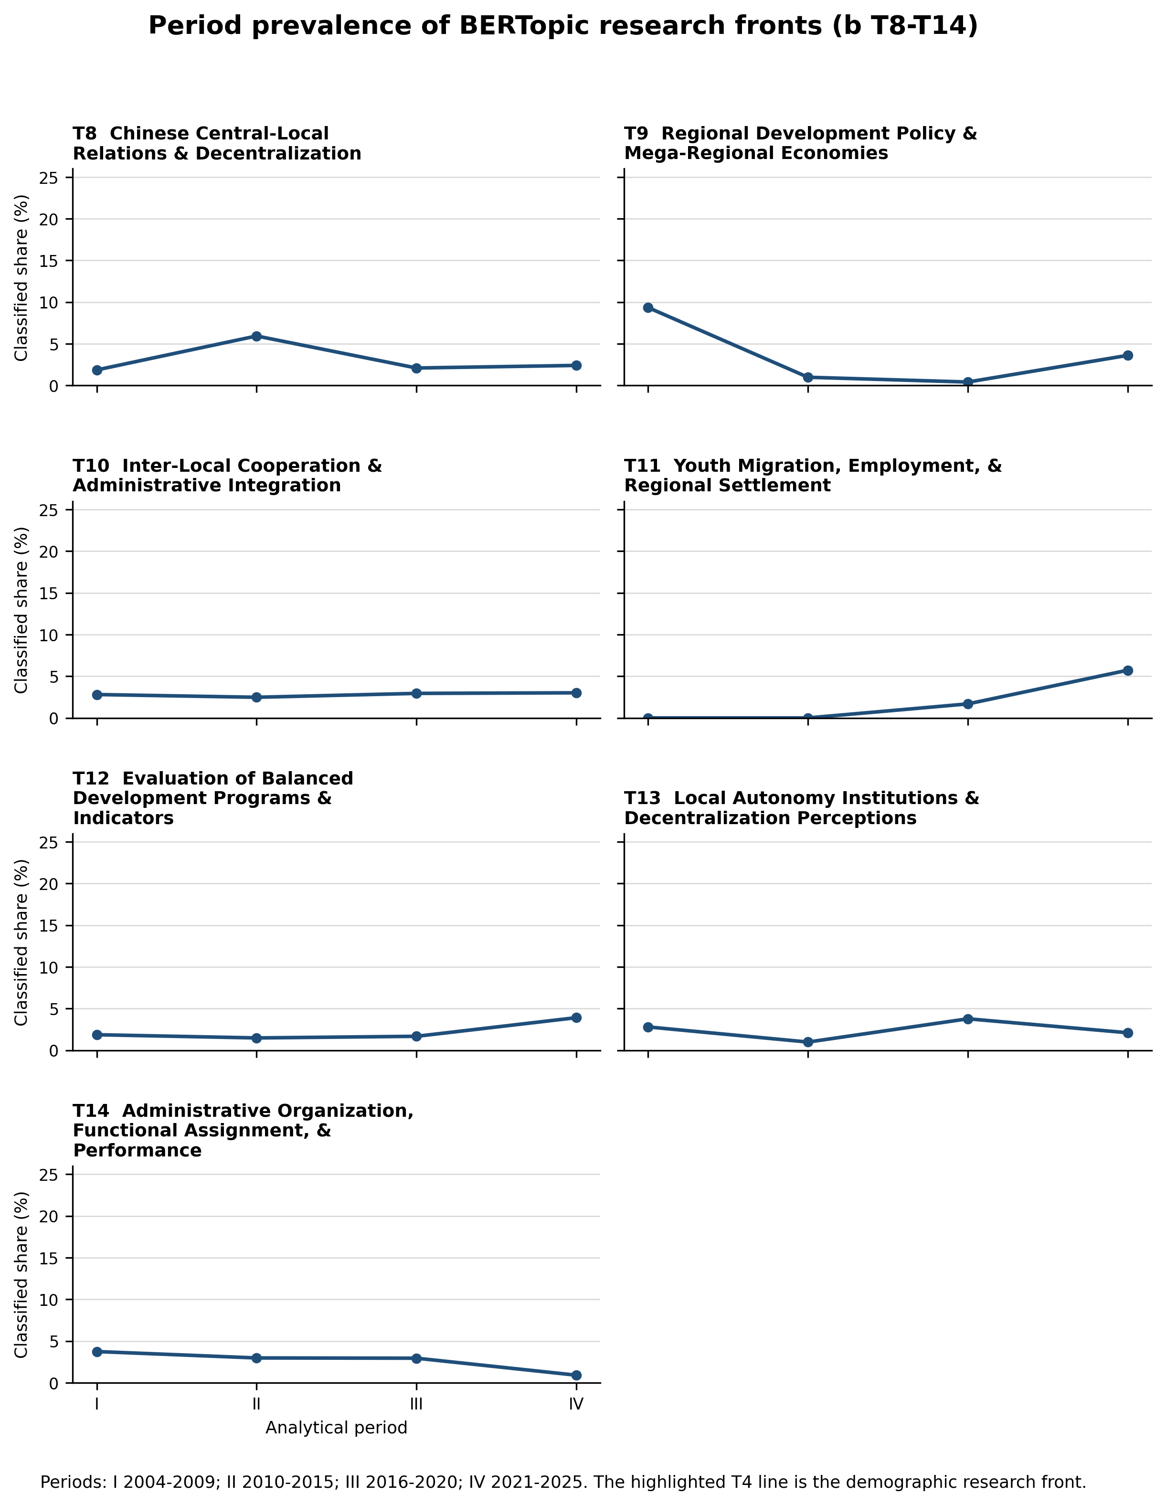
Figure S1. Period prevalence of all 15 BERTopic research fronts: (b) T8–T14. Periods I–IV correspond to 2004–2009, 2010–2015, 2016–2020, and 2021–2025.
Table S4. Population-decline/local-extinction uncertainty with classified and all-document denominators
Period | n | Classified N | % | 95% CI | All N | % | 95% CI
I (2004-09) | 2 | 107 | 1.87 | 0.00–4.81 | 134 | 1.49 | 0.00–3.73
II (2010-15) | 10 | 202 | 4.95 | 2.08–8.13 | 270 | 3.70 | 1.48–6.30
III (2016-20) | 18 | 238 | 7.56 | 4.31–11.16 | 295 | 6.10 | 3.39–8.81
IV (2021-25) | 71 | 332 | 21.39 | 17.14–25.89 | 428 | 16.59 | 13.08–20.09
Note. 95% confidence intervals were obtained by resampling documents with replacement within each period 10,000 times and recalculating the corresponding percentage; both the bootstrap and the Cochran–Armitage trend test treat documents as independent. Cochran–Armitage trend test: classified denominator z = 6.767, p = 1.317e-11; all-document denominator z = 6.692, p = 2.195e-11.

S4. Partition stability and targeted refits
The main 15-front BERTopic specification and the 14-cluster comparison specification have NMI = 0.9416 and ARI = 0.9065. The crosswalk has 14 one-to-one matches because T14 in the main specification (n = 20) has no remaining one-to-one counterpart in the 14-cluster specification. Topic IDs are assigned independently within each fitted solution and should not be interpreted as equivalent across alternative specifications.
Table S5. Hungarian overlap crosswalk: main 15-front specification versus 14-cluster comparison specification
Main topic | Matched comparison topic | Overlap | Comparison/main topic n | Jaccard
T0 | 0 | 146 | 147/146 | 0.993
T1 | 1 | 123 | 125/123 | 0.984
T2 | 2 | 116 | 116/116 | 1.000
T4 | 3 | 101 | 115/101 | 0.878
T3 | 4 | 106 | 106/106 | 1.000
T5 | 5 | 56 | 56/60 | 0.933
T10 | 6 | 25 | 53/25 | 0.472
T6 | 7 | 37 | 37/37 | 1.000
T7 | 8 | 27 | 32/27 | 0.844
T8 | 9 | 27 | 27/27 | 1.000
T9 | 10 | 25 | 26/25 | 0.962
T12 | 11 | 22 | 24/22 | 0.917
T11 | 12 | 23 | 23/23 | 1.000
T13 | 13 | 21 | 21/21 | 1.000

Table S6. Targeted refits: matched demographic front by period
Specification | Period | Total N | K | Period class. N | Demo n | % class. | % all | Jaccard
No keyword fields | I (2004-09) | 1127 | 14 | 100 | 3 | 3.00 | 2.24 | 0.610
 | II (2010-15) | 1127 | 14 | 217 | 8 | 3.69 | 2.96 | 0.610
 | III (2016-20) | 1127 | 14 | 242 | 22 | 9.09 | 7.46 | 0.610
 | IV (2021-25) | 1127 | 14 | 335 | 85 | 25.37 | 19.86 | 0.610
Korean fields only | I (2004-09) | 1127 | 15 | 104 | 3 | 2.88 | 2.24 | 0.754
 | II (2010-15) | 1127 | 15 | 220 | 11 | 5.00 | 4.07 | 0.754
 | III (2016-20) | 1127 | 15 | 253 | 18 | 7.11 | 6.10 | 0.754
 | IV (2021-25) | 1127 | 15 | 359 | 88 | 24.51 | 20.56 | 0.754
Add 246 flagged records (N=1,373) | I (2004-09) | 1373 | 19 | 133 | 6 | 4.51 | 3.77 | 0.555
 | II (2010-15) | 1373 | 19 | 256 | 21 | 8.20 | 6.58 | 0.555
 | III (2016-20) | 1373 | 19 | 313 | 36 | 11.50 | 9.86 | 0.555
 | IV (2021-25) | 1373 | 19 | 456 | 126 | 27.63 | 23.77 | 0.555
Broad prefilter refit (N=1,939) | I (2004-09) | 1939 | 25 | 177 | 6 | 3.39 | 2.83 | 0.621
 | II (2010-15) | 1939 | 25 | 383 | 18 | 4.70 | 3.86 | 0.621
 | III (2016-20) | 1939 | 25 | 452 | 34 | 7.52 | 6.31 | 0.621
 | IV (2021-25) | 1939 | 25 | 611 | 146 | 23.90 | 20.22 | 0.621
Note. Keyword-excluded input uses titles and abstracts; Korean-fields-only uses Korean title, author keywords, and abstract; the 1,373 specification adds the 246 flagged exclusions; and the 1,939 specification fits UMAP/HDBSCAN anew on the entire preliminary screen. For the main multilingual embedding, 1,373 already encoded rows were reused exactly and the remaining 566 were newly encoded with the identical seven fields and model; sentence-transformer inference is document-independent. Period classified N is the actual denominator for each period, not the repeated full-fit classified total. For the 1,373- and 1,939-record specifications, the Jaccard value is calculated only over records shared with the primary 1,127-record corpus, while the period percentages use each specification's own denominator; Jaccard measures membership overlap and does not establish semantic equivalence.

S5. English metadata, document length, and outliers
Table S7. Metadata coverage and length by period
Period | N | English abstract % | English keywords % | Median tokens | Outlier %
I (2004-09) | 134 | 89.55 | 88.81 | 475.5 | 20.15
II (2010-15) | 270 | 98.52 | 98.52 | 502.0 | 25.19
III (2016-20) | 295 | 99.32 | 99.66 | 537.0 | 19.32
IV (2021-25) | 428 | 99.77 | 99.77 | 532.0 | 22.43

Note. Year–token Spearman correlation: ρ = 0.108, p = 0.00028. Classified and outlier median lengths were 518 and 521 tokens (Mann–Whitney p = 0.740). The outlier rate was higher with an English abstract than without one (22.15% vs 14.29%), so English metadata may affect local density. Period outlier rates were non-monotonic (20.15%, 25.19%, 19.32%, 22.43%), which does not support a simple temporal-confounding explanation.

S6. Descriptive co-word analysis
Table S8. Equal-N without-replacement subsampling distribution of raw qualifying edges (weight ≥ 3)
Period | Original N | Subsample N | B | Full edges | Median | Mean | 95% interval
Early (2004-12) | 265 | 265 | 5000 | 3 | 3 | 3.0 | 3–3
Middle (2013-18) | 307 | 265 | 5000 | 11 | 9 | 8.6 | 5–11
Recent (2019-25) | 555 | 265 | 5000 | 33 | 8 | 8.3 | 4–13
Note. Original N is the number of eligible documents in each period; all resamples use the common subsample size of 265 documents without replacement. B = 5,000 resamples. Full edges is the number of qualifying edges (weight ≥ 3) in the unsampled period network; the interval summarizes the resampling distribution.
Co-word analysis describes relations among terms through their joint occurrence (Callon et al., 1991). Table S9 reports raw support, pointwise mutual information (PMI), and Jaccard rankings; PMI follows the association formulation of Church and Hanks (1990).

Table S9. Quantitative comparison of raw, PMI, and Jaccard edge rankings
Period | Edges | Pair | Spearman ρ | p | RBO | Top-N overlap
Early (2004-12) | 3 | raw support vs PMI | 0.000 | 1 | 0.900 | 3
Early (2004-12) | 3 | raw support vs Jaccard | 0.000 | 1 | 0.900 | 3
Early (2004-12) | 3 | PMI vs Jaccard | 1.000 | 0 | 1.000 | 3
Middle (2013-18) | 11 | raw support vs PMI | 0.075 | 0.826 | 0.628 | 9
Middle (2013-18) | 11 | raw support vs Jaccard | 0.356 | 0.283 | 0.656 | 9
Middle (2013-18) | 11 | PMI vs Jaccard | 0.855 | 0.000807 | 0.918 | 10
Recent (2019-25) | 33 | raw support vs PMI | -0.224 | 0.211 | 0.209 | 1
Recent (2019-25) | 33 | raw support vs Jaccard | 0.274 | 0.123 | 0.542 | 3
Recent (2019-25) | 33 | PMI vs Jaccard | 0.794 | 3.6e-08 | 0.557 | 8

Note. Without-replacement equal-N subsampling was used because repeated selection of the same document would inflate edge support. The middle and recent matched-N distributions overlap substantially. Because author keywords are also included in the BERTopic input, the co-word analysis is descriptive and does not provide independent validation.

S7. Auxiliary corpus relevance score (CRS)
The Conservative Relevance Score (CRS) is an auxiliary rule for identifying domestic policy-type mega-regional governance, not demographic vocabulary. CRS = 5×hard + 1×soft − 2×foreign − 1×urban. Hard terms include 특별지방자치단체 and 초광역권계획; soft terms include regional-coalition names such as 부울경 and 대구경북. Extended requires score ≥ 5, hard ≥ 1, foreign ≤ 1, and urban ≤ 1. Core requires score ≥ 6, hard ≥ 1, foreign = 0, and urban ≤ 1; Stricter Core raises the score cutoff to 7. Core is nested within Extended.
Table S10. CRS threshold-region census confusion matrix and metrics
 | Human relevant | Human not relevant
CRS Core | 11 | 2
Not CRS Core | 2 | 15

Note. The census covered all 30 records with scores 4–7. Agreement compares the fixed CRS rule with a single human adjudication, not two independent human coders. Precision = recall = F1 = 0.846; accuracy = 0.867; Cohen's κ = 0.729. The human reference labels themselves therefore do not have an independently estimated inter-coder reliability. The Conservative Relevance Score is exploratory and domain-specific, not a validated screening classifier, and this 30-record census does not estimate its sensitivity, specificity, or recall over the full corpus.
Table S11. CRS alternative specifications
Specification | Hard | Soft | Foreign | Urban | Cut | Foreign max | n | % corpus
lenient | 4 | 1 | −1 | −1 | 5 | 1 | 24 | 2.13
baseline_extended | 5 | 1 | −2 | −1 | 5 | 1 | 38 | 3.37
baseline_core | 5 | 1 | −2 | −1 | 6 | 0 | 20 | 1.77
stricter_cutoff | 5 | 1 | −2 | −1 | 7 | 0 | 9 | 0.80
strong_hard_term | 6 | 1 | −2 | −1 | 7 | 0 | 20 | 1.77
strong_penalties | 5 | 1 | −3 | −2 | 6 | 0 | 19 | 1.69
Note. Hard, Soft, Foreign, and Urban are the fixed CRS component weights; Cut is the classification threshold, and Foreign max is the maximum allowed foreign-context count. n and % corpus report the number and share of the 1,127-document analytical corpus classified as relevant under each specification.

S8. Bibliographic descriptives
Table S12. Top journals by article count
Journal (Korean) | Journal (English) | Articles | KCI citations
지방자치법연구 | Local Government Law Journal | 85 | 511
지방행정연구 | The Korea Local Administration Review | 54 | 544
한국경제지리학회지 | Journal of the Economic Geographical Society of Korea | 45 | 340
한국지방자치학회보 | Journal of Local Government Studies | 38 | 310
한국비교정부학보 | Korean Comparative Government Review | 32 | 245
한국지방재정논집 | The Korea Journal of Local Public Finance | 32 | 250
국토연구 | The Korea Spatial Planning Review | 29 | 146
한국자치행정학보 | Korean Journal of Local Government & Administration Studies | 24 | 119
한국도시지리학회지 | Journal of the Korean Urban Geographical Society | 19 | 153
주거환경 | Journal of The Residential Environment Institute of Korea | 18 | 87
GRI연구논총 | Not available in KCI export | 16 | 109
한국거버넌스학회보 | The Korean Governance Review | 16 | 135
지역사회연구 | Journal of Regional Studies | 14 | 90
국가정책연구 | Public Policy Review | 13 | 72
지방정부연구 | The Korean Journal of Local Government Studies | 13 | 170
Note. Citation counts are descriptive. Reference-list text was present for 95.5%, 100.0%, 100.0%, and 92.3% of Period I–IV records, but stable reference-to-KCI-record identifiers were not consistently supplied. This combination of high text presence and heterogeneous linkability prevents a temporally comparable citation network.

Table S13. Top 15 KCI subject fields by article count
Subject field | Articles
행정학 | 138
법학 | 125
경제학 | 96
지리학 | 92
정치외교학 | 73
국제/지역개발 | 67
사회과학일반 | 49
정책학 | 46
Unspecified | 32
지역학 | 26
도시/지방행정 | 24
기타인문학 | 24
기타사회과학 | 16
지역개발 | 16
지역학일반 | 15

S9. Reproducibility materials and analytical specifications
The reproducibility materials distinguish the main 15-front BERTopic specification from the 14-cluster comparison specification and other sensitivity analyses used in the study. Documentation reconstructed from retained project evidence is explicitly labeled as reconstructed rather than contemporaneous.
The reproducibility materials do not redistribute KCI-derived titles, abstracts, keywords, or personal metadata. They include stable record IDs, BERTopic and LDA assignments, topic-coherence results, temporal sensitivity outputs, the denominator-aligned BERTopic–LDA comparison, descriptive co-word results, ID-only Scopus source-screen and article-confirmation evidence, environment information, code, inventory files, and checksums. The archived KCI query is identified as a reconstruction because the original account-level search history was not retained. The numerical results, tables, and figures in this manuscript and Online Resource correspond to public package version kci_tm_reproducibility_public_v2.6.1_corpus_screening_sync. Its Zenodo DOI and anonymous reviewer-access link will be inserted after the corresponding author completes the upload.
Table S14. Files included in the reproducibility materials
Material | Purpose
Document-level BERTopic assignments | Stable KCI IDs with main and comparison topic assignments
Research-front and period-share tables | Main topic sizes, prevalence, and trend summaries
Bootstrap and trend-test outputs | Uncertainty estimates for the principal demographic trajectory
Corpus and model sensitivity outputs | Alternative metadata, corpus, embedding, seed, and clustering specifications
Document-level LDA assignments | Same-corpus 15-topic baseline and BERTopic–LDA comparison
Topic-coherence outputs | C_v and NPMI results for BERTopic and LDA topics
Descriptive co-word outputs | Equal-N and weighting diagnostics for the supplementary co-word analysis
Code, environment information, and checksums | Reproduction scripts, software environment information, and file-integrity records
ID-only Scopus validation evidence | Source-list candidate screen, 13-candidate live recheck, 11-confirmed status file, summaries, provenance, and verification code
Final-manuscript correspondence and artifact builder | Exact source mapping for final Tables 1–6 and Figures 1–3, plus a public-data script that regenerates their tables and figures

S10. Additional model and corpus sensitivity analyses
These sensitivity analyses evaluate the stability of the main demographic trajectory under five UMAP seeds (42, 7, 99, 123, and 2024), alternative HDBSCAN cluster-size settings, and a Korean-specific embedding. Each seed run used the same 1,127 sentence embeddings and HDBSCAN settings and varied only UMAP random_state. The 14-cluster multilingual specification serves as the comparison reference for the NMI and ARI statistics reported below.
Table S15. UMAP seed, HDBSCAN cluster-size, and embedding sensitivity
Specification | Clusters | Outliers | Outlier % | ARI | NMI
seed_42 (main) | 15 | 248 | 22.01 | 0.907 | 0.942
seed_7 | 16 | 254 | 22.54 | 0.654 | 0.805
seed_99 | 14 | 234 | 20.76 | 0.707 | 0.826
seed_123 | 15 | 304 | 26.97 | 0.601 | 0.799
seed_2024 | 17 | 290 | 25.73 | 0.670 | 0.829
min_cluster_15 | 19 | 177 | 15.71 | 0.819 | 0.929
min_cluster_25 | 11 | 194 | 17.21 | 0.911 | 0.946
korean_embedding_ko_sroberta | 12 | 232 | 20.59 | 0.193 | 0.359
Note. ARI and NMI compare each clustering with the 14-cluster multilingual comparison specification. Seed 42 also reproduces the main 15-front partition exactly up to numeric labels (ARI = NMI = 1.000 against that partition). Against the main 15-front partition, seeds 7, 99, 123, and 2024 yielded ARI values of .656, .701, .609, and .639 and NMI values of .816, .822, .805, and .811, respectively. Across these four seeds, the maximum-overlap demographic counterpart rose from 1.0–4.2% in Period I to 17.2–23.4% in Period IV; all ordered trends had p < .001. The lower ARI and NMI values for the Korean-specific embedding indicate greater partition sensitivity to representation choice.
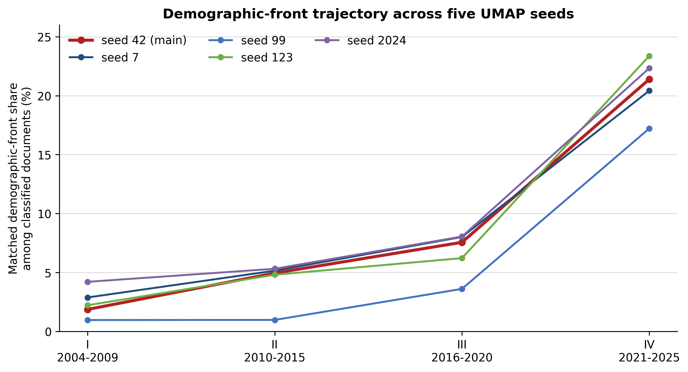
Figure S2. Matched demographic-front prevalence across five UMAP seeds. For each seed, the demographic counterpart is the cluster with maximum Jaccard overlap with the main T4 membership; percentages use each run's period-specific classified-document denominator.

Table S16. Demographic trajectory using the Korean-specific embedding (ko-sroberta-multitask)
Period | Cluster | n | Period class. N | % class. | Jaccard
I (2004-09) | 4 | 1 | 100 | 1.00 | 0.399
II (2010-15) | 4 | 6 | 208 | 2.88 | 0.399
III (2016-20) | 4 | 22 | 233 | 9.44 | 0.399
IV (2021-25) | 4 | 119 | 354 | 33.62 | 0.399
Note. Period class. N is the number of documents classified by the Korean-specific embedding in each period. Jaccard = .399 is the document-level overlap between its matched demographic cluster and the main demographic front over the full corpus, so the same value applies across period rows.

S11. Slope uncertainty
Table S17. Document-bootstrap confidence intervals for all front-share slopes
ID | Slope | 95% CI | P(slope ≥ +2) | P(slope ≤ −2)
T0 | -2.27 | -4.80 to +0.24 | 0.000 | 0.577
T1 | -1.09 | -3.64 to +1.33 | 0.006 | 0.232
T2 | -1.25 | -3.60 to +0.92 | 0.002 | 0.257
T3 | +0.03 | -1.99 to +1.89 | 0.020 | 0.024
T4 | +6.12 | +4.50 to +7.75 | 1.000 | 0.000
T5 | -2.40 | -4.43 to -0.55 | 0.000 | 0.652
T6 | +1.70 | +0.50 to +2.81 | 0.304 | 0.000
T7 | -0.68 | -2.22 to +0.66 | 0.000 | 0.046
T8 | -0.22 | -1.26 to +0.70 | 0.000 | 0.001
T9 | -1.78 | -3.62 to -0.13 | 0.000 | 0.392
T10 | +0.11 | -1.07 to +1.15 | 0.000 | 0.001
T11 | +1.88 | +1.16 to +2.70 | 0.374 | 0.000
T12 | +0.63 | -0.46 to +1.59 | 0.003 | 0.000
T13 | +0.07 | -1.08 to +1.07 | 0.000 | 0.001
T14 | -0.85 | -2.11 to +0.20 | 0.000 | 0.036
Note. Slope is the change in front share, in percentage points per ordered analytical period, not an annual rate; the four periods span six, six, five, and five years, respectively. Confidence intervals are obtained by resampling documents with replacement within each period 10,000 times and recalculating the corresponding front share, treating documents as independent. P(slope ≥ +2) and P(slope ≤ −2) are the shares of bootstrap resamples in which the estimated slope met or exceeded the ±2.0-percentage-point thresholds used only in this table as an exploratory description of directional consistency; they do not correspond to a categorical Emerging/Declining classification applied elsewhere in the manuscript.

S12. Reference-list metadata coverage
Table S18. Reference-list metadata coverage by analytical period
Period | N | Reference text n | Reference text % | Positive count n | Positive count %
I (2004-09) | 134 | 128 | 95.52 | 128 | 95.52
II (2010-15) | 270 | 270 | 100.00 | 270 | 100.00
III (2016-20) | 295 | 295 | 100.00 | 295 | 100.00
IV (2021-25) | 428 | 395 | 92.29 | 395 | 92.29

Note. The presence of a reference list is not equivalent to a stable citation edge. The export lacks consistently resolved reference-to-KCI-record identifiers across the full period, so these percentages quantify metadata availability while explaining why a record-level citation network was not constructed.

S13. Same-corpus LDA baseline and topic coherence
The LDA baseline uses the same 1,127 records and k = 15. Okt retains nouns, verbs, adjectives, and alphabetic tokens after Korean/English stopword removal; dictionary thresholds are no_below = 3 and no_above = 0.60. Gensim LDA uses seed 42, 10 passes, 200 iterations, and automatic alpha/eta. All documents have non-empty bags of words. A topic joins the demographic family when at least three of its top 20 terms match the disclosed population/decline/extinction lexicon; this transparent rule—defined by inspecting each topic's top terms after LDA fitting but before computing period-specific prevalence—selected T2 and T7. The best single Jaccard match is reported separately. Coherence uses the top 10 terms and the same Okt corpus augmented with adjacent bi- and trigrams.
Table S19. C_v and NPMI coherence for every BERTopic research front
T | Research front | n | C_v | NPMI
0 | Decentralization and Comparative Local Governance | 146 | 0.749 | 0.128
1 | Regional Innovation Systems and Industrial Clusters | 123 | 0.724 | 0.164
2 | Fiscal Decentralization and Local Public Finance | 116 | 0.570 | 0.051
3 | Constitutional and Legal Reform for Local Autonomy | 106 | 0.785 | 0.206
4 | Population Decline, Local Extinction, and Regional Vitality | 101 | 0.368 | -0.082
5 | Firms, Manufacturing Location, and Regional Economies | 60 | 0.905 | 0.263
6 | Comparative Population Decline and Ageing | 37 | 0.748 | 0.186
7 | Metropolitan Governance, Urban Regeneration, and Entrepreneurship | 27 | 0.654 | 0.117
8 | Chinese Central-Local Relations and Decentralization | 27 | 0.895 | 0.249
9 | Regional Development Policy and Mega-Regional Economies | 25 | 0.367 | -0.120
10 | Inter-Local Cooperation and Administrative Integration | 25 | 0.726 | 0.127
11 | Youth Migration, Employment, and Regional Settlement | 23 | 0.747 | 0.191
12 | Evaluation of Balanced Development Programs and Indicators | 22 | 0.700 | 0.033
13 | Local Autonomy Institutions and Decentralization Perceptions | 21 | 0.767 | 0.166
14 | Administrative Organization, Functional Assignment, and Performance | 20 | 0.892 | 0.248
Note. Across 15 BERTopic fronts, mean C_v = 0.706 and mean NPMI = 0.128. T4 is below those means (C_v = .368; NPMI = −.082), so the label is interpreted as a broad policy assemblage rather than a compact lexical topic.
Table S20. C_v and NPMI coherence for every 15-topic LDA component
LDA T | n | C_v | NPMI | Top 10 terms
0 | 47 | 0.727 | -0.002 | public; decentralization; 지방; local; political; party; performance; 성과; government; efficiency
1 | 34 | 0.625 | -0.046 | energy; 수도권; local; employment; 에너지; capital; non; region; metropolitan; korea
2 | 68 | 0.754 | -0.024 | 인구; population; local; 감소; areas; 소멸; decline; regional; extinction; 지방
3 | 100 | 0.726 | -0.004 | metropolitan; area; administrative; 통합; consolidation; 수도권; seoul; development; policy; spatial
4 | 65 | 0.812 | 0.081 | local; welfare; government; city; development; public; governments; 복지; urban; social
5 | 86 | 0.742 | 0.110 | regional; development; policy; economic; 정책; balanced; 발전; region; china; 광역
6 | 40 | 0.273 | -0.208 | der; social; die; korea; 사회; und; cultural; area; news; local
7 | 86 | 0.796 | 0.056 | population; 인구; area; 감소; decline; urban; areas; local; cities; extinction
8 | 53 | 0.791 | 0.020 | housing; metropolitan; area; 수도권; economic; non; korea; capital; 주택; regional
9 | 66 | 0.885 | 0.254 | local; regional; development; government; autonomy; special; education; self; decentralization; policy
10 | 28 | 0.899 | 0.401 | la; le; et; des; en; les; du; centralisation; collectivit; 지방
11 | 71 | 0.785 | 0.040 | policy; 정책; local; regional; areas; industry; new; region; 산업; cultural
12 | 153 | 0.776 | 0.042 | local; government; 지방; decentralization; autonomy; 분권; governments; 지방자치단체; special; act
13 | 142 | 0.833 | 0.144 | regional; innovation; 혁신; 산업; economic; industrial; growth; policy; development; industry
14 | 88 | 0.812 | 0.124 | fiscal; 재정; local; decentralization; tax; 분권; government; governments; welfare; financial
Note. Coherence varies substantially across LDA components; some topics, including T6, contain multilingual or weakly consolidated term sets. T6 is neither part of the demographic family (T2 + T7) nor the best single demographic match (T7), so this low-coherence component does not affect the demographic comparison reported in Table S21.

Table S21. Demographic trajectory in BERTopic and the same-corpus LDA baseline; all-document denominator
Model/unit | n | I % all | II % all | III % all | IV % all | Overlap/Jaccard
BERTopic T4 | 101 | 1.49 | 3.70 | 6.10 | 16.59 | reference
LDA best single T7 | 86 | 2.24 | 3.33 | 7.80 | 11.92 | 37 / 0.247
LDA family T2+T7 | 154 | 3.73 | 5.56 | 8.47 | 25.47 | 58 / 0.294
Note. Every percentage in Table S21 uses all documents in the corresponding period (N = 134, 270, 295, and 428). The classified-document BERTopic trajectory remains available in main Table 4 and SI Tables S3–S4.

The LDA single-topic trend is z = 4.781 (p = 1.74×10⁻⁶); the two-topic family trend is z = 8.244 (p = 1.67×10⁻¹⁶). These tests support directional convergence, while Jaccard values show limited membership convergence.

S14. 2025-exclusion and period-boundary sensitivity
Table S22. Period IV with and without publications dated 2025
Specification | Demo n | Classified N | % classified | All N | % all
Period IV excluding 2025 (2021-24) | 54 | 254 | 21.26 | 326 | 16.56
Full Period IV (2021-25) | 71 | 332 | 21.39 | 428 | 16.59
Note. The 2025-exclusion check compares the same demographic-front definition using Period IV restricted to 2021–2024 with the full 2021–2025 period. The near-identical shares indicate that the Period IV result is not driven by 2025 alone.

Table S23. Demographic trend under alternative period definitions
Specification | Window | Demo n | Classified N | % classified | z | p
primary_four | 2004-2009 | 2 | 107 | 1.87 | 6.767 | 1.32e-11
 | 2010-2015 | 10 | 202 | 4.95 | 6.767 | 1.32e-11
 | 2016-2020 | 18 | 238 | 7.56 | 6.767 | 1.32e-11
 | 2021-2025 | 71 | 332 | 21.39 | 6.767 | 1.32e-11
shift_2010_to_early | 2004-2010 | 5 | 143 | 3.50 | 6.549 | 5.81e-11
 | 2011-2015 | 7 | 166 | 4.22 | 6.549 | 5.81e-11
 | 2016-2020 | 18 | 238 | 7.56 | 6.549 | 5.81e-11
 | 2021-2025 | 71 | 332 | 21.39 | 6.549 | 5.81e-11
three_period_equalish | 2004-2010 | 5 | 143 | 3.50 | 5.843 | 5.13e-09
 | 2011-2017 | 10 | 249 | 4.02 | 5.843 | 5.13e-09
 | 2018-2025 | 86 | 487 | 17.66 | 5.843 | 5.13e-09
Note. For each alternative period definition, z and p are from a Cochran–Armitage test of ordered change across the full set of windows in that specification; the statistic is therefore repeated across the rows belonging to the same specification.

S15. Subject, journal, and outlier profiles
These tables are descriptive diagnostics. Percentages are calculated within categories meeting the prespecified display threshold (subject N ≥ 15; journal N ≥ 10); they are not adjusted comparisons and do not identify causal disciplinary effects.
Table S24. KCI subject profiles meeting N ≥ 15
Subject | N | Outlier n | Outlier % | T4 n | T4 %
국제/지역개발 | 67 | 20 | 29.85 | 10 | 14.93
행정학 | 138 | 22 | 15.94 | 9 | 6.52
법학 | 125 | 21 | 16.80 | 9 | 7.20
경제학 | 96 | 12 | 12.50 | 9 | 9.38
지리학 | 92 | 21 | 22.83 | 9 | 9.78
Unspecified | 32 | 8 | 25.00 | 6 | 18.75
사회과학일반 | 49 | 12 | 24.49 | 5 | 10.20
정치외교학 | 73 | 16 | 21.92 | 4 | 5.48
기타사회과학 | 16 | 3 | 18.75 | 4 | 25.00
정책학 | 46 | 11 | 23.91 | 2 | 4.35
지역개발 | 16 | 6 | 37.50 | 2 | 12.50
사회복지학 | 15 | 4 | 26.67 | 2 | 13.33
지역학일반 | 15 | 4 | 26.67 | 2 | 13.33
기타인문학 | 24 | 7 | 29.17 | 1 | 4.17
도시/지방행정 | 24 | 5 | 20.83 | 1 | 4.17
지역학 | 26 | 8 | 30.77 | 0 | 0.00
Note. Percentages are calculated within each KCI subject category. Only subjects with N ≥ 15 are displayed. These profiles are descriptive and unadjusted and should not be interpreted as causal disciplinary differences.

Table S25. Journal profiles meeting N ≥ 10
Journal | N | Outlier n | Outlier % | T4 n | T4 %
한국비교정부학보 | 32 | 8 | 25.00 | 6 | 18.75
지방자치법연구 | 85 | 12 | 14.12 | 5 | 5.88
국토연구 | 29 | 8 | 27.59 | 4 | 13.79
지역사회연구 | 14 | 2 | 14.29 | 4 | 28.57
한국지방자치학회보 | 38 | 10 | 26.32 | 3 | 7.89
한국지방재정논집 | 32 | 3 | 9.38 | 3 | 9.38
한국도시지리학회지 | 19 | 5 | 26.32 | 3 | 15.79
서울도시연구 | 11 | 4 | 36.36 | 3 | 27.27
지방행정연구 | 54 | 4 | 7.41 | 2 | 3.70
한국경제지리학회지 | 45 | 8 | 17.78 | 2 | 4.44
주거환경 | 18 | 5 | 27.78 | 2 | 11.11
GRI연구논총 | 16 | 6 | 37.50 | 2 | 12.50
국가정책연구 | 13 | 1 | 7.69 | 2 | 15.38
한국공공관리학보 | 11 | 3 | 27.27 | 2 | 18.18
인문사회 21 | 10 | 2 | 20.00 | 2 | 20.00
한국자치행정학보 | 24 | 5 | 20.83 | 1 | 4.17
한국거버넌스학회보 | 16 | 2 | 12.50 | 0 | 0.00
지방정부연구 | 13 | 3 | 23.08 | 0 | 0.00
경제연구 | 12 | 4 | 33.33 | 0 | 0.00
정책분석평가학회보 | 11 | 2 | 18.18 | 0 | 0.00
21세기정치학회보 | 10 | 2 | 20.00 | 0 | 0.00
공간과 사회 | 10 | 3 | 30.00 | 0 | 0.00
인문사회과학연구 | 10 | 6 | 60.00 | 0 | 0.00
Note. Percentages are calculated within each journal. Only journals with N ≥ 10 are displayed. These profiles are descriptive and unadjusted and should not be interpreted as causal journal effects.

S16. Author-concentration and permutation-based robustness check for the demographic front (T4)
This section addresses two related concerns about the Cochran–Armitage trend test reported in the main text (Section 4.4): whether repeated publication by the same authors could reduce the effective independence of T4 documents, and whether the observed temporal trend is more extreme than a suitable null model would produce. It reports both checks in full; a condensed summary appears in the main text.
Table S26. Author-name concentration in the demographic front (T4) versus the classified corpus
Metric | T4 (n = 101 documents) | Full classified corpus (n = 879 documents)
Total (document, author) authorship slots | 174 | 1,307
Distinct author-name strings | 148 | 1,014
Most-prolific single author (max documents) | 3 | 10
Authors appearing on 2+ documents | 23 (15.5%) | 184 (18.1%)
Note. Author-name matching uses exact string identity on the semicolon-delimited author field and cannot fully disambiguate common-name homonyms or transliteration variants of the same person, so these counts approximate rather than exactly identify unique individuals. T4's authorship concentration is not elevated relative to the classified corpus as a whole: its most-prolific-author count (3 documents) is well below the corpus-wide maximum (10), and its repeat-contributor share (15.5%) is comparable to, if anything slightly below, the corpus baseline (18.1%).

A permutation check randomly reassigned the T4 label to 101 of the 879 classified documents while holding each document’s period fixed and recomputed the Cochran–Armitage z-statistic for 10,000 seeded reassignments. The null distribution was centered near zero (mean = −0.01, SD = 1.00), and the largest |z| was 4.10. None of the 10,000 reassignments produced a statistic as extreme as the observed z = 6.77; the plus-one Monte Carlo estimate is p = (0 + 1)/(10,000 + 1) = .00010. This is a conditional random-reassignment check using the same corpus and fitted assignments, not an independent validation. It does not address model-selection, corpus-boundary, repeated-author, or author-clustering uncertainty.

S17. Scopus source screening and confirmed article overlap
The cross-database diagnostic used two stages. First, KCI print and electronic ISSNs and publication years were linked to the official Elsevier July 2026 Scopus source list. Thirteen records had an exact ISSN match within the source’s listed coverage years. Eight additional records matched an ISSN but fell outside the listed coverage years. Seventeen exact-title-only source matches were reviewed and excluded as unrelated homonyms or aliases because their ISSNs and publishers differed; 1,089 records had no exact ISSN or exact source-title match. The official source-list URL, retrieval date, and SHA-256 digest are preserved in the reproducibility package, but the source workbook itself is not redistributed.
Second, all 13 journal-year candidates were checked at the article level on 8 September 2026 in the institutionally authenticated Scopus document interface. Eleven were confirmed: eight by exact DOI, one by exact title, and two by presence in the complete source-ISSN and publication-year result set. Although earlier relaxed-title API searches returned Scopus EIDs for two other documents, those hits did not establish matches to the target KCI articles: the target articles were absent from the complete corresponding source-ISSN and publication-year result sets. The two candidates were therefore classified as not confirmed and excluded from the reported overlap. The ID-only evidence records Scopus document identifiers for confirmed records and the search route and result-set size for every candidate.
Table S27. Confirmed Scopus overlap under the two-stage procedure
Group | N | Confirmed | %
All records | 1,127 | 11 | 0.98
Period I (2004–2009) | 134 | 2 | 1.49
Period II (2010–2015) | 270 | 1 | 0.37
Period III (2016–2020) | 295 | 2 | 0.68
Period IV (2021–2025) | 428 | 6 | 1.40
T4 | 101 | 1 | 0.99
All other records | 1,026 | 10 | 0.97
Note. These values are confirmed-overlap proportions, not estimates of Scopus coverage. Journal-level inclusion in a source list does not prove article-level indexing, and the source-list screen may miss records with incomplete or inconsistent source identifiers. The false-negative rate was not estimated. A previously recorded 12-item no-hit check was reverified, but its original sampling sequence could not be reconstructed; it is therefore retained only as a bounded audit record and is not used to support the confirmed count or infer a corpus-wide error rate. The public package reproduces all counts from ID-only evidence. Repeating the live document searches requires authorized Scopus access.

References
Callon, M., Courtial, J. P., & Laville, F. (1991). Co-word analysis as a tool for describing the network of interactions between basic and technological research. Scientometrics, 22(1), 155–205. https://doi.org/10.1007/BF02019280
Church, K. W., & Hanks, P. (1990). Word association norms, mutual information, and lexicography. Computational Linguistics, 16(1), 22–29.

