Supplementary Table 1
ARNI prescription rates by clinical team
Clinical Team | ARNI (n) | Perindopril (n) | Total (n) | ARNI proportion (%)
Team ZHOU | 28 | 17 | 45 | 62.22%
Team ZONG | 41 | 28 | 69 | 59.42%
Team XUAN | 30 | 15 | 45 | 67.67%
Overall | 99 | 60 | 159 | 62.26%
Abbreviations: ARNI, angiotensin receptor–neprilysin inhibitor.

Supplementary Table 2
Comparison of insurance type distributions between the ARNI and perindopril groups
Insurance type | ARNI (n=99) | Perindopril (n=60) | Total (n=159) | P value
Urban employee | 76(76.8%) | 41(68.3%) | 117
Urban resident | 9(9.1%) | 8(13.3%) | 17
New Rural Cooperative | 3(3.0%) | 4(6.7%) | 7
Self-pay | 11(11.1%) | 7(11.7%) | 18
Total | 99 | 60 | 159 | 0.547
Abbreviations: ARNI, angiotensin receptor–neprilysin inhibitor

Supplementary Table 3
Intra- and inter-observer reproducibility of LA strain parameters
Parameter | Intraobserver ICC (95% CI) | Interobserver ICC (95% CI)
LASr | 0.96 (0.90-0.98) | 0.94 (0.87–0.98)
LAScd | 0.96 (0.87–0.98) | 0.95 (0.87–0.98)
LASct | 0.95 (0.89–0.98) | 0.94 (0.84–0.98)
Abbreviations: ICC, intraclass correlation coefficient; CI, confidence interval; LASr, left atrial reservoir strain; LAScd, left atrial conduit strain; LASct, left atrial booster strain.

Supplementary Figure 1
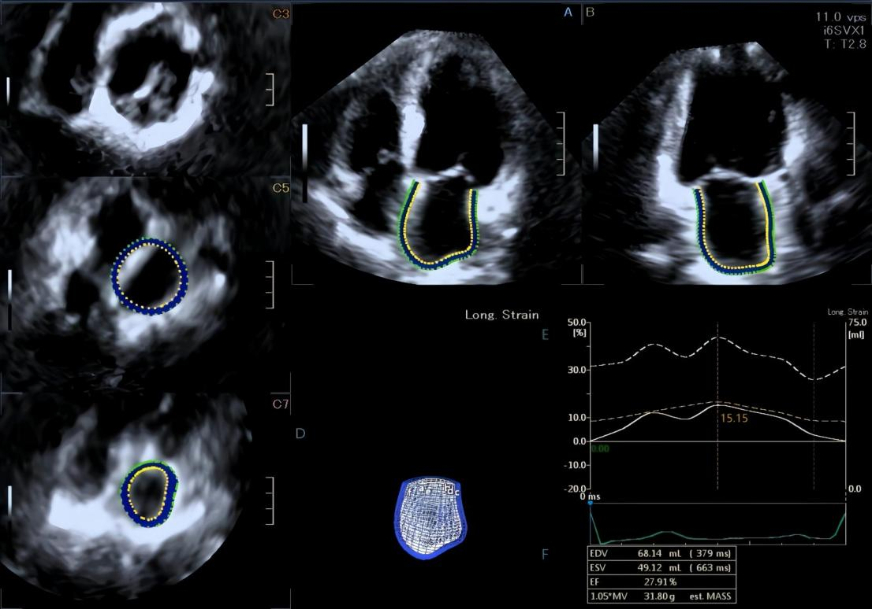
Three-dimensional (3D) speckle-tracking echocardiography-based left atrial volumetric analysis. Apical four-chamber view (A), apical two-chamber view (B), short-axis slices at the basal (C3), mid-atrial (C5), and superior left atrial (C7) levels, alongside a three-dimensional cast of the left atrium (D) and derived left atrial volumetric parameters (F). The time–global left atrial longitudinal strain curve (solid white line) and time–left atrial volume curve (dashed white line) are displayed in panel (E).
Supplementary Figure 2
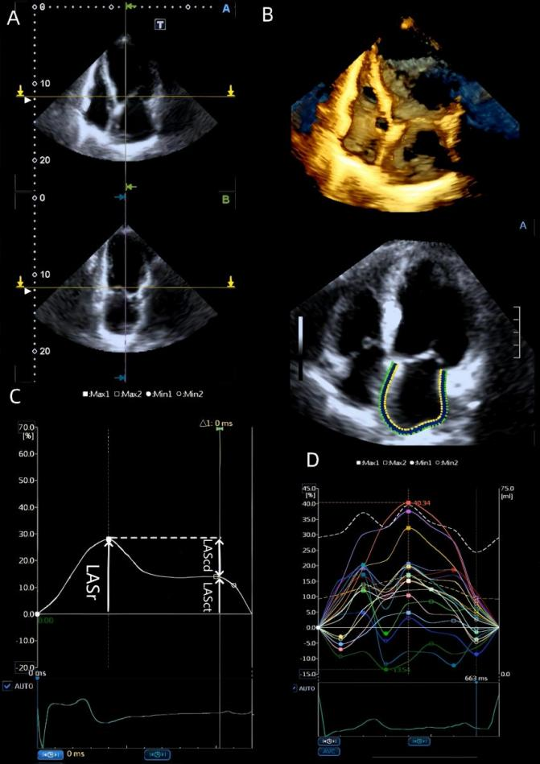
Measurement of left atrial (LA) phasic function via volumetric analysis with three-dimensional echocardiography (A, B) and strain analysis with speckle-tracking echocardiography (C, D). Left atrial strain was calculated as the mean longitudinal strain across all left atrial segments in the apical four-chamber view, with QRS onset set as the reference timing point. The solid white curve denotes the averaged LA strain derived from all analysed left atrial segments.LASr is defined as peak LA strain attained at ventricular end-systole prior to mitral valve opening; LAScd corresponds to the difference between LASr and the strain value at the onset of LA contraction; LASct represents the strain difference from the onset of LA contraction to LV end-diastole.
Supplementary Figure 3
Bland‒Altman plot for intra- and interobserver reproducibility of LA strain.
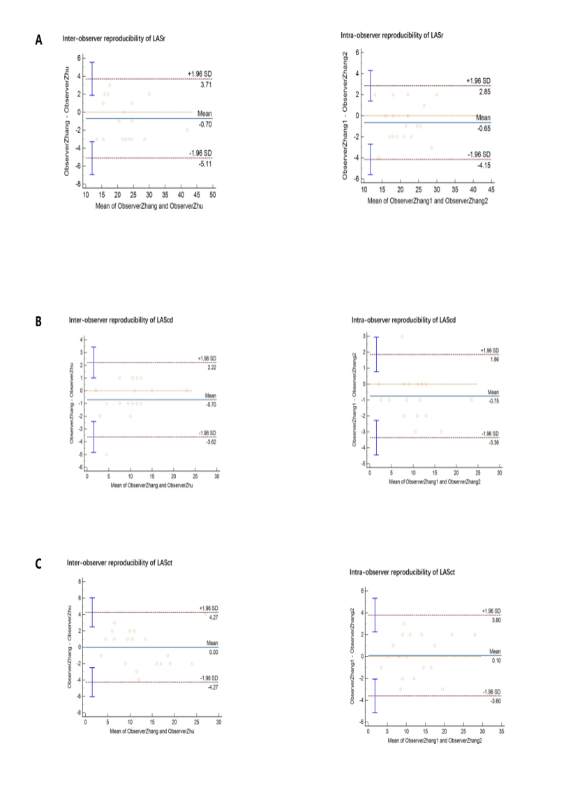
Abbreviations: ARNI; angiotensin receptor–neprilysin inhibitor, LASr; left atrial reservoir strain, LAScd; left atrial conduit strain, LASct; left atrial booster strain
- Inter- and intraobserver reproducibility of LASr;
- Inter- and intraobserver reproducibility of LASct;
- Inter- and intraobserver reproducibility of LAScd

