Supplementary Table 1. Parameters of the transcranial photobiomodulation device used (Capellux Infrared).
Device Parameters | Red light | Infrared light
Wavelength (nm) | 660 | 850
Spectral bandwidth (nm) | 20 | 20
Number of diodes | 102 | 102
Application time (s) | 900 | 900
Power per LED (mW) | 7.5 | 23
Total power (mW) | (102*7.5) = 765 | (102*23) = 2.346
Energy per LED (J) | 6.75 | 20.7
Total energy (J) | (102*6.75) = 688.5 | (102*20.7) = 2,111.4
Irradiance per LED (mW/cm²) | 37.5 | 115
Energy density per LED (J/cm²) | 33.75 | 103.5
Optical spot diameter (mm) | 5 | 5
Light emission angle (°) | 30° | 10°
Beam emission area (cm²) | 0.20 | 0.20
Legend: nm: nanometers. s: seconds. mW: milliwatts. J: Joules. cm²: square centimeters. mm: millimeters. °: degrees.

Supplementary Table 2. Description of the cranial manual therapy maneuvers performed during the 15-min intervention session
Name of the maneuver | Descriptive | Illustrative image of the maneuver
Sympathetic Trunk Maneuver | The patient is seated while the therapist positions their fingers over the intercostal muscles in the posterior trunk region, near the paravertebral muscles (between the spine and the scapulae). With assistance from the therapist, the patient then lies back onto the therapist’s hands and remains in this position for 1 min[34]. | 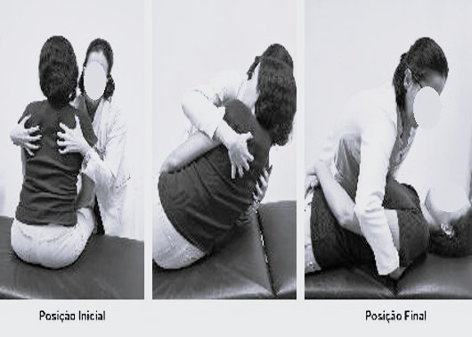
Basic Exercise | The patient lies in a supine position, interlaces the fingers of both hands, and places them behind the head. The patient then directs their gaze to the right side (eye movement only), as far as comfortably possible, for approximately one minute while performing slow inhalations and exhalations. The gaze is then returned to the neutral position, and the same procedure is repeated for the left side. One repetition was performed on each side[35]. | 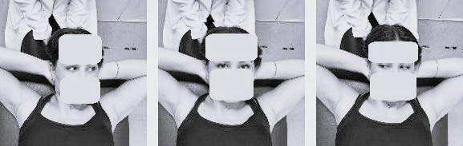
Cranial Membrane Release Maneuver | The patient is positioned in a supine position. The therapist places the dominant hand under the patient’s occiput and the other hand over the frontal bone (forehead) using a pincer grip. The hand on the forehead applies a frontal lift, while the occipital hand directs pressure toward the treatment table. Both hands aim to achieve a still point, which is maintained for 1 min[36]. | 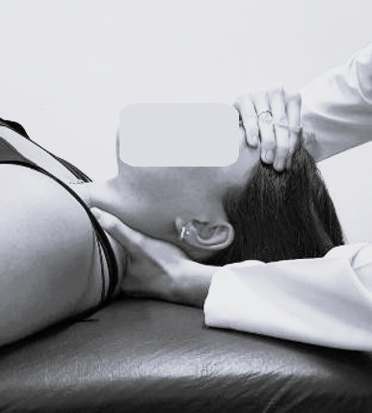
Fourth Ventricle Compression Maneuver (CV4) | The patient is positioned in a supine position. The physiotherapist is seated at the head of the treatment table, with the arms resting on it. The dorsum of the therapist’s hands rests on the table, with the fingertips pointing upward, acting as a support on which the patient rests the occipital bone and the upper cervical vertebrae, allowing the posterior aspect of the skull to rest on the palms. Gentle pressure is applied to facilitate tissue release against the fingertips for 1 min[36]. | 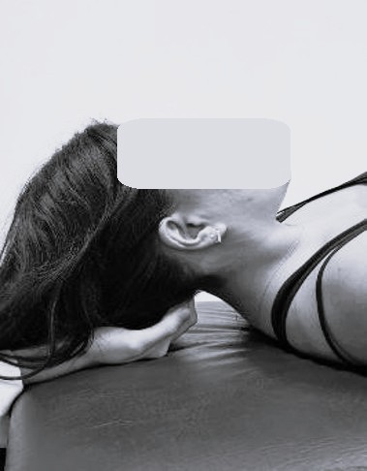
Hypothalamic–Pituitary Stimulation or Superior–Inferior Falx Relaxation | The patient is positioned in a supine position, while the therapist is seated at the head of the treatment table. The therapist places the thumbs crossed over the top of the head (along the sagittal suture), with the remaining fingers resting on the lateral aspects of the head (temporal bones). Gentle movements are performed by separating the thumbs while the other fingers glide upward. These movements are smooth and repeated 15 times[36]. | 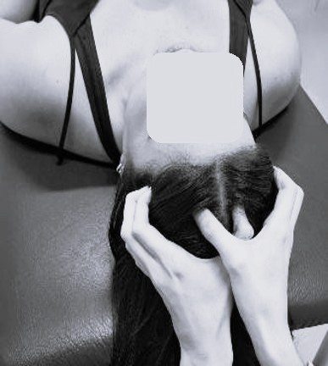
Somatoemotional Release Maneuver (Sphenobasilar Technique) | The patient is positioned in a supine position, with the therapist seated at the head of the treatment table. The therapist places the fingers bilaterally over the zygomatic bones, the thumbs over the eyebrows, and the hypothenar eminences over the frontal bones. Subtle movements are performed in which the fingers on the zygomatic bones move in a cephalad direction, while the thumbs move toward the treatment table and laterally. The maneuver is repeated 15 times[37, 38]. | 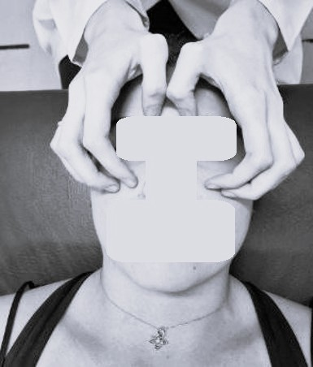
Temporal Bone Release Maneuver | The patient is positioned in a supine position, with the therapist seated at the head of the treatment table, arms parallel to each other. The therapist places the pads of the thumbs on the auricular cartilage, while the index and middle fingers are positioned opposite the thumbs on the posterior surfaces of the external ear. Gentle movements are applied to slightly traction the ears away from the skull, without causing discomfort, and this position is maintained for 1 min[36]. | 