Appendix 1
No | FAME | Synonym name | Group of Compounds | Chemical Structure Depiction | Molecular Weight | Molecular Formula | melting point (°C)
1 | Dodecanoic acid, methyl ester | Lauric acid methyl ester | Saturated fatty acid (SAFA) | 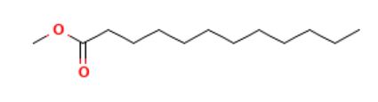  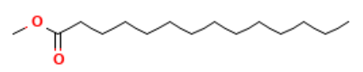 | 214.34 g/mol | C₁₃H₂₆O₂ | 5 – 5.2
2 | Methyl tetradecanoate | Tetradecanoic acid, methyl ester | Saturated fatty acid (SAFA) |  | 242.40 g/mol | C₁₅H₃₀O₂ | 18.5-19
3 | Pentadecanoic acid, methyl ester | Methyl n-pentadecanoate | Saturated fatty acid (SAFA) | 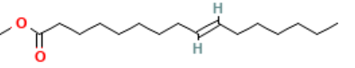  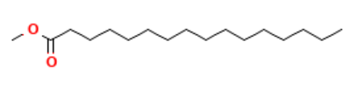  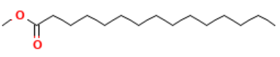  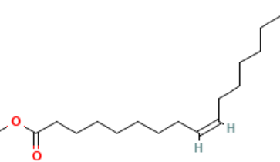 | 256.42 g/mol | C₁₆H₃₂O₂ | 18.5
4 | Hexadecanoic acid, methyl ester | Palmitic acid methyl ester | Saturated fatty acid (SAFA) |  | 270.5 g/mol | C₁₇H₃₄O₂ | 30
5 | Methyl hexadec-9-enoate | Palmitelaidic acid methyl ester | Monounsaturated fatty acid (MUFA) |  | 268.4 g/mol | C₁₇H₃₂O₂ | - 0.5 – 0.5
6 | 9-Hexadecenoic acid, methyl ester, (Z)- | Methyl palmitoleate | Monounsaturated fatty acid (MUFA) |  | - g/mol | C₁₇H₃₂O₂ | - 0.5 – 0.5
7 | Docosanoic acid, methyl ester | Methyl behenate | Saturated fatty acid (SAFA) | 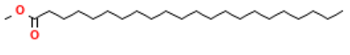 | 354.6 g/mol | C₂₃H₄₆O₂ | 54
8 | Heptadecanoic acid, methyl ester | Methyl heptadecanoate | Saturated fatty acid (SAFA) | 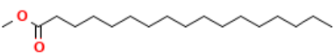 | 284.5 g/mol | C₁₈H₃₆O₂ | 29.8-30.3
9 | 13-Docosenoic acid, methyl ester, (Z)- | Methyl erucate | Monounsaturated fatty acid (MUFA) | 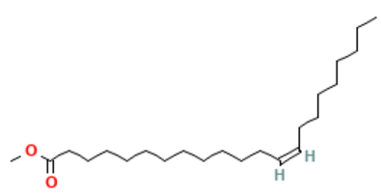 | - g/mol | C₂₃H₄₄O₂ | - 1.16 – 1.20
10 | 9,12-Octadecadienoic acid (Z,Z)-, methyl ester | Methyl lineoleate | Polyunsaturated fatty acid (PUFA) | 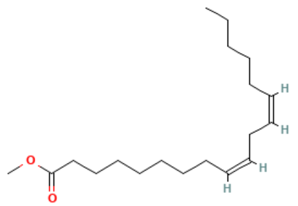 | 294.5 g/mol | C₁₉H₃₄O₂ | - 35
11 | Methyl stearate | Octadecanoic acid, methyl ester | Saturated fatty acid (SAFA) |  | 298.5 g/mol | C₁₉H₃₈O₂ | 39.1
  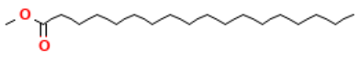
12 | 9-Octadecenoic acid, methyl ester, (E)- | Methyl elaidate | Monounsaturated fatty acid (MUFA) | 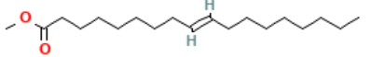 | 296.5 g/mol | C₁₉H₃₆O₂ | 9–10
13 | 9-Octadecenoic acid (Z)-, methyl ester | Methyl oleate | Monounsaturated fatty acid (MUFA) |  | 296.5 g/mol | C₁₉H₃₆O₂ | - 19.9
  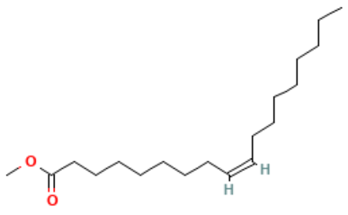
14 | 9,12,15-Octadecatrienoic acid, methyl ester, | Methyl linolenate | Polyunsaturated fatty acid (PUFA) | 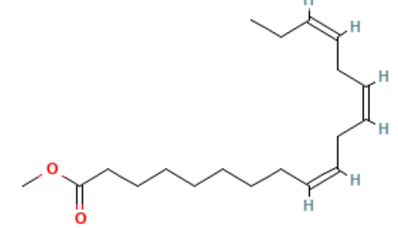 | 292.5 g/mol | C₁₉H₃₂O₂ | - 57
15 | Eicosanoic acid, methyl ester | Methyl arachidate | Saturated fatty acid (SAFA) | 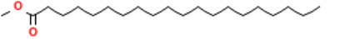  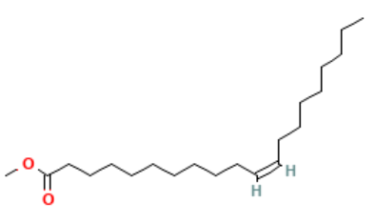 | 326.6 g/mol | C₂₁H₄₂O₂ | 45 - 48
16 | Methyl cis-11-eicosenoate | cis-11-Eicosenoic acid methyl ester | Monounsaturated fatty acid (MUFA) |  | 324.5 g/mol | C₂₁H₄₀O₂ | - 34
17 | formyl 7E-hexadecenoate | Formyl 7E-hexadecenoate is a fatty acid methyl ester. |  | 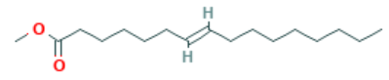 | 268.4 g/mol | C₁₇H₃₂O₂ | n.a
  Monounsaturated fatty acid (MUFA)
18 | cis-11,14-Eicosadienoic acid, methyl ester | Cis-11,14-eicosadienoic acid methyl ester | Polyunsaturated fatty acid (PUFA) | 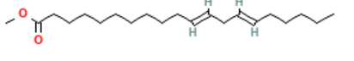 | 322.5 g/mol | C₂₁H₃₈O₂ | n.a

