Supplementary Material
CD81
CD63
CD9
Calnexin

Supplementary Figure S1
The original Western blot analysis of exosome markers CD81, CD63, CD9, and Calnexin
Supplementary Figure S2
Exosome treatment remodeled changes in the gut microbiota of DSS-induced mice. Histograms of relative abundance for top 35 microbes at the phylum(A) and genus (B) levels. n = 6 mice per group.

Supplementary Table S1. Results of differential metabolite screening.
Compared Samples | Num. of Total metabolites | Num. of Total Sig. | Num. of Sig.Up | Num. of Sig.down
DSS.vs.MSC_Exo_POS | 2630 | 725 | 180 | 545
DSS.vs.MSC_Exo_NEG | 1518 | 387 | 117 | 270

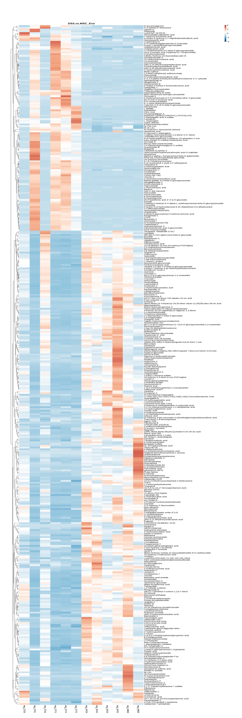
Supplementary Figure S3
The clustering heatmap showed the differential metabolites in DSS and MSC-Exos groups. n = 6 mice per group.

