Supplementary Information
Appendix 1 - Additional information for the GAM performed on Country-specific predictors

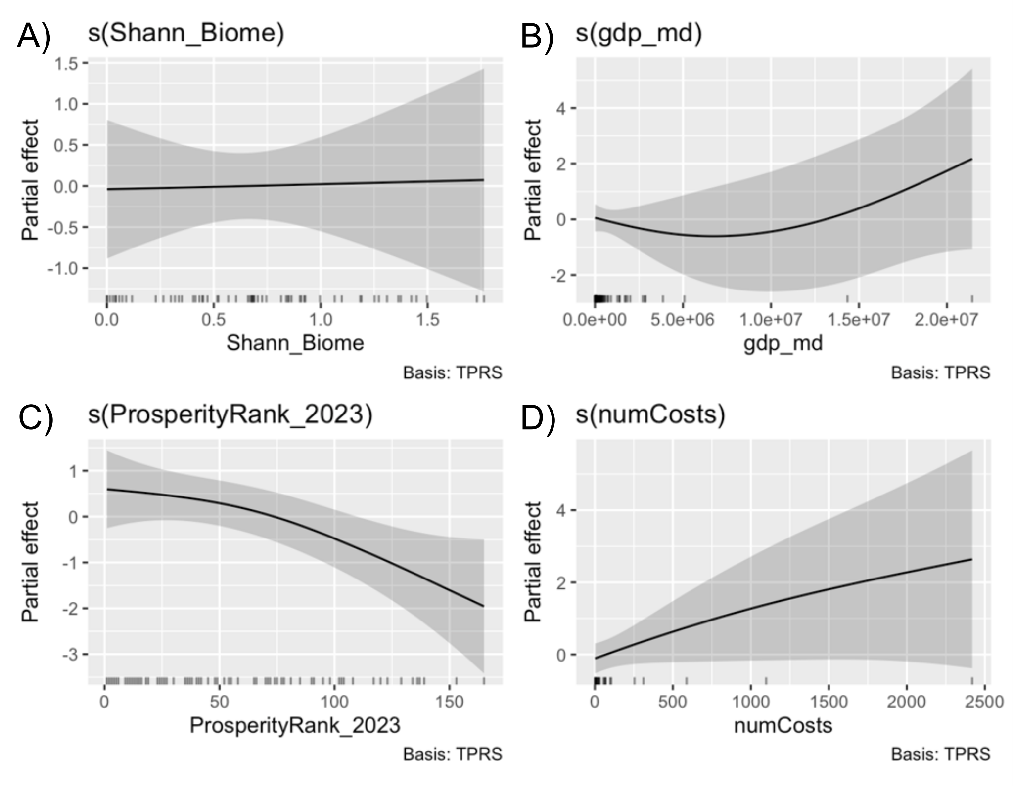
Figure S1. Partial effects of the generalized additive model on the global costs of invasive plants, on country ecological diversity (A), on GDP (B), on prosperity rank (C), and on number of assessments (D).
Table S1. Summary statistics of the GAM identifying the main drivers of cost estimates of vascular plants across countries (n = 65).
Term | Estimate/edf | Std. Error | Test statistic (t/F) | p-value
Intercept | 9.580 | 2.267 | 4.226 | <0.001
Area (log₁₀) | 1.861 | 0.413 | 4.504 | <0.001
s(Shann_Biome) | 1.004 | 1.008 | 0.012 | 0.934
s(GDP) | 1.698 | 2.091 | 1.432 | 0.237
s(ProsperityRank_2023) | 1.529 | 1.885 | 5.434 | 0.020
s(#Costs) | 1.112 | 1.213 | 2.428 | 0.091
adjusted R² = 0.79.
Appendix 2 - Additional information for the GAM performed on Residence time
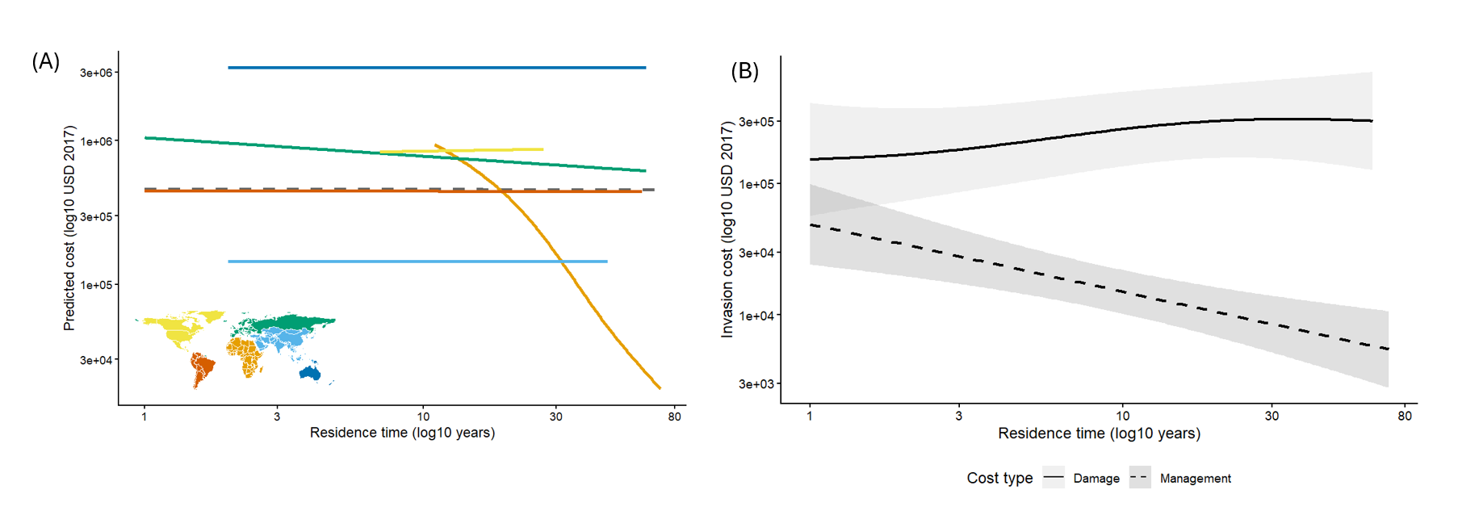
Figure S2. All lines represent predicted costs generated from a Generalised Additive Model (GAM) with a Gamma error distribution. All axes are on the log scale. Shaded ribbons represent 95% confidence intervals. (A) Costs as a function of residence time across continents. The dashed grey line represents the global smooth term, reflecting the average relationship across all continents independent of continent-specific variation. Lines extend only across each continent's observed residence time range. Continent identity is indicated by line colour, as shown in the inset map. (B) Costs as a function of residence time for damage (solid) and management (dashed) cost types.
Table S2. Summary of GAM which examined how costs (n = 281) of plants vary with residence time, continent, and cost type.
Term | Estimate/edf | Std. Error | Test statistic (t/F) | p-value
Intercept | 12.417 | 0.949 | 13.089 | <0.001
ContinentAsia | 0.025 | 1.401 | 0.018 | 0.986
ContinentEurope | 1.704 | 1.109 | 1.537 | 0.127
ContinentNorth America | 0.780 | 1.737 | 0.449 | 0.654
ContinentOceania | 2.375 | 1.689 | 1.406 | 0.162
ContinentSouth America | 0.265 | 1.401 | 0.189 | 0.850
cost_typeManagement | -2.877 | 0.237 | -12.127 | <0.001
log(n_records) | 1.447 | 0.114 | 12.744 | <0.001
s(log10(residence_time)):ContinentAfrica | 1.214 | – | 16.527 | 0.002
s(log10(residence_time)):ContinentAsia | 0.003 | – | 0.000 | 0.840
s(log10(residence_time)):ContinentEurope | 1.519 | – | 12.479 | 0.039
s(log10(residence_time)):ContinentNorth America | 0.003 | – | 0.001 | 0.453
s(log10(residence_time)):ContinentOceania | 0.001 | – | 0.000 | 0.986
s(log10(residence_time)):ContinentSouth America | 1.730 | – | 17.491 | 0.259
s(log10(residence_time)):cost_typeDamage | 0.439 | – | 0.408 | 0.240
s(log10(residence_time)):cost_typeManagement | 0.003 | – | 0.000 | 0.649
s(Species) | 88.866 | – | 3.267 | <0.001
s(Official_country) | 33.326 | – | 21.150 | <0.001

Appendix 3 - Cost comparisons within InvaCost
Taxon | Geographic scale | Cost | Notes | References
All | Global | US$4,563.9 billion | considering only highly reliable and observed costs | InvaCost v.4.1
Terrestrial invertebrates | Global | US$712.44 billion | From 1960 to 2020 | Renault et al. 2022
Vertebrates | Global | U$92.28 billion | From 1960 to 2020 | Haubrock et al. 2022b; Bodey et al. 2025
Invasive mosquitoes Aedes aegypti and Aedes albopictus together | Global | US$94.7 billion | Same InvaCost version and filtering steps as the current study | Roiz et al. 2024
Black rat Rattus rattus | Global | US$24 billion | Same InvaCost version and filtering steps as the current study | Wang et al. 2023
Domestic cat Felis catus | Global | US$6 billion | Same InvaCost version and filtering steps as the current study | Wang et al. 2023
Diverse | Global | U$788.2 billion | Costs associated to multiple taxa (e.g. plants and animals together), with disaggregation impossible | InvaCost v.4.1

Appendix 4 - Invasive plants estimations
Source | Invasive plant species estimation | Species in common with the InvaCost database | Notes | References
GISD | 477 | 118 | It defines ‘invasive’ based on ecological impacts. | www.iucngisd.org/gisd, accessed on 30th December 2025
Global Impacts Dataset of Invasive Alien Species database (GIDIAS) | 1,009 | 203 | Invasive plant species with recorded impacts | Bacher et al. 2025
GloNAF | 4,493 | 378 | Plant species that are considered invasive somewhere (based on establishment and spread) | Davis et al. 2025
GloNAF | 16,429 | 420 | Naturalized non-native plant species worldwide | Davis et al. 2025

Appendix 5 - Sources of bias
Considering the minority of global invasive plant species for which we do have cost data, costs are heavily skewed towards a few species, and many invasions by these and other species have not yet been captured — for example, those not monetized or those reported in inaccessible or very recent literature or in languages not included in InvaCost (Diagne et al. 2020; Angulo et al. 2021). Even where data are available, cost estimates can often remain imprecise (Hulme et al. 2024). Accurately quantifying impacts is very difficult for biological invasions (Carneiro et al. 2024), especially for plants, which are particularly affected by data gaps (Novoa et al. 2021). However, the InvaCost version used for our study represents a substantial increase over the original cost estimates for plants of US$9.54billion (based only on highly-reliable and observed costs) published in the first version of the database (Diagne et al. 2020). Furthermore, several plant cost entries in the InvaCost database are further underestimated since they report a cost per unit area (per ha or even m²) when the size of the affected area was not reported in the original source.
An equally important yet often overlooked dimension is that several invasive plants generate both negative and positive impacts, further contributing to knowledge gaps alongside management. These species may provide economic value (e.g., ornamental use, fodder, erosion control) and even underpinning economically significant industries while having strong ecological and socio-economic impacts (Kourantidou et al. 2022). Such cases highlight trade-offs and socio-ecological tensions that often delay or dilute management actions, despite long-term economic inefficiencies (Hulme & Vilà 2017). A clearer understanding of these ambivalent cases (cf. Balzani et al. 2022)—where costs and benefits coexist or are distributed unevenly across stakeholders—is essential to develop more economically sound management strategies. Such an improved understanding can enhance the completeness of databases like InvaCost, and support more context-sensitive management decisions (Kourantidou et al. 2022), helping lay the groundwork for future cost projections to close knowledge gaps, inform prioritizations, and ultimately support trade-off analyses. Indeed, monetization is not only a way to quantify impacts and increase public awareness (Vaissière et al. 2022), but also to improve management and, more specifically, inform more effective regulation and management of key introduction pathways — such as trade and the ornamental plant industry — and guide prioritization strategies (Ahmed et al. 2022a; Turbelin et al. 2022). Such strategies, in turn, can help curb the current and projected rising trend of species introductions into novel regions (Seebens et al. 2017, 2021, 2025) and their associated costs (Diagne et al. 2021a). Importantly, it is essential to bear in mind that the occasional benefits of biological invasions are often much lower than their associated costs, do not concern the same stakeholders, and do not negate the costs incurred elsewhere (Carneiro et al. 2024).

Diagne, C. et al. InvaCost, a public database of the economic costs of biological invasions worldwide. Scientific Data, 7(1), 1–12 (2020). https://doi.org/10.1038/s41597-020-00586-z
Angulo, E. et al. Non-English languages enrich scientific knowledge: The example of economic costs of biological invasions. Science of the Total Environment, 775, 144441 (2021). https://doi.org/10.1016/j.scitotenv.2020.144441
Hulme, P. E. et al. Widespread imprecision in estimates of the economic costs of invasive alien species worldwide. Science of the Total Environment, 909, 167997 (2024). https://doi.org/10.1016/j.scitotenv.2023.167997
Carneiro, L. et al. Benefits do not balance costs of biological invasions. BioScience, 74(5), 340–344 (2024). https://doi.org/10.1093/biosci/biae010
Novoa, A. et al. Global costs of plant invasions must not be underestimated. NeoBiota, 69, 75–78 (2021). https://doi.org/10.3897/neobiota.69.74121
Kourantidou, M. et al. Invasive alien species as simultaneous benefits and burdens: trends, stakeholder perceptions and management. Biological Invasions, 24(7), 1905–1926 (2022). https://doi.org/10.1007/s10530-021-02727-w
Hulme, P. E. & Vilà, M. Integrating the Impacts of Non-Native Species on Ecosystem Services into Environmental Policy. In: Vilà, M. & Hulme, P. E. (eds), Impact of Biological Invasions on Ecosystem Services. Springer, Heidelberg (2017). https://doi.org/10.1007/978-3-319-45121-3_21
Balzani, P. et al. Knowledge needs in economic costs of invasive species facilitated by canalization. NeoBiota, 78, 207–223 (2022). https://doi.org/10.3897/neobiota.78.95050
Vaissière, A. C. et al. The nature of economic costs of biological invasions. Biological Invasions, 24(7), 2081–2101 (2022). https://doi.org/10.1007/s10530-022-02837-z
Ahmed, D. A. et al. Modelling the damage costs of invasive alien species. Biological Invasions, 24, 1949–1972 (2022). https://doi.org/10.1007/s10530-021-02586-5
Turbelin, A. J. et al. Introduction pathways of economically costly invasive alien species. Biological Invasions, 24(7), 2061–2079 (2022). https://doi.org/10.1007/s10530-022-02796-5
Seebens, H. et al. No saturation in the accumulation of alien species worldwide. Nature Communications, 8(1), 1–9 (2017). https://doi.org/10.1038/ncomms14435
Seebens, H. et al. Projecting the continental accumulation of alien species through to 2050. Global Change Biology, 27(5), 970–982 (2021). https://doi.org/10.1111/gcb.15333
Seebens, H. et al. Biological invasions: a global assessment of geographic distributions, long-term trends, and data gaps. Biological Reviews, 100(6), 2542–2583 (2025). https://doi.org/10.1111/brv.70058
Diagne, C. et al. High and rising economic costs of biological invasions worldwide. Nature, 592(7855), 571–576 (2021). https://doi.org/10.1038/s41586-021-03405-6
Carneiro, L. et al. Benefits do not balance costs of biological invasions. BioScience, 74(5), 340–344 (2024). https://doi.org/10.1093/biosci/biae010

Appendix 6 - Cost descriptors taken from InvaCost database (with addition coming from cross-checking phases)

Column title | Description (from Diagne et al., 2020 https://doi.org/10.1038/s41597-020-00586-z)
Acquisition method | The method used to provide the cost estimate as a report/estimation (gathered or derived from field-based information) or extrapolation (cost modelled beyond the original spatial and/or temporal observation range)
Applicable year | The year of the ‘Currency’ value (not the year of the cost occurrence) considered for the conversion/standardization of the cost estimate
Authors | The authors of the material analysed
Availability | The accessibility of the material as a searchable document (yes/no)
Benefit value(s) | The mention of if any benefit value was found in the analysed material (yes/no); the figure was not recorded or described as being out of the scope of InvaCost
Check 2025 | New column indicating whether th entry has been checked for this article
Common name | The non-scientific (or vernacular) name(s) provided by the authors, or by the International Union for Conservation of Nature (IUCN) when not provided
Cost estimate per year 2017 USD exchange rate | The ‘Cost estimate per year local currency’ standardised from local ‘Currency’ and ‘Applicable year’ to 2017 USD based on ER** (See the formula in the ‘Standardisation of cost data’ section). The value may differ from last version of InvaCost due to the correction/changes made for this article
Cost estimate per year 2017 USD PPP | The ‘Cost estimate per year local currency’ standardised from local ‘Currency’ and ‘Applicable year’ to 2017 USD based on PPP*** (See the formula in the ‘Standardisation of cost data’ section). The value may differ from last version of InvaCost due to the correction/changes made for this article
Cost estimate per year local currency | The ‘Raw cost estimate local currency’ transformed to a cost estimate per year of the ‘Period of estimation’ (obtained by dividing the raw cost estimate by the number of years* of the ‘Period of estimation’)
Cost ID | A unique numerical identifier for the cost estimate
Currency | The currency of the ‘Raw cost estimate local currency’ as extracted from the material
Details | When necessary, narrative elements deemed important either to understand the cost estimate or to support choices made for completing the database; this column was left unchanged from the original entries in order to allow trace-back investigations
Double checking | Column present in IC4.1 indicating whether the entry has been previously checked
Environment | The type of habitat (aquatic, terrestrial, semi-aquatic) where the cost estimate occurred
Geographic region | The geographical region(s) where the cost estimate occurred (Africa, Asia, Central America, Europe, North America, Oceania-Pacific islands, South America)
Impacted sector | The sector impacted by the cost estimate in our socio-ecosystems (e.g. agriculture, health, public and social welfare; see Table 3 for details on each category)
Implementation | This states – at the time of the estimation – whether the reported cost was actually observed (i.e. cost actually incurred) or potential (i.e. not incurred but expected cost)
Initial contributors | The name of collaborator(s) having recorded the cost estimate; currently, it is only the initials of the authors, but each future contributor will be consistently acknowledged here
Location | When provided, the precise location (e.g., region, city, area) where the cost estimate occurred
Max Raw cost estimate local currency | The higher boundary of the ‘Raw cost estimate local currency’ (if a range of estimates was provided by the authors)
Method reliability | The assessment of the methodological approach used for cost estimation as of (i) high reliability if either provided by officially pre-assessed materials (peer-reviewed articles and official reports) or the estimation method was documented, repeatable and/or traceable if provided by other grey materials, or (ii) low reliability if not (see Fig. 2 for more details)
Min Raw cost estimate local currency | The lower boundary of the ‘Raw cost estimate local currency’ (if a range of estimates was provided by the authors)
Notes 2025 | New column indicating the evaluation/correction made after the checking process for this article. When necessary, narrative elements deemed important either to understand the corrections/changes or to support choices made for completing the database; this column was left unchanged from the original entries in order to allow trace-back investigations
Occurrence | The status of the cost estimate as potentially ongoing (if the cost can be expected to continue over time) or one-time (if the cost was explicitly considered as over by the authors)
Official country | The country or official territory where the cost is incurred; sometimes, this is not congruent with the geographic regions as some territories (e.g. Overseas areas) are situated on other continents than their country of attachment
Period of estimation | If provided, the exact period of time covered by the costs estimated, otherwise the raw formulation (e.g. late 90’s, during 5 years)
Previous materials | If any, the list of successive materials checked before reaching the material originally providing the cost estimate
Probable starting year | The year range in which the cost is known or assumed to occur. When not explicitly provided by the authors, we mentioned ‘unspecified’ in both columns unless the authors provided a clear duration time. In this case, we considered the ‘Publication year’ as a reference for the probable starting/ending year from which we added/subtracted the number of years* of the ‘Period of estimation’. In the case of a cost estimate provided for a one-year period straddling two calendar years, we mentioned the latest year of the cost occurrence in both columns. When vague formulations were used (e.g. early 90’s), we still translated them in probable ending/starting year (e.g. 1990–1995). We will harmonise the way these specific cases are dealt with when reviewing and validating new lines proposed by new contributors.
Probable ending year
Publication year | The publication year of the material analysed
Raw cost estimate 2017 USD exchange rate | The ‘Raw cost estimate local currency’ standardised from local ‘Currency’ and ‘Applicable year’ to 2017 US$ based on ER** See the formula in the Standardisation of cost data section. The value may differ from last version of InvaCost due to the correction/changes made for this article
Raw cost estimate 2017 USD PPP | The ‘Raw cost estimate local currency’ standardised to 2017 US$ based on PPP*** See the formula in the Standardisation of cost data section
Raw cost estimate local currency | The cost estimate directly retrieved from the analysed materials.The value may differ from last version of InvaCost due to the correction/changes made for this article
Reference ID | The numerical identifier of the material analysed, which - along with ‘Repository’ - allows correspondence with the InvaCost_references file30 that provides bibliographic details
Reference title | The title of the material analysed
Repository | The original source of each material: ‘Web of Science (WoS)’, ‘Google Scholar (GS)’, ‘Google search engine (Go)’ or ‘Targeted collection (TC)’
Spatial scale | The spatial scale considered for estimating the cost: global (worldwide-scale), intercontinental (sites from two or more geographic regions) continental (‘geographic region’ level), regional (several countries within a single geographic region), country, site (for cost evaluated at intra-country level, including USA states) and unit (for costs evaluated for a well-defined surface area or entity)
Taxonomy | For each species recorded, the taxonomic information from kingdom to species level using the Global Biodiversity Information Facility (GBIF) as a reference
Time range | The time range considered by the authors for providing the cost estimate: year (when costs were if the estimate is given yearly or for a period up to one year) or period (when costs were provided for a period exceeding a year)
Type of applicable year | The assessment of the applicable year as effective if explicitly stated by the authors or publication year if no explicit information provided
Type of cost | The type of the cost includes: damages and losses incurred by an invasion (e.g. damage repair, medical care, value of crop losses), or means dedicated to understand or predict (e.g. research), prevent (e.g. education, biosecurity), early detect (e.g. monitoring, surveillance) and/or manage (e.g. control, eradication) the invaders
Type of material | The type of material analysed (i.e. scientific peer-reviewed article or grey literature); for grey literature, the exact nature of the material was indicated (e.g., official report, press release)
User check 2025 | New column indicating the name of the coathor who checked the entry

