SUPPORTING INFORMATION

for
Dodecyltriphenylphosphonium Bromide Antimicrobial Finishing and Pigment Coloring of Polyester Fabrics in One-Bath
Jiao-Jiao Ji¹, Mei-Yu Ci², Jin-Zhi Kuang¹, Lin Zhang^{1*}

1. Institute of Functional Textiles and Advanced Materials, College of Textiles & Clothing, Qingdao Key Laboratory of Flame-Retardant Textile Materials, Qingdao University, Qingdao 266071, China.
2. Qingdao Product Quality Testing Research Institute, Qingdao 266071, China.

Corresponding to lindazl@qdu.edu.cn (LZ)

Thermal Stability of 8-TPPB, 12-TPPB, and 16-TPPB
The thermal degradation characteristics of the three quaternary phosphonium salts are shown in Fig S1. The TG and DTG curves of the sample in nitrogen are shown in Fig S1 (a) and Fig S1 (b)，In Fig. S1 (a), initial thermal degradation occurs between 260 and 280 °C. It was found that all three quaternary phosphonium salts exhibit thermal stability up to 270 °C or higher. At temperatures above 270 °C, slight structural changes begin to occur in the quaternary phosphonium salts, indicating that 8-TPPB, 12-TPPB, and 16-TPPB possesses excellent thermal stability.

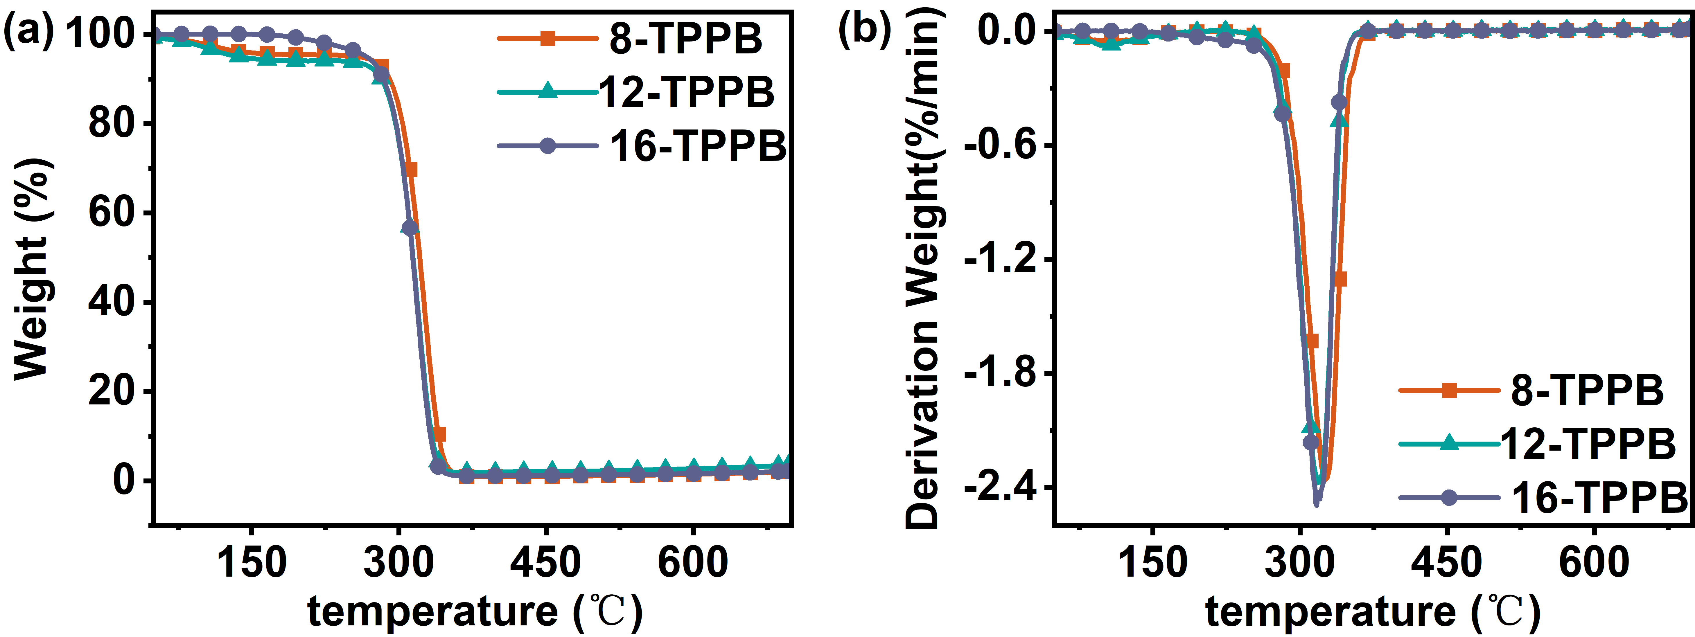
Fig. S1. TG and DTG curves of 8-TPPB, 12-TPPB, and 16-TPPB: (a, b)

