Supplementary:

Definitions and description of data used in each analysis:
Baseline incubation duration: total time (minutes) each queen spent incubating during the post-manipulation phase (8 hours) in control colonies. Only control queens with workers present were used to provide a baseline of incubation across colony developmental stages.

Incubation frequency per hour: the number of incubation events per hour, calculated by dividing the total number of events by the total observation time across each experimental phase (either two (pre-manipulation) or eight (post-manipulation) For the baseline group-size comparison, we used only the post-manipulation control (W+) queens when comparing across colony developmental stages.

Average incubation duration per event: the mean duration of individual incubation events (in minutes) for each queen throughout both experimental phases, calculated for each phase separately. This metric standardizes incubation behavior independent of the total number of events and possible observation hours. For the baseline group-size comparison, we only used the post-manipulation control (W+) queens across colony developmental stages.

Cumulative feeding/incubation: Either the total number of feeding events or the total time spent incubating (minutes) across all events observed during mirrored pre- and post-manipulation hours (4-5 and 19-20). These values were calculated to enable direct comparisons for a given queen across specific brood care behaviors, as both hours 4-5 and 19-20 are present at both treatment points; see Supplementary Figure 1 for an example of matched timeframes.

Change in allocation of incubation duration: the within-individual difference in cumulative incubation duration across experimental phases, calculated as post-manipulation minus pre-manipulation incubation duration (Post − Pre). Positive values indicate increased incubation after manipulation, whereas negative values indicate decreased incubation.
Standardized incubation duration: The proportion of a queen’s cumulative incubation time allocated to each brood type, including eggs, younger larvae, older larvae, and late-stage brood. For each queen in the post-manipulation phase, this metric was calculated by dividing the total time spent incubating a given brood type by the queen’s total cumulative incubation duration across all brood types during that phase. This standardization allowed incubation allocation to be compared across brood types while accounting for differences in overall incubation effort among queens. Because bumble bee brood structures are inherently three-dimensional, with new brood cells often constructed on top of existing brood (e.g., eggs laid over late-stage brood; Heinrich, 2004; Alford, 1970; Rozen et al., 2018; Sladen, 1912; Michener, 1969), individual incubation events may involve multiple brood types located in close proximity or vertically stacked. Additionally, the top-down perspective of video recordings can make overlapping brood types appear two-dimensional, limiting the ability to distinguish among brood types during some incubation events. These factors were considered during behavioral scoring, and each incubation event was assigned to the brood type most clearly associated with the queen’s position and contact during that event.
Supplement figures:
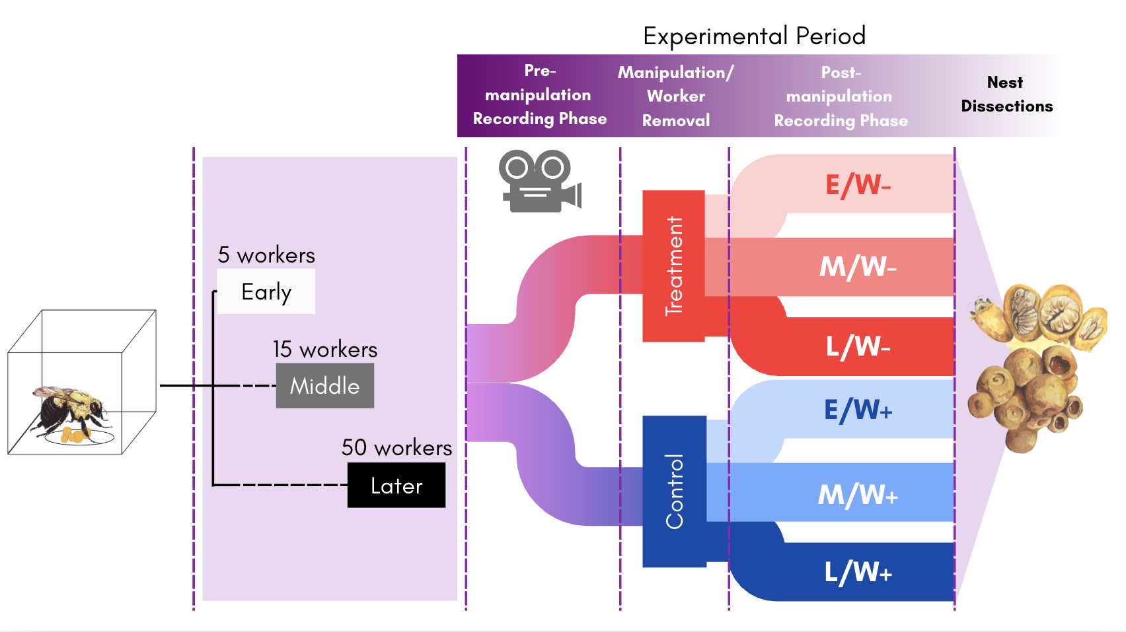
Supplementary Figure 1: Experimental Flowchart. Colonies were assigned to early (E), middle (M), or later (L)-stage groups based on worker number, recorded during a pre-manipulation phase, and then assigned to either worker-removal treatment (W−) or control conditions with workers present (W+). Treatment groups are abbreviated as E/W−, M/W−, L/W−, E/W+, M/W+, and L/W+. Queen behavior was recorded again during the post-manipulation phase, after which nests were dissected to quantify brood composition and reproductive output.

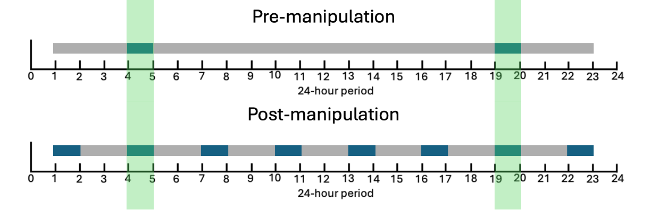
Supplementary Figure 2. Video sampling schedule used to quantify queen behavior across experimental phases. One-hour video segments were used for behavioral observations during the 24-hour recording period. Grey horizontal bars indicate the usable recording window (hours 1–23), and dark blue bars represent the observation hours (every three hours). The light green-shaded region highlights the two-hour periods used for matched timepoint comparisons between experimental phases. The same sampling scheme was applied to both control and treatment colonies.

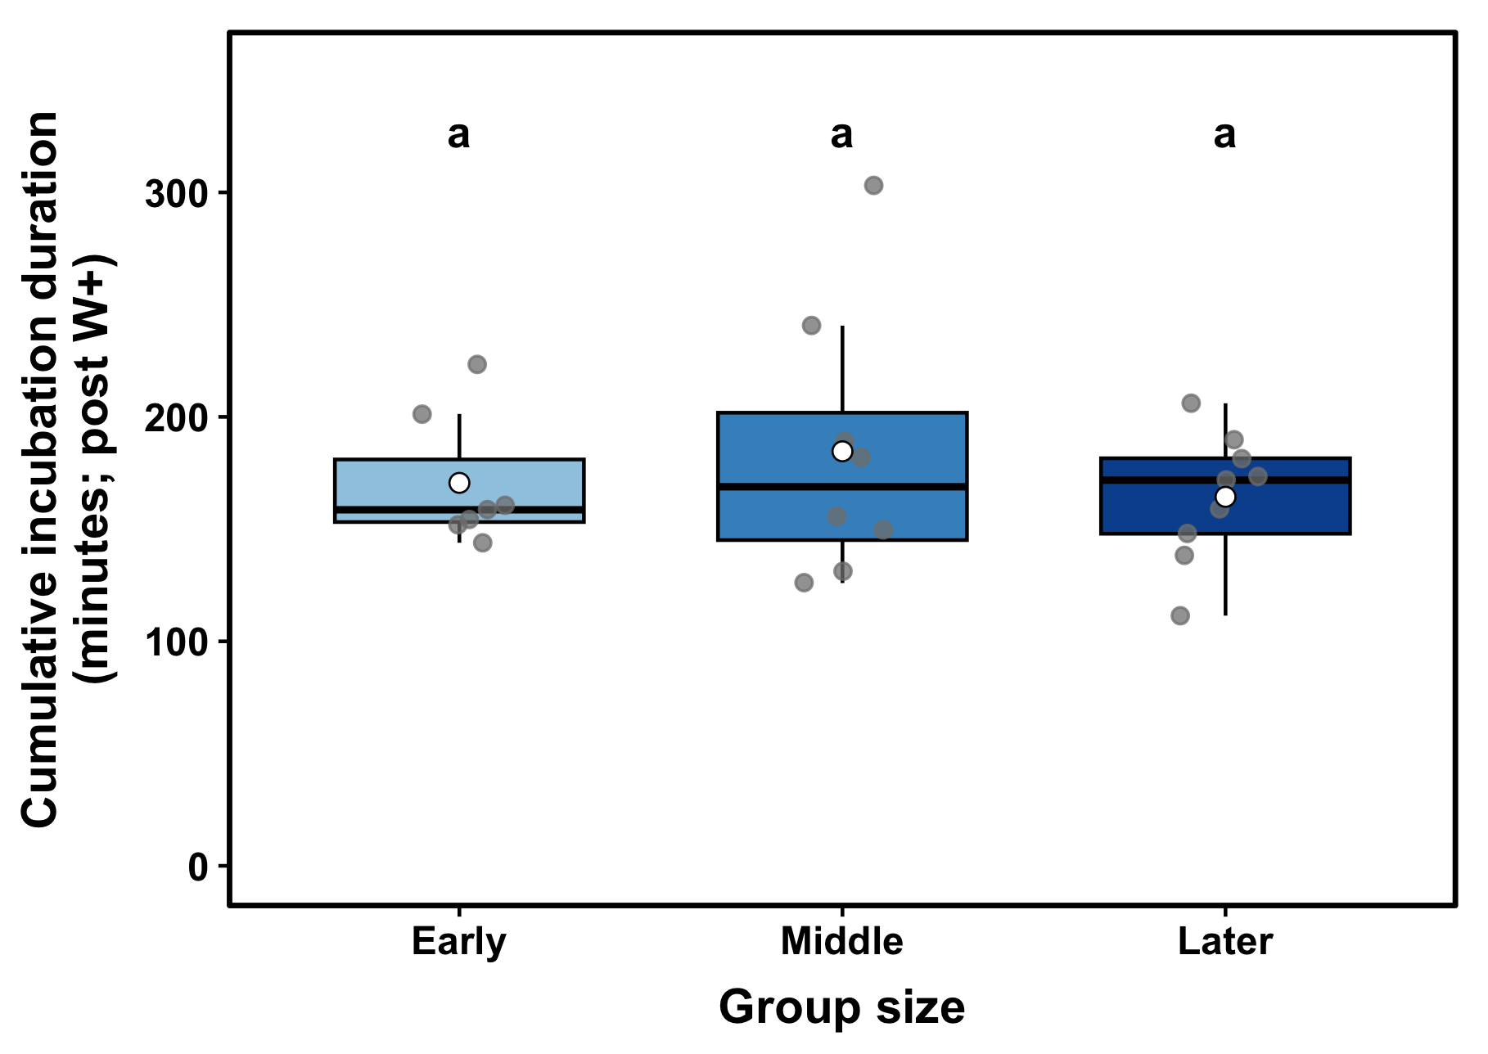
Supplementary Figure 3. Cumulative incubation duration did not differ across colony developmental stages in post-manipulation control colonies (W+). Points represent individual queens, boxplots show the median and interquartile range, and white circles indicate group means. Identical letters above groups indicate no significant differences among colony developmental stages based on emmeans pairwise comparisons.

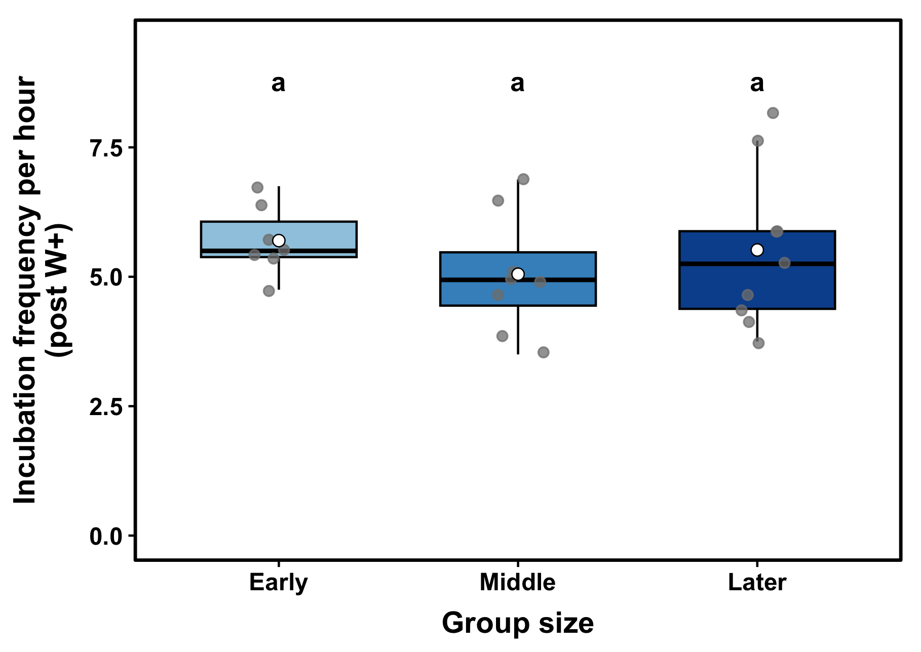
Supplementary Figure 4. Incubation frequency in post-manipulation control colonies (W+) did not differ across developmental stages. Points represent individual queens, boxplots show the median and interquartile range, and white circles indicate group means. Identical letters above groups indicate no significant differences among colony developmental stages based on emmeans pairwise comparisons.
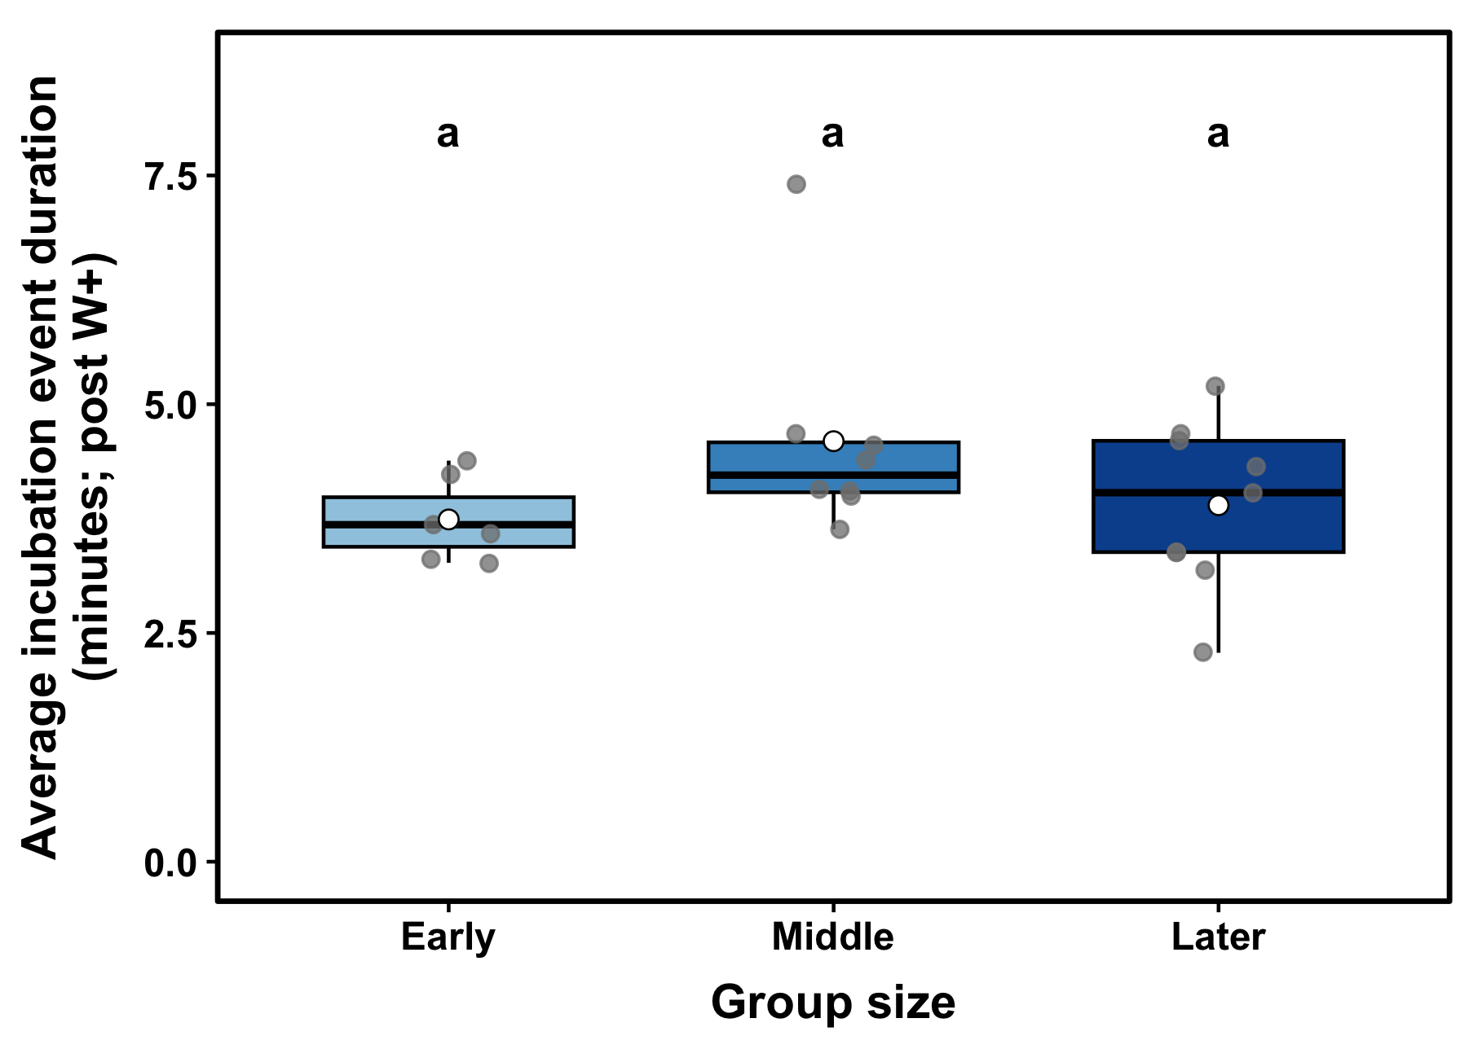
Supplementary Figure 5. Average incubation event duration did not differ across colony developmental stages in post-manipulation control (W+) colonies. Points represent individual queens, boxplots show the median and interquartile range, and white circles indicate group means. Identical letters above groups indicate no significant differences among colony developmental stages based on emmeans pairwise comparisons.

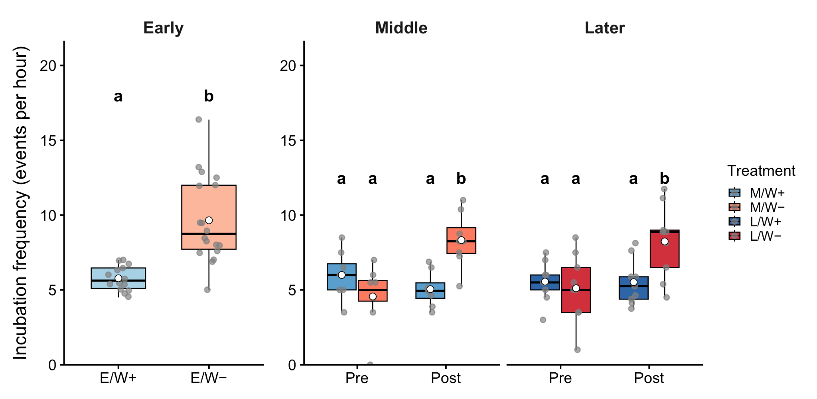
Supplementary Figure 6. Box plot of incubation frequency across colony developmental stages and treatment across experimental phases. Colony developmental stages are shown as early (E), middle (M), and later (L), and treatments are shown as control colonies with workers present (W+) and worker-removal colonies (W−). Treatment labels combine colony stage and worker condition: E/W+, M/W+, and L/W+ indicate control colonies, whereas E/W−, M/W−, and L/W− indicate worker-removal colonies. Early-stage colonies are shown as overall treatment-level comparisons because experimental phase did not significantly affect incubation frequency in this group. Middle- and later-stage colonies are shown across pre- and post-manipulation phases. Points represent individual queens, boxplots show medians and interquartile ranges, and white circles represent group means. Letters indicate post hoc groupings; groups that do not share a letter are significantly different from one another.

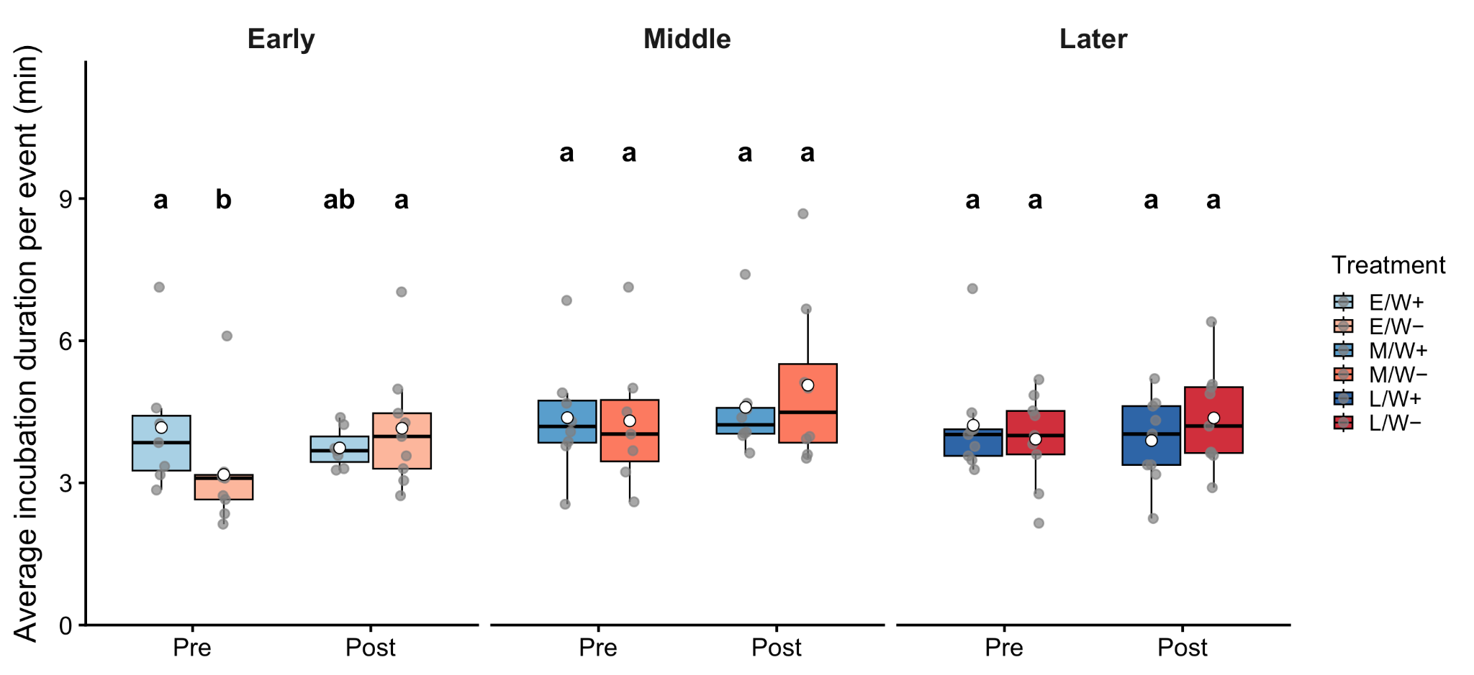
Supplementary Figure 7. Box plot of average incubation duration per individual event (minutes) across colony developmental stage and treatment before and after manipulation. Colony developmental stages are shown as early (E)-, middle (M)-, and later (L)-stage colonies, and treatments are shown as control colonies with workers present (W+) and worker-removal colonies (W-). Treatment labels combine colony stage and worker condition: E/W+, M/W+/ L/W+ indicate control colonies, whereas E/W-, M/W-, and LW- indicate worker-removal colonies for early, middle, and later stages, respectively. Points represent individual queens, and white circles represent group means. Letters indicate post hoc groupings, where groups that do not share a letter are significantly different from one another.

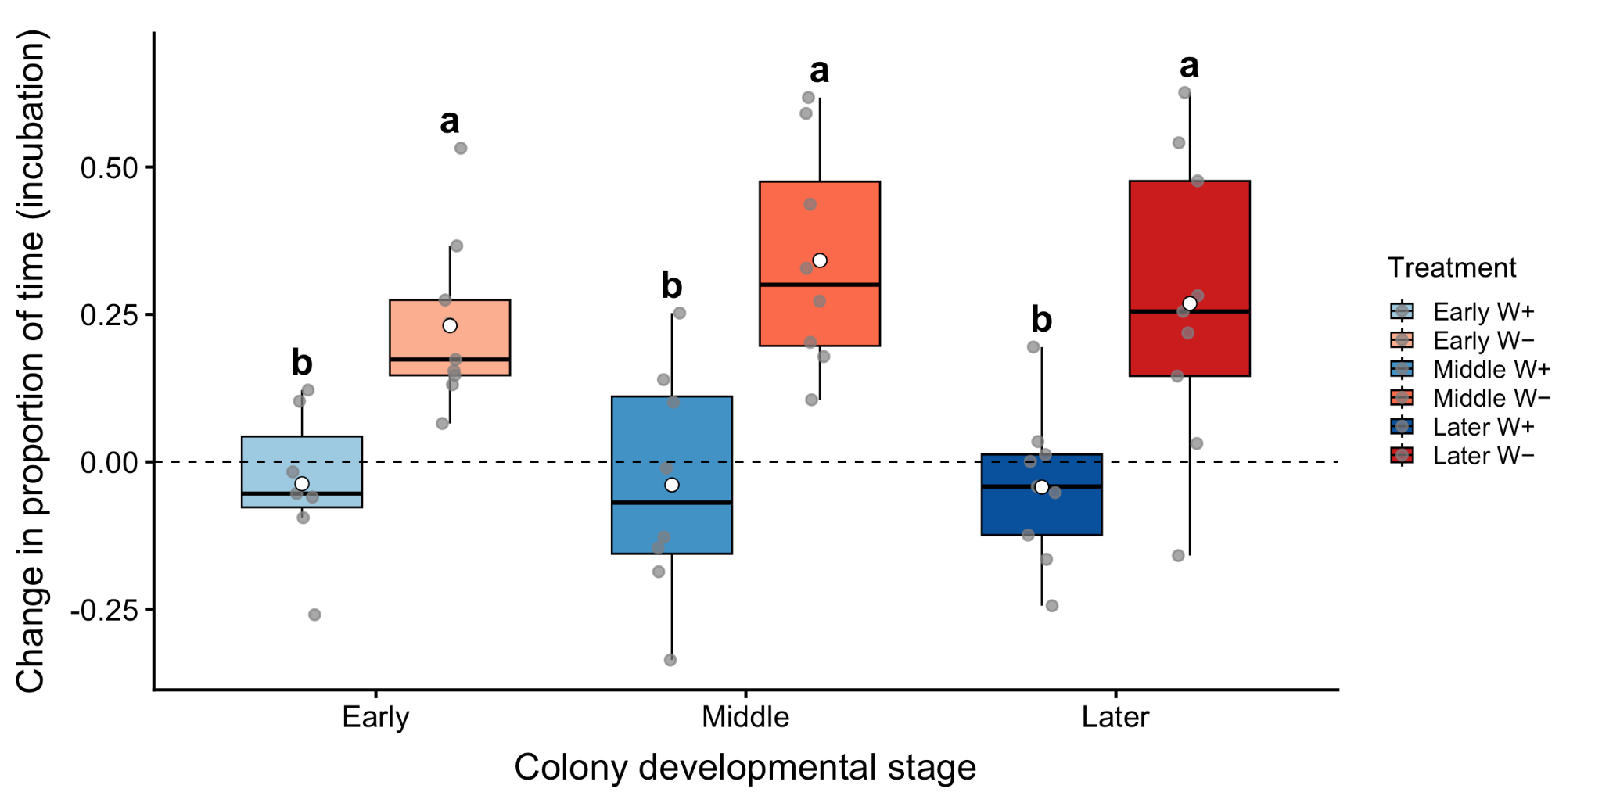
Supplementary Figure 8. Change in the proportion of time allocated to incubation duration per queen across colony developmental stages and worker conditions. Change in incubation duration was calculated as post-manipulation minus pre-manipulation incubation duration (Post − Pre). Worker-removal queens (W−) showed significantly greater increases in the proportion of time they spent incubating than control queens (W+), but there were no differences among the early, middle, and later-stage colony developmental stages within each treatment (W+ or W-, respectively; all p > 0.05). Points represent individual queens, boxplots show median and interquartile range, and white circles indicate group means. The dashed line indicates no change (zero) between experimental phases, and identical letters denote no significant differences among groups per emmeans comparison.

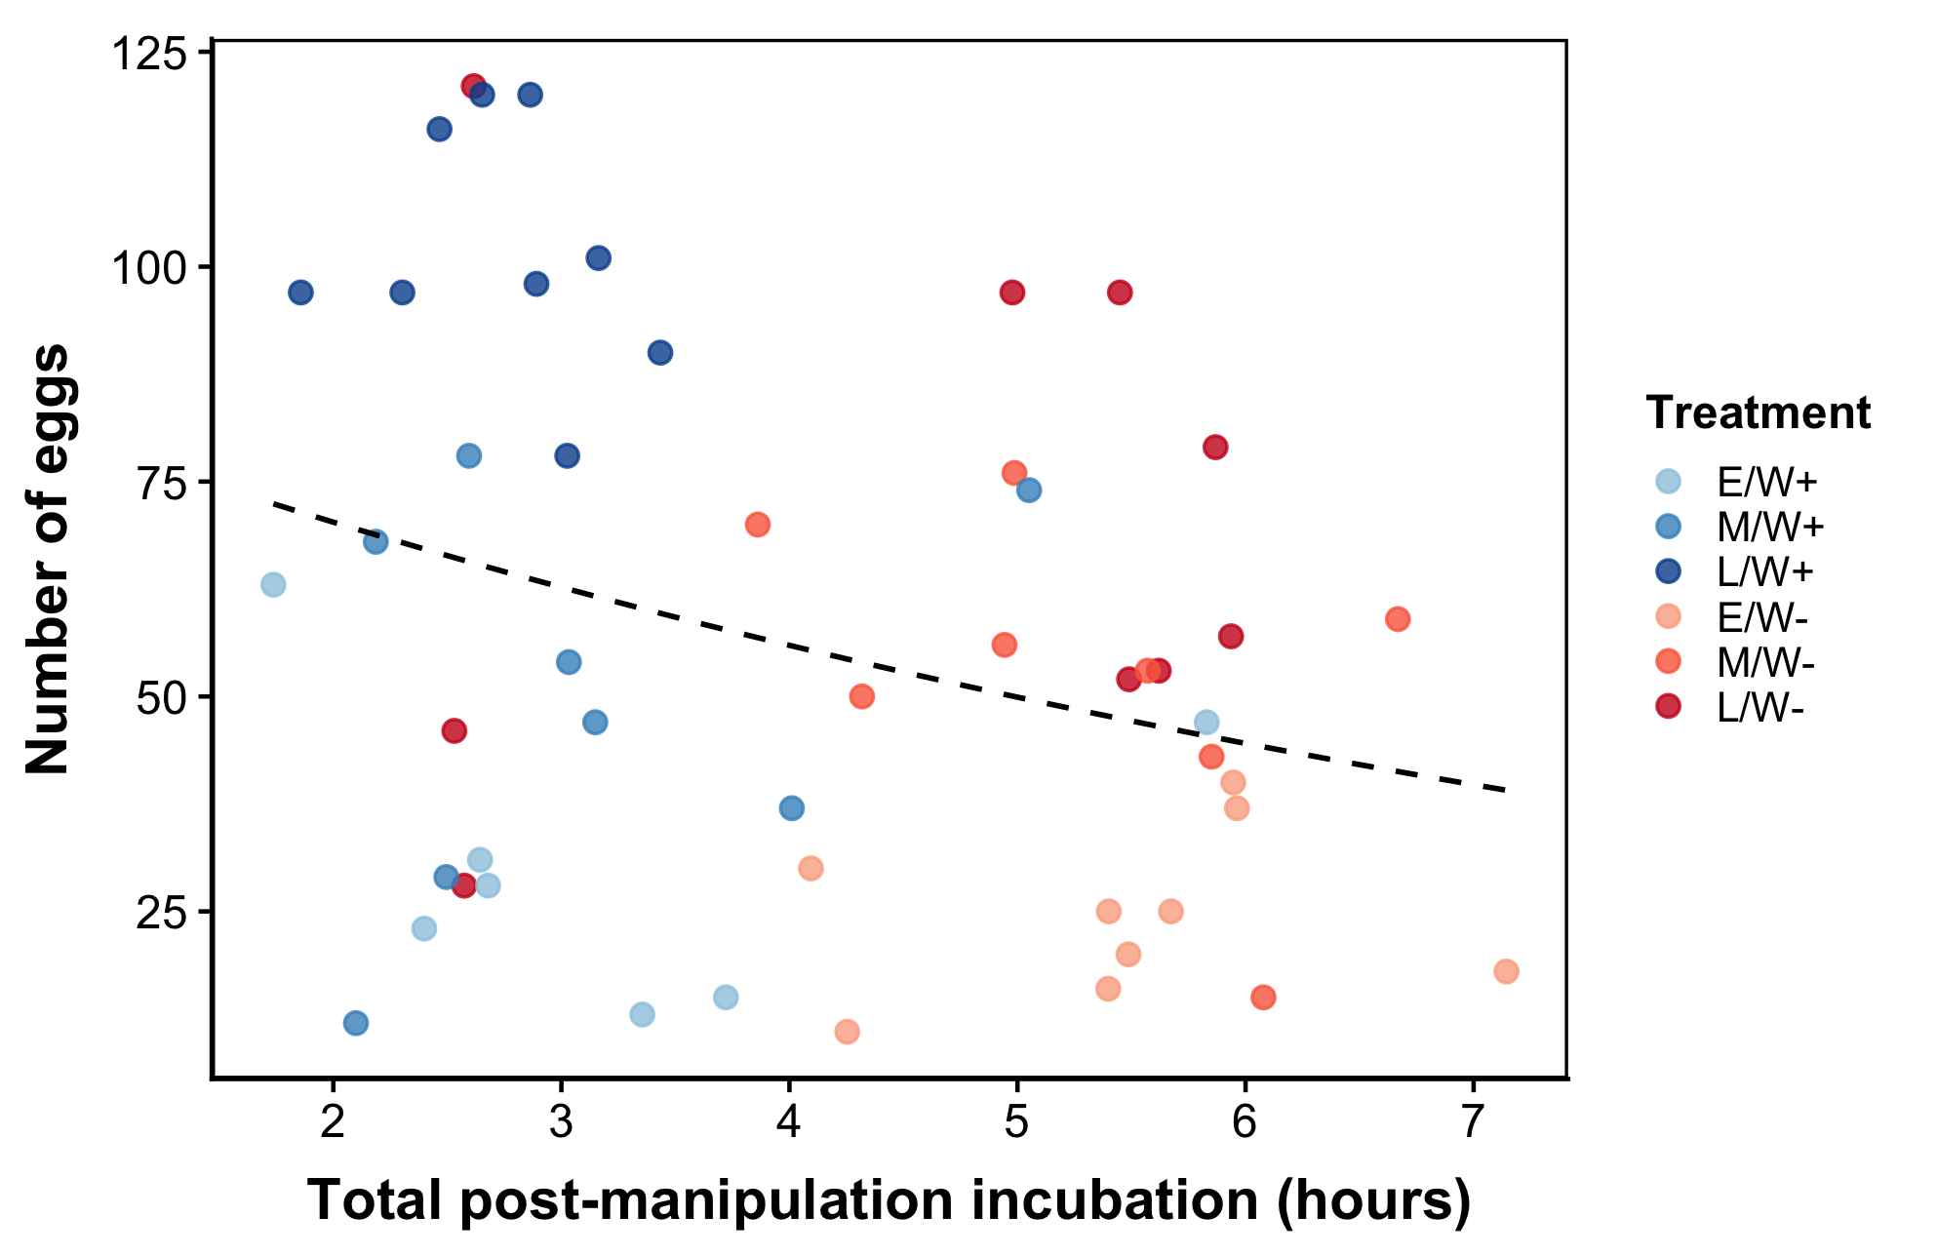
Supplementary Figure 9. No relationship between total post-manipulation incubation time and final egg production across colonies. Total incubation time is shown in hours on the x-axis, with the total number of eggs on the y-axis. Each point represents an individual queen, with colors indicating colony stage and treatment group. Treatment labels combine colony stage and worker condition: E/W+, M/W+, and L/W+ indicate control colonies with workers present at the early, middle, and later stages, respectively, whereas E/W−, M/W−, and L/W− indicate worker-removal colonies at the early, middle, and later stages, respectively. The dashed line represents the overall fitted trend across all queens.

Supplementary Tables:
INCUBATION FREQUENCY:  MIDDLE & LATER COLONIES |  | Control (W+) |  | Treatment (W-)
 |  | Pre | Post | Pre | Post
Control (W+) | Pre | - | M: p = 0.6359  L: p =1.000 | M: p = 0.30  L: p = 0.96 | M: p < 0.05  L: p < 0.05
Control (W+) | Post | M:p = 0.64  L: p =1.000 | - | M: p = 0.93  L: p < 0.05 | M: p < 0.01  L: p <0.05
Treatment (W-) | Pre | M: p = 0.30  L: p = 0.96 | M: p = 0.93  L: p < 0.05 | - | M: p < 0.001  L: p = 0.01
Treatment (W-) | Post | M: p < 0.05  L: p < 0.05 | M: p < 0.005  L: p < 0.05 | M: p < 0.001  L: p = 0.01 | -

Supplementary Table 1. Post-hoc comparisons for incubation frequency in the middle and later colony developmental stages. Values represent p-values comparing incubation frequency among control (W+) and worker-removal (W−) colonies across experimental phases. The early colony developmental stage is not included because post-hoc comparisons did not indicate phase-specific differences in incubation frequency; instead, treatment differences were observed across phases. Significant values are bolded within the table. Diagonal cells represent identical comparisons and are therefore not applicable.

Incubation by brood type:  EARLY, MIDDLE & LATER |  | Control (W+) |  |  |  | Treatment (W-)
 |  | Eggs | Younger larvae | Older larvae | Late-  stage brood | Eggs | Younger larvae | Older larvae | Late-  stage brood
Control (W+) | Eggs |  | E: 0.8377 | E: <0.05 | E: 0.2006 | E: 0.9316 | E: 0.5911 | E: <0.05 | E: 0.8776
Control (W+) | Eggs |  | M: 0.9971 | M: 1.000 | M: <0.001 | M: 0.5776 | M: 0.9852 | M: 0.9946 | M: <0.0001
Control (W+) | Eggs |  | L: 0.8382 | L: 0.9999 | L: 0.0066 | L: 0.9060 | L: 1.000 | L: 1.000 | L: < 0.001
Control (W+) | Younger  larvae | E: 0.8377 |  | E: 0.1686 | E: <0.01 | E: 1.0000 | E: 0.9316 | E: 0.0947 | E: 0.1763
Control (W+) | Younger  larvae | M: 0.9971 |  | M: 1.000 | M: <0.001 | M: 0.8444 | M: 0.7205 | M: 1.0000 | M: <0.0001
Control (W+) | Younger  larvae | L: 0.8382 |  | L: 0.8175 | L: <0.01 | L: 0.1360 | L: 0.1723 | L: 0.5570 | L: < 0.001
Control (W+) | Older larvae | E: <0.05 | E: 0.1686 |  | E: 0.0001 | E: 0.1835 | E: 0.5783 | E: 0.9316 | E: < 0.01
Control (W+) | Older larvae | M: 1.000 | M: 1.000 |  | M: <0.01 | M: 0.8436 | M: 0.9489 | M: 0.9999 | M: 0.0001
Control (W+) | Older larvae | L: 0.9999 | L: 0.8175 |  | L: <0.001 | L: 0.6114 | L: 0.9824 | L: 1.000 | L: <0.0001
Control (W+) | Late-stage brood | E: 0.2006 | E: <0.01 | E: 0.0001 |  | E: 0.1244 | E: < 0.01 | E: 0.0001 | E: 0.9316
Control (W+) | Late-stage brood | M: 0.0002 | M: <0.001 | M: <0.01 |  | M: 0.0708 | M: <0.0001 | M: 0.0017 | M: 0.9061
Control (W+) | Late-stage brood | L: 0.0066 | L: <0.01 | L: <0.001 |  | L: < 0.001 | L: < 0.0001 | L:< 0.0001 | L: 0.7169
Treatment (W-) | Eggs | E: 0.9316 | E: 1.0000 | E: 0.1835 | E: 0.1244 |  | E: 0.8377 | E: < 0.05 | E: 0.2006
Treatment (W-) | Eggs | M: 0.5776 | M: 0.8444 | M: 0.8436 | M: 0.0708 |  | M: 0.1496 | M: 0.9341 | M: <0.01
Treatment (W-) | Eggs | L: 0.9060 | L: 0.1360 | L: 0.6114 | L: <0.001 |  | L: 0.8958 | L: 0.7164 | L: <0.0001
Treatment (W-) | Younger  larvae | E: 0.5911 | E: 0.9316 | E: 0.5783 | E: <0.01 | E: 0.8377 |  | E: 0.1686 | E: <0.01
Treatment (W-) | Younger  larvae | M: 0.9852 | M: 0.7205 | M: 0.9489 | M: <0.0001 | M: 0.1496 |  | M: 0.7290 | M: <0.0001
Treatment (W-) | Younger  larvae | L: 1.000 | L: 0.1723 | L: 0.9824 | L: <0.0001 | L: 0.8958 |  | L: 0.9980 | L: <0.0001
Treatment (W-) | Older larvae | E: <0.05 | E: 0.0947 | E: 0.9316 | E: 0.0001 | E: < 0.05 | E: 0.1686 |  | E: 0.0001
Treatment (W-) | Older larvae | M: 0.9946 | M: 1.0000 | M: 0.9999 | M: 0.0017 | M: 0.9341 | M: 0.7290 |  | M: 0.0001
Treatment (W-) | Older larvae | L: 1.000 | L: 0.5570 | L: 1.000 | L: <0.0001 | L: 0.7164 | L: 0.9980 |  | L: <0.0001
Treatment (W-) | Late-stage brood | E: 0.8776 | E: 0.1763 | E: <0.01 | E: 0.9316 | E: 0.2006 | E: <0.01 | E: 0.0001
Treatment (W-) | Late-stage brood | M:<0.0001 | M: <0.0001 | M: 0.0001 | M: 0.9061 | M: <0.01 | M: <0.0001 | M: 0.0001
Treatment (W-) | Late-stage brood | L: <0.001 | L: <0.001 | L: <0.0001 | L: 0.7169 | L: <0.0001 | L: <0.0001 | L: <0.0001
Supplementary Table 2. Post-hoc comparisons for standardized incubation duration across brood types in the early, middle, and later colony developmental stages. Values represent p-values from emmeans pairwise comparisons of the proportion of cumulative post-manipulation incubation time allocated to each brood type, including eggs, younger larvae, older larvae, and late-stage brood. Comparisons are shown separately by colony developmental stage and treatment. Standardized incubation duration was calculated to account for variation among queens in total incubation time during the post-manipulation phase. Diagonal cells represent identical comparisons and are therefore not applicable.

Best-fitting models:
Incubation Frequency (L)
Model | T | EP | T:EP | df | AIC
Null | NA | NA | NA | 3 | 166.3
IncFreq1 | NA | + | NA | 4 | 164.2
IncFreq2 | + | NA | NA | 4 | 166.4
IncFreq3 | NA | NA | + | 5 | 164.1
IncFreq4 | NA | NA | * | 6 | 160.9

Included T i.e. Treatment type (W+ or W-), EP i.e. Experimental phase (pre- or post-manipulation time points) as fixed factors and natal colony as a random factor. The best model fitting our data was selected based on the Akaike’s Information Criterion (AIC). (+) parameters included in the model, and NA, not included parameters. The selected best model is given in bold.

Individual incubation event duration (L)
Model | T | EP | T:EP | df | AIC
Null | NA | NA | NA | 3 | 106.5
IncDur1 | NA | + | NA | 4 | 109.0
IncDur2 | + | NA | NA | 4 | 109.0
IncDur3 | NA | NA | + | 5 | 111.6
IncDur4 | NA | NA | * | 6 | 113.1

Included T i.e. Treatment type (W+ or W-), EP i.e. Experimental phase (pre- or post-manipulation time points) as fixed factors and natal colony as a random factor. The best model fitting our data was selected based on the Akaike’s Information Criterion (AIC). (+) parameters included in the model, and NA, not included parameters. The selected best model is given in bold.

Cumulative incubation duration (L)
Model | T | EP | T:EP | df | AIC
Null | NA | NA | NA | 3 | 329.4
IncDur1 | NA | + | NA | 4 | 324.5
IncDur2 | + | NA | NA | 4 | 328.7
IncDur3 | NA | NA | + | 5 | 323.1
IncDur4 | NA | NA | * | 6 | 315.1

Included T i.e. Treatment type (W+ or W-), EP i.e. Experimental phase (pre- or post-manipulation time points) as fixed factors and natal colony as a random factor. The best model fitting our data was selected based on the Akaike’s Information Criterion (AIC). (+) parameters included in the model, and NA, not included parameters. The selected best model is given in bold.

Incubation Frequency (M)
Model | T | EP | T:EP | df | AIC
Null | NA | NA | NA | 3 | 146.7
IncFreq1 | NA | + | NA | 4 | 145.7
IncFreq2 | + | NA | NA | 4 | 147.8
IncFreq3 | NA | NA | + | 5 | 146.9
IncFreq4 | NA | NA | * | 6 | 135.9

Included T i.e. Treatment type (W+ or W-), EP i.e. Experimental phase (pre- or post-manipulation time points) as fixed factors and natal colony as a random factor. The best model fitting our data was selected based on the Akaike’s Information Criterion (AIC). (+) parameters included in the model, and NA, not included parameters. The selected best model is given in bold.

Individual incubation event duration (M)
Model | T | EP | T:EP | df | AIC
Null | NA | NA | NA | 3 | 106.3
IncDur1 | NA | + | NA | 4 | 107.3
IncDur2 | + | NA | NA | 4 | 108.8
IncDur3 | NA | NA | + | 5 | 110.0
IncDur4 | NA | NA | * | 6 | 112.8

Included T i.e. Treatment type (W+ or W-), EP i.e. Experimental phase (pre- or post-manipulation time points) as fixed factors and natal colony as a random factor. The best model fitting our data was selected based on the Akaike’s Information Criterion (AIC). (+) parameters included in the model, and NA, not included parameters. The selected best model is given in bold.

Cumulative incubation duration (M)
Model | T | EP | T:EP | df | AIC
Null | NA | NA | NA | 3 | 287.8
IncDur1 | NA | + | NA | 4 | 286.1
IncDur2 | + | NA | NA | 4 | 285.0
IncDur3 | NA | NA | + | 5 | 283.0
IncDur4 | NA | NA | * | 6 | 272.0

Included T i.e. Treatment type (W+ or W-), EP i.e. Experimental phase (pre- or post-manipulation time points) as fixed factors and natal colony as a random factor. The best model fitting our data was selected based on the Akaike’s Information Criterion (AIC). (+) parameters included in the model, and NA, not included parameters. The selected best model is given in bold.

Incubation Frequency (S)
Model | T | EP | T:EP | df | AIC
Null | NA | NA | NA | 3 | 158.8
IncFreq1 | NA | + | NA | 4 | 160.4
IncFreq2 | + | NA | NA | 4 | 136.6
IncFreq3 | NA | NA | + | 5 | 138.0
IncFreq4 | NA | NA | * | 6 | 139.2

Included T i.e. Treatment type (W+ or W-), EP i.e. Experimental phase (pre- or post-manipulation time points) as fixed factors and natal colony as a random factor. The best model fitting our data was selected based on the Akaike’s Information Criterion (AIC). (+) parameters included in the model, and NA, not included parameters. The selected best model is given in bold.

Individual incubation event duration (S)
Model | T | EP | T:EP | df | AIC
Null | NA | NA | NA | 3 | 96.9
IncDur1 | NA | + | NA | 4 | 98.1
IncDur2 | + | NA | NA | 4 | 98.0
IncDur3 | NA | NA | + | 5 | 99.0
IncDur4 | NA | NA | * | 6 | 97.3

Included T i.e. Treatment type (W+ or W-), EP i.e. Experimental phase (pre- or post-manipulation time points) as fixed factors and natal colony as a random factor. The best model fitting our data was selected based on the Akaike’s Information Criterion (AIC). (+) parameters included in the model, and NA, not included parameters. The selected best model is given in bold.

Cumulative incubation duration(S)
Model | T | EP | T:EP | df | AIC
Null | NA | NA | NA | 3 | 290.0
IncDur1 | NA | + | NA | 4 | 281.7
IncDur2 | + | NA | NA | 4 | 283.2
IncDur3 | NA | NA | + | 5 | 274.6
IncDur4 | NA | NA | * | 6 | 271.8

Included T i.e. Treatment type (W+ or W-), EP i.e. Experimental phase (pre- or post-manipulation time points) as fixed factors and natal colony as a random factor. The best model fitting our data was selected based on the Akaike’s Information Criterion (AIC). (+) parameters included in the model, and NA, not included parameters. The selected best model is given in bold.

Incubation duration (standardized, L)
Model | T | B | T:B | df | AIC
Null | NA | NA | NA | 4 | 148.2
Brood1B | NA | + | NA | 7 | 96.8
Brood2CT | + | NA | NA | 5 | 148.7
Brood3+ | NA | NA | + | 8 | 97.6
Brood4* | NA | NA | * | 11 | 95.4

Included T i.e., Treatment type (W+ or W-), B i.e., Brood type (younger larvae, older larvae, late-stage brood) added as fixed factors and natal colony as a random factor. The best model fitting our data was selected based on the Akaike’s Information Criterion (AIC). (+) parameters included in the model, and NA, not included parameters. The selected best model is given in bold.

Incubation duration (standardized, M)
Model | T | B | T:B | df | AIC
Null | NA | NA | NA | 4 | 130.9
Brood2CT | + | NA | NA | 5 | 133.0
Brood3+ | NA | NA | + | 8 | 90.1
Brood4* | NA | NA | * | 11 | 90.4

Included T i.e., Treatment type (W+ or W-), B i.e., Brood type (younger larvae, older larvae, late-stage brood) added as fixed factors and natal colony as a random factor. The best model fitting our data was selected based on the Akaike’s Information Criterion (AIC). (+) parameters included in the model, and NA, not included parameters. The selected best model is given in bold.
Note: As an additive interaction may not be biologically relevant, the next best fit model (Brood4*) was used for the analysis.

Incubation duration (standardized, S)
Model | T | B | T:B | df | AIC
Null | NA | NA | NA | 4 | 152.8
Brood1B | NA | + | NA | 7 | 128.5
Brood2CT | + | NA | NA | 5 | 154.2
Brood3+ | NA | NA | + | 8 | 129.5
Brood4* | NA | NA | * | 11 | 131.1

Included T i.e., Treatment type (W+ or W-), B i.e., Brood type (younger larvae, older larvae, late-stage brood) added as fixed factors and natal colony as a random factor. The best model fitting our data was selected based on the Akaike’s Information Criterion (AIC). (+) parameters included in the model, and NA, not included parameters. The selected best model is given in bold. Best AIC score within one point and biologically relevant
Note: Because treatment is a central component of our experimental question, Brood1B, a model that included only brood type, may not fully address the biological hypotheses of this study.

Feeding events (L)
Model | T | EP | T:EP | df | AIC
Null | NA | NA | NA | 2 | 104.6
Feed1 | + | NA | NA | 3 | 105.9
Feed2 | NA | + | NA | 3 | 106.5
Feed3 | NA | NA | + | 5 | 109.9
Feed4 | NA | NA | * | 4 | 108.0

Included T i.e. Treatment type (W+ or W-), EP i.e. Experimental phase (pre- or post-manipulation time points) as fixed factors and natal colony as a random factor. The best model fitting our data was selected based on the Akaike’s Information Criterion (AIC). (+) parameters included in the model, and NA, not included parameters. The selected best model is given in bold.

Feeding events (M)
Model | T | EP | T:EP | df | AIC
Null | NA | NA | NA | 2 | 102.0
Feed1 | + | NA | NA | 3 | 100.3
Feed2 | NA | + | NA | 3 | 101.8
Feed3 | NA | NA | + | 5 | 101.3
Feed4 | NA | NA | * | 4 | 100.2

Included T i.e. Treatment type (W+ or W-), EP i.e. Experimental phase (pre- or post-manipulation time points) as fixed factors and natal colony as a random factor. The best model fitting our data was selected based on the Akaike’s Information Criterion (AIC). (+) parameters included in the model, and NA, not included parameters. The selected best model is given in bold.

Feeding events (S)
Model | T | EP | T:EP | df | AIC
Null | NA | NA | NA | 2 | 126.0
Feed1 | + | NA | NA | 3 | 126.6
Feed2 | NA | + | NA | 3 | 128.2
Feed3 | NA | NA | + | 5 | 130.4
Feed4 | NA | NA | * | 4 | 129.1

Included T i.e. Treatment type (W+ or W-), EP i.e. Experimental phase (pre- or post-manipulation time points) as fixed factors and natal colony as a random factor. The best model fitting our data was selected based on the Akaike’s Information Criterion (AIC). (+) parameters included in the model, and NA, not included parameters. The selected best model is given in bold.

Total Brood
Model | C | T | C:T | df | AIC
Null | NA | NA | NA | 3 | 618.5
Brood1 | + | NA | NA | 5 | 526.2
Brood2 | NA | + | NA | 4 | 620.6
Brood 3 | NA | NA | + | 6 | 528.4
Brood4 | NA | NA | * | 8 | 533.7

Included C i.e. Colony developmental size (E, M, or L) and T i.e. Treatment type (W+ or W-), as fixed factors and queen ID as a random factor. The best model fitting our data was selected based on the Akaike’s Information Criterion (AIC). (+) parameters included in the model, and NA, not included parameters. The selected best model is given in bold.

Incubation vs. Eggs
Model | R | df | AIC
Null | NA | 3 | 488.5
EggsInc | + | 4 | 490.9

Included R i.e. Residuals of incubation and treatment as a fixed factor and natal colony as a random factor. The best model fitting our data was selected based on the Akaike’s Information Criterion (AIC). (+) parameters included in the model, and NA, not included parameters. The selected best model is given in bold.

Number of Eggs (L)
Model | T | df | AIC
Null | NA | 3 | 174.6
Eggs | + | 4 | 171.4
Included T i.e. Treatment type (W+ or W-), as fixed factors and natal colony as a random factor. The best model fitting our data was selected based on the Akaike’s Information Criterion (AIC). (+) parameters included in the model, and NA, not included parameters. The selected best model is given in bold.

Number of Eggs (M)
Model | T | df | AIC
Null | NA | 3 | 152.2
Eggs | + | 4 | 155.8
Included T i.e. Treatment type (W+ or W-), as fixed factors and natal colony as a random factor. The best model fitting our data was selected based on the Akaike’s Information Criterion (AIC). (+) parameters included in the model, and NA, not included parameters. The selected best model is given in bold.

Number of Eggs (S)
Model | T | df | AIC
Null | NA | 3 | 125.0
Eggs | + | 4 | 128.6
Included T i.e. Treatment type (W+ or W-), as fixed factors and natal colony as a random factor. The best model fitting our data was selected based on the Akaike’s Information Criterion (AIC). (+) parameters included in the model, and NA, not included parameters. The selected best model is given in bold.

Number of Non-Egg Brood (L)
Model | T | df | AIC
Null | NA | 3 | 203.9
N-E Brood | + | 4 | 207.2
Included T i.e. Treatment type (W+ or W-), as fixed factors and natal colony as a random factor. The best model fitting our data was selected based on the Akaike’s Information Criterion (AIC). (+) parameters included in the model, and NA, not included parameters. The selected best model is given in bold.

Number of Non-Egg Brood (M)
Model | T | df | AIC
Null | NA | 3 | 162.5
N-E Brood | + | 4 | 165.7
Included T i.e. Treatment type (W+ or W-), as fixed factors and natal colony as a random factor. The best model fitting our data was selected based on the Akaike’s Information Criterion (AIC). (+) parameters included in the model, and NA, not included parameters. The selected best model is given in bold.

Number of Non-Egg Brood (S)
Model | T | df | AIC
Null | NA | 3 | 142.9
N-E Brood | + | 4 | 146.5
Included T i.e. Treatment type (W+ or W-), as fixed factors and natal colony as a random factor. The best model fitting our data was selected based on the Akaike’s Information Criterion (AIC). (+) parameters included in the model, and NA, not included parameters. The selected best model is given in bold.

Baseline incubation frequency (Post/W+)
Model | G | df | AIC
Null | NA | 3 | 80.9
Freq | + | 4 | 85.9
Included colony developmental stages (E, M, L), as fixed factors and natal colony as a random factor. The best model fitting our data was selected based on the Akaike’s Information Criterion (AIC). (+) parameters included in the model, and NA, not included parameters. The selected best model is given in bold.

Baseline average incubation duration per event (Post/W+)
Model | G | df | AIC
Null | NA | 3 | 68.4
IncDur | + | 4 | 71.2
Included colony developmental stages (E, M, L), as fixed factors and natal colony as a random factor. The best model fitting our data was selected based on the Akaike’s Information Criterion (AIC). (+) parameters included in the model, and NA, not included parameters. The selected best model is given in bold.

Baseline cumulative incubation duration (Post/W+)
Model | G | df | AIC
Null | NA | 3 | 249.0
IncDur | + | 5 | 253.9
Included colony developmental stages (E, M, L), as fixed factors and natal colony as a random factor. The best model fitting our data was selected based on the Akaike’s Information Criterion (AIC). (+) parameters included in the model, and NA, not included parameters. The selected best model is given in bold.

Change in proportion of time (incubation)
Model | G | T | G:T | df | AIC
Null | NA | NA | NA | 3 | 3.1
Prop1 | + | NA | NA | 5 | 7.6
Prop2 | NA | + | NA | 4 | -26.3
Prop3 | NA | NA | + | 6 | -22.2
Prop4 | NA | NA | * | 8 | -17.7

Included T i.e. Treatment type (W+ or W-), G i.e. Colony developmental stages (E, M, or L) as fixed factors and natal colony as a random factor. The best model fitting our data was selected based on the Akaike’s Information Criterion (AIC). (+) parameters included in the model, and NA, not included parameters. The selected best model is given in bold.

Model Descriptions:

Model Description | Response | Factors | Estimate | Std. Error | Z or T value | P-value | AIC
Incubation frequency (L) | Events per hour | Experimental phase/Treatment:  (Post-manipulation,  L/W-,  Post-manipulation: L/W-)  +Random factor “natal colony” | -0.0378  -0.4445  3.1656 | 0.8665  0.8665  1.2254 | -0.044  -0.513  2.583 | 0.96521  0.60800  0.00979 | 160.9
Individual incubation event duration (L) | NA | NA | NA | NA | NA | NA | NA
Cumulative incubation duration (L) | Hours 4–5 (pre) vs 19–20 (post) totals | Experimental phase/Treatment:  (Post-manipulation,  L/W-,  Post-manipulation: L/W-)  +Random factor “natal colony” | -0.1034  -5.8744  37.2901 | 7.2905  7.3778  10.3103 | -0.014  -0.796  3.617 | 0.98868  0.42590  0.00030 | 315.1
Incubation frequency (M) | Events per hour | Experimental phase/Treatment:  (Pre-manipulation,  M/W-,  Pre-manipulation: M/W-)  +Random factor “natal colony” | 0.9500  3.2788  -4.7163 | 0.7956  0.7956  1.1251 | 1.194  4.121  -4.192 | 0.232  3.77e-05  2.77e-05 | 135.9
Individual incubation event duration (M) | NA | NA | NA | NA | NA | NA | NA
Cumulative incubation duration (M) | Hours 4–5 (pre) vs 19–20 (post) totals | Experimental phase/Treatment:  (Post-manipulation,  M/W-,  Post-manipulation: M/W-)  +Random factor “natal colony” | -6.570  -6.421  46.071 | 7.524  7.981  10.844 | -0.873  -0.805  4.249 | 0.383  0.421  2.15e-05 | 272.0
Incubation frequency (M) | Events per hour | Treatment:  (S/W-)  +Random factor “natal colony” | 0.51782 | 0.08399 | 6.165 | 7.05e-10 | 136.6
Individual incubation event duration (S) | NA | NA | NA | NA | NA | NA | NA
Cumulative incubation duration (S) | Hours 4–5 (pre) vs 19–20 (post) totals | Experimental phase/Treatment:  (Post-manipulation,  S/W-,  Post-manipulation: S/W-)  +random factor “natal colony” | 0.10537  0.11718  0.38823 | 0.11487  0.11253  0.15304 | 0.92  1.04  2.54 | 0.3590  0.2978  0.0112 | 271.8
Incubation duration (standardized, L) | Brood type | Brood type present in nest/Treatment:  (younger larvae,  older larvae,  late-stage brood,  treatment (W-),  younger larvae: W-,  older larvae: W-,  late-stage brood: W-)  +random factor “natal colony” | 0.9561  0.3129  2.5490  -1.2429  0.1471  1.0971  2.2017 | 0.6636  0.7100  0.6997  0.9701  1.0569  1.0729  1.1295 | 1.441  0.441  3.643  -1.281  0.139  1.023  1.949 | 0.14962  0.65949  0.00027  0.20012  0.88930  0.30654  0.05126 | 95.4
Incubation duration (standardized, M) | Brood type | Brood type present in nest/Treatment:  (younger larvae,  older larvae,  late-stage brood,  treatment (W-),  younger larvae: W-,  older larvae: W-,  late-stage brood: W-)  +random factor “natal colony” | 0.3301  0.1650  2.4625  0.9634  -1.8319  -0.7379  -0.2172 | 0.4729  0.5816  0.5552  0.5176  0.7427  0.7568  0.7777 | 0.698  0.284  4.436  1.861  -2.467  -0.975  -0.279 | 0.48506  0.77668  9.19e-06  0.06267  0.01364  0.32951  0.78004 | 90.4
Incubation duration (standardized, S) | Brood type | Brood type present in nest+Treatment:  (younger larvae,  older larvae,  late-stage brood,  treatment (W-))  +random factor “natal colony” | -0.55379  -2.31390  1.09776  -0.37462 | 0.38406  0.71684  0.44132  0.31169 | -1.442  -3.228  2.487  -1.202 | 0.14932  0.00125  0.01287  0.22940 | 129.5
Feeding events (L) | NA | NA | NA | NA | NA | NA | NA
Feeding events (M) | Total feeding counts across hours 4–5 (pre) vs 19–20 (post) | Experimental phase + Treatment:  (M/W-,  Post-manipulation)  +random factor “natal colony” | -0.6526  -0.4990 | 0.3318  0.3075 | -1.967  -1.623 | 0.04919  0.10461 | 100.2
Feeding events (S) | NA | NA | NA | NA | NA | NA | NA
Total brood | Total # brood | Colony Dev. Stage:  M,  L,  +random factor “queen ID” | 0.80026  1.55419 | 0.11036  0.10392 | 7.25  14.96 | 4.13e-13  < 2e-16 | 526.2
Number of total eggs and incubation | NA | NA | NA | NA | NA | NA | NA
Number of eggs (L) | Total # of eggs | Treatment:  Worker removal (W-) | -0.32537 | 0.11717 | -2.78 | 0.00549 | 171.4
Number of eggs (M) | NA | NA | NA | NA | NA | NA | NA
Number of eggs (S) | NA | NA | NA | NA | NA | NA | NA
Number of non-egg brood (L) | NA | NA | NA | NA | NA | NA | NA
Number of non-egg brood (M) | NA | NA | NA | NA | NA | NA | NA
Number of non-egg brood (S) | NA | NA | NA | NA | NA | NA | NA
Baseline incubation frequency (Post/W+) | NA | NA | NA | NA | NA | NA | NA
Baseline cumulative incubation duration (Post/W+) | NA | NA | NA | NA | NA | NA | NA
Baseline average incubation duration per event (Post/W+) | NA | NA | NA | NA | NA | NA | NA
Change in proportion of time (incubation) | Post-Pre in incubation | Treatment:  Worker removal (W-) | 0.32013 | 0.04695 | 6.819 | 9.18e-12 | -26.3

