Supporting Information for

TASTET: a Python package for geometry-driven selection of representative atomistic structures from large configurational spaces

Alejandro Cañete-Archéª, Ana McGinleyª, Pablo Castro-Latorre^{b}, Graeme W. Watsonª, and Max García-Melchor ^{a,b,c,*}

ªSchool of Chemistry, Trinity College Dublin, College Green, D02 PN40, Dublin, Ireland.

^{b}Center for Cooperative Research on Alternative Energy (CIC energiGUNE), Basque Research and Technology Alliance (BRTA), 01510 Vitoria-Gasteiz, Spain.

^{c}IKERBASQUE, Basque Foundation for Science, 48009 Bilbao, Spain

E-mail: maxgarcia@cicenergigune.com

Table of Contents

Case study 1: Conformational landscape exploration 2

Candidate structure generation 2

Configurational representation and hyperparameter selection 3

Additional selection strategies 9

DFT computational details 12

Case study 2: Supported nanocluster configurational exploration 12

Candidate structure generation 12

Configurational representation and hyperparameter selection 14

DFT computational details 16

References 17

Case study 1: Conformational landscape exploration

Candidate structure generation

The initial conformational ensemble was generated using the genetic algorithm implemented in OpenBabel¹. The algorithm employs an elitist selection scheme with a mutation probability of 0.2 and scores candidate structures according to their root-mean-square deviation (RMSD), thereby promoting structural diversity within the generated ensemble. Individual genetic-algorithm runs were considered converged when the population remained unchanged for five consecutive generations. OpenBabel was selected because the resulting conformers preserve the molecular bonding geometry while sampling the accessible conformational degrees of freedom. This feature is particularly advantageous for the subsequent SOAP-based analysis because structural differences across the ensemble arise predominantly from conformational rearrangements rather than variations in local bond lengths.

To ensure that conformer generation sampled the chemically relevant degrees of freedom of the Rh complex, the molecular connectivity assigned to the ligand was modified before sampling. Specifically, the bond-order pattern was adjusted so that the P–C(aryl) bonds were treated as rotatable, whereas the C(aryl)–O(Me) bonds were assigned double-bond character to prevent the methoxy substituents from being sampled as independently rotatable groups in the presence of the neighboring bulky tert-butyl substituents (Fig. S1a). The methoxy orientations could nevertheless vary through rotation of the corresponding aryl rings. This treatment reproduces the conformational degrees of freedom identified in previous studies of this system². The modified connectivity was used exclusively for conformer generation and was not retained during the subsequent DFT calculations.

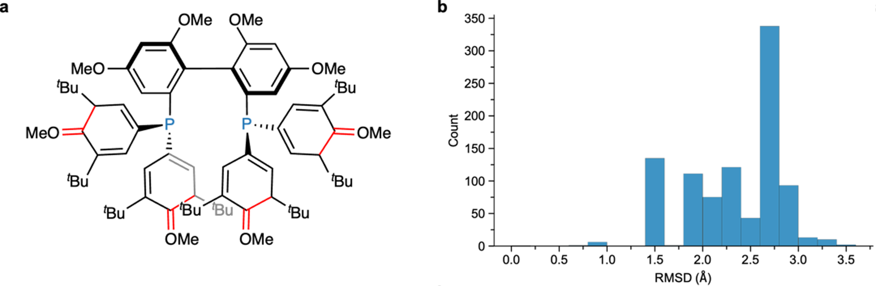
Fig. S1. Conformer generation and structural diversity of the Rh-complex ensemble. a Ligand connectivity used to sample the relevant conformational degrees of freedom, with red bonds indicating modified connectivity assignments. b Distribution of heavy-atom RMSD values for the 949 OpenBabel-generated conformers relative to the initial input structure, using a bin width of 0.20 Å and treating identical tert-butyl groups as equivalent.

A single genetic-algorithm run typically generated approximately 120 conformers, which was insufficient to provide adequate coverage of the conformational space associated with the nine rotatable bonds. Multiple independent runs were therefore performed from the same initial structure, and the resulting conformers were progressively combined. Additional runs were carried out until no new structure differing by more than 0.5 Å RMSD from the accumulated ensemble was generated, a criterion reached after 11 runs. Exact duplicates were subsequently removed using an RMSD threshold of 10^{–6} Å, yielding a final ensemble of 949 conformers.

The structural diversity of the resulting ensemble was assessed from the heavy-atom RMSD of each conformer relative to the initial input structure, with identical tert-butyl groups treated as equivalent (Fig. S1b). RMSD values range from approximately 0.8 to 3.4 Å, with most conformers lying between 2.5 and 3.0 Å from the initial structure. This broad distribution confirms that the conformer-generation procedure samples configurations substantially displaced from the starting geometry and provides a structurally diverse ensemble for subsequent representative selection.

Configurational representation and hyperparameter selection

Unsupervised hyperparameter selection

Because no reliable energetic or target-property information was available before the first round of DFT calculations, the initial configurational representation was optimized using the unsupervised strategy described in the Methods section. Candidate representations were evaluated from their distributions of kernel-induced pairwise distances, with the aim of identifying a representation that provides sufficient resolution to distinguish structurally different regions of the conformational ensemble without mapping most structures to either nearly identical or effectively unrelated points in kernel space.

For each candidate representation, TASTET therefore evaluates the distribution of pairwise kernel distances across the conformational ensemble. Broad or multimodal distributions can indicate that the representation resolves multiple structurally distinct regions, whereas distributions concentrated within a narrow distance range provide comparatively little discrimination among conformers. These characteristics were treated as indicators of structural resolution rather than absolute optimization criteria because the shape of the distance distribution alone does not establish whether the resolved structural differences are chemically or energetically meaningful. In the absence of reliable target properties, however, this analysis provides a practical basis for comparing candidate representations before representative sampling.

The hyperparameter search considered the following components:

- SOAP hyperparameters. SOAP descriptors were constructed using Gaussian radial basis functions, with the cutoff radius, $r_{cut}$, and Gaussian width, $σ$, varied across the search space. The radial and angular basis sizes were fixed at $n_{max}=l_{max}=$ 8.

- SOAP centers. Different sets of atomic centers were considered to define the local environments included in the representation.
- Local similarity kernel. SOAP feature vectors $p_{a}$ and $p_{b}$ were compared using either a linear kernel,

$$\begin{aligned}p_{a}^{⊤}p_{b}\#\left(S1\right)\end{aligned}$$

or a radial basis function (RBF) kernel,

$$\begin{aligned}\exp\left[-γ{\left\|p_{a}-p_{b}\right\|}^{2}\right]\#\left(S2\right)\end{aligned}$$

For the RBF kernel, $γ$ was determined dynamically for each representation using the median heuristic,

$$\begin{aligned}γ=\frac{1}{2,{{median}_{a<b}\left\|p_{a}-p_{b}\right\|}^{2}}\#\left(S3\right)\end{aligned}$$

- Global kernel. Local environment similarities were aggregated at the structure level using either an average kernel or a REMatch kernel with $λ_{REMatch}=$ 0.5.

Because the Rh complex contains 214 atoms and the conformational ensemble comprises 949 structures, constructing and systematically optimizing representations centered on all atoms would be computationally prohibitive. We therefore defined chemically motivated subsets of atomic centers that capture the principal regions of conformational variability while reducing the computational cost of the hyperparameter search. Two alternative representations were considered for the initial unsupervised optimization (Fig. S2).

The first provides a single-channel baseline in which the SOAP environment is centered exclusively on the Rh atom and therefore describes structural variation around the coordination center. The second uses the multi-channel formulation introduced in the Methods section and separates the complex into core and peripheral regions. The core channel describes the Rh coordination environment using centers located on the Rh atom, the coordinating ligand P atoms, and the substrate C and O atoms. The periphery channel describes conformational variation in the outer ligand environment using centers located on the ligand carbon atoms bearing the methoxy substituents. The corresponding structure-level kernels, $K_{core}$ and $K_{periphery}$, were combined through their element-wise product so that structural similarity requires agreement across both regions of the complex. The complete hyperparameter search space for the two representations is summarized in Table S1.
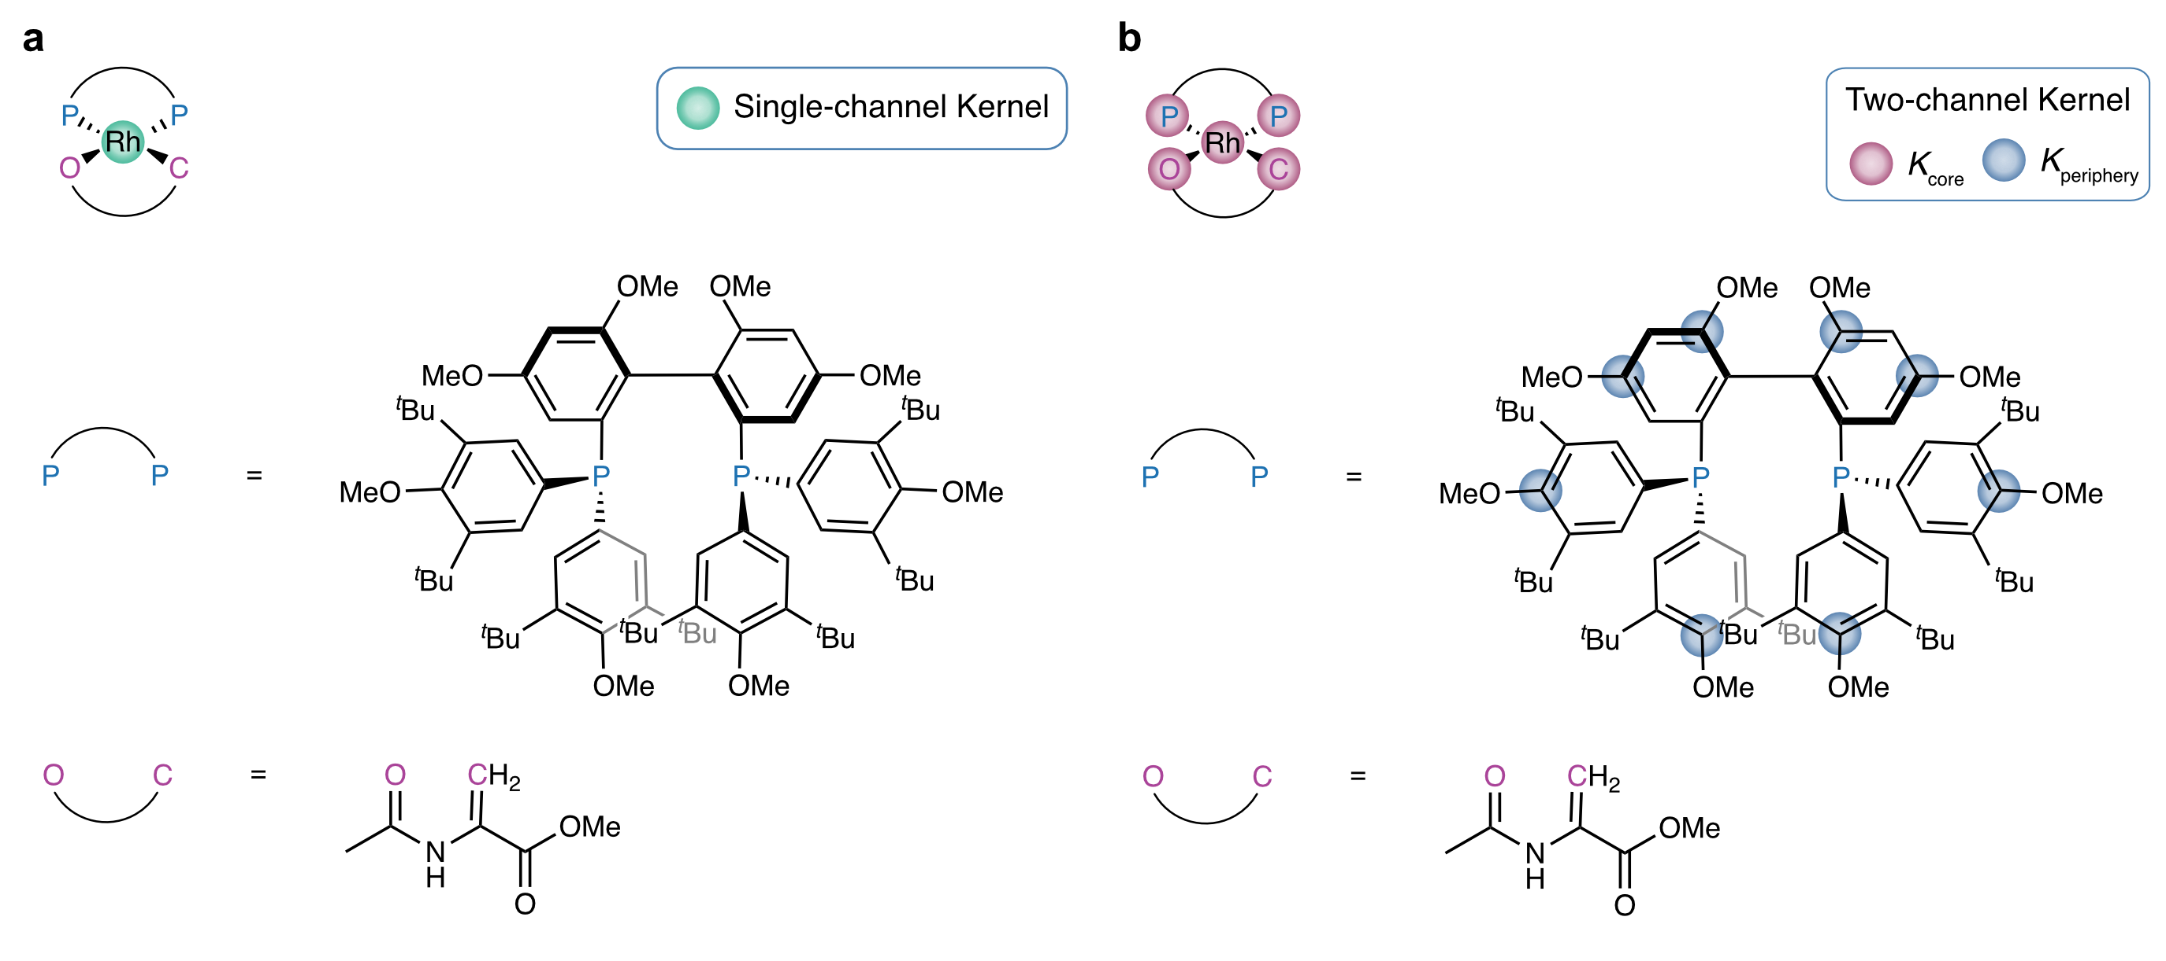
Fig. S2. SOAP centers used to construct the configurational representations of the Rh complex. a Single-channel baseline representation defined by a SOAP environment centered on the Rh atom. b Two-channel representation separating the complex into core and peripheral environments, with the corresponding structure-level kernels combined through the element-wise product $K_{core}∘K_{periphery}$. Pink and blue markers indicate the atomic centers included in the core and periphery channels, respectively.

Table S1. Hyperparameter search space for the single- and two-channel kernel representations. The SOAP basis was fixed at $n_{max}=l_{max}=$ 8 in all cases.

Parameter | Single-channel kernel | Two-channel product kernel
Global kernel | Average | Core: Average; Periphery: Average or REMatch
Local similarity kernel | Linear or RBF | Linear, RBF
$r_{cut}$ (Å) | 4.0, 5.0, 6.0, 7.0, 8.0, 9.0 | 2.0, 3.0, 4.0, 5.0
$σ$ (Å) | 0.1, 0.3, 0.5 | 0.1, 0.5
Structures used | Full ensemble | Subsample of 100 structures

The grid search comprised 36 candidate representations for the single-channel formulation and 256 for the two-channel formulation. Candidate representations were initially compared using the shape of their kernel-distance distributions, with particular attention to the number of resolved modes (peaks) and the overall spread of the distribution. Histogram bin widths were estimated using Scott’s normal reference rule:

$$\begin{aligned}W=\frac{3.49×σ}{N^{1/3}} \#\left(S4\right)\end{aligned}$$

where $σ$ is the standard deviation of the pairwise distances and $N$ is the number of distance values. This procedure yielded a bin width of approximately 0.01.

A kernel-density-estimation (KDE) bandwidth of 0.01 was subsequently adopted to provide a comparable visualization of the distributions across the candidate representations. Fig. S3 shows the distributions obtained for the selected single- and two-channel representations.

The single-channel representation was:

$$\begin{aligned}K_{\text{RBF}}^{\text{Average}}\left(r_{cut}=4.0, σ=0.1 | γ=458.62\right)\#\left(S5\right)\end{aligned}$$

whereas the selected two-channel representation was:

$$\begin{aligned}K_{\text{RBF}}^{\text{Average}}\left(r_{cut}=3.0, σ=0.1 | γ=0.25\right) ∘ \\ K_{\text{RBF}}^{\text{REMatch}}\left(r_{cut}=2.0, σ=0.5 \left| γ=26.21 \right| λ_{REMatch}=0.5\right)\#\left(S6\right)\end{aligned}$$

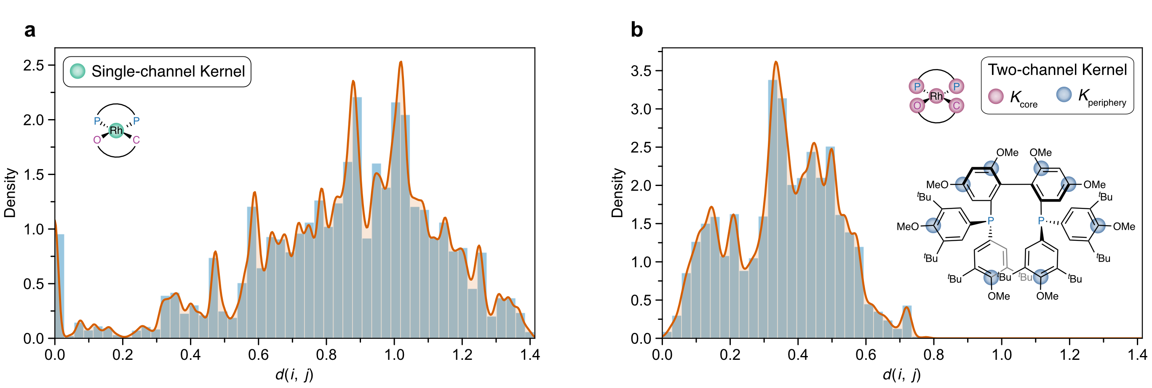
Fig. S3. Pairwise kernel-distance distributions for the representations selected from the unsupervised hyperparameter search. a Single-channel Rh-centered representation using an average global kernel and an RBF local kernel. b Two-channel product representation combining an average core kernel with a REMatch periphery kernel. Histograms are shown together with KDE curves calculated using a bandwidth of 0.01.

At first glance, the single-channel representation appears to provide greater structural resolution. Its kernel-distance distribution spans almost the full theoretical range, approaching $\sqrt{2}≈1.41$, whereas the two-channel representation remains below approximately $0.79$ and exhibits fewer distinct modes. Closer inspection, however, shows that this apparent increase in diversity arises from the interaction between the median heuristic and the underlying SOAP feature space rather than from a more informative description of the conformational ensemble, as discussed below.

The single-channel representation describes the Rh complex using a single SOAP environment centered on the Rh atom, with $r_{cut}=$ 4.0 Å and a narrow Gaussian width of $σ=$ 0.1 Å. Because this cutoff is less than half the approximate 9 Å distance from Rh to the outermost ligand atom, the descriptor probes only the immediate coordination environment of the metal and does so with high spatial resolution. Across the 949 conformers, these Rh-centered environments are nearly indistinguishable, as reflected in the median squared distance in the raw SOAP feature space,

$$\begin{aligned}\text{median}\left(D^{2}\right)=\frac{1}{2γ}=\frac{1}{2×458.62}≈1.1×{10}^{-3}\#\left(S7\right)\end{aligned}$$

which corresponds to a median cosine similarity of approximately 0.995. The median heuristic therefore assigns a very large inverse length scale, $γ≈$458.62, which strongly amplifies otherwise minute differences between the Rh-centered environments. As a result, small local geometric fluctuations are mapped to large distances in kernel space, pushing much of the distribution toward the theoretical upper limit. The broad, high-variance tail of the single-channel representation therefore reflects amplified local variations around the metal center rather than meaningful conformational diversity across the entire complex.

The two-channel representation behaves differently because the selected environments probe structurally distinct and more informative regions of the complex. Each channel remains independently scaled using the same median heuristic, but the underlying SOAP environments are substantially better separated before kernel transformation. The core channel is defined by five centers distributed across the complex core, with $r_{cut}=$ 3.0 Å and $σ=$ 0.1 Å. For this channel,

$$\begin{aligned}median\left(D^{2}\right)=\frac{1}{\left(2×0.25\right)}≈2.00\#\left(S8\right)\end{aligned}$$

corresponding to substantially more distinct local environments and yielding a comparatively small inverse length scale of $γ≈$ 0.25. The resulting similarities therefore vary smoothly across the conformational ensemble rather than being dominated by the amplification of near-degenerate local environments.

The periphery channel, defined by eight centers distributed over the outer ligand region with $r_{cut}=$ 2.0 Å and $σ=$ 0.5 Å, occupies an intermediate regime, with $\text{median}\left(D^{2}\right)≈$0.02 and $γ≈$26.21. Although the individual cutoff radii are relatively short, the thirteen centers distributed across the two channels collectively capture conformational variation through the Rh complex. The resulting product kernel therefore provides a more balanced and chemically meaningful representation than the single Rh-centered description, while avoiding the artificial amplification of nearly degenerate local fluctuations. This two-channel representation was consequently selected for the first round of representative sampling.

Supervised hyperparameter selection

Following DFT relaxation of the 28 conformers selected during the first sampling round, their energies provided a target property with which to refine the configurational representation. The two-channel representation was therefore reoptimized using the supervised procedure described in the Methods section, with candidate kernels evaluated by their CKA with the DFT energy vector. The grid search comprised 256 combinations, spanning the same descriptor and kernel parameters considered for the initial two-channel representation. Fig. S4 shows four representative heatmaps from this search.

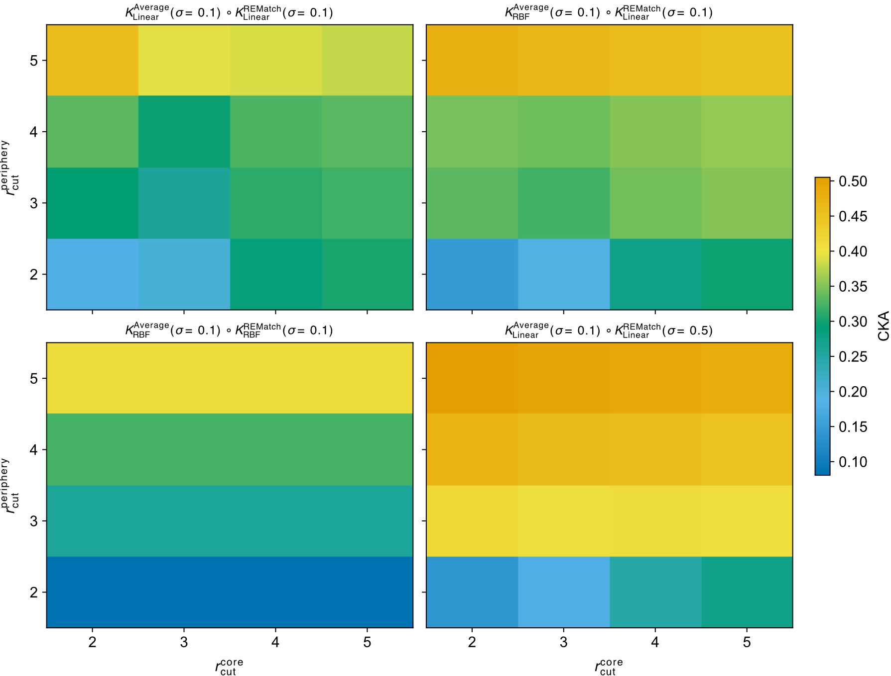
Fig. S4. CKA-guided optimization of the two-channel SOAP product-kernel representation. Heatmaps show the CKA between each candidate kernel and the DFT energies of the 28 conformers selected and relaxed during the first sampling round. The horizontal and vertical axes correspond to the cutoff radii of the core and periphery SOAP descriptors, respectively. Each panel shows a different combination of local kernel type and SOAP Gaussian width for the two channels. Colors indicate CKA on a common scale.

The resulting CKA values range from 0.08 to 0.51, demonstrating substantial sensitivity of the structure–energy alignment to the choice of descriptor and kernel hyperparameters. The highest-performing representation achieved a CKA of 0.51, corresponding to a more than two-fold increase relative to the initial unsupervised representation (CKA = 0.20). The selected representation was

$$\begin{aligned}K_{\text{Linear}}^{\text{Average}}\left(r_{cut}=2.0, σ=0.1 \right) ∘ K_{\text{Linear}}^{\text{REMatch}}\left(r_{cut}=5.0, σ=0.5 | λ_{REMatch}=0.5\right)\#\left(S9\right)\end{aligned}$$

Relative to the initial representation (Eq. S6), both channels therefore favor linear local kernels, while the core cutoff decreases from 3.0 to 2.0 Å and the periphery cutoff increases from 2.0 to 5.0 Å. This change indicates that improved alignment with the DFT energetics is obtained by combining a more localized description of the Rh coordination environment with a more extended description of the ligand periphery. The resulting representation was used for the subsequent structure–energy-informed sampling strategies described in the main text.

Additional selection strategies

Following supervised refinement of the configurational representation, the remaining 19 structures required to complete the predefined 5% DFT budget were selected using three complementary strategies, as described in the main text. Regional refinement within a user-defined region of the energy-colored configurational landscape is shown in Fig. 2c of the main text. Fig. S5 presents the two alternative strategies based on global and local sampling of the CKA-refined kernel space.

For global exploration, FPS was reapplied to the full 949-conformer ensemble using the CKA-refined representation, yielding 19 additional structures distributed across the configurational landscape (Fig. S5a). This strategy preserves the space-filling character of the initial selection while incorporating the structure–energy information obtained from the first round of DFT calculations into the representation used for sampling.

At the opposite scale, local exploration was performed by selecting the 19 nearest neighbors of a single conformer of interest directly in the unprojected CKA-refined kernel space (Fig. S5b). The reference (blue marker within a black circle) was the starting geometry associated with the DFT global minimum identified during the first sampling round. Because this structure underwent rearrangement during DFT relaxation, the selected neighborhood reflects similarity among the initial conformer geometries rather than among the corresponding DFT-relaxed structures. The kPCA projection in Fig. S5b is therefore used only to visualize the selected neighborhood, whereas nearest-neighbor identification was performed in the full kernel-induced configurational space.

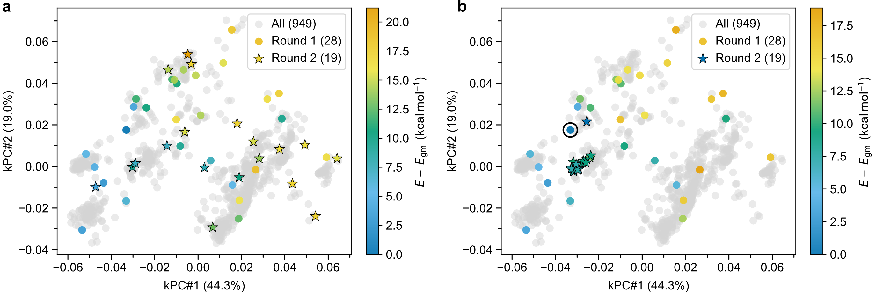
Fig. S5. Alternative second-round conformer-selection strategies for the Rh-complex case study. Two-dimensional kPCA projections of the CKA-refined configurational representation obtained after the first round of DFT calculations. Gray points denote the full ensemble of 949 conformers, colored circles denote the 28 conformers selected by FPS and relaxed with DFT during the first round, and colored stars denote the 19 additional conformers selected during the second round. Colors indicate DFT energies relative to the global minimum, $E-E_{gm}$. a Global exploration, in which FPS was reapplied to the full conformer ensemble using the CKA-refined representation. b Local exploration, in which the 19 nearest neighbors of the starting geometry associated with the DFT global minimum were selected directly in the unprojected kernel space. The black circle identifies the reference conformer used to define the local neighborhood.

For comparison with the structure-based selection, we also applied a conventional low-level energy-ranking strategy to the same conformational ensemble, using UFF energies to prioritize structures for subsequent DFT calculations. All 949 initial conformers were relaxed with UFF³ using OpenBabel and ranked according to their resulting energies. For the predefined budget of 25 DFT calculations, the 25 lowest-energy UFF conformers were selected, corresponding to a very permissive energy window of 54 kcal mol^{–1} relative to the UFF global minimum. Their UFF-relaxed geometries were then used as starting structures for DFT relaxation, consistent with conventional workflows in which geometries optimized at a lower level of theory are carried forward for higher-level calculations. The resulting UFF and DFT energies are reported in Table S2.

Table S2. Relative UFF and corresponding DFT energies of the 25 conformers selected by UFF energy ranking. UFF energies are referenced to the lowest-energy UFF-relaxed conformer, whereas DFT energies are referenced to the DFT global minimum, E_{gm}, identified during the first round of structure-based selection.

Conformer ID | E_{UFF} – E_{UFF, min} (kcal mol^{–1}) | E_{DFT} – E_{gm} (kcal mol^{–1})
863 | 0.0 | 15.8
577 | 5.0 | 15.4
98 | 5.8 | 15.8
492 | 8.7 | 15.8
833 | 10.6 | 15.8
509 | 15.0 | 17.3
76 | 15.8 | 14.1
868 | 21.1 | 14.1
583 | 28.6 | 17.3
500 | 29.8 | 17.3
224 | 31.3 | 15.8
824 | 31.6 | 15.8
328 | 35.1 | 15.8
46 | 37.6 | 6.4
323 | 39.5 | 17.3
825 | 41.2 | 17.3
94 | 41.9 | 17.3
270 | 43.1 | 7.6
420 | 44.6 | 20.4
908 | 45.5 | 7.9
428 | 50.7 | 15.8
692 | 50.8 | 26.9
140 | 52.4 | 17.3
10 | 52.7 | 17.9
97 | 53.9 | 27.6

As expected for an energy-based selection strategy, the 25 conformers are concentrated within relatively small regions of conformational space, occupying only four distinct regions in the initial configurational representation (Fig. S6). These regions contain conformers associated with both low- and high-energy regions identified by the initial TASTET selection after DFT relaxation, indicating that low UFF energies do not necessarily correspond to low energies at the DFT level.
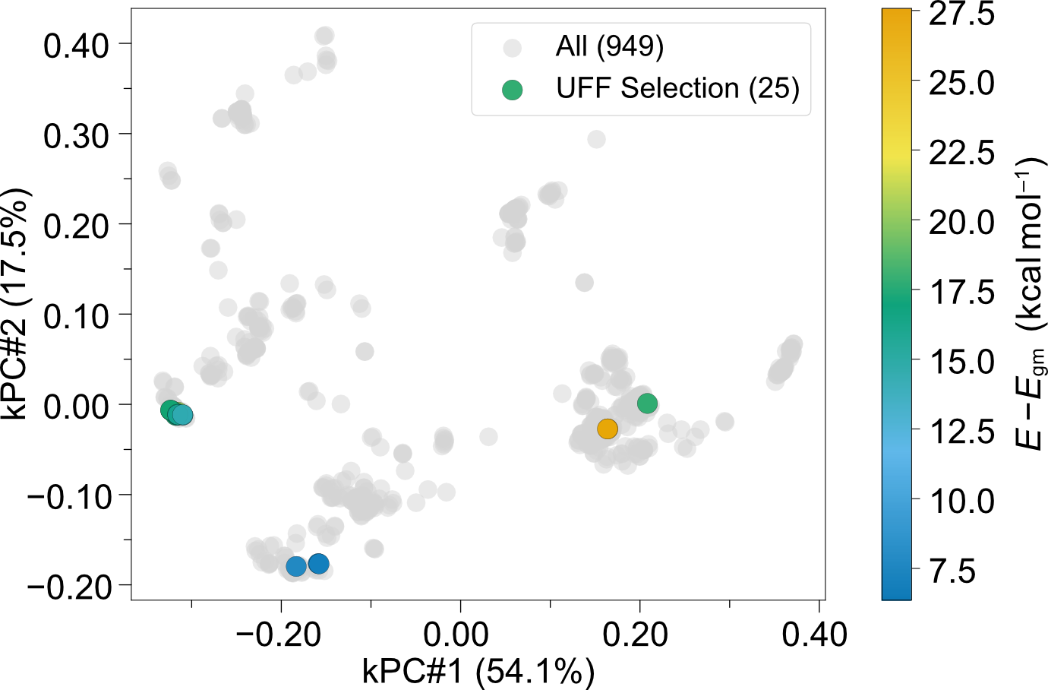
Fig. S6. UFF energy-ranking conformer selection. Two-dimensional kPCA projection of the initial unsupervised configurational representation prior to CKA refinement. Gray points represent the full ensemble of 949 conformers, whereas colored circles denote the 25 conformers selected according to their UFF energies and subsequently relaxed with DFT. Colors indicate the resulting DFT energies relative to the global minimum, E_{gm}, identified during the first round of structure-based selection.

Further inspection revealed that the discrepancy between UFF and DFT energies is closely related to structural changes introduced during UFF relaxation. In particular, UFF relaxation distorts the substrate coordination geometry around Rh, favoring a tetrahedral arrangement at the Rh-bound CH₂ carbon accompanied by a short Rh···H–C contact, in contrast to the planar CH₂ geometry obtained when the original conformers are relaxed directly with DFT. Only three of the 25 UFF-relaxed structures recover the planar coordination geometry during subsequent DFT relaxation, yielding final energies of +6.4, +7.6, and +7.9 kcal mol^{–1} relative to E_{gm}. The remaining structures retain the distorted coordination motif and converge to substantially higher DFT energies ranging from +14.1 to +27.6 kcal mol^{–1}. Several conformers also converge to the same minima during DFT relaxation despite having distinct UFF energies, further reducing the structural diversity of the final set.

The effect of UFF relaxation can be examined directly for two conformers that were independently selected by both UFF energy ranking and TASTET. When their original geometries are relaxed directly with DFT, they yield energies of +5.4 and +4.0 kcal mol^{–1} relative to E_{gm}, respectively. When the same conformers are first relaxed with UFF and the resulting geometries are subsequently relaxed with DFT, their final energies increase to +15.8 and +14.1 kcal mol^{–1}, respectively. This comparison shows that low-level geometry relaxation can alter the subsequent DFT relaxation outcome even when the same initial conformer is considered. This effect is particularly relevant when low-level relaxation forms part of the conformer-generation procedure itself, because the resulting geometries define the configurational ensemble from which structures are subsequently selected for higher-level calculations.

DFT computational details

All DFT calculations for the Rh-complex case study were performed using Gaussian 16 (Revision C.01)⁴ with the PBE0 exchange-correlation functional⁵ and Grimme’s D3(BJ) dispersion correction⁶. The def2-SV(P) basis set was employed for all atoms, with the corresponding effective core potential applied to Rh⁷. Geometry optimizations were carried out in the gas phase without imposing symmetry constraints. The optimized structures were subsequently characterized by frequency calculations, with all reported minima confirmed by the absence of imaginary frequencies.

Case study 2: Supported nanocluster configurational exploration

Candidate structure generation

Candidate structures for Cu₁₂ clusters supported on a ZnO(10–10) surface were generated using the Global Optimization with First-principles Energy Expressions (GOFEE) algorithm. GOFEE combines an evolutionary search procedure with a Gaussian Process Regression (GPR) surrogate model. For each candidate structure, the GPR predicts an energy, $E$, together with an associated uncertainty, $σ$, defined as the standard deviation of the predicted distribution. These quantities are combined through the lower confidence bound (LCB) acquisition function

$$\begin{aligned}f=E-κσ \#\left(S10\right)\end{aligned}$$

where $κ$ is a dimensionless parameter set to 2⁸. The LCB determines which candidate is selected for subsequent DFT evaluation. The energy term favors exploitation of configurations predicted to have low energies, whereas the uncertainty term promotes exploration by lowering the acquisition score of configurations for which the surrogate prediction is less certain. The LCB criterion therefore balances exploration of the configurational space with exploitation of regions predicted to contain energetically favorable structures.

Each GOFEE search was initialized by generating random Cu₁₂/ZnO(10–10) structures and evaluating their energies through single-point DFT calculations using the settings described in the DFT computational details section (see below). The resulting structures and energies formed the initial training set for the GPR model. At each subsequent iteration, a new set of candidate structures was generated and evaluated using the surrogate model to obtain their predicted energies and uncertainties. The corresponding LCB values were then used to select a candidate for DFT evaluation. The resulting DFT energy was added to the training set, the GPR model was updated, and the procedure was repeated iteratively.
Three complementary structure generators were used to construct the candidate set at each iteration. The random generator places atoms randomly within a predefined simulation box, whereas the rattle generator introduces atomic displacements into previously sampled structures. A third generator promotes agglomeration of atoms around the center of geometry of the cluster⁹. Each GOFEE iteration generated 30 candidate structures, comprising 10 from the random generator, 15 from the rattle generator, and 5 from the center-of-geometry generator. For the rattle and center-of-geometry generators, parent structures were drawn from the current structural population using k-means clustering-based sampling¹⁰.

Ten independent GOFEE searches were performed using different random initialization seeds. Each search comprised 500 iterations, with two structures retained per iteration. These correspond to the candidate selected at the surrogate level using the LCB acquisition function and the associated structure following DFT evaluation. Each run therefore contributed 1,000 structures, yielding a combined configurational ensemble of 10,000 structures across the ten searches.

The surrogate-predicted energy profile of the complete configurational ensemble is shown in Fig. S7. The 10 independent GOFEE searches are concatenated sequentially, with their boundaries indicated by vertical dashed lines every 1,000 structures. Because each search begins from a different random initialization, the start of a new run is generally associated with a sharp increase in predicted energy, followed by a rapid decrease as the configurational search progresses toward more favorable structures. All energies in Fig. S7 correspond to GPR predictions and are reported relative to the surrogate-predicted global minimum, $E_{\text{gm}}$.

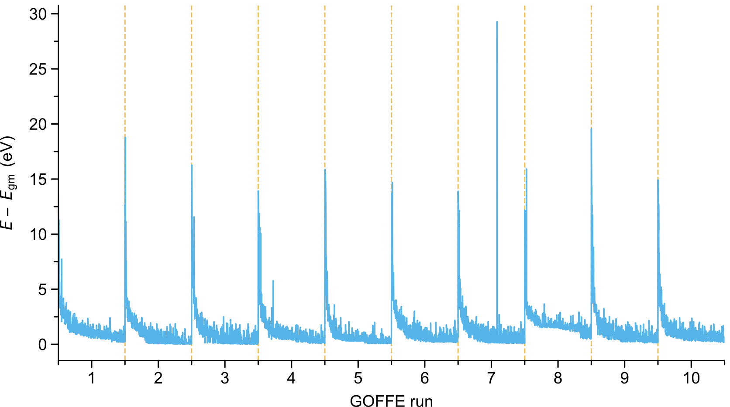
Fig. S7. Surrogate-predicted energy profile of the Cu₁₂/ZnO(10–10) configurational ensemble generated by GOFEE. The 10,000 structures obtained from ten independent GOFEE searches are concatenated sequentially, with vertical dashed lines marking the boundaries between individual runs. Energies correspond to GPR predictions and are reported relative to the surrogate-predicted global minimum, $E_{\text{gm}}$. Each run contains 1,000 structures generated over 500 GOFEE iterations.

Configurational representation and hyperparameter selection

For the Cu₁₂/ZnO(10–10) system, the configurational representation was optimized using the supervised CKA procedure described in the Methods section. The target values were the energies predicted by the GPR surrogate trained on single-point DFT calculations during the GOFEE searches. These low-cost energetic predictions therefore provide supervision for identifying a structural representation that reflects the energetic organization learned during configurational exploration. Importantly, the surrogate energies are used here only to optimize the representation and are not subsequently used as an energetic criterion for FPS selection.

The hyperparameter grid included the following components:

- SOAP hyperparameters. The cutoff radius, $r_{cut}$, Gaussian width, $σ$, number of radial basis functions, $n_{max}$, and maximum angular degree, $l_{max}$, were varied across the grid.

- Similarity metric. Linear and RBF local similarities were considered. For the RBF kernel, $γ$ was determined dynamically using the median heuristic defined in Eq. S3.

- Global kernel. Average and REMatch global kernels were considered, with $λ_{REMatch}=$0.5.

Because the relevant configurational variation in this system arises primarily from differences in the geometry of the supported Cu₁₂ cluster, SOAP environments were centered on all Cu atoms. The ZnO support atoms were retained within the corresponding local environments and therefore contributed to the SOAP descriptors whenever they fell within the specified cutoff radius. This construction allows the representation to distinguish changes in both cluster morphology and the local Cu–support environments while restricting the descriptor centers to the atoms whose arrangements vary across the configurational ensemble. Table S3 summarizes the hyperparameter grid.

Table S3. Hyperparameter grid used to optimize the SOAP-kernel representation for Cu₁₂/ZnO(10–10).

Centers | Global kernel | Similarity metric | $r_{cut}$ (Å) | $σ$ (Å) | $$n_{max}$$ | $$l_{max}$$
Cu atoms | Average, REMatch | Linear, RBF | 3.0, 4.0, 5.0 | 0.1, 0.5 | 4, 6, 8 | 4, 6, 8

Evaluating the complete hyperparameter grid over all 10,000 structures would be computationally demanding. We therefore subsampled 50 structures for hyperparameter optimization using inverse-density weighting with respect to the GPR-predicted relative energies. This procedure increases the probability of selecting structures from sparsely populated regions of the energy distribution and prevents the optimization subset from being dominated by densely sampled energetic regions. Fig. S8 compares the surrogate-energy distribution of the complete configurational ensemble with that of the resulting subsample.
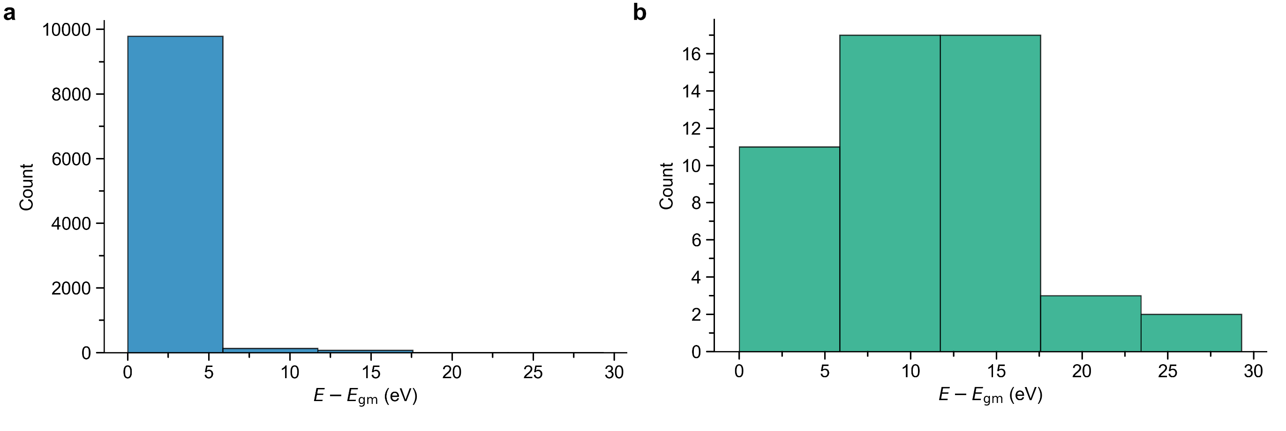
Fig. S8. GPR-predicted relative-energy distributions used for subsampling. a Distribution for the complete 10,000-structure configurational ensemble generated by GOFEE. b Distribution for the 50-structure energy-balanced subsample used for SOAP-kernel hyperparameter optimization. Energies are reported relative to the surrogate-predicted global minimum, $E_{\text{gm}}$.

Each candidate representation was evaluated by calculating its CKA with the GPR-predicted energies of the 50-structure subsample. Representative results from the grid search are shown in Fig. S9. The highest-CKA representations reach values of approximately 0.75, indicating strong alignment between the configurational similarity encoded by the SOAP kernel and the energetic variation predicted by the surrogate model. The final representation was selected by considering both CKA and representation complexity, favoring the least computationally demanding construction among those providing comparable structure–energy alignment. The selected representation employed an average global kernel with: $r_{cut}=$ 4.0 Å, $σ=$ 0.1 Å, $n_{max}=$ 8, and $l_{max}=$ 4. This representation achieved a CKA of 0.73 and was subsequently used to construct the configurational space for representative structure selection by FPS.
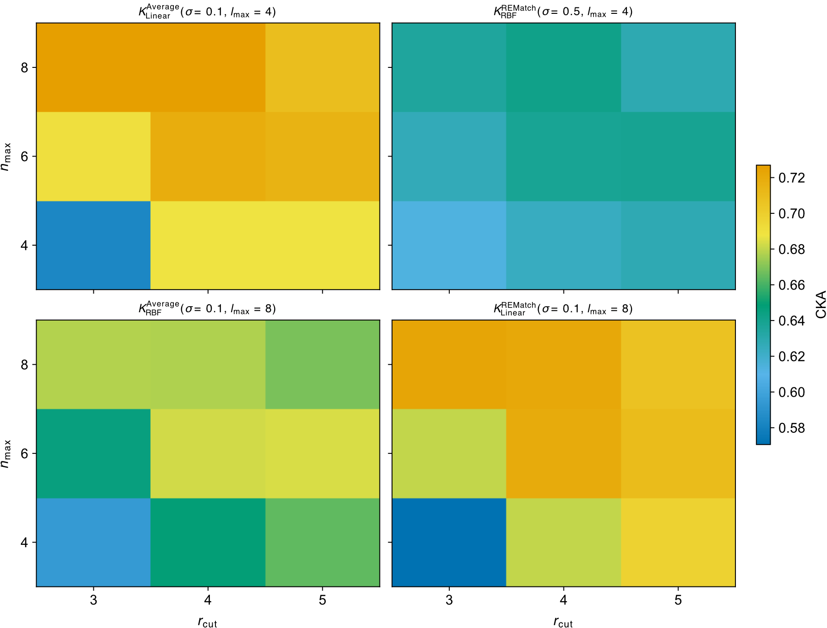
Fig. S9. CKA-guided optimization of the SOAP-kernel representation for Cu₁₂/ZnO(10–10). Four representative heatmaps from the hyperparameter search are shown, illustrating the CKA between each candidate kernel representation and the GPR-predicted energies of the 50-structure subsample used for hyperparameter optimization. The horizontal and vertical axes correspond to the SOAP cutoff radius, $r_{cut}$, and the number of radial basis functions, $n_{max}$, respectively. Each panel represents a different combination of local similarity metric, global kernel, SOAP Gaussian width, $σ$, and maximum angular degree, $l_{max}$. Panel labels specify the corresponding kernel parameters. Colors indicate CKA values on a common scale.

DFT computational details

Periodic DFT calculations were performed using the Vienna Ab Initio Simulation Package (VASP, version 6.4.2)¹¹ with the PBE exchange-correlation functional¹². Core and valence electrons were described using the projector-augmented-wave (PAW) method¹³. The periodic slabs were sampled using a 𝛤-centered 1×2×1 k-point mesh, corresponding to reciprocal-space in-plane spacings of approximately 0.48 and 0.30 Å^{–1} along the two surface-periodic directions, respectively. Two sets of computational parameters were employed according to the purpose of the calculations. Lower-cost single-point DFT evaluations were used during the GOFEE searches to enable efficient surrogate-model training and configurational exploration, whereas higher-accuracy geometry optimizations were reserved for refinement of the structures selected by FPS.

For the GOFEE searches, single-point DFT calculations were performed using a plane-wave kinetic-energy cutoff of 400 eV and a Gaussian smearing with a width of 0.1 eV. The calculations were non-spin polarized, and the electronic energy was converged to 10^{–4} eV. To further reduce the computational cost of configurational exploration, the ZnO(10–10) support was represented using a single-layer slab.
For the final refinement, the FPS-selected structures were optimized using a plane-wave kinetic-energy cutoff of 500 eV and a Gaussian smearing with a width of 0.05 eV. These calculations were spin-polarized. Geometry relaxations were performed using a conjugate-gradient algorithm with convergence criteria of 10^{–6} eV and 0.01 eV Å^{–1} for the electronic and ionic steps, respectively. Dispersion interactions were accounted for using the DFT-D3 method¹⁴ with Becke-Johnson damping⁶. The ZnO(10–10) support was represented using a four-layer slab, with the bottom two layers fixed at their bulk positions during geometry optimization.

References

1. O’Boyle, N. M. et al. Open Babel: An open chemical toolbox. J. Cheminformatics 3, 33 (2011).
2. Baidun, M. S., Kalikadien, A. V., Lefort, L. & Pidko, E. A. Impact of Model Selection and Conformational Effects on the Descriptors for In Silico Screening Campaigns: A Case Study of Rh-Catalyzed Acrylate Hydrogenation. J. Phys. Chem. C 128, 7987–7998 (2024).
3. Rappe, A. K., Casewit, C. J., Colwell, K. S., Goddard, W. A., III & Skiff, W. M. UFF, a full periodic table force field for molecular mechanics and molecular dynamics simulations. J. Am. Chem. Soc. 114, 10024–10035 (1992).
4. Frisch, M. J. et al. Gaussian 16, Revision C.01. Gaussian, Inc. (2016).
5. Adamo, C. & Barone, V. Toward reliable density functional methods without adjustable parameters: The PBE0 model. J. Chem. Phys. 110, 6158–6170 (1999).
6. Grimme, S., Ehrlich, S. & Goerigk, L. Effect of the damping function in dispersion corrected density functional theory. J. Comput. Chem. 32, 1456–1465 (2011).
7. Weigend, F. & Ahlrichs, R. Balanced basis sets of split valence, triple zeta valence and quadruple zeta valence quality for H to Rn: Design and assessment of accuracy. Phys. Chem. Chem. Phys. 7, 3297–3305 (2005).
8. Christiansen, M.-P. V., Rønne, N. & Hammer, B. Atomistic global optimization X: A Python package for optimization of atomistic structures. J. Chem. Phys. 157, 054701 (2022).
9. Paleico, M. L. & Behler, J. Global optimization of copper clusters at the ZnO(101¯0) surface using a DFT-based neural network potential and genetic algorithms. J. Chem. Phys. 153, 054704 (2020).
10. Merte, L. R. et al. Structure of an Ultrathin Oxide on Pt3Sn(111) Solved by Machine Learning Enhanced Global Optimization. Angew. Chem. 134, e202204244 (2022).
11. Kresse, G. & Furthmüller, J. Efficient iterative schemes for ab initio total-energy calculations using a plane-wave basis set. Phys. Rev. B 54, 11169–11186 (1996).
12. Perdew, J. P., Burke, K. & Ernzerhof, M. Generalized Gradient Approximation Made Simple. Phys. Rev. Lett. 77, 3865–3868 (1996).
13. Blöchl, P. E. Projector augmented-wave method. Phys. Rev. B 50, 17953–17979 (1994).
14. Grimme, S., Antony, J., Ehrlich, S. & Krieg, H. A consistent and accurate ab initio parametrization of density functional dispersion correction (DFT-D) for the 94 elements H-Pu. J. Chem. Phys. 132, 154104 (2010).

