Title: From mesenteric lymph nodes to the rest of the body: Microplastic translocation and accumulation in subsistence harvested eastern Chukchi Sea beluga whales

Authors: Noelle A Picard^{1,*}, John J Citta², Katrin Iken¹, Raphaela Stimmelmayr², Zachary C Redman³, Patrick L Tomco³, Brian P DiMento³, Lara Horstmann¹

*Corresponding author: Noelle A Picard; phone: (413)887-7984; email: napicard@alaska.edu
¹ University of Alaska Fairbanks College of Fisheries and Ocean Sciences, Department of Marine Biology, Fairbanks, AK 99775, United States
² North Slope Borough Department of Wildlife Management, Utqiaġvik, AK 99723, United States
³ University of Alaska Anchorage Applied Sciences, Engineering, and Technology Laboratory, ConocoPhillips Integrated Science Building, Anchorage, AK 99508, United States

Acknowledgements
We thank the beluga hunters of the Native Village of Point Lay for welcoming us into their community and providing samples from subsistence harvested whales. Stable isotope analysis was conducted by T Howe and S Daniels with the Alaska Stable Isotope Facility. Fourier-transform infrared spectroscopy was done under the guidance of J Larsen and the University of Alaska Advanced Instrumentation Laboratory. Pyrolysis-gas chromatography-mass spectroscopy was conducted at the University of Alaska Anchorage Applied Sciences, Engineering, and Technology Laboratory. Beluga whale samples were collected under National Marine Fisheries Service collection permits 792-1399, 782-1694, 814-1899, 17350, 26667, and their amendments, issued to the North Slope Borough Department of Wildlife Management. This project was supported by the Rasmuson Fisheries Research Center Graduate Fellowship, Alaska National Science Foundation Established Program to Stimulate Competitive Research: Fire and Ice travel funding, the Stephen R Okkonen memorial research award, the Feder and Shaw award, the Byrd award, and UAF Transformative Experience funding.

Submission of supplementary figures and tables to Environmental Science and Pollution Research.

Online Resource 1 Sample sizes of juvenile (gray), juvenile/young adult (white/gray), and adult (white) beluga whales for each tissue to assess bioaccumulation of microplastics.
Liver |  | Muscle |  | Kidney |  | Blubber
Color | Sample size | Color | Sample size | Color | Sample size | Color | Sample size
Gray | 2 | Gray | 4 | Gray | 2 | Gray | 1
White/Gray | 4 | White/Gray | 13 | White/Gray | 9 | White/Gray | 6
White | 9 | White | 16 | White | 3 | White | 6

Online Resource 2 Minimum detection limits (MDL) for qualitatively identifying microplastics (MPs) via pyrolysis-gas chromatography-mass spectroscopy using plastic polymer standards from Frontier Laboratories containing known volumes of acrylonitrile butadiene styrene (ABS), nylon-6 (N6, aka polyamide), nylon-66 (N66), polycarbonate (PC), polyethylene (PE), polyethylene terephthalate (PET), poly(methyl methacrylate) (PMMA), polypropylene (PP), polystyrene (PS), polyurethane (PU), polyvinyl chloride (PVC), and styrene butadiene rubber (SBR) in 4 g of calcium carbonate diluent (Frontier Laboratories). It is assumed that all polymers are evenly distributed throughout the calcium carbonate diluent. These data set the MDL of plastic polymer detections using matches found in the ‘Frontier Laboratories F-Search MPs 2.1 Software’ (Frontier Laboratories), and we considered polymer masses a MDL, once it yielded an above 90 % match value, as these are known, non-worn polymers and should yield high match values.
Plastic Polymer | MDL (µg) | Plastic Polymer | MDL (µg)
ABS | 1.6 | PMMA | 0.8
N6 | 0.5 | PP | 4.0
N66 | 1.8 | PS | 0.8
PC | 0.4 | PU | 0.4
PE | 16.0 | PVC | 4.0
PET | 1.6 | SBR | 1.6

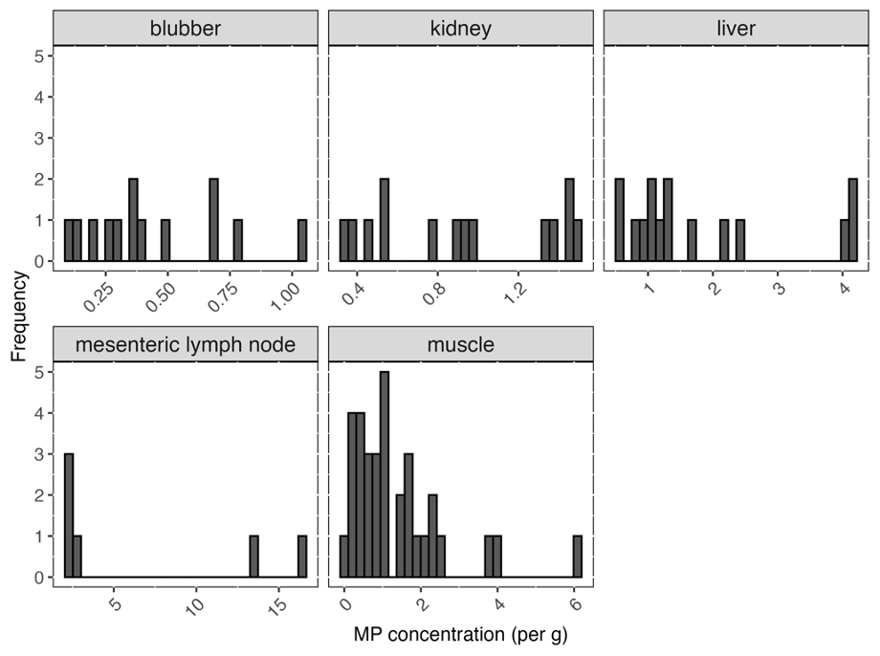
Online Resource 3 Histograms showing the distribution of microplastics (MP) isolated from Eastern Chukchi Sea subsistence harvested male beluga whale mesenteric lymph nodes (MLNs), liver, muscle, kidney, and blubber. The x-axis represents MP concentration (count per gram of tissue), and the y-axis denotes the frequency of samples that fall into each bin. (A) MLN, (B) liver, (C) muscle, (D) kidney, and (E) blubber. Bin width is set to 0.5 for all histograms.

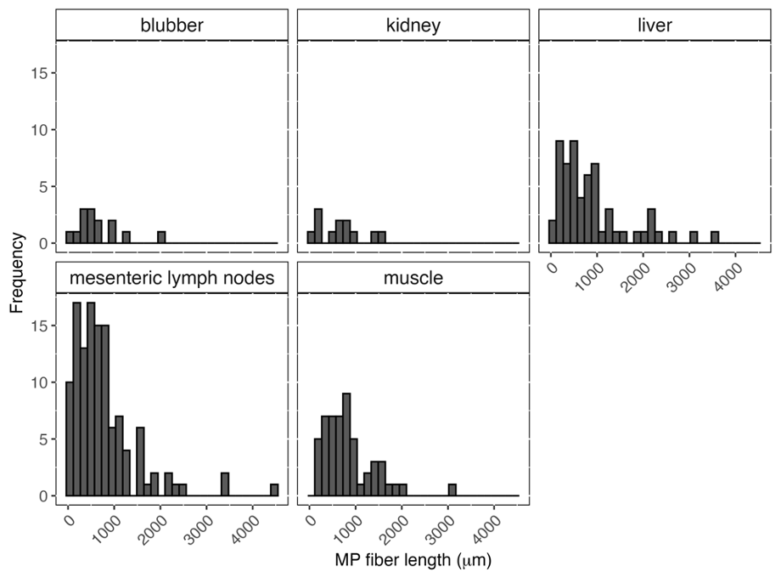
Online Resource 4 Length of microplastic (MP) fibers (μm) isolated from subsistence harvested male beluga whale (A) mesenteric lymph nodes (MLN), (B) liver, (C) muscle, (D) kidney, and (E) blubber. MP fiber lengths were determined using CaptaVision+ software. MP fiber lengths are shown on the x-axis and frequency of each MP length is displayed on the y-axis. Bin width is 153 for all histograms.

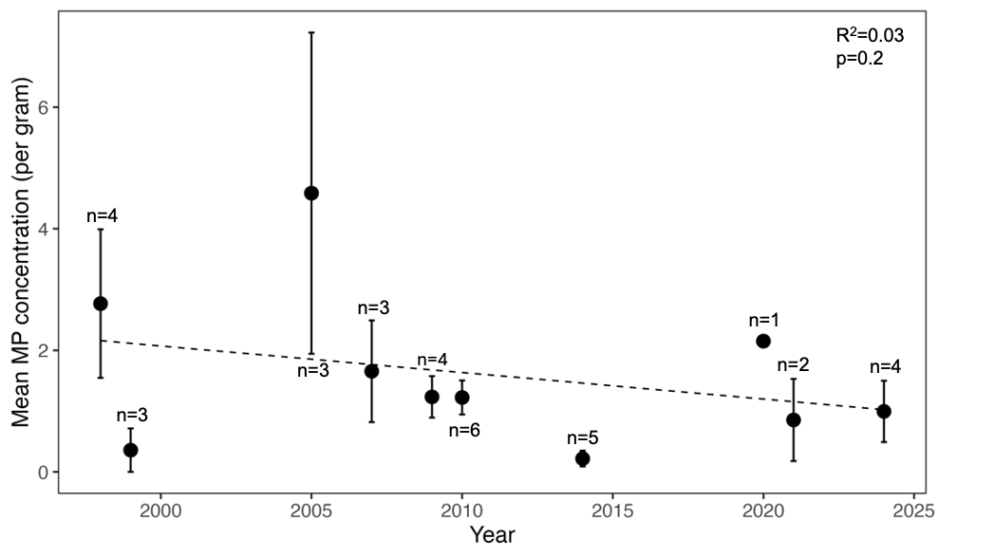
Online Resource 5 Time series plot of mean microplastic (MP) concentrations (count per gram of tissue) in subsistence harvested male Eastern Chukchi Sea beluga whale muscle from 1998–2024 (n=33). Blue symbols represent mean annual MP concentration and error bars represent 1 standard deviation. Sample size is listed above each data point for each corresponding year.

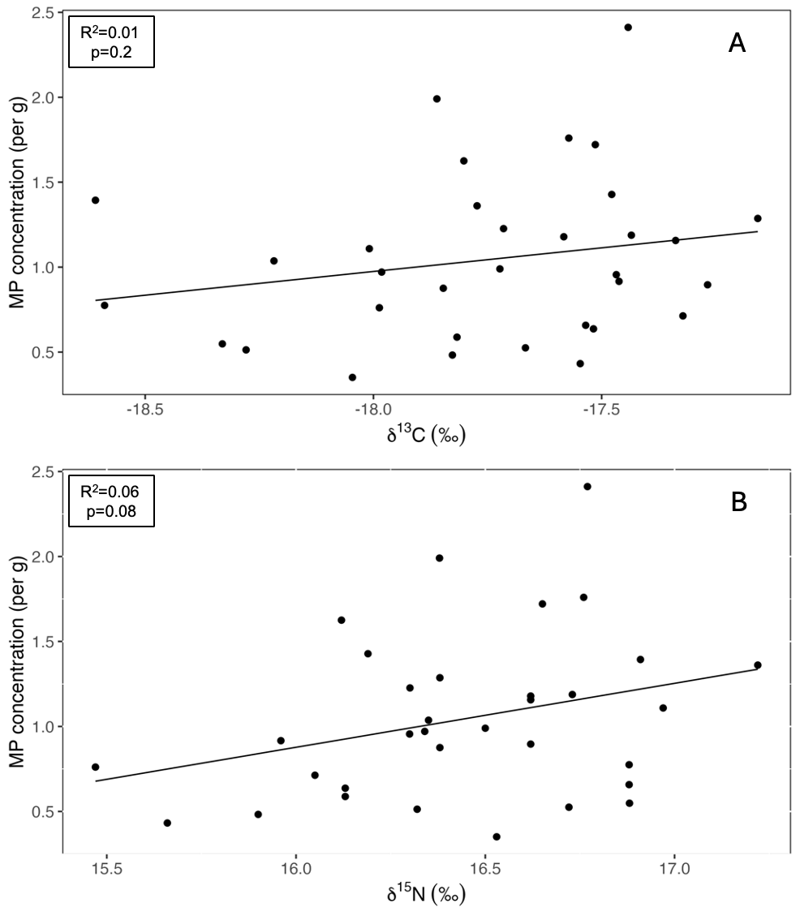 Online Resource 6 Microplastic (MP) concentrations (count per gram of tissue) as a function of (A) bulk stable carbon isotope values and (B) bulk stable nitrogen isotope values (parts per mile) in muscle of in subsistence harvested male Eastern Chukchi Sea beluga whales. Microplastic concentrations are log-transformed due to right-skewed residuals. Regression parameters are included in the top left corner of each panel.

