A Techno-Economic, Environmental and Social Life Cycle Assessments of Sustainable Aviation Fuel production via the Alcohol-to-Jet process - A UK Case Study
Chike Ucheana^{a,1}, Maria Fernanda Rojas-Michagaª, Kevin J. Hughesª, Derek Inghamª, Mohamed Pourkashanianª
ªEnergy 2050, School of Mechanical, Aerospace and Civil Engineering, University of Sheffield, Sheffield, United Kingdom
¹Corresponding author: email address: cnucheana2@sheffield.ac.uk

Supplementary Material

A1.0 Supplementary to Section 1.0: Introduction

A1.1 Statement of Novelty
This study presents a first-of-its-kind integration of detailed process simulation, multistage power recovery and heat integration with full-spectrum sustainability assessment including techno-economic, life cycle, and social impact evaluations for SAF production via the Alcohol-to-Jet pathway using wheat straw as a feedstock. The model uniquely incorporates in-situ hydrogen and oxygen production, enzyme generation, and a 66 MW waste-to-energy Rankine cycle, demonstrating a closed-loop, self-sufficient biorefinery capable of high SAF selectivity and surplus power export. For the first time, a comprehensive study that considers the social responsibility, associated social risks and opportunities of siting a SAF production plant via AtJ is conducted.

A2.0 Supplementary to Section 2.0: Methods

A2.1 Opportunities in the UK
Currently there are three ongoing projects in the UK whose process involves an Alcohol-to-Jet (AtJ). Table 1 is a listing of ongoing AtJ SAF production projects in the UK which are projected to come on stream soon. The United Kingdom presents a strategically advantageous landscape for the development and deployment of SAF, particularly via the AtJ pathway. With aviation contributing approximately 7% of the UK's greenhouse gas (GHG) emissions [1], decarbonising this sector has become a national priority, underlined by the UK Government’s Jet Zero Strategy which targets at least 10% SAF blending by 2030 [2]. The AtJ pathway, which converts lignocellulosic biomass or industrial ethanol into drop-in jet fuel, aligns well with the UK's abundant feedstock resources, such as agricultural residues (e.g., wheat straw) and industrial CO₂-derived ethanol, offering potential for regional biomass valorisation and circular economy integration [3, 4]. Additionally, the UK's strong research ecosystem, policy support via SAF mandates and CfDs (Contracts for Difference), an investment Up to 14 commercial SAF plants in seven UK industrial clusters (e.g., Teesside and South Wales) foster an enabling environment for AtJ scale-up [5]. These developments not only advance energy sovereignty and emission reductions but also present socio-economic benefits including rural job creation, infrastructure repurposing, and industrial decarbonisation synergies, especially in hard-to-abate sectors like steel and chemicals [5]. UK Government projections estimate up to 15,000 jobs and £5 billion GVA by 2050 from SAF deployment [6]. Therefore, the AtJ route emerges as a technically viable and policy-aligned opportunity to accelerate SAF adoption in the UK’s net-zero transition. In line with the opportunities, this research focuses on the lignocellulosic biomass conversion to SAF via AtJ for which the methods used is detailed in the manuscript section Error! Reference source not found..

Table 1: Current AtJ SAF production projects in the UK
Project Name | Capacity (SAF) | Feedstock | Expected Commercial Operation | Location (UK) | Technology
Project Speedbird | 102 million L/yr (90,000 t/yr) | Lignocellulosic biomass (wood/agri-residues) to Ethanol to SAF | ~2027 | Teesside  , Wilton International | Nova Pangaea Technologies (NPT) and Lanzajet AtJ technologies [7].
LanzaJet DRAGON | 100 million L/yr (90,000 t/yr) | Recycled ethanol from industrial/steel CO₂ waste gases | ~2026 | Port Talbot, Wales | Lanzajet gas fermentation and AtJ technologies [8].
AtmosFUEL | 100 million L/yr (90,000 t/yr) | DAC CO₂ turned into ethanol and to SAF | ~2029 | Milford Haven, South Wales | Carbon Engineering technology for capture and Lanzajet gas fermentation and AtJ technologies [8].

A2.2 Supplementary to section 2.3: Process Modelling Approach

A2.2.1 Feedstock Logistics and Handling (A100)
Wheat straw (2,000 t/d, 15% moisture) is supplied as pre-milled bales from a nearby satellite facility (negligible distance) and transported by road. Upon arrival, conveyors and enclosed transfer systems automatically feed biomass into the pretreatment area [9] , minimizing manual handling and moisture exposure. This continuous handling preserves straw quality and feed consistency.

A2.2.2 Pretreatment and Delignification (A200)
The biomass (wheat straw) is slurried (20% solids) with 5 wt% NaOH at 70 °C, then enters a pressurized (5 bar) reactor. Oxygen (5 wt% of biomass) is supplied [10, 11], and the mixture is held at 150 °C, 5 bar for alkaline-oxygen delignification [12]. This oxidative treatment selectively solubilizes lignin and hemicellulose, enriching the solid fraction in cellulose. Literature reports that lignin removal and hemicellulose dissolution could be up to 70% with cellulose 20% up under similar conditions [13]. After reaction, the slurry is cooled and flashed: volatiles (e.g. organics, CO₂) are flashed off, and the solids are filtered. The resulting cellulose-rich solids proceed to hydrolysis, while dissolved ash, and inorganic salts remain in the liquid effluent.

A2.2.3 Hydrolysis and Fermentation (A300)
The pretreated solids are enzymatically hydrolyzed to sugars in a continuous reactor[14, 15]. Commercial cellulases (i.e. Celluclast 1.5L, Novozyme 188) are applied to convert glucan to glucose; hemicellulose-derived xylose is also released. Typically, 20 mg enzyme protein per g cellulose is used (from on-site production)[16]. A side-stream (10% of hydrolysate) is sent to a “seed” fermenter to cultivate yeast inoculum, supplemented with corn steep liquor (CSL) and diammonium phosphate (DAP) nutrients. The main fermentation is a fed-batch anaerobic reactor (32 °C, 1 atm) where Saccharomyces or Zymomonas spp. co-ferment glucose and xylose to ethanol and CO₂. Minor microbial byproducts (3%) such as lactic acid (from contamination) are included as losses[16]. Fermentation yields reach 70-80% of theoretical (e.g. NREL reports 76% efficiency[16]. The dilute beer (5-6% ethanol by weight) is cooled and forwarded for distillation; CO₂ is separated and vented. The hydrolysis reaction follows the typical Equation 1Error! Reference source not found..
${\left(C_{6}H_{10}O_{5}\right)}_{n}+nH_{2}O$→ $nC_{6}H_{12}O_{6}$ | Equation 1

A2.2.4 On-site Enzyme Production (A400)
To supply hydrolytic enzymes, a dedicated on-site fermentation (Area 400) produces cellulase [17, 18]. In practice, a portion of sugars (or purchased glucose) is fermented by Trichoderma reesei (or similar) in large bioreactors. The fermentation is a fed-batch cycle (120 h on, 48 h off [16] optimized to secrete cellulases. After completion, the enzyme broth is separated (cells removed) and returned to the hydrolysis reactor. Using on-site production eliminates purchased enzymes and targets an enzyme loading of ~ 10 mg protein/g cellulose [16].

A2.2.5 Ethanol Recovery and Purification (A500)
Fermentation “beer” is concentrated via a standard distillation train (Area 500). The ethanol separation train consists of two beer columns (each 9 stages with a molar reflux of 2.7:1) producing approximately 30 wt% ethanol, followed by a 17-stage rectification column with a molar reflux ratio of 7.6:1 producing ~86 wt% ethanol. The rectification column does not break the ethanol-water azeotrope; rather, it pre-concentrates ethanol to reduce the water load to the downstream dehydration unit. Final dehydration to ~99.5 wt% ethanol is achieved exclusively in the molecular sieve unit, consistent with established biochemical ethanol purification practices reported in the literature [16].
For rigorous simulation practice, preliminary column design was first performed using the DSTWU shortcut method to estimate the minimum number of stages and reflux ratio. These values were subsequently implemented and refined using the RadFrac rigorous distillation model.
No column flooding or entrainment issues occur at the design loads. Vapor-liquid equilibrium and tray sizing confirm effective ethanol-water separation. The concentrated ethanol is then flashed to remove residual volatiles. Water condensate from distillation and flashing is recycled for process heating or reuse. The material balance summary is provided in Supplementary Material A-5, allowing full verification of the simulation results.

A2.2.6 Wastewater Treatment (A600)
The biorefinery generates large volumes of effluent (600 m³/h) from distillation column condensates and dehydration reactors. A multi-step biological/physical treatment train is implemented [19, 20]:
- Anaerobic digestion: Fermentable COD is converted to biogas (CH₄) in a closed anaerobic digester, removing about 90% of organic.
- Aerobic treatment: The digester effluent goes to an activated sludge reactor for further BOD/COD and ammonia removal.
- Solid-liquid separation: A clarifier (or membrane filter) removes biomass and suspended solids, protecting downstream RO units.
- Reverse osmosis (RO): The clarified water is passed through RO membranes to strip dissolved salts and trace inhibitors, yielding high-purity effluent suitable for recycle or safe discharge.
The dewatered sludge from digesters and clarifiers is centrifuged to ≥ 30% solids (cake) and combusted in the boiler (co-fired with lignin) to recover energy [20]. RO concentrate (brine) can be further evaporated or crystallized for disposal. In this way, water is recycled, and waste is minimized. Alternatively, in lieu of cost intensive WWT process, typical advanced treatment costs are on the order of $0.3–1.0 per m³ [20].

A2.2.7 Storage (A700)
On-site storage is provided for key consumables. CSL and DAP are stored in stainless steel tanks with corrosion-resistant lining and mechanical agitators to prevent nutrient settling [21]. Each tank has calibrated feed pumps to deliver nutrients at the stoichiometric rate to fermenters[16, 21]. The storage and handling design follows standard biofuel plant guidelines [16]. NREL’s ethanol designs similarly include dedicated tanks and dosing pumps for CSL and DAP [16] ensuring continuous supply of yeast nutrients without process interruption.

A2.2.8 Power Generation (A800)
The lignin-rich residue and bio sludge are used as fuel the combustor. A high-efficiency, three-pressure steam Rankine cycle (adapted from DOE/NETL Case 1a non-CCS design) is used[22, 23]. The residue is dried and combusted in a boiler (oxygen environment), producing flue gases >1000 °C. Heat recovery generates steam at high (HP), medium (MP), and low (LP) pressures via a series of heat exchangers. The steam cycle operates as follows:
- LP cycle: Low-pressure steam expands in a turbine stage, is reheated (via the flue) to MP conditions, then recompressed.
- MP cycle: The reheated MP steam expands in a second turbine stage, is superheated to HP, and recompressed.
- HP cycle: The superheated HP steam expands in high-pressure turbines, then is returned to the condenser.
Together, these stages extract maximal work. In our model the multi-pressure system produces 66 MW gross electricity (versus 40 MW for a simple single-pressure design). After meeting internal needs (3 MW process, plus 13 MW for H₂ generation and 2 MW for the ASU), about 48 MW is exported to the grid [24], boosting revenues and offsetting fuel cost [16]. Additionally, 1.1×10⁸ kJ/h (30 MW) of mid-temperature heat (110 °C) is recovered for process heating. (Raising the steam cycle outlet to 900 °C could increase recoverable heat to 7×10⁸ kJ/h (195 MW), albeit with a small drop in turbine power to 44 MW, still maintaining energy surplus.) This integration makes the plant heat- and power-self-sufficient and turns residues into high-value electricity [16].

A2.2.9 Utilities (A900)
A full set of utility networks is included to ensure autonomy. These include:
- Steam network: Multi-pressure steam system (LP/MP/HP) feeding process heaters and generators.
- Flue-gas system: Piped and integrated to heat cold stream.
- Cooling water circuits: Closed-loop cooling for condensers and process coolers (tower and water treatment).
- Air systems: Compressed air (for instrumentation and control), instrument air, and turbine air.
- Safety systems: Fire water (stored) and emission control (e.g. scrubbers, electrostatic precipitators).
These systems are designed to support the biorefinery with minimal off-site utilities, following standard chemical plant practice (e.g. tie-in with turbine generation [16].

A2.2.10 Ethylene Production from Ethanol (A1000)
The purified ethanol is catalytically dehydrated to ethylene in a fixed-bed reactor train:
- Reaction Stage: A three-reactor series (adiabatic tubular reactors, γ-Al₂O₃ catalyst) operates at 400-420 °C, 1–2 bar. Ethanol (96 wt% feed) is converted 99% into ethylene, diethyl ether (DEE), acetaldehyde and light olefins, following power-law kinetics [25, 26]. The reactions that occur are represented in the following equations:
C₂H₅OH → C₂H₄ +H₂O | Equation 2
2C₂H₅OH → (C₂H₅)₂O +H₂O | Equation 3
(C₂H₅)₂O → 2 C₂H₄ +H₂O | Equation 4
C₂H₅OH → C₂H₄O +H₂ | Equation 5
2C₂H₄ → C₄H₈ | Equation 6
Industrial alumina catalysts at 300–500 °C, 1-2 bar achieve very high ethylene yields at 94-99% C₂H₄ selectivity). The reactor design based on industrial benchmarks features 2642 tubes, 4197 kg catalyst, to ensure the desired throughput and 1.0 m/s superficial gas velocity[26].
- Recovery Stage: The reactor effluent is quenched to 40 °C in a wash tower to remove tars and residual condensable. A high-pressure separator then splits gases/liquids. The vapor (rich in H₂O/ethanol/ethylene/alkanes) is compressed in three stages (with intercooling); condensate (water + unreacted ethanol) is recycled. A caustic scrubber (or water wash) removes residual organics/CO₂ from the gas. After compression to 22 bar, the gas is dried and ready for distillation.
- Purification Stage: Crude ethylene is purified via low-temperature cryogenic distillation at –24 °C, 22 bar using NRTL-RK VLE models. RadFrac columns remove light impurities (C3–C4) overhead and heavy byproducts (C > 4) at the bottoms. The product stream leaves as 99.7 wt% C₂H₄. Cryogenic distillation is conducted using two sequential columns: an ethylene column, which separates heavier impurities such as propylene, butadiene, diethyl ether, acetaldehyde, and ethane; and a stripper column, which removes lighter components, primarily hydrogen and methane, from the ethylene stream[25].

A2.2.11 Oligomerisation (A1100)
The purified ethylene is oligomerized via a two-stage Ziegler process to longer α-olefins [27-29]. In stage 1, ethylene (100 bar, 90–120 °C) is contacted with triethylaluminium (AlEt₃) to form linear α-olefins by chain growth. Reactor products (C₄–C₂₀ olefins) pass to stage 2, where olefins are thermally quenched and additional ethylene (100 bar, 200–300 °C) displaces Al-based catalyst residues[30]. The oligomer distribution is approximately (C₄:5%, C₆:10%, C₈:16%, C₁₀:19%, C₁₂:18%, C₁₄:15%, C₁₆:9%, C₁₈:5%, C₂₀+:3%), predominantly α-olefins (95%)[30]. Unreacted ethylene is flashed from the product and recycled; the stream pressure is reduced to 36 bar before hydrogenation.

A2.2.12 Hydrogenation (A1200)
Excess hydrogen from electrolyzer is compressed to 36 bar and mixed with the olefin-rich product. Over a suitable metal catalyst (i.e. Cobalt Molybdenum), all C=C double bonds are saturated, yielding linear n-paraffins with the same carbon distribution as the olefin feed[31]. The reaction is represented in Equation 7.
R-CH=CH-R’ + H₂​ → R-CH₂​-CH₂​-R’ | Equation 7

This exothermic hydrogenation is run within temperature range of 200–250 °C. A pressure-swing adsorption (PSA) unit then recovers unreacted H₂ for recycle to the electrolyzer. The net result is a fully saturated hydrocarbon mixture ready for fractionation.

A2.2.13 Product Distillation (A1300)
The hydrocarbon mixture is separated into naphtha, jet and diesel fractions via distillation:
- First Column: (C2–C4 cut): Removes and recover light/off gasses from heavier liquids with column top temperature < 30 °C.
- Second Column (C₄–C₆ cut): Operated at atmospheric pressure, this column removes light bio-naphtha (C₄–C₆) overhead (top temperature of 30 °C and bottom temperature of 157 °C). The C₇⁺ bottoms pass to the second column.
- Third Column (C₇–C₁₆ cut): Operated under slight pressure, this column splits the remaining mixture. The jet-range fraction (C₈–C₁₆) is drawn overhead with temperatures (top: 118 °C, and bottom: 314 °C), matching conventional kerosene boiling limits. Heavier (>C₁₆) compounds remain in the bottoms (biodiesel range).
This column configuration ensures a clean SAF cut (C₈–C₁₆) aligned with jet fuel specifications, with minimal re-boiling and thermal degradation[32].

A2.2.14 Electrolyzer (A1400)
An alkaline electrolyzer provides H₂ which typically requires 53.4 kWh per kg H₂ produced [33]. The process requires a 244 kg/h of H₂ supply; hence, the electrolyzer requires 13 MW electrical power input. The high-purity H₂ is produced at moderate pressure (10-30 bar) and supplied to the hydrogenation reactor [34, 35].

A2.2.15 Air Separation Unit (A1500)
A cryogenic Air Separation Unit (ASU) supplies pure O₂ (95%) for pretreatment[36]. Oxygen demand is 4,167 kg/h (5 wt% of biomass), so the ASU is sized for 2 MW which is in accordance with typical cryogenic units which requires 0.4 – 0.5 kWh/kg O₂ and large air and cooling duties. We estimate a required air flow of 840 tons/day and cooling water 3,500 tons/day for this scale. This on-site ASU ensures a reliable oxygen supply without off-site purchase.

A2.2.16 Heat Integration
The process is fully heat-integrated via pinch analysis (Aspen Energy Analyzer). Hot and cold composite curves were generated to match hot streams (condensers, flue gas streams) with cold sinks (heaters, reboilers) [37]. Using Aspen Plus Energy Analyzer (APEA), composite curves were generated to visualize the heat exchange opportunities within the plant. As shown in Figure 1, the hot composite curve (red) and cold composite curve (blue) illustrate the potential for energy integration by revealing temperature-enthalpy relationships across the system.
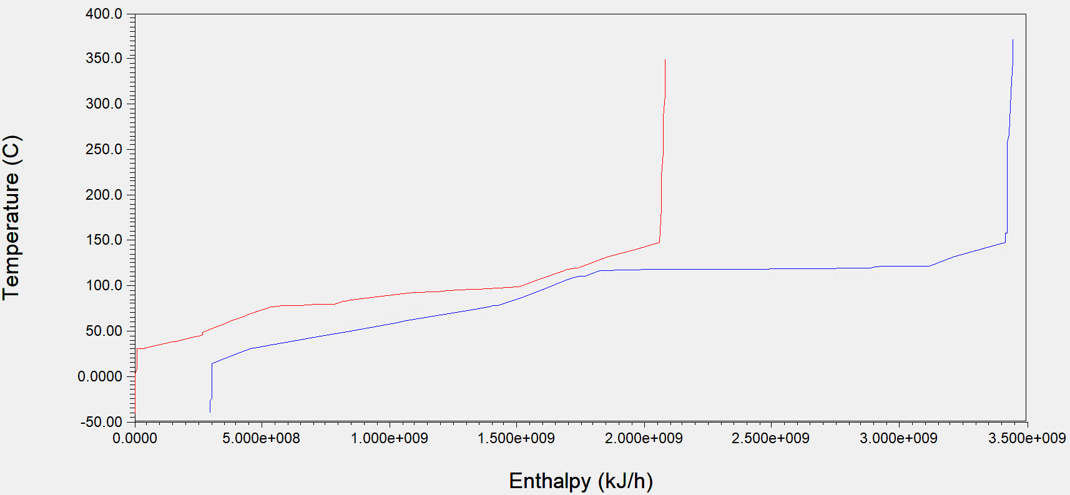
Figure 1. Heat Integration composite curve
After optimal matching, about 1.1×10⁸ kJ/h (30 MW) of heat (primarily at 110 °C) remains available. The exergy (usable work potential) of this residual heat was evaluated as 2.44 x 10⁷ kJ/h (6.76 MW) using Equation 8:
$$E=Q\left(1-\frac{T_{0}}{T}\right)$$ | Equation 8

A2.3 Supplementary to section 2.5: Economic Evaluation

A2.3.1 CAPEX
The capital expenditure (CAPEX) was estimated based on the detailed assumptions outlined in the Table 2. The methodology follows a bottom-up approach, beginning with the calculation of the Purchased Equipment Cost (PEC) for each process unit [16, 38, 39]. The PEC is estimated using Aspen Plus Economic Evaluator tool and benchmarked against the referenced cost data from past studies and vendor quotes. For most units excluding wastewater treatment, the alkaline electrolyser, and the air separation unit (ASU), PEC values were obtained from historical vendor quotations previously compiled by the National Renewable Energy Laboratory (NREL) [16, 40].
To project costs to the current base year (2024), two standard cost-scaling methodologies were employed. First, the effect of capacity change between the reference and study plants was incorporated using the well-established six-tenths rule to calculate the purchased equipment cost value for each process unit as depicted in Equation 9 [41].
$${Cost}_{2}={Cost}_{1}*{\left(\frac{{Capacity}_{2}}{{Capacity}_{1}}\right)}^{α}$$ | Equation 9
Where: ${Cost}_{2}$ represents the new cost, ${Cost}_{1} is$ the base cost, ${Capacity}_{2}$is the new capacity, ${Capacity}_{1}$is the base capacity, and $α$is the scaling factor.

The Chemical Engineering Plant Cost Index (CEPCI)[42], which is a valuable tool developed for chemical reaction processing plants, from which indices obtained are used to correct purchased equipment cost from original cost at year it was obtained to the present cost and study base year (2023). The relationship for cost conversion is as depicted in Equation 10 [41].
$$C_{b}=C_{o}*\left(\frac{{index}_{b}}{{index}_{o}}\right)$$ | Equation 10
Where: $C_{b}$ represents the study base year cost, $C_{o}$is the original cost, ${index}_{b}$is the study base year index, and ${index}_{o}$is the original cost year index.

The equipment installation costs are determined as the product of the specific installation factor per equipment type and the purchased equipment cost (PEC) and as depicted in Equation 11 [16, 43].
$$IC=IF x PEC$$ | Equation 11
Where IC is Installed Cost, IF is installed Factor and PEC is Purchased Equipment Cost.
Table 2 indicates the parameters considered for calculation of installed direct costs (IDC), non-installed direct costs (NIDC), and indirect costs, all of which contribute to the fixed capital investment.
- Installed direct costs comprise PEC, electrical and instrumentation (E&I), piping, and ancillary infrastructure.
- Non-installed direct costs include land acquisition, site development, and yard improvements.
- Indirect costs account for engineering, procurement, and construction management (EPCM), contingencies, and project overhead.
In addition to fixed capital, further financial provisions were included for working capital, bank interest during construction, and start-up costs. The Total capital investment (TCI) is determined from the summation of fixed capital investment (FCI), start-up costs, interest during construction and working capital (WC) [16, 43].
Table 2. CAPEX Methodology [44, 45]
Component | Cost, MM £
Installed direct costs (IDC) | PEC+(A+B+C+D)
A) Purchased equipment installation | 0.39*PEC
B) Instrumentation and controls | 0.26*PEC
C) Piping | 0.31*PEC
D) Electrical systems | 0.10*PEC
Non-installed direct costs (NIDC) | E+F+G
E) Buildings | 0.55*PEC
F) Yard improvements | 0.12*PEC
G) Land | 0.06*PEC
1) Total direct costs (TDC) | IDC+NIDC
2) Indirect costs (IC) | 0.255*PEC
3) Fixed Capital Investment (FCI) | TDC+IC
4) Start-up costs | 0.05*FCI
5) Interest during construction | Calculated
6) Working Capital (WC) | 0.05*FCI
Total Capital Investment (TCI) or CAPEX | 3+4+5+6

A2.3.2 OPEX
The operating expenditure (OPEX) for the biorefinery was estimated following the methodological framework outlined in Table 3. Labour costs were computed for each major process unit using the labour estimation equations presented therein, originally adapted from the NREL 2002 design report [16, 40]. In this study, it is assumed that an equivalent number of personnel operate a facility of comparable scale and complexity. However, salary values have been updated to reflect 2024 economic conditions using the U.S. Bureau of Labor Statistics wage index [46].
Supervisory costs, direct overhead, and general plant overhead was calculated as proportional functions of the base labour costs. Similarly, costs associated with maintenance materials and labour, property insurance, taxes, and financing of working capital are derived as percentage functions of the fixed capital investment (FCI). Together, these elements constitute the fixed operating costs. In contrast, variable operating costs which include the consumption of raw materials and auxiliary inputs such as enzymes, process chemicals, nutrients, and utilities are assessed separately and are discussed in detail in manuscript Section Error! Reference source not found..
Specifically, the labour cost is determined using Equation 12 [44].
$$h_{labour}\left[\frac{h}{year}\right]=2.13×PC{\left[\frac{kg_{SAF output}}{h}\right]}^{0.242}×n_{process_steps}×\frac{h_{plant operation}}{24}$$ | Equation 12
Where: $h_{labour}$represents hour of labour, $PC$is the plant capacity i.e. amount of SAF produced (kg/h),$n_{process_steps} is the$ number of process units where significant physical or chemical change occur, and $h_{plant operation}$is the annual operating hours of the plant i.e. typically 8,400 h/year.

The cost of the labour was calculated by considering multiplying hour of labour in Equation 12 with the price of one hour of labour which is assumed equivalent to 15 £/h [44].
Table 3. OPEX Methodology [44]
Fixed Operating and Maintenance (FOM) | Value
A) Labour | $h_{labour}$ * 15 £/h
B) Supervision | 0.25*A
C) Direct overhead | 0.5*(A+B)
D) General overhead | 0.5*(A+B+C)
E) Maintenance Labour | 0.015*FCI
F) Maintenance materials | 0.015*FCI
G) Insurance and tax | 0.010*FCI
H) Financing WC | 0.1*WC
Fixed Operating Cost (FOC) | A+B+C+D+E+F+G+H
OPEX | FOM+VOC

The total manufacturing costs of the biorefinery encompass both variable and fixed operating expenditures. These include the cost of raw materials (e.g., lignocellulosic biomass - wheat straw), process-related consumables (e.g., chemicals, enzymes, and nutrients), and fixed operational outlays such as personnel salaries, plant overheads, maintenance, and insurance.
The feedstock cost is based on an average market price of approximately US £65.2 per dry metric tonne, which aligns with the U.S. Department of Energy’s feedstock cost target adopted by Patrick Lamers in his work [47]. A summary of these variable costs basis is provided in Table 4.
Table 4. Variable Operating Costs (VOC)
Material | Quantity (Kg/h) | Yearly cost MM£/yr | Quantity basis | Cost basis
Biomass processing
Feedstock | 83,333 | 60 | Based on 20,000 tons / day capacity plant. | 2024 UK market data £70 - £120/t [48]
Pre-treatment
NaOH 50% v/v | 4,167 | 6.91 | 5% wt/wt biomass assumed in line with benchmarked 20 – 80 kg/tonne biomass [49]. | £207.40 - 450 per ton
Oxygen | 4,167 | - | Internally supplied by ASU. 5% wt/wt biomass assumed. 15 - 25 kg/tonne biomass [50]. | £229.63 per ton
Hydrolysis & Fermentation
Cellulases | 408 | 3.86 | 10 mg protein/g cellulose used for cost and formulation bases [49]. | ~$0.10 - 0.40 per gallon of ethanol as per recent NREL design case benchmarks.
Corn steep liquor | 162.5 | 0.29 | Approximately 0.25 wt % (fermentation) and 0.5 wt% (seed) of CSL per kg of biomass [16]. | £207.40 to £244.45 per ton.
Diammonium phosphate | 0.19 | 0.0056 | Approximately 0.33 g (fermentation) 0.67 g (seed) of DAP per liter of fermentation broth [16]. | DAP has an average price of £567.41 per ton.
Zymomonas mobilis bacterium | 2 | 0.12 | Seed Trains Needed: 5​ vials required per day. Daily Inoculum Requirement: circa 405,000 litres​ based on inoculum size of 7.5% v/v of fermentation volume [51].​ | £74 per vial.
Waste Water Treatment
Caustic Soda (NaOH) | 2252 | 3.70
Dehydration
HZSM-5 | 28.13 | 5.23 | Solid fixed bed, lifespan: 400 – 1,000 hours, 28.13 Kg/d based on upper inventory of 2 h⁻¹ and 1000 hours. WHSV: 2-5 h⁻¹ [52, 53]. | £23.26 - £51.78/kg [54].
Oligomerisation
Ziegler catalyst  (homogeneous) -  triethylaluminum | 0.04 | 0.18 | 1-2 Kg/d. 0.17 to 1.65 kg/day of TEAL (homogeneous, consumed) [55]. | £548,150/ton [56].
Hydrogenation
Hydrogen | 244 | - | Internally supplied by alkaline electrolyzer. | Green Hydrogen if supplied, costs ranges from £2,222 to £4,444 per ton [57].
Cobalt Molybdenum | 2.6 | 0.2 | Solid fixed bed, lifespan: 1.5–2 years. 62.4 kg/day based on upper inventory of 2 years (1600 hours). WHSV: 0.4 h⁻¹ [58]. | £ 9,630 per tonne based on recent import data [59].

Note: Given the strong volatility in UK wheat straw markets driven by competing uses (bedding, anaerobic digestion, soil health mandates), the sensitivity analysis was performed over a realistic price range (£70–£120/t) averaged at £90/t, representative of 2023–2024 UK market conditions [48, 60].

A2.3.3 Economies of Scale
Equation 13 indicates how the total plant CAPEX was annualized using the Capital Recovery Factor (CRF):
$$CRF=\frac{r{\left(1+r\right)}^{n}}{{\left(1+r\right)}^{n}-1}$$ | Equation 13
with $r$ = discount rate (10%); $n$ = project life (30 years), yielding the equivalent annualised loan payments over the project life. The annualized CAPEX was then combined with scaled OPEX to compute the total annualized cost of production:
$$C_{total}\left(Q\right)=Annualized CAPEX\left(Q\right)+OPEX\left(Q\right)$$ | Equation 14
The MJSP at each scale was obtained by normalizing the total annualized cost (£) by the annual fuel production, $Q_{annual}$ (kg/year):
$$MJSP\left(Q\right)=\frac{C_{total}\left(Q\right)}{Q_{annual}}$$ | Equation 15

A2.4 Supplementary to section 2.6.3: Life Cycle Inventory and Modelling
Subsequent sections show the Database Mapping and Modelling Assumptions for each stage of the life cycle and the site-specific information.

A2.4.1 SAF Production System Modelling
The SAF production process was modelled under the category Processes – Materials, with the system boundaries including both upstream inputs and downstream outputs. The SAF input-output data considered for modelling is as depicted in Table 6 of main manuscript.

A2.4.2 Upstream Biomass Modelling
The wheat straw feedstock was modelled using the Ecoinvent process data: Processes – Materials – Plant Production – Roughages – Straw (RoW)| wheat grain production | Cut-off, U. This reflects cradle-to-farm-gate impacts associated with wheat grain cultivation and associated straw residues.

A2.4.3 Transportation and Logistics Modelling
Transport of SAF from the production facility (assumed located in Southeast UK) to the nearest airport of about 200 km was modelled using Processes – Materials – Transport – Road – Transport, freight, lorry >32 metric ton, EURO6 (RER)| Cut-off, U. This transport modules reflect best-available fuel efficiency data and vehicle classifications, in accordance with European emission standards and global aviation baselines.

A2.4.4 SAF End Use Modelling
SAF combustion/end use in passenger/commercial aviation represented by air freight was modelled using Processes – Materials – Transport – Air – Transport, freight, aircraft, dedicated freight, long haul (GLO)| Cut-off, U

A2.4.5 Assumptions and Site-Specific Parameters
The assessment is contextualized to the southeast region of the United Kingdom, with the following key assumptions:
- Wheat straw is sourced from nearby agricultural land.
- Biomass pre-processing and SAF production facilities are co-located to minimize transportation burden.
- The biomass to ethanol and upgrading process to SAF are integrated in the biorefinery.
- SAF is transported ~200 km by tanker to end-use hubs (e.g. a representative UK airport).
- SAF is combusted in aircraft engines operating on long-haul and regional routes within and outside the UK.
- Combustion emissions include CO₂, CO, H₂O, and trace impurities, all accounted for in GWP estimates.

A2.4.6 PSILCA Proxy-Sector Selection and Functional Equivalency
Table 5 indicates the proxy sector selected for the life cycle stages while
Table 6 depicts the industries for which different SAF production process stages are matched against as the basis for modelling multi-regional input-output social life cycle modelling. The justification for the selected proxy sectors and their functional equivalence is provided in Table 7 while Table 8 details the product energy allocation.
Table 5. SLCA stages and PSILCA proxy sectors
Social Life Cycle Stages
S/N | Stage | PSILCA proxy sector | Proxy country
1 | Wheat cultivation | Growing of wheat | GBR
2 | Transport to plant/airport | Freight transport by road | GBR
3 | SAF production | SAF production model by stages | Mixed (GBR / USA)

Table 6. SAF production process areas and corresponding PSILCA country-sector proxies
SAF Production Facility
S/N | Process area | PSILCA proxy sector | Proxy country
A100 | Feedstock & Storage | Storage and warehousing | GBR
A200 | Pre-treatment | General purpose machinery | USA
A300 | Enzymatic Hydrolysis | Production of ethyl alcohol from fermented materials | GBR
A400 | Fermentation | Production of ethyl alcohol | GBR
A500 | Ethanol distillation | Distilleries | USA
A600 | Wastewater treatment | Collection, purification and distribution of water | GBR
A700 | Storage facility | Storage and warehousing | GBR
A800 | Power | Electric power generation, transmission and distribution | USA
A900 | Utilities | N/A | N/A
A1000 | Ethylene production | Production of ethyl alcohol from fermented materials | USA
A1100 | Oligomerisation | General purpose machinery n.e.c. | GBR
A1200 | Hydrogenation | General purpose machinery | USA
A1300 | Distillation and Refining | Distilleries | USA
A1400 | Electrolyser | General purpose machinery n.e.c. | GBR
A1500 | Air Separation Unit | General purpose machinery n.e.c. | GBR

Table 7. Justification of PSILCA Proxy Sector Selection and Functional Equivalency
S/N | Stage | Modeled Unit Operation (Foreground) | Selected PSILCA / MRIO Sector | Supplier Country | Functional Equivalency & Justification
A100 | Feedstock & Storage | Biomass handling, conveying, loading, and on-site storage systems | Storage and warehousing | GBR | For the feedstock and storage stage, “storage and warehousing” was selected over “agricultural machinery and equipment” as it more accurately reflects labour-intensive biomass handling activities rather than capital goods manufacturing.
A200 | Pre-treatment | Size reduction, conditioning, and thermal/mechanical pre-treatment | General purpose machinery | USA | Pre-treatment operations are dominated by standard industrial machinery (mills, grinders, presses, heaters) that are not process-specific. The general-purpose machinery sector adequately represents manufacturing, labour intensity, and social risks associated with such equipment.
A300 | Enzymatic Hydrolysis | Biochemical conversion using enzymes in stirred reactors | Production of ethyl alcohol from fermented materials | GBR | Although enzymatic hydrolysis is upstream of fermentation, it is embedded within bioethanol production chains and uses similar biochemical processing infrastructure. Both processes share similar labour structures, operational contexts, and regulatory settings. This proxy reflects comparable labour conditions, chemical handling, and bioprocessing activities in fermentation-based industries.
A400 | Fermentation | Microbial conversion of sugars to ethanol | Production of ethyl alcohol | GBR | Fermentation is the core unit operation in ethanol production. The selected sector directly corresponds to industrial fermentation activities, capturing social risks linked to biochemical processing plants, workforce exposure, and operational practices.
A500 | Ethanol distillation | Separation and purification of ethanol | Distilleries | USA | Distillation columns, reboilers, and condensers used here are functionally identical to those in beverage and industrial distilleries. The distilleries sector therefore provides a close proxy for labour structure, occupational hazards, and operational scale.
A600 | Wastewater treatment | Effluent treatment, neutralisation, and discharge | Collection, purification and distribution of water | GBR | On-site wastewater treatment plants share operational characteristics with municipal and industrial water treatment facilities. This sector captures social impacts related to water treatment infrastructure, chemical use, and workforce safety.
A700 | Storage facility | Intermediate and product storage tanks and warehouses | Storage and warehousing | GBR | Bulk liquid and solid storage operations are functionally equivalent to warehousing and logistics services. This proxy reflects labour conditions, material handling risks, and logistics-related social impacts.
A800 | Power | Mechanical and electrical power generation equipment | Electric power generation, transmission and distribution | USA | The Power stage is mapped to “electric power generation, transmission and distribution” to reflect the functional role of this stage as the provision of electricity. This work ensures that social impacts are attributed to electricity generation and grid operation activities, which are the dominant sources of power-related social risks, and improves consistency with PSILCA’s process-level framework.
A900 | Utilities | Steam, cooling water, compressed air, plant services | N/A | N/A | Utilities are internally integrated services rather than discrete supply-chain products. Social impacts are therefore accounted for indirectly through upstream energy, water, and machinery sectors already included in the system boundary.
A1000 | Ethylene production | Ethanol dehydration to ethylene | Production of ethyl alcohol from fermented materials | USA | Ethylene is produced via downstream processing of bioethanol. Given PSILCA’s process-level resolution, this proxy captures the closest available industrial context, reflecting labour and supply-chain characteristics of ethanol-based chemical production.
A1100 | Oligomerisation | Catalytic conversion of light olefins to longer chains | General purpose machinery n.e.c. | GBR | Oligomerisation reactors and associated systems are specialised chemical processing units without a direct MRIO match. The “n.e.c.” machinery category is appropriate for bespoke reactor fabrication and chemical plant equipment.
A1200 | Hydrogenation | Catalytic saturation using pressurised hydrogen | General purpose machinery | USA | Hydrogenation relies on standard high-pressure reactors, compressors, and heat exchangers. These are well represented by general-purpose machinery manufacturing, capturing relevant labour and occupational risks.
A1300 | Distillation and Refining | Final product separation and upgrading | Distilleries | USA | Like ethanol distillation, refining operations are separation-intensive and employ equipment and workforce profiles comparable to industrial distilleries and refining facilities.
A1400 | Electrolyser | Water electrolysis for hydrogen production | General purpose machinery n.e.c. | GBR | Electrolysers are advanced, bespoke electrochemical systems not explicitly represented in MRIO databases. The “n.e.c.” machinery category is commonly adopted in PSILCA studies to represent emerging energy technologies.
A1500 | Air Separation Unit | Cryogenic separation of air into O₂ and N₂ | General purpose machinery n.e.c. | GBR | ASUs are highly specialised, capital-intensive systems with no dedicated MRIO sector. This proxy captures the manufacturing complexity and labour conditions associated with large-scale industrial gas equipment.

Table 8. Product energy allocation and normalised economic flows used for S-LCA modelling
Parameter | 30-year quantity/cost | LHV (MJ/kg) | Energy output (PJ) | Energy allocation (%) | Cost per kg fuel product (£/kg) | Normalised cost (£/MJ)
SAF | 1.59 MMT | 43.48 | 69.13 | 69.77 | — | —
Bio-naphtha | 0.37 MMT | 44 | 16.28 | 16.43 | — | —
Biodiesel | 0.36 MMT | 38 | 13.68 | 13.81 | — | —
Total fuel products | 2.32 MMT | — | 99.09 | 100 | — | —
Biomass feedstock | £1,459,259,259 | — | — | — | 0.629 | 0.0147
Land transport | £3,607,870,998 | — | — | — | 1.555 | 0.0364

A3.0 Supplementary to Section 3.0: Results and Discussion

A3.1 Supplementary to Section 3.2.1: CAPEX
Table 9. Installed Direct Cost (IDC) comparison in Dollars ($)
Area | Year | 2010 | 2011 | 2022 | 2017 | 2024
Area | Author | Kazi (NERL) | Humbird (NERL) | Yuan | **Abas Mohsenzadeh | This study
Area | Plant Capacity | 2,000 ton/day BM | 2,000 ton/day BM | 2,000 ton/day BM | (100,000 Kg/h ethanol) | 2,000 ton/day BM (21,000 Kg/h ethanol)
Area | IDC | ($) | ($) | ($) | ($) | ($)
100 | Feed Logistics | 10,851,970 | 24,155,013 |  |  | 31,068,221
200 | Pretreatment | 36,235,330 | 32,957,310 | 28,157,000 |  | 33,414,304
300 | Hydrolysis & Fermentation | 21,835,156 | 49,541,980 | 167,299,000 |  | 126,603,139
500 | Ethanol | 26,118,926 | 22,343,314 |  |  | 35,193,438
600 | Waste water treatment* | 3,466,097 | 49,389,478 | 78,951,000 |  | 11,706,382
700 | Storage facility | 3,170,437 | 4,953,786 | 5,544,000 |  | 8,066,160.00
800 | Power facility | 56,110,709 | 65,959,573 | 39,386,000 |  | 56,330,476
900 | Utilities | 6,315,850 | 6,890,517 |  |  | Included
1000 | Ethylene*** |  |  |  | 30,000,000 | 42,177,101
1100 | Oligomerisation*** |  |  |  |  | 6,170,318
1200 | Hydrogenation*** |  |  |  |  | 812,426
1300 | Distillation*** |  |  |  |  | 12,433,603
1400 | Electrolyzer |  |  |  |  | 13,047,413
1500 | ASU |  |  |  |  | 33,863,027
 |  | 164,104,475 | 256,190,971 | 319,337,000 |  | 410,886,007
* Cost of WWT based on water treatment cost of $0.5/m3
**Techno-economical evaluation" by Abas Mohsenzadeh, et al.
*** Cost evaluation is based on similar equipment considered

A3.2 Supplementary to Section 3.4.2: Social Risk Comparison for SAF & co Products Phase

A.3.2.1 Fair Salary Contributors by Substance
The chart in Figure 2 shows that the most significant contributors to fair salary-related social risks in the SAF & co, linked to very high-risk and high-risk categories for minimum and living wages, indicating wage inadequacies in associated supply chains. Minor contributions from medium and low risk categories suggest that only a small portion of the workforce involved receives wages aligned with fair compensation standards. The same pattern is followed by wheat cultivation and road freight phases.
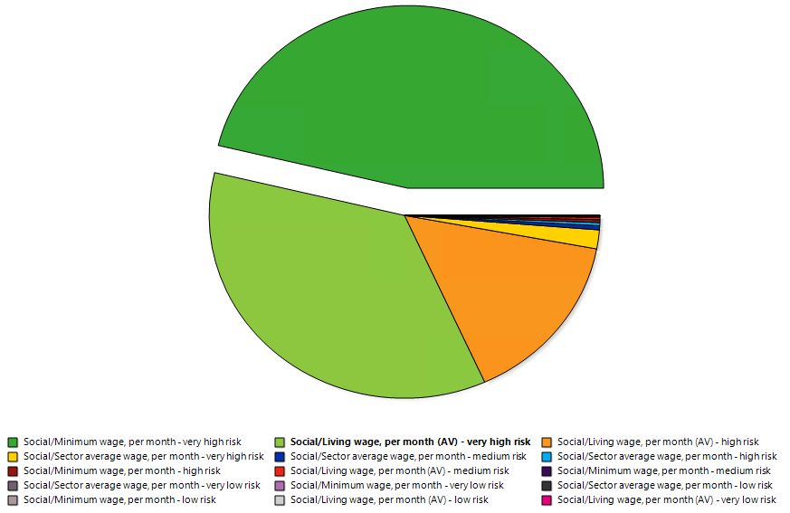
Figure 2. SAF Phase: Fair salary contributors by Substance

A3.2.2 Fair Salary Key Contributors by Process
Figure 3 shows that in the SAF production phase, the highest social risk related to fair salary arises from Industries – Fluid power process machinery (USA) at 8.33%, followed by Industries – Other general-purpose machinery (USA), contributing 6.94%, reflecting wage-related risks embedded in the supply of specialized equipment. For straw cultivation, the leading contributor is Industries – Organic growing of wheat (GBR) at 4.18%, with Commodities – Crop cultivation (CHN) contributing 2.78%, indicating both local agricultural labour and international upstream inputs as relevant sources of wage-related social concerns. For the road freight phase, Industries – Freight transport by road (GBR) is the dominant contributor, accounting for 12.5% of the total social risk, indicating that domestic logistics operations carry substantial social burdens, particularly related to labour conditions, wage structures, and public service reliance within the UK transport sector.
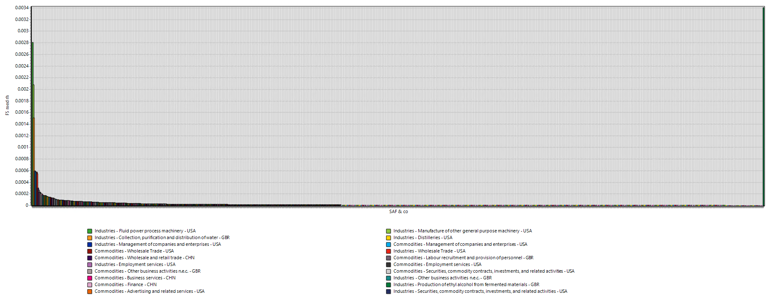
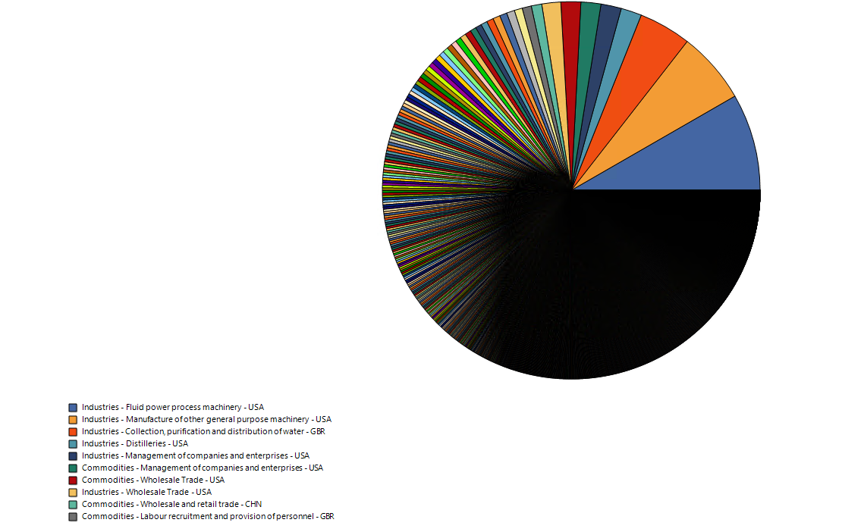
Figure 3. SAF Phase: Fair salary contributors by Process

A3.2.3 Safety Measure Contributors by Substance
The chart in Figure 4 shows that the most significant contributors to safety measure-related social risks in the SAF & co is linked to very high- and high-risk categories for presence of sufficient safety measures, indicating high safety related concerns. Minor contributions from low and very low risk categories suggest that only a small portion of the workforce involved are not exposed to safety related concerns and may be office based. The wheat cultivation and road freight phases follow the same pattern by the SAF & co.
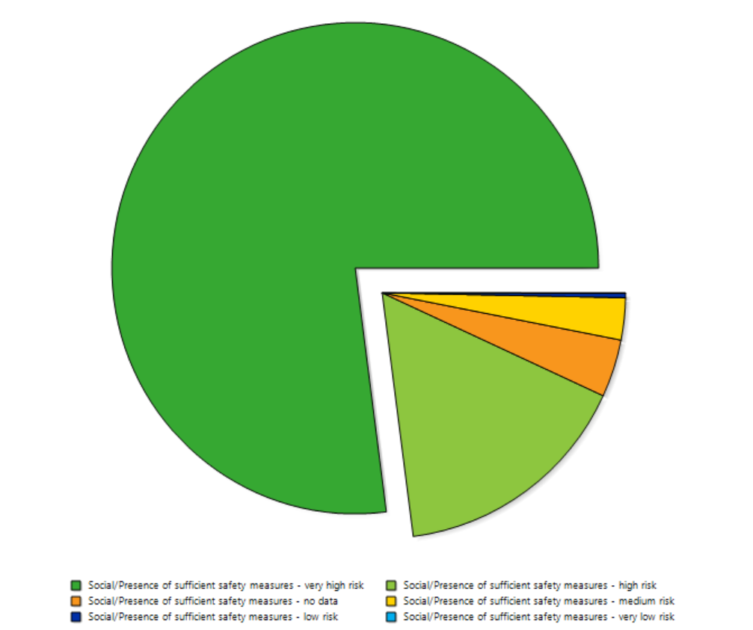
Figure 4. SAF Phase: Safety measures contributors by Substance

A3.2.4 Safety Measure Key Contributors by Process
In the SAF production phase, Commodities – Crop Cultivation (CHN) and Industries – Storage and warehousing (GBR) contribute the largest share of social risk at 11.11% each, as shown in Figure 5 reflecting persistent occupational safety risks associated with primary production in developing regions and the domestic feedstock handling. This is followed by Commodities and Industries – Installation of electrical wiring and fittings (GBR), contributing 2.78%, indicating potential concerns related to labour conditions and safety within domestic electrical component manufacturing. In the wheat cultivation phase, Commodities – Crop Cultivation (CHN) again emerges as the dominant contributor, with a substantially higher share of 37.5%, suggesting intensified safety-related risks in agricultural supply chains. The remaining contributions in this phase are more evenly distributed across various sectors. In the road freight phase, Commodities – Crop Cultivation (CHN) accounts for 12.5% of the social risk, with an additional 12.5% collectively attributed to Commodities and Industries – Manufacture of other plastic products (GBR). This indicates that social risks in road freight are influenced by both upstream agricultural inputs from regions with limited labour protections and domestic industrial processes, highlighting the interplay of global and local factors in shaping overall social performance.
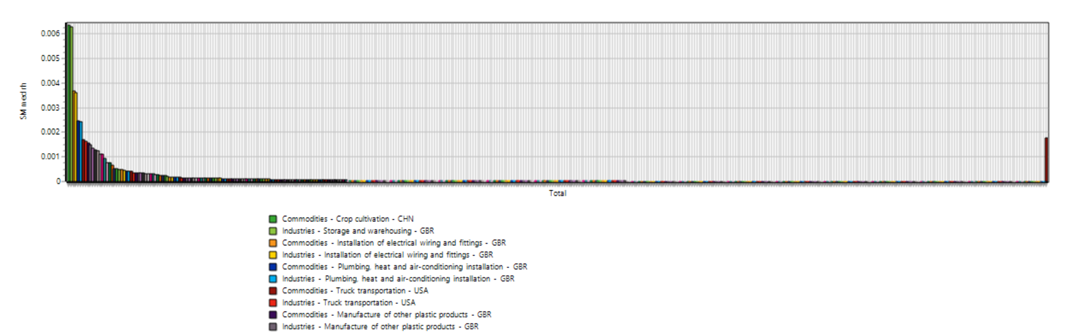

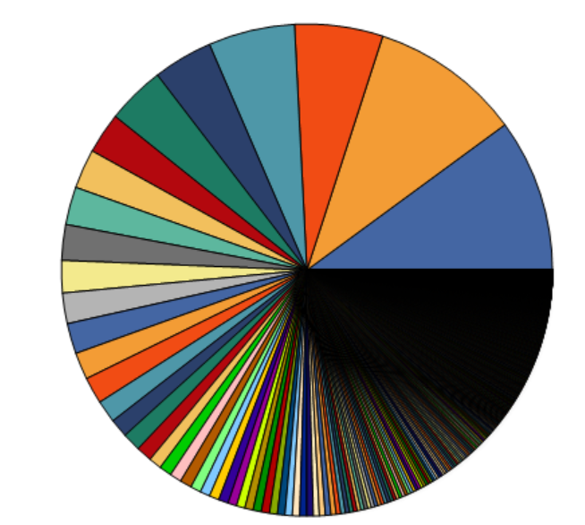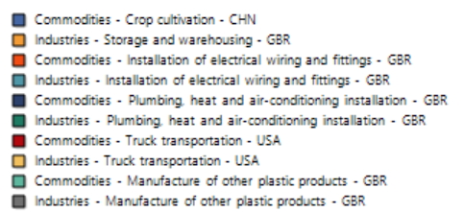
Figure 5. SAF Phase: Safety measures contributors by Process

A3.2.5 Social security expenditure comparison by Substance
Figure 6 shows that the most significant contributors to social security-related social risks in the SAF & co is primarily linked to very high-risk categories, accounting for 72.22% of the total social risk associated with social security expenditures. This indicates a substantial burden on public welfare systems in regions supplying equipment and agricultural inputs, likely due to inadequate employer contributions or weak national social protection schemes. The remaining share is contributed by high- and medium-risk categories and without contribution from low risk and very low-risk, which suggests that a significant portion of the supply chain still operates in contexts where social safety nets are either underfunded or inconsistently enforced, posing systemic socioeconomic vulnerabilities. The same pattern is followed by wheat cultivation and road freight phases.
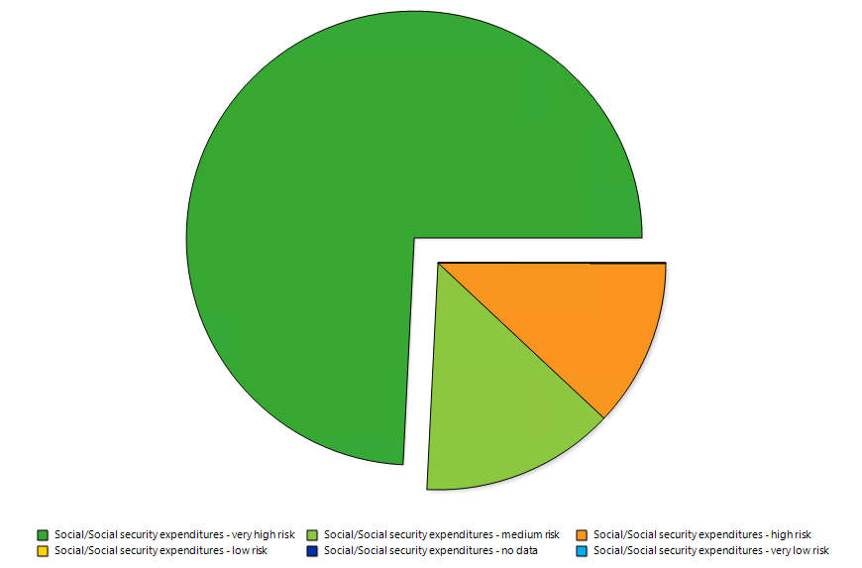
Figure 6. SAF Phase: Social security contributors by Substance

A3.2.6 Social Security Expenditure: Key Contributors by Process
In the SAF production phase, the largest share, at 2.78% each of the total social risk contribution related to social security expenditure is attributed to Industries – Collection, purification and distribution of water (GBR), Industries – Banking (IND), Commodities – Banking (IND), Commodities – Trade (IND), and Industries – Trade (IND) as shown in Figure 7. This indicates a broad distribution of social risk across essential services and global trade and financial sectors, reflecting systemic gaps in employer social contributions or inadequate national social protection frameworks in both high- and middle-income economies. In contrast, the crop cultivation phase is dominated by Commodities – Other crops (IND) and Industries – Other crops (IND), each contributing 5.56%, which signifies in the supply chain, a more concentrated risk profile within the Indian agricultural sector, highlighting structural weaknesses in social security provision for agricultural labour, particularly in regions with informal employment and limited access to welfare support. In the road freight stage, the largest contributor to social risk is Industries – Freight transport by road (GBR), accounting for 5.56%, followed by evenly distributed contributions from Commodities & Industries – Trade (IND), Commodities – Business Services (MYS), and Industries & Commodities – Banking (IND). This indicates that while domestic logistics operations in the UK carry notable social risks, likely linked to labour conditions, wages, and service demands, there is also a significant influence from international trade, financial, and service sectors, particularly in developing economies. This distribution highlights the interconnected nature of global supply chains, where both local and upstream international sectors contribute to the overall social risk profile.
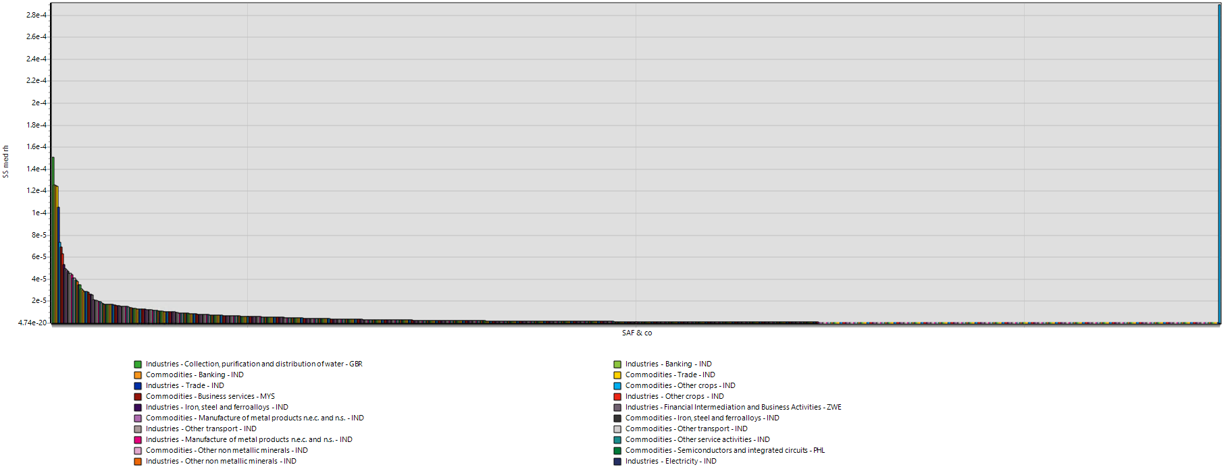
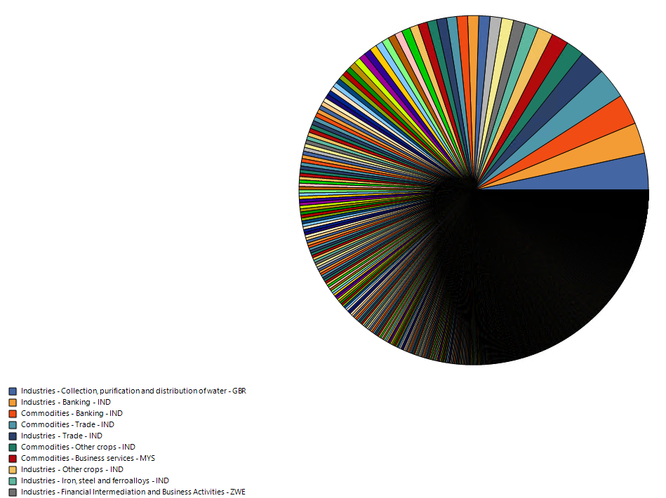
Figure 7. SAF Phase: Social security expenditure contributors by process

A3.2.7 Education Expenditure Contributors Comparison by Substance
For the SAF production phase, Figure 8 shows that the major contributor to social risk related to expenditure on education is the high-risk category at 72.22%, followed by medium-risk at 25%, with very high-risk contributing only marginally. This signifies that the social risk is primarily concentrated in regions where public investment in education is insufficient but not critically deficient, particularly within industrial supply chains requiring technical expertise. In comparison, the crop cultivation phase exhibits a medium-risk contribution that is 2.78% higher than in the SAF phase, while the high-risk contribution is 2.78% lower, indicating a modest shift in the social risk profile toward regions with slightly more robust but still inadequate educational infrastructure, likely reflective of rural agricultural contexts in developing economies within the supply chain. The high-risk and medium-risk categories contribute 55.56% and 44.44%, respectively, while the very high-risk category accounts for only 5.56%, and all other categories contribute negligibly to the total social risk in the road freight sector. This indicates that most social risks are concentrated in regions with moderately to significantly inadequate social systems, such as limited access to healthcare, education, or social security, rather than in critically underdeveloped areas. It suggests that while extreme deprivation is less prevalent, systemic gaps in social protection across key parts of the logistics supply chain still pose meaningful challenges that require policy attention and corporate responsibility measures.
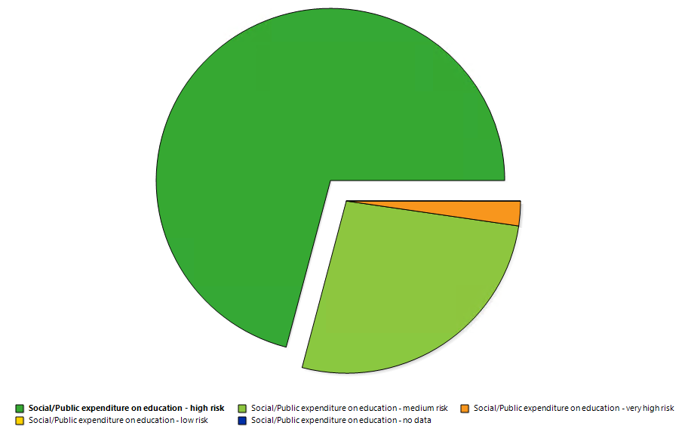
Figure 8. SAF Phase: Education expenditure contributors by substance

A3.2.8 Education Expenditure Key Contributors by Process
In the SAF production phase, as shown in Figure 9 the largest share of the total social risk contribution related to education expenditure is attributed to Industries – Collection, purification and distribution of water (GBR) responsible for 8.33% of total social risk, followed by Industries – Manufacture of other general-purpose machinery (USA) and Industries – Electric power generation transmission and distribution (USA), each contributing 5.56% . This indicates a broad distribution of education-related social risks across essential service sectors and high-value manufacturing supply chains, suggesting potential underinvestment in workforce development even within high-income economies, where advanced technical skills are required but not always supported by equitable access to education. In contrast, the crop cultivation phase is dominated by Industries – Organic: Growing of wheat (GBR) at 6.94%, followed by Commodities & Industries – Other crops (IND) and Industries – Mining and quarrying (energy) (RUS), each at 1.38%, indicating a more localized concentration of educational social risk within agricultural sectors and upstream resource inputs, likely reflecting structural challenges in ensuring consistent educational investment across rural and extractive industry regions. In the road freight phase, Industries – Freight transport by road (GBR) contributes as much as 16.67% of the overall social risk, highlighting significant domestic pressures related to labour conditions, wage structures, and occupational health within the UK logistics sector. This is followed by Industries – Coke, refined petroleum products and nuclear fuel (RUS) and Industries – Mining and quarrying (energy) (RUS), indicating that upstream energy-intensive industries in Russia also play a notable role in driving social risks, likely due to their association with hazardous working conditions and limited social protection in extractive operations.

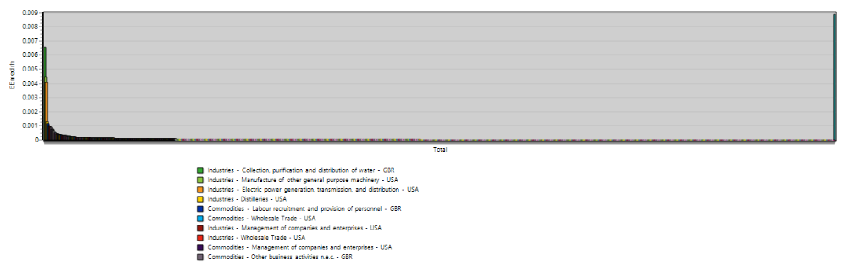
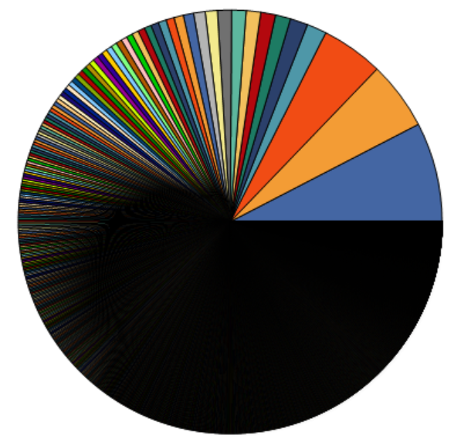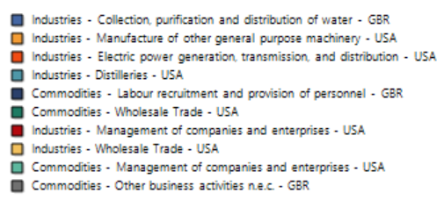
Figure 9. SAF Phase: Education expenditure contributors by process

A3.2.9 Health Expenditure Contribution by Substance
In the SAF production phase, Figure 10 indicates that the primary contributor to social risk related to health expenditure is the very high-risk category for out-of-pocket spending, accounting for 55.6%, followed by high-risk total health expenditure at 12.5%, with moderate contributions from high-risk out-of-pocket and medium-risk total expenditure. This suggests that the social risk is concentrated in regions where public healthcare investment is limited, leading to a reliance on personal spending to access health services, posing a substantial burden on workers despite not being critically deficient at a systemic level. The crop cultivation phase exhibits a similar trend, with out-of-pocket very high-risk contributing approximately 62.5%, indicating a shift toward regions with slightly weaker health infrastructure, particularly in rural agricultural settings within developing countries, where limited access to affordable healthcare heightens vulnerability across the supply chain. In the road freight phase, the very high-risk out-of-pocket health expenditure contributes nearly 42.22%, followed by contributions from medium-risk total expenditure and high-risk out-of-pocket expenditure. This signifies a pronounced lack of accessible and affordable healthcare services within parts of the supply chain, particularly in regions where individuals must bear a significant share of medical costs directly. Such a pattern reflects systemic gaps in public healthcare infrastructure and employer-provided health benefits, posing considerable social risks for workers involved in logistics and related upstream sectors.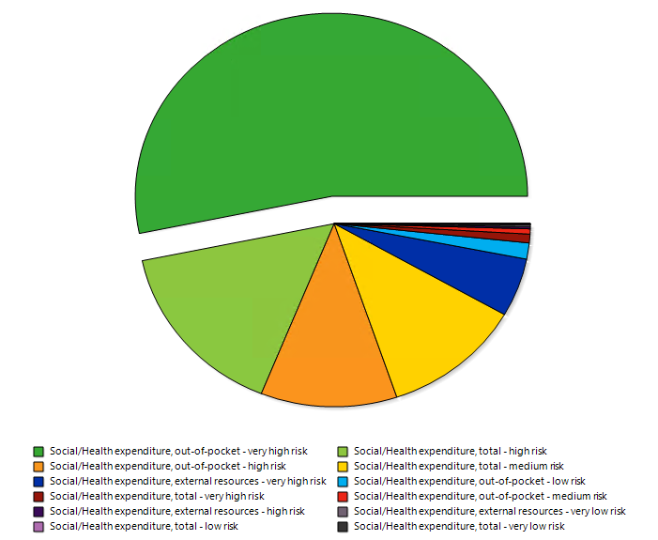
Figure 10. SAF Phase: Health expenditure contributors by substance

A3.2.10 Health Expenditure - Key Contributors by Process
In the SAF production phase, as per Figure 11, the largest shares of total social risk related to health expenditure are attributed to Industries – Collection, purification and distribution of water (GBR), Industries – Banking (IND), Commodities – Trade (IND) and Industries – Trade (IND), each contributing approximately 2.78%. This reflects a broad distribution of health-related social risks across essential public services in high-income economies and commercial sectors in emerging markets, suggesting that even within advanced economies, essential services may face underfunding, while in developing contexts, trade-related sectors may lack adequate health protections for workers. Similarly, in the crop cultivation phase, excluding essential services from GBR, the dominant contributors are Commodities & Industries – Other crops (IND), each contributing around 5.56%, likely indicating persistent health-related vulnerabilities within the agricultural workforce in developing countries, particularly across rural regions with limited healthcare infrastructure and social protections. For the road freight phase, the biggest contributor to health expenditure-related social risk is Industries – Freight transport by road (GBR) at 6.94%, followed by Commodities & Industries – Trade (IND). This signifies that a substantial portion of health-related social risks originate from the UK’s domestic logistics sector, likely due to occupational health concerns, limited employer-provided healthcare coverage, or high exposure to work-related stress and injuries. The contribution from trade sectors in India further highlights the extended health vulnerabilities embedded in global supply chains, particularly in regions where access to affordable healthcare remains constrained for workers in commercial and service-related industries.
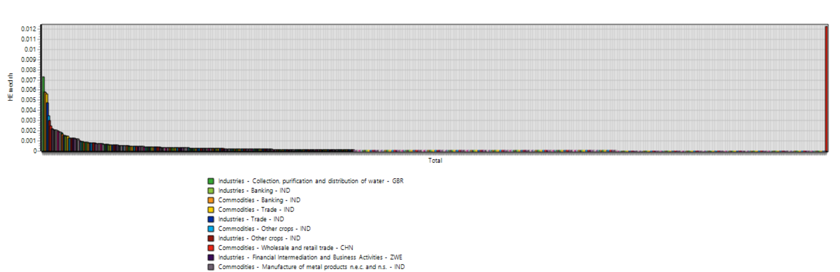

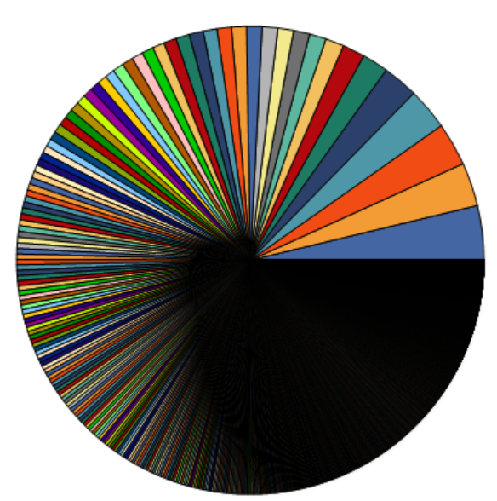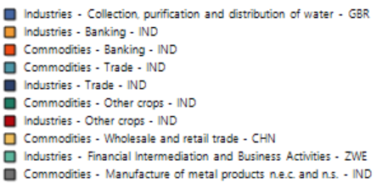
Figure 11. SAF Phase: Health expenditure contributors by Process

A3.3 Social Risk Geographic Distribution
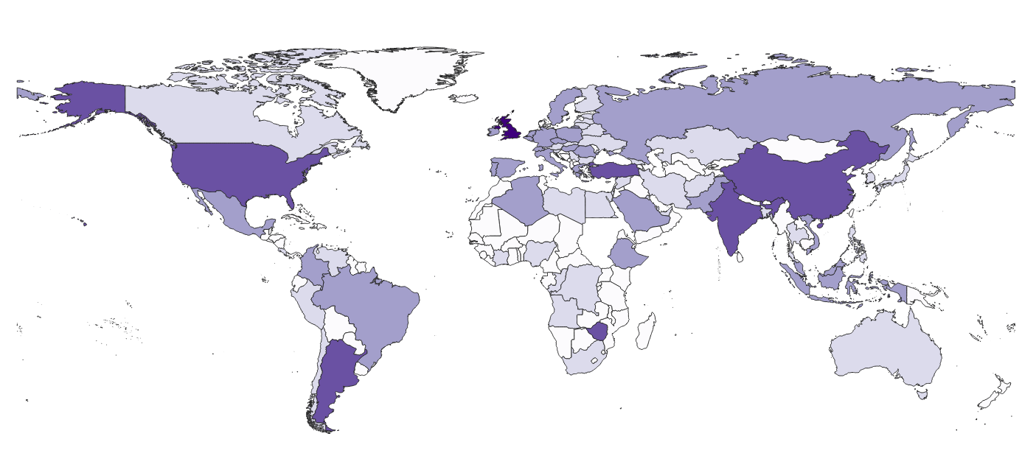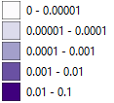

Figure 12. Geographic distribution of SAF process contributions to Safety Measures risks
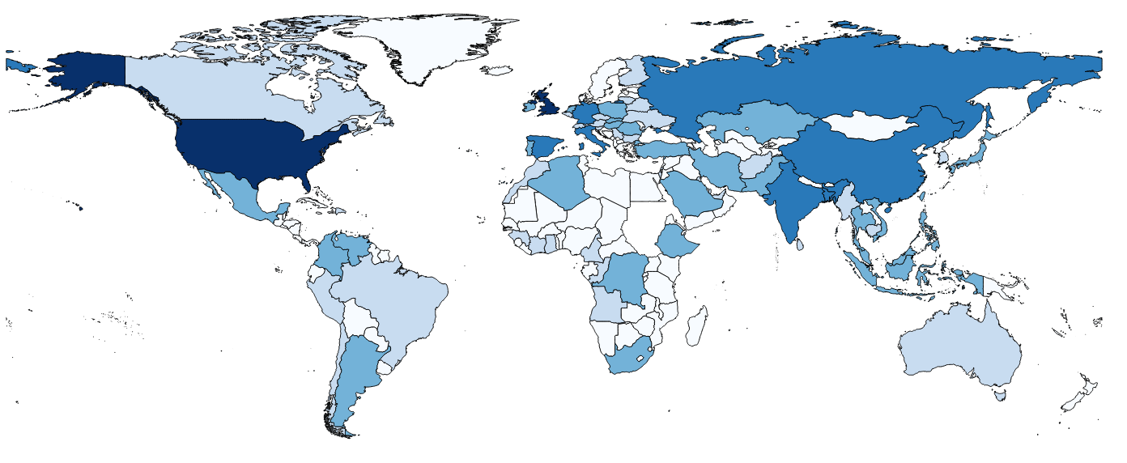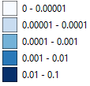

Figure 13. Geographic distribution of SAF process contributions to Education Expense risks

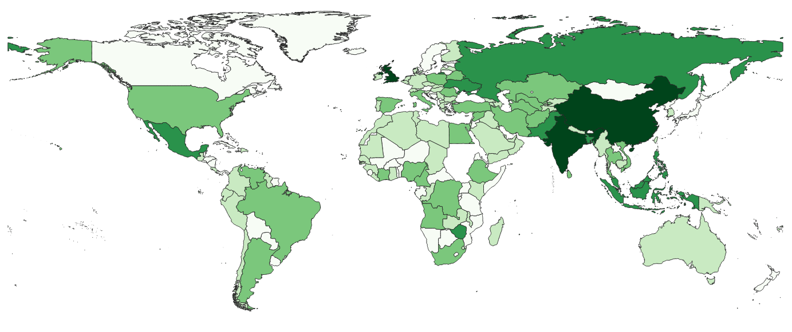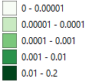
Figure 14. Geographic distribution of SAF process contributions to Health Expense risks

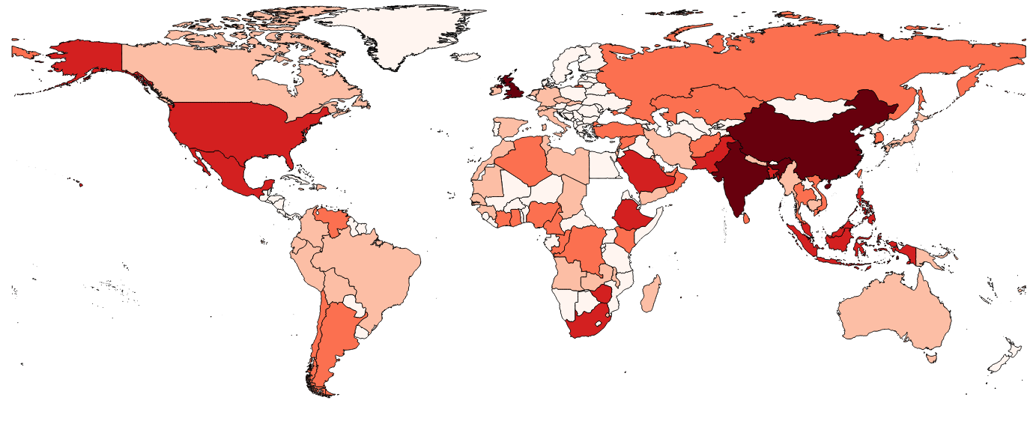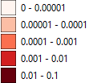
Figure 15. Geographic distribution of SAF process contributions to Social Security Expense risks

A4.0 Aspen Plus Model Validation

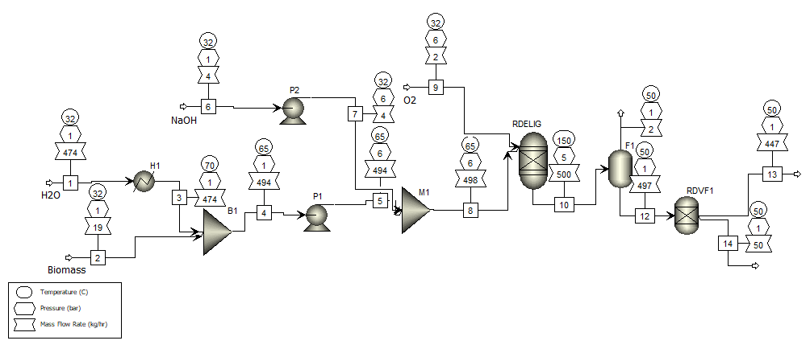
Figure 16. Aspen Plus simulation model of oxygen delignification pre-treatment unit (Validation of Calderon’s experimental studies)
Table 10. Mass balance of oxygen delignification pre-treatment unit (Validation of Calderon’s experimental studies)
Components | Streams | 1 | 2 | 4 | 6 | 8 | 10 | 11 | 12 | 13 | 14
Total Mass flows | Kg/h | 474.47 | 19.10 | 493.57 | 4.00 | 497.57 | 499.57 | 2.15 | 497.42 | 447.12 | 50.29
H2O | kg/hr | 474.47 | 1.47 | 475.94 | 2 | 477.94 | 477.94 | 0.13 | 477.82 | 437.20 | 40.61
H2O-C |  | 474.47 | 1.47 | 475.94 | 2 | 477.94 | 477.94 | 0.17 | 477.77 | 434.11 | 43.66
Dev |  | 0 | 0 | 0 | 0 | 0 | 0 | -0.22 | 0.00 | -0.01 | -0.07
GLUCOSE | kg/hr | 0 | 0 | 0 | 0 | 0 | 0 | 0 | 0 | 0 | 0
GLUCOSE-C |  | 0 | 0 | 0 | 0 | 0 | 0 | 0 | 0 | 0 | 0
Dev |  | 0 | 0 | 0 | 0 | 0 | 0 | 0 | 0 | 0 | 0
XYLOSE | kg/hr | 0 | 0 | 0 | 0 | 0 | 0 | 0 | 0 | 0 | 0
XYLOSE-C |  | 0 | 0 | 0 | 0 | 0 | 0 | 0 | 0 | 0 | 0
Dev |  | 0 | 0 | 0 | 0 | 0 | 0 | 0 | 0 | 0 | 0
ARABINOS | kg/hr | 0 | 0 | 0 | 0 | 0 | 0 | 0 | 0 | 0 | 0
ARABINOS-C |  | 0 | 0 | 0 | 0 | 0 | 0 | 0 | 0 | 0 | 0
Dev |  | 0 | 0 | 0 | 0 | 0 | 0 | 0 | 0 | 0 | 0
GALCATOS | kg/hr | 0 | 0 | 0 | 0 | 0 | 0 | 0 | 0 | 0 | 0
GALACTOS-C |  | 0 | 0 | 0 | 0 | 0 | 0 | 0 | 0 | 0 | 0
Dev |  | 0 | 0 | 0 | 0 | 0 | 0 | 0 | 0 | 0 | 0
MANNOSE | kg/hr | 0 | 0 | 0 | 0 | 0 | 0 | 0 | 0 | 0 | 0
MANNOSE-C |  | 0 | 0 | 0 | 0 | 0 | 0 | 0 | 0 | 0 | 0
Dev |  | 0 | 0 | 0 | 0 | 0 | 0 | 0 | 0 | 0 | 0
LIGNSOL | kg/hr | 0 | 0 | 0 | 0 | 0 | 2.71 | 0.0 | 2.69 | 2.446 | 0.23
LIGNSOL-C |  | 0 | 0 | 0 | 0 | 0 | 2.71 | 0 | 2.71 | 2.47 | 0.25
Dev |  | 0 | 0 | 0 | 0 | 0 | 0 | 0 | -0.01 | 0 | -0.09
GLUCOLIG | kg/hr | 0 | 0 | 0 | 0 | 0 | 1.85 | 0 | 1.85 | 1.69 | 0.16
GLUCOLIG-C |  | 0 | 0 | 0 | 0 | 0 | 1.85 | 0 | 1.85 | 1.68 | 0.17
Dev |  | 0 | 0 | 0 | 0 | 0 | 0 | 0 | 0 | 0.01 | -0.06
XYLOSEOL | kg/hr | 0 | 0 | 0 | 0 | 0 | 1.69 | 0 | 1.69 | 1.55 | 0.14
XYLOSEOL-C |  | 0 | 0 | 0 | 0 | 0 | 1.69 | 0 | 1.69 | 1.54 | 0.15
Dev |  | 0 | 0 | 0 | 0 | 0 | 20 | 0 | 0 | 0 | 0
ARABINOL | kg/hr | 0 | 0 | 0 | 0 | 0 | 0.43 | 0 | 0.43 | 0.39 | 0.04
ARABINOL-C |  | 0 | 0 | 0 | 0 | 0 | 0.43 | 0 | 0.43 | 0.39 | 0.04
Dev |  | 0 | 0 | 0 | 0 | 0 | 0 | 0 | 0 | 0 | 0
GALACTOL | kg/hr | 0 | 0 | 0 | 0 | 0 | 0.15 | 0 | 0.15 | 0.14 | 0.01
GALACTOL-C |  | 0 | 0 | 0 | 0 | 0 | 0.15 | 0 | 0.15 | 0.14 | 0.01
Dev |  | 0 | 0 | 0 | 0 | 0 | 0 | 0 | 0 | 0 | 0
MANNOSOL | kg/hr | 0 | 0 | 0 | 0 | 0 | 0.16 | 0 | 0.16 | 0.15 | 0.01
MANNOSOL-C |  | 0 | 0 | 0 | 0 | 0 | 0.16 | 0 | 0.16 | 0.14 | 0.01
Dev |  | 0 | 0 | 0 | 0 | 0 | 0 | 0 | 0 | 0.07 | 0
EXTRASOL | kg/hr | 0 | 0 | 0 | 0 | 0 | 1.47 | 0 | 1.47 | 1.35 | 0.12
EXTRASOL-C |  | 0 | 0 | 0 | 0 | 0 | 1.47 | 0 | 1.47 | 1.34 | 0.13
Dev |  | 0 | 0 | 0 | 0 | 0 | 0 | 0 | 0 | 0 | 0
ASHSOL | kg/hr | 0 | 0 | 0 | 0 | 0 | 0.37 | 0 | 0.37 | 0.37 | 0
ASHOL-C |  | 0 | 0 | 0 | 0 | 0 | 0.37 | 0 | 0.37 | 0.37 | 0
Dev |  | 0 | 0 | 0 | 0 | 0 | 0 | 0 | 0 | 0 | 0
NAOH | kg/hr | 0 | 0 | 0 | 2 | 2 | 2 | 0 | 2 | 1.83 | 0.17
NAOH-C |  | 0 | 0 | 0 | 2 | 2 | 2 | 0 | 2 | 1.82 | 0.18
Dev |  | 0 | 0 | 0 | 0 | 0 | 0 | 0 | 0 | 0.01 | -0.06
GLUCAN | kg/hr | 0 | 7.17 | 7.17 | 0 | 7.17 | 5.32 | 0 | 5.32 | 0 | 5.32
GLUCAN-C |  | 0 | 7.17 | 7.17 | 0 | 7.17 | 5.32 | 0 | 5.32 | 0 | 5.32
Dev |  | 0 | 0 | 0 | 0 | 0 | 0 | 0 | 0 | 0 | 0
XYLAN | kg/hr | 0 | 4.02 | 4.02 | 0 | 4.02 | 2.33 | 0 | 2.33 | 0 | 2.33
XYLAN-C |  | 0 | 4.02 | 4.02 | 0 | 4.02 | 2.33 | 0 | 2.33 | 0 | 2.33
Dev |  | 0 | 0 | 0 | 0 | 0 | 0 | 0 | 0 | 0 | 0
ARABINAN | kg/hr | 0 | 0.65 | 0.65 | 0 | 0.65 | 0.21 | 0 | 0.21 | 0 | 0.21
ARABINAN |  | 0 | 0.65 | 0.65 | 0 | 0.65 | 0.21 | 0 | 0.21 | 0 | 0.21
Dev |  | 0 | 0 | 0 | 0 | 0 | 0 | 0 | 0 | 0 | 0
GALACTAN | kg/hr | 0 | 0.19 | 0.19 | 0 | 0.19 | 0.03 | 0 | 0.03 | 0 | 0.03
GALACTAN-C |  | 0 | 0.19 | 0.19 | 0 | 0.19 | 0.03 | 0 | 0.03 | 0 | 0.03
Dev |  | 0 | 0 | 0 | 0 | 0 | 0 | 0 | 0 | 0 | 0
MANNAN | kg/hr | 0 | 0.16 | 0.16 | 0 | 0.16 | 0 | 0 | 0 | 0 | 0
MANNAN-C |  | 0 | 0.16 | 0.16 | 0 | 0.16 | 0 | 0 | 0 | 0 | 0
Dev |  | 0 | 0 | 0 | 0 | 0 | 0 | 0 | 0 | 0 | 0
LIGNIN | kg/hr | 0 | 3.17 | 3.17 | 0 | 3.17 | 0.46 | 0 | 0.46 | 0 | 0.46
LIGNIN-C |  | 0 | 3.17 | 3.17 | 0 | 3.17 | 0.46 | 0 | 0.46 | 0 | 0.46
Dev |  | 0 | 0 | 0 | 0 | 0 | 0 | 0 | 0 | 0 | 0
EXTRACT | kg/hr | 0 | 1.47 | 1.47 | 0 | 1.47 | 0 | 0 | 0 | 0 | 0
EXTRACT-C |  | 0 | 1.47 | 1.47 | 0 | 1.47 | 0 | 0 | 0 | 0 | 0
Dev |  | 0 | 0 | 0 | 0 | 0 | 0 | 0 | 0 | 0 | 0
ASH | kg/hr | 0 | 0.8 | 0.8 | 0 | 0.8 | 0.44 | 0 | 0.44 | 0 | 0.44
ASH-C |  | 0 | 0.8 | 0.8 | 0 | 0.8 | 0.44 | 0 | 0.44 | 0 | 0.44
Dev |  | 0 | 0 | 0 | 0 | 0 | 0 | 0 | 0 | 0 | 0
OXYGEN | kg/hr | 0 | 0 | 0 | 0 | 0 | 2 | 2 | 0 | 0 | 0
OXYGEN-C |  | NA | NA | NA | NA | NA | NA | NA | NA | NA | NA
Dev
CELLULAS | kg/hr | 0 | 0 | 0 | 0 | 0 | 0 | 0 | 0 | 0 | 0
CELLULAS-C |  | 0 | 0 | 0 | 0 | 0 | 0 | 0 | 0 | 0 | 0
Dev |  | 0 | 0 | 0 | 0 | 0 | 0 | 0 | 0 | 0 | 0

A5.0 Aspen Simulation Stream Table

References for Supplementary Material
1. Parliament., U.C.C.C.P.R.t., How significant are the UK’s aviation emissions? House of Commons Library, 2022.
2. (DfT), D.f.T., Delivering Net Zero Aviation by 2050. UK Government, 2022.
3. Han, J.W., L. Tao, and M. Wang, Well-to-wake analysis of ethanol-to-jet and sugar-to-jet pathways. Biotechnology for Biofuels, 2017. 10: p. 15.
4. Geleynse, S., et al., The Alcohol-to-Jet Conversion Pathway for Drop-In Biofuels: Techno-Economic Evaluation. Chemsuschem, 2018. 11(21): p. 3728-3741.
5. Bauen, A., et al., Sustainable Aviation Fuels Status, challenges and prospects of drop-in liquid fuels, hydrogen and electrification in aviation. Johnson Matthey Technology Review, 2020. 64(3): p. 263-278.
6. Transport, T.C.I.o.L.a. DfT Share Update on SAF Plans Amid Rising EU Aviation Emissions. 2025; Available from: https://ciltuk.org.uk/News/Latest-News/ArtMID/6887/ArticleID/38023/Transport-Secretary-updates-SAF-plans-as-report-shows-Europe%E2%80%99s-aviation-emissions-rise-to-near-pre-Covid-highs.
7. Airways, B. UK moves a step closer to aviation decarbonisation as British Airways, Nova Pangaea Technologies and Lanzajet’s ‘Project Speedbird’ wins £9m government funding. 17/Nov/2023 05/Aug/2025]; Available from: https://mediacentre.britishairways.com/pressrelease/details/18264.
8. Lanzajet. LanzaJet technology to be deployed across three different projects in the UK. 08/Apr/2021; Available from: https://www.lanzajet.com/news-insights/lanzajet-technology-to-be-deployed-across-three-different-projects-in-the-uk-to-meet-growing-demand-for-sustainable-aviation-fuels.
9. Erin Searcy , J.R.H., JayaShankar Tumuluru, Leslie Ovard , David J. Muth , Erik Trømborg , Michael Wild , Michael Deutmeyer, Lars Nikolaisen , Tapio Ranta , and Ric Hoefnagels, Optimization of Biomass Transport and Logistics. Springer Science+Business Media Dordrecht, 2014. Chapter 5.
10. Zhu, J.Y. and X.J. Pan, Woody biomass pretreatment for cellulosic ethanol production: Technology and energy consumption evaluation. Bioresource Technology, 2010/07/01. 101(13).
11. Yang, B. and C.E. Wyman, Pretreatment: the key to unlocking low‐cost cellulosic ethanol. Biofuels, Bioproducts and Biorefining, 2008/01/01. 2(1).
12. Calderon, O.R., PhD Thesis: Economic feasibility of lignocellulosic ethanol production with enzyme recycling, in Department of Chemical and Biological Engineering. The University of Columbia, Vancouver: 2014.
13. Ma, Q., et al., Oxidative delignification: The roles of lignin reactivity and accessibility. JOURNAL OF CLEANER PRODUCTION, 2022. 363.
14. Saha, B.C., et al., Pilot scale conversion of wheat straw to ethanol via simultaneous saccharification and fermentation. Bioresource Technology, 2015/01/01. 175.
15. Olsson, L. and B. Hahn-Hägerdal, Fermentation of lignocellulosic hydrolysates for ethanol production. Enzyme and Microbial Technology, 1996/04/01. 18(5).
16. D. Humbird, R.D., L. Tao, C. Kinchin, D. Hsu, and A. Aden, Process Design and Economics for Biochemical Conversion of Lignocellulosic Biomass to Ethanol: Dilute-Acid Pretreatment and Enzymatic Hydrolysis of Corn Stover. NREL, 2011.
17. van den Brink, J., et al., Fungal enzyme sets for plant polysaccharide degradation. Applied Microbiology and Biotechnology 2011 91:6, 2011-07-23. 91(6).
18. D, K.-M., et al., The challenge of enzyme cost in the production of lignocellulosic biofuels - PubMed. Biotechnology and bioengineering, 2012 Apr. 109(4).
19. McCarty, P.L., J. Bae, and J. Kim, Domestic Wastewater Treatment as a Net Energy Producer–Can This be Achieved? Environmental Science & Technology, July 26, 2011. 45(17).
20. Thomas Steinwinder, E.G., Matthew Gerhardt, Process Design of Wastewater Treatment for the NREL Cellulosic Ethanol Model. NREL, 2011. SR-5100-51838.
21. Tao, L., et al., Techno-economic analysis for upgrading the biomass-derived ethanol-to-jet blendstocks. Green Chemistry, 2017. 19(4): p. 1082-1101.
22. NETL, Gas Turbine Baseline Current and Future Technologies for NGCC Power Plants. U.S. Department of Energy, 2013. DOE/NETL-341/061013.
23. Miller, B.G. and D.A. Tillman, Combustion Engineering Issues for Solid Fuel Systems. 2008.
24. Faaij, A. and A. Faaij, Modern Biomass Conversion Technologies. Mitigation and Adaptation Strategies for Global Change 2006 11:2, 2006-05-16. 11(2).
25. Mohsenzadeh, A., A. Zamani, and M.J. Taherzadeh, Bioethylene Production from Ethanol: A Review and Techno‐economical Evaluation. ChemBioEng Reviews, 2017/04/01. 4(2).
26. Kagyrmanova, A.P., et al., Catalytic dehydration of bioethanol to ethylene: Pilot-scale studies and process simulation. Chemical Engineering Journal, 2011/12/01. 176-177.
27. Sydora, O.L., Selective Ethylene Oligomerization. Organometallics, February 18, 2019. 38(5).
28. Agapie, T., Selective ethylene oligomerization: Recent advances in chromium catalysis and mechanistic investigations. Coordination Chemistry Reviews, 2011/04/01. 255(7-8).
29. Finiels, A., et al., Nickel-based solid catalysts for ethylene oligomerization – a review. Catalysis Science & Technology, 2014/07/07. 4(8).
30. Lilonfe, S., et al., Comparative techno-economic and life cycle analyses of synthetic "drop-in" fuel production from UK wet biomass. Chemical Engineering Journal, 2024. 479.
31. Alawisi, H., H.D. Arman, and Z.J. Tonzetich, Catalytic Hydrogenation of Alkenes and Alkynes by a Cobalt Pincer Complex: Evidence of Roles for Both Co(I) and Co(II). Organometallics, March 15, 2021. 40(8).
32. William L. Luyben, I.-L.C., Design and Control of Distillation Systems for Separating Azeotropes. 2010.
33. Fraunhofer, Cost forecast for low temperature electrolysis - Technology Driven Bottom-up Prognosis for PEM and Alkaline Water Electrolysis System. Fraunhofer Institute for Solar Energy Systems ISE, 2021.
34. Turner, J.A., A Realizable Renewable Energy Future. Science, 1999-7-30. 285(5428).
35. Gottesfeld, S., et al., Anion exchange membrane fuel cells: Current status and remaining challenges. Journal of Power Sources, 2018/01/31. 375.
36. André F. Young, H.G.D.V., Leonardo S. Araujo, Luciano S. C. Raptopoulos, and Max S. Dutra, Detailed Design and Economic Evaluation of a Cryogenic Air Separation Unit with Recent Literature Solutions. I&EC Research, 2021.
37. Kübra Laçın, B.B., Cryogenic Separation - an overview | ScienceDirect Topics. Energy Conversion and Management, 2018. 171.
38. Seufitelli, G.V.S., et al., Techno-economic analysis of an integrated biorefinery to convert poplar into jet fuel, xylitol, and formic acid. Biotechnology for Biofuels and Bioproducts, 2022. 15(1).
39. A. Aden, M.R., K. Ibsen, J. Jechura, K. Neeves, J. Sheehan, and B. Wallace, Lignocellulosic Biomass to Ethanol Process Design and Economics Utilizing Co-Current Dilute Acid Prehydrolysis and Enzymatic Hydrolysis for Corn Stover. NREL, 2002. NREL/TP-510-32438.
40. Kazi, F.K., et al., Techno-economic comparison of process technologies for biochemical ethanol production from corn stover. Fuel, 2010. 89: p. S20-S28.
41. Alisson Aparecido Vitoriano Julio, E.A.O.B., Christian Jeremi Coronado Rodriguez, and J.C.E. Palacio, Exergoeconomic and Environmental Analysis of a Palm Oil Biorefinery for the Production of Bio‑Jet Fuel. Springer - Waste and Biomass Valorization, 2020.
42. CEPCI. The Chemical Engineering Plant Cost Index. 1963; Available from: https://www.chemengonline.com/pci-home.
43. Vela-García, N., et al., Techno-economic and life cycle assessment of triisobutane production and its suitability as biojet fuel. Applied Energy, 2020. 268.
44. Michaga, M.F.R., PhD Thesis: Techno-Economic and Life Cycle Assessment of Jet Fuel Production through various Fischer-Tropsch Pathways, in Department of Mechanical Engineering. University of Sheffield: 2023.
45. Rojas-Michaga, M.F., et al., Sustainable aviation fuel (SAF) production through power-to-liquid (PtL): A combined techno-economic and life cycle assessment. Energy Conversion and Management, 2023. 292.
46. Labor, U.S.D.o. U.S. Bureau of Labor Statistics. 2024; Available from: https://www.bls.gov/.
47. Lamers, P., Strategic supply system design – a holistic evaluation of operational and production cost for a biorefinery supply chain. Biofpr, 2015. Biofuel, Bioprod. Bioref. 9:648–660 (2015).
48. Weekly, F. Straw trading at £120 an acre with demand due to stay high. 2024; Available from: https://www.fwi.co.uk/business/markets-and-trends/input-prices/straw-trading-at-120-an-acre-with-demand-due-to-stay-high?utm_source=chatgpt.com.
49. Davis, R., Biochemical Conversion of Lignocellulosic Biomass to Hydrocarbon Fuels and Products: 2021 State of Technology and Future Research. NREL, 2022. NREL/TP-5100-82512
50. Ji, Y., Kinetics and Mechanism of Oxygen Delignification, in Chemical Engineering. 2007, University of Maine. p. 191.
51. Kun, Z. and H. Feng, Fermentation potentials of Zymomonas mobilis and its application in ethanol production from low-cost raw sweet potato. African Journal of Biotechnology, 2010. 9: p. 6122-6128.
52. Wu, C.-Y. and H.-S. Wu, Ethylene Formation from Ethanol Dehydration Using ZSM-5 Catalyst. ACS Omega, 2017 Aug 7. 2(8).
53. Moon, S., et al., Dehydration of Bioethanol to Ethylene over H-ZSM-5 Catalysts: A Scale-Up Study. Catalysts 2019, Vol. 9, Page 186, 2019-02-16. 9(2).
54. Anekwe, I.M.S., et al., Techno-economic and life-cycle analysis of single-step catalytic conversion of bioethanol to fuel blendstocks over Ni-doped HZSM-5 zeolite catalyst. Energy Conversion and Management: X, 2024/04/01. 22.
55. LESKINEN, P., Catalyst Transition Process, in EUROPEAN PATENT APPLICATION, B. AG, Editor. 2024: UK.
56. Book, C. CAS DataBase List and Cost. 2025 10-Aug-2025]; Available from: https://www.chemicalbook.com/SupplierPriceList_EN.aspx?cbn=CB3854738&c=1kg#price.
57. Franco, A., et al., Recent and Future Advances in Water Electrolysis for Green Hydrogen Generation: Critical Analysis and Perspectives. Sustainability 2023, Vol. 15, Page 16917, 2023-12-17. 15(24).
58. Alamo, G.D., et al., Techno-Economic Analysis of the Production of Liquid Biofuels from Sewage Sludge via Hydrothermal Liquefaction. Energy & Fuels, 2022 Dec 27. 37(2).
59. Volza. Molybdenum Catalyst Imports In World Market Size & Demand Based On Import Trade Data. 2025 10-Aug-2025]; Available from: https://www.volza.com/p/molybdenum-catalyst/import/.
60. AHDB. Straw Market Outlook. 2025; Available from: https://ahdb.org.uk/straw-market-outlook.

