Fluctuating conduit dynamics during the Hrafntinnuhraun rhyolitic fissure eruption, Torfajökull, Iceland
Supplementary Information

Jingwei Zhang¹* · Alastair G. E. Hodgetts² · Marina Godbillot³ ·
Hugh Tuffen*¹ · Dave McGarvie¹ · Fabian B. Wadsworth⁴ ·
Jeremie Vasseur⁴ · Corin Jorgenson⁵ · Katherine J. Dobson⁵ ·
Lucia Gurioli³ · Andrew Harris³ · Simon Falvard³ · Daniel Freyr Sigurbjargarson⁶

- Lancaster Environment Centre, Lancaster University, Lancaster, UK.
- School of GeoSciences, University of Edinburgh, King’s Buildings, Edinburgh, UK.
- Laboratoire Magmas et Volcans, Université Clermont Auvergne, CNRS, IRD, OPGC, Aubière, France.
- Department of Earth and Environmental Sciences, Ludwig-Maximilians-Universität München, Germany.
- Departments of Civil & Environmental Engineering and Chemical & Process Engineering, University of Strathclyde, Glasgow, G1 1XJ, UK.
- Nature Conservation Agency of Iceland, Hvolsvöllur, Iceland.

* j.zhang77@lancaster.ac.uk

List of Supplementary datasets
All supplementary data are provided as a single Excel® spreadsheet, including the following datasets:
- Grain size: total grain size distributions (via sieving), including both data (sheet “GSD_totals”) and GRADISTAT analysis results (sheet “GRADISTAT”);
- Volatile contents: all TGA measurements (sheet “TGA”);
- Geochemistry: all XRF data, including major elements (sheet “XRF_major”) and trace elements (sheet “XRF_trace”).

Complete XRF methodology
We used X-ray Fluorescence (XRF) to characterize modal pumices from layers 2, 5, 8, 11, 13, in order to examine any bulk compositional shifts through the eruption.
Fresh material interior to the clasts was selected where possible to minimize the effects of weathering and alteration. Samples (minimum of 50 g) were crushed using a steel jaw crusher and powdered to a fine homogeneous flour (<75 µm) in an agate mill. For major element analysis, approximately 0.6 g of ignited sample powder was mixed with 6 g of purified lithium metaborate–tetraborate flux and fused to produce homogeneous glass discs. Prior to this, samples were dried at 100◦C in an oven for 24 hours and the flux was kept in a desiccator before disc preparation to remove any adsorbed water. The loss on ignition (LOI) of samples was calculated through weighing the powered sample, heating the powder to 1080◦C for 20 minutes and re-weighing, calculating the difference. Major element concentrations were analyzed using a Panalytical PW2404 wavelength-dispersive sequential X-ray spectrometer at the University of Edinburgh. Results are reported as oxide weight percentages and normalized to 100 wt.% anhydrous where appropriate.
Trace element concentrations were determined from pressed powder pellets prepared by mixing approximately 5–8 g of sample powder with a small quantity of organic binder before pressing under high load to produce stable pellets. These were also analyzed at the University of Edinburgh.
Instrument calibration was performed using a suite of certified international rock reference materials spanning a range of igneous compositions. Analytical precision and accuracy were monitored through repeated analyses of secondary reference materials and procedural duplicates throughout the analytical session. Relative analytical uncertainties were generally better than 2% for major elements and better than 5–10% for most trace elements present at concentrations significantly above their detection limits.

FOAMS image data and nests
Table S1: Scaling ratios associated with the different magnifications used.
Magnification | Imaging method | Scaling ratio (pixel/mm)
n/a | Optical (scanning) | 329
2.5 | Optical (microscopy) | 332
100 | SEM | 1070
500 | SEM | 5400
1000 | SEM | 10700

Figure S2: Images nests used in FOAMS analyses.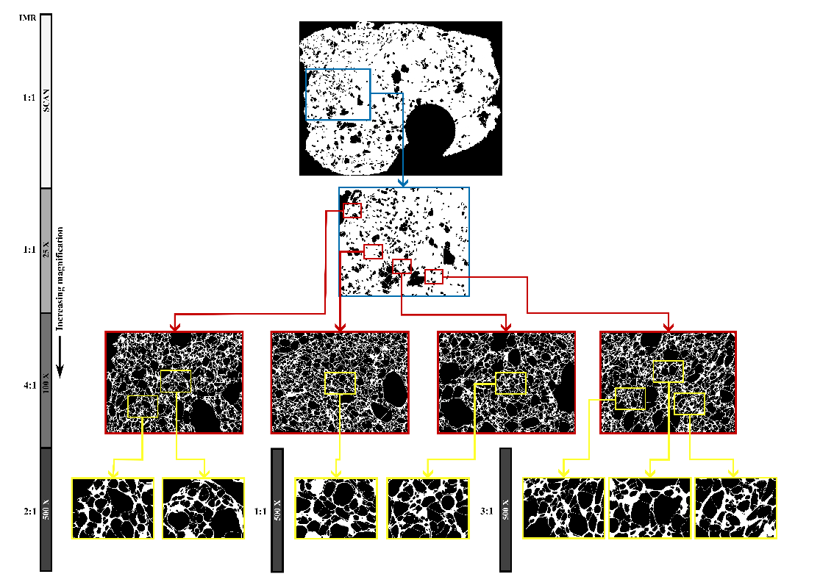
Package 2
(continued)

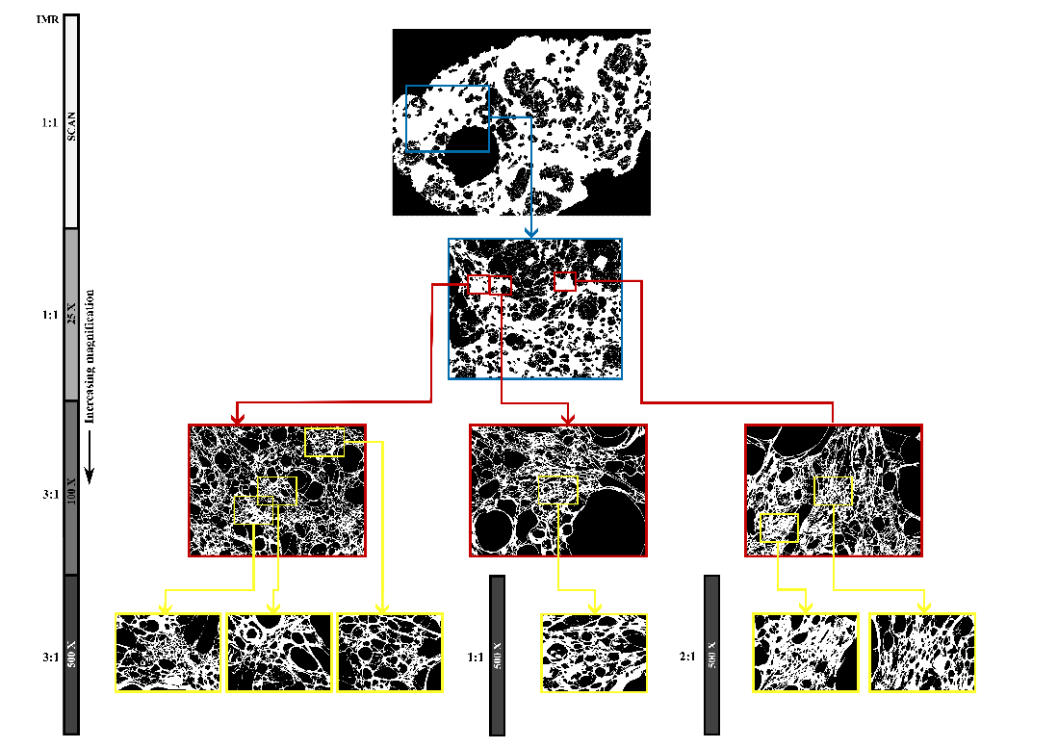
Package 8
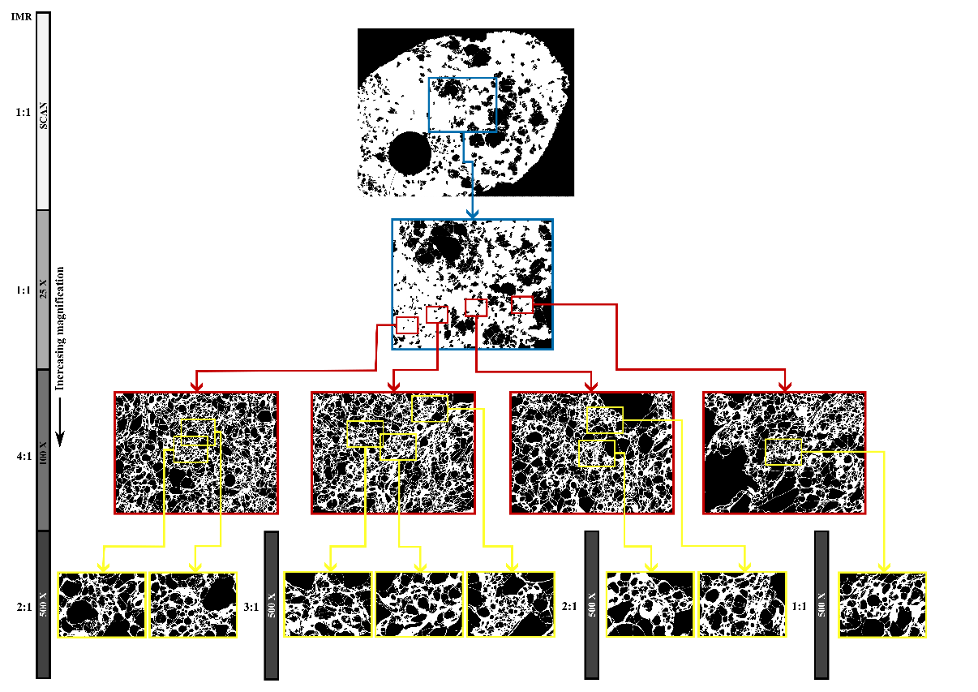
Package 13

Complete XCT methodology
X-ray Computed Tomography (XCT) was used to analyze 3D textures of modal pumices. Cylindrical cores (∼8 mm diameter) from representative pumice clasts from packages 2, 8, 13 were analyzed at the Université Clermont Auvergne Laboratoire Magmas et Volcans, using an RX-Solutions EasyTom tomograph, equipped with a tungsten cathode of 130 kV and 30 uA, for 2.5-3.5 μm/voxel resolution. Scans have an angular resolution of 2016 projections, with 2.4 seconds of exposure per frame. Images were then reconstructed by filtered back projection using the logical Xact (RS Solutions).
An additional pumice clast from package 11 was analyzed at the University of Strathclyde, using 273 a Zeiss 730 XRM, with 4x detector, with a LE1 filter, exposure time of 11.14s, voltage of 50 kV and power of 4.5W. We used the LE1 filter and 3501 projections and binning 2, for 3.5 μm/voxel resolution, utilizing the Zeiss Versa 730 with scan settings optimized for each sample using the Zeiss NavX system.. We used a standard reconstruction which includes beam hardening correction of 0.05, a de-speckling feature (kernel size 5).
The reconstructed data were processed using Thermo Fisher Avizo 3D® (version 2024.1). A common method was developed to apply to both datasets, with parameters tweaked to suit each sample (indicated where applicable). The processing pipeline is summarized below:
Figure S3: Processing pipeline used for XCT data in this study.
