Supplementary Materials

This file contains Figures S1–S7 and Table S1 referenced in the main manuscript (Additional file 1).
Supplementary Methods
Causal forest analysis. We estimated treatment-effect heterogeneity using a causal forest (econml/grf framework; 2,000 trees; honest splitting rules, out-of-bag prediction) [31]. Candidate effect modifiers comprised the trajectory subphenotype, age, sex, total SOFA score, lactate, baseline platelet count, INR, and PTT values, and the comorbidity indicators used in the propensity model (atrial fibrillation, venous thromboembolism, valvular heart disease, stroke, intracranial hemorrhage, chronic kidney disease, cancer, bleeding). Exposure (any subcutaneous or intravenous heparin within 72 hours) and outcome (28-day mortality) matched the target trial emulation in the main text. Conditional average treatment effects (CATE) were estimated out-of-bag; variable importance was ranked by the proportion of splits using each variable, and mean out-of-bag CATE was summarized within each trajectory subphenotype.

Figure S1. Study flowchart
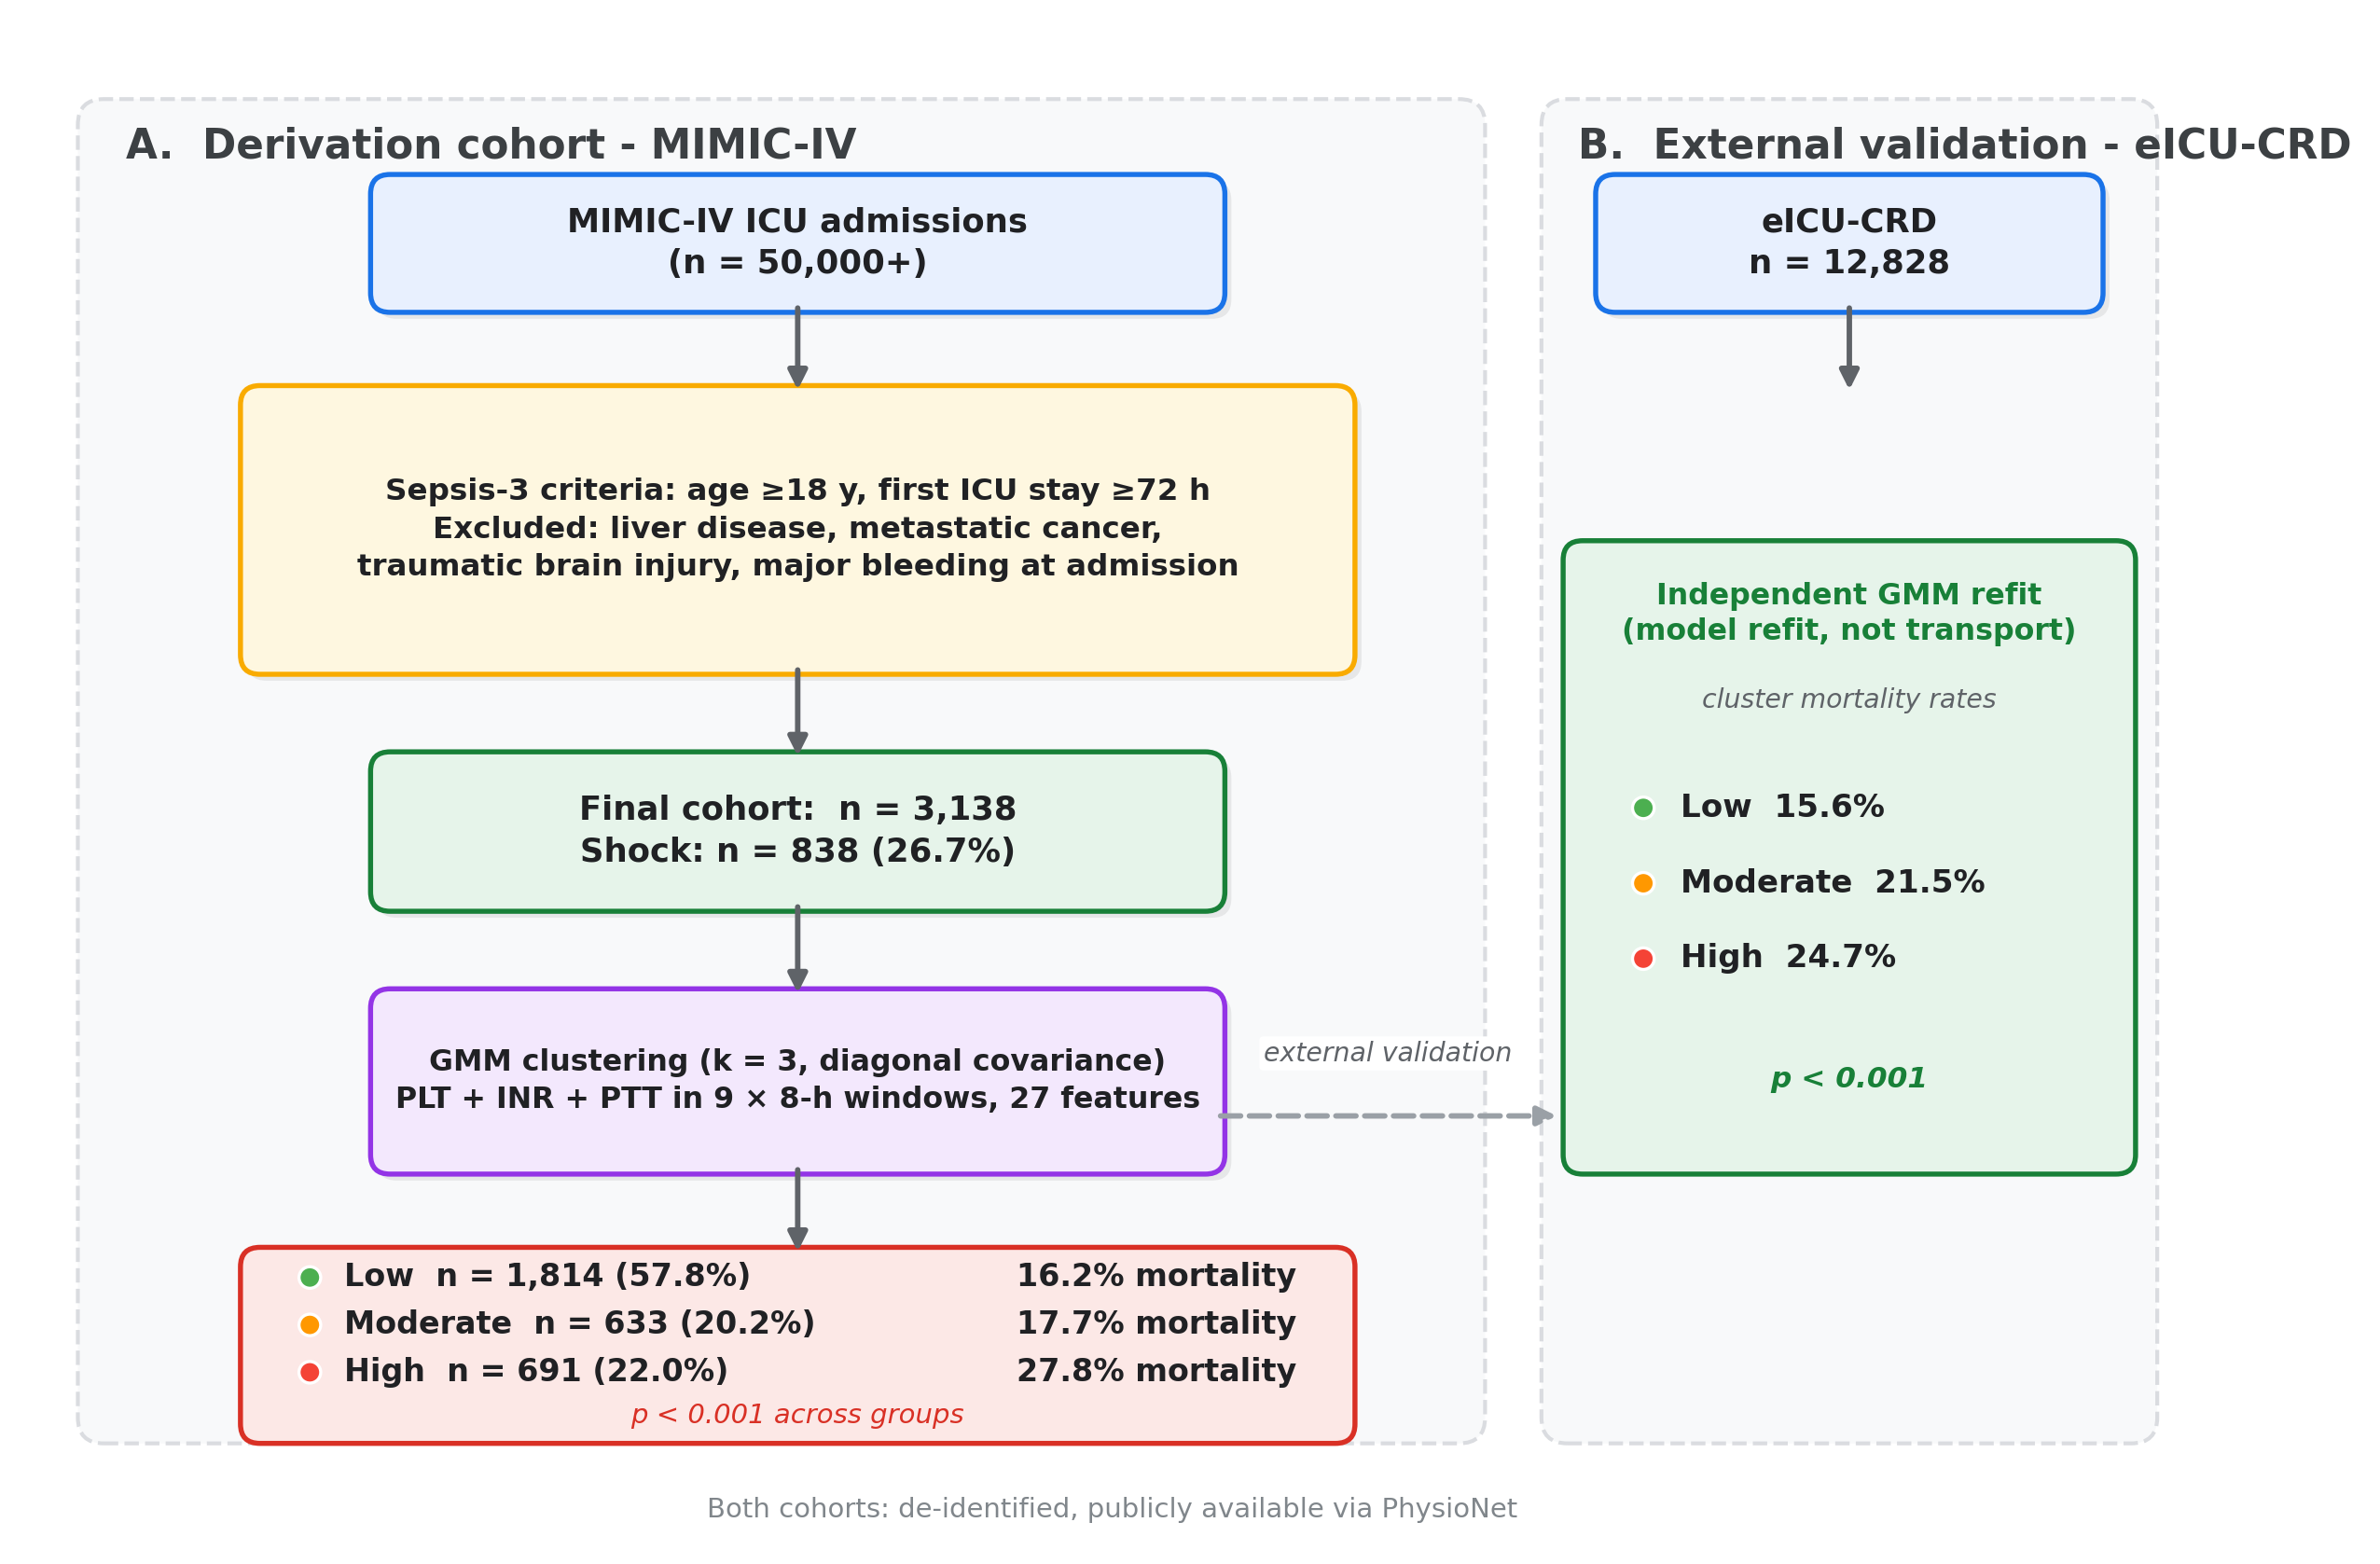

Legend: Study cohort selection from MIMIC-IV (2008–2022). Sepsis-3 criteria, first ICU stay ≥72 hours. Exclusions: liver disease, metastatic cancer, traumatic brain injury, major bleeding at admission.

Figure S2. Independent GMM validation in eICU-CRD
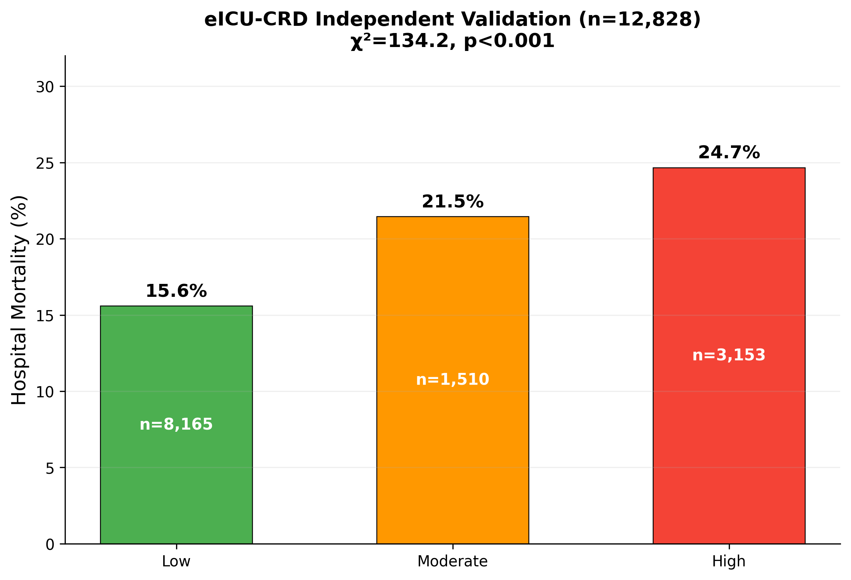

Legend: Independent GMM refitting in eICU-CRD (n=12,828) reproduced the same three-group mortality gradient: Low 15.6%, Moderate 21.5%, High 24.7% (χ²=134.2, p<0.001 by chi-square test).

Figure S3. Mortality by subphenotype stratified by shock status
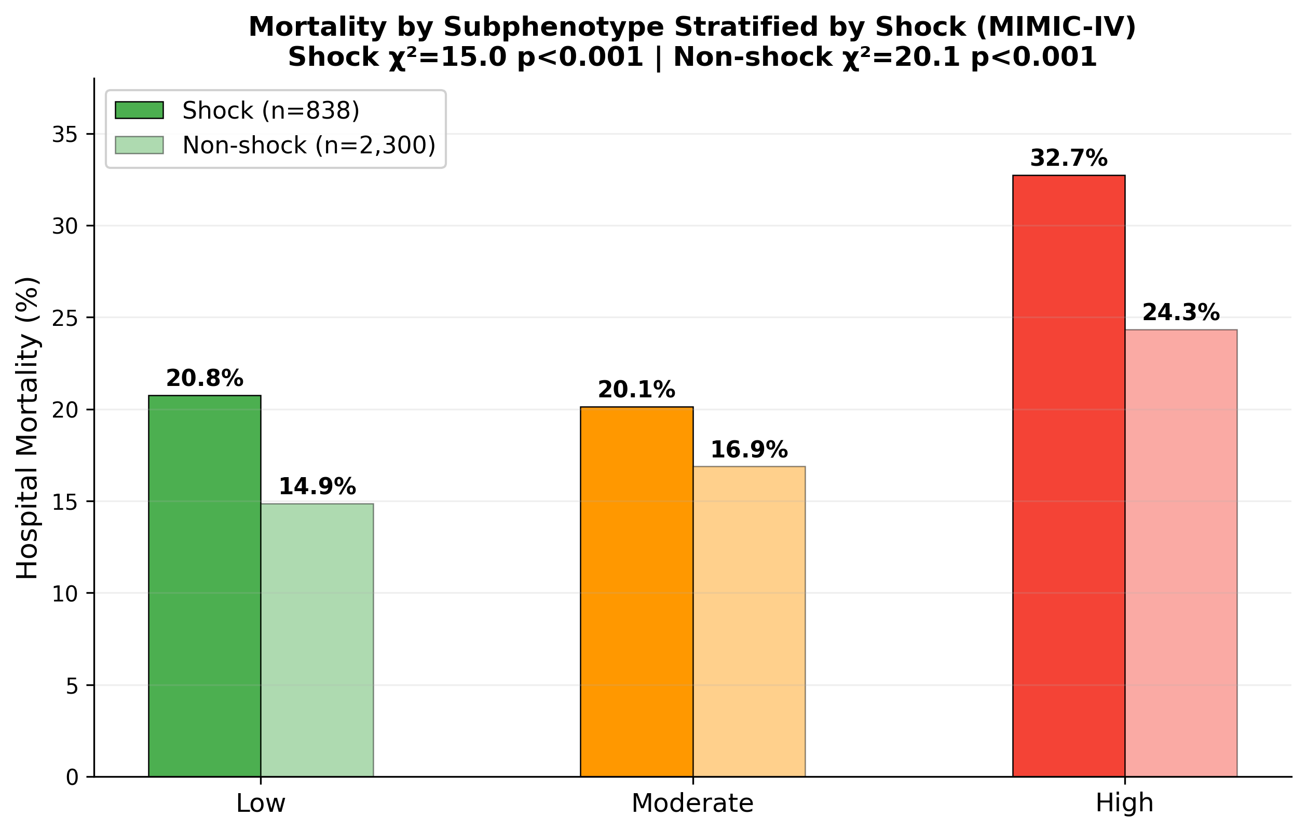

Legend: The mortality gradient was preserved in both shock (vasopressor use; 20.8%, 20.1%, 32.7%; χ²=15.0) and non-shock patients (14.9%, 16.9%, 24.3%; χ²=20.1). Shock: n=838; non-shock: n=2,300.

Figure S4. Cox proportional hazards forest plot
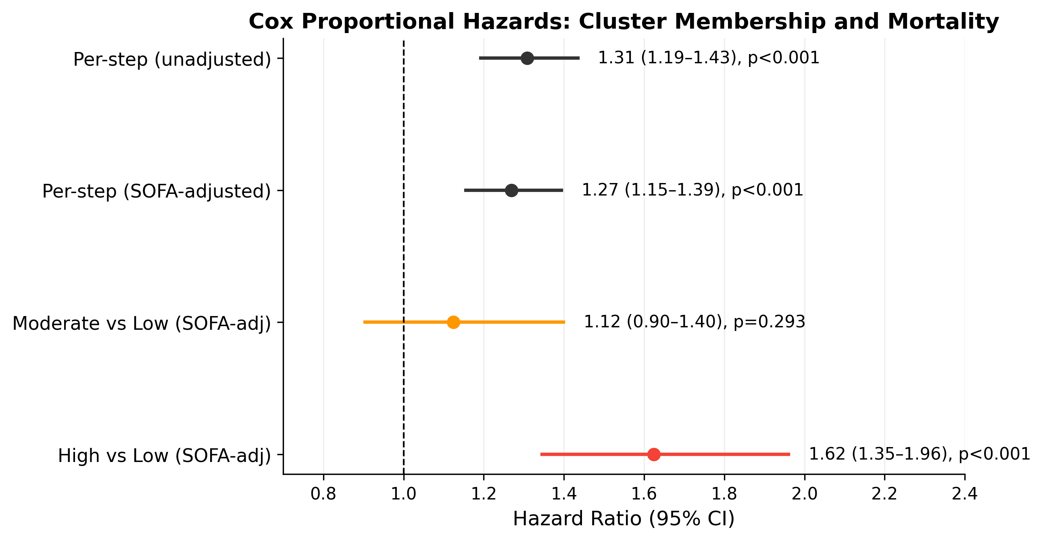

Legend: Per-step hazard ratios for cluster membership and pairwise comparisons versus Low (reference), adjusted for SOFA score. Unadjusted per-step: HR 1.31 (95% CI 1.19–1.43). SOFA-adjusted per-step: HR 1.27 (95% CI 1.15–1.39). Moderate vs Low: HR 1.12 (95% CI 0.90–1.40, p=0.29). High vs Low: HR 1.62 (95% CI 1.35–1.96, p<0.001). Error bars denote 95% confidence intervals.

Figure S5. Reclassification analysis (NRI)
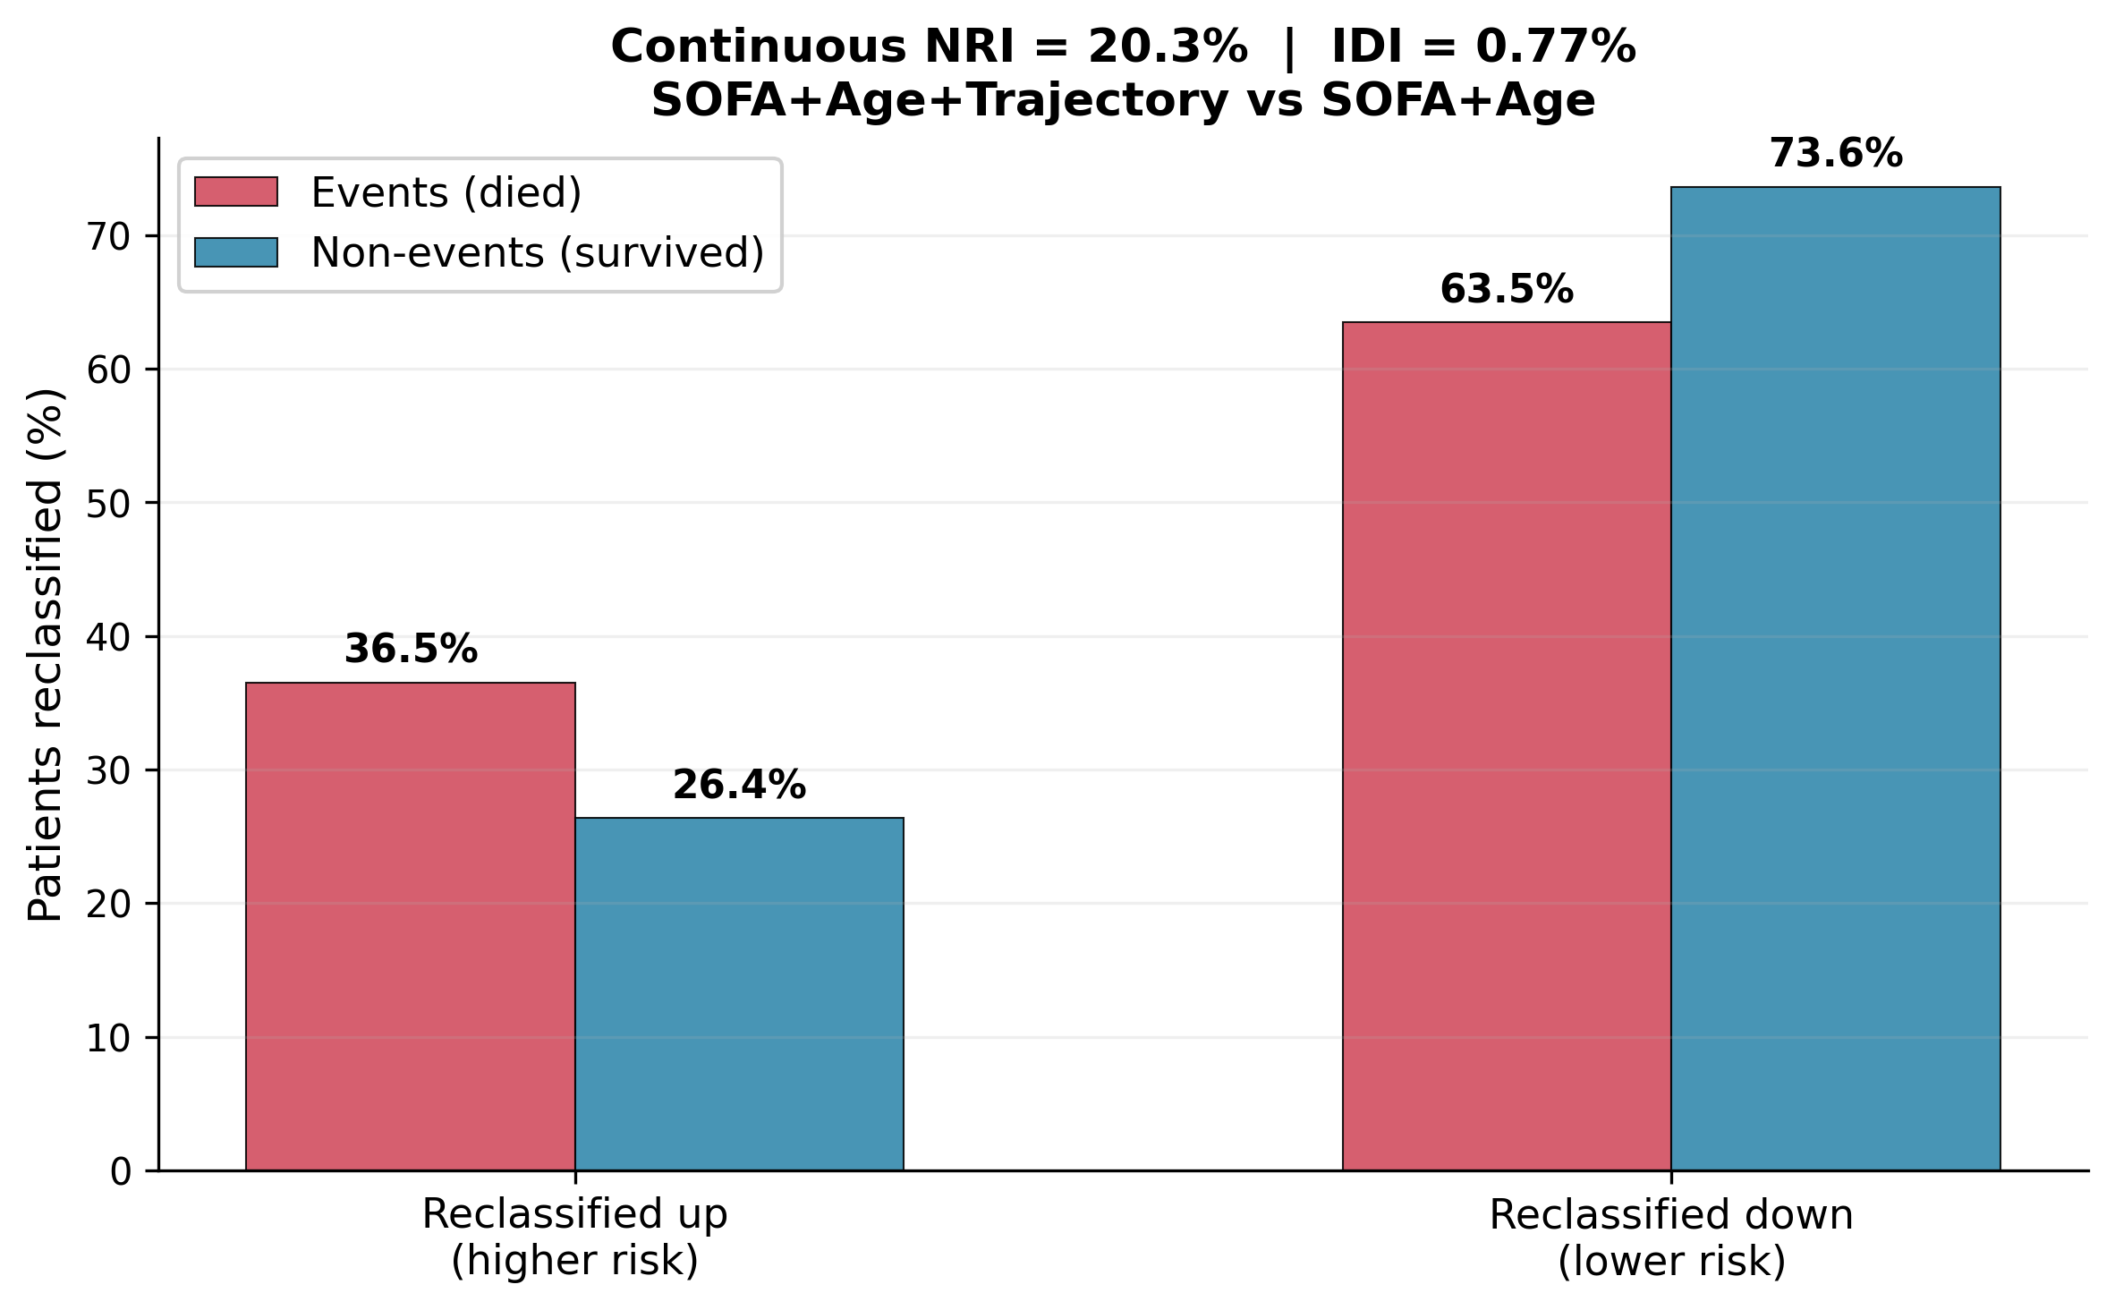

Legend: Comparison of risk reclassification between SOFA+Age and SOFA+Age+trajectory cluster models. Continuous net reclassification improvement: 20.3%. Integrated discrimination improvement: 0.77%.

Figure S6. Decision curve analysis (DCA)
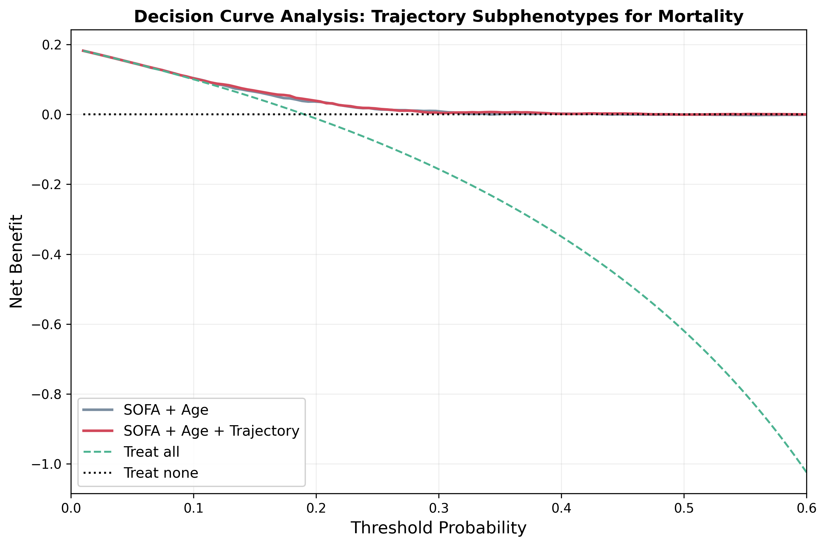
Legend: Decision curve analysis comparing SOFA+Age model (gray) with SOFA+Age+trajectory cluster model (red) for mortality prediction. Adding trajectory clusters yielded net benefit gains at higher risk thresholds (≥25%). Treat-all (green) and treat-none (black) reference lines.
Figure S7. Causal forest analysis of heparin treatment effect. (A) Mean out-of-bag estimated treatment effect (28-day mortality reduction, percentage points) by trajectory subphenotype (High -5.7%, Moderate -4.0%, Low -3.2%). (B) Variable importance for effect modification. The overall out-of-bag average treatment effect was -3.9 percentage points, and 88.3% of patients had directionally favorable estimates.

Table S1. Target trial emulation of heparin initiation (72-hour landmark) by trajectory subphenotype
Subphenotype | N | Heparin, n (%) | No heparin, n (%) | HR (95% CI) | p | 28-day survival diff (pp; 95% CI)
Low | 1,814 | 858 (47.3) | 956 (52.7) | 0.95 (0.76-1.19) | 0.68 | -2.8 (-15.2 to 8.7)
Moderate | 633 | 260 (41.1) | 373 (58.9) | 0.72 (0.49-1.05) | 0.09 | +22.9 (1.4 to 42.1)
High | 691 | 453 (65.6) | 238 (34.4) | 0.67 (0.51-0.89) | 0.006 | +20.9 (3.8 to 36.0)
Weights: stabilized inverse-probability-of-censoring weights (logistic; truncated at 1st/99th percentiles). Cox models adjusted for age, sex, total SOFA, SOFA coagulation subscore, peak lactate, vasopressor use, and comorbidities (atrial fibrillation, venous thromboembolism, valvular disease, stroke, intracranial hemorrhage, chronic kidney disease, cancer, bleeding). 28-day survival difference = weighted Kaplan-Meier survival at day 28 in the heparin-initiation arm minus the no-heparin arm (bootstrap 95% CI, 500 resamples). Global treatment-by-subphenotype interaction: p=0.49. Sensitivity analyses: subcutaneous-only exposure, High HR 0.62 (0.45-0.85, p=0.003); intravenous-only exposure, High HR 0.94 (0.69-1.28, p=0.70). Causal forest (2,000 trees, out-of-bag): overall average treatment effect -3.9 percentage points; mean CATE -5.7 (High), -4.0 (Moderate), -3.2 (Low); 88.3% of patients with directionally favorable estimates. Given the observational design, these results should be interpreted as hypothesis-generating rather than definitive.

