Supplementary Files
Supplementary Table 1. Conceptual comparisons of foundation models in spatial transcriptomics.
 | Nicheformer | scGPT-spatial | Novae | spaGFM
Graph aware |  |  | √ | √
Dynamic Receptive fields |  |  |  | √
Cellular representation | √ | √ |  | √
Neighborhood representation |  |  | √ | √
Model size | 49.3M | 50.1M | 33.6M | 317M

Supplementary Table 2. Ablation analysis of spaGFM model components.
 | Initial representation | Graph representation | Transformer backbone | Variance regularization | Figure Index
spaGFM | √ | √ | √ | √ | -
No variance loss | √ | √ | √ |  | Suppl. Fig. 2
RW + pooling | √ | √ |  |  | Suppl. Fig. 7
Gene expression | √ |  |  |  | Suppl. Fig. 7
RW: Random-walk sampling

Supplementary Table 3. Comparison of Methods for identifying Tertiary Lymphoid Structures in Lung and Kidney
 | Graph aware | Foundation model
spaGFM | √ | √
Finetuned scGPT |  | √
scGPT |  | √
Novae | √ | √
NicheCompass | √
scGPT-spatial |  | √
See the main Fig. 3

Supplementary Table 4. Comparison of Methods for characterizing glomerular in Diabetic Kidney Disease
 | Graph aware | Model size
spaGFM-317M | √ | 317M
spaGFM-36M | √ | 36M
Novae | √ | 33.6M
See the Supplementary Fig. 15

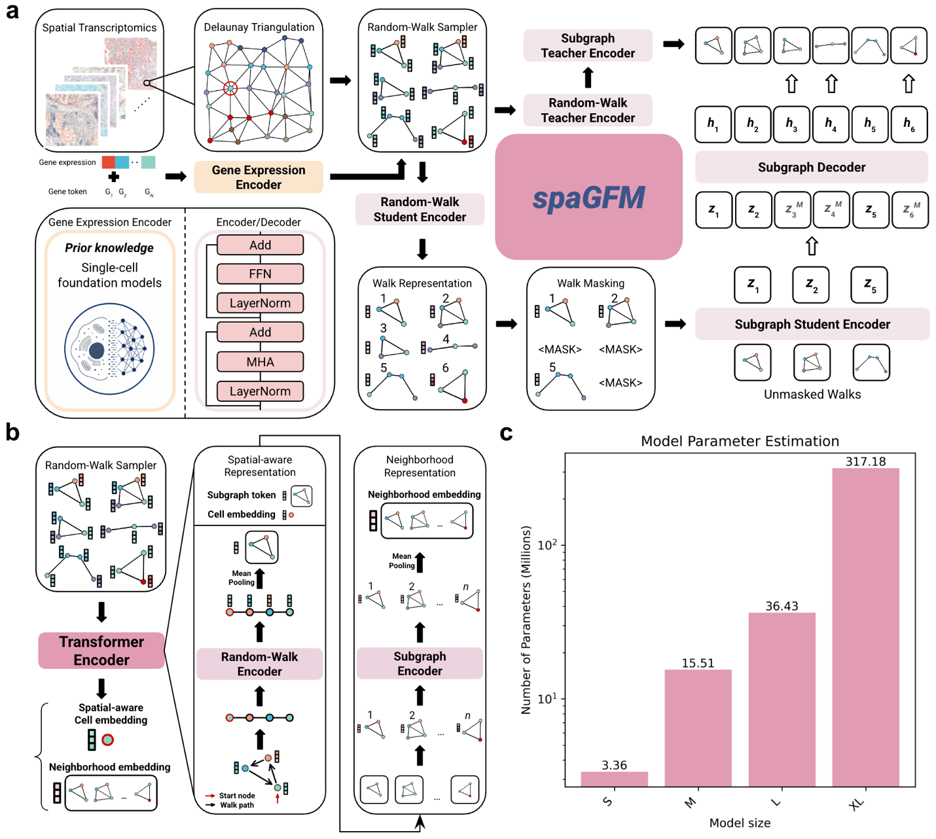
Supplementary Fig. 1. Schematic overview of spaGFM. (a) Detailed architecture of spaGFM. spaGFM takes gene expression profiles and graph structures as input. A random-walk sampler generates multiple walk sets for each source node (e.g., starting from the cell indicated by the red circle). Each walk set is tokenized into a graph token, as detailed in (b). spaGFM adopts a masked autoencoder architecture to reconstruct masked random-walk sets from the visible walk sets. In the illustrated example, the 3rd, 4th, and 6th graphs are randomly masked, while the 1st, 2nd, and 5th graphs remain visible. The overall objective is to optimize the model parameters such that the embeddings of the masked 3rd, 4th, and 6th graphs can be reconstructed from the visible 1st, 2nd, and 5th graphs. The Random-Walk Encoder, Subgraph Encoder, and Subgraph Decoder are all Transformer-based architectures. (b) Hierarchical encoder architecture for representing cell-level and neighborhood-level features within a unified framework. Each walk set is tokenized into a high-dimensional representation by the Random-Walk Encoder. Random-Walk Encoder is a set transformer encoder that models relationships among cells (nodes) per walk set. The mean-pooled representation of all cells (nodes) within a walk set serves as a subgraph token. The source-node embedding is interpreted as a spatially aware cell embedding that incorporates information from its spatial neighborhood. Dependencies among subgraphs are learned through the Subgraph Encoder. Similarly, Subgraph Encoder is a set transformer encoder that models relationships among walk sets starting at the same source node. For each source node, the neighborhood representation is obtained by mean-pooling the representations of all associated subgraphs.

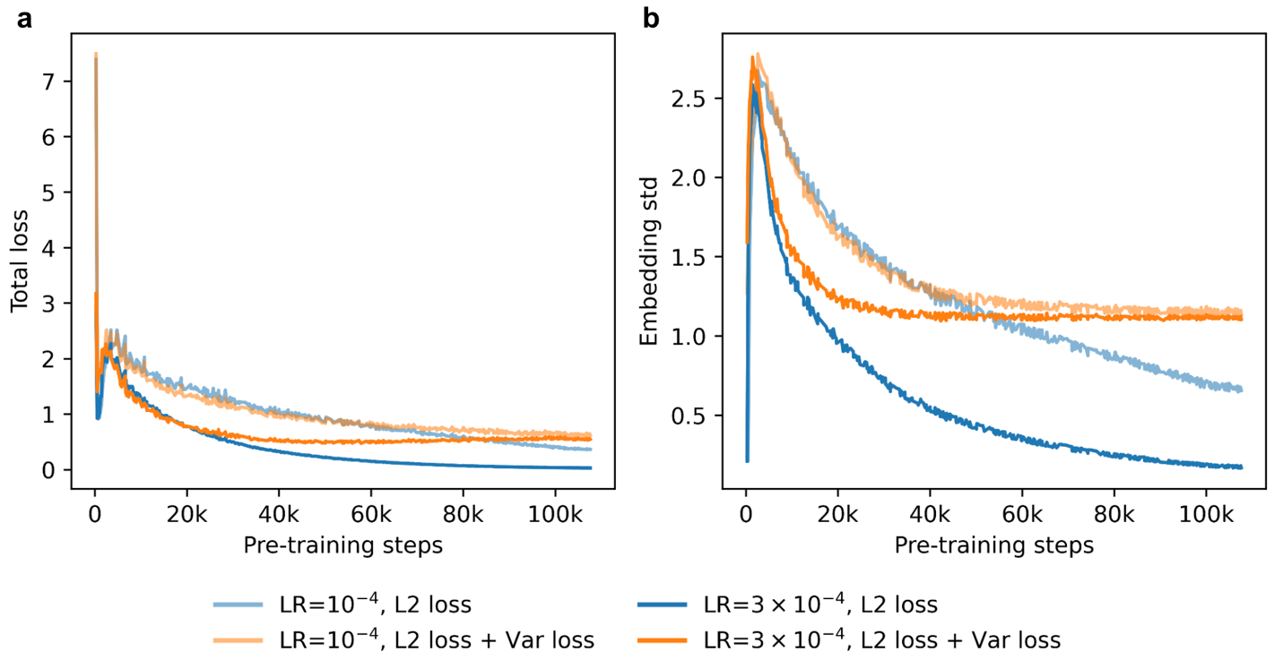
Supplementary Fig. 2. Adding variance loss effectively stabilizes pre-training and prevents embedding collapse to trivial solutions. The model was pre-trained on the CosMx Human Lung dataset for demonstration using two different learning rates; walk length was set to 8. (a) Total loss over pre-training steps. (b) Embedding standard deviation across the batch dimension over pre-training steps. LR: learning rate.
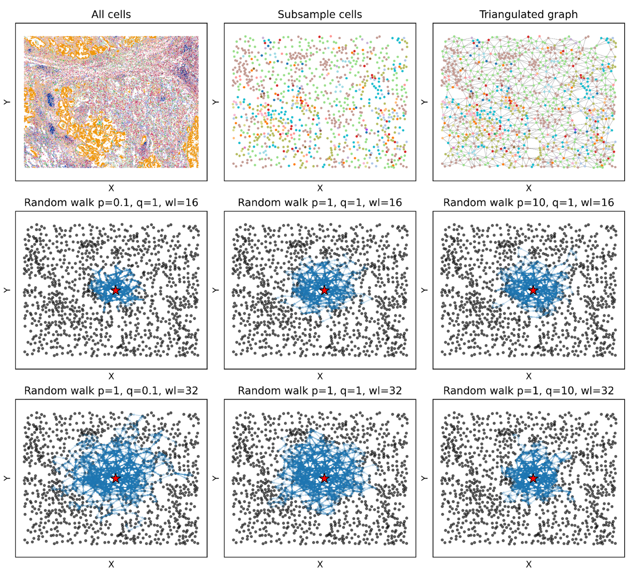
Supplementary Fig. 3. Illustration of random-walk parameterization in the CosMx Lung dataset. A small patch region subsampled from the original tissue section is shown for demonstration. Each dot represents a cell at its spatial location. The red star denotes an example cell used as the source node during random-walk sampling. p/q, return/in-out parameters; wl, walk length used by the random-walk sampler.
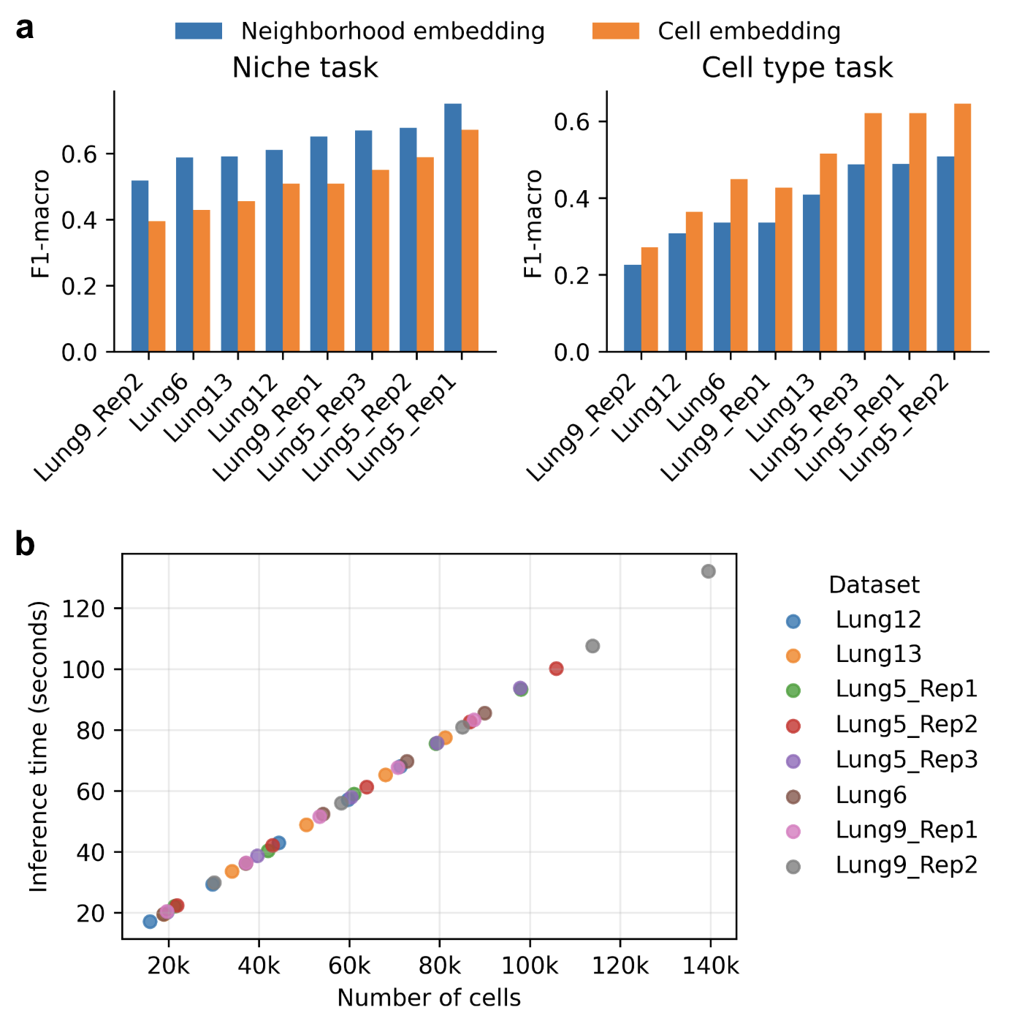
Supplementary Fig. 4. Zero-shot embedding representations in the CosMx Human Lung datasets. (a) Linear-probing evaluation using two levels of embeddings for niche- and cell type-prediction tasks, respectively. (b) Zero-shot embedding inference time for spaGFM as a function of the number of cells across datasets. Walk length was set to 8 for both (a) and (b).
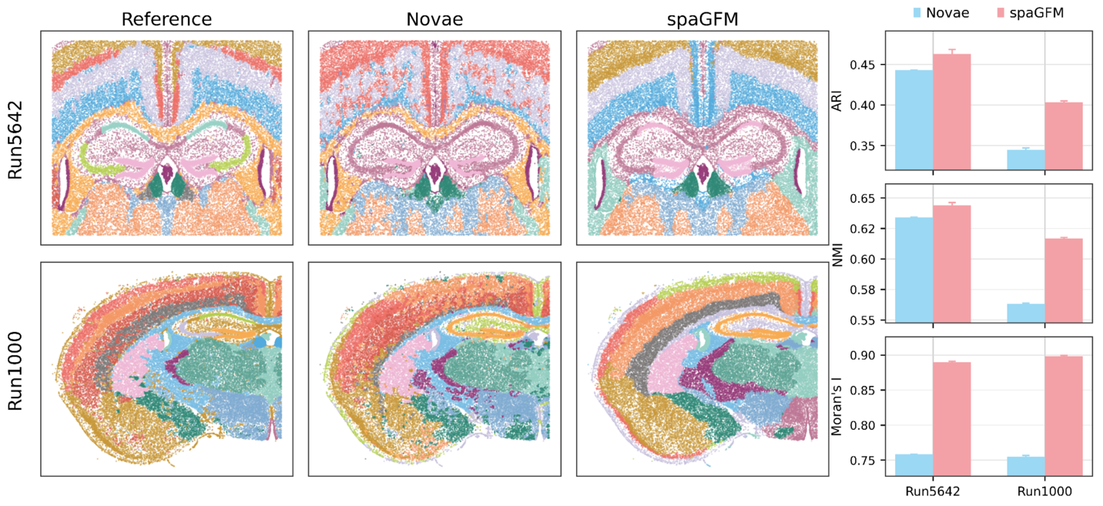
Supplementary Fig. 5. Unsupervised evaluation of niche representations in the CosMx Brain datasets. Spatial annotations of two CosMx Mouse Brain samples generated using reference labels, Novae, and spaGFM: Run5642 (top left) and Run1000 (bottom left). Corresponding ARI, NMI, and Moran’s I scores are shown on the right. ARI: Adjusted Rand Index. NMI: Normalized Mutual Information.

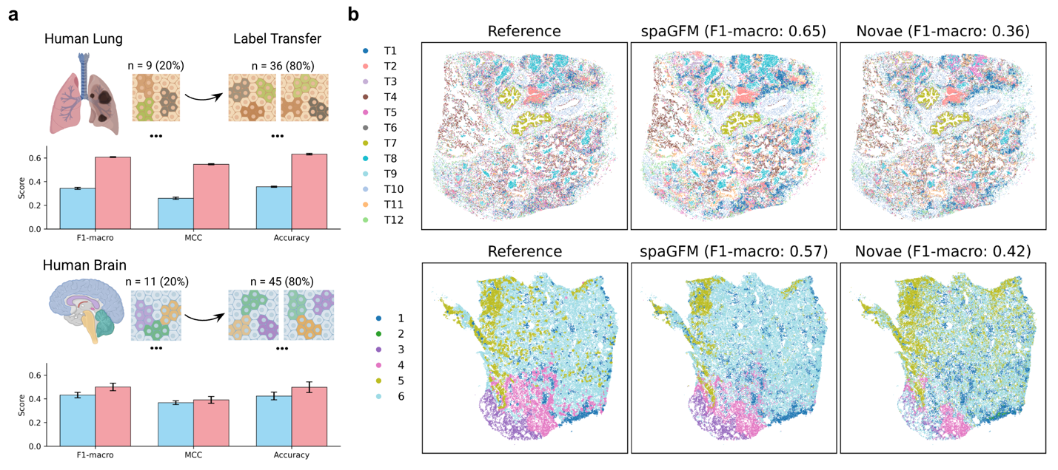
Supplementary Fig. 6. Cross-patient evaluation of niche representations in the Xenium Human Lung and Brain datasets. (a) Evaluation scheme for zero-shot niche-label transfer using embeddings derived from spaGFM or Novae in the Human Lung (top) and Brain (bottom) datasets. (b) Spatial visualization of niche predictions for representative samples across methods.

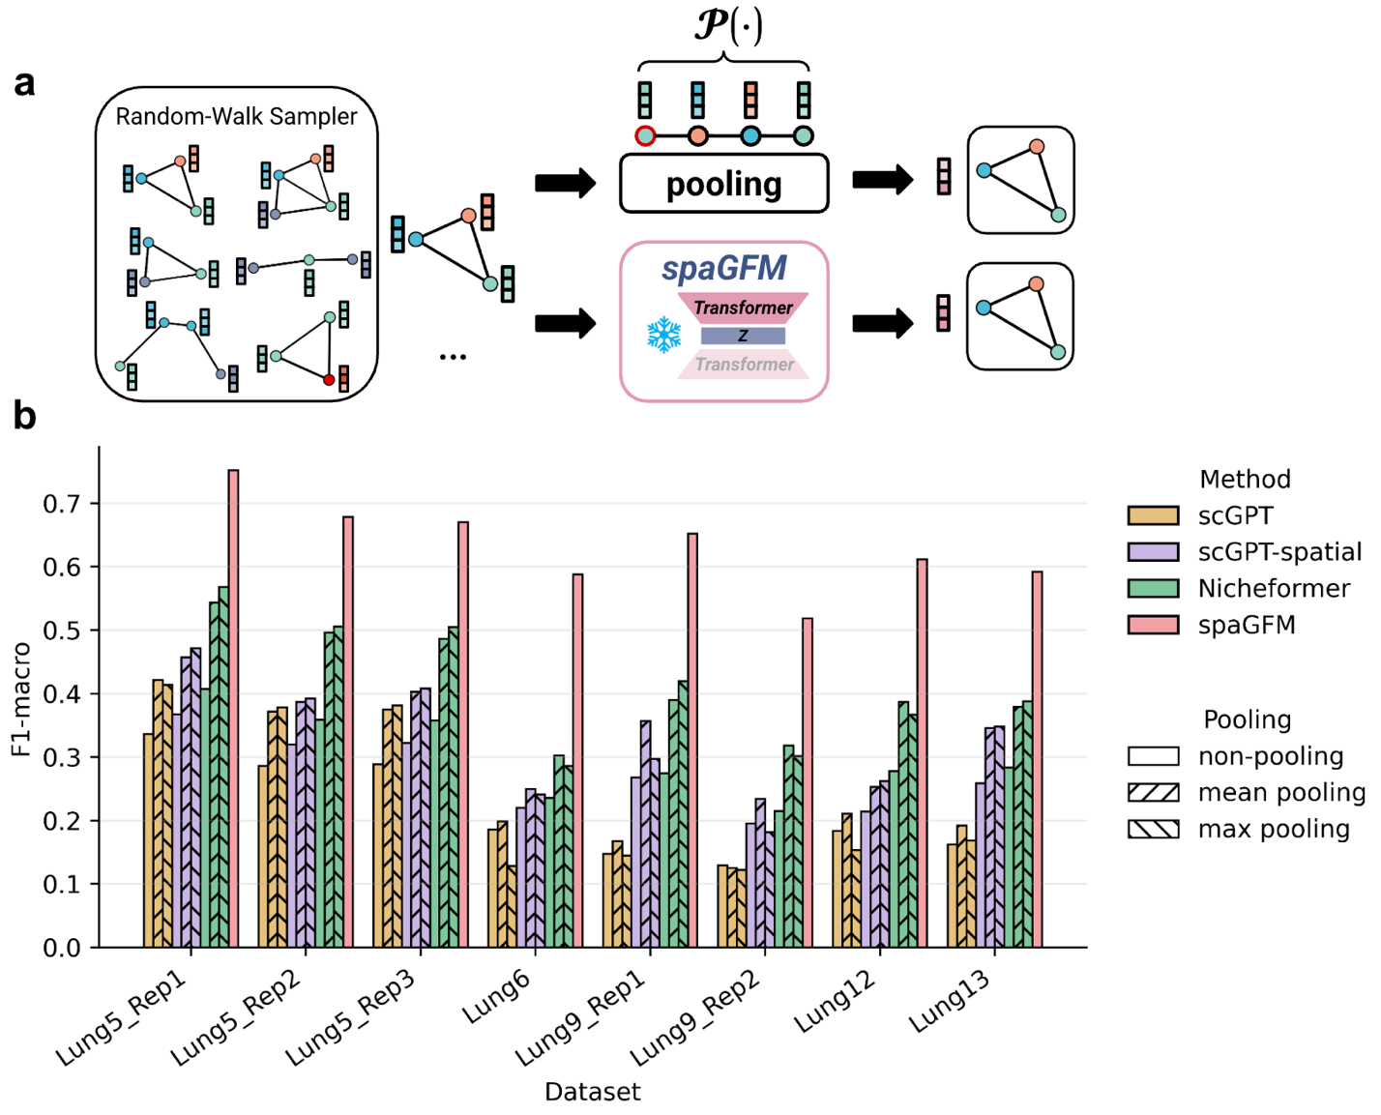
Supplementary Fig. 7. Ablation study comparing non-graph foundation models with spaGFM for niche-task embedding representations. (a) Schematic of the strategy used to incorporate graph information into non-graph foundation models for neighborhood characterization. Cell embeddings from non-graph foundation models were pooled over random walks. spaGFM-derived embeddings were extracted in a zero-shot manner. Walk length was set to 8. (b) Linear-probing evaluation on the CosMx Human Lung dataset for the niche-prediction task.

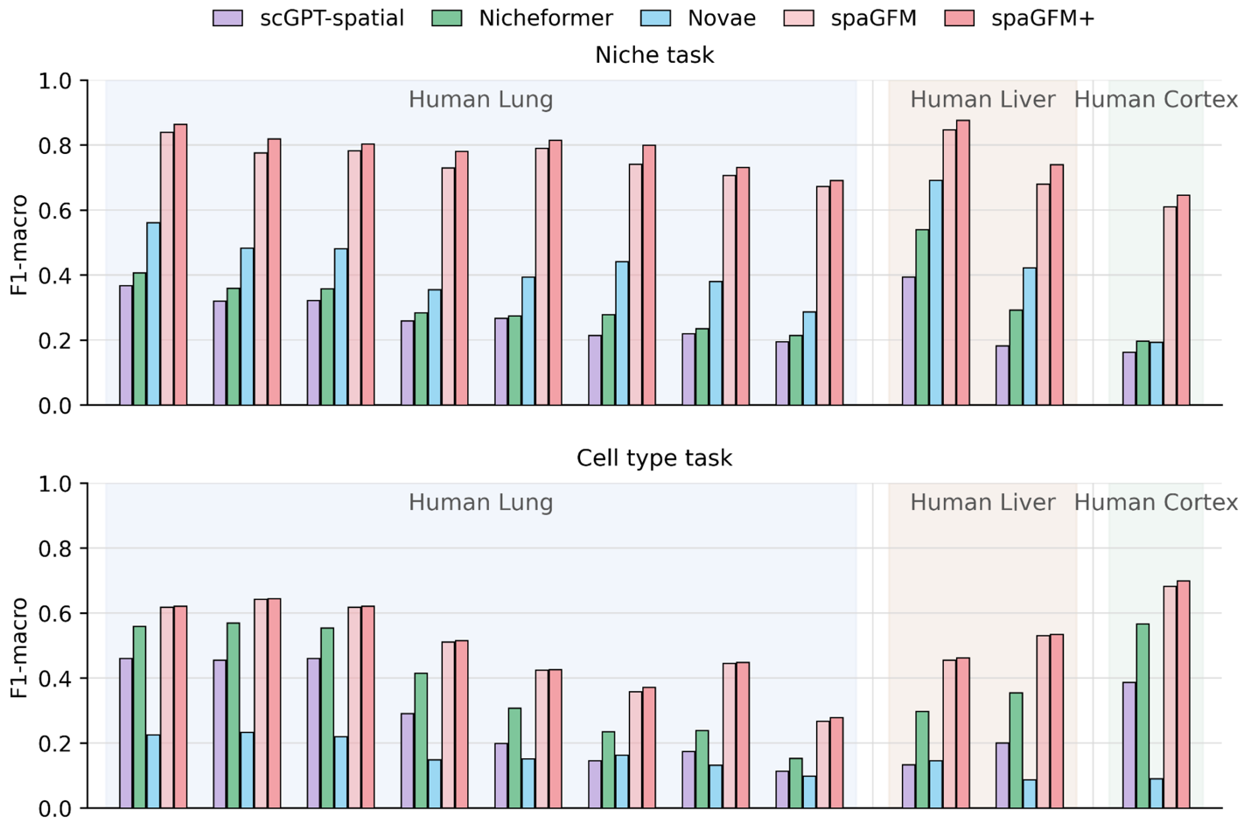
Supplementary Fig. 8. Domain adaptation of spaGFM for niche- and cell type-prediction tasks in CosMx Human Lung, Liver and Cortex datasets. Linear-probing evaluation for the niche-prediction task (top) and cell type-prediction task (bottom). spaGFM, zero-shot embedding representations; spaGFM+, pre-trained spaGFM adapted to specific datasets for a few epochs.

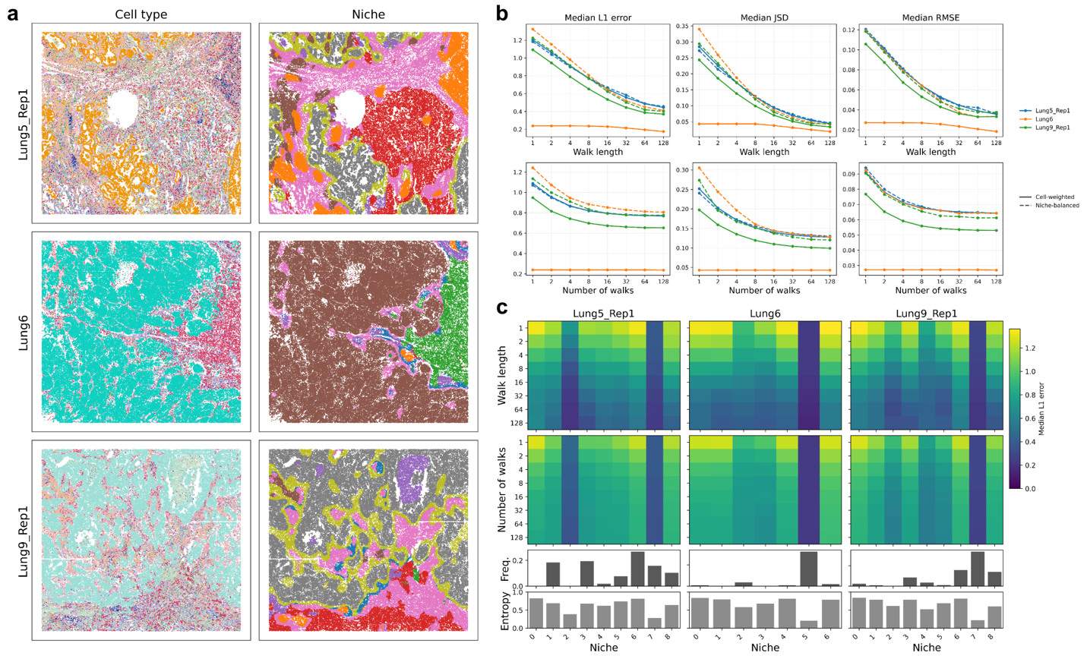
Supplementary Fig. 9. Large graph contexts in random walks enable accurate capture of cell type composition per niche in CosMx Human Lung datasets. (a) Spatial locations of cells colored by cell type or niche. (b) Estimated errors between ground-truth cell type composition and cell type composition captured per walk as a function of walk length (top) and number of walks (bottom). (c) Estimated cell type composition errors stratified by niche across samples. Heatmap panels show estimated errors across niches. The top bar plot shows cell frequency, and the bottom panel shows the degree of heterogeneity in cell-type composition across niches.

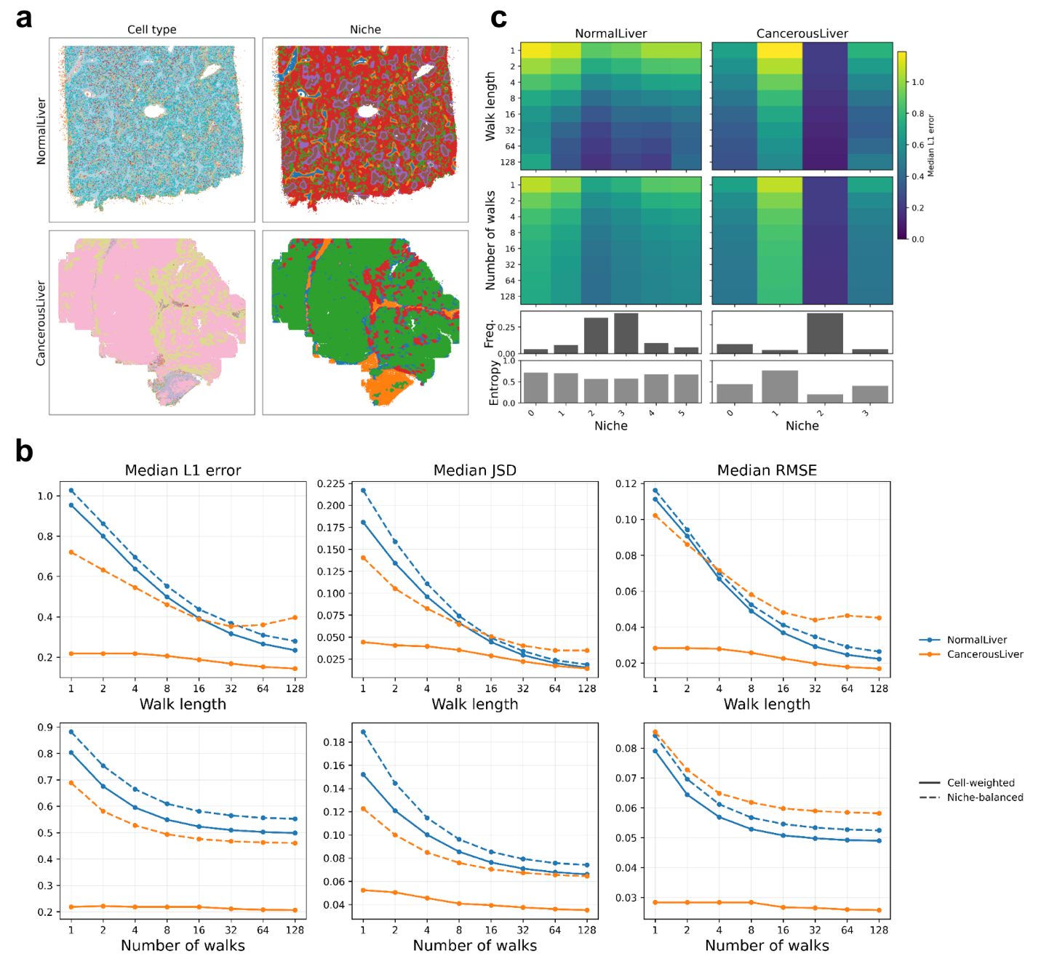
Supplementary Fig. 10. Large graph contexts in random walks enable accurate capture of cell type composition per niche in CosMx Human Liver datasets. (a) Spatial locations of cells colored by cell type or niche. (b) Estimated errors between ground-truth cell type composition and cell type composition captured per walk as a function of walk length (top) and number of walks (bottom). (c) Estimated cell type composition errors stratified by niche across samples. Heatmap panels show estimated errors across niches. The top bar plot shows cell frequency, and the bottom panel shows the degree of heterogeneity in cell type composition across niches.
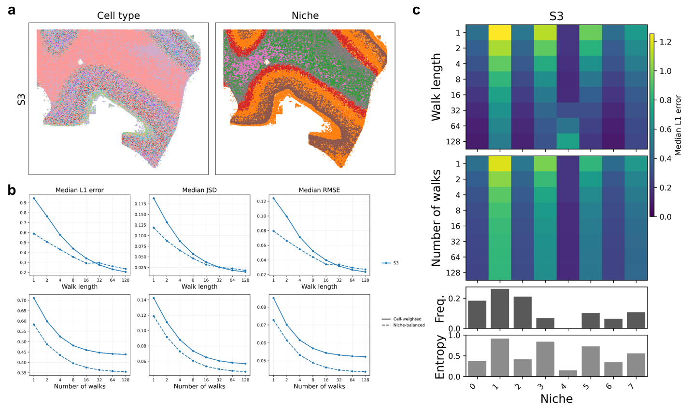
Supplementary Fig. 11. Large graph contexts in random walks enable accurate capture of cell type composition per niche in CosMx Human Cortex datasets. (a) Spatial locations of cells colored by cell type or niche. (b) Estimated errors between ground-truth cell type composition and cell type composition captured per walk as a function of walk length (top) and number of walks (bottom). (c) Estimated cell type composition errors stratified by niche across samples. Heatmap panels show estimated errors across niches. The top bar plot shows cell frequency, and the bottom panel shows the degree of heterogeneity in cell-type composition across niches.
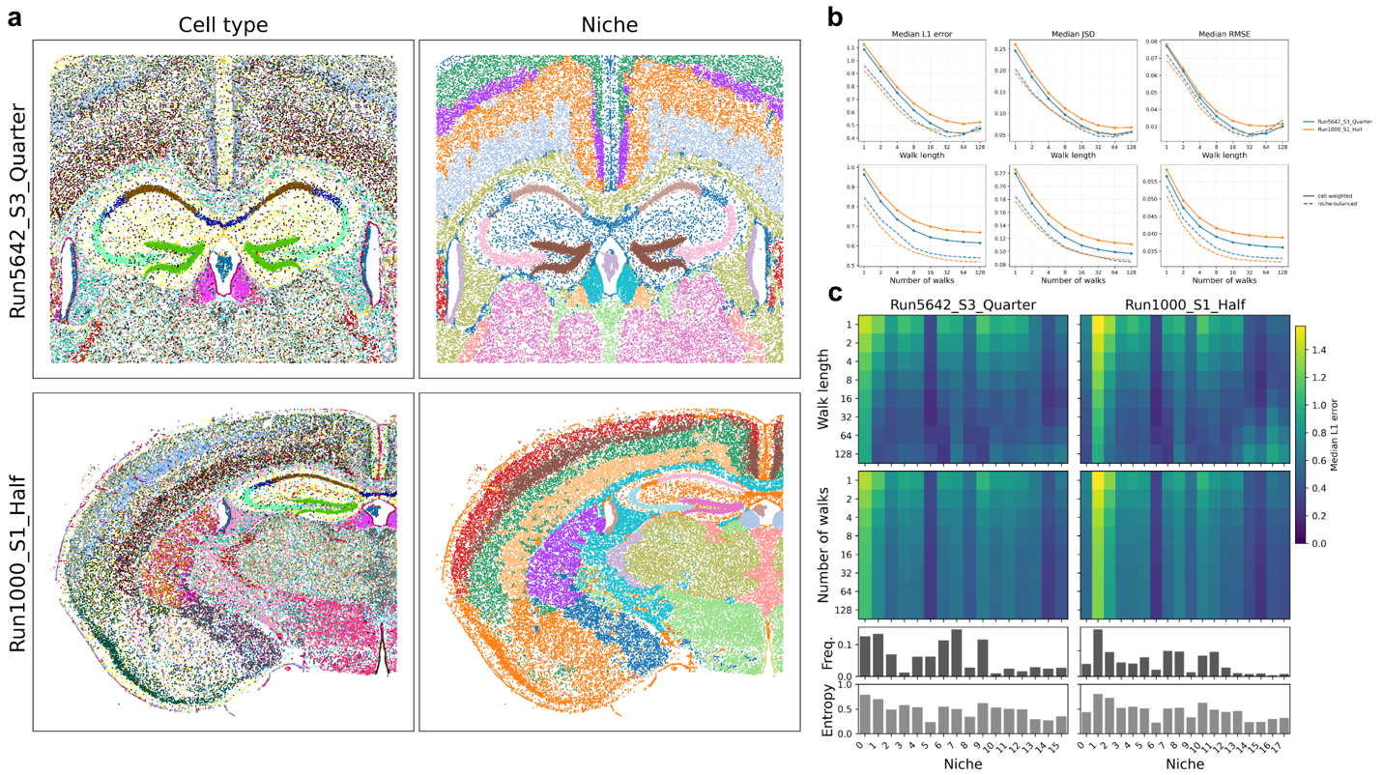
Supplementary Fig. 12. Large graph contexts in random walks enable accurate capture of cell type composition per niche in CosMx Mouse Brain datasets. (a) Spatial locations of cells colored by cell type or niche. (b) Estimated errors between ground-truth cell type composition and cell type composition captured per walk as a function of walk length (top) and number of walks (bottom). (c) Estimated cell type composition errors stratified by niche across samples. Heatmap panels show estimated errors across niches. The top bar plot shows cell frequency, and the bottom panel shows the degree of heterogeneity in cell-type composition across niches.

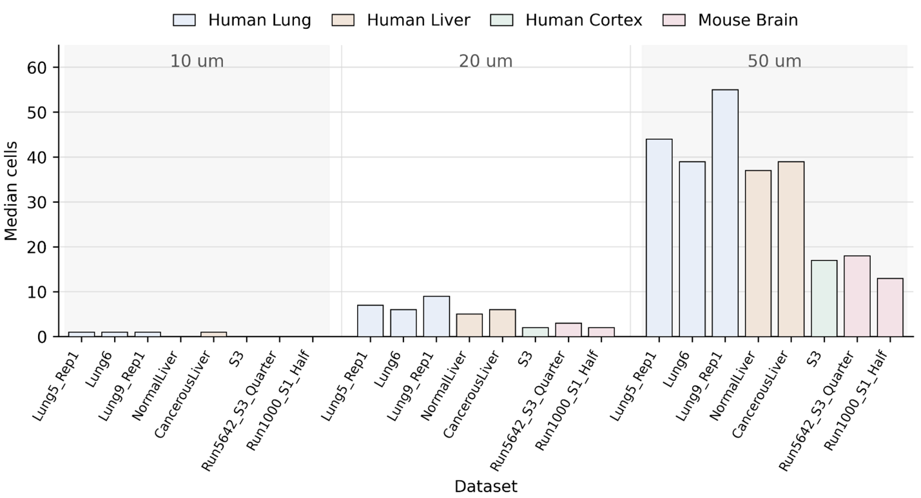
Supplementary Fig. 13. Heterogeneity of cell density across tissue contexts where large neighborhoods contain more heterogeneous cell types. Median number of cells within 10-μm, 20-μm and 50-μm radii centered on each cell in Human Lung, Liver, Cortex and Mouse Brain datasets.

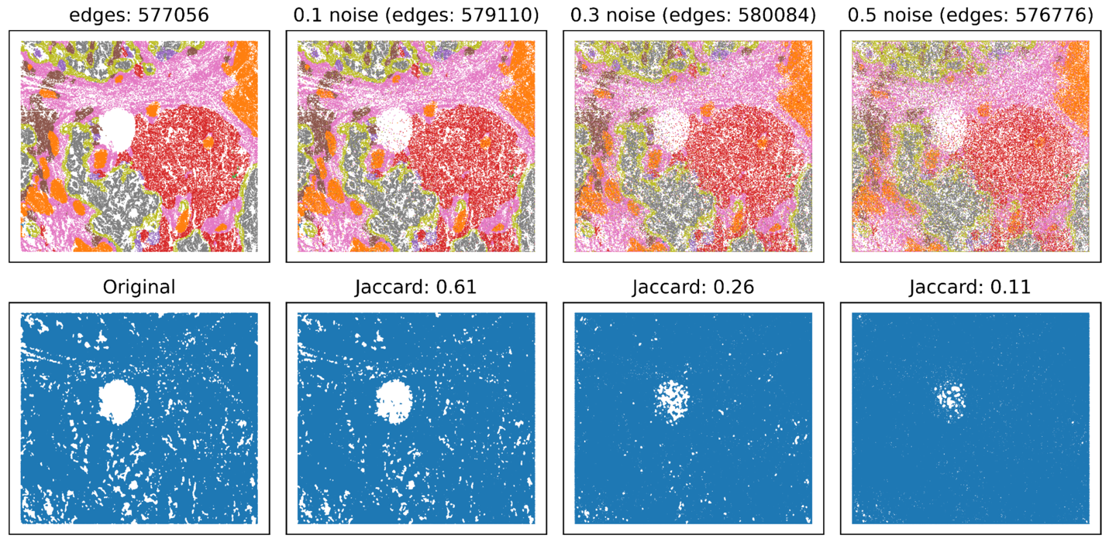
Supplementary Fig. 14. Illustration of shifted node positions in CosMx Human Lung datasets. Spatial locations of cells with increasing levels of positional corruption, with the number of retained graph edges shown above each panel (top). Delaunay triangulation graphs are shown with the Jaccard similarity to the original graph indicated for each corruption level (bottom).
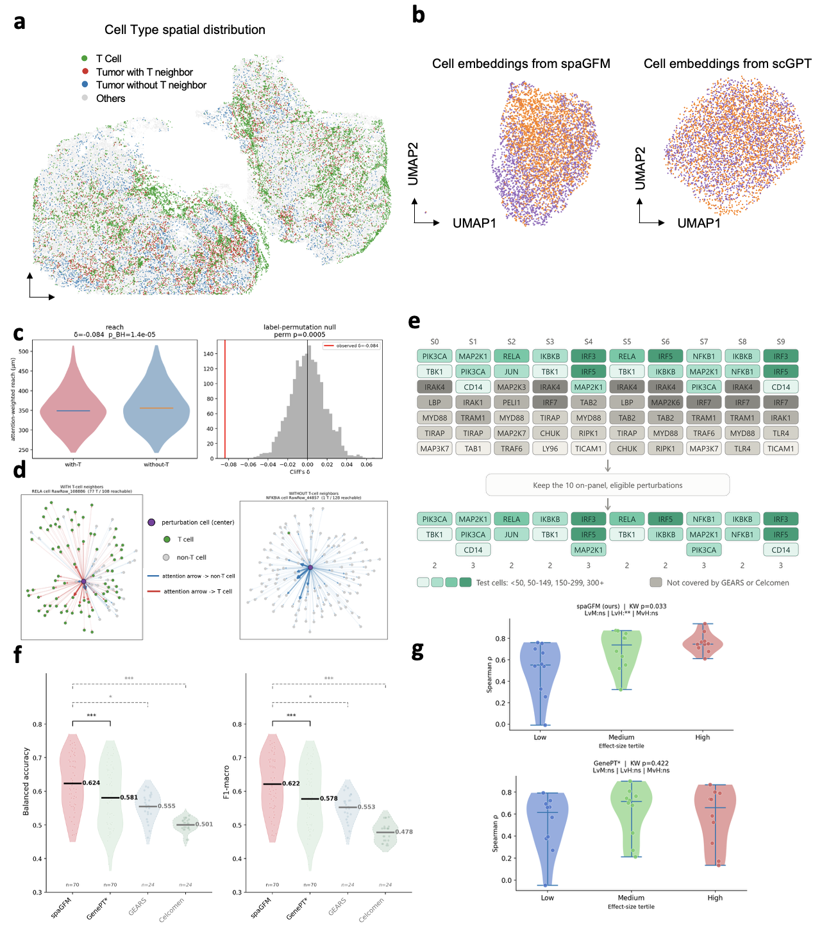
Supplementary Fig. 15. Spatial-context analyses and perturbation benchmarking. (a) Spatial distribution of T cells, tumor cells with or without T-cell neighbors, and other cells in the Perturb-FISH tumor section. (b) UMAPs of tumor-cell embeddings from spaGFM (left) and scGPT (right), colored by T-cell-neighbor status. (c) Attention-weighted spatial reach for perturbed tumor cells with versus without T-cell neighbors (left; Cliff’s $δ=-0.084$, BH-adjusted $P=1.4×{10}^{-5}$) and the corresponding label-permutation null distribution (right; $P=0.0005$). Here, reach was defined for each focal perturbed tumor cell as the attention-weighted mean Euclidean distance to its walk-reachable neighboring cells. (d) Representative attention fields for perturbed tumor cells with (left) and without (right) T-cell neighbors. Arrow width and opacity indicate attention weight. (e) Construction of the matched four-method benchmark used in Fig. 5d. Restricting to perturbations jointly supported by all methods yielded 24 split-perturbation pairs across 10 eligible perturbations. (f) Prediction performance measured by balanced accuracy (left) and F1-macro (right). spaGFM and GenePT* were evaluated on 70 pairs, whereas GEARS and Celcomen were evaluated on 24 supported pairs. Significance was assessed by paired Wilcoxon signed-rank tests with Holm correction. (g) Spearman correlation between signed prediction confidence and observed LFC across low-, medium-, and high-effect perturbations for spaGFM (top) and GenePT* (bottom). Differences across tertiles were assessed by Kruskal-Wallis tests.

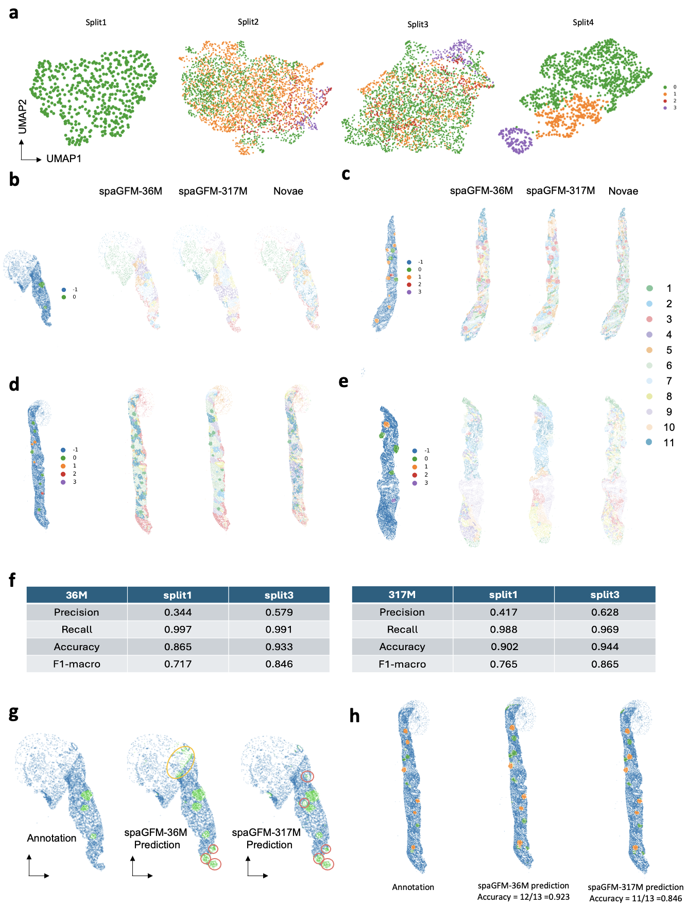
Supplementary Fig. 16. Zero-shot and fine-tuned spaGFM representations capture glomerular spatial organization and pathological grade. (a) UMAP of glomerular-cell embeddings, including glomerulus cells only, colored by pathological grade (0-3) for Split 1, Split 2, and Split 4. Grade-3 cells concentrate at one extreme of the embedding space. (b-e) Zero-shot spatial organization across four tissue sections. Spatial domains from spaGFM-36M, spaGFM-317M and Novae are plotted in tissue coordinates alongside the corresponding manual glomerular annotations (-1, non-glomerulus; 0-3, pathological grade). spaGFM and Novae embeddings were partitioned by Leiden clustering, as described in Methods. (f) Per-cell binary glomerulus detection in tissue coordinates using fine-tuned spaGFM-36M and spaGFM-317M models. (g) Glomerulus detection by the fine-tuned model. Ground-truth annotation, spaGFM-36M and spaGFM-317M model prediction. Blue represents non-glomeruli, green represents predicted glomeruli, red circles highlight additional glomerular regions detected beyond manual H&E annotation, and yellow circles highlight putative false-positive regions due to edge artifact. (h) Prediction results of per-glomerulus Grade 0-versus-Grades 1-3 classification in tissue coordinates (-1, non-glomerulus; 0, Grade 0; 1, Grades 1-3).

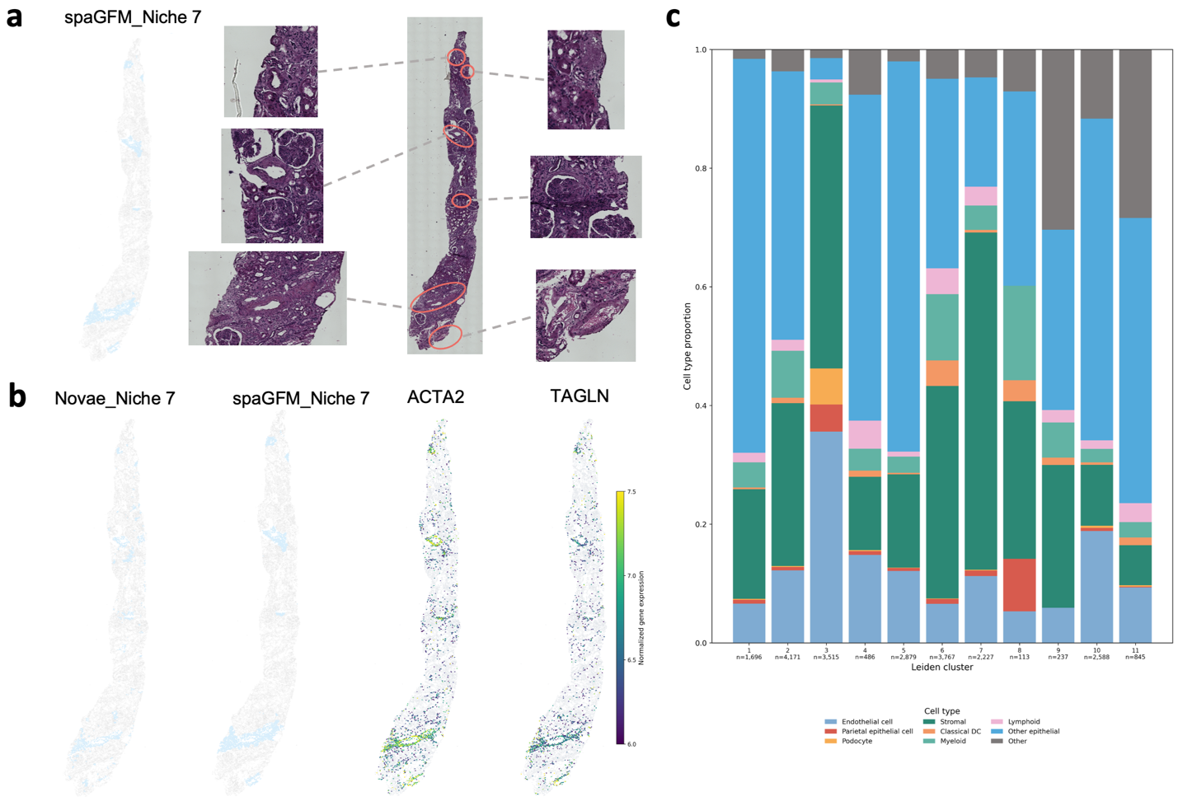
Supplementary Fig. 17. spaGFM enables more accurate identification of a disease-associated niche in kidney samples. (a) Spatial distribution of niche 7 identified by spaGFM and the corresponding H&E-stained tissue region. (b) Spatial maps of niche 7 identified by Novae (left) and spaGFM (middle), alongside the spatial expression of the fibrosis marker genes ACTA2 and TAGLN (right). (c) Cell-type composition of the 11 spatial domains identified by spaGFM.
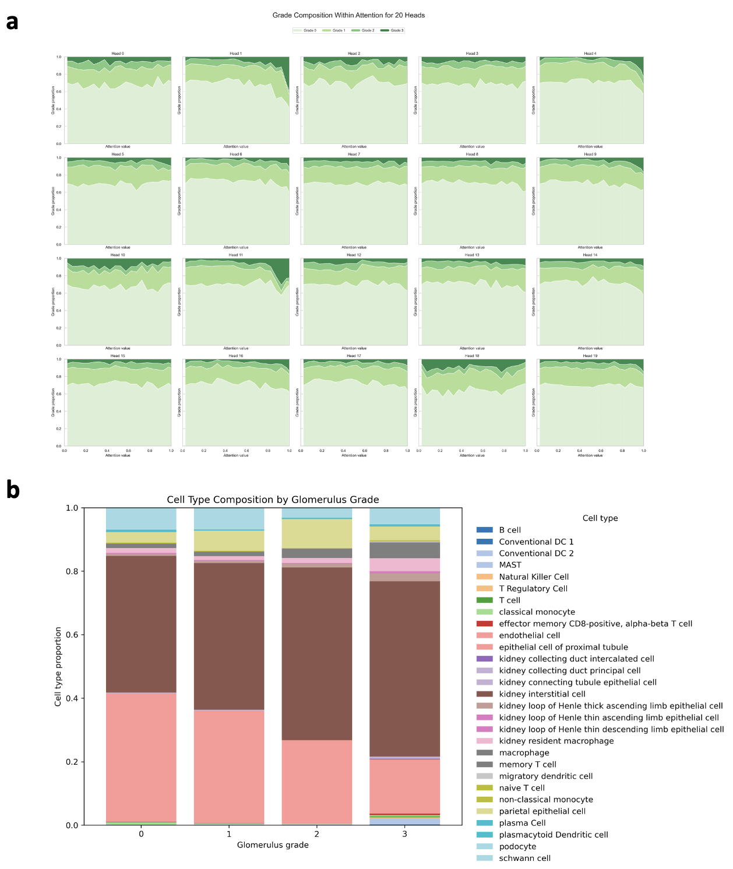
Supplementary Fig. 18. Attention patterns and cell type composition vary with glomerulus pathological grade. (a) Grade composition across attention values for all 20 heads. For each head, stacked proportions of cells from each glomerulus grade (0-3) are plotted as a function of attention value. In Head 1, the proportion of Grade-3 cells increases sharply at high attention values. (b) Cell type composition by glomerulus grade, shown as stacked proportions per grade (0-3) across glomeruli. Podocytes decrease while parietal epithelial cells, immune, and kidney interstitial cells increase with increasing pathological grade of severity.
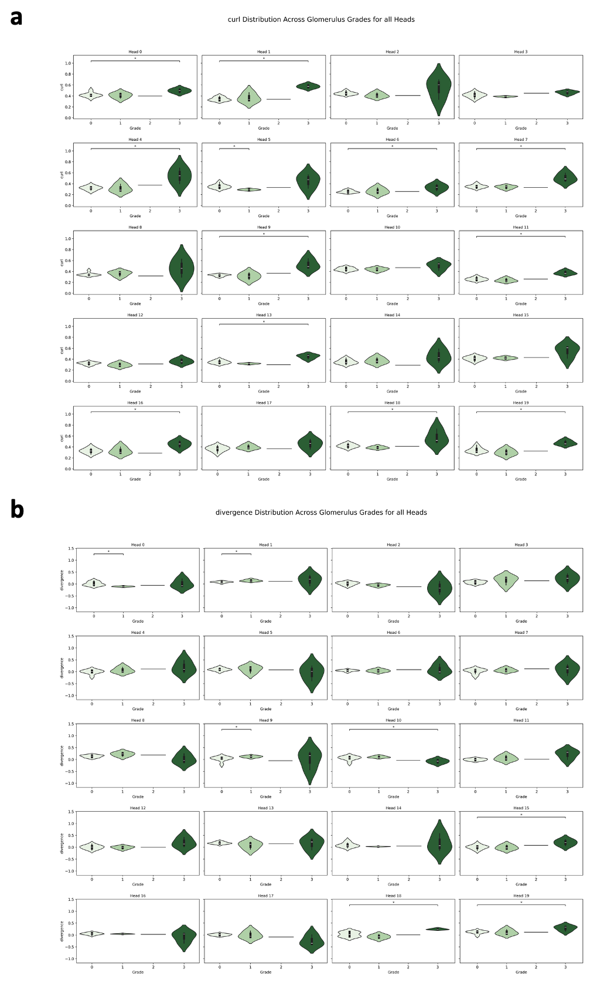
Supplementary Fig. 19. Attention-field curl and divergence vary across glomerulus pathological grades. (a) Curl of the attention field across glomerulus grades for all 20 heads, shown as violin plots with significance brackets. Curl quantifies the local rotational structure of each head’s attention flow and increases at Grade 3 in several heads, including Head 1. (b) Divergence of the attention field across glomerulus grades for all 20 heads, shown as violin plots. Divergence quantifies local attention concentration and broadens at Grade 3 across many heads.

