The Brexit Tuition Shock and the Price Elasticity of International Students
Evidence from a Natural Experiment
Online appendix

A1. Control-group construction
The analysis uses UCAS applicant counts by origin country and application cycle. Treated origins are European Union countries excluding Ireland, and candidate donors are non-EU origins. For each country $c$, the outcome is the natural logarithm of the applicant count $\left(Y_{ct}=\ln\left(App_{ct}\right)\right)$. The pre-reform window covers 2014-2020 and contains seven observations per country. Donors are selected on the shape of the pre-reform trajectory instead of the level of applications. Each logged series is z-standardized within country over 2014-2020:
$$z_{ct} =\frac{\left(Y_{ct} -{\overline{Y}}_{c}\right)}{σ_{c}}$$
Pairwise Euclidean distances are then calculated between the standardized paths, and every treated origin is matched to the three non-EU paths with the smallest distances. The step of dividing by the country standard deviation and subtracting the means removes the mechanical influence of market size and retains the timing and direction of pre-reform movements.
After donor selection for each treated origin j, nonnegative donor weights are selected such that they sum to one, are all positive and minimize pre-reform squared prediction error. Country-specific weights are set to zero outside the relevant three-country pool, averaged across the 26 treated origins, and normalized. The procedure follows the synthetic-control principle of choosing a transparent weighted comparison path before estimating post-reform effects (Abadie et al., 2010; Abadie & Cattaneo, 2018).
The resulting global donor weights enter the saturated difference-in-differences regression as fixed observation weights. Treated observations receive unit weight, and donor weights are multiplied by 26 so that the treated and control sides carry equal total weight. The specification includes country and cycle fixed effects and the time-varying controls described in the manuscript. Donor selection and weighting use only pre-treatment outcomes. For the R implementation the feols library was used because the plm package does not appear to be calculating the weighted regressions correctly.

A2. From post-reform effects to price elasticities
Clifton-Sprigg et al. (2025) derive a mechanical elasticity from a synthetic-DiD average treatment effect. To state the structural assumptions needed for the present transformation, consider a segmented constant-elasticity demand system indexed by origin $j$ and year $t$. Let $A_{jt}$ denote applicants from origin $j$ and $P_{jt}$ the effective price they face. A signed country-specific elasticity model is
$$logA_{j,t}=μ_{j}+δ_{t}+η_{j}logP_{j,t}+X_{j,t}^{'}θ+ε_{j,t}.$$
where:
- $μ_{j}$ are country fixed effects, or time-invariant demand shifters;
- $δ_{t}$ are year fixed effects, including common shocks;
- $X_{jt}^{'}$ is a vector of observed controls;
- $θ$ is a vector of coefficients for the control variables;
- $η_{j}<0$ is the signed demand elasticity for origin j;
- $ε_{jt}$ is a mean-zero demand disturbance.
The signed elasticity is $η_{j}=\frac{∂\log{Q_{jt}}}{∂\log{P_{jt}}}$. No constant is added inside the applicant logarithm because we select every sample so it is strictly positive. Let ${Post}_{t}$ be an indicator equal to 1 in years after the new fee regime is introduced (post-2020) and 0 otherwise, and let $1\left[Country j in EU\right]$ indicate EU origin countries (excluding Ireland). The Brexit shock enters the price equation as the system of simultaneous equations defining the country-specific reaction to the exogenous tuition shock:
$$logP_{j,t}=ϕ_{j}+k_{j}1\{j∈EU\}{Post}_{t}+ν_{j,t}.$$
- $ϕ_{j}$ is the pre-reform log price level for origin j;
- $k_{j}$ is the Brexit-induced log price change for origin j;
- $ν_{j,t}$ is a mean-zero price disturbance.
Combining equations (1) and (2) yields:
$$logA_{j,t}=μ_{j}+δ_{t}+η_{j}\left[ϕ_{j}+k_{j}1\{j∈EU\}{Post}_{t}+ν_{j,t}\right]+X_{j,t}^{'}θ+ε_{j,t}.$$
$$logA_{j,t}=\left(μ_{j}+η_{j}ϕ_{j}\right)+δ_{t}+η_{j}k_{j}1\{j∈EU\}{Post}_{t}+X_{j,t}^{'}θ+\left(ε_{j,t}+η_{j}ν_{j,t}\right).$$
Let $α_{j}=μ_{j}+η_{j}ϕ_{j}$ and $ε_{jt}^{*} = ε_{jt}+η_{j}ν_{jt}$. The fixed effects absorb time-invariant components, giving the reduced-form specification below. The reported tables use Driscoll–Kraay standard errors with one lag. Because the panels contain only nine or ten time periods, inference should also be treated as a short-panel sensitivity concern.
$$logA_{j,t}=α_{j}+δ_{t}+β_{j}1\{j∈EU\}{Post}_{t}+X_{j,t}^{'}θ+ε_{j,t}^{*}.$$
The country-specific DiD coefficient is $β_{j}=η_{j}k_{j}$, so the signed elasticity is $η_{j}=\frac{β_{j}}{k_{j}}$. Under the maintained price equation and $Δν_{j}≈0$, the Brexit price change is:
$$ΔlogP_{j}^{Brexit}=k_{j}.$$
Under a common change from £9,250 to £22,200, the homogeneous log price shock is:
$$k_{j}=log\left(22,200\right)-log\left(9,250\right)=0.875.$$
and since:
$$PV_{subjective}\left(δ,w_{j}\right)=max\left\{1,\sum_{t=1}^{30}{\frac{R_{t}\left(w_{j}\right)}{{\left(1+δ\right)}^{t}}}\right\}.$$
Country-specific price shocks are then specified as:
$$k_{j}\left(δ\right)=log\left(22,200\right)-log\left[PV_{subjective,j}\left(δ\right)\right].$$
A near-zero income gradient after this rescaling is compatible with loan-valuation mechanics explaining much of the raw cross-country pattern. Intentionally, we discount one year of the loan since the student is required to pay for one year of education at a time.

A3. Initial and later post-reform effects
We separate the post-reform period into an initial window covering 2021-2023 and a later window covering 2024-2025. The saturated regression estimates one country-specific effect in each window while retaining country and cycle fixed effects and the same control variables as the main specification, produces:
$$Δ_{j} = β_{j,later} - β_{j,initial}$$
Because the estimated country effects are predominantly negative, a positive difference indicates partial recovery after 2023, while a negative difference indicates that the decline intensified. A value near zero indicates persistence. The comparison is descriptive. It shows whether the initial contraction weakened, stabilized, or deepened once the fee regime was established and the most acute pandemic disruption had passed.

A4. Log and arc elasticities
Using $\frac{ΔQ}{Q}=\exp{(β)}-1$, Malta’s $β=-0.362$ implies $-30.4\%$, Lithuania’s $β = -2.17$ implies $-88.6\%$, and the pooled ATT $β = -1.11$implies $-67.0\%$, all relative to the control trajectory.
A naive arc elasticity divides the proportional quantity change by the $140\%$ arithmetic price increase:
$$η_{arc}=\frac{exp\left(-1.109\right)-1}{1.4}=-0.479.$$
However, for a finite log price change k and log quantity change β, the exact relationship is:
$$η_{arc}=\frac{ΔQ/Q}{ΔP/P}=\frac{e^{β}-1}{e^{k}-1}.$$
The signed log elasticity is $η_{\log{ }} =\frac{β}{k}$. If $β = η_{\log{ }}k$, then:
$$\lim_{k→0}\frac{e^{η_{log}k}-1}{e^{k}-1}=η_{log}.$$
The measures coincide only as the price change approaches zero. A constant-elasticity demand curve is linear in log-log space, not convex there. In levels, the large positive price change makes the secant percentage-change measure substantially flatter than the signed log elasticity in this application.
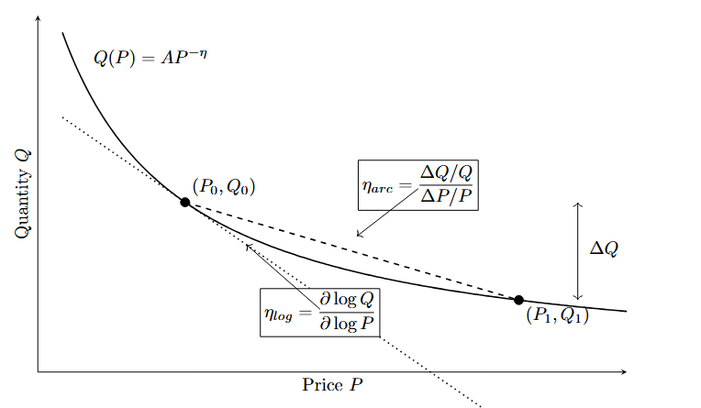
Figure A1
Constant-elasticity demand and alternative elasticity measures
Note. The dashed line represents the arc measure between the two equilibria. The dotted line represents the signed log elasticity at the initial equilibrium. For the Brexit calibration, the absolute arc elasticity is smaller than the absolute log elasticity due to the massive price shift.

A5. Detailed regression results
Table A1
Country-specific post-reform log effects under alternative specifications
Variable | Weighted  TWFE | Weighted  country FE | Weighted  no FE | Unweighted  TWFE
Intercept |  |  | 6.844***  (0.032)
Austria | -0.549***  (0.053) | -0.525***  (0.051) | -0.961***  (0.046) | -0.686***  (0.080)
Belgium | -0.603***  (0.066) | -0.579***  (0.063) | -0.434***  (0.059) | -0.740***  (0.093)
Bulgaria | -1.887***  (0.131) | -1.864***  (0.128) | -1.007***  (0.101) | -2.025***  (0.158)
Croatia | -1.655***  (0.109) | -1.631***  (0.105) | -2.572***  (0.098) | -1.792***  (0.130)
Cyprus | -0.902***  (0.067) | -0.879***  (0.066) | 0.255***  (0.042) | -1.040***  (0.096)
Czech Republic | -1.137***  (0.056) | -1.114***  (0.051) | -0.901***  (0.052) | -1.275***  (0.065)
Denmark | -1.046***  (0.109) | -1.023***  (0.105) | -1.609***  (0.093) | -1.184***  (0.132)
Estonia | -1.447***  (0.118) | -1.424***  (0.115) | -2.237***  (0.104) | -1.585***  (0.144)
Finland | -1.756***  (0.206) | -1.733***  (0.204) | -1.817***  (0.174) | -1.894***  (0.232)
France | -0.597***  (0.062) | -0.574***  (0.059) | 1.179***  (0.060) | -0.735***  (0.085)
Germany | -0.681***  (0.072) | -0.658***  (0.071) | 0.652***  (0.063) | -0.819***  (0.100)
Greece | -0.866***  (0.078) | -0.842***  (0.078) | 0.105  (0.077) | -1.003***  (0.103)
Hungary | -1.114***  (0.077) | -1.091***  (0.075) | -1.032***  (0.073) | -1.252***  (0.089)
Italy | -0.925***  (0.112) | -0.902***  (0.110) | 0.676***  (0.098) | -1.063***  (0.139)
Latvia | -1.512***  (0.127) | -1.488***  (0.122) | -1.928***  (0.122) | -1.649***  (0.145)
Lithuania | -2.173***  (0.277) | -2.150***  (0.271) | -1.412***  (0.244) | -2.311***  (0.297)
Luxembourg | -0.493***  (0.047) | -0.470***  (0.040) | -1.237***  (0.040) | -0.630***  (0.068)
Malta | -0.362***  (0.045) | -0.338***  (0.049) | -2.335***  (0.041) | -0.499***  (0.049)
Netherlands | -0.535***  (0.024) | -0.512***  (0.026) | -0.491***  (0.037) | -0.672***  (0.047)
Poland | -1.668***  (0.149) | -1.645***  (0.146) | -0.135  (0.141) | -1.806***  (0.164)
Portugal | -0.939*  (0.350) | -0.916*  (0.345) | -0.087  (0.321) | -1.077*  (0.362)
Romania | -1.711***  (0.136) | -1.688***  (0.133) | -0.363*  (0.130) | -1.849***  (0.157)
Slovakia | -1.516***  (0.119) | -1.493***  (0.119) | -1.570***  (0.094) | -1.654***  (0.125)
Slovenia | -1.280***  (0.121) | -1.256***  (0.120) | -3.108***  (0.094) | -1.417***  (0.147)
Spain | -0.508***  (0.083) | -0.484***  (0.079) | 0.964***  (0.065) | -0.645***  (0.086)
Sweden | -0.967***  (0.140) | -0.944***  (0.138) | -0.630***  (0.124) | -1.104***  (0.166)
Observations | 520 | 520 | 520 | 520
Weights | Yes | Yes | Yes | No
Country fixed effects | Yes | Yes | No | Yes
Year fixed effects | Yes | No | No | Yes
Adjusted R² | 0.98 | 0.98 | 0.27 | 0.98
Within R² | 0.82 | 0.87 |  | 0.81
Note. Driscoll-Kraay standard errors with one lag are in parentheses. + p < .10, * p < .05, ** p < .01, *** p < .001.

Variable | S1 Saturated DiD | S2 + GDPpc | S3 + GDPpc + Pop | S4 + GDPpc + Pop + YouthUnempl
Austria | -0.529***  (0.058) | -0.521***  (0.059) | -0.499***  (0.052) | -0.504***  (0.057)
Belgium | -0.581***  (0.073) | -0.583***  (0.070) | -0.570***  (0.064) | -0.575***  (0.068)
Bulgaria | -1.855***  (0.149) | -1.888***  (0.138) | -1.770***  (0.095) | -1.781***  (0.105)
Croatia | -1.616***  (0.127) | -1.657***  (0.117) | -1.528***  (0.097) | -1.529***  (0.101)
Cyprus (European Union) | -0.887***  (0.069) | -0.920***  (0.059) | -0.948***  (0.060) | -0.944***  (0.054)
Czech Republic | -1.121***  (0.064) | -1.121***  (0.060) | -1.070***  (0.071) | -1.075***  (0.072)
Denmark | -1.035***  (0.131) | -1.037***  (0.127) | -1.025***  (0.122) | -1.030***  (0.127)
Estonia | -1.412***  (0.132) | -1.412***  (0.124) | -1.393***  (0.120) | -1.407***  (0.132)
Finland | -1.680***  (0.217) | -1.669***  (0.220) | -1.625***  (0.206) | -1.622***  (0.206)
France | -0.575***  (0.069) | -0.571***  (0.068) | -0.541***  (0.058) | -0.537***  (0.057)
Germany | -0.659***  (0.077) | -0.650***  (0.079) | -0.581***  (0.055) | -0.584***  (0.058)
Greece | -0.819***  (0.067) | -0.835***  (0.059) | -0.735***  (0.035) | -0.719***  (0.042)
Hungary | -1.076***  (0.086) | -1.098***  (0.082) | -1.008***  (0.080) | -1.020***  (0.078)
Italy | -0.886***  (0.118) | -0.892***  (0.113) | -0.824***  (0.091) | -0.811***  (0.084)
Latvia | -1.474***  (0.154) | -1.488***  (0.145) | -1.383***  (0.126) | -1.389***  (0.129)
Lithuania | -2.163***  (0.347) | -2.187***  (0.334) | -2.157***  (0.331) | -2.164***  (0.339)
Luxembourg | -0.505***  (0.056) | -0.490***  (0.056) | -0.575***  (0.085) | -0.577***  (0.090)
Malta | -0.351***  (0.044) | -0.376***  (0.050) | -0.523***  (0.064) | -0.526***  (0.065)
Netherlands | -0.521***  (0.023) | -0.523***  (0.023) | -0.522***  (0.024) | -0.527***  (0.027)
Poland | -1.612***  (0.165) | -1.649***  (0.152) | -1.516***  (0.132) | -1.524***  (0.135)
Portugal | -0.863+  (0.421) | -0.867+  (0.420) | -0.833+  (0.417) | -0.836+  (0.421)
Romania | -1.653***  (0.154) | -1.680***  (0.145) | -1.577***  (0.124) | -1.597***  (0.135)
Slovakia | -1.472***  (0.117) | -1.482***  (0.113) | -1.385***  (0.116) | -1.396***  (0.110)
Slovenia | -1.201***  (0.121) | -1.218***  (0.117) | -1.171***  (0.099) | -1.177***  (0.107)
Spain | -0.492***  (0.094) | -0.488***  (0.096) | -0.490**  (0.099) | -0.476**  (0.102)
Sweden | -0.910***  (0.143) | -0.906***  (0.142) | -0.916***  (0.141) | -0.927***  (0.151)
c_log_GDPpc |  | 0.279  (0.254) | 0.332  (0.262) | 0.376  (0.236)
c_log_Pop15_64 |  |  | 1.646**  (0.359) | 1.617**  (0.340)
c_YouthUnempl |  |  |  | 0.002  (0.003)
Num.Obs. | 468 | 468 | 468 | 468
R2 Within | 0.817 | 0.818 | 0.830 | 0.830
R2 Within Adj. | 0.804 | 0.805 | 0.818 | 0.817
FE: Domicile_named_country | YES | YES | YES | YES
FE: Year | YES | YES | YES | YES
Weights | YES | YES | YES | YES
Table A2
Country-specific log effects in the initial and later post-reform windows
Country | Post | Country | Post | Country | Post 2023 | Country | Post 2023
Austria | -0.524***  (0.072) | Italy | -0.813***  (0.102) | Austria | -0.585***  (0.032) | Italy | -1.093***  (0.030)
Belgium | -0.551***  (0.078) | Latvia | -1.429***  (0.189) | Belgium | -0.681***  (0.022) | Latvia | -1.636***  (0.033)
Bulgaria | -1.795***  (0.169) | Lithuania | -2.026***  (0.384) | Bulgaria | -2.025***  (0.048) | Lithuania | -2.394***  (0.113)
Croatia | -1.591***  (0.158) | Luxembourg | -0.490***  (0.066) | Croatia | -1.751***  (0.039) | Luxembourg | -0.498***  (0.038)
Cyprus | -0.869***  (0.072) | Malta | -0.321***  (0.040) | Cyprus | -0.952***  (0.056) | Malta | -0.423***  (0.041)
Czech Republic | -1.107***  (0.078) | Netherlands | -0.518***  (0.030) | Czech Republic | -1.183***  (0.045) | Netherlands | -0.561***  (0.021)
Denmark | -0.962***  (0.114) | Poland | -1.529***  (0.175) | Denmark | -1.173***  (0.055) | Poland | -1.877***  (0.057)
Estonia | -1.341***  (0.128) | Portugal | -0.705  (0.495) | Estonia | -1.607***  (0.033) | Portugal | -1.291***  (0.135)
Finland | -1.571***  (0.206) | Romania | -1.604***  (0.188) | Finland | -2.035***  (0.063) | Romania | -1.873***  (0.051)
France | -0.542***  (0.073) | Slovakia | -1.397***  (0.111) | France | -0.679***  (0.006) | Slovakia | -1.695***  (0.090)
Germany | -0.615***  (0.070) | Slovenia | -1.229***  (0.161) | Germany | -0.781***  (0.027) | Slovenia | -1.355***  (0.151)
Greece | -0.778***  (0.062) | Spain | -0.465**  (0.106) | Greece | -0.997***  (0.035) | Spain | -0.572***  (0.067)
Hungary | -1.064***  (0.111) | Sweden | -0.825***  (0.126) | Hungary | -1.190***  (0.064) | Sweden | -1.180***  (0.033)
Observations | 520
Weights | YES
Country FE
Time FE
Adj. R2: | 0.98
Within R2: | 0.84

A6. Income-contingent loan calibration

A6.1 RPI calibration
Student-loan interest-rate years change in September, while the repayment projection is organized from April to March. Each calibration year uses five months from the earlier rate year and seven months from the later rate year. The weighted RPI is 1.9583% for April 2021 to March 2022 and 3.6583% for April 2025 to March 2026.
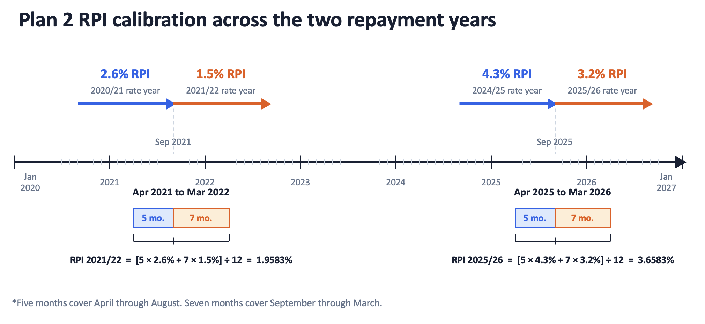
Figure A2. Plan 2 RPI calibration across the two repayment years
Note. Five months cover April through August and seven months cover September through March. Source values come from the Student Loans Company announcements listed in the references (Student Loans Company, 2020, 2021, 2024, 2025)

A6.2 Overseas earnings thresholds
Tables A3 and A4 group the treated EU origins by their Plan 2 overseas lower and upper earnings thresholds. The values are stated in pounds. The 2021-2022 schedule represents the pre-reform repayment environment, while the 2025-2026 schedule is used for the later calibration.

Table A3
Plan 2 overseas earnings thresholds in 2021-2022.
Countries | Lower threshold | Upper threshold
Bulgaria, Romania | £10,920 | £19,655
Croatia, Czech Republic, Hungary, Latvia, Lithuania, Poland, Slovakia | £16,380 | £29,480
Cyprus, Estonia, Greece, Italy, Malta, Portugal, Slovenia, Spain | £21,840 | £39,305
Austria, Belgium, Finland, France, Germany, Luxembourg, Netherlands, Sweden | £27,295 | £49,130
Denmark | £32,755 | £58,960
Source: Student Loans Company (n.d.)

Table A4
Plan 2 overseas earnings thresholds in 2025-2026, Source: Student Loans Company (2026).
Countries | Lower threshold | Upper threshold
Bulgaria, Romania | £11,390 | £20,500
Croatia, Czech Republic, Greece, Hungary, Latvia, Lithuania, Poland, Portugal, Slovakia | £17,085 | £30,750
Cyprus, Estonia, France, Italy, Malta, Slovenia, Spain | £22,780 | £41,000
Austria, Belgium, Denmark, Finland, Germany, Luxembourg, Netherlands, Sweden | £28,470 | £51,245

References
Abadie, A., & Cattaneo, M. D. (2018). Econometric methods for program evaluation. Annual Review of Economics, 10, 465-503. https://doi.org/10.1146/annurev-economics-080217-053402
Abadie, A., Diamond, A., & Hainmueller, J. (2010). Synthetic control methods for comparative case studies. Journal of the American Statistical Association, 105(490), 493-505. https://doi.org/10.1198/jasa.2009.ap08746
Clifton-Sprigg, J., Homburg, I., Huyghe, A., & Vujić, S. (2026). International student migration. Did Brexit close the door to EU students? In B. Elsner & S. W. Polachek (Eds.), Migration, human capital and the labor market (Research in Labor Economics, Vol. 53A). Emerald Publishing. https://doi.org/10.1108/S0147-91212026000053A002
Driscoll, J. C., & Kraay, A. C. (1998). Consistent covariance matrix estimation with spatially dependent panel data. Review of Economics and Statistics, 80(4), 549-560. https://doi.org/10.1162/003465398557825
Student Loans Company. (2020, August 11). Student loans interest rates and repayment threshold announcement. GOV.UK. https://www.gov.uk/government/news/student-loans-interest-rates-and-repayment-threshold-announcement
Student Loans Company. (2021, August 12). Student loans interest rates and repayment threshold announcement. GOV.UK. https://www.gov.uk/government/news/student-loans-interest-rates-and-repayment-threshold-announcement--2
Student Loans Company. (2024, August 13). Student loans interest rates and repayment threshold announcement. GOV.UK. https://www.gov.uk/government/news/student-loans-interest-rates-and-repayment-threshold-announcement--5
Student Loans Company. (2025, August 19). Student loans interest rates and repayment threshold announcement. GOV.UK. https://www.gov.uk/government/news/student-loans-interest-rates-and-repayment-threshold-announcement--6
Student Loans Company. (2026). Overseas earnings thresholds for Plan 2 student loans, 2025–26. GOV.UK. https://www.gov.uk/government/publications/overseas-earnings-thresholds-for-plan-2-student-loans/overseas-earnings-thresholds-for-plan-2-student-loans-2024-25
Student Loans Company. (n.d.). Overseas earnings thresholds for Plan 2 student loans, 2021–22. GOV.UK. Retrieved February 11, 2022, archived under https://web.archive.org/web/20220211005047/https://www.gov.uk/government/publications/overseas-earnings-thresholds-for-plan-2-student-loans/overseas-earnings-thresholds-for-plan-2-student-loans-2020-21

