9. SUPPLEMENTARY TABLES
Table S1. Univariable logistic regression

Variable | OR | 95% CI | p-value
ASA class ≥3 | 2.32 | 2.16-2.48 | <0.001
Operative time >120min | 2.02 | 1.87-2.17 | <0.001
Functional dependence | 4.87 | 4.07-5.78 | <0.001
CHF | 5.22 | 4.14-6.49 | <0.001
Diabetes | 1.74 | 1.61-1.89 | <0.001
COPD | 2.41 | 2.12-2.74 | <0.001
Bleeding disorder | 2.76 | 2.32-3.26 | <0.001
BMI (continuous) | 1.02 | 1.02-1.03 | <0.001
Obesity (BMI ≥30) | 1.37 | 1.28-1.46 | <0.001
Disseminated cancer | 2.17 | 1.78-2.61 | <0.001
Hypertension | 1.29 | 1.2-1.38 | <0.001
Dialysis | 4 | 2.69-5.72 | <0.001
Age (continuous) | 1.01 | 1.01-1.01 | <0.001
Steroid use | 1.66 | 1.39-1.96 | <0.001
Race (Black) | 1.33 | 1.2-1.47 | <0.001
Smoking | 1.26 | 1.14-1.39 | <0.001
General anesthesia | 1.3 | 1.15-1.47 | <0.001
Table S2. Interaction analysis: risk factors × mastectomy type (N = 154,210). Interaction between each risk factor and mastectomy type was assessed using likelihood ratio tests comparing multivariable models with and without interaction terms. All models were adjusted for age, race, obesity, diabetes, smoking, hypertension, COPD, CHF, dialysis, steroid use, bleeding disorder, disseminated cancer, functional dependence, ASA class, operative time, and general anesthesia. aOR = adjusted odds ratio (95% CI) from stratified multivariable models. P-int = p-value for interaction from likelihood ratio test. Bold = significant interaction (p < 0.05). Effect Pattern describes how the risk factor effect differs across surgery types.
Risk Factor | Effect Pattern | Partial aOR | Total aOR | Radical aOR | P-int
Operative time > 120 min | Strongest effect in Total mastectomy | 1.37 (1.18-1.59) | 1.68 (1.47-1.9) | 1.22 (1.01-1.48) | <0.001
Hypertension | Risk factor only in Total | 0.93 (0.83-1.03) | 0.8 (0.69-0.92) | 1.06 (0.85-1.31) | 0.001
Steroid use | Effect reverses between surgery types | 1.59 (1.25-1.98) | 0.79 (0.54-1.12) | 1.27 (0.82-1.88) | 0.001
Disseminated cancer | Risk factor in Partial and Radical | 2.19 (1.61-2.91) | 1.15 (0.76-1.66) | 1.51 (1.05-2.12) | 0.015
Obesity (BMI >= 30) | Risk factor in Total/Radical only | 1.05 (0.95-1.16) | 1.3 (1.15-1.48) | 1.4 (1.15-1.69) | 0.016
ASA class >= 3 | Effect decreases with surgery extent | 1.84 (1.65-2.05) | 1.63 (1.42-1.86) | 1.55 (1.26-1.92) | 0.030
Functional dependence | - | 3.3 (2.46-4.33) | 2.46 (1.73-3.41) | 2.47 (1.59-3.69) | 0.068
COPD | - | 1.56 (1.29-1.88) | 1.49 (1.15-1.91) | 1.93 (1.36-2.68) | 0.105
Diabetes | - | 1.36 (1.2-1.53) | 1.22 (1.04-1.43) | 1.31 (1.05-1.64) | 0.132
Dialysis | - | 2.66 (1.55-4.28) | 1.32 (0.54-2.75) | 2.17 (0.73-5.22) | 0.159
Bleeding disorder | - | 2.02 (1.58-2.54) | 1.96 (1.39-2.69) | 1.54 (0.93-2.41) | 0.417
Congestive heart failure | - | 2.87 (2.05-3.93) | 2.8 (1.76-4.29) | 2.33 (1.23-4.15) | 0.531
Black race | - | 1.07 (0.92-1.23) | 1.2 (1-1.43) | 1.18 (0.91-1.51) | 0.648
Current smoker | - | 1.11 (0.96-1.29) | 1.1 (0.92-1.31) | 1.22 (0.95-1.56) | 0.766
General anesthesia | - | 0.99 (0.86-1.14) | 0.86 (0.52-1.56) | 0.73 (0.26-3.01) | 0.904
aOR = adjusted odds ratio (95% CI) from stratified multivariable models. P-int = p-value for interaction from likelihood ratio test. Bold = significant interaction (p < 0.05). Effect Pattern describes how the risk factor effect differs across surgery types.

Table S3. Variable importance comparison across machine learning models (N = 154,210). XGBoost importance was measured by information gain; LASSO importance was measured by absolute coefficient value. Variables are ranked by XGBoost gain. All models used the same 15 preselected clinical predictors. Higher values indicate greater contribution to model prediction.
Rank | Variable | XGBoost (Gain) | LASSO (|Coef|)
1 | Age | 0.305 | 0.008
2 | ASA Class >=3 | 0.151 | 0.487
3 | Operative Time >120 min | 0.083 | 0.530
4 | COPD | 0.062 | 0.619
5 | Functional Dependence | 0.056 | 1.055
6 | Obesity | 0.053 | 0.121
7 | Diabetes | 0.045 | 0.215
8 | Bleeding Disorder | 0.040 | 0.713
9 | Black Race | 0.039 | 0.003
10 | Current Smoker | 0.038 | 0.268
11 | General Anesthesia | 0.034 | 0.172
12 | CHF | 0.030 | 0.710
13 | Disseminated Cancer | 0.025 | 0.567
14 | Steroid Use | 0.022 | 0.258
15 | Dialysis | 0.017 | 0.920

Table S4. LASSO feature selection from exploratory analysis using 26 candidate variables (N = 154,210). Coefficients represent penalized log-odds from LASSO regression. "Selected" indicates variables retained by LASSO (coefficient ≠ 0). "In Original Model" indicates inclusion in the primary 15-predictor model. Variables marked with an asterisk (*) were not in the original model.
Variable | Coefficient | Selected | In Original Model
Ventilator dependence* | 2.7000 | Yes | No
Functional dependence | 1.0470 | Yes | Yes
Dialysis | 0.8230 | Yes | Yes
CHF | 0.6800 | Yes | Yes
COPD | 0.6470 | Yes | Yes
Bleeding disorder | 0.6300 | Yes | Yes
Ascites* | 0.6180 | Yes | No
Disseminated cancer | 0.5290 | Yes | Yes
Operative time >120 min | 0.4930 | Yes | Yes
ASA class >=3 | 0.4460 | Yes | Yes
Current smoker | 0.2660 | Yes | Yes
Steroid use | 0.2320 | Yes | Yes
Diabetes | 0.2180 | Yes | Yes
General anesthesia | 0.1460 | Yes | Yes
Obesity | 0.1020 | Yes | Yes
Age (per year) | 0.0030 | Yes | Yes
INR* | 0.0030 | Yes | No
WBC* | 0.0010 | Yes | No
BUN* | 0.0010 | Yes | No
Renal failure* | 0.0003 | Yes | No
*New variables not in original 15 predictors. Variables with coefficient = 0 (not selected): Black race, preoperative transfusion, preoperative sepsis, albumin, creatinine, hematocrit.
Table S5. Tumor and surgical characteristics stratified by mastectomy type. Values are n (%). P-value: Chi-square test for categorical variables. Abbreviations: SLNB, sentinel lymph node biopsy; ALND, axillary lymph node dissection.

Variable | Overall  N = 191,559 | Partial  N = 136,437 | Total  N = 40,021 | Radical  N = 15,101 | P-value
Axillary Surgery, n (%) |  |  |  |  | <0.001
SLNB | 98,505 (51.4) | 69,246 (50.8) | 25,830 (64.5) | 3,429 (22.7)
ALND | 1,718 (0.9) | 836 (0.6) | 757 (1.9) | 125 (0.8)
None | 91,336 (47.7) | 66,355 (48.6) | 13,434 (33.6) | 11,547 (76.5)
Cancer Type, n (%) |  |  |  |  | <0.001
Malignant | 151,552 (79.1) | 105,027 (77.0) | 32,454 (81.1) | 14,071 (93.2)
In situ | 40,007 (20.9) | 31,410 (23.0) | 7,567 (18.9) | 1,030 (6.8)
Laterality, n (%) |  |  |  |  | <0.001
Unilateral | 180,307 (94.1) | 134,752 (98.8) | 33,672 (84.1) | 11,883 (78.7)
Bilateral | 11,251 (5.9) | 1,685 (1.2) | 6,349 (15.9) | 3,218 (21.3)

10. SUPPLEMENTARY FIGURES
Figure S1. Calibration plot for the logistic regression-based nomogram predicting 30-day unplanned readmission after outpatient breast cancer surgery. Calibration was assessed using 200 bootstrap resamples (N = 154,210). The dashed line represents ideal calibration. Mean absolute error = 0.001.

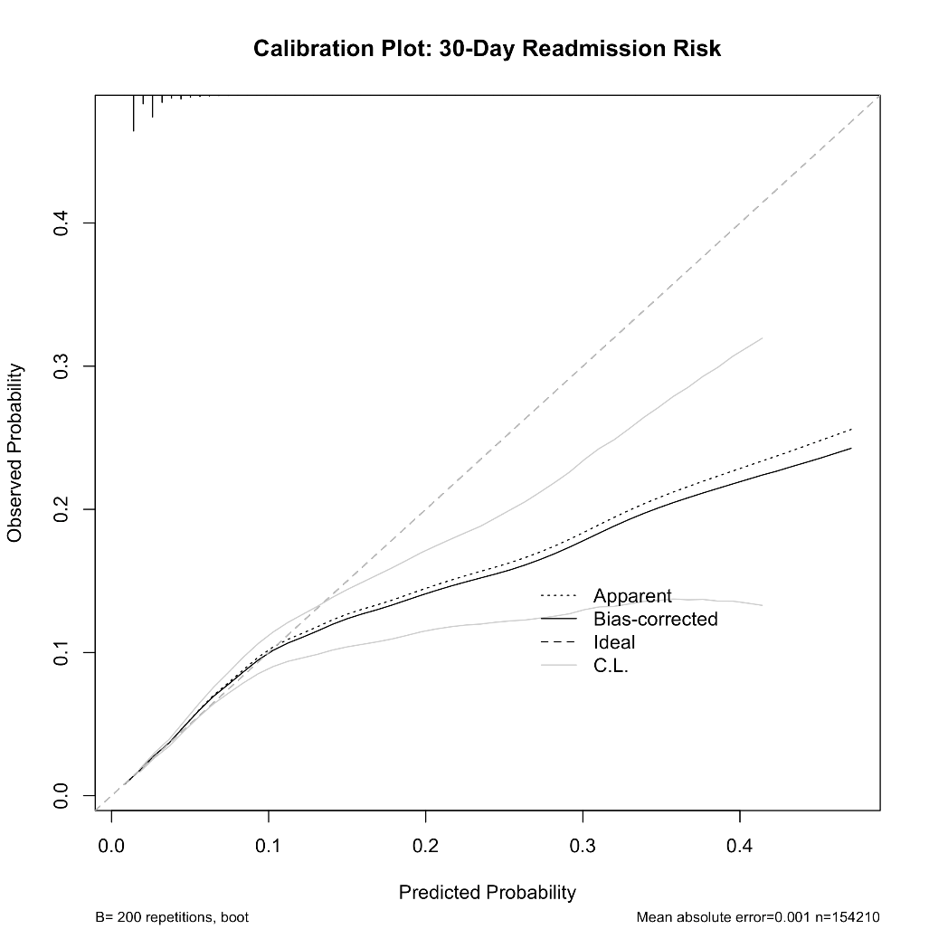

Figure S2. Interaction forest plot of significant risk factor × mastectomy type interactions (p < 0.05). Adjusted odds ratios with 95% confidence intervals from multivariable logistic regression stratified by surgery type (N = 154,210). Variables are ordered by interaction p-value. The dashed vertical line indicates aOR = 1.0 (no effect). Five of 15 predictors demonstrated significant interaction effects: operative time >120 minutes (p < 0.001), steroid use (p = 0.001), disseminated cancer (p = 0.015), obesity (p = 0.016), and ASA class ≥3 (p = 0.030).

