Supplementary Information:

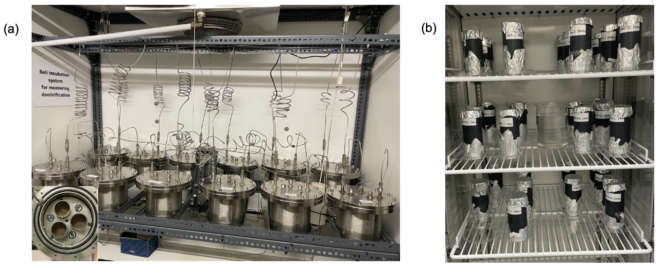
Supplementary Figure 1. Experimental setups used in this study. (a) DENIS experiment showing soil cores inside the chambers. (b) Destructive soil incubation experiment conducted in parallel under controlled conditions (25 °C and relative humidity was maintained between 60-70%

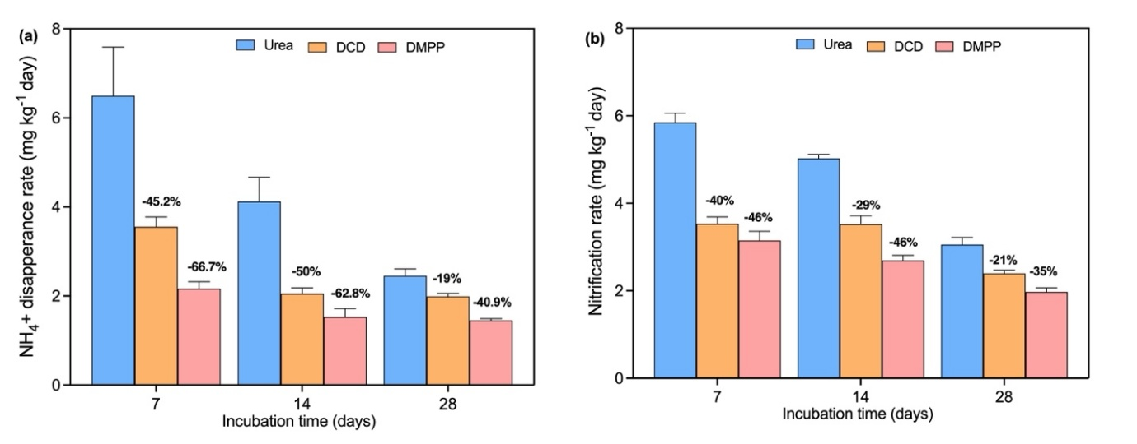
Supplementary Figure 2. (a) Ammonium disappearance rate and (b) nitrification rate under DCD and DMPP treatments on days 7, 14, and 28. Error bars represent standard deviations of the means (n = 3). Percentages shown above the bars represent the effectiveness of DCD and DMPP in reducing ammonium disappearance and nitrification rates relative to the urea treatment.

