CDK4/6 inhibition exploits the radiobiology of lutetium-177 therapy to induce replication stress and durable senescence
Supplementary file – uncropped Gels and Blots

Edward O’Neill*^{1,2}, Francesca Amoroso ¹, Michael Mosley¹, Julie Nonnekens³, Txema Heredia Genestar ³, Bart Cornelissen* ^{1,4}

¹ Oxford Institute for Radiation Oncology, Department of Oncology, University of Oxford, Oxford, UK
² Nuffield Department of Surgical Sciences, University of Oxford, Oxford, UK
³ Departments of Nuclear Medicine and Genetics, Erasmus University Medical Center, Rotterdam, the Netherlands
⁴ Department of Nuclear Medicine and Molecular Imaging, University Medical Center Groningen, University of Groningen, Groningen, the Netherlands

Supplementary Figure 19. a) Original membranes for western the blots shown in Figure 3.a. The membranes were cut before the incubation with the primary antibody (see Material and Methods for specifications). b) Original membranes for western blots in Figure 3.c. The membranes were striped between each incubation with a new primary antibody (see Material and Methods for specifications). a-b) Highlighted with a red box is the portion of the membrane utilized for the main figure. The samples have been loaded as described in the main. All the membranes were exposed for 10 minutes.
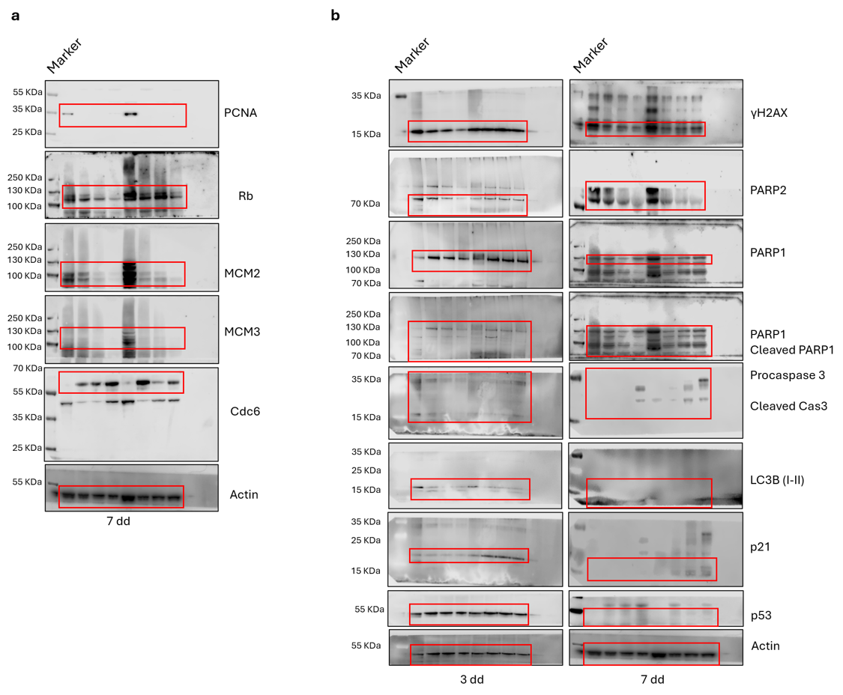

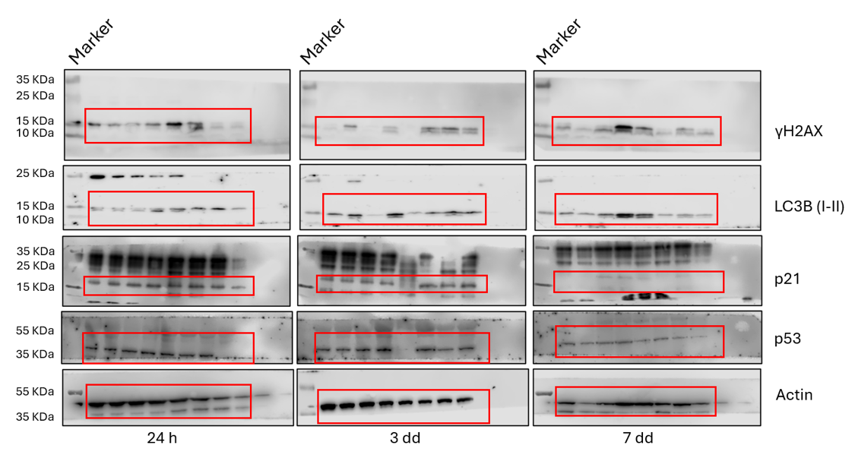
Supplementary Figure 20. Original membranes for western the blots shown in Figure 4.a. The membranes were cut before the incubation with the primary antibody (see Material and Methods for specifications). Highlighted with a red box is the portion of the membrane utilized for the main figure. The samples have been loaded as described in the main. All the membranes were exposed for 10 minutes.

Supplementary Figure 21. Original membranes for western the blots shown in Supplementary Figure 6 (22Rv1, top). The membranes were cut before the incubation with the primary antibody (see Material and Methods for specifications). Highlighted with a red box is the portion of the membrane utilized for the main figure. The samples have been loaded as described in the main. All the membranes were exposed for 10 minutes.
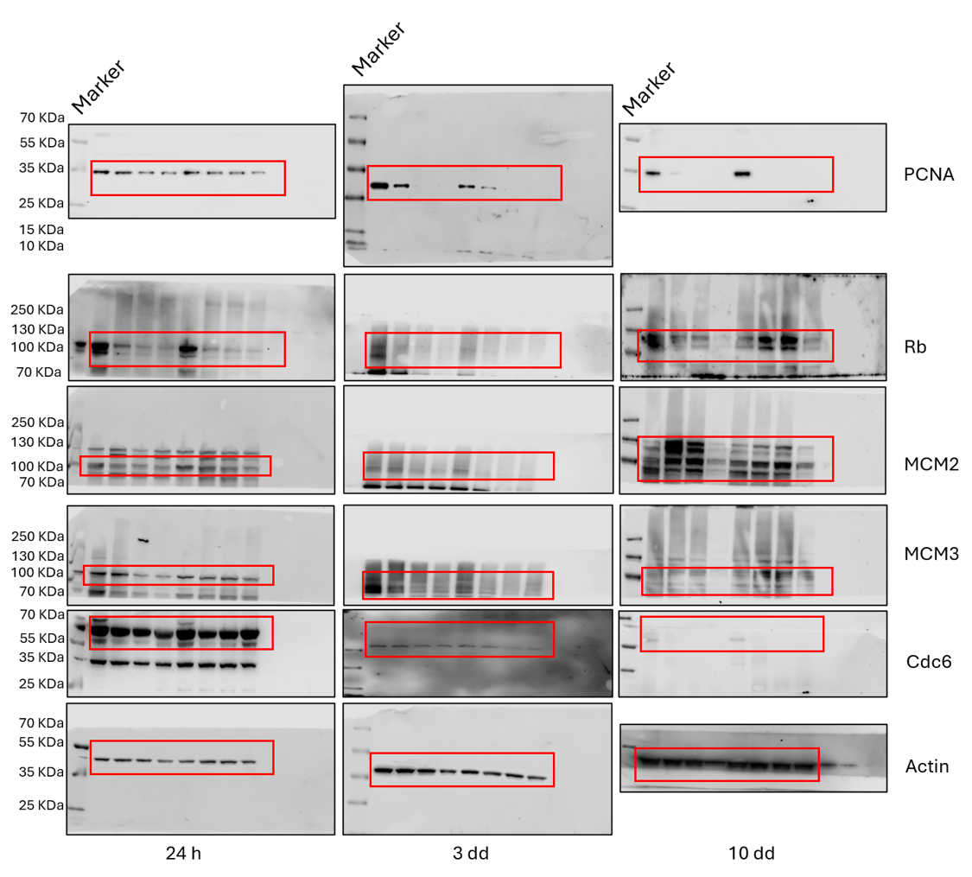

Supplementary Figure 22. Original membranes for western the blots shown in Supplementary Figure 6 (CA20948, bottom). The membranes were cut before the incubation with the primary antibody (see Material and Methods for specifications). Highlighted with a red box is the portion of the membrane utilized for the main figure. The samples have been loaded as described in the main. All the membranes were exposed for 10 minutes.
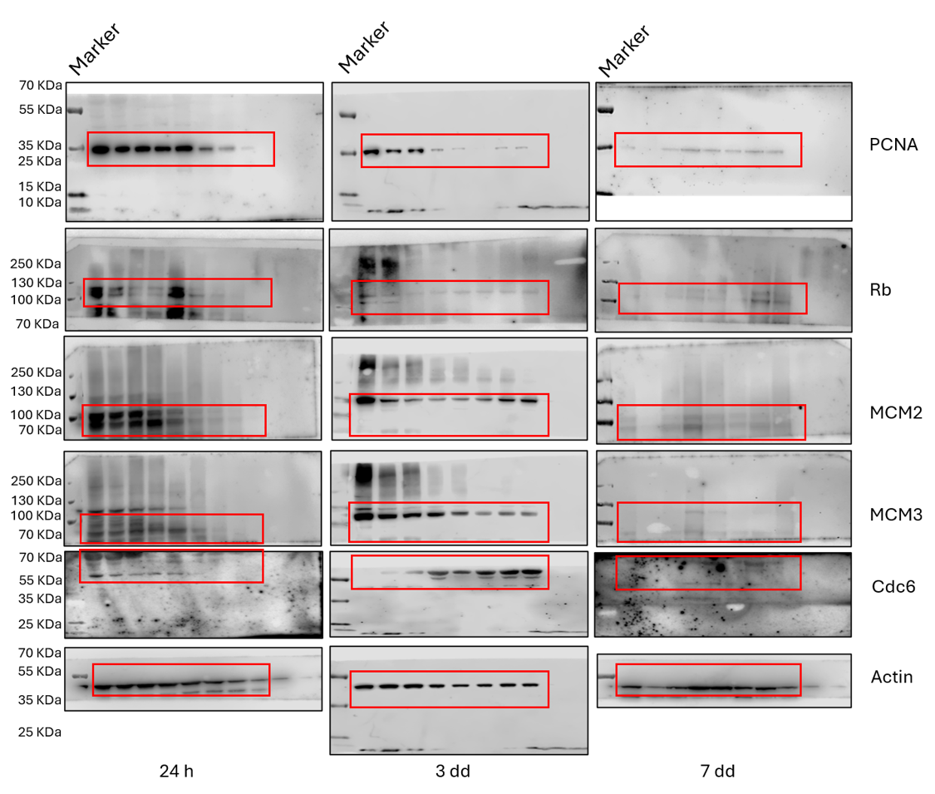

Supplementary Figure 23. Original membranes for western the blots shown in Supplementary Figure 7. The membranes were cut before the incubation with the primary antibody (see Material and Methods for specifications). Highlighted with a red box is the portion of the membrane utilized for the main figure. The samples have been loaded as described in the main. All the membranes were exposed for 10 minutes.
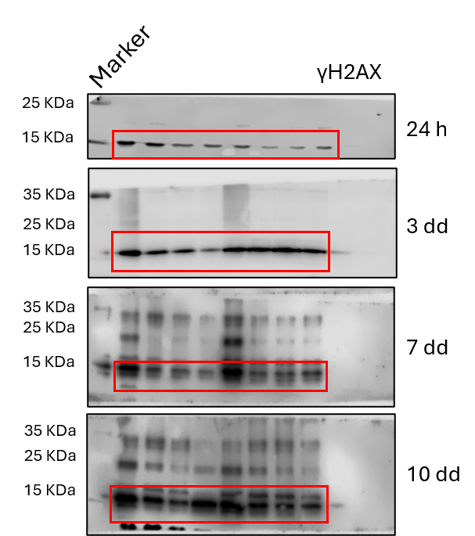

Supplementary Figure 24. Original membranes for western the blots shown in Supplementary Figure 8. The membranes were cut before the incubation with the primary antibody (see Material and Methods for specifications). Highlighted with a red box is the portion of the membrane utilized for the main figure. The samples have been loaded as described in the main. All the membranes were exposed for 10 minutes.
