CDK4/6 inhibition exploits the radiobiology of lutetium-177 therapy to induce replication stress and durable senescence
Supplementary Figures

Edward O’Neill*^{1,2}, Francesca Amoroso ¹, Michael Mosley¹, Julie Nonnekens³, Txema Heredia Genestar ³, Bart Cornelissen* ^{1,4}

¹ Oxford Institute for Radiation Oncology, Department of Oncology, University of Oxford, Oxford, UK
² Nuffield Department of Surgical Sciences, University of Oxford, Oxford, UK
³ Departments of Nuclear Medicine and Genetics, Erasmus University Medical Center, Rotterdam, the Netherlands
⁴ Department of Nuclear Medicine and Molecular Imaging, University Medical Center Groningen, University of Groningen, Groningen, the Netherlands

Supplementary Figure 1: CA20948 cells were exposed to ¹⁷⁷Lu-DOTATATE (0.32 MBq/mL, TRT), for a brief time, or vehicle, or exposed to an equitoxic dose of external beam radiation (EBRT), washed and incubated on in varying concentrations of one of a panel of drugs. 14 days later, cells are stained to assess clonogenic survival. (a) Combination index of drug with EBRT or TRT was compared. (b) ratio of the combination index with TRT vs. EBRT (c) CI of drug combinations with TRT, (d) Synergistic hits from the clonogenic drug screen.
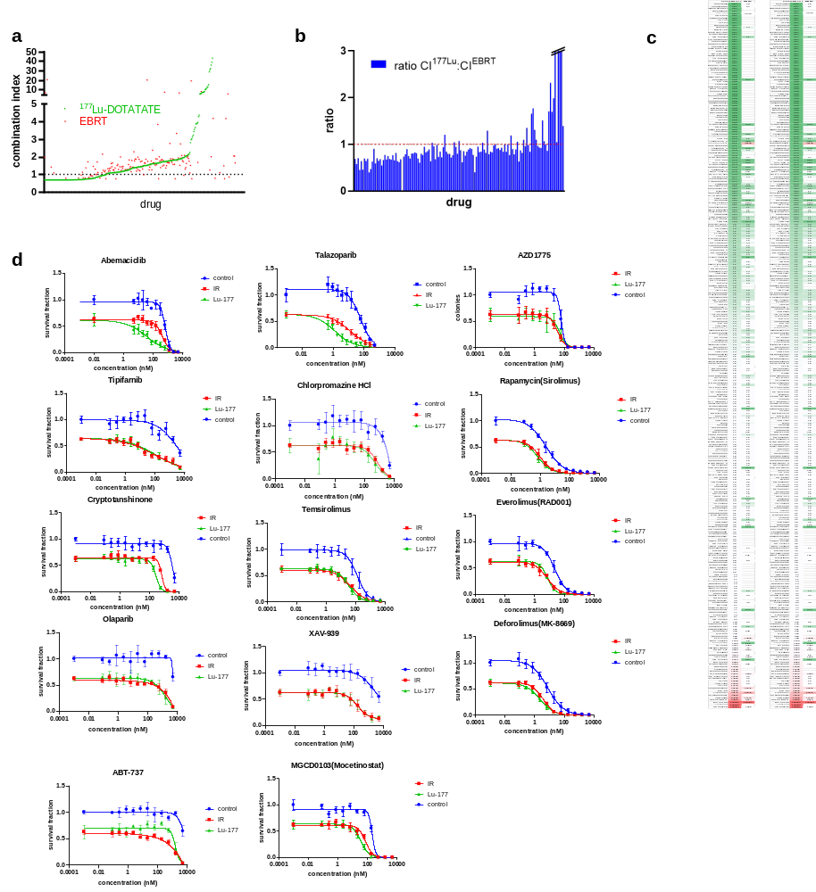
Supplementary Figure 2: (a) 22Rv1, (b) LNCaP or (c) LNCaP^{p53-/-} cells were exposed to ¹⁷⁷Lu-PSMA, for a brief time, or vehicle, washed and incubated on in abemaciclib or vehicle control. After 10 (22Rv1) or 14 days (LNCaP, LNCaP^{p53-/-}) cells were stained to assess clonogenic survival. (d) CA20948 xenograft bearing athymic mice were administered ¹⁷⁷Lu-DOTATATE (7.2±1.2 MBq). Starting 24 h later, abemaciclib (25 or 50 mg/kg) or vehicle control was administered intraperitoneally daily for 10 days. Animal weight and tumour size were recorded over time where the addition of abemaciclib to ¹⁷⁷Lu-DOTATATE did not affect overall mice weight compared to ¹⁷⁷Lu-DOTATATE. (e,f) there was no correlation between uptake and survival between the ¹⁷⁷Lu-DOTATATE treatment groups. (g,h) C.B-17/Icr SCID male mice were inoculated with 10⁶ 22Rv1 cells in a 1:1 Matrigel and media mix (100 µl) and randomised to receive vehicle (purple), ¹⁷⁷Lu-PSMA (40 MBq, blue), abemaciclib (25 mg/Kg, OG, green) or the combination of the two (red), survival represented as the time needed to 2.5X times the original tumour size measured right before the treatment. Tumour sizes were measured with callipers every 3 days. (i) Mice weights in each treatment group are reported as average of 10 animals ± SD. Two-way ANOVA did not show any significant difference between the groups (n.s.).
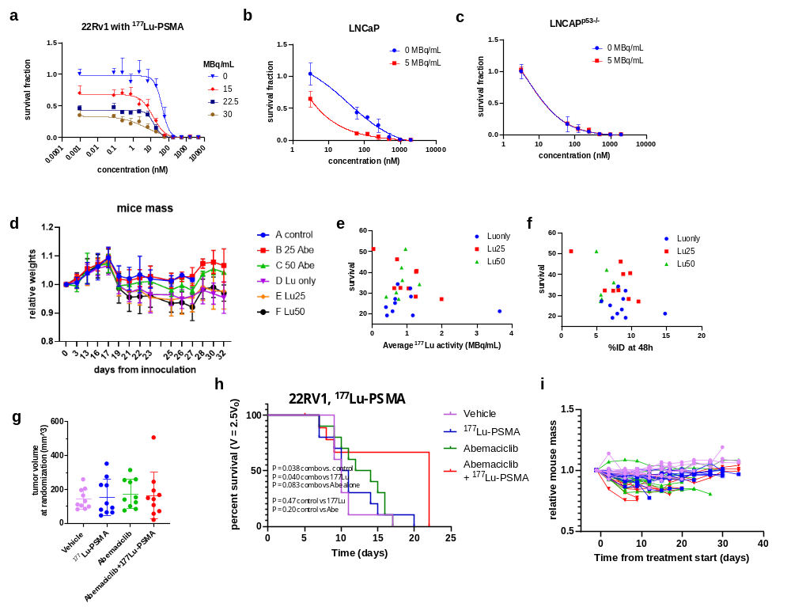

Supplementary Figure 3: p53 mutant cell lines BON1 and QGP1 did not demonstrate any evidence of any synergy or cooperativity with ¹⁷⁷Lu-DOTATATE and CDK4/6i in (a,b,c,d) BON1^{wt} cells (e) which may affected by the limited capacity of ¹⁷⁷Lu-DOTATATE as a monotherapy to reduce clonogenic survival in BON1 cell line. (f) Overexpression of sstr2 in QGP1 resulted in significant increase in efficacy of ¹⁷⁷Lu-DOTATATE, but (g-j) did not provide any evidence of synergy or cooperation with CDK4/6i (abemaciclib, ribociclib).
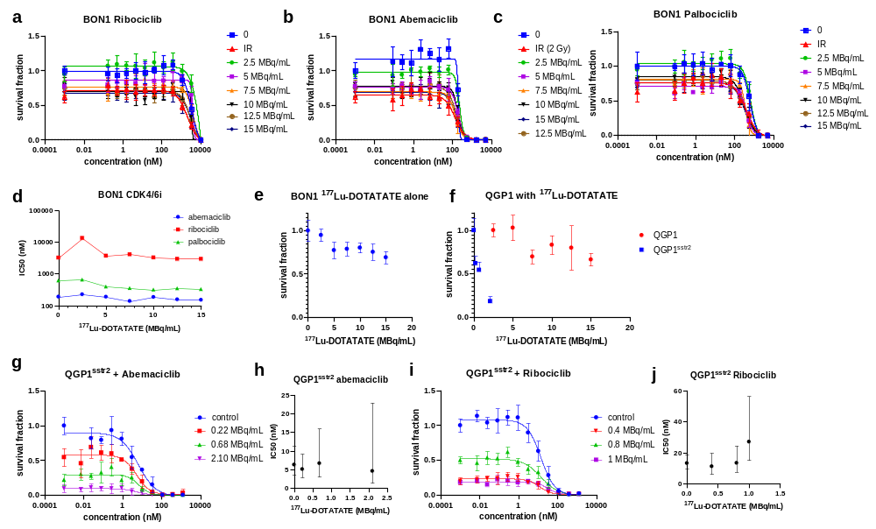

Supplementary Figure 4: Metabolic luminescence based assay, Cell Titre Glo (Promega) generated false negatives of activity with increased relative viability to varying activity concentrations of ¹⁷⁷Lu-DOTATATE (0-1.5 MBq/mL) in CA20948 cells across the CDK4/6i concentration range with (a) abemaciclib, and (d) palbociclib. Cell numbers of these plates prior to viability assay using Celigo imaging cytometer revealed a dose-dependent decrease in cell number with CDK4/6i concentration for (b) abemaciclib, and (e) palbociclib. Correlating the average viability by CellTitre Glo to cell number within these wells there was an apparent increase in viability with increasing concentration of CDK4/6i for (c) abemaciclib, and (f) palbociclib.
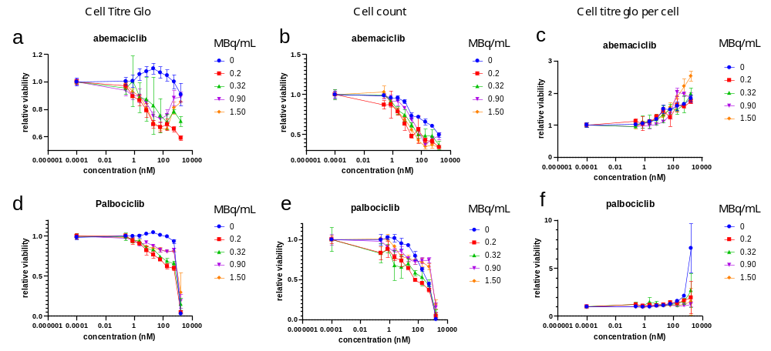

Supplementary Figure 5: Cell cycle analysis did not indicate a CDK4/6i dose-dependent cell cycle arrest for the mechanism of action in (a) 22Rv1 cell lines at days 6 and 7, and in (b) CA20948 cells at day 2 as well as (c) day 10. Cell cycle distribution was based upon DNA content imaged using Celigo imaging cytometer with cells treated within 96 well plates for the same initial treatment conditions used for the clonogenic assays. Cells were fixed in ice cold methanol and stored in -20 °C and stained with Hoescht 33342 when activity was at background levels before imaging on Celigo imaging cytometer.
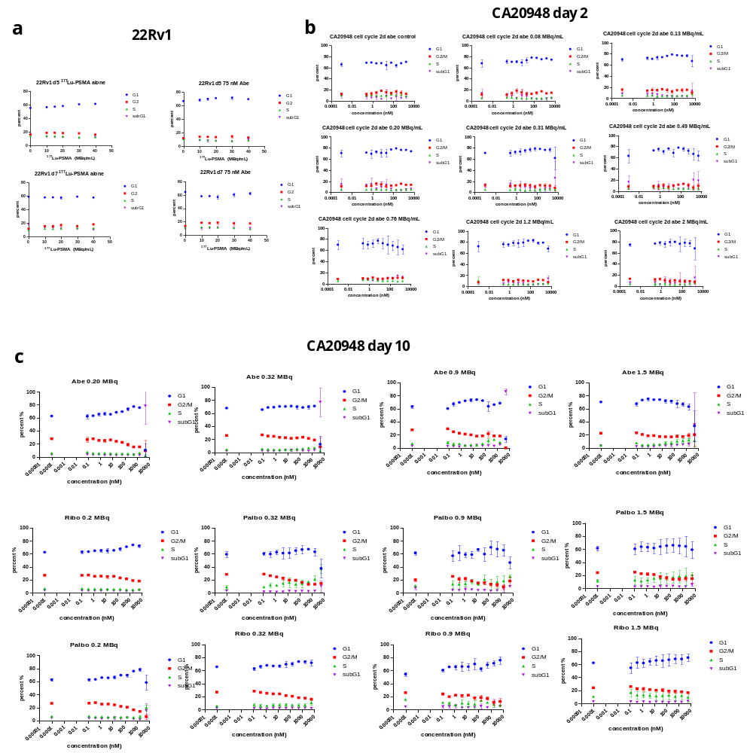
Supplementary Figure 6: (a) 22Rv1 or CA20948 cells were treated with ¹⁷⁷Lu-PSMA or ¹⁷⁷Lu-DOTATATE, respectively, for a brief time, or vehicle, washed and incubated on in abemaciclib or vehicle control. After 1, 3, 7 or 10 days, cells were harvested and proteins of the replisome assessed by western blot. Images are representative of n=3 independent experiments. (b) There was no evidence of any significant change in the densitometric ratio of ppRb:pRb+Rb within the same blots which would be indicative of cell cycle arrest by abemaciclib compared to control without Abe with and without the addition of ¹⁷⁷Lu-PSMA or ¹⁷⁷Lu-DOTATATE.
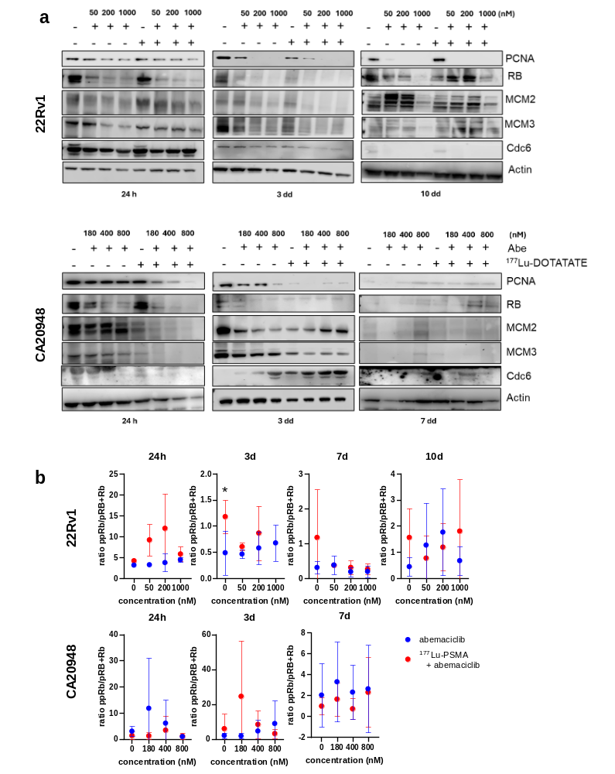
Supplementary Figure 7: 22Rv1 cells were treated with ¹⁷⁷Lu-PSMA for 2 hours, washed and incubated for 1, 3, 7 or 10 days, after which γH2AX content was determined by western blot. Images are representative of n=3 independent experiments. Actin was utilised for intrinsic normalization.
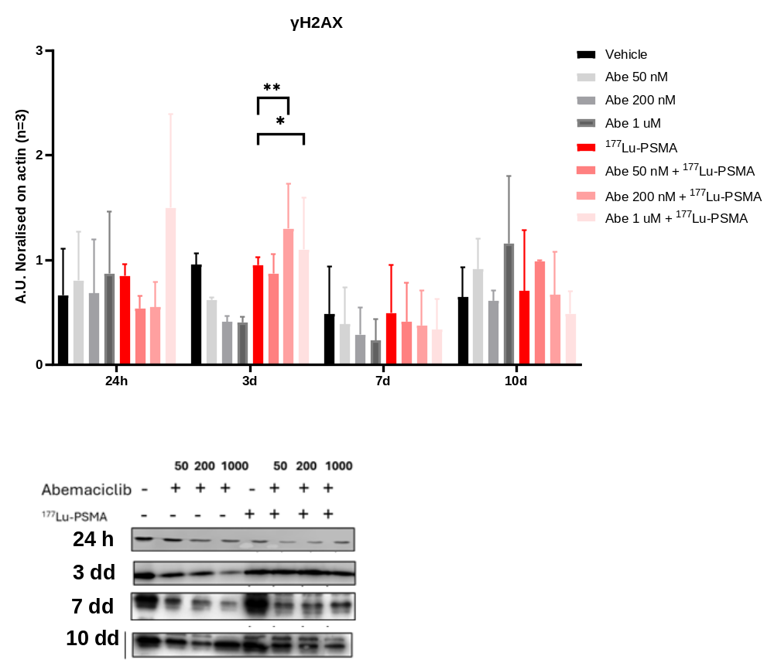

Supplementary Figure 8: 22Rv1 cells were treated with ¹⁷⁷Lu-PSMA, for a brief time, or vehicle, washed and incubated on in abemaciclib or vehicle control. After 1 or 10 days, cells were harvested and protein markers of cell stress and cell death assessed by western blot. Images are representative of n=3 independent experiments.
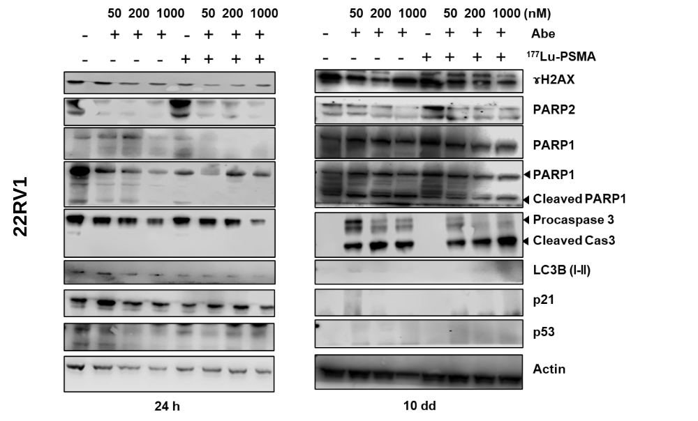

Supplementary Figure 9: Greater incidence of permanent senescence was achieved in CA20948 cells treated with both ¹⁷⁷Lu-DOTATATE (0.5 MBq/mL) and abemaciclib (600 nM) compared with abemaciclib (600 nM) alone which resulted in a transient senescence/quiescence. Plates were treated with as per normal clonogenic conditions but with a washout and replacement of media every 3 days until day 14 post wash-out.
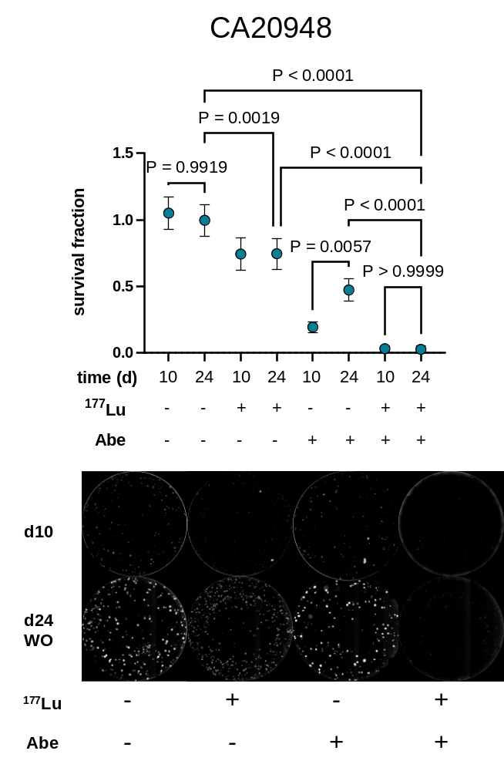

Supplementary Figure 10: Cell cycle expression of p21^{hi} and p21^{lo} at earlier (3d) vs late sustained expression (10d) in 22Rv1 cells following ¹⁷⁷Lu-PSMA treatment (22 MBq/mL) and abemaciclib (50, 200, 1000 nM). Early high expression of p21 is almost entirely in G2, whereas there is the emergence of p21^{hi} cells at day 10 which is greater with ¹⁷⁷Lu-PSMA. Cell cycle determined by DNA content (Hoescht 33342) and p21^{hi} and p21^{lo} levels were determined by integrated florescence intensity per cell using Celigo imaging cytometer.

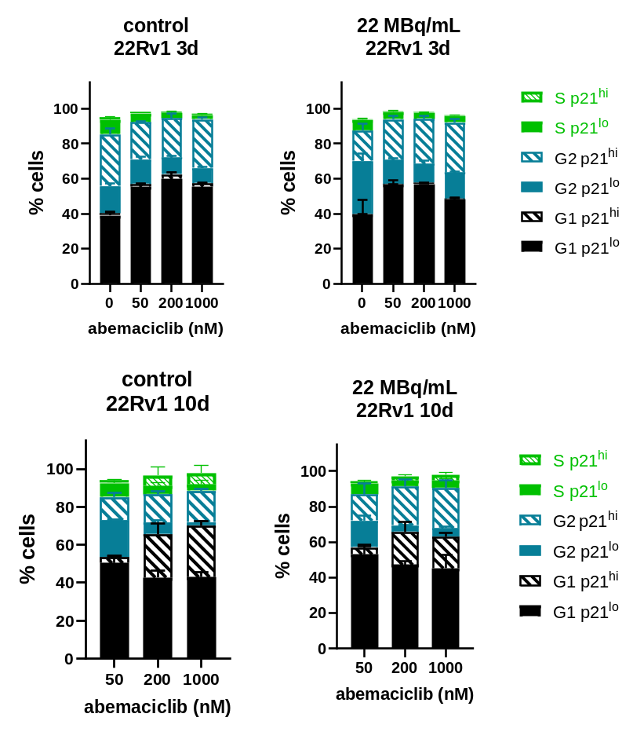

Supplementary Figure 11: Inhibition of autophagy by HCQ is synergistic with ¹⁷⁷Lu-DOTATATE in CA20948 cells with diminishing effect in combination with ¹⁷⁷Lu+Abe as determined by decreasing synergistic potency of abemaciclib on ¹⁷⁷Lu-DOTATATE (log alpha) in MuSyC (Wooten et al. 2021 Nat Commun, 12, 4607).
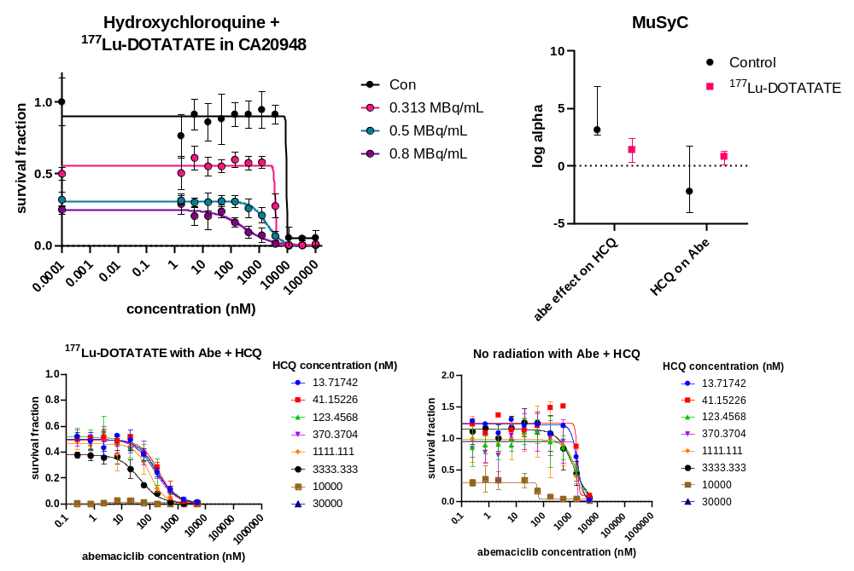

Supplementary Figure 12: Inhibition of autophagy by HCQ (5 µM) does not appear to be synergistic at all activity concentrations of ¹⁷⁷Lu-PSMA in 22Rv1 due to decreased induction of senescence (% cells with high levels of SA-β-Gal) with the addition of increasing concentration of abemaciclib (50, 200, 1000 nM), while not affecting the percentage of cells undergoing apoptosis (% cells with high levels of Annexin V staining).
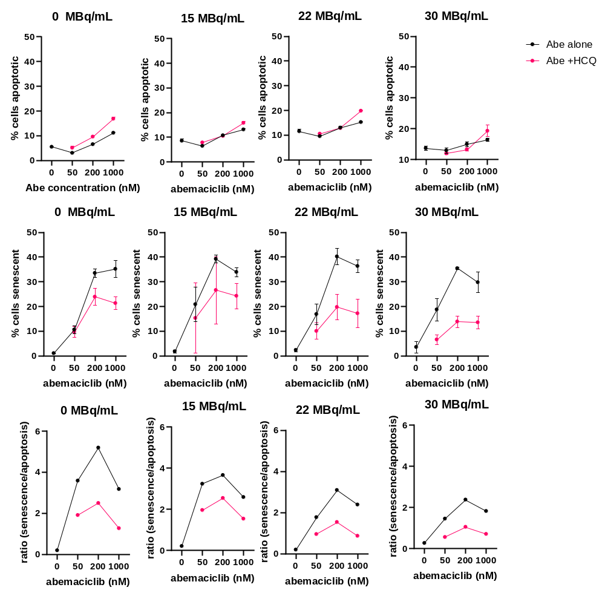

Supplementary Figure 13: (a) Inhibition of autophagy by HCQ (5 µM) in 22Rv1 cells reduces senescence within p21^{lo} and p21^{hi} senescent cell populations with the most significant reduction with p21^{lo} population with and without the addition of ¹⁷⁷Lu-PSMA (0,15,22,30 MBq/mL). (b) Only abemaciclib (200 nM)+HCQ (5 µM) resulted in a reduction in cell number relative to abemaciclib alone (200 nM), whereas the addition of ¹⁷⁷Lu-PSMA did not result in any reduction of cell number with the addition of HCQ to Abe.

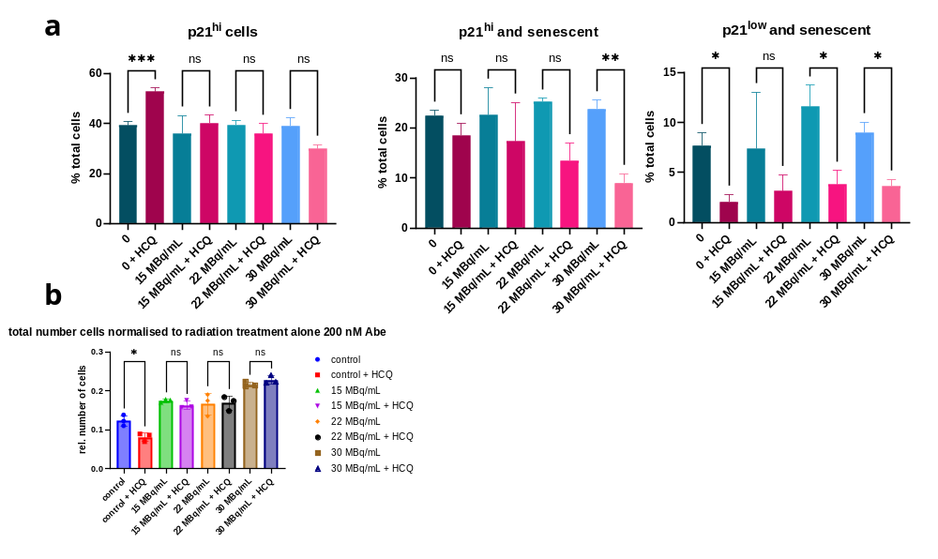

Supplementary Figure 14: Inhibition of autophagy by HCQ (5 µM) in 22Rv1 cells does not affect p21 levels in combination with ¹⁷⁷Lu-PSMA, but it does reduce the incidence of senescence that is associated with high levels of p21. Representative immunofluorescence images of cells processed in SI Fig 13 (Celigo Imaging Cytometer, scale bar = 100 µm).
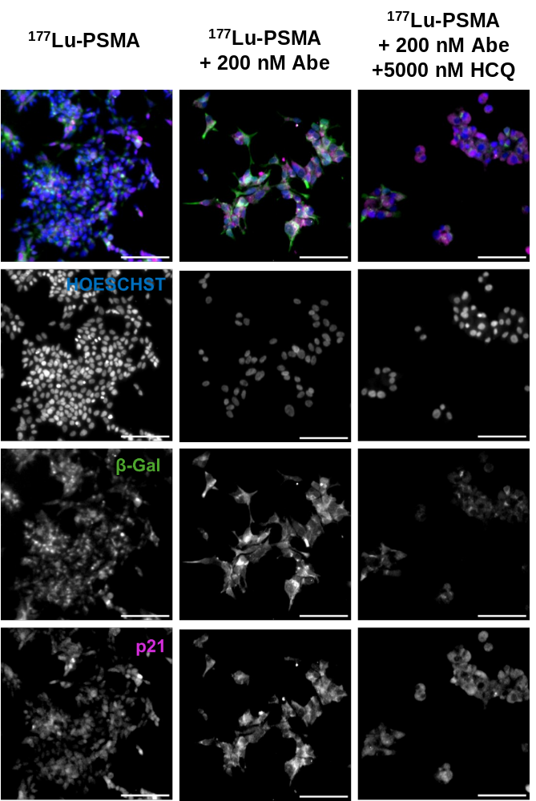
Supplementary Figure 15: Cytoplasmic chromatin fragments detected in the cytoplasm of senescent CA20948 cells using Hoescht 33342 in cells treated with higher concentrations of abemaciclib alone at day 7 (400, 800 nM), and at all concentrations of abemaciclib (189,400, 800 nM) when in combination with ¹⁷⁷Lu-PSMA (1.5 MBq/mL) with no CCF detected in cells treated with ¹⁷⁷Lu-DOTATATE alone.
Supplementary Figure 16: CA20948 cells treated with ¹⁷⁷Lu-DOTATATE (1.5 MBq/mL) and abemaciclib (400 nM) with stressed nucleoli had atypical expression of Annexin V, with focal expression of annexin V on the surface of the cell, as well as cytoplasmic staining of Annexin V (observable from day 3, but day 10 is shown, scale bar: 20 μm).

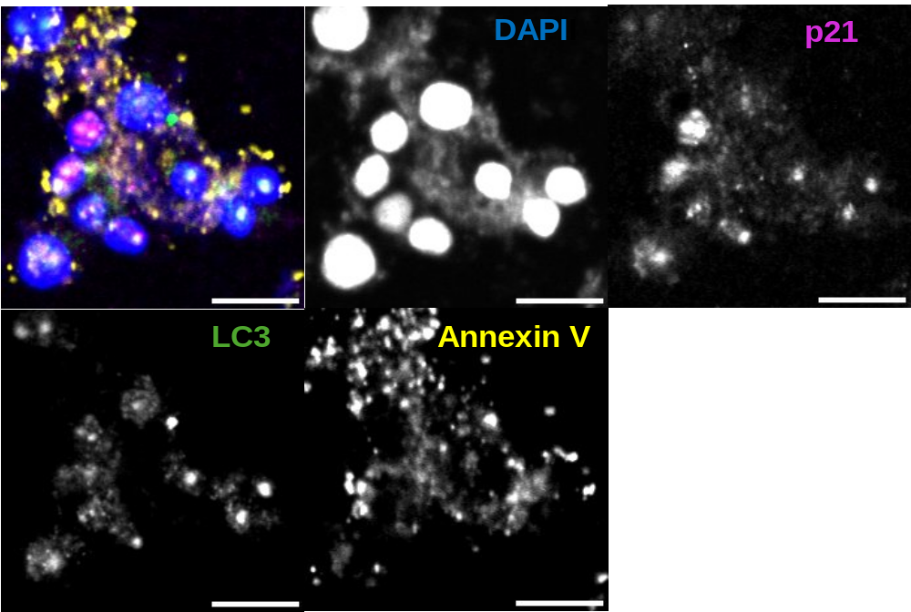

Supplementary Figure 17: p21 and p53 coincide within the release of CCF into the cytoplasm in CA20948 cells treated with ¹⁷⁷Lu-DOTATATE (0.32 MBq/mL) and abemaciclib (800 nM) (day 5, scale bar: 10 μm) and indicates a potentially disrupted nucleophagic clearance mechanism by the combination of Abemaciclib and ¹⁷⁷Lu-DOTATATE.
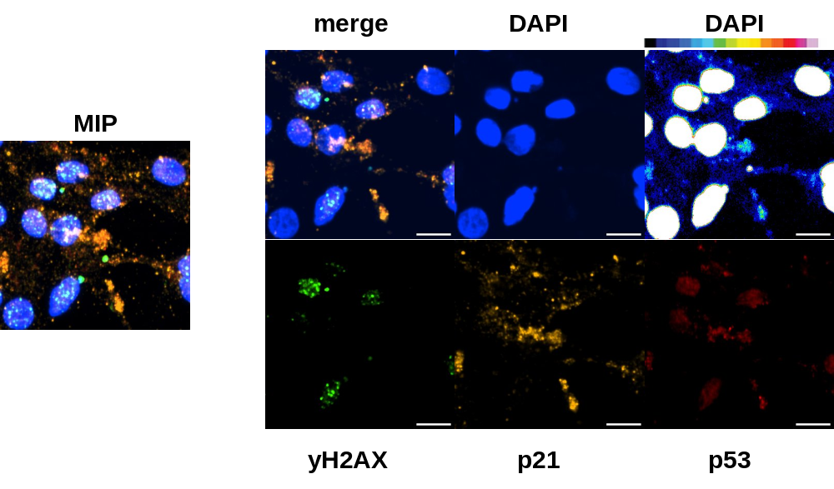

Supplementary Figure 18: (A) Evaluation of SASP in (A) Supernatants, and (B) cell lysates collected from 22Rv1 cell lines treated with either Abemaciclib alone (200, 1000 nM) or in combination with ¹⁷⁷Lu-PSMA (22 MBq/mL). Samples were harvested at 7 days from the treatment. Only one factor results impacted by the treatments, MIF (red open box). (C) Quantitative analysis (integrated intensity) of MIF as reported in A and B is shown for the supernatants (black bars) and for the cell lysates (white bars).

