Online Resource 1 — Supporting Information
Regional thermodynamic constraints on nighttime temperatures during heatwaves: heat retention under humid conditions and stronger cooling under dry conditions
Theoretical and Applied Climatology
Shulin Tang
School of Geography and Planning, Longdong University, Qingyang 745000, Gansu, China
Corresponding author: Shulin Tang, tangshulin@126.com

Appendix S1. Event-window sensitivity of fixed-region contrasts
This descriptive sensitivity uses the same 158 event-control pairs, including 32 cross-year matches, and compares the days 0–5 and days 0–10 windows. For each of five variables, an ordinary least-squares model includes a centred warm-season-year term and three region indicators. The contrast is the equal-weight mean of Europe and East Asia minus the equal-weight mean of Australia and southern South America, evaluated at a common year. The 95% confidence interval uses heteroskedasticity-consistent type 3 (HC3) covariance and a Student-t reference with 153 residual degrees of freedom. Benjamini–Hochberg adjustment is applied separately to the five contrasts in each window. These fixed geographic groups differ from the PCA-derived descriptive groups. This check does not refit PCA and is not part of the main 20-link hourly audit.
The equal-weight Europe-plus-East-Asia minus Australia-plus-southern-South-America contrasts keep the same sign in both windows (Fig. S1a–e). The northern regions have lower VPD and sensible-heat fraction, and higher dew point, downward longwave radiation, and warm-night area. Nine of the ten window-specific contrasts pass their FDR families. The exception is downward longwave radiation over days 0–10: 3.7531 W m⁻², with a 95% HC3 interval of −0.3970 to 7.9031 and q=0.0760 (Fig. S1d). The VPD contrast changes from −0.2618 to −0.2237 kPa, and the warm-night-area contrast from 0.0310 to 0.0248. The two windows overlap, so they are not independent replications, and no test of the difference between windows is claimed.

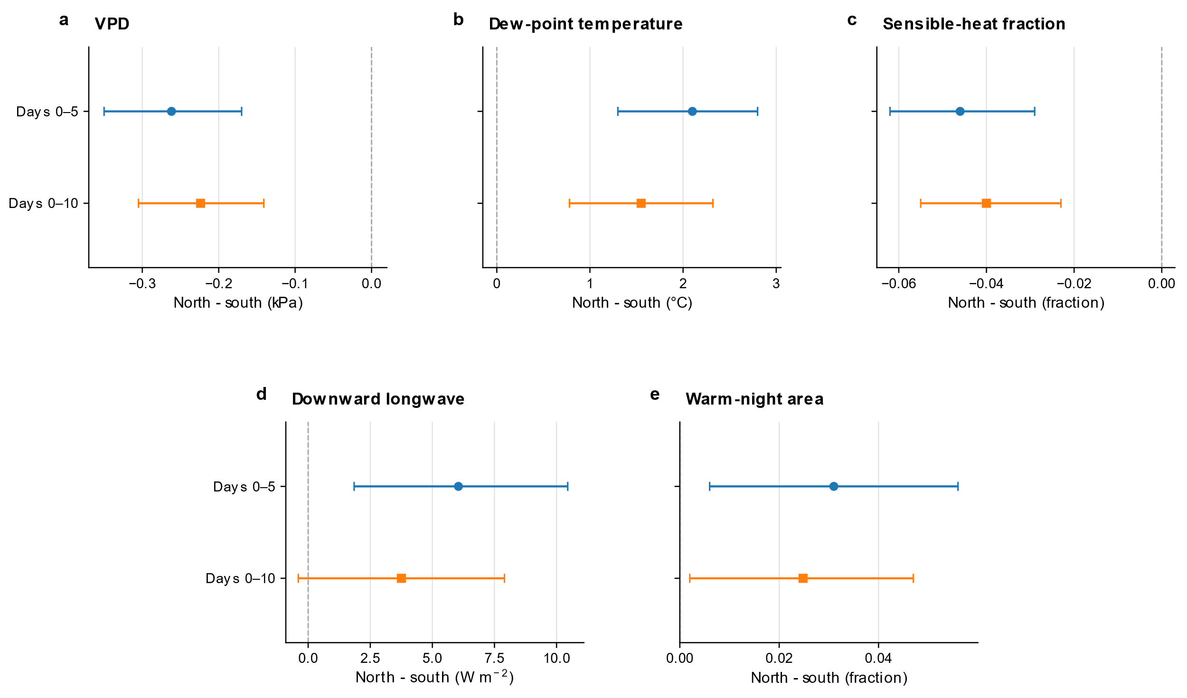
Fig. S1 Fixed-region contrasts under two event windows. Year-adjusted equal-weight Europe-plus-East-Asia minus Australia-plus-southern-South-America contrasts are shown for (a) VPD, (b) dew-point temperature, (c) sensible-heat fraction, (d) downward longwave radiation, and (e) P90 warm-night area. Purple circles show days 0–5 and green squares days 0–10; all comparisons use the same 158 matched pairs. Error bars are HC3 Student-t 95% intervals with 153 residual degrees of freedom, and the dashed vertical line marks zero. Benjamini–Hochberg adjustment is applied to five contrasts per window. The extended-window longwave interval includes zero (q=0.0760); the other nine contrasts pass their within-window FDR criterion. These fixed geographic groups are not the PCA-derived groups. VPD denotes vapour pressure deficit; P90 is the local 90th percentile of daily minimum temperature; HC3 denotes heteroskedasticity-consistent type 3 covariance; FDR denotes false discovery rate; PCA denotes principal component analysis

Appendix S2. Resampling and blocked validation
Both endpoint bootstrap schemes refit feature standardization, PCA, whole-vector orientation, score scaling, and the Year + Region regression in every repetition. Event resampling preserves the original regional counts; season-year cluster resampling keeps all events belonging to each sampled season year. There are 35 distinct sampled season years, and the random seed is 20260830. Percentile intervals describe uncertainty conditional on the selected features and sample design, not uncertainty from all earlier exploratory choices.
Table S1 Full-refit bootstrap uncertainty of the PC1–warm-night-area coefficient
Resampling unit | Successful / failed | Median coefficient | 95% percentile interval
Event, within region | 5000 / 0 | 0.0338 | 0.0213 to 0.0478
Season-year cluster | 5000 / 0 | 0.0338 | 0.0189 to 0.0465
The coefficient is warm-night-area fraction per standard deviation of each refitted PC1. All 5000 requested repetitions succeed in both schemes. Because the thermodynamic axis is re-estimated in every resample, these percentile intervals differ from the HC3 normal-reference interval used in the main text. PC1 denotes the first principal component; HC3 denotes heteroskedasticity-consistent type 3 covariance.
Table S2 Held-out warm-night-area errors in the fixed time blocks
Held-out years | n | Baseline RMSE | PC1-model RMSE | Change (%)
1986–2010 | 53 | 0.1219 | 0.1160 | −4.86
2011–2018 | 43 | 0.0657 | 0.0701 | 6.73
2019–2024 | 62 | 0.0955 | 0.0898 | −5.98
Pooled | 158 | 0.0987 | 0.0949 | −3.79
The baseline is Year + Region, and the extended model adds the training-derived PC1. Feature means and standard deviations, PCA loadings, score and year scaling, and regression coefficients are estimated from training observations only. RMSE denotes root-mean-square error and is expressed as warm-night-area fraction; negative change means lower error. Blocks are withheld in turn, so this is not forward forecasting. Pooled RMSE uses all 158 held-out predictions and is not the mean of the three block RMSEs.

Appendix S3. Fixed spatial mask and humidity-feature sensitivities
The main weights are cosine latitude × fractional land cover. The binary sensitivity keeps grid cells with land fraction ≥0.5 and uses cosine-latitude weights. Two fixed feature checks separately omit dew point or VPD; no other feature combinations are searched. Each row below refits PCA and the warm-night-area model. The two feature-deletion analyses also repeat blocked validation using their own training-only transformations.
Table S3 Warm-night-area relation under fixed spatial and feature definitions
Analysis | PC1 variance explained (%) | Coefficient | 95% HC3 interval | P | Pooled RMSE
Fractional land mask; four features | 59.85 | 0.0342 | 0.0193 to 0.0490 | 6.32 × 10⁻⁶ | 0.0949
Binary land mask; four features | 59.82 | 0.0343 | 0.0194 to 0.0491 | 6.08 × 10⁻⁶ | Not evaluated
Omit dew point | 55.92 | 0.0291 | 0.0145 to 0.0437 | 9.42 × 10⁻⁵ | 0.0944
Omit VPD | 70.39 | 0.0349 | 0.0206 to 0.0491 | 1.71 × 10⁻⁶ | 0.0949
Coefficients are expressed per standard deviation of the score fitted in each row, so the feature-deletion axes are related but not identical exposures. Confidence intervals use HC3 covariance and a normal reference. The pooled baseline RMSE is 0.0987. The binary-mask analysis is an association sensitivity only and does not include an additional completed prediction experiment. PC1 denotes the first principal component; HC3 denotes heteroskedasticity-consistent type 3 covariance; RMSE denotes root-mean-square error.
Loadings in the original four-feature order (dew point, downward longwave radiation, sensible-heat fraction, VPD) are 0.5883, 0.4590, −0.5202, and −0.4155. With dew point omitted, the remaining loadings (longwave, sensible fraction, VPD) are 0.4328, −0.6678, and −0.6056. With VPD omitted, the remaining loadings (dew point, longwave, sensible fraction) are 0.6470, 0.5601, and −0.5174. The same-year PCA explains 57.62% of variance, with loadings 0.5979, 0.4734, −0.5194, and −0.3854.

Appendix S4. Exploratory sensitivity of four-UTC-sample daily local relations
This appendix retains exploratory local relations from the earlier four-UTC-sample daily diagnostics to document analysis development and sensitivity. They are not the same test family as the main 20 prespecified links based on complete hourly data in Section 2.5, and they are not used to select N03 or S04. The five models use 126 same-year pairs, split into 62 southern and 64 northern pairs. Predictors and outcomes are standardized within each model sample, and all models control for year and region. The nine process coefficients form one Benjamini–Hochberg family. Confidence intervals and raw P values use HC3 covariance and a Student-t reference based on residual degrees of freedom. Predictive-error change evaluates all predictors in a model jointly, not one coefficient in isolation.
Table S4 Nine exploratory local-process coefficients from the four-UTC-sample daily diagnostics, including unsupported relations
Model / predictor–outcome | β | 95% HC3 interval | P | BH q | RMSE change (%)
S1：Soil moisture / sensible fraction | −0.278 | −0.600 to 0.044 | 0.0897 | 0.1346 | 3.46
S2：Soil moisture / VPD | 0.227 | −0.021 to 0.475 | 0.0715 | 0.1288 | −8.51
S2：Sensible fraction / VPD | 0.463 | 0.159 to 0.766 | 0.0034 | 0.0154 | −8.51
N1：MFC / dew point | 0.108 | −0.172 to 0.388 | 0.4441 | 0.4441 | −6.89
N1：IVT / dew point | 0.313 | 0.002 to 0.623 | 0.0488 | 0.1097 | −6.89
N2：Dew point / LW | 0.855 | 0.713 to 0.998 | 1.79 × 10⁻¹⁷ | 1.61 × 10⁻¹⁶ | −51.87
N2：Cloud / LW | 0.166 | 0.050 to 0.283 | 0.0058 | 0.0174 | −51.87
N3：LW / warm-night area | 0.395 | −0.182 to 0.972 | 0.1761 | 0.2264 | −1.17
N3：Dew point / warm-night area | −0.269 | −0.895 to 0.357 | 0.3935 | 0.4426 | −1.17
Slash labels show predictor / outcome, not causal direction. S denotes Australia and southern South America; N denotes Europe and East Asia. Soil is layer-2 soil moisture; MFC, vertically integrated moisture-flux convergence; IVT, vertically integrated vapour transport magnitude; LW, downward longwave radiation; VPD, vapour pressure deficit; BH, Benjamini–Hochberg; RMSE, root-mean-square error; HC3, heteroskedasticity-consistent type 3 covariance. Soil-moisture and transport predictors use the preconditioning phase; sensible fraction and dew point use onset; cloud, LW, VPD, and the local warm-night outcome use maintenance. The two coefficients in the same model share its RMSE change.

Appendix S5. Thermodynamic-axis consistency and descriptive-group stability
Table S5 Leave-one-region-out PCA consistency
Held-out region | n | Score correlation | Loading cosine | Training loadings: dew / LW / sensible / VPD
Australia | 36 | 0.9313 | 0.8407 | 0.684 / 0.642 / −0.339 / 0.077
East Asia | 36 | 0.9999 | 0.9987 | 0.583 / 0.426 / −0.523 / −0.453
Europe | 45 | 0.9999 | 0.9999 | 0.578 / 0.460 / −0.526 / −0.422
Southern South America | 41 | 0.9999 | 1.0000 | 0.585 / 0.461 / −0.521 / −0.417
Standardization and PCA use only the three training regions. Score correlation compares the held-out regional projections with a full-sample reference that includes the held-out observations. It therefore measures axis consistency, not independent validation or warm-night prediction. When Australia is omitted, the fitted VPD loading becomes positive, unlike the full-sample fit. Loading cosine compares training and full-sample loading vectors after whole-vector orientation. PCA denotes principal component analysis; PC1 denotes the first principal component.
Time-block score correlations with the full-sample reference are 0.9988 for 1986–2010, 0.9998 for 2011–2018, and 0.9999 for 2019–2024; these differ from the warm-night-area held-out errors in Table S2. Silhouette widths for k=2, 3, 4, and 5 are 0.4882, 0.2903, 0.2281, and 0.2299. The descriptive k=2 groups contain 20 low-score and 138 high-score events. Of the 20 low-score events, 18 are Australian, one is East Asian, and one is from southern South America; all 45 European events are in the high-score group. Across 5000 successful region-stratified full refits, the adjusted Rand index (ARI) has a median of 0.7762 and a percentile interval of 0.0551–1.0000.
Table S6 Descriptive rank associations between PC1 score and warm-night-area anomaly
Sample | n | Spearman ρ | Unadjusted P
All | 158 | 0.4885 | 7.42 × 10⁻¹¹
Australia | 36 | 0.3900 | 0.0187
East Asia | 36 | 0.2322 | 0.1730
Europe | 45 | 0.5921 | 1.83 × 10⁻⁵
Southern South America | 41 | 0.5817 | 6.64 × 10⁻⁵
These correlations do not control for year or region and are not a second confirmatory test of the multivariable model. Within-region P values are descriptive and are not adjusted for multiple testing. All results use the fixed 158 pairs and the full-sample PC1 scores. PC1 denotes the first principal component.

Appendix S6. Spatial support and time sampling
The ERA5 fractional land cover comes from the time-invariant 0.25° field in the NSF National Center for Atmospheric Research (NCAR) ERA5 archive (European Centre for Medium-Range Weather Forecasts 2019; https://doi.org/10.5065/BH6N-5N20). Coordinates are matched explicitly. The coarser 0.5° inputs use coincident points from the 0.25° mask rather than a remapped coarse-cell area fraction. Weights are normalized over finite cells with positive land weight; valid ocean values are not treated as land. Table S7 reports the geometric effective land area from the fractional mask for each regional grid before any variable-specific missing-value normalization.

Table S7 Fractional-land spatial support of the regional ERA5 grids
Region | Grid (°) | Effective land area (10⁶ km²) | Binary land area (10⁶ km²)
Australia | 0.25 | 7.652 | 7.682
Australia | 0.5 | 7.660 | 7.666
East Asia | 0.25 | 9.129 | 9.185
East Asia | 0.5 | 9.212 | 9.289
Europe | 0.25 | 7.644 | 7.770
Europe | 0.5 | 7.714 | 7.822
Southern South America | 0.25 | 7.289 | 7.379
Southern South America | 0.5 | 7.352 | 7.433
Effective area uses fractional land cover and latitude-dependent grid-cell area; the binary comparison uses land fraction ≥0.5. Small differences between grid resolutions reflect the sampled coordinates. Regional boundaries, event dates, and phase definitions are fixed across analyses.
Exploratory daily ERA5 diagnostics use the mean of 00, 06, 12, and 18 UTC samples. VPD is calculated from original grid-cell air and dew-point temperatures at each time, then averaged over time and fractional land area. Turbulent sensible-heat fraction is calculated each day from regional land-weighted H and LE and requires H + LE >10 W m⁻². The 20 main links in the manuscript instead use complete hourly data and local-solar-time nighttime diagnostics, so these four-sample daily quantities should not be mixed with the main hourly nighttime quantities. CPC daily minimum temperature is a separate daily extreme product, not a four-sample ERA5 mean.
Reference: European Centre for Medium-Range Weather Forecasts (2019) ERA5 Reanalysis (0.25 Degree Latitude-Longitude Grid) [Data set]. NSF National Center for Atmospheric Research. https://doi.org/10.5065/BH6N-5N20

Appendix S7. Regional slope differences in the PC1–warm-night-area relation
Table S8 Regional heterogeneity of the PC1–warm-night-area relation
This exploratory sensitivity uses all 158 matched pairs and the fixed full-sample PC1 score. The model includes a common standardized-year term, region intercepts, and PC1 × Region interactions. PC1 is scaled by its full-sample standard deviation rather than separately within each region. Features, thresholds, controls, and events are not reselected. This analysis was carried out after the main results were known to check regional slope differences; it is not preregistered.
A. Omnibus test of equal slopes across the four regions: HC3 Wald F(3, 149)=7.996; P=0.0000561.
B. Regional slopes (percentage-point change in warm-night area per one full-sample PC1 standard deviation).
Region | n | Slope | 95% HC3 CI | P
Australia | 36 | 1.42 | 0.25 to 2.60 | 0.0178
East Asia | 36 | 2.39 | −0.65 to 5.42 | 0.1236
Europe | 45 | 9.82 | 4.88 to 14.77 | 0.0000976
Southern South America | 41 | 11.99 | 6.63 to 17.35 | 0.0000115
C. All pairwise slope contrasts (left region minus right region; percentage points of warm-night area per one PC1 standard deviation).
Contrast | Difference | 95% HC3 CI | P | BH q
Australia − East Asia | −0.96 | −4.23 to 2.30 | 0.5624 | 0.5624
Australia − Europe | −8.40 | −13.47 to −3.33 | 0.0012 | 0.0035
Australia − Southern South America | −10.57 | −16.02 to −5.12 | 0.0001451 | 0.0008705
East Asia − Europe | −7.44 | −13.26 to −1.61 | 0.0123 | 0.0184
East Asia − Southern South America | −9.60 | −15.82 to −3.39 | 0.0025 | 0.0049
Europe − Southern South America | −2.17 | −9.44 to 5.11 | 0.5599 | 0.5624
Note. Confidence intervals and slope/contrast P values use HC3 covariance with a normal reference; the omnibus test uses the residual-df robust Wald F reference. Regional-slope P values are unadjusted; Benjamini–Hochberg (BH) adjustment covers all six pairwise contrasts. SD denotes standard deviation; PC1, first principal component; CI, confidence interval; HC3, heteroskedasticity-consistent type 3 covariance; BH, Benjamini–Hochberg. Intervals are conditional on the fixed full-sample PCA and do not propagate uncertainty from axis estimation or exploratory feature selection. These within-sample contrasts are not independent regional prediction tests. Because the interaction model conditions on the fixed pooled PC1, while leave-one-region-out refitting shows that PC1 loading composition is not fully invariant across regions (Table S5), regional slope differences should not be interpreted as different causal sensitivities to an identical physical exposure.
The interaction model has 9 estimable coefficients, 149 residual degrees of freedom, R²=0.3471, and adjusted R²=0.3121. The pooled coefficient summarizes the current sample; it is not a common regional slope.

Appendix S8. Descriptive k-means grouping and pooled PC1 relation
The four standardized variables are partitioned with k-means for k=2–5 and compared by silhouette width. The k=2 solution is used only to describe low- and high-score groups, not as a formal two-type heatwave classification. Stability is assessed with 5000 region-stratified bootstrap refits and the adjusted Rand index. Of the 20 low-score events, 18 are Australian, so regional composition is strongly imbalanced and the groups cannot define stable cross-region heatwave types.
The pooled regression between PC1 and P90 warm-night area is used only to summarize the current 158 pairs. The PC1 × Region interaction shows that regional slopes differ (HC3 Wald P=0.0000561), so the pooled slope cannot be interpreted as a common response across all four regions. Full regional slopes are reported in Table S8.
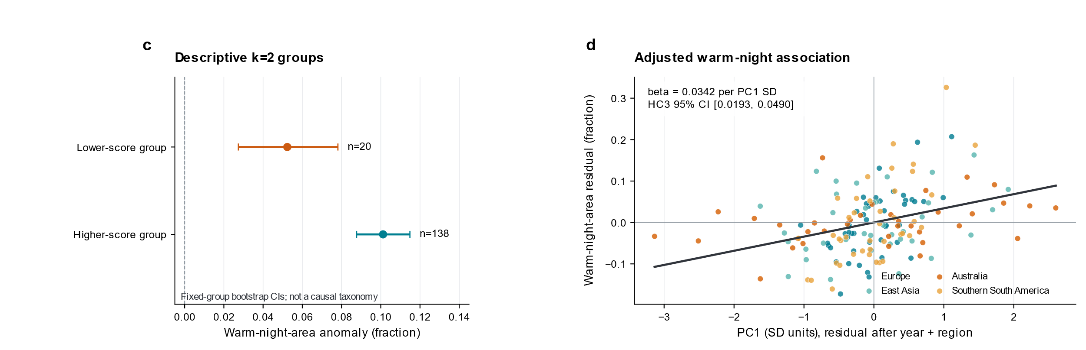
Fig. S2 P90 warm-night-area anomalies for the descriptive k=2 groups and the pooled partial-residual relation between PC1 and warm-night area after removing year and region. The pooled line summarizes the current sample only; it does not imply a common regional slope. Regional differences are reported in Table S8

Appendix S9. Event-relative evolution of the descriptive groups
In the high-score group (n=138), dew point and downward longwave radiation are already positive before heatwave onset and remain positive through maintenance; P90 warm-night area increases after onset. The group contains all European events as well as events from other regions, so these curves describe the thermodynamic background of the high-score group and should not be labelled a “northern mechanism.”
In the low-score group (n=20), sensible-heat fraction and VPD rise near onset and during maintenance, and P90 warm-night area also increases. However, 18 of the 20 events are Australian, so regional composition is highly uneven. The coexistence of drier daytime conditions and warm nights does not show that dryness causes nighttime warming, and the group should not be treated as a common Australia–southern South America type.
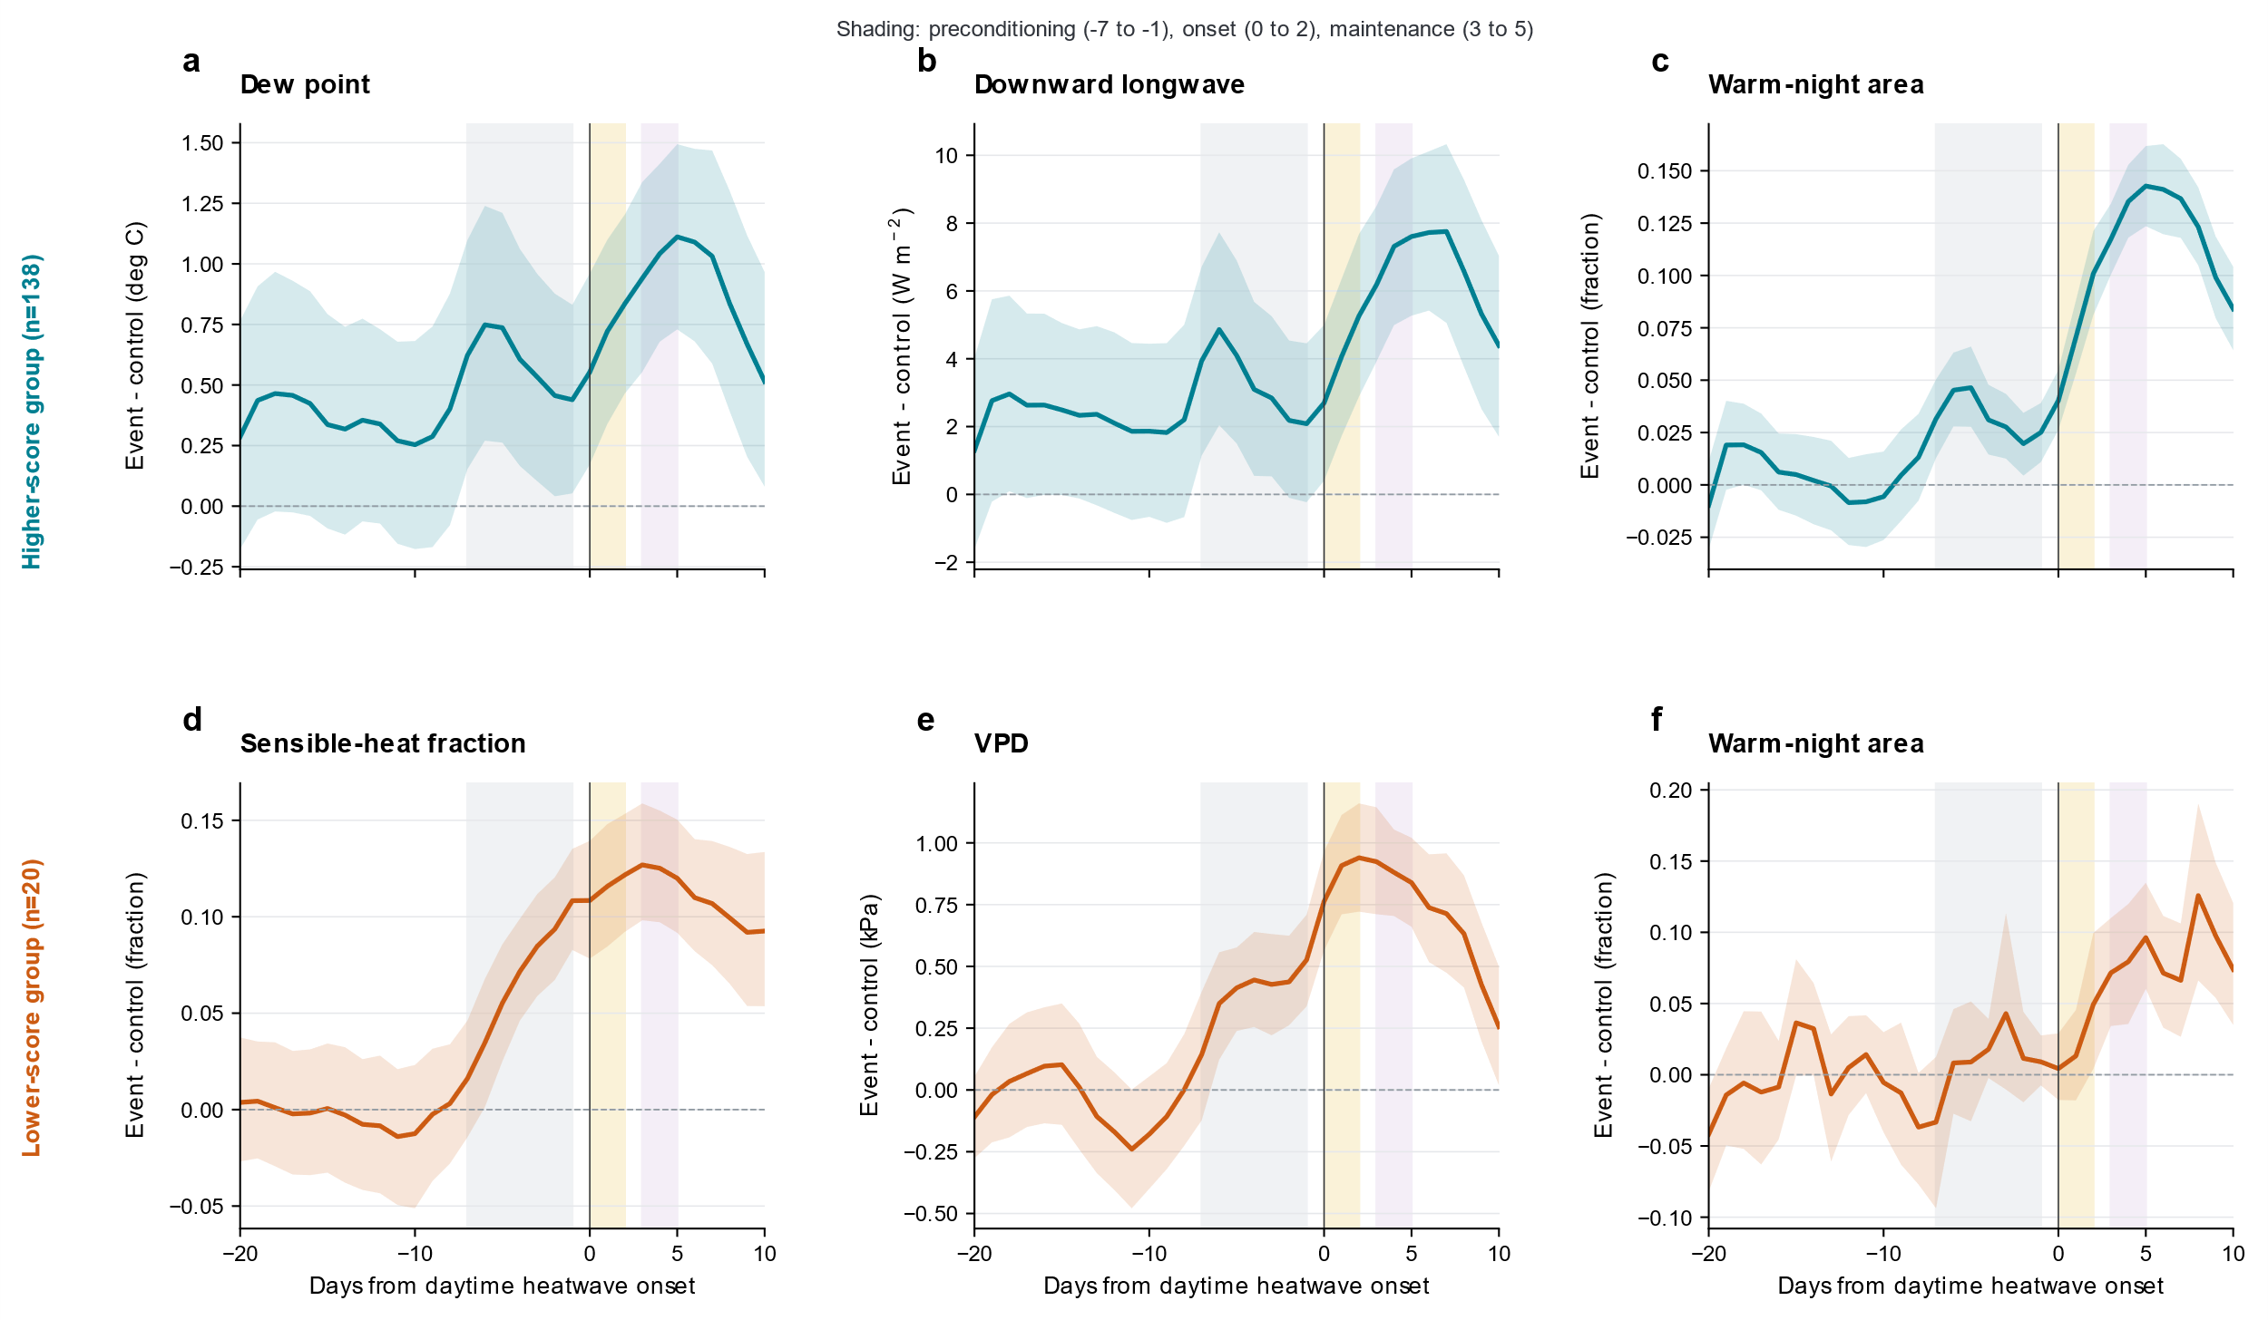
Fig. S3 Event-relative evolution of the exploratory groups. Mean event-minus-control anomalies from relative day −20 to +10 are shown for the high-score group (a–c; n=138) and low-score group (d–f; n=20). The four process variables themselves are used in the grouping, so their group differences are not independent validation; warm-night area is not used to define the groups

