Appendix
Supplementary Figure 1: Flowchart of participant recruitment

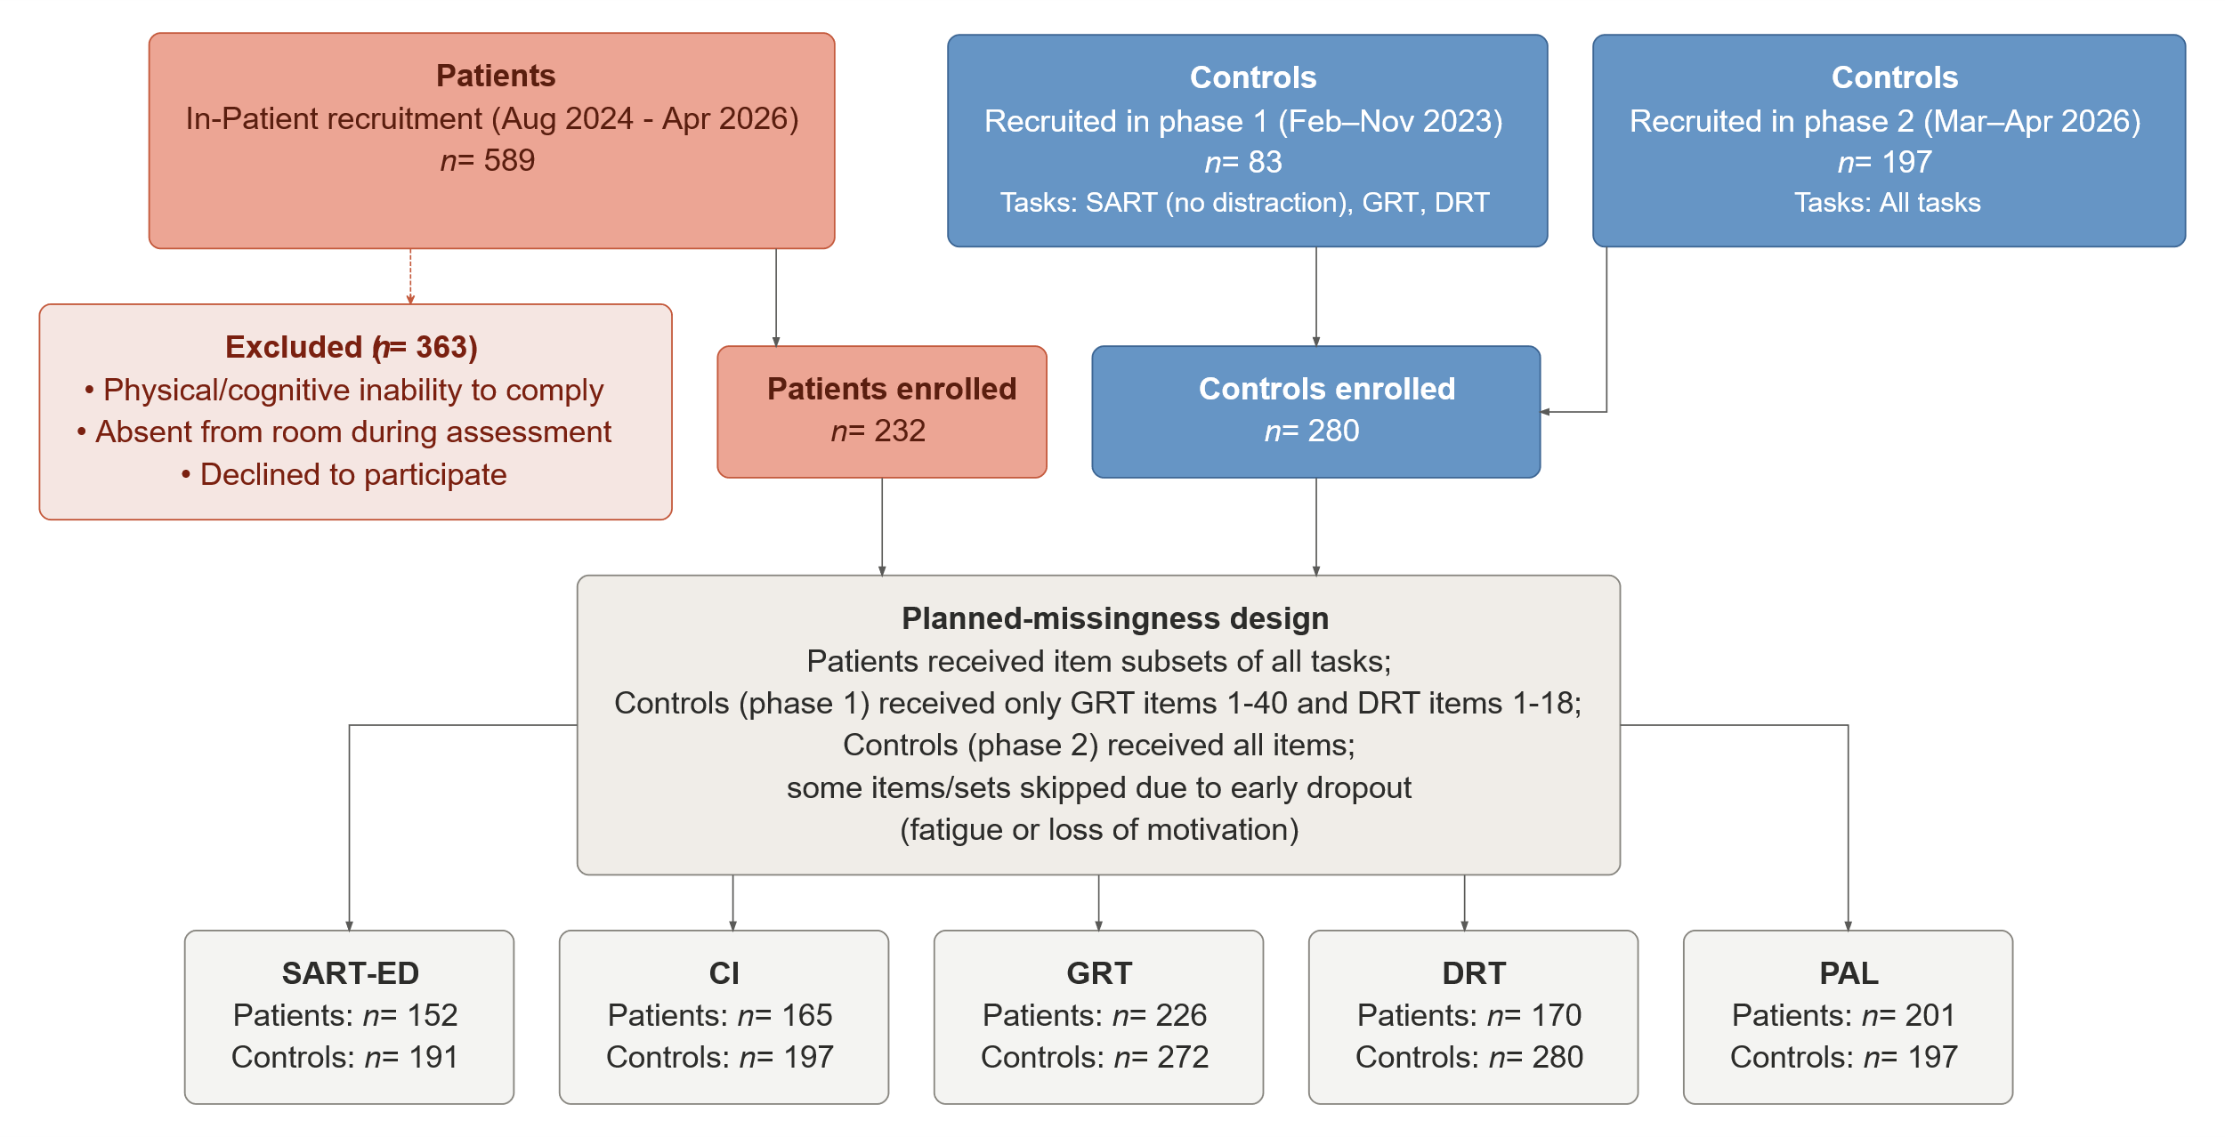Note. Recruitment and progression of stroke patients and control participants through this study. Stroke patients were recruited from in-patient settings (August 2024–April 2026); control participants were recruited in two phases: Phase 1 (February–November 2023) and Phase 2 (March–April 2026). Task-specific sample sizes vary due to a planned-missingness design and participant attrition related to fatigue or loss of motivation. SART-ED=Sustained Attention to Response Task with External Distractor. CI=Cognitive Interference task. GRT=Geometric Reasoning Task. DRT=Delayed Recognition Task. PAL=Paired Association Learning task.

Supplementary Table 1. Participant characteristics.
 | Patients (n=232) | Controls (n=280) | Statistic (df) |  | p value* | Effect size
Age (years) | 64.1 ± 13.3 | 62.0 ± 8.3 | t(369)=2.10 |  | 0.505 | d=0.20
Sex |  |  | Fisher |  | 0.009 | -
Female | 82 (35.3%) | 147 (52.5%)
Male | 147 (63.4%) | 131 (46.8%)
Other | 2 (0.9%) | 2 (0.7%)
Handedness |  |  | χ²(2)=2.60 |  | 1.000 | -
Right | 201 (86.6%) | 178 (90.4%)
Left | 12 (5.2%) | 11 (5.6%)
Ambidextrous | 18 (7.8%) | 8 (4.1%)
BMI (kg/m²) | 27.7 ± 5.3 | 27.7 ± 5.7 | t(391)=0.04 |  | 1.000 | d=0.00
School qualification |  |  | Fisher |  | 0.009 | -
None | 3 (1.3%) | 1 (0.4%)
Secondary (Hauptschule) | 78 (33.6%) | 99 (35.4%)
Intermediate (Realschule) | 75 (32.3%) | 35 (12.5%)
University entrance (Abitur) | 75 (32.3%) | 145 (51.8%)
Time since stroke onset (days) | 5.5 ± 3.1 (Mdn=5.0) | N/A
Number of strokes (total) | 1.27 ± 0.62 (Mdn=1.0) | N/A
NIHSS score† | 2.66 ± 3.43 (Mdn=2.0) | N/A
Comorbidity |  |  | Fisher
Hypertension | 109 (47.0%) | 105 (53.3%) | 0.208
Lipid disorder | 64 (27.6%) | 41 (20.8%) | 0.115
Diabetes | 32 (13.8%) | 29 (14.7%) | 0.784
Orthopaedic | 18 (7.8%) | 12 (6.1%) | 0.571
Thyroid | 4 (1.7%) | 5 (2.5%) | 0.738
Digestive organ | 3 (1.3%) | 3 (1.5%) | 1.000
Digestive problems | 2 (0.9%) | 1 (0.5%) | 1.000
Renal | 1 (0.4%) | 0 (0.0%) | 1.000
Data are mean ± SD or n (%). Continuous variables compared by Welch's t-test; categorical variables by Fisher's exact test or χ² test. p values are Holm-corrected for multiple comparisons unless otherwise stated.
* Comorbidity p values are uncorrected Fisher's exact tests (exploratory).
† National Institute of Health Stroke Severity Scale score.
Abbreviations: BMI=body-mass index; Mdn=median; SD=standard deviation; df=degrees of freedom.

Supplementary Table 2: Data completeness and psychometric reliability across tasks.
Task | Subscale | Items (k) | N total | Analysed n (%) | Reliability [95% CI] | Reliability metric
SART-ED | Resilience to external interference | 30 | 368 | 343 (93.2%) | 0.62 [0.51, 0.70] | Split-half
 | Mental Speed | 110 | 368 | 362 (98.4%) | 0.93 [0.92, 0.95] | Split-half
CI | Resilience to internal interference | 9 × 5 | 517 | 362 (70.0%) | 0.52 [0.38, 0.63] | Split-half
GRT | Reasoning | 49 | 517 | 498 (96.3%) | 0.86 [0.82, 0.88] | Split-half
DRT | Familiarity-based recognition | 21 | 517 | 450 (87.0%) | 0.88 [0.85, 0.90] | Split-half
 | Recollection-based discrimination | 11 | 517 | 449 (86.8%) | 0.88 [0.85, 0.90] | Split-half
PAL | Associative memory | 4 × 5 levels | 517 | 398 (77.0%) | 0.86 [0.80, 0.90] | Split-half
Reliability was estimated using split-half methodology with Spearman-Brown correction. N total reflects the full analytic sample; analysed n reflects participants with sufficient item-level data to compute the split-half estimate. 95% confidence intervals were obtained by bootstrapping (1000 resamples). Items (k): for tasks with repeated blocks (CI internal interference: 9 blocks × 5 trials; PAL: 4 difficulty levels × 5 pairs), k denotes block × trial structure rather than a single item count.

Supplementary Figure 2: Heatmap item response coverage per item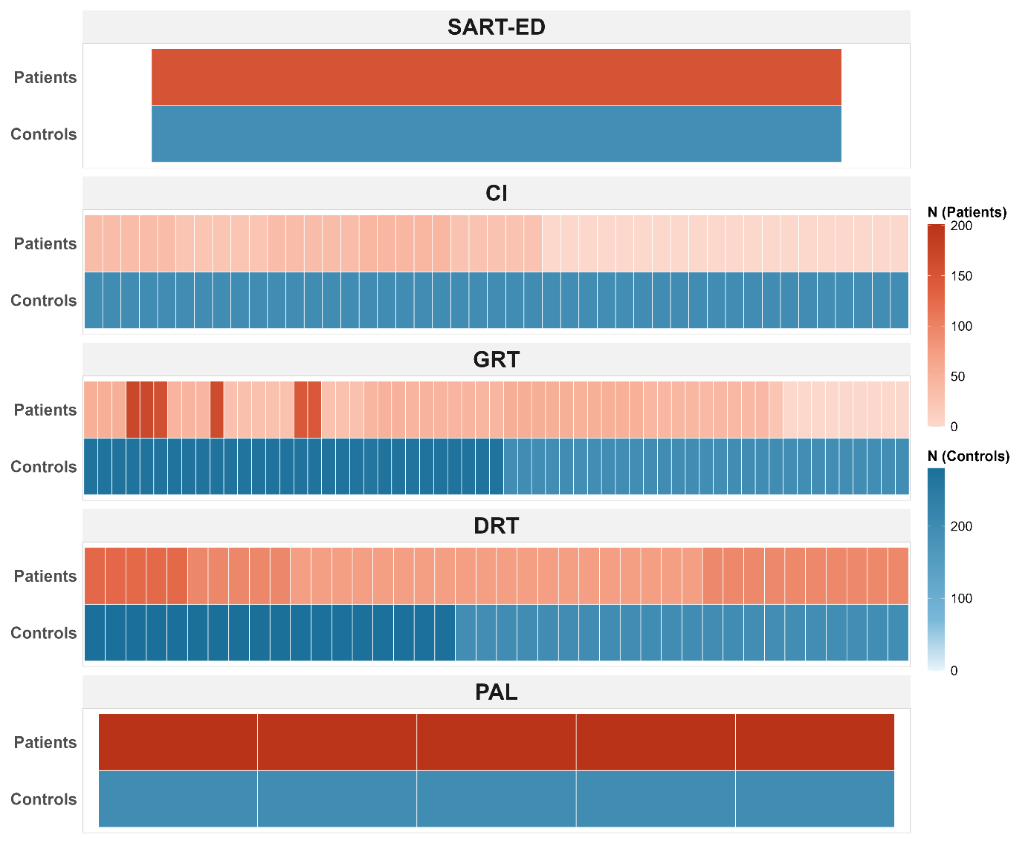
Response coverage across all five ORPheoS tasks (SART-ED, CI, GRT, DRT, PAL) by group. For each task, the number of participants with valid, scorable responses is shown per item. In the cognitive Interference task (CI), coverage reflects participants with both baseline (AC) and interference (AD) responses present, as both are required to compute a joint interference score. Colour intensity encodes absolute response counts, with blue indicating healthy controls and red indicating stroke patients. SART-ED indicators reflect participant-level empirical Bayes slope estimates rather than individual trial items. AC, baseline recall condition; AD, interference recall condition; DRT, delayed object recognition task; GRT, geometric reasoning task; PAL, paired association learning task; SART-ED, sustained attention to response task with external distractor.

Supplementary Table 3. Known-groups validity of cognitive task subscales.
Task | Subscale | Control n | Control Mean (SD) | Stroke n | Stroke Mean (SD) | Test statistic | p-value | Hedges' g [95% CI]
SART-ED | External interference | 191 | 0.03 (0.52) | 152 | −0.04 (0.45) | t(338.8) = 1.47 | 0.142 | 0.16 [−0.06, 0.37]
SART-ED | Mental speed | 191 | 0.17 (0.41) | 171 | −0.22 (0.44) | t(226.6) = 8.06 | < 0.001 | 0.91 [0.68, 1.14]
CI | Internal interference | 197 | −0.04 (0.86) | 165 | 0.09 (1.33) | t(197.9) = −1.02 | 0.309 | −0.13 [−0.35, 0.10]
GRT | Reasoning | 272 | 0.27 (1.39) | 226 | −0.33 (1.23) | t(494.1) = 5.09 | < 0.001 | 0.45 [0.27, 0.63]
DRT | Familiarity-based recognition | 280 | −0.02 (1.72) | 170 | 0.04 (1.59) | t(378.5) = −0.34 | 0.734 | −0.03 [−0.22, 0.16]
DRT | Recollection-based discrimination | 280 | −0.27 (1.68) | 169 | 0.45 (1.16) | t(439.4) = −5.35 | < 0.001 | −0.48 [−0.67, −0.28]
PAL | Associative memory | 197 | 0.12 (0.94) | 201 | −0.11 (0.89) | t(394.4) = 2.54 | 0.011 | 0.25 [0.06, 0.45]
Scores are z-standardised within each task. Group differences were tested using Welch's two-sample t-test (two-tailed). Effect sizes are Hedges' g with 95% confidence intervals; positive values indicate higher scores in healthy controls.
Residualisation of interference scores
To evaluate whether the near-zero inter-task correlations of the residualised interference scores reflected construct specificity or methodological challenges due to variance restriction of residual scores, full-task non-residualised scores were derived for both tasks: a unidimensional 1PL model fitted across all CI items jointly, and a single-factor composite across pooled SART-ED conditions. As shown in Appendix Table 4, full-task scores showed meaningful convergent correlations with other battery measures (rs = .18–.43), whereas residualised scores did not (rs ≤ .10). The two versions of each score were near-orthogonal to one another (r = .12 for SART-ED; r = .01 for CI), consistent with the algebraic independence of a weighted sum and its residual. Together, these results confirm that the residualisation selectively removed general memory and processing speed-related variance (the component shared with reasoning and associative memory), establishing interference sensitivity as a distinct, capacity-independent construct.
Supplementary table 4. Correlations of full-task and residualised interference scores
 | N | Mean (SD) | 1 | 2 | 3 | 4 | 5 | 6 | 7 | 8
1. SART-ED (full task) | 365 | 0.00 (0.70) | —
2. Resilience to external interference (SART-ED residualized) | 343 | 0.00 (0.49) | 0.12* | —
3. CI (full task) | 362 | 0.04 (2.08) | 0.29*** | 0.07 | —
4. Resilience to internal interference (CI residualized) | 362 | 0.01 (1.07) | −0.02 | 0.05 | 0.01 | —
5. Mental speed | 362 | 0.00 (0.46) | 0.17** | 0.63*** | 0.07 | 0.19*** | —
6. Reasoning | 498 | 0.00 (1.35) | 0.36*** | 0.10 | 0.39*** | 0.00 | 0.25 | —
7. Familiarity-based recognition | 450 | 0.00 (1.67) | −0.02 | 0.00 | 0.18*** | 0.01 | -0.07 | 0.39*** | —
8. Recollection-based discrimination | 449 | 0.00 (1.55) | −0.11* | −0.03 | 0.07 | 0.05 | 0.20*** | 0.07 | 0.35*** | —
9. Associative memory | 398 | 0.01 (0.92) | 0.32*** | 0.02 | 0.32*** | 0.07 | 0.16** | 0.43*** | 0.25*** | 0.10*
Data are Pearson r (pairwise complete observations). Full-task scores reflect overall task performance without baseline correction: a unidimensional 1PL model across all CI items jointly (CI full task), and a single-factor factor-analytic composite across pooled SART-ED conditions (SART-ED full task). Residualised scores remove baseline capacity variance as described in the main text. *p < .05; ***p < .001. CI = cognitive interference task; SART-ED = sustained attention to response task with external distractor.

Appendix 3. Sensitivity Analysis: Education as a Potential Confound
Groups differed significantly in educational attainment (see supplementary table 1), with healthy controls more frequently holding a university-entrance qualification (Abitur) than stroke patients. To assess whether this imbalance confounded cognitive group differences, a sensitivity analysis was conducted for each task. Education was operationalised as a binary dummy variable (Abitur = 1; Realschule, Hauptschule, and no degree = 0), reflecting the theoretically meaningful threshold for university access in the German education system. For each task, theta scores were regressed on this dummy, and residuals were grand-mean re-centred to preserve the original scale. Group comparisons were then repeated on the residualised scores.
Results are summarised in supplementary table 5. For all tasks that showed a significant group difference in the primary analysis, effects remained statistically significant after education adjustment. The largest attenuation was observed for the GRT (Hedges g: 0.453 → 0.342, Δg = −0.111), consistent with geometric reasoning being more proximal to school-taught content than the other tasks. Effects for SART-ED (g: 0.382 → 0.358, Δg = −0.024) and DRT-D2 (g: −0.476 → −0.523, Δg = −0.047) were negligibly affected, with DRT-D2 showing a marginal increase in effect size after adjustment, indicating that the delayed recognition deficit is not attributable to educational differences. Tasks that were non-significant in the primary analysis (CI, DRT-D1) remained non-significant. These results indicate that the education imbalance between groups does not account for the observed cognitive differences, and primary analysis findings are interpreted accordingly.
Supplementary Table 5. Education sensitivity analysis: unadjusted and education-adjusted group comparisons (stroke patients vs. controls) across ORPheoS tasks
Task | n (Controls . patients) | Unadjusted |  | Education-adjusted† |  | Δg
 |  | Hedges g [95% CI] | p value | Hedges g [95% CI] | p value
SART-ED (external interference)* | 191 . 152 | 0.157 [−0.057 to 0.371] | 0.142 | 0.141 [−0.074 to 0.356] | 0.191 | −0.016
CI (cognitive interference)* | 197 . 165 | −0.126 [−0.348 to 0.097] | 0.309 | −0.115 [−0.340 to 0.110] | 0.361 | +0.011
SART-ED (mental speed) | 191 . 171 | 0.906 [0.674 to 1.139] | <0.001 | 0.883 [0.651 to 1.115] | <0.001 | −0.023
GRT (geometric reasoning) | 272 . 226 | 0.453 [0.274 to 0.631] | <0.001 | 0.342 [0.164 to 0.520] | <0.001 | −0.111
DRT-D1 (familiarity-based recognition) | 280 . 170 | −0.032 [−0.223 to 0.158] | 0.734 | −0.160 [−0.352 to 0.031] | 0.095 | −0.128
DRT-D2 (recollection-based discrimination) | 280 . 169 | −0.476 [−0.670 to −0.282] | <0.001 | −0.523 [−0.718 to −0.329] | <0.001 | −0.047
PAL (associative memory) | 197 . 201 | 0.25 [0.06 to 0.45] | 0.011 | 0.201 [0.003 to 0.400] | 0.046 | −0.053
† Education-adjusted scores were obtained by regressing individual task θ on a binary Abitur contrast (Abitur=1 vs. below-Abitur=0) and grand-mean re-centring residuals. Both groups were entered jointly into the regression.
* Patient n for the education-adjusted comparison is slightly reduced for SART-ED (n=167) and CI (n=125) owing to missing education data in four patients per task; healthy control n is identical across comparisons.
Positive Δg indicates amplification of the group effect after adjustment; negative Δg indicates attenuation. Hedges g > 0 indicates higher performance in controls; g < 0 indicates higher performance in stroke patients. SART-ED=sustained attention to response task with external distractor; CI=cognitive interference task; DRT=delayed object recognition task; GRT=geometric reasoning task; PAL=paired association learning task.
Appendix 4. Sensitivity Analysis: Sex as a Potential Confound
Groups differed significantly in sex distribution (see supplementary table 1), with the stroke patient group being predominantly male (82 female, 147 male) compared to the roughly balanced healthy control group (135 female, 143 male). To assess whether this imbalance confounded cognitive group differences, a sensitivity analysis was conducted for each task. Sex was operationalised as a binary dummy variable (Male = 1; Female = 0). For each task, theta scores were regressed on this dummy, and residuals were grand-mean re-centred to preserve the original scale. Group comparisons were then repeated on the residualised scores.
Results are summarised in supplementary table 6. For all tasks that showed a significant group difference in the primary analysis, effects remained statistically significant after sex adjustment. The largest attenuation was observed for SART-ED mental speed (Hedges g: 0.911 → 0.860, Δg = −0.051), consistent with baseline sex differences frequently reported in mental speed and reaction time tasks. Effects for reasoning (g: 0.453 → 0.467, Δg = +0.014) and familiarity-based recognition (g: −0.476 → −0.472, Δg = +0.004) were negligibly affected, indicating that geometric reasoning and familiarity-based recognition deficits are not attributable to sex differences. Tasks that were non-significant in the primary analysis (SART-ED external interference, CI, DRT-D1) remained non-significant.
These results indicate that the sex imbalance between groups does not account for the observed cognitive differences, and primary analysis findings are interpreted accordingly.
Supplementary Table 6. Sex sensitivity analysis: unadjusted and sex-adjusted group comparisons (stroke patients vs. controls) across ORPheoS tasks
Task | n (Controls . patients) | Unadjusted Hedges g [95% CI] | Unadjusted p value |  | Sex-adjusted† Hedges g [95% CI] | Adjusted p value |  | Δg
SART-ED (external interference) | 191 . 152 | 0.16 [−0.06 to 0.37] |  | 0.14 | 0.18 [−0.04 to 0.39] |  | 0.10 | +0.02
CI (cognitive interference) | 197 . 165 | −0.13 [−0.35 to 0.10] |  | 0.31 | −0.14 [−0.36 to 0.09] |  | 0.27 | −0.01
SART-ED (mental speed) | 191 . 171 | 0.91 [0.68 to 1.14] |  | <0.001 | 0.86 [0.63 to 1.09] |  | <0.001 | −0.05
GRT (geometric reasoning) | 272 . 226 | 0.45 [0.27 to 0.63] |  | <0.001 | 0.47 [0.29 to 0.65] |  | <0.001 | +0.01
DRT-D1 (recollection-based recognition) | 280 . 170 | −0.03 [−0.22 to 0.16] |  | 0.73 | −0.04 [−0.24 to 0.15] |  | 0.65 | −0.01
DRT-D2 (familiarity-based recognition) | 280 . 169 | −0.48 [−0.67 to −0.28] |  | <0.001 | −0.47 [−0.67 to −0.28] |  | <0.001 | +0.00
PAL (associative memory) | 197 . 201 | 0.25 [0.06 to 0.45] |  | 0.01 | 0.23 [0.03 to 0.43] |  | 0.03 | −0.03
† Sex-adjusted scores were obtained by regressing individual task θ on a binary male contrast (Male=1 vs. Female=0) and grand-mean re-centring residuals. Both groups were entered jointly into the regression.
Note: Patient and healthy control ns for the sex-adjusted comparisons are slightly reduced across tasks owing to missing demographic data (overall n drops: SART-ED EI = 1 patient; SART-ED MS = 1 patient; CI = 1 control, 1 patient; GRT = 2 controls, 1 patient; DRT-D1 = 2 controls, 1 patient; DRT-D2 = 2 controls, 1 patient; PAL = 1 control, 1 patient).
Positive Δg indicates amplification of the group effect after adjustment; negative Δg indicates attenuation (total change from full unadjusted sample to residualised sample). Hedges g > 0 indicates higher performance in controls; g < 0 indicates higher performance in stroke patients. SART-ED=sustained attention to response task with external distractor; CI=cognitive interference task; DRT=delayed object recognition task; GRT=geometric reasoning task; PAL=paired association learning task.

