Supplementary figures
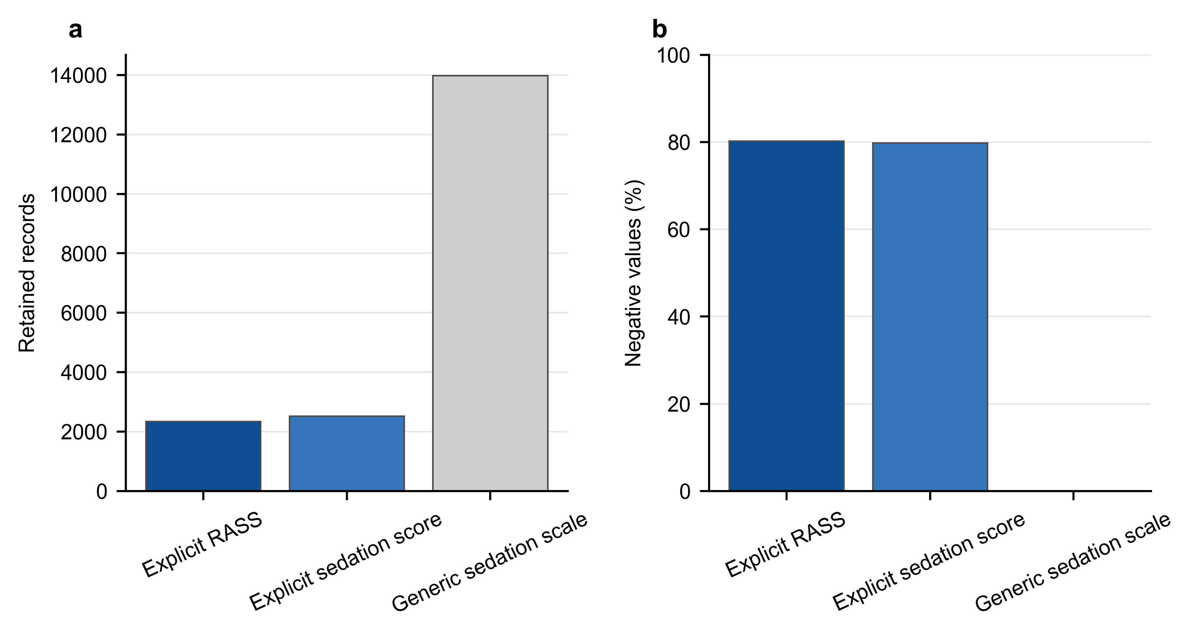
Figure S1. Record-level eICU RASS source audit. a, Retained records from explicit RASS, explicit SEDATION SCORE, and generic Sedation Scale pathways. b, Proportion of retained records with negative values. The generic Sedation Scale pathway contained no negative values and was not treated as RASS. This audit was completed before the eICU outcome analysis. RASS, Richmond Agitation–Sedation Scale; ICU, intensive care unit.
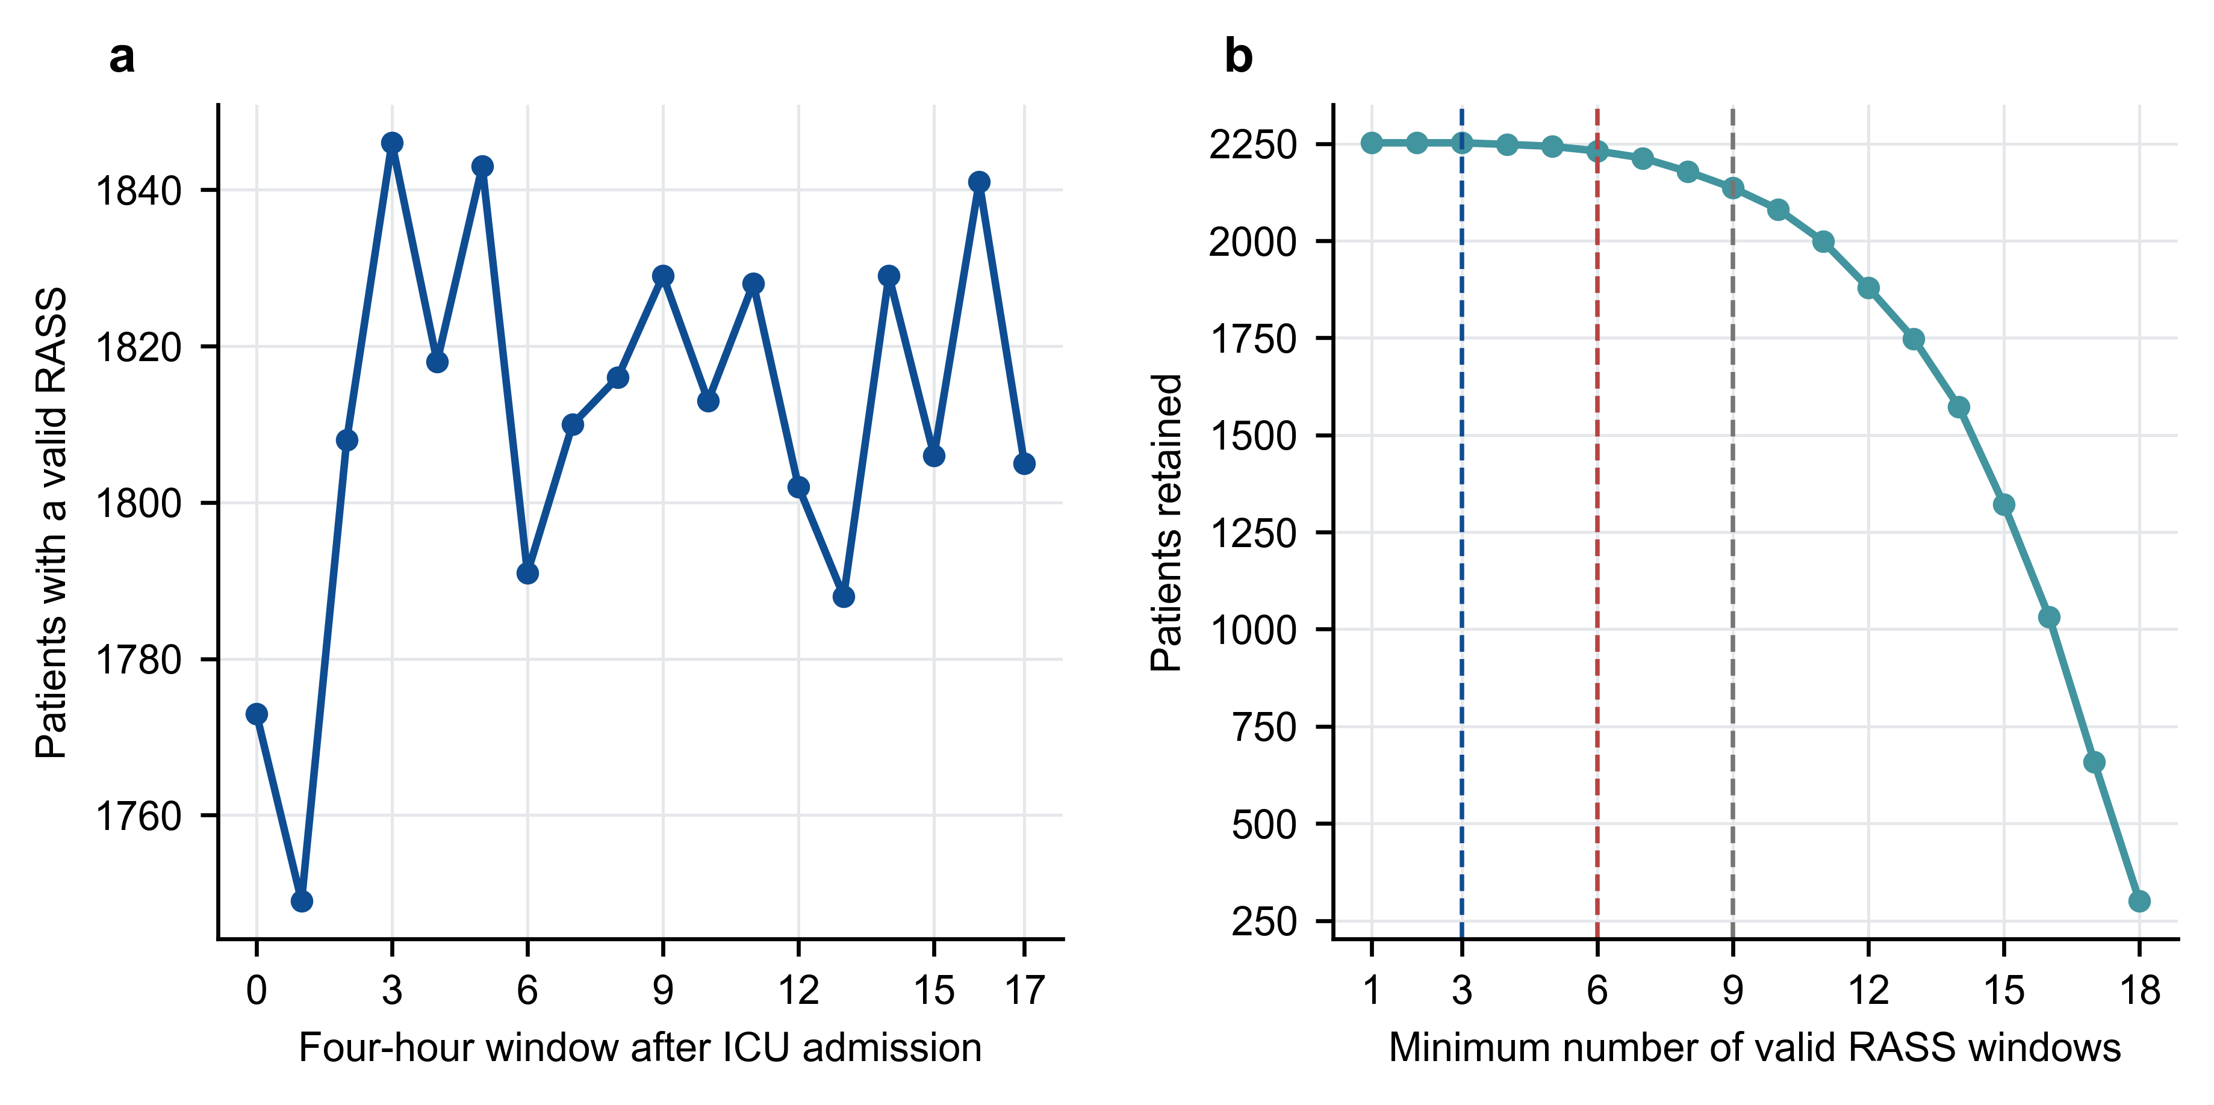
Figure S2. RASS window completeness and measurement-density thresholds. a, Number of patients with a valid RASS measurement in each of 18 four-hour windows during the 72-h exposure period. b, Number of retained patients at increasing minimum valid-window thresholds. Dashed vertical lines denote the prespecified thresholds of at least 3, 6, and 9 windows. RASS, Richmond Agitation–Sedation Scale; ICU, intensive care unit.
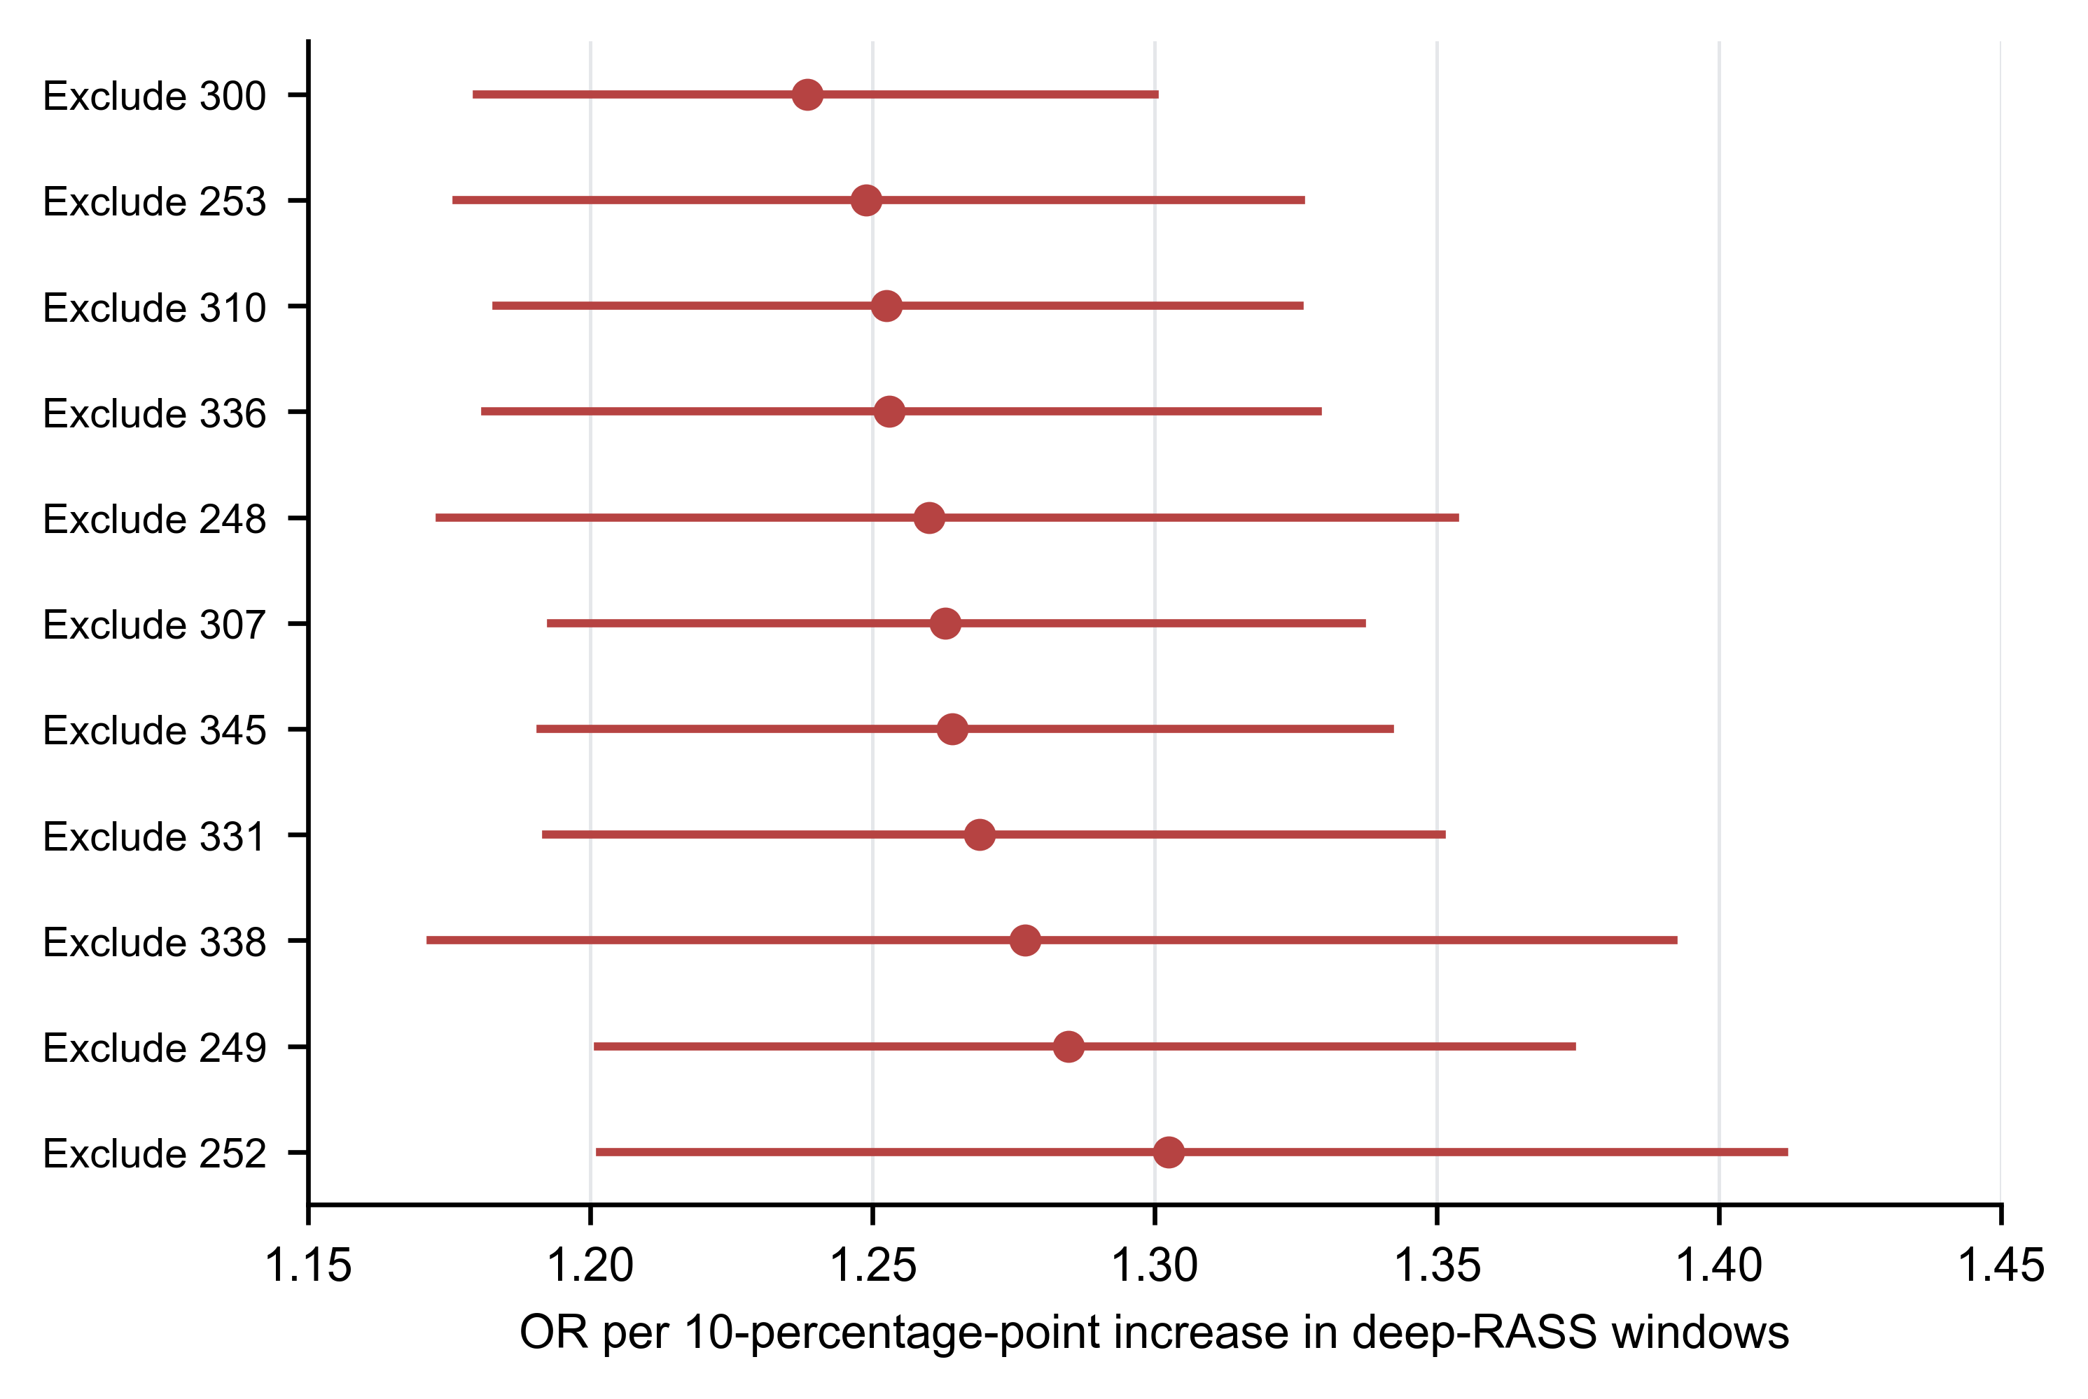
Figure S3. eICU leave-one-hospital-out analyses. APACHE IV-imputed hospital-clustered GEE estimates after exclusion of each eligible hospital in turn. Points denote odds ratios and horizontal lines 95% confidence intervals. All 11 exclusion analyses were directionally positive. This is a robustness description and does not establish absence of hospital-level confounding. APACHE IV, Acute Physiology and Chronic Health Evaluation IV; GEE, generalised estimating equation; OR, odds ratio; RASS, Richmond Agitation–Sedation Scale.
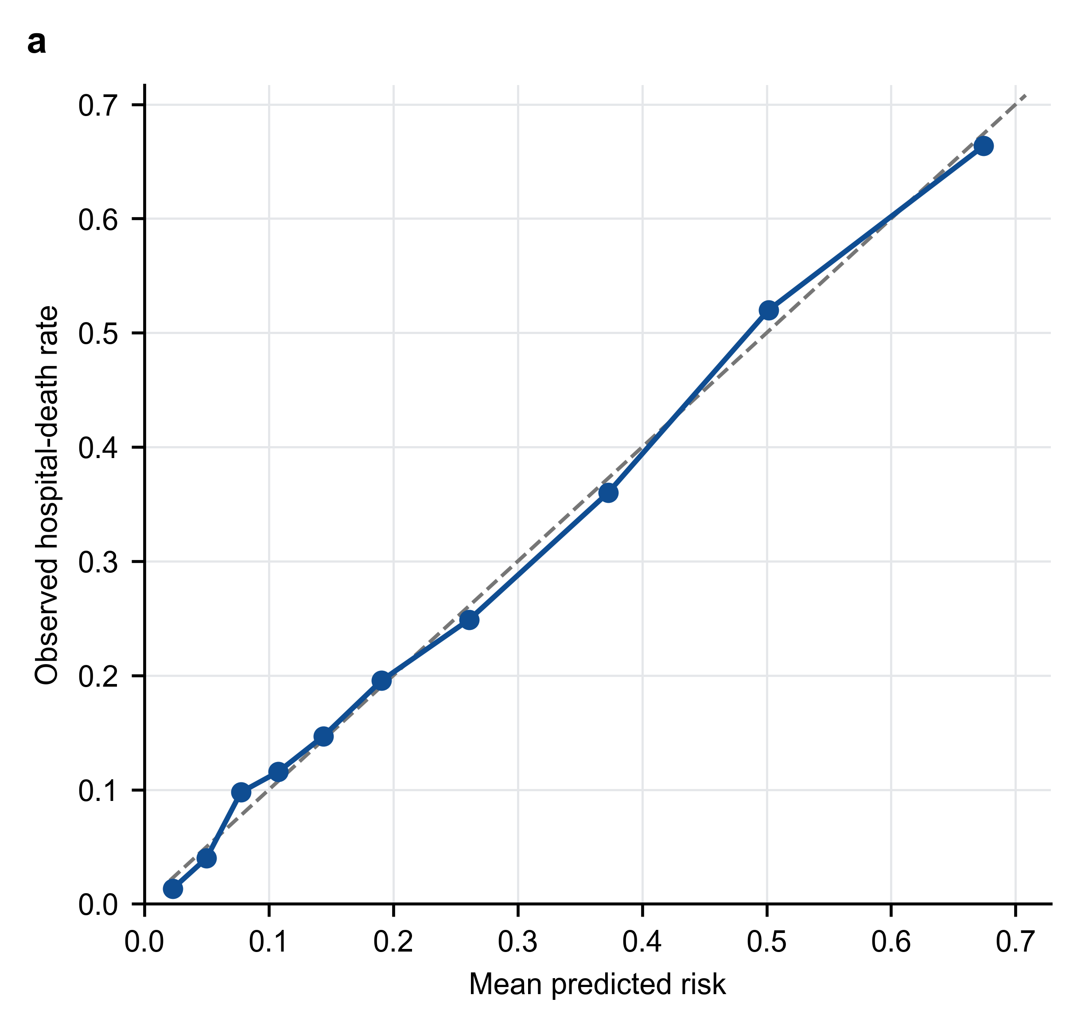
Figure S4. Apparent calibration of the MIMIC-IV primary model. Observed subsequent in-hospital mortality plotted against mean predicted risk by decile. The dashed line denotes perfect calibration. n=2,252; events=541; apparent Brier score=0.1399; calibration intercept approximately 0; calibration slope=1.007. This is an in-sample diagnostic and not independent validation.
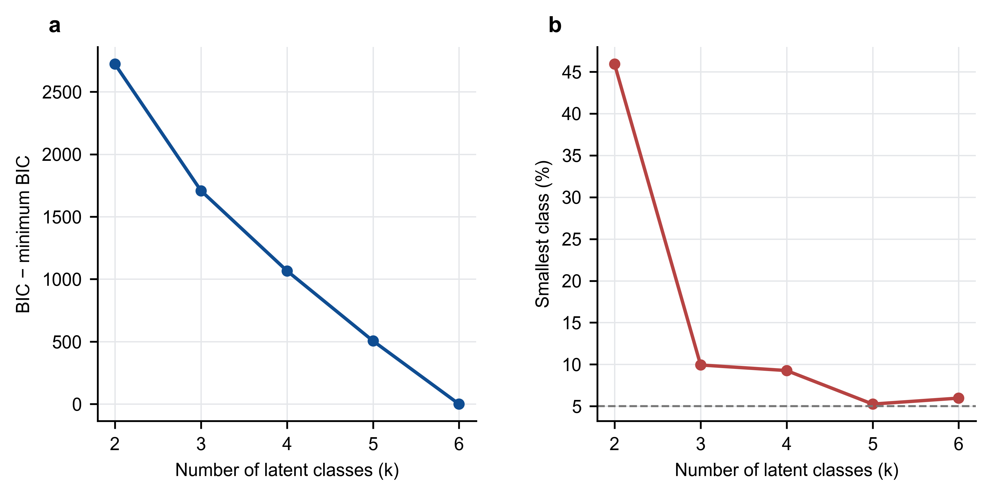
Figure S5. Exploratory trajectory model assessment. a, Bayesian information criterion relative to the minimum across random-intercept trajectory models with two to six classes. b, Smallest class proportion; the dashed line denotes the 5% threshold. BIC continued to decrease at the upper class boundary and class structure was specification-sensitive; trajectory results were therefore retained as exploratory rather than interpreted as stable phenotypes.

