Effects of Acute Cognitively Engaging Physical Activity on Executive Function Development in Children Aged 4–12 Years: A Systematic Review and Meta-analysis
Content
Supplemental Material 1 PRISMA 2020 checklist 1
Supplemental Material 2: Search strategies and screenshots of different databases 6
2.1 Search strategies 6
2.2 screenshots for different databases 8
Supplemental Material 3 Description of Studies Excluded at the Full-Text Stage 11
Supplemental Material 4 Study characteristics 17
Supplemental Material 5 Risk of bias and evidence assessment 19
5.1 The risk of bias for each study 19
5.2 GRADE evidence profile 20
Supplemental Material 6 Forest plot of the subgroup analysis 21
Supplemental Material 7 Forest plot of the subgroup analysis 23
7.1 Publication bias test (Funnel plot) 23
7.2 Publication bias test (Begg’s and Egger’s tests) 24
7.3 Trim-and-fill funnel plot of the effects of exercise on total aggression 24
Supplemental Material 8 Results of the Sensitivity Analysis 25
8.1 Sensitivity Analysis 1: leave-one-out approach 25
8.2 Sensitivity Analysis 2: Excluding studies judged to have an overall high risk of bias 26

Supplemental Material 1. PRISMA 2020 checklist
Table 1 PRISMA 2020 checklist
Section and Topic | Item # | Checklist item | Location where item is reported
TITLE
Title | 1 | Identify the report as a systematic review. | Title
ABSTRACT
Abstract | 2 | See the PRISMA 2020 for Abstracts checklist. | Abstract
INTRODUCTION
Rationale | 3 | Describe the rationale for the review in the context of existing knowledge. | Intro, para 1-4
Objectives | 4 | Provide an explicit statement of the objective(s) or question(s) the review addresses. | Intro, para 5
METHODS
Eligibility criteria | 5 | Specify the inclusion and exclusion criteria for the review and how studies were grouped for the syntheses. | Methods, 2.2,2.3
Information sources | 6 | Specify all databases, registers, websites, organizations, reference lists and other sources searched or consulted to identify studies. Specify the date when each source was last searched or consulted. | Methods, 2.1,para 2
Search strategy | 7 | Present the full search strategies for all databases, registers and websites, including any filters and limits used. | Supplemental Material 2
Selection process | 8 | Specify the methods used to decide whether a study met the inclusion criteria of the review, including how many reviewers screened each record and each report retrieved, whether they worked independently, and if applicable, details of automation tools used in the process. | Methods, 2.3 para 1
Data collection process | 9 | Specify the methods used to collect data from reports, including how many reviewers collected data from each report, whether they worked independently, any processes for obtaining or confirming data from study investigators, and if applicable, details of automation tools used in the process. | Methods, 2.3 para 2 and 8
Data items | 10a | List and define all outcomes for which data were sought. Specify whether all results that were compatible with each outcome domain in each study were sought (e.g. for all measures, time points, analyses), and if not, the methods used to decide which results to collect. | Methods, 2.3 2.4
Data items | 10b | List and define all other variables for which data were sought (e.g. participant and intervention characteristics, funding sources). Describe any assumptions made about any missing or unclear information. | Methods, 2.3.
Study risk of bias assessment | 11 | Specify the methods used to assess risk of bias in the included studies, including details of the tool(s) used, how many reviewers assessed each study and whether they worked independently, and if applicable, details of automation tools used in the process. | Methods, 2.5 para 1
Effect measures | 12 | Specify for each outcome the effect measure(s) (e.g. risk ratio, mean difference) used in the synthesis or presentation of results. | Methods,2.4  2.6, para 1
Synthesis methods | 13a | Describe the processes used to decide which studies were eligible for each synthesis (e.g. tabulating the study intervention characteristics and comparing against the planned groups for each synthesis (item #5)). | Methods, 2.2-2.4
Synthesis methods | 13b | Describe any methods required to prepare the data for presentation or synthesis, such as handling of missing summary statistics, or data conversions. | Methods, 2.3,  2.4
Synthesis methods | 13c | Describe any methods used to tabulate or visually display results of individual studies and syntheses. | Methods, 2.6
Synthesis methods | 13d | Describe any methods used to synthesize results and provide a rationale for the choice(s). If meta-analysis was performed, describe the model(s), method(s) to identify the presence and extent of statistical heterogeneity, and software package(s) used. | Methods, 2.6
Synthesis methods | 13e | Describe any methods used to explore possible causes of heterogeneity among study results (e.g. subgroup analysis, meta-regression). | Methods,  2.6 para 5-7
Synthesis methods | 13f | Describe any sensitivity analyses conducted to assess robustness of the synthesized results. | Methods,  2.6, para3
Reporting bias assessment | 14 | Describe any methods used to assess risk of bias due to missing results in a synthesis (arising from reporting biases). | Methods, 26 para 3
Certainty assessment | 15 | Describe any methods used to assess certainty (or confidence) in the body of evidence for an outcome. | Methods, 2.5 para 2
RESULTS
Study selection | 16a | Describe the results of the search and selection process, from the number of records identified in the search to the number of studies included in the review, ideally using a flow diagram. | Results,3.1  Figure 1
Study selection | 16b | Cite studies that might appear to meet the inclusion criteria, but which were excluded, and explain why they were excluded. | Supplemental Material 3
Study characteristics | 17 | Cite each included study and present its characteristics. | Supplemental Material 4
Risk of bias in studies | 18 | Present assessments of risk of bias for each included study. | Supplemental Material 5.1
Results of individual studies | 19 | For all outcomes, present, for each study: (a) summary statistics for each group (where appropriate) and (b) an effect estimate and its precision (e.g. confidence/credible interval), ideally using structured tables or plots. | Supplemental Material 6
Results of syntheses | 20a | For each synthesis, briefly summarize the characteristics and risk of bias among contributing studies. | Results, 3.2-3.3
Results of syntheses | 20b | Present results of all statistical syntheses conducted. If meta-analysis was done, present for each the summary estimate and its precision (e.g. confidence/credible interval) and measures of statistical heterogeneity. If comparing groups, describe the direction of the effect. | Results, 3.4.3.6
Results of syntheses | 20c | Present results of all investigations of possible causes of heterogeneity among study results. | Results, 3.5
Results of syntheses | 20d | Present results of all sensitivity analyses conducted to assess the robustness of the synthesized results. | Results, 3.6
Reporting biases | 21 | Present assessments of risk of bias due to missing results (arising from reporting biases) for each synthesis assessed. | Supplemental Material 7.1-7.3
Certainty of evidence | 22 | Present assessments of certainty (or confidence) in the body of evidence for each outcome assessed. | Supplemental Material 5.2
DISCUSSION
Discussion | 23a | Provide a general interpretation of the results in the context of other evidence. | Disc., 4.1-4.6
Discussion | 23b | Discuss any limitations of the evidence included in the review. | Disc., 4.7
Discussion | 23c | Discuss any limitations of the review processes used. | Disc., 4.7
Discussion | 23d | Discuss implications of the results for practice, policy, and future research. | Disc., 4.3, 4.7
OTHER INFORMATION
Registration and protocol | 24a | Provide registration information for the review, including register name and registration number, or state that the review was not registered. | Abstract
Registration and protocol | 24b | Indicate where the review protocol can be accessed, or state that a protocol was not prepared. | Methods, Section 2.1
Registration and protocol | 24c | Describe and explain any amendments to information provided at registration or in the protocol. | NA
Support | 25 | Describe sources of financial or nonfinancial support for the review, and the role of the funders or sponsors in the review. | Funding
Competing interests | 26 | Declare any competing interests of review authors. | Competing interests
Availability of data, code and other materials | 27 | Report which of the following are publicly available and where they can be found: template data collection forms; data extracted from included studies; data used for all analyses; analytic code; any other materials used in the review. | Data availability

Supplemental Material 2. Search strategies and screenshots for different databases

2.1 Search strategies
Table 2 Search strategy for PubMed
Step | Search strategy(PubMed as an Example)
#6 | (#1 AND #2 AND #3 AND4# AND#5)
#5 | Search:("Randomized Controlled Trial" [Publication Type]) OR ((((((Randomized Controlled Trial[Title/Abstract]) OR (random[Title/Abstract])) OR (randomized[Title/Abstract])) OR (randomised[Title/Abstract])) OR (randomly[Title/Abstract])) OR (RCT[Title/Abstract]))
#4 | Search: (executive function[MeSH Terms]) OR ((((((((((Executive Functions[Title/Abstract]) OR (Function, Executive[Title/Abstract])) OR (Functions, Executive[Title/Abstract])) OR (Executive Control[Title/Abstract])) OR (Executive Controls[Title/Abstract])) OR (Cognitive Function[Title/Abstract])) OR (Cognitive Functions[Title/Abstract])) OR (working memory[Title/Abstract])) OR (Updating[Title/Abstract])) OR (Shifting[Title/Abstract]))
#3 | Search:("Exercise"[Mesh]) OR (((physical activity[Title/Abstract]) OR (training[Title/Abstract])) OR (chronic exercise[Title/Abstract]))
#2 | Search:(((((((((((((cognitively engaging[Title/Abstract]) OR (cognitive engagement[Title/Abstract])) OR (cognitive demand[Title/Abstract])) OR (cognitively challenging[Title/Abstract])) OR (cognitive challenge[Title/Abstract])) OR (engage[Title/Abstract])) OR (engaged[Title/Abstract])) OR (engagement*[Title/Abstract])) OR (engages[Title/Abstract])) OR (engaging[Title/Abstract])) OR (social participation[Title/Abstract])) OR (participation[Title/Abstract])) OR (Cognition*[Title/Abstract])) OR (cognitive*[Title/Abstract])
#1 | Search: ("Child"[Mesh]) OR (((((((primary student[Title/Abstract])) OR (children[Title/Abstract])) OR (Pupils[Title/Abstract])) OR (Preadolescent[Title/Abstract])) OR (juvenile[Title/Abstract])) OR (child[Title/Abstract]))

2.2 Screenshots from different databases

2.2.1 Database: PubMed (n = 681)
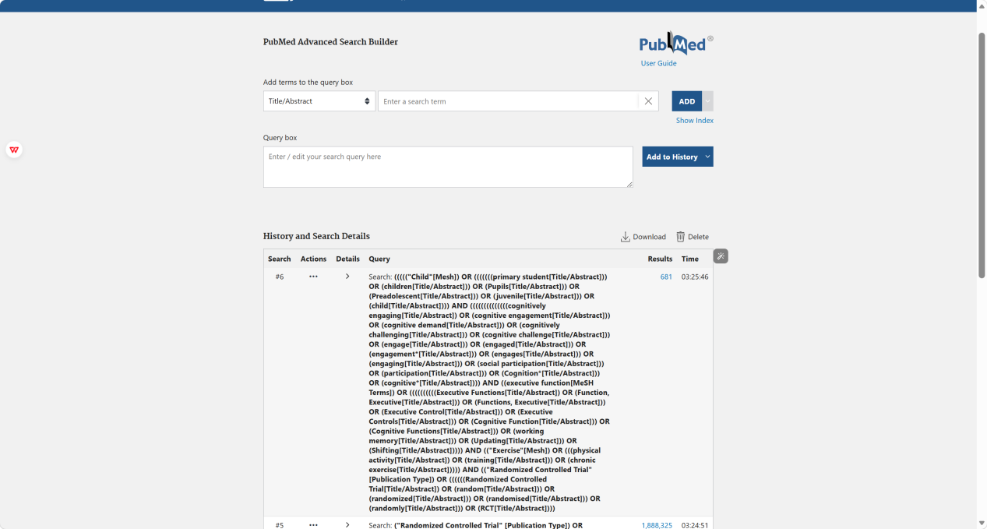
Figure 1 PubMed search strategy screenshot

2.2.2 Database: Web of Science (n=4021)
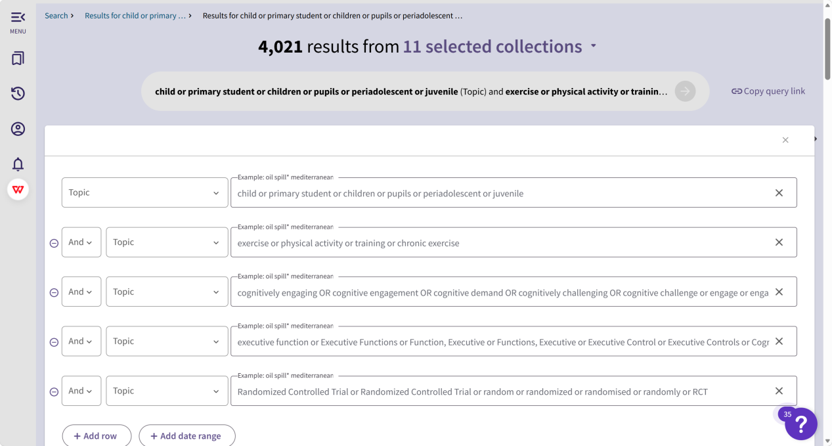
Figure 2 Web of Science search strategy screenshot

2.2.3 Database: EBSCOhost (n=209)
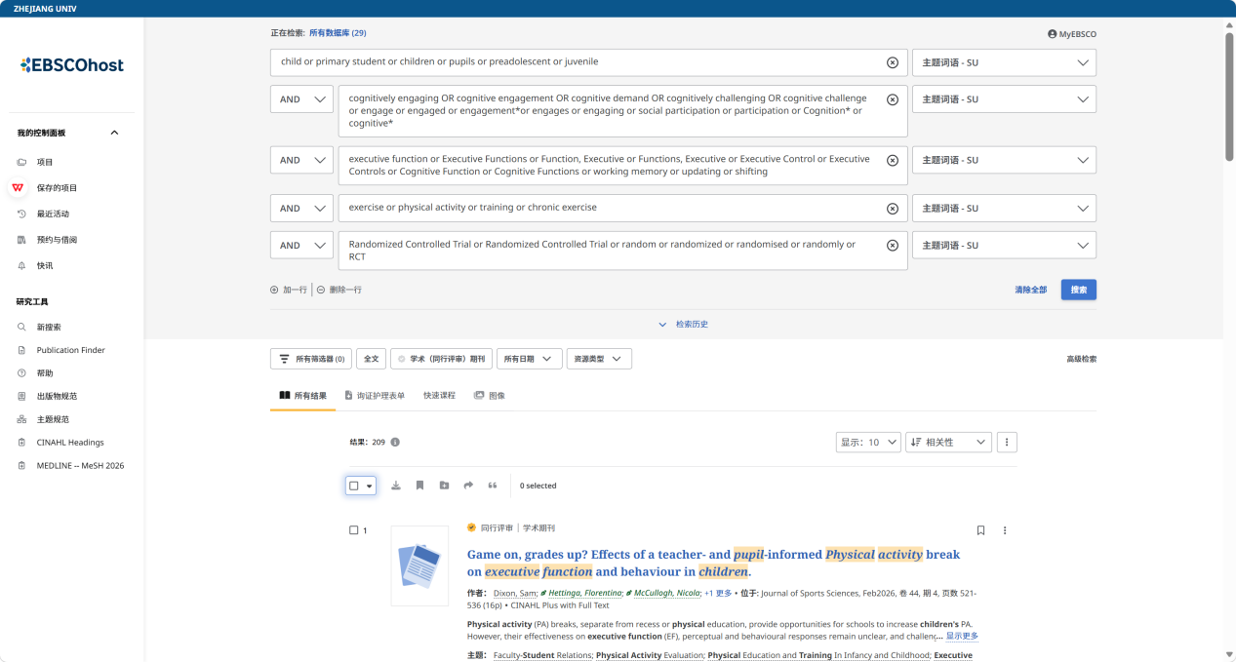
Figure 3 EBSCOhost search strategy screenshot

2.2.4 Database: Embase (n=947)
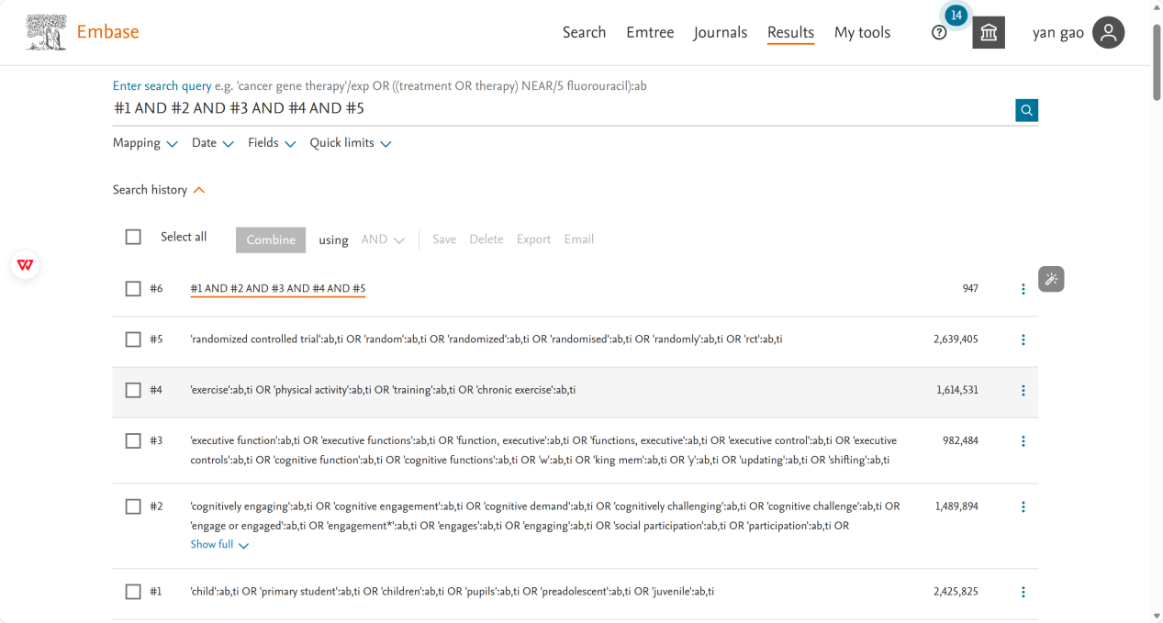
Figure 4 Embase search strategy screenshot

2.2.5 Database: Cochrane (n=1452)

Figure 5 Cochrane search strategy screenshot

2.2.6 Database: CNKI (n=86)
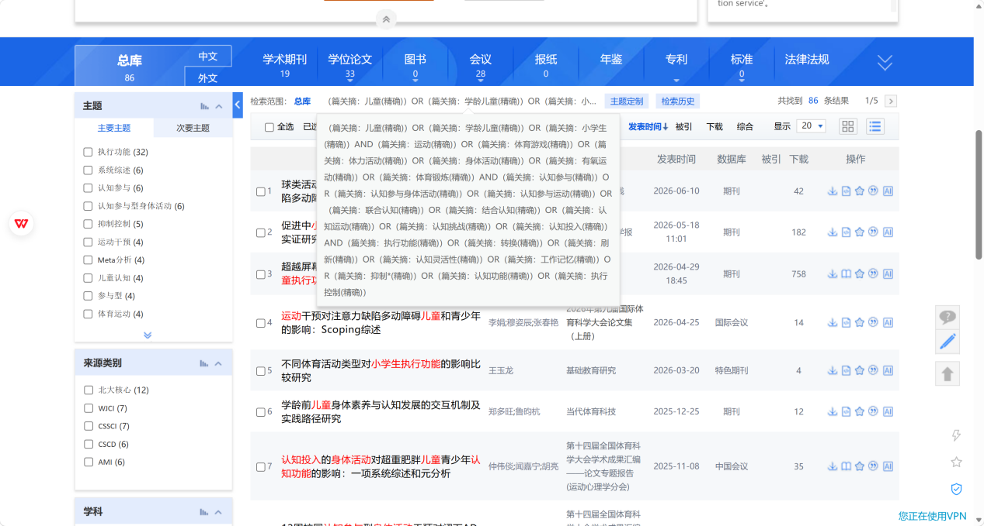
Figure 6 CCNI search strategy screenshot

Supplemental Material 3. Description of studies excluded at the full-text stage
Table 3 Description of studies excluded at the full-text stage
Author | Title | Reason for exclusion
Schmidt 2016 | Classroom-Based Physical Activity Breaks and Children's Attention: Cognitive Engagement Works! | Lack of extractable outcomes
Atak 2023 | The effect of Dual-Task balance exercises on cognitive functions among children with mild and borderline mental retardation: a randomized controlled trial | Lack of extractable outcomes
Anzeneder 2023 | Dose–response relation between the duration of a cognitively challenging bout of physical exercise and children's cognition | Lack of extractable outcomes
JÃger 2014 | Cognitive and physiological effects of an acute physical activity intervention in elementary school children | Lack of extractable outcomes
Gentile 2020 | The Effect of an Enriched Sport Program on Children’s Executive Functions: The ESA Program | Nonexperimental study
Meijer 2022 | Effects of aerobic versus cognitively demanding exercise interventions on brain structure and function in healthy children—Results from a cluster randomized controlled trial | Nonexperimental study
Tocci 2022 | Giving Ideas Some Legs or Legs Some Ideas? Children’s Motor Creativity Is Enhanced by Physical Activity Enrichment: Direct and Mediated Paths | Nonexperimental study
Ramezani 2024 | Cognitive-Motor Training Improves Reading-Related Executive Functions: A Randomized Clinical Trial Study in Dyslexia | Nonexperimental study
Algabbani 2026 | Effects of a cognitive–motor dual-task exercise program versus exergaming on cognitive function in children with down syndrome: A single-blinded randomized trial | Nonexperimental study
Schneider 2025 | Smart exercise in pediatric oncology: enhancing executive functions through cognitively challenging physical activity– a non-randomized controlled trial | Nonexperimental study
Benzing 2016 | Acute Cognitively Engaging Exergame-Based Physical Activity Enhances Executive Functions in Adolescents | Ineligible participants
Wu 2019 | Exergaming Improves Executive Functions in Patients With Metabolic Syndrome: Randomized Controlled Trial | Ineligible participants
Nekar 2022 | Feasibility of Using Multiplayer Game-Based Dual-Task Training with Augmented Reality and Personal Health Record on Social Skills and Cognitive Function in Children with Autism | Ineligible participants
Meha 2025 | A new injury prevention program ‘FUNBALL’ improves cognitive performance of young football (soccer) players: A cluster randomized controlled trial | Ineligible participants
Wang 2025 | Cognitively engaging running enhances inhibitory control and prefrontal activation in children with ADHD: the moderating role of physical self-efficacy | Ineligible participants
Chou 2023 | Cognitively engaging movement games improve interference control and academic performance in overweight children: A randomized control trial | Non-acute intervention
Crova 2014 | Cognitively challenging physical activity benefits executive function in overweight children | Non-acute intervention
Egger 2019 | Boost your brain, while having a break! The effects of long-term cognitively engaging physical activity breaks on children’s executive functions and academic achievement | Non-acute intervention
Liu 2022 | Usability and Effects of a Combined Physical and Cognitive Intervention Based on Active Video Games for Preschool Children | Non-acute intervention
Mavilidi 2023 | Effects of Cognitively Engaging Physical Activity on Preschool Children’s Cognitive Outcomes | Non-acute intervention
Meijer 2021 | The Effects of Aerobic Versus Cognitively Demanding Exercise Interventions on Executive Functioning in School-Aged Children: A Cluster-Randomized Controlled Trial | Non-acute intervention
Pesce 2016 | Deliberate Play and Preparation Jointly Benefit Motor and Cognitive Development: Mediated and Moderated Effects | Non-acute intervention
Schmidt 2015 | Cognitively Engaging Chronic Physical Activity, But Not Aerobic Exercise, Affects Executive Functions in Primary School Children: A Group-Randomized Controlled Trial | Non-acute intervention
De Bruijn 2021 | Differential effects of long-term aerobic versus cognitively-engaging physical activity on children’s visuospatial working memory related brain activation: A cluster RCT | Non-acute intervention
Giordano 222 | Does Physical Activity Improve Inhibition in Kindergarteners? A Pilot Study | Non-acute intervention
Schmidt 2020 | Combining physical and cognitive training to improve kindergarten children’s executive functions: A cluster randomized controlled trial | Non-acute intervention
Gao 2019 | Home-Based Exergaming on Preschoolers’ Energy Expenditure, Cardiovascular Fitness, Body Mass Index and Cognitive Flexibility: A Randomized Controlled Trial | Non-acute intervention
Tse 2021 | Improving Executive Function of Children with Autism Spectrum Disorder through Cycling Skill Acquisition | Non-acute intervention
Bai 2022 | Effects of Group-Play Moderate to Vigorous Intensity Physical Activity Intervention on Executive Function and Motor Skills in 4- to 5-Year-Old Preschoolers: A Pilot Cluster Randomized Controlled Trial | Non-acute intervention
Cai 2026 | Effects of a 12-week mini-basketball exercise intervention on executive function in children with attention-deficit/hyperactivity disorder: a randomized controlled trial | Non-acute intervention
Xu 2026 | Effects of cognitively engaging physical activity on executive function, mental health, and physical fitness in school-age children: a cluster-randomized controlled trial | Nonexperimental study
Huang 2025 | Effects of Exercise Intervention in Children With Attention‐Deficit/Hyperactivity Disorder: The Mediating Role of Executive Function | Nonexperimental study
Zhu 2026 | Integrated cognitive-motor exercise for core symptoms and executive functions in children with attention deficit hyperactivity disorder: a randomized clinical trial | Nonexperimental study
Chen 2024 | Sports game intervention aids executive function enhancement in children with autism - An fNIRS study | Nonexperimental study
He 2026 | The effects of combined exercise on working memory in children with attention-deficit/hyperactivity disorder: a randomized controlled trial | Nonexperimental study
Rymarczyk 2024 | The Impact of the Interactive Floor Device and Aerobic Training on Executive Functions in Children | Nonexperimental study
Liang 2022 | The impacts of a combined exercise on executive function in children with ADHD: A randomized controlled trial | Nonexperimental study
Liu 2022 | Usability and Effects of a Combined Physical and Cognitive Intervention Based on Active Video Games for Preschool Children | Nonexperimental study
Ma 2026 | Beyond the screen : sports video game training can better improve children 's executive function | Nonexperimental study
Vazou 2021 | Cognitively Engaging Physical Activity for Targeting Motor, Cognitive, Social, and Emotional Skills in the Preschool Classroom: The Move for Thought preK-K Program | Inappropriate intervention
Kvalø 2017 | Does increased physical activity in school affect children's executive function and aerobic fitness? | Inappropriate intervention
Benzing 2019 | A classroom intervention to improve executive functions in late elementary school children: Too “old” for improvements? | Inappropriate intervention
Barboza 2021 | Effects of Physically Active Lessons on Movement Behaviors, Cognitive, and Academic Performance in Elementary Schoolchildren: ERGUER/Aracaju Project | Inappropriate intervention
Santner 2018 | Partly randomised, controlled study in children aged 6–10 years to investigate motor and cognitive effects of a 9-week coordination training intervention with concurrent mental tasks | Inappropriate intervention
Veldman 2020 | Promoting Physical Activity and Executive Functions Among Children: A Cluster Randomized Controlled Trial of an After-School Program in Australia | Inappropriate intervention
Xiong 2019 | Effects of Exergaming on Preschoolers’ Executive Functions and Perceived Competence: A Pilot Randomized Trial | Inappropriate intervention
Nekar 2022 | Effects of Augmented Reality Game-Based Cognitive–Motor Training on Restricted and Repetitive Behaviors and Executive Function in Patients with Autism Spectrum Disorder | Inappropriate intervention
Robinson 2023 | Effects of Classroom-Based Resistance Training With and Without Cognitive Training on Adolescents’ Cognitive Function, On-task Behavior, and Muscular Fitness | Inappropriate intervention
Tse 2026 | Cycling Interventions Enhance Executive Function in Children with Autism via Heart Rate Variability Mediation: A Randomized Controlled Trial | Inappropriate intervention
Bonab 2025 | The Impact of Virtual Reality Intervention on Emotion Regulation and Executive Functions in Autistic Children | Inappropriate intervention
Chaddock 2010 | A neuroimaging investigation of the association between aerobic fitness, hippocampal volume, and memory performance in preadolescent children | Inappropriate intervention
Budde 2008 | Acute coordinative exercise improves attentional performance in adolescents | Inappropriate intervention
Drollette 2014 | Acute exercise facilitates brain function and cognition in children who need it most: An ERP study of individual differences in inhibitory control capacity | Inappropriate intervention
Hwang 2021 | Comparison of Inhibitory Control After Acute Bouts of Exergaming Between Children with Obesity and Their Normal-Weight Peers | Inappropriate intervention
Chen 2014 | Effects of acute aerobic exercise on multiple aspects of executive function in preadolescent children | Inappropriate intervention
Chang 2011 | Effects of Acute Exercise on Executive Function: A Study With a Tower of London Task | Inappropriate intervention
Kramer 2007 | Effects of physical activity on cognition, well‐being, and brain: Human interventions | Inappropriate intervention
Pesce 2009 | Physical activity and mental performance in preadolescents: Effects of acute exercise on free-recall memory | Inappropriate intervention
Verburgh 2014 | Physical exercise and executive functions in preadolescent children, adolescents and young adults: a meta-analysis | Inappropriate intervention
Pontifex 2009 | The Effect of Acute Aerobic and Resistance Exercise on Working Memory | Inappropriate intervention
Hillman 2009 | The effect of acute treadmill walking on cognitive control and academic achievement in preadolescent children | Inappropriate intervention

Supplemental Material 4. Study characteristics
Table 4 Study characteristics
Study |  |  | Participants |  | Interventions |  |  | Outcomes
Author | year | Country | Sample size  （E/C） | Age  (years) | type | Intensity | Duration | Outcomes
Bedard (1) [28] | 2021 | Canada | 16/16 | 7.04 ±1 .37 | Running + Connect 4 strategy game | Moderate | 20 | ①
Bedard (2) [28] | 2021 | Canada | 16/16 | 7.04 ± 1.37 | Sedentary Connect 4 board game | Low | 20 | ①
Kolovelonis (1) [43] | 2022 | Greece | 29/39 | 10.97 ± 0.51 | Rule-changing chase games | N | 45 | ①③
Kolovelonis (2) [43] | 2022 | Greece | 36/39 | 10.97 ± 0.51 | Signal inhibition/switching games | N | 45 | ①③
Kolovelonis (3) [43] | 2022 | Greece | 36/39 | 10.97 ± 0.51 | Multi-solution exploration games | N | 45 | ①③
Egger (1) [29] | 2018 | Switzerland | 59/54 | 7.94 ± 0.44 | Running + rule-switching | Moderate | 20 | ①②③
Egger (2) [29] | 2018 | Switzerland | 53/54 | 7.94 ± 0.44 | Sedentary + rule-switching | Low | 20 | ①②③
Bulten [44] | 2022 | Canada | 13/12 | 11.95 ± 0.49 | Running + Connect 4 strategy game | Moderate | 20 | ①②③
Jäger (1) [45] | 2015 | Switzerland | 54/58 | 10 - 12 | Team-based rule games; | Moderate | 20 | ①②③
Jäger (2) [45] | 2015 | Switzerland | 62/58 | 10 - 12 | Sedentary card rule-switching | Low | 20 | ①②③
van der Fels [46] | 2020 | Netherlands | 19/47 | 8.8 ± 0.6 | Team tactical games (dynamic rule changes) | N | 35 | ①
Gai (1) [47] | 2021 | China | 32/30 | 4 - 6 | Exergame adventure (obstacles/decision-making) | Moderate | 20 | ①②③
Gai (2) [47] | 2021 | China | 30/30 | 4 - 6 | Sedentary Mario (obstacles/planning) | Low | 20 | ①②③
Ludyga (1) [48] | 2024 | Switzerland | 29/29 | 11.1 ± 1.2 | Interactive wall cognitive tasks (during exercise) | N | 10 | ①
Ludyga (2) [48] | 2024 | Switzerland | 29/29 | 11.1 ± 1.2 | Interactive wall cognitive tasks (standing) | N | 10 | ①
Du [53] | 2025 | China | 27/29 | 5.19 ± 0.38 | Rule-change/signal-response/multi-solution exploration games | Moderate | 20 | ①②
Best (1) [49] | 2012 | USA | 33/33 | 8.1 ± 1.3 | Wii exergame obstacle course | Moderate | 20 | ①②
Best (2)[49] | 2012 | USA | 33/33 | 8.1 ± 1.3 | Sedentary Mario | Low | 20 | ①②
Kolovelonis [50] | 2023 | Greece | 38/36 | 9.98 ± 0.59 | Kinect dance imitation | N | 19.5 | ①③
Anzeneder [51] | 2023 | Switzerland | 103/103 | 11.1 ± 0.9 | Projection-based exergame racing (high-distraction adaptive) | Moderate | 20 | ①③
Flynn (1) [52] | 2018 | USA | 35/41 | 9.5 ± 1.42 | Wii dance mat | Moderate | 20 | ①②③
Flynn (2) [52] | 2018 | USA | 35/41 | 9.5 ± 1.42 | Sedentary handheld dance | Low | 20 | ①②③
* ①: Inhibitory control; ②: Working memory; ③: Cognitive flexibility

Supplemental Material 5. Risk of bias and evidence assessment

5.1 The risk of bias for each study
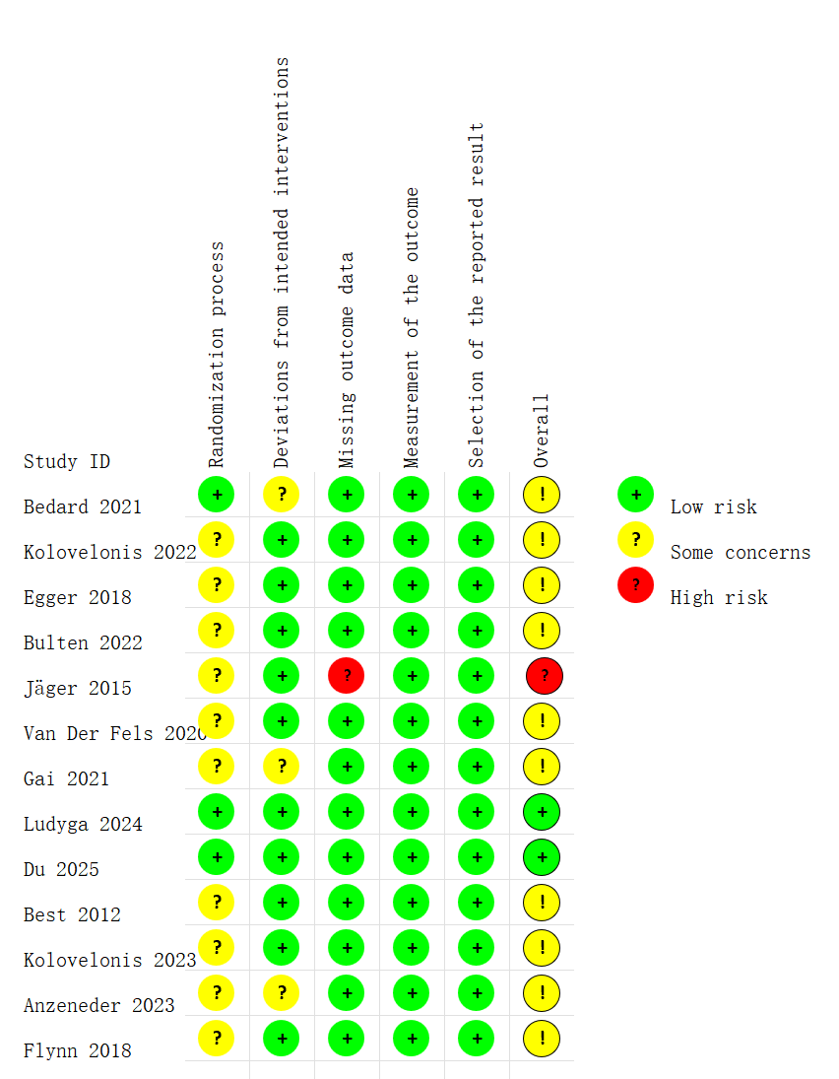
Figure 6 The risk of bias for each study

5.2 Evidence assessment
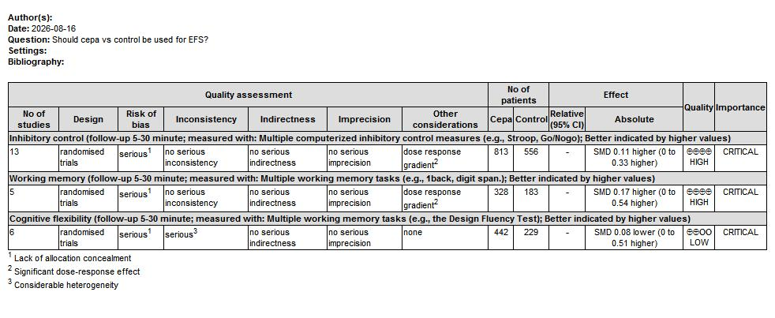
Figure 7 GRADE evidence profile

Supplemental Material 6. Forest plot of the subgroup analysis

6.1 Forest plot of the subgroup analysis-Inhibitory control
Figure 8 Forest plot of the subgroup analysis-Inhibitory control: (a) modality; (b) duration; (c) intensity; (d) ages

6.2 Forest plot of the subgroup analysis-Working memory
Figure 9 Forest plot of the subgroup analysis-Working memory: (a) modality; (b) ages; (c) intensity

6.3 Forest plot of the subgroup analysis-Cognitive flexibility
Figure 10 Forest plot of the subgroup analysis-Cognitive flexibility: (a) modality; (b) ages; (c) intensity

Supplemental Material 7. Forest plot of the subgroup analysis

7.1 Publication bias test (Funnel Plot)
Figure 10 Funnel plots: (a) inhibitory control; (b) working memory; (c) cognitive flexibility

7.2 Publication bias test (Begg’s test and Egger’s test)
Figure 11 Begg’s and Egger’s tests: (a) inhibitory control; (b) working memory; (c) cognitive flexibility

7.3 Trim-and-fill Funnel plot of exercise effects on cognitive flexibility
Figure 12 Trim-and-fill Funnel plot of exercise effects on cognitive flexibility

Supplemental Material 8. The results of the sensitivity analysis

8.1 Sensitivity analysis 1: leave-one-out approach
Figure 13 Results of the leave-one-out approach: (a) inhibitory control; (b) working memory; (c) cognitive flexibility

8.2 Sensitivity analysis 2: excluding studies judged to have an overall high risk of bias
Figure 14 Results of excluding studies judged to have an overall high risk of bias: (a) inhibitory control; (b) working memory; (c) cognitive flexibility

