Supplementary Material
Prospective Validation of the Canadian Syncope Risk Score in an Indian Emergency Department Population: Performance in Syncope and Near-Syncope
Shah M, Mehta S, Shah S, Kotharthil D
Contents
Supplementary Figures S1–S13 (pages 2–13)
Annexure A: Case Record Form
Annexure C: 30-Day Serious Outcome Definitions
Annexure D: CSRS Scoring Card
Annexure E: 30-Day Telephone Follow-up Script
STROBE Checklist
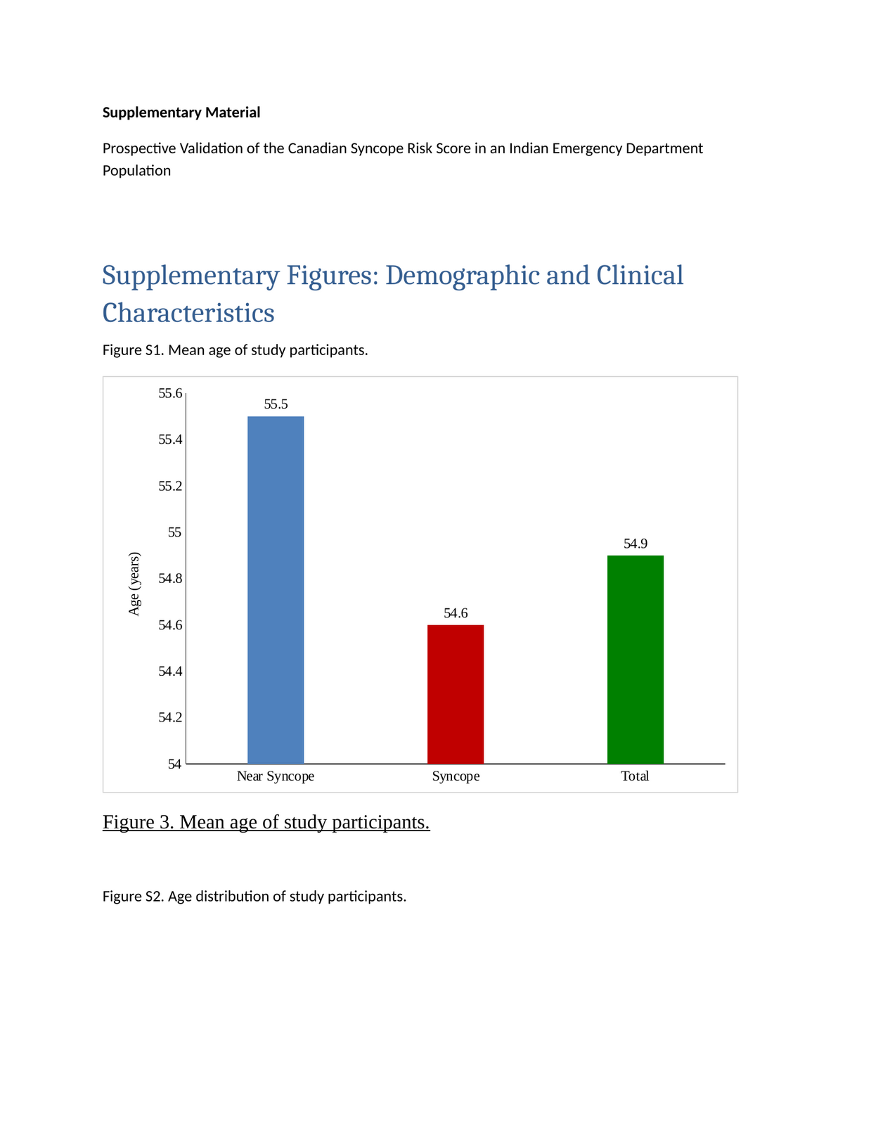

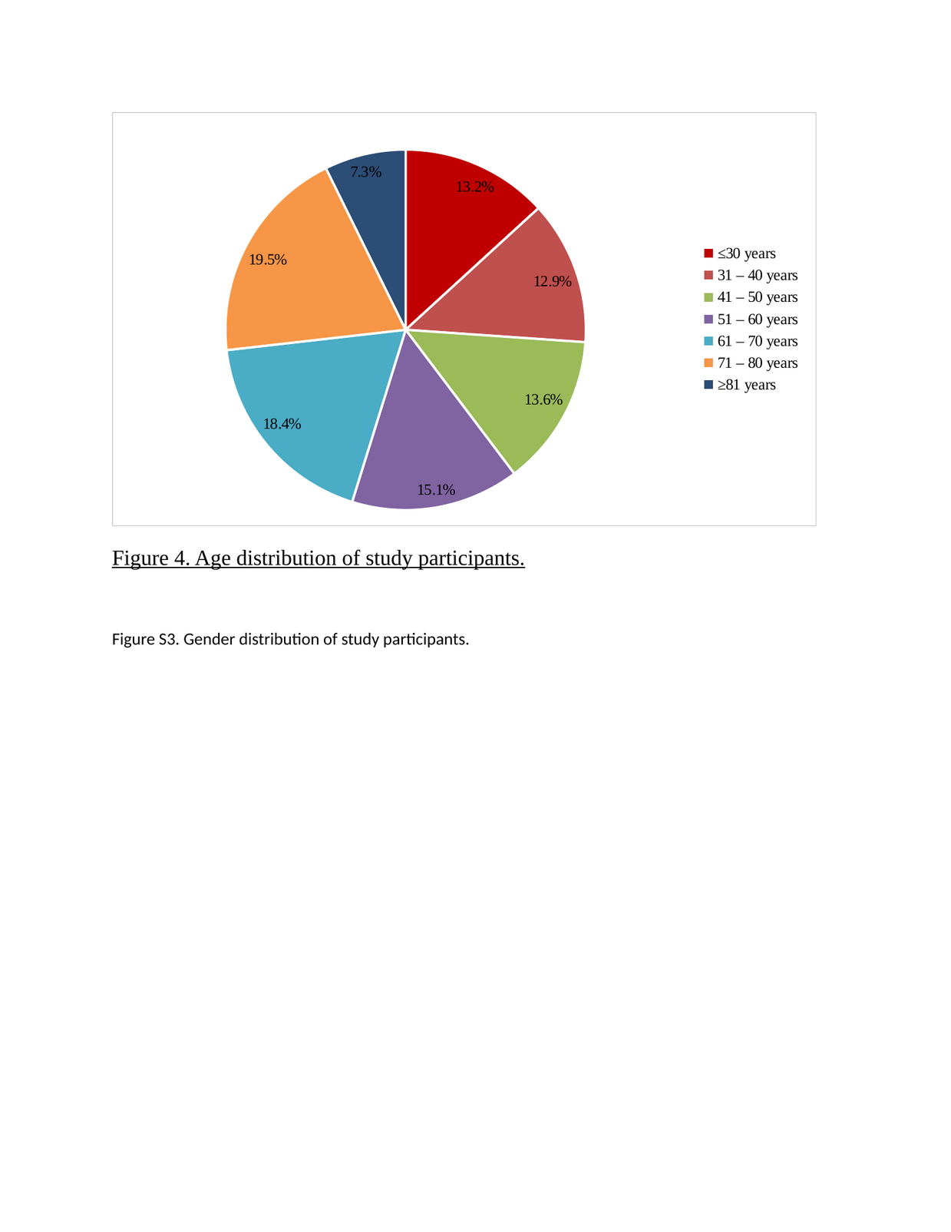

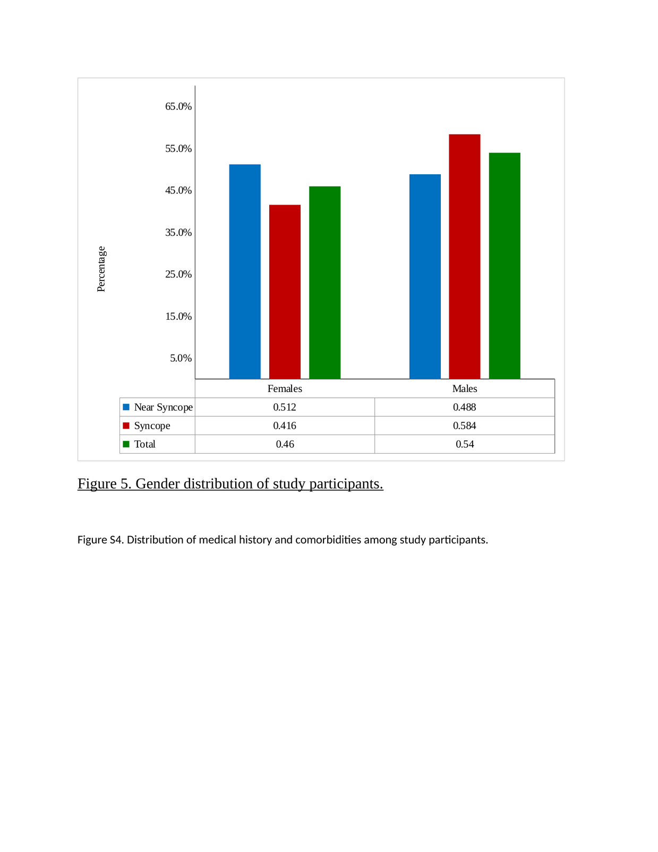

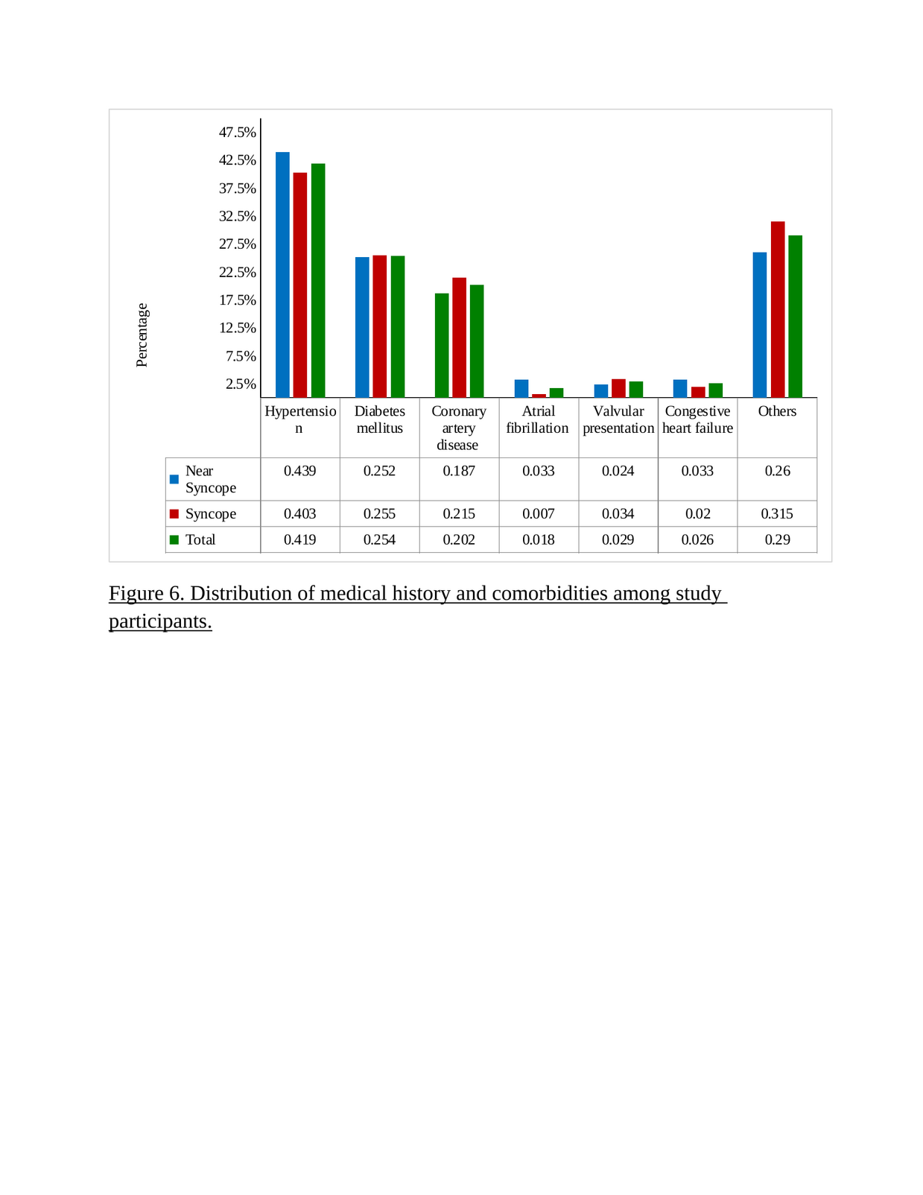

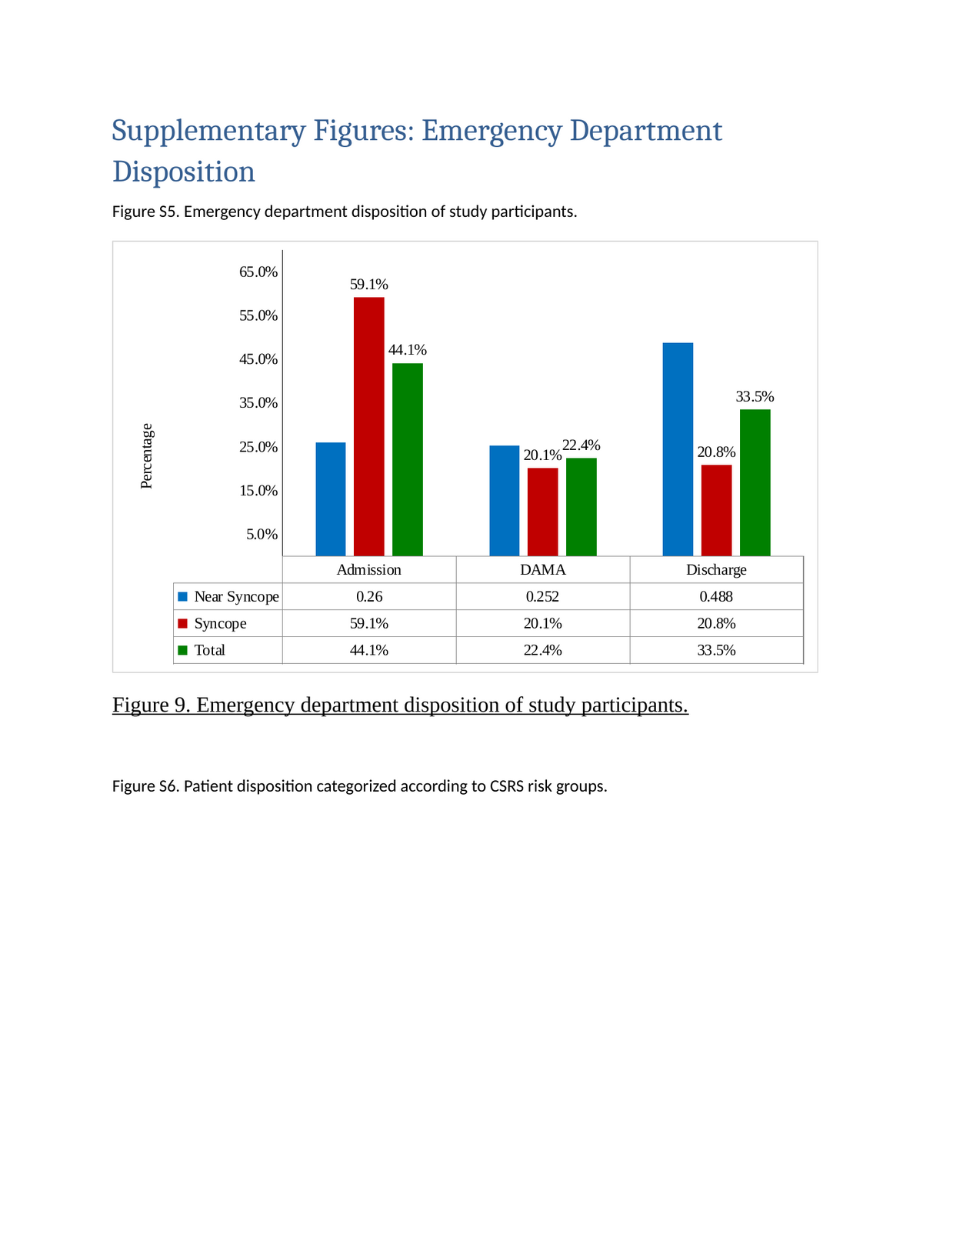

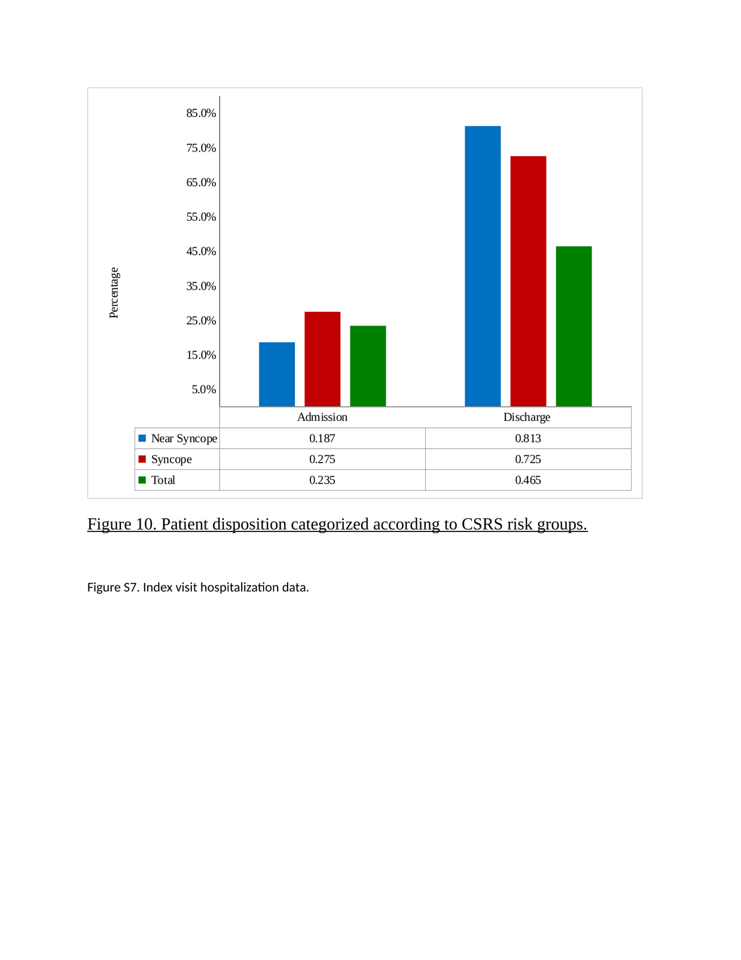

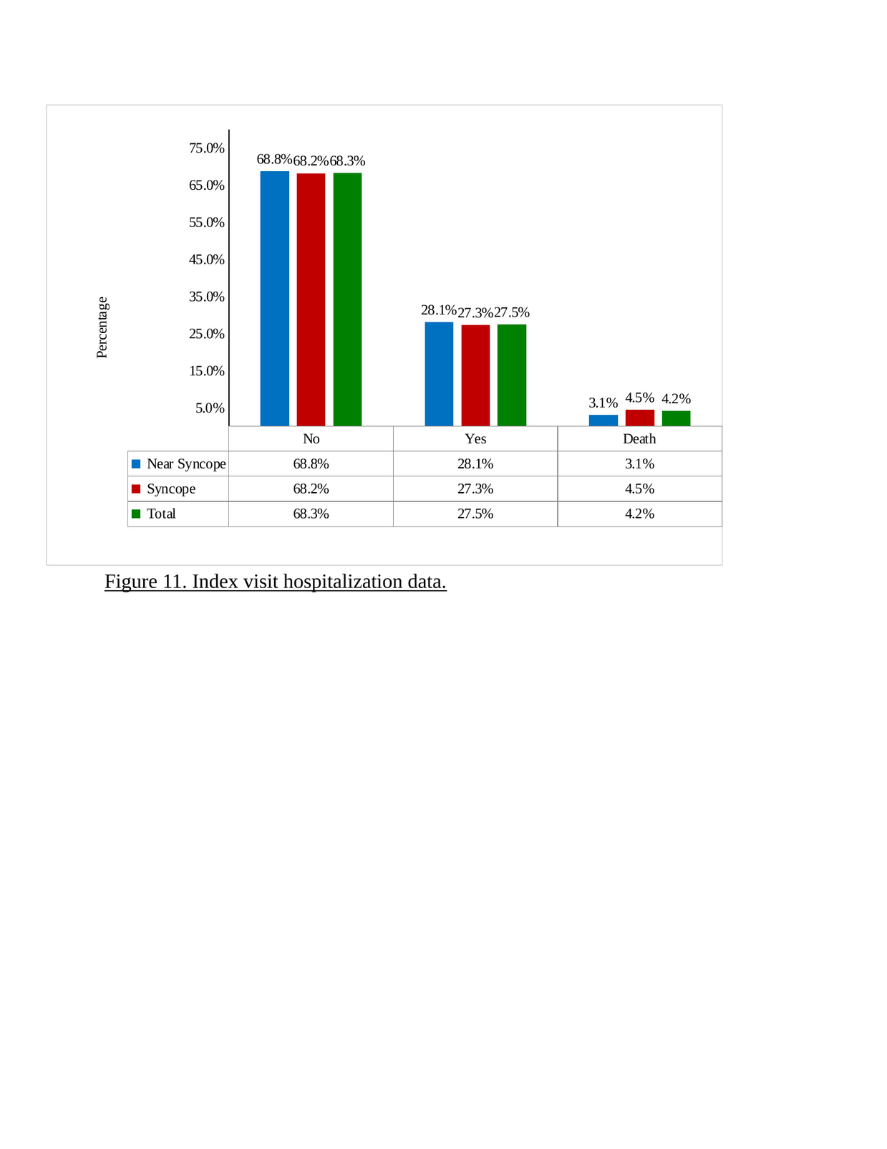

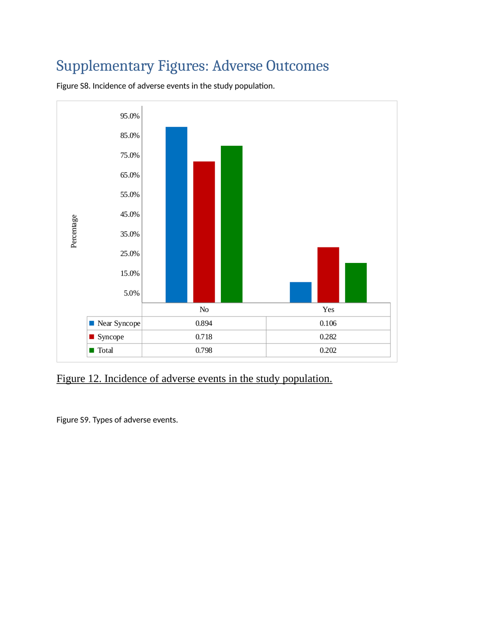

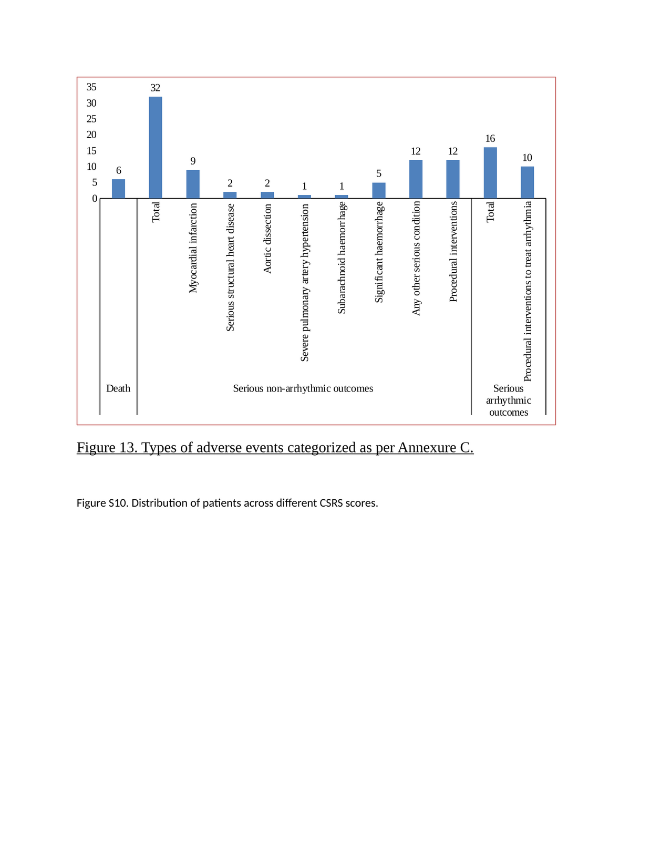

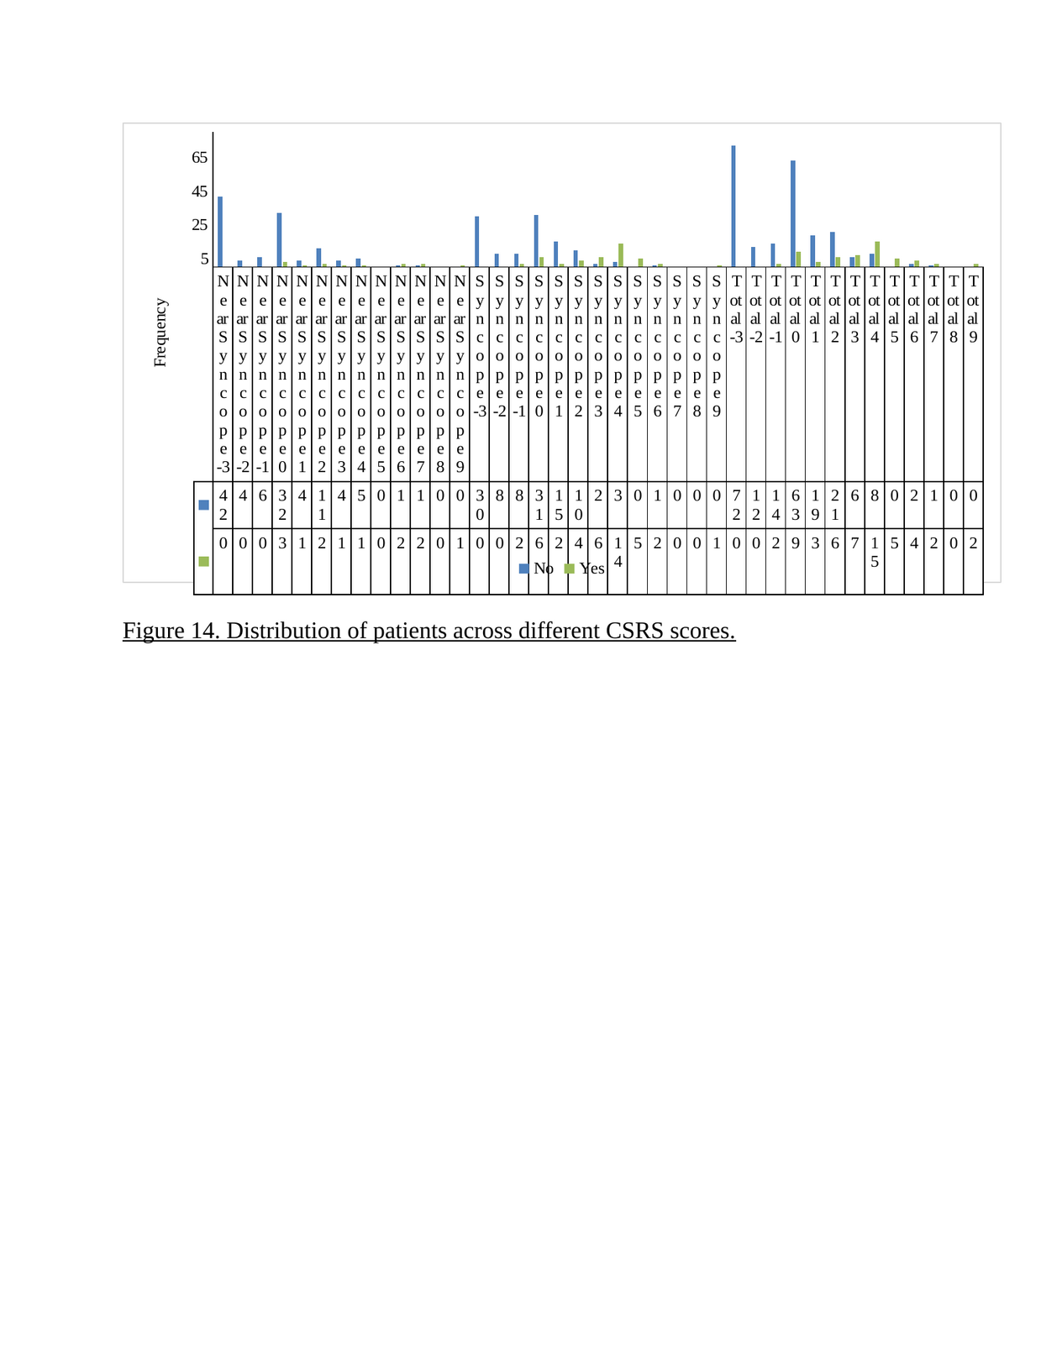

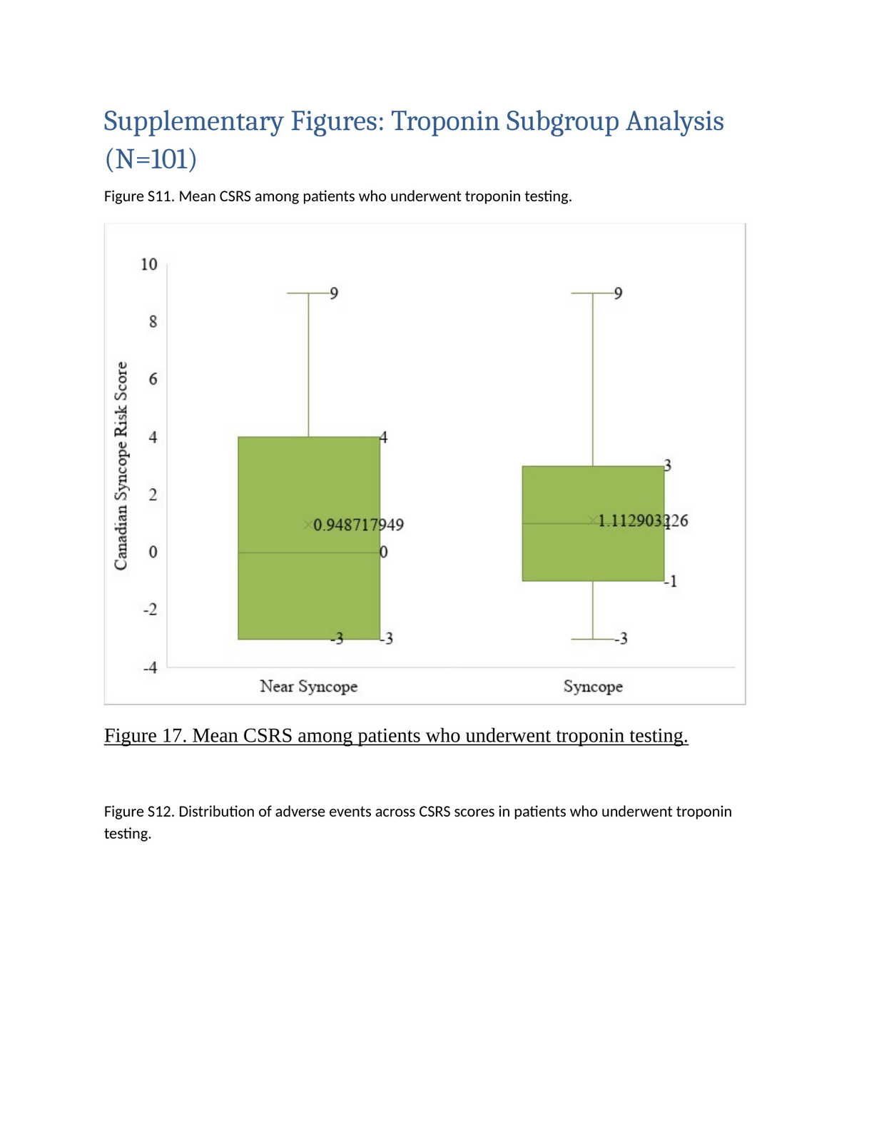

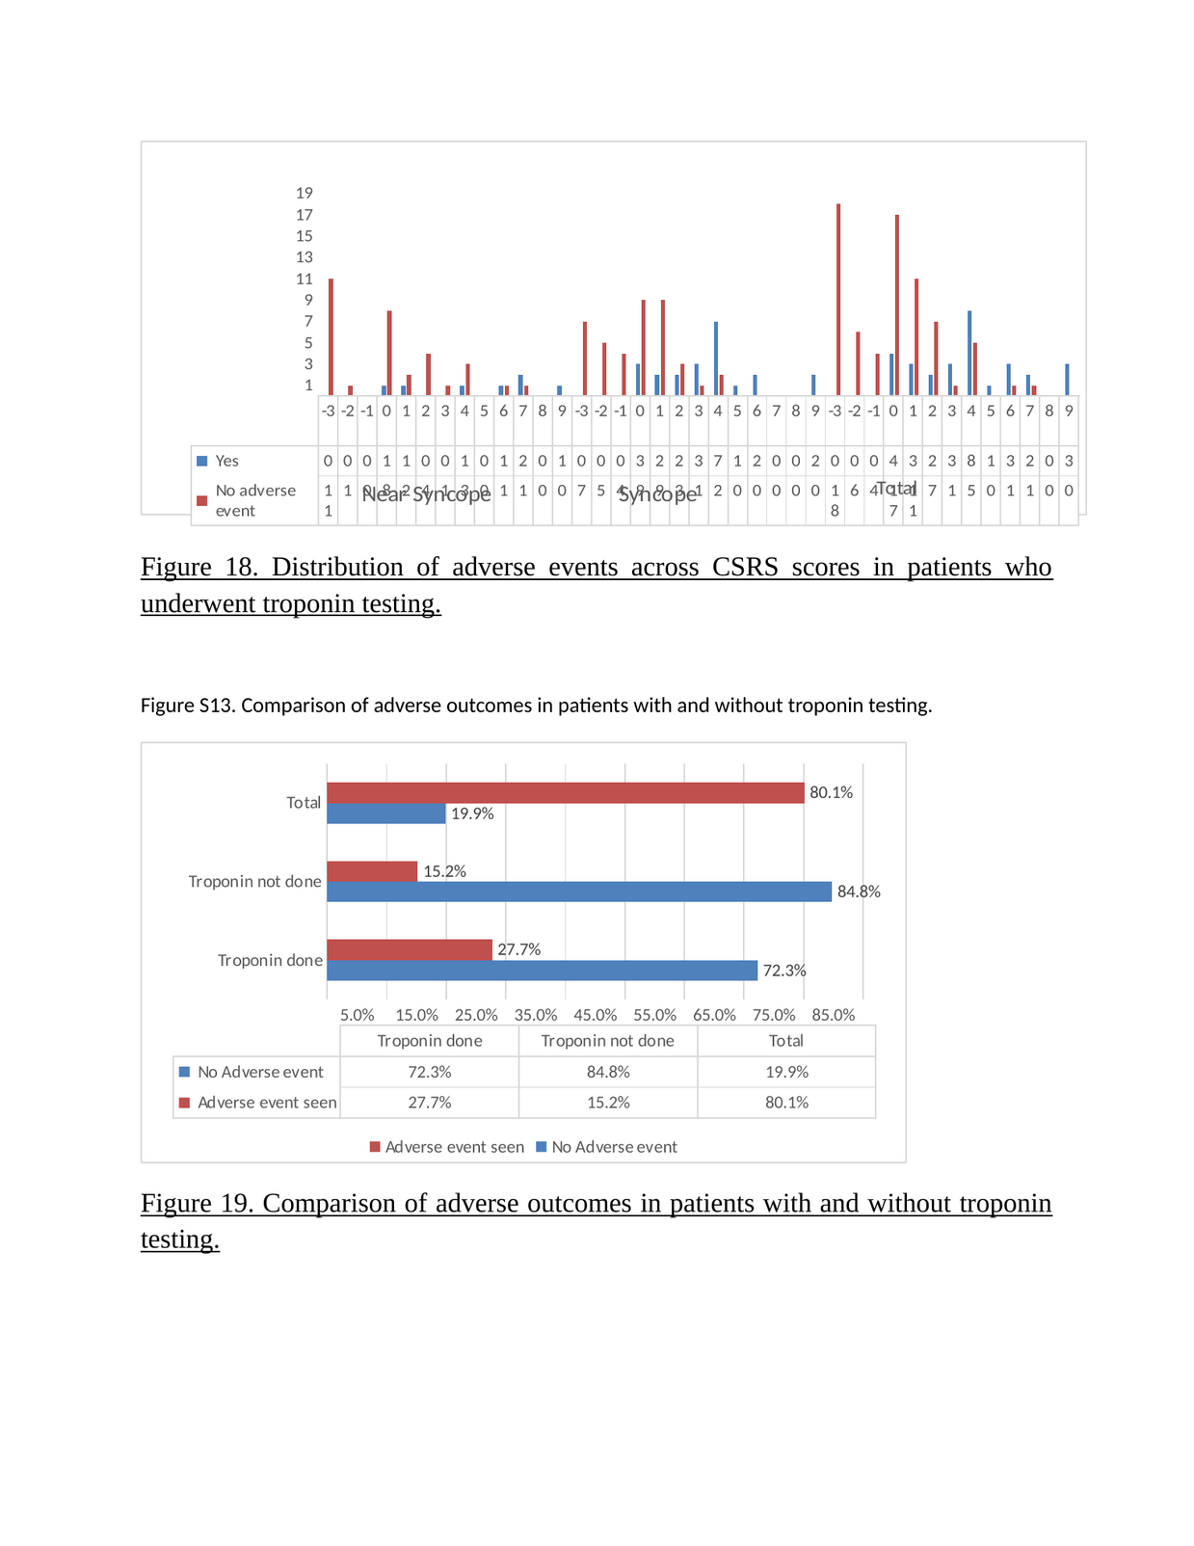

Annexure A: Case Record Form (CRF)
Study: Prospective Validation of the Canadian Syncope Risk Score in an Indian ED Population
Patient Code No.: ___________ Age: ___________ Gender: ___________ Date of Enrolment: ___________
Presentation: ☐ Syncope ☐ Near Syncope
Key Elements in History:
• Time of the event: _______________
• Activity leading to the event: _______________
• Associated symptoms: ☐ Chest pain ☐ Palpitations ☐ Dyspnea ☐ Headache ☐ Exertion ☐ Prodromal symptoms ☐ Near-fainting/dizziness
• Posture at time of event: ☐ Sitting ☐ Standing ☐ Supine
• Family history of Syncope/Near Syncope: ☐ Yes ☐ No
Medical History:
☐ Hypertension ☐ Diabetes ☐ Coronary artery disease ☐ Atrial fibrillation/flutter ☐ Valvular heart disease ☐ Congestive heart failure
Canadian Syncope Risk Score:
Supine and standing systolic blood pressure: _______ mmHg
CSRS Predictor | NO | YES
1. SBP <90 or >180 mmHg (on any reading) | 0 | +2
2. Heart disease history (CAD, AF/flutter, CHF, valvular disease) | 0 | +1
3. Predisposition to vasovagal symptoms (warm/crowded place, prolonged standing, fear, emotion, pain) | 0 | −1
4a. Abnormal QRS axis (<−30° or >100°) | 0 | +1
4b. QRS duration >130 ms | 0 | +1
4c. Corrected QT interval >480 ms | 0 | +2
5. Elevated troponin (>99th percentile of normal population) | 0 | +2
6a. ED diagnosis — Vasovagal syncope | 0 | −2
6b. ED diagnosis — Cardiac syncope | 0 | +2
Total Score (−3 to 11) | ______

Risk Category: ___________ Estimated Risk: ___________% Disposition: ☐ Admission ☐ Discharge ☐ DAMA
Serious adverse events in hospital: _______________
Serious adverse events within 30 days: ☐ None ☐ Death ☐ Arrhythmia ☐ Non-arrhythmic ☐ Procedural intervention
Conclusion of participation: ☐ Completed ☐ Withdrawn ☐ Loss to Follow-up

Annexure C: 30-Day Serious Outcomes and Their Definitions
1) Deaths
Deaths due to a cause of syncope or due to unknown cause.
2) Serious Non-Arrhythmic Outcomes
a) Myocardial infarction — Clinically important elevation in troponin or ECG change, confirmed by the emergency physician or cardiologist.
b) Serious structural heart disease — Aortic stenosis (valve area ≤1 cm²); hypertrophic cardiomyopathy with outflow tract obstruction; left atrial myxoma or thrombus with outflow tract obstruction; pericardial effusion with ventricular wall motion abnormalities or tamponade.
c) Aortic dissection — Confirmed by CT chest, trans-esophageal echocardiogram, MRI, or angiography.
d) Pulmonary embolism — Confirmed by VQ scan or CT pulmonary angiography.
e) Severe pulmonary artery hypertension — Mean pulmonary arterial pressure >30 mmHg on catheterization or echocardiography, responsible for syncope.
f) Subarachnoid hemorrhage — Confirmed by CT/MRI brain with or without CSF analysis.
g) Significant hemorrhage — Gastrointestinal bleeding, ruptured abdominal aortic aneurysm, or ectopic pregnancy that is clinically significant to cause syncope.
h) Any other serious condition — Includes ectopic pregnancy, pneumothorax, or sepsis requiring treatment and causing return to ED if undetected.
i) Procedural interventions — Any intervention to treat a non-arrhythmic cause of syncope (surgery for valvular heart disease, chest tube insertion, surgery for aortic aneurysm or ruptured spleen).
3) Serious Arrhythmic Outcomes
j) Arrhythmias:
• Sustained (>30 seconds) or polymorphic ventricular tachycardia
• Sick sinus syndrome with alternating sinus bradycardia and tachycardia
• Sinus pause >3 seconds
• Mobitz type II atrioventricular heart block
• Complete heart block or junctional/idioventricular rhythm
• Alternating left and right bundle branch block
• Symptomatic supraventricular tachycardia with rate >100/minute
• Symptomatic atrial flutter or fibrillation (fast >100/min or slow RR interval >3 seconds)
• Symptomatic sinus bradycardia <40 beats/minute
• Pacemaker or ICD malfunction with cardiac pauses
• Abnormal electrophysiological study (corrected sinus node recovery time >550 ms; His-Ventricular intervals >100 ms; inducible VT >30 seconds; polymorphic VT/VF in Brugada or ventricular dysplasia; symptomatic SVT or infra-Hisian block)
k) Procedural interventions to treat arrhythmia — Pacemaker/defibrillator insertion, cardioversion, or dialysis for electrolyte abnormalities causing arrhythmia.

Annexure D: Canadian Syncope Risk Score — Scoring Card

Category / Variable | Points
CLINICAL EVALUATION
Predisposition to vasovagal symptoms* | −1
History of heart disease† | +1
Any systolic pressure reading <90 or >180 mmHg‡ | +2
INVESTIGATIONS
Elevated troponin level (>99th percentile of normal population) | +2
Abnormal QRS axis (<−30° or >100°) | +1
QRS duration >130 ms | +1
Corrected QT interval >480 ms | +2
DIAGNOSIS IN EMERGENCY DEPARTMENT
Vasovagal syncope | −2
Cardiac syncope | +2
Total score (−3 to 11) | ____

* Triggered by being in a warm crowded place, prolonged standing, fear, emotion, or pain.
† Includes coronary or valvular heart disease, cardiomyopathy, congestive heart failure, and non-sinus rhythm (ECG evidence during index visit or documented history of ventricular or atrial arrhythmias, or device implantation).
‡ Includes blood pressure values from triage until disposition from the emergency department.
Total Score | Estimated Risk of Serious Adverse Event (%) | Risk Category
−3 | 0.4% | Very Low
−2 | 0.7% | Very Low
−1 | 1.2% | Low
0 | 1.9% | Low
1 | 3.1% | Medium
2 | 5.1% | Medium
3 | 8.1% | Medium
4 | 12.9% | High
5 | 19.7% | High
6 | 28.9% | Very High
7 | 40.3% | Very High
8 | 52.8% | Very High
9 | 65.0% | Very High
10 | 75.5% | Very High
11 | 83.6% | Very High

Annexure E: 30-Day Telephone Follow-up Script
Patient Code No.: _______________ 30-day cutoff date (dd/mm/yy): ___/___/___
"Hello, my name is Dr. Manan Shah, calling from the Emergency Department at Kokilaben Dhirubhai Ambani Hospital. I am calling you because of your recent visit on (____________). I am following all patients who came in with fainting or near-fainting to determine how they are doing after their emergency visit. I would like to ask you a few short questions. Is this alright with you? ☐ Yes ☐ No"
Date and time reached: _______________ ☐ Dead ☐ Lost to Follow-up
Q1. Since your initial emergency visit, has a physician found the cause for your fainting? ☐ Yes ☐ No
Type of physician: ☐ ED physician ☐ GP/Family Doctor ☐ Cardiologist ☐ Internal Medicine ☐ Neurologist ☐ Other
Cause diagnosed as: _______________
Q2. Since your initial emergency visit, have you had any further tests? ☐ Yes ☐ No
☐ Holter ☐ Echo ☐ Electrophysiology ☐ EEG ☐ Blood tests ☐ ECG ☐ Other: ___
Result: ☐ Normal ☐ Abnormal ☐ Not Known
Q3. Since your initial emergency visit, have you had any further treatment? ☐ Yes ☐ No
☐ Pacemaker/Defibrillator ☐ Cardioversion ☐ Surgery (valve/abdomen/AAA) ☐ Blood thinners (PE) ☐ Endoscopy (GI bleeding) ☐ Chest tube ☐ Other: ___
Q4. Since your initial emergency visit, have you been admitted to another hospital? ☐ Yes ☐ No
Hospital: _______________ When: ___/___/___ Reason: _______________
30-day serious adverse event:
☐ None ☐ Death ☐ Arrhythmic outcome ☐ Non-arrhythmic outcome ☐ Procedural intervention

STROBE Checklist — Cohort Study
Study: Prospective Validation of the Canadian Syncope Risk Score in an Indian Emergency Department Population
Reference: von Elm E, et al. The Strengthening the Reporting of Observational Studies in Epidemiology (STROBE) statement: guidelines for reporting observational studies. Ann Intern Med. 2007;147:573–577.
Item | Section/Topic | STROBE Recommendation | Location in Manuscript
1 | Title and abstract | (a) Indicate the study's design with a commonly used term in the title or abstract | Title; Abstract — Design, Setting, and Participants
 |  | (b) Provide an informative and balanced summary in the abstract | Abstract (all structured fields)
2 | Background/rationale | Explain the scientific background and rationale for the investigation | Introduction ¶1–4
3 | Objectives | State specific objectives, including any prespecified hypotheses | Introduction ¶5; Methods — Outcome Ascertainment
4 | Study design | Present key elements of study design early in the paper | Methods — Study Design and Setting
5 | Setting | Describe the setting, locations, and relevant dates, including periods of recruitment, exposure, follow-up, and data collection | Methods — Study Design and Setting
6 | Participants | (a) Give the eligibility criteria, and the sources and methods of selection of participants. Describe methods of follow-up | Methods — Participants; Outcome Ascertainment
 |  | (b) For matched studies, give matching criteria and number of exposed and unexposed | N/A — not a matched study
7 | Variables | Clearly define all outcomes, exposures, predictors, potential confounders, and effect modifiers | Methods — Outcome Ascertainment; Annexure C
8* | Data sources/measurement | For each variable of interest, give sources of data and details of methods of assessment | Methods — Study Protocol; Outcome Ascertainment
9 | Bias | Describe any efforts to address potential sources of bias | Methods — Study Protocol (both admitted and discharged included); Discussion — Limitations
10 | Study size | Explain how the study size was arrived at | Methods — Sample Size
11 | Quantitative variables | Explain how quantitative variables were handled in the analysis | Methods — Statistical Analysis
12 | Statistical methods | (a) Describe all statistical methods, including those used to control for confounding | Methods — Statistical Analysis
 |  | (b) Describe any methods used to examine subgroups and interactions | Results — Troponin Subgroup Analysis; near-syncope vs syncope subgroup
 |  | (c) Explain how missing data were addressed | Methods — Study Protocol ¶5 (missing troponin treated as normal, per original CSRS derivation)
 |  | (d) Explain how loss to follow-up was addressed | Methods — Outcome Ascertainment; Results — Enrollment (n=2 lost to follow-up)
 |  | (e) Describe any sensitivity analyses | Not performed — DAMA rate acknowledged as limitation in Discussion
13* | Participants | (a) Report numbers of individuals at each stage of study | Results — Enrollment and Baseline Characteristics
 |  | (b) Give reasons for non-participation at each stage | Results — Enrollment (1 withdrew consent, 2 lost to follow-up)
 |  | (c) Consider use of a flow diagram | Not included — recommend adding at revision stage if requested
14* | Descriptive data | (a) Give characteristics of study participants | Results — Enrollment and Baseline Characteristics; Tables 1–2
 |  | (b) Indicate number of participants with missing data for each variable | Methods — Study Protocol (troponin missing in 62.9%); Troponin Subgroup Analysis
 |  | (c) Summarise follow-up time | Methods — Outcome Ascertainment (30-day follow-up); Results — Enrollment
15* | Outcome data | Report numbers of outcome events or summary measures over time | Results — Thirty-Day Serious Adverse Events; Table 4
16 | Main results | (a) Give unadjusted estimates and their precision (95% CI) | Results — Diagnostic Accuracy of the CSRS; Tables 6–8
 |  | (b) Report category boundaries when continuous variables were categorized | Results — CSRS Scores and Risk Stratification; Tables 3, 5; Annexure D
 |  | (c) Consider translating estimates of relative risk into absolute risk | Results — Association Between CSRS Risk Categories and Outcomes; Table 5
17 | Other analyses | Report other analyses done — e.g. subgroups and interactions | Results — Troponin Subgroup Analysis; near-syncope vs syncope subgroup throughout
18 | Key results | Summarise key results with reference to study objectives | Discussion ¶1; Conclusion
19 | Limitations | Discuss limitations, taking into account sources of potential bias or imprecision | Discussion — Limitations
20 | Interpretation | Give a cautious overall interpretation of results | Discussion — all subsections; Conclusion
21 | Generalisability | Discuss the generalisability (external validity) of the study results | Discussion — Limitations ¶1; Conclusion ¶2
22 | Funding | Give the source of funding and the role of the funders | Declarations — Funding
* Indicates items where information is given separately for each group (syncope and near-syncope) where applicable.

