Appendix
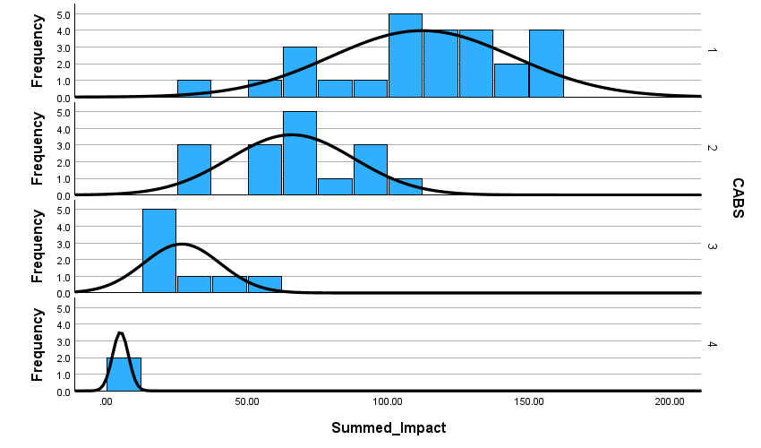
Figure (2) Impact data by CABS/AJG category for IB journals

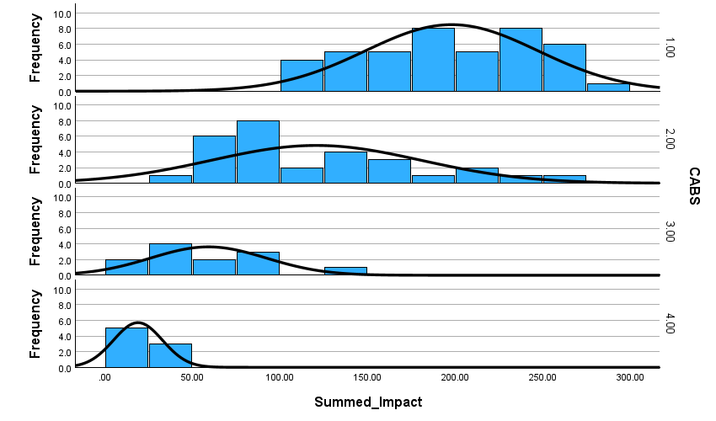
Figure (3) Impact data by CABS/AJG category for Management journals

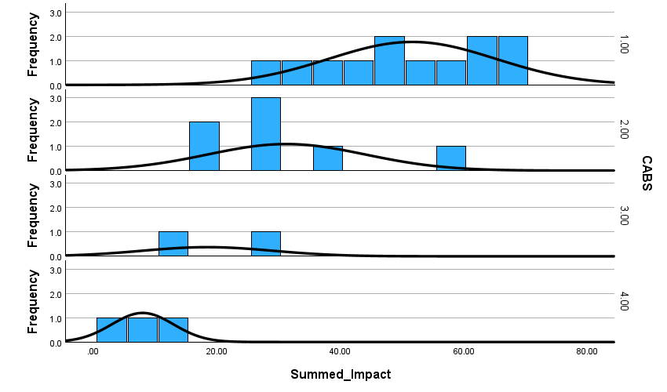
Figure (4) Impact data by CABS/AJG category for Strategy journals

