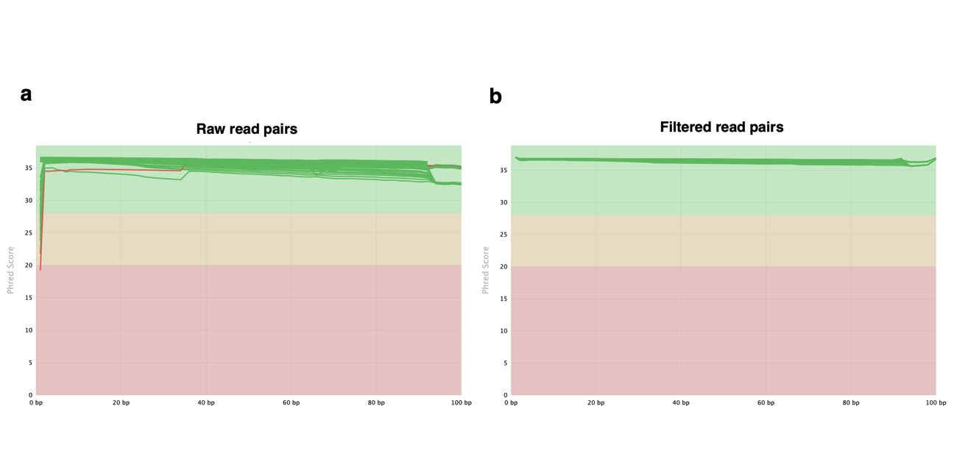Figure S1. Quality control of RNA-seq data before and after filtering. Per-base sequence quality distributions across the 72 RNA-seq libraries for (a) raw read pairs (5.81 billion) and (b) filtered read pairs (4.74 billion). The y-axis shows Phred quality score by read position. Green, yellow and red areas indicate high, moderate and low-quality bases, respectively.

