SUPPLEMENTARY MATERIAL

Table S1: Description of predictor variables used to model the species distribution.

Drivers | Variable | Description
Human activity | U100 | Distance to the nearest town with more than 100,000 inhabitants (km)
Human activity | U500 | Distance to the nearest town with more than 500,000 inhabitants (km)
Human activity | Daut | Minimun distance road (km)
Geographic and topographic | Alti | Average altitude (m)
Geographic and topographic | Dalt | Difference in altitude (slope, m)
Geographic and topographic | Slope | Average slope
Geographic and topographic | Lati | Latitude
Geographic and topographic | Long | Longitude
Weather | Tjan | Average temperature in January (ºC)
Weather | Tjul | Average temperature in July (ºC)
Weather | Huja | Average humidity in January (%)
Weather | Huju | Average humidity in July (%)
Weather | Tmed | Average annual temperature (ºC)
Weather | Vhum | Annual relative air humidity range
Weather | Vtem | Annual temperature range = (TJul-TJan)
Weather | Perm | Soil permeability
Weather | Inso | Mean annual insolation (hours/year)
Weather | Rads | Mean annual sun radiation (KWh/m²/day)
Weather | Etp | Mean annual potential evapotranspiration (mm)
Weather | Etr | Mean annual real evapotranspiration (mm)
Weather | Prec | Mean annual precipitation (mm)
Weather | Dipr | Mean annual number of days with precipitation ≥ 0.1 mm
Weather | Pm24 | Maximum precipitation in 24 hours
Weather | Pmr | Relative maximum precipitation (Pm24/Pmed)
Weather | Dihe | Frost days
Land cover | Improductive | Improductive (%)
Land cover | Urban | Urban areas (%)
Land cover | Roads | Roads (%)
Land cover | Mines | Mine zones (%)
Land cover | Rainfall crops | Rainfall crops (%)
Land cover | Irrigated crops | Irrigated crops (%)
Land cover | Pasture | Pasture (%)
Land cover | Mixed crops | Mixed crops (%)
Land cover | Abandoned | Abandoned crops (%)
Land cover | Agroforestry | Agroforestry areas (%)
Land cover | Forest | Forest (%)
Land cover | Shrubland | Shrubland (%)
Land cover | Sandrock | Sand and rock (%)
Land cover | River | Rivers (%)
Land cover | Wetland | Wetland areas (%)

Table S2: Summary of the SDM techniques used to model the bat and moth distribution.

Technique type | Name |  | Acronyms | Reference
Individual |  | Generalized Linear Model | GLM | McCullagh, 1984
 |  | Maximum Entropy | M.Ph | Phillips et al., 2006
 |  | Random Forest | RF | Breiman, 2001
 |  | Generalized Additive Model | GAM | Hastie & Tibshirani, 2017
 |  | Artificial Neural Network | ANN | Ripley, 2007
 |  | Flexible Discriminant Analysis | FDA | Hastie et al., 1994
 |  | Classification Tree Analysis | CTA | Breiman et al., 2017
 |  | Generalized Boosting Model | GBM | Elith et al., 2008
Ensemble |  | Ensemble Weight Means Probabilities | EWMP | Hao et al., 2019, 2020
 |  | Ensemble Means Probabilities | EMP | Hao et al., 2019, 2020
 |  | Ensemble Model Committee Average | ECA | Hao et al., 2019, 2020

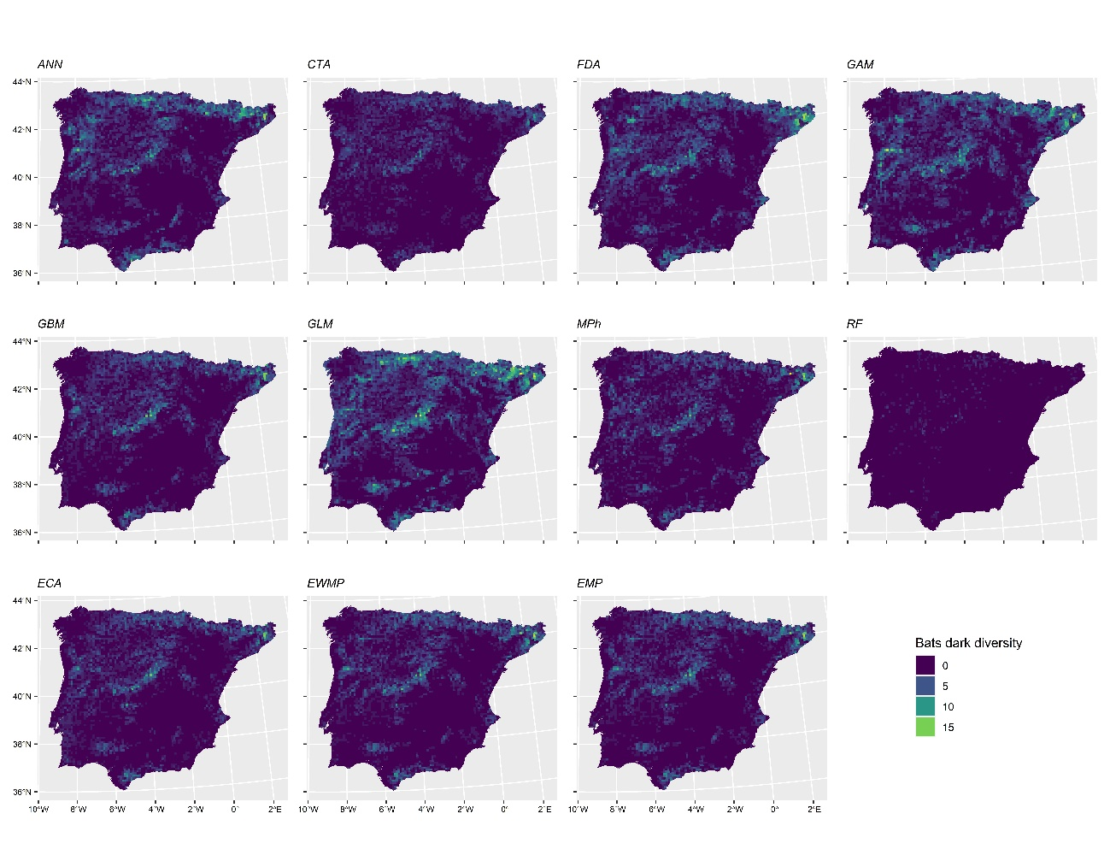
Figure S1. Geographic distribution of estimated Animal Dark Diversity by SDM technique for bats in the Iberian Peninsula using MaxKappa threshold.

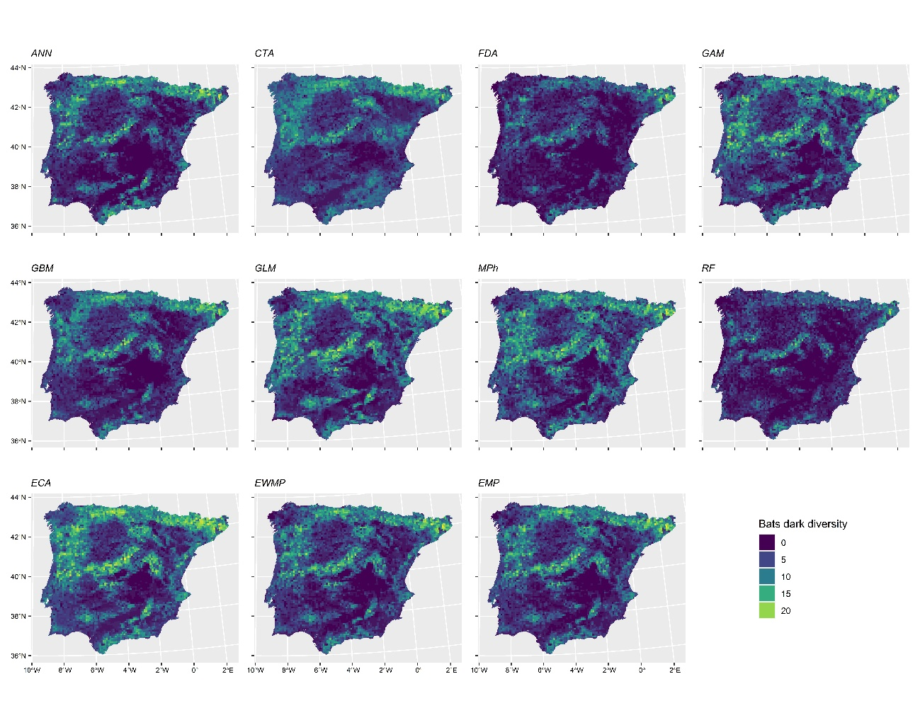
Figure S2. Geographic distribution of estimated Animal Dark Diversity by SDM technique for bats in the Iberian Peninsula using MeanProb threshold.

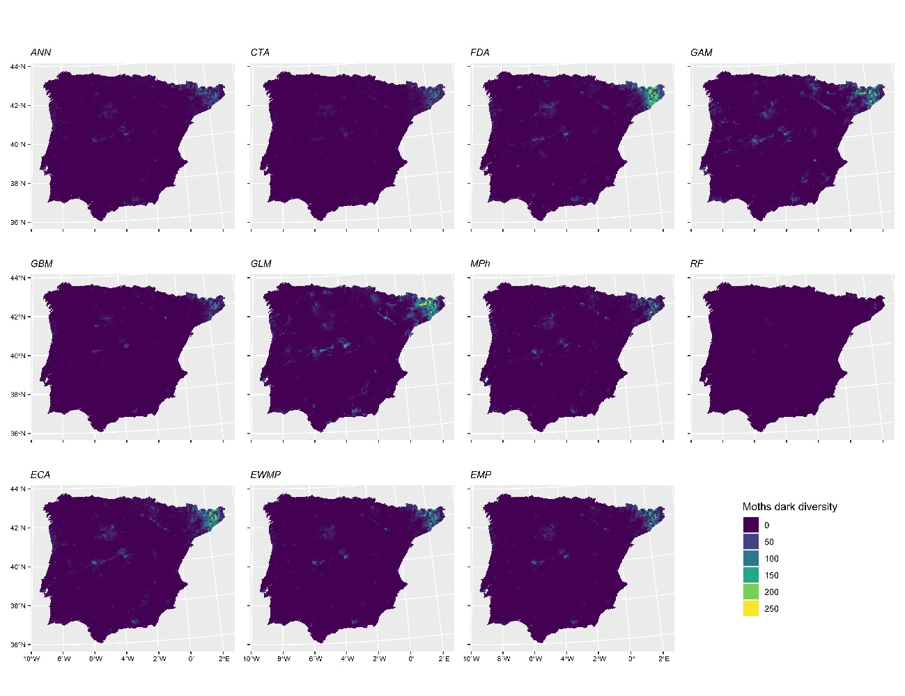
Figure S3. Geographic distribution of estimated Animal Dark Diversity by SDM technique for moths in the Iberian Peninsula using MaxKappa threshold.

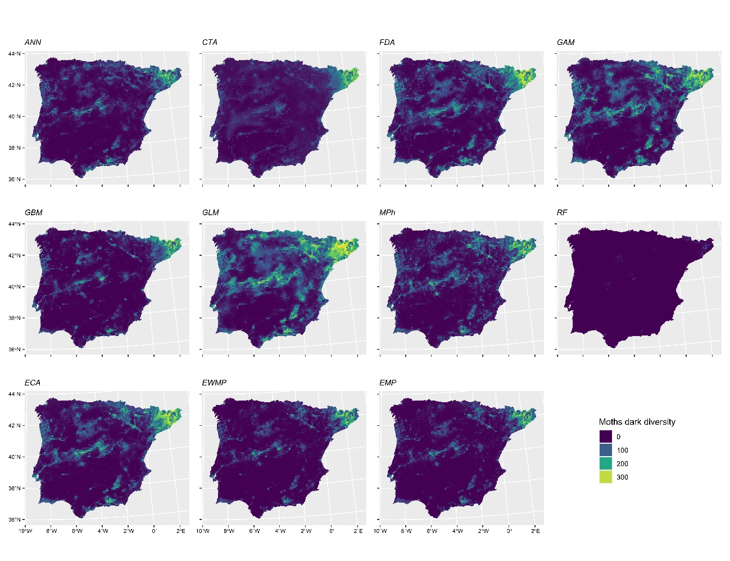
Figure S4. Geographic distribution of estimated Animal Dark Diversity by SDM technique for moths in the Iberian Peninsula using MaxTSS threshold.

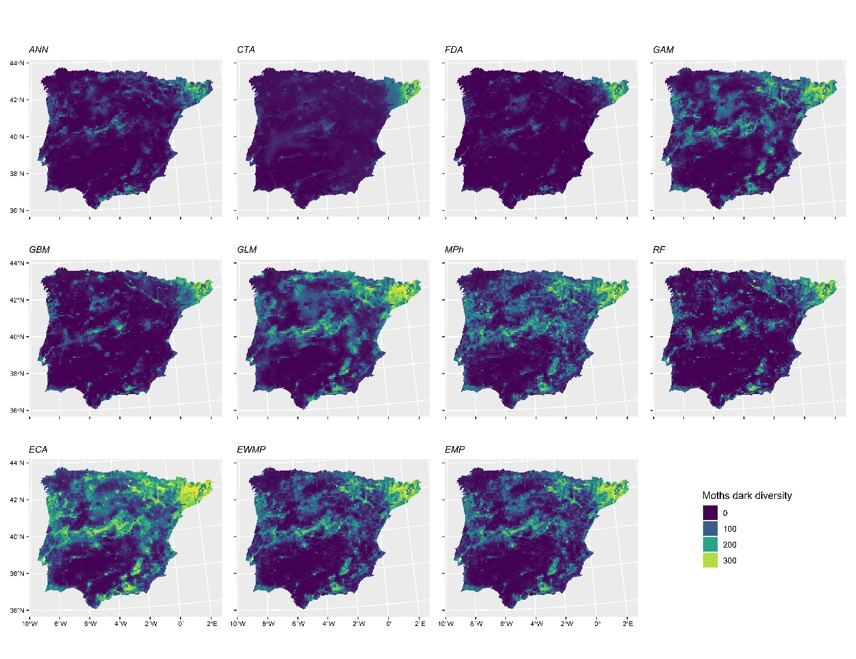
Figure S5. Geographic distribution of estimated Animal Dark Diversity by SDM technique for moths in the Iberian Peninsula using MeanProb threshold.

