A minimum-data-set soil quality index reveals early soil formation in bauxite residue under garbage enzyme-mediated bioweathering
Jie Renª, Kai Chenª, Ting Liª, Xiaokun Changª, Ping Du^{b, *}
ª Ministry of Education Key Laboratory of Ecology and Resource Use of the Mongolian Plateau, Inner Mongolia Key Laboratory of Grassland Ecology, and School of Ecology and Environment, Inner Mongolia University, Hohhot, China
^{b} Technical Centre for Soil, Agricultural and Rural Ecology and Environment, Ministry of Ecology and Environment, Beijing 100012, China
* Corresponding author: Ping Du (duping@craes.org.cn)
Technical Centre for Soil, Agricultural and Rural Ecology and Environment, Ministry of Ecology and Environment, Beijing 100012, China

Text S1. Determination of physicochemical properties and enzyme activities of GEs
Chemical oxygen demand (COD) was determined spectrophotometrically by measuring absorbance at a specific wavelength of trivalent chromium ions generated during the reaction between potassium dichromate and reducing substances (Geerdink et al., 2017). Total dissolved solids and total suspended solids were determined using the combustion-gravimetric method (Gong et al., 2025). Total phenolics content was determined using the Folin-Ciocalteu assay (Singleton et al., 1999). Total and reducing sugar contents were quantified using the 3,5-dinitrosalicylic acid (DNS) colorimetric method (Deshavath et al., 2020). Substrate-based method is used for determination of amylase (Wen et al., 2025) and protease activities (Greenfield et al., 2021). Polyphenol oxidase and superoxide dismutase activity were determined using the catechol oxidation method (Matuschek & Svanberg, 2005) and the pyrogallol autoxidation assay (Prakash Jain et al., 2025). One unit of amylase activity was defined as the amount of enzyme that releases 1 µmol of maltose per minute. One unit of protease activity was defined as the amount of enzyme that releases 1 µmol of tyrosine from casein hydrolysis per minute. One unit of polyphenol oxidase activity was defined as an increase of 1.0 in absorbance per minute per milliliter of enzyme solution. One unit of superoxide dismutase activity was defined as the amount of enzyme required to inhibit the nitroblue tetrazolium reduction by 50% under specified conditions.

Text S2. Detailed information for soil quality assessment framework
(1) Indicator selection and Minimum Data Set (MDS) establishment
In this study, 25 soil quality indicators were initially selected to form the total data set (TDS). To reduce data redundancy, principal component analysis (PCA) was performed to group these indicators into uncorrelated principal components (PCs). PCs with eigenvalues > 1 were retained because they explained most of the variance in the dataset. MDS indicators selection followed three steps (Liu et al., 2025):
Loading filter: within each PC, indicators with absolute factor loadings > 0.50 were retained. If an indicator had high loadings on multiple PCs, it was assigned to the group in which it had the lowest correlation with other indicators.
Norm value calculation: the comprehensive loading (Norm value) for each indicator was calculated to quantify its explanatory power. The formula is as follows:
$$N_{ik}=\sqrt{\sum_{1}^{k}{\left(U_{ik}^{2}×λ_{k}\right)}}$$
Where N_{ik} is the Norm value of the i-th indicator on the first k principal components with eigenvalues > 1; U_{ik} is the loading of the i-th indicator on the k-th PC; and λ_{k} is the eigenvalue of the k-th PC.
Correlation filter: indicators with Norm values within 10% of the maximum Norm value in each group were provisionally selected. Pearson correlation analysis was then conducted among these candidates. If two indicators were highly correlated (r > 0.50), only the one with the higher Norm value was retained in the MDS to avoid multicollinearity.
(2) Scoring functions and weight assignment
After establishing of the MDS, indicator values were normalized to a 0-1 scale using non-linear scoring functions based on their relationship with soil function.
S-shaped function (for "more is better" indicators, e.g., nutrients, enzyme activities):
$$f_{(x)}=\left\{\begin{aligned}1, x≥a_{2} \\ \frac{x−a_{1}}{a_{2}−a_{1}} \\ 0, x≤a_{1}\end{aligned}, a_{2}>x>a_{1}\right.$$
Inverse S-shaped function (for "less is better" indicators, e.g., Na content, pH in alkaline soil):
$$f_{(x)}=\left\{\begin{aligned}1, x≤a_{1} \\ \frac{x−a_{2}}{a_{1}−a_{2}} \\ 0, x≥a_{2}\end{aligned}, a_{2}>x>a_{1}\right.$$
Parabolic function (for "optimum is best" indicators, e.g., pH in neutral soil): (Insert specific parabolic formula here)
$$\left\{\begin{aligned}1, b_{2}≥x≥b_{1} \\ \frac{x−a_{1}}{b_{1}−a_{1}}, a_{1}<x<b_{1} \\ \frac{x−a_{2}}{b_{2}−a_{2}}, a_{2}>x>b_{2} \\ 0, x≤a_{1}, x≥a_{2}\end{aligned}\right.$$
In these equations, x represents the measured indicator value; a₁ and a₂ denote the minimum and maximum measured values; and b₁ and b₂ represent the lower and upper thresholds of the optimal range.
Weights (Wi) for each MDS indicator were calculated as the ratio of their communality to the sum of communalities of all MDS indicators derived from the PCA.
(3) Calculation and validation of Soil Quality Index (SQI)
The SQI was calculated using the weighted summation method:
$$SQI=\sum_{i=1}^{n}{(W_{i}×S_{i})}$$
where W_{i} is the weight of the i-th indicator, S_{i} is the assigned score of the i-th indicator, and n is the number of indicators in the MDS.
In addition, linear regression was performed. An R² > 0.5 indicates that the MDS could effectively replace the TDS for soil quality evaluation.

Table S1 Selected properties of bauxite residue
Basic properties
pH |  | EC (mS cm⁻¹) |  | ESP (%) |  | SAR |  | TA (cmol kg⁻¹)
10.69±0.13 |  | 2.31±0.05 |  | 51.45±0.19 |  | 7.45±0.23 |  | 42.59±0.37
TOC (g kg⁻¹) |  | TN (g kg⁻¹) |  | AN (mg kg⁻¹) |  | TP (g kg⁻¹) |  | AP (mg kg⁻¹)
2.35±0.13 |  | 0.11±0.01 |  | 0.19±0.03 |  | 0.17±0.01 |  | 2.17±0.13
Major constituents (g kg⁻¹)
Fe | Ca |  | Na |  | Ti |  | Al |  | K
574.93±1.07 | 24.67±0.50 |  | 46.82±5.33 |  | 23.39±0.26 |  | 16.57±3.96 |  | 13.14±0.58
Trace metals (mg kg⁻¹) ª
Cr | Mn |  | V |  | Zn |  | As |  | Pb
1262±53.4 | 801±24.3 |  | 520±12.2 |  | 72.7±4.2 |  | 43.7±2.6 |  | 46.3±2.9
The values in the table are the means of three replicate experiments.
^{a.} Determined using microwave-assisted acid digestion of the bauxite residue with concentrated HNO₃ + HF + HClO₄ (3:2:3, v/v) and the elemental content determined using ICP-MS (7500 ICP–MS; Agilent Technologies, USA).

Additional information for mineral composition analysis
The mineralogical composition of the bauxite residue samples was analyzed using X-ray diffraction (XRD). The air-dried samples were ground into a fine powder (<75 μm) and analyzed using a diffractometer (Bruker D8 advance, Bruker, Germany) equipped with Cu Kα radiation. The diffraction patterns were recorded over a 2θ range of 10-90° with a scanning speed of 2° min⁻¹. The mineral phases were identified by comparing the obtained diffraction peaks with standard cards from the Powder Diffraction File (PDF) using MDI Jade 5.0 software.
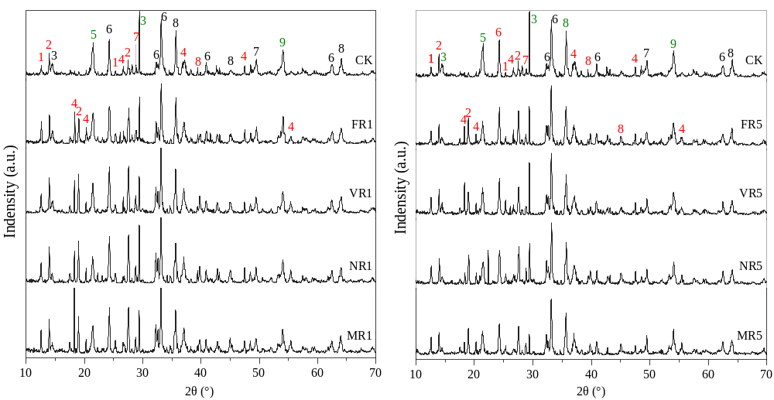
Fig. S1 Mineral analysis of bauxite residue samples. The GE-treated bauxite residue used in the analysis was collected after 90 days of incubation. Green numbers denote minerals that decrease in content, red numbers denote minerals that increase in content or newly formed after GE treatment, and black numbers indicate minerals with negligible change. 1 kaolinite, Al₂(Si₂O₅)(OH)₄; 2 boehmite, AlO(OH); 3 cancrinite, Na₈(AlSiO₄)₆(CO₃)(H₂O)₂; 4 gibbsite, Al(OH)₃; 5 sodalite, Na₈(Al₆Si₆O₂₄)OH₂ 6 hematite, Fe₂O₃; 7 calcite, CaCO₃; 8 andradite, Ca₃(Fe_{0.87}Al_{0.13})₂(SiO₄)_{1.65}(OH)_{5.4}; 9 katoite, Ca₃Al₂(SiO₄)(OH)₈;

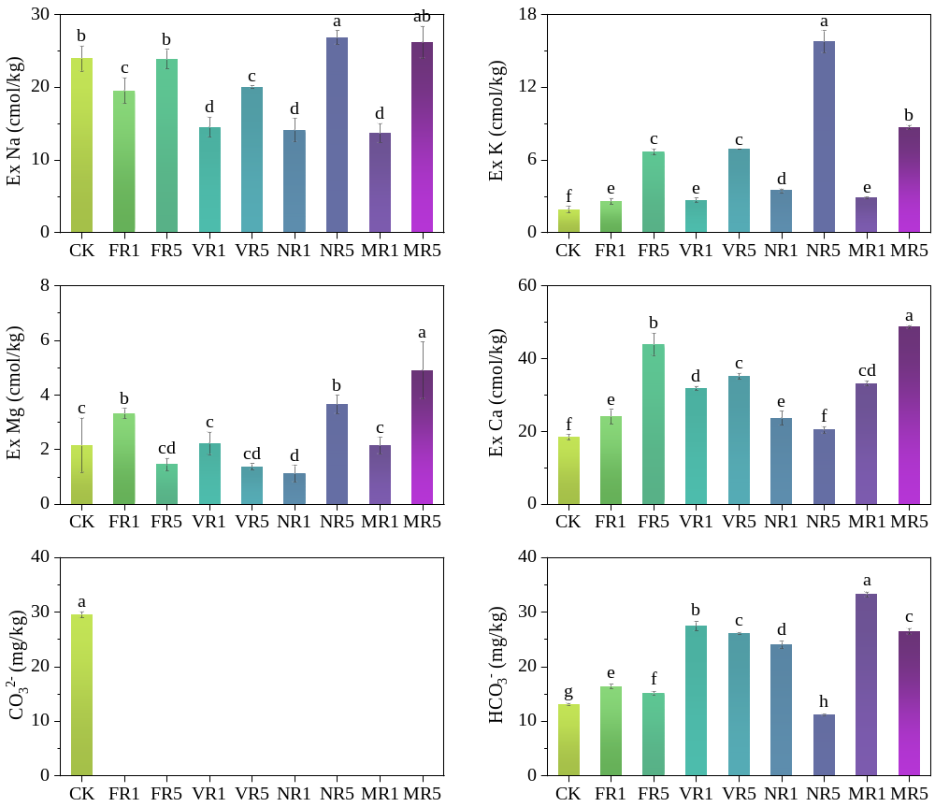
Fig. S2 Changes in exchangeable cations and carbonate concentrations with GE application.

Table S2 Principal component loading matrix of pedogenic quality indicators and Norm values of each factor.
Indicator | Principal component |  |  |  | Norm | Group
 | 1 | 2 | 3 | 4
AN | 0.9438 | 0.2196 | 0.1504 | 0.1176 | 3.4639 | 1
EC | 0.9323 | 0.1449 | 0.2121 | 0.0827 | 3.4101 | 1
TN | 0.8304 | 0.1133 | 0.2407 | 0.4498 | 3.0950 | 1
TP | 0.8027 | 0.3982 | 0.3637 | 0.1448 | 3.1087 | 1
Ex K | 0.7896 | 0.0078 | 0.5490 | 0.2053 | 3.0149 | 1
TOC | 0.7686 | 0.0749 | 0.5649 | 0.1687 | 2.9527 | 1
Ex Na | 0.7450 | 0.3996 | 0.2859 | 0.4108 | 2.9306 | 1
Ex Mg | 0.7441 | 0.0791 | 0.2130 | 0.1382 | 2.7281 | 1
BG | 0.6792 | 0.0764 | 0.5836 | 0.2798 | 2.6765 | 1
AP | 0.5839 | 0.5176 | 0.3947 | 0.3867 | 2.5542 | 1
SCP | 0.5530 | 0.4961 | 0.3756 | 0.3241 | 2.4166 | 1
SAR | 0.5114 | 0.8223 | 0.2225 | 0.0652 | 2.6567 | 1
ESP | 0.0723 | 0.9808 | 0.0127 | 0.595 | 2.2438 | 2
pH | 0.3367 | 0.8042 | 0.4407 | 0.0225 | 2.3179 | 2
MIA | 0.0791 | 0.7730 | 0.4308 | 0.3333 | 1.9662 | 2
MAA | 0.2167 | 0.7623 | 0.4521 | 0.3591 | 2.0965 | 2
MWD | 0.2301 | 0.7591 | 0.4531 | 0.3607 | 2.1101 | 2
Ex Ca | 0.2719 | 0.7452 | 0.0025 | 0.5571 | 2.0780 | 2
GWD | 0.3932 | 0.6433 | 0.4455 | 0.4015 | 2.2306 | 2
CBH | 0.1336 | 0.1174 | 0.9566 | 0.1083 | 1.7112 | 3
TA | 0.1617 | 0.1803 | 0.8514 | 0.0962 | 1.6088 | 3
DOC | 0.4883 | 0.4284 | 0.7041 | 0.1050 | 2.3455 | 3
ALP | 0.3672 | 0.4469 | 0.5858 | 0.3201 | 1.9831 | 3
NAG | 0.1211 | 0.0198 | 0.2732 | 0.8831 | 1.2765 | 4
LAP | 0.0894 | 0.4061 | 0.0142 | 0.7852 | 1.3865 | 4
Eigenvalue | 13.0951 | 5.1561 | 2.8468 | 1.5681
Interpretability / % | 52.3803 | 20.6243 | 11.3873 | 6.2725
Accumulated  Interpretability / % | 52.3803 | 73.0046 | 84.3918 | 90.6643

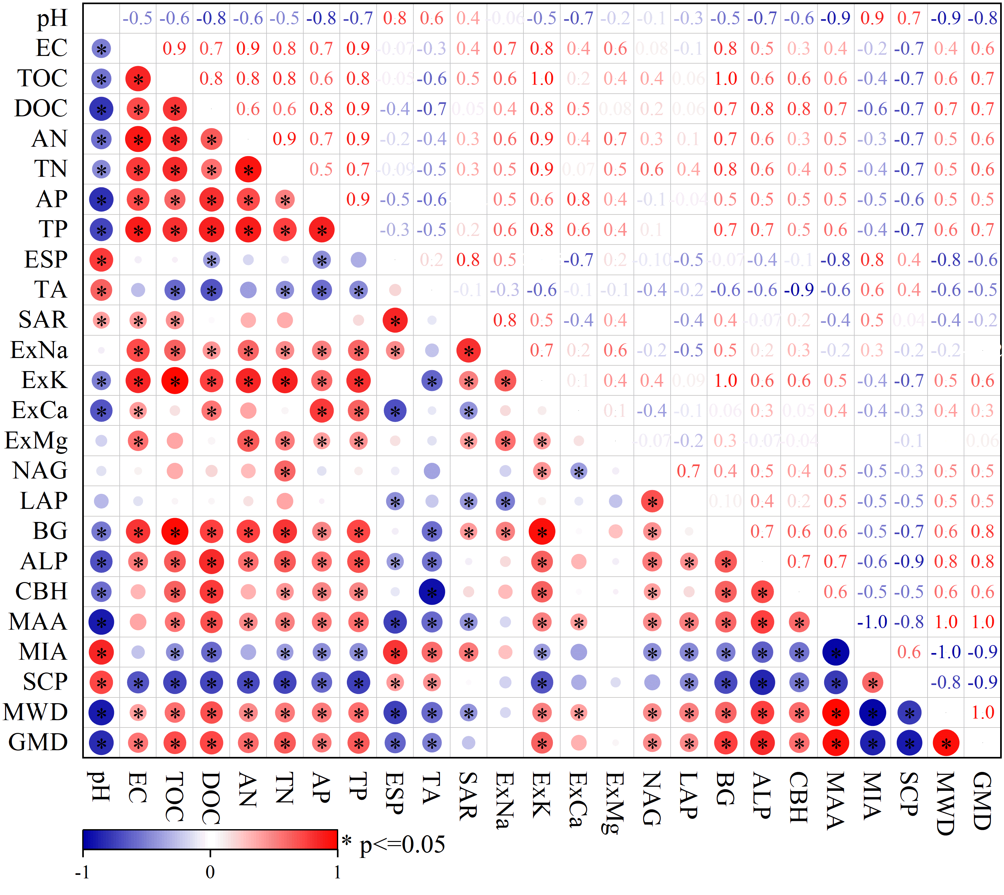
Fig. S3 Correlations among indicators of early soil-forming development in bauxite residue.

Table S3 Communality, weights, and W values of pedogenic quality indicators
Indicator | TDS |  |  | MDS
 | Community | Weight | W | Community | Weight | W
AN | 0.9754 | 0.0569 | 56.4153
EC | 0.9420 | 0.0552 | 54.7571 | 0.9420 | 0.2821 | 54.7571
TN | 0.9627 | 0.0518 | 51.3979
TP | 0.9561 | 0.0558 | 55.3067
Ex K | 0.9671 | 0.0495 | 49.0617
TOC | 0.9440 | 0.0497 | 49.2968
Ex Na | 0.9652 | 0.0535 | 53.0961
Ex Mg | 0.6244 | 0.0443 | 43.9011
BG | 0.8860 | 0.0459 | 45.5541
AP | 0.9142 | 0.0486 | 48.1799
SCP | 0.7981 | 0.0459 | 45.5087
SAR | 0.9914 | 0.0471 | 46.6866
ESP | 0.9710 | 0.0247 | 24.5346
pH | 0.9548 | 0.0397 | 39.3801 | 0.9548 | 0.2029 | 39.3801
MIA | 0.9005 | 0.0273 | 27.0833
MAA | 0.9614 | 0.0348 | 34.4753
MWD | 0.9646 | 0.0354 | 35.1282
Ex Ca | 0.9396 | 0.0334 | 33.1338
GWD | 0.9281 | 0.0418 | 41.4530 | 0.9281 | 0.0418 | 41.4530
CBH | 0.9584 | 0.0212 | 20.9897
TA | 0.7928 | 0.0227 | 22.4871
DOC | 0.9287 | 0.0435 | 43.0875 | 0.9287 | 0.2220 | 43.0875
ALP | 0.7801 | 0.0374 | 37.1274
NAG | 0.8696 | 0.0155 | 15.3991 | 0.8696 | 0.0155 | 15.3991
LAP | 0.7897 | 0.0183 | 18.1471
In the context of principal component analysis (PCA), the W value for each principal component is defined as the absolute value of its coefficient multiplied by the corresponding variance percentage. The weight of each principal component is calculated as the ratio of its W value to the total sum of all W values. The community of each variable refers to the sum of squared loadings of that variable across all retained principal components, representing the proportion of variance explained by these components.

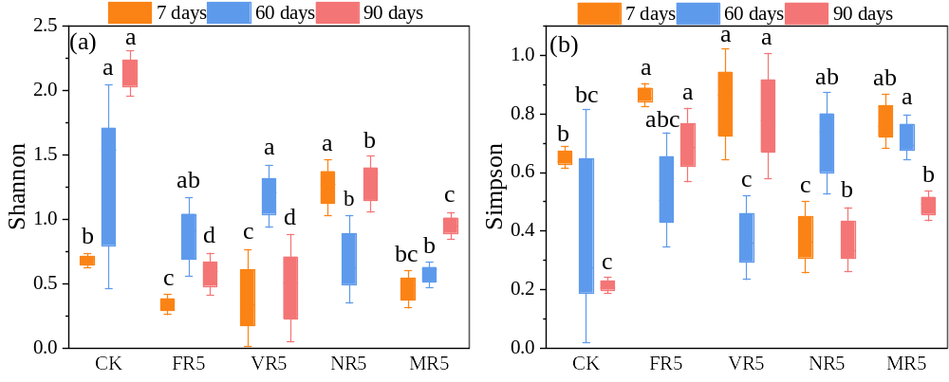
Fig. S4 Fungal α-diversity in bauxite residue. Different letters indicate significant differences among treatments (P < 0.05).

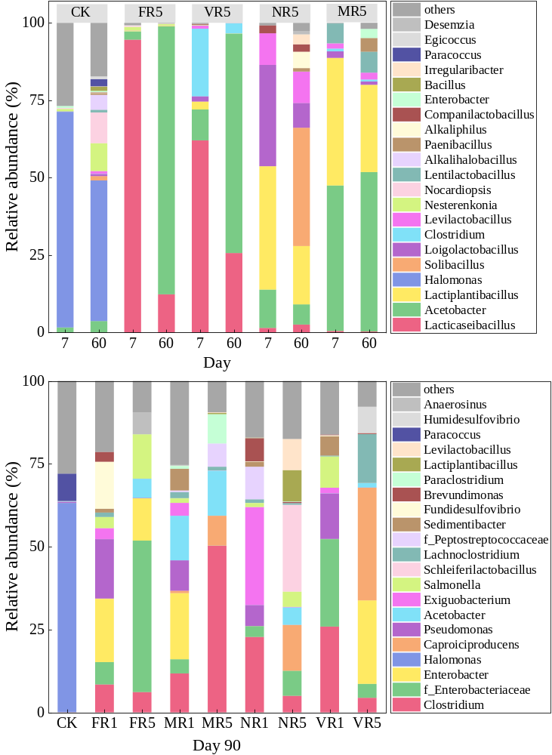
Fig. S5 Relative abundance of the most abundant bacterial taxa at the genus level in bauxite residue samples after different treatments for 7, 60, and 90 days.
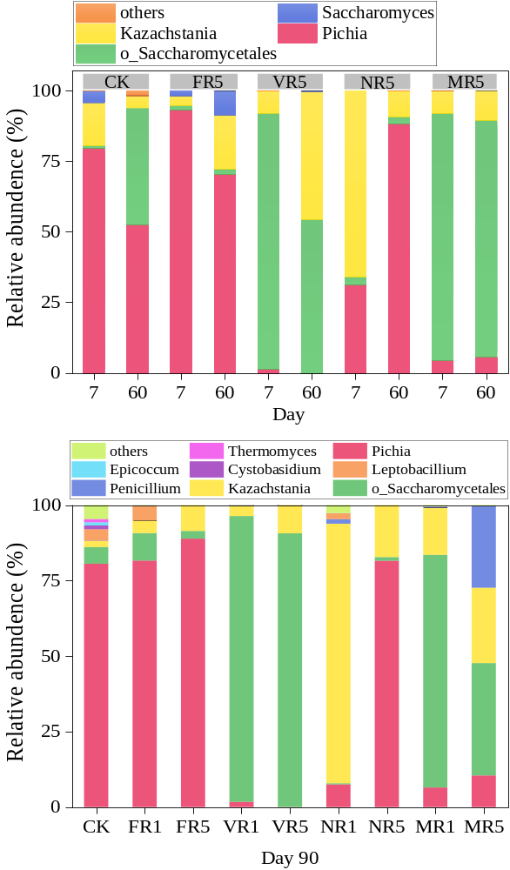
Fig. S6 Relative abundance of the most abundant fungal taxa at the genus level in bauxite residue samples after different treatments for 7, 60, and 90 days.

Table S4 Co-occurrence network parameters
 | Day 7 | Day 60 | Day 90
Nodes | 44 | 83 | 230
Edges | 212 | 691 | 5953
Average degree | 9.636 | 16.651 | 51.765
Average path length | 1.794 | 1.467 | 1.947
Network diameter | 4.703 | 3.709 | 5.069
Network density | 0.224 | 0.203 | 0.226
Clustering coefficient | 0.741 | 0.873 | 0.925
Modularity | 0.418 | 0.582 | 0.555
Positive number | 204 | 779 | 6430
Negative number | 80 | 30 | 355

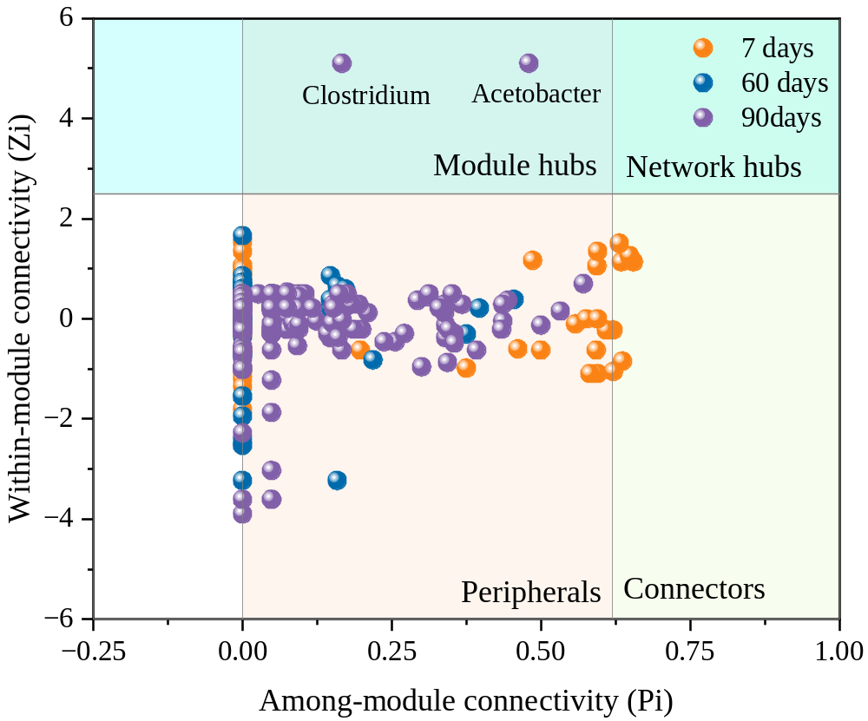
Fig. S7 Distributions of keystone taxa in bacteria co-occurrence networks.

References
Deshavath, N.N., Mukherjee, G., Goud, V.V., Veeranki, V.D., Sastri, C.V. 2020. Pitfalls in the 3, 5-dinitrosalicylic acid (DNS) assay for the reducing sugars: Interference of furfural and 5-hydroxymethylfurfural. International Journal of Biological Macromolecules, 156, 180-185.
Geerdink, R.B., Sebastiaan van den Hurk, R., Epema, O.J. 2017. Chemical oxygen demand: Historical perspectives and future challenges. Analytica Chimica Acta, 961, 1-11.
Gong, C., Zhang, H., Huo, S., Zhang, J., Weng, N., Li, W. 2025. Transformation processes of total suspended solids and dissolved organic matter in rivers: Influences of different land use sources and degradation processes. Science of The Total Environment, 963, 178509.
Greenfield, L.M., Puissant, J., Jones, D.L. 2021. Synthesis of methods used to assess soil protease activity. Soil Biology and Biochemistry, 158, 108277.
Liu, L., Qin, F., Sheng, Y., Li, L., Dong, X., Zhang, S., Shen, C. 2025. Soil quality evaluation and limiting factor analysis in different microtopographies of hilly and gully region based on minimum data set. CATENA, 254, 108973.
Matuschek, E., Svanberg, U. 2005. The effect of fruit extracts with polyphenol oxidase (PPO) activity on the in vitro accessibility of iron in high-tannin sorghum. Food Chemistry, 90(4), 765-771.
Prakash Jain, B., Pandey, S., Goswami, S.K. 2025. Chapter 87 - Superoxide Dismutase (SOD) Assay (Marklund et al., 1974). in: Protocols in Biochemistry and Clinical Biochemistry (Second Edition), (Eds.) B. Prakash Jain, S. Pandey, S.K. Goswami, Academic Press, pp. 223-224.
Singleton, V.L., Orthofer, R., Lamuela-Raventós, R.M. 1999. [14] Analysis of total phenols and other oxidation substrates and antioxidants by means of folin-ciocalteu reagent. in: Methods in Enzymology, Vol. 299, Academic Press, pp. 152-178.
Wen, R., Chai, X., Wang, P., Wu, K., Duan, X., Chen, J., Li, X. 2025. The structural characteristics of hydroxyl and galloyl groups determine the inhibitory activity of α-amylase in four catechin monomers. LWT, 222, 117624.

