Supplementary information

Speicies | Sample code | Voucher inst. | Gen. Mito. | Origine
Casinycteris Argynis | R08126 | MNHN | MN816300 | Central Africa Republic
Casinycteris Argynis | 2209 | NA | MN816299 | Gabon
Casinycteris Campomaanensis | C0741 | MNHN | MN816301 | Cameroon
Casinycteris Ophiodon | NW2455 (EBO0139) | Koch institut |  | Liberia
Casinycteris Ophiodon | T690 | SMF | MN816302 | Ivory Coast
Casinycteris Ophiodon | ZMB5001 | ZMB | MN816303 | Cameroon
Eidolon Helvum 1 | B001 (EBO0156) | Koch institut |  | Sierra Leone
Eidolon Helvum 2 | VN1176 (EBO0009) | MNHN |  | Guinea
Eonycteris Spelaea 1 | VN410 | NA | MN816309 | Vietnam
Eonycteris Spelaea 2 | JPH05 | NA | MN816308 | Thailand
Epomophorus Crypturus | K09378 | MNHN | MN816310 | DRC
Epomophorus Crypturus | T310 | NA | MN816311 | South Africa
Epomophorus Dobsonii | T674 | SMF | MN816324 | Malawi
Epomophorus Gambianus 1 | KAB27-2014 (EBO0010) | MNHN |  | Guinea
Epomophorus Gambianus 2 | MNG03 (EBO0148) | MNHN |  | Togo
Epomophorus Gambianus 3 | 3320 | MNHN | MN816312 | Senegal
Epomophorus Gambianus 4 | R085 | MNHN | MN816313 | Central Africa Republic
Epomophorus Labiatus | T273 | MNHN | MN816315 | Djibouty
Epomophorus Labiatus | T689 | SMF | MN816316 | Malawi
Epomophorus Minimus | K09222 | MNHN | MN816318 | DRC
Epomophorus Minor | T667 | FMNH | MN816319 | Tanzania
Epomophorus Pusillus 1 | KOR6 (EBO0018) | MNHN |  | Ivory Coast
Epomophorus Pusillus 2 | 1566 | NA | MN816332 | Gabon
Epomophorus Pusillus 3 | K0970 | MNHN | MN816333 | DRC
Epomophorus Wahlbergi | 187408 | FMNH | MN816322 | Tanzania
Epomophorus Wahlbergi | K09325 | MNHN | MN816321 | DRC
Epomophorus Wahlbergi | K0935 | MNHN | MN816317 | DRC
Epomops Buettikoferi 1 | VN1016 (EBO0012) | MNHN |  | Guinea
Epomops Buettikoferi 2 | LTO17 (EBO0013) | MNHN |  | Ivory Coast
Epomops Buettikoferi 3 | G093 | NA | MN816323 | Ivory Coast
Epomops Franqueti 1 | BA0429 (EBO0075) | MNHN |  | Central Africa Republic
Epomops Franqueti 2 | 1427 | NA / MNHN | MN816325 | Gabon
Hypsignathus Monstrosus 1 | LTO18 (EBO0015) | MNHN |  | Ivory Coast
Hypsignathus Monstrosus 2 | 1699 | NA | MN816326 | Gabon
Hypsignathus Monstrosus 3 | R24716 (EBO0096) | MNHN |  | Ivory Coast
Megaloglossus Azagnyi 1 | YAP3 (EBO0017) | MNHN |  | Ivory Coast
Megaloglossus Azagnyi 2 | GUI_031 (EBO0125) | Koch institut | MN816329 | Guinea
Megaloglossus Woermanni 1 | 1538 | NA | MN816330 | Gabon
Megaloglossus Woermanni 2 | T702 | SMF | MN816331 | DRC
Myonycteris Angolensis 1 | NC0559 (EBO0110) | Koch institut |  | Central Africa Republic
Myonycteris Angolensis 2 | GUI_074 (EBO0134) | Koch institut |  | Guinea
Myonycteris Angolensis 3 | G0935 | NA | MN816334 | Ivory Coast
Myonycteris Angolensis 4 | K09300 | MNHN | MN816335 | DRC
Myonycteris Brachycephala | T672 | ST | MN816336 | Sao Tomé
Myonycteris Leptodon 1 | Pon 28 (EBO0127) | Koch institut |  | Ivory Coast
Myonycteris Leptodon 2 | YAP7 (EBO0152) | Koch institut |  | Ivory Coast
Myonycteris Leptodon 3 | G0944 | NA | MN816337 | Ivory Coast
Myonycteris Relicta | T668 | FMNH | MN816338 | Tanzania
Myonycteris Torquata | 1732 | NA | MN816339 | Gabon
Nanonycteris Veldkampii 1 | GUI_002 (EBO0130) | Koch institut |  | Guinea
Nanonycteris Veldkampii 2 | LTO47 (EBO0155) | MNHN |  | Ivory Coast
Nanonycteris Veldkampii 3 | T180 | NA | MN816340 | Central Africa Republic
Nanonycteris Veldkampii 4 | G0939 | NA | MN816341 | Ivory Coast
Nyctimene Cephalotes | 180810X3 | NA | MN816342 | NA
Plerotes Anchietae | K09279 | MHNH | MN816343 | DRC
Pteropus Alecto | NA | NA | KF726143
Pteropus Vampyrus | NA | NA | KP214033
Rousettus Aegyptiacus 1 | NW1878 (EBO0146) | Koch institut |  | Republic Congo
Rousettus Aegyptiacus 2 | T2219 | MHNG | MN816351 | Malawi
Rousettus Aegyptiacus 3 | T2209 | NA | MN816350 | Egypt
Rousettus Aegyptiacus 4 | T2206 | MHNG | MN816349 | Cyprus
Rousettus Aegyptiacus 5 | K09236 | MNHN | MN816347 | DRC
Rousettus Aegyptiacus 6 | 1412 | NA | MN816345 | Gabon
Rousettus Aegyptiacus 7 | K09235 | MNHN | MN816346 | DRC
Rousettus Aegyptiacus 8 | T246 | NA | MN816348 | Senegal
Rousettus Amplexicaudatus | DSB8558 | Prague Uni. | NC_045044 | Philippines
Rousettus Amplexicaudatus | CKM76 | NA | MN816352 | Cambodia
Rousettus Amplexicaudatus | VN1368 / NA | NA | MN816353 | Vietnam
Rousettus Leschenaultii | CKM109 | NA | MN816354 | Cambodia
Rousettus Leschenaultii | VN1368 |  | MN816355 | Vietnam
Rousettus Madagascariensis 1 | T2204 | UADBA | MN816356 | Madagascar
Rousettus Madagascariensis 2 | T2205 | UADBA | MN816357 | Madagascar
Rousettus Oblivious 1 | T2199 | FMNH | MN816358 | Madagascar
Rousettus Oblivious 2 | T2202 | FMNH | MN816359 | Madagascar
Scotonycteris Bergmansi | NW1900 | Koch institut |  | Republic Congo
Scotonycteris Bergmansi | F149402 | FMNH | MN816361 | DRC
Scotonycteris Bergmansi | 1337 | NA | MN816360 | Gabon
Scotonycteris Occidentalis |  |  | MN816362 | Sierra Leone
Scotonycteris Zenkeri | ZM2011-682 | MNHN | MN816363 | Cameroun
Stenonycteris Lonosus | 151178 | FMNH | MN816365 | Tanzania
Outgroup
Hipposideros Armiger |  |  | JN980966
Rhinolophus Ferrumequinum |  |  | CM016610

Supplementary table 1: Specimens sequenced and used for phylogenetic trees based on mitochondrial analyses in this study. In grey, mitochondrial genomes added in the literature.
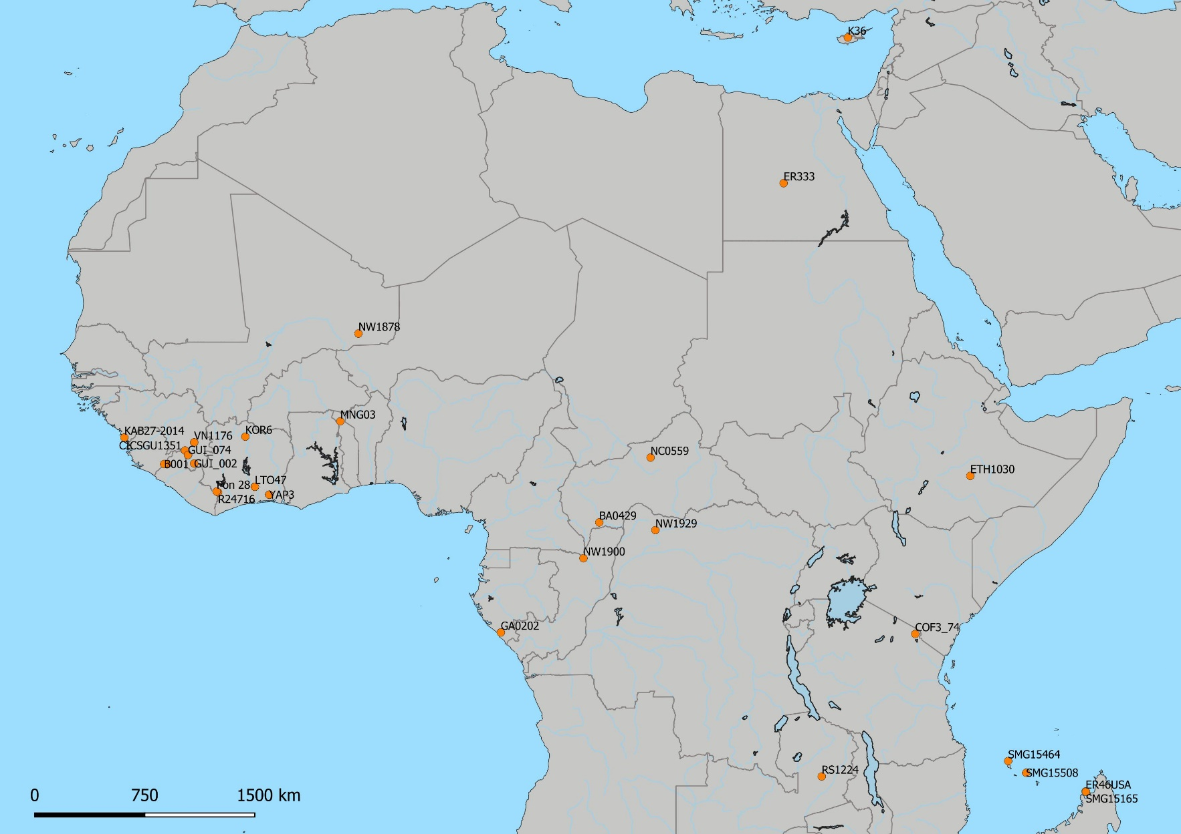

Supplementary Figure 1: Location of the specimens added in this study (n=33).
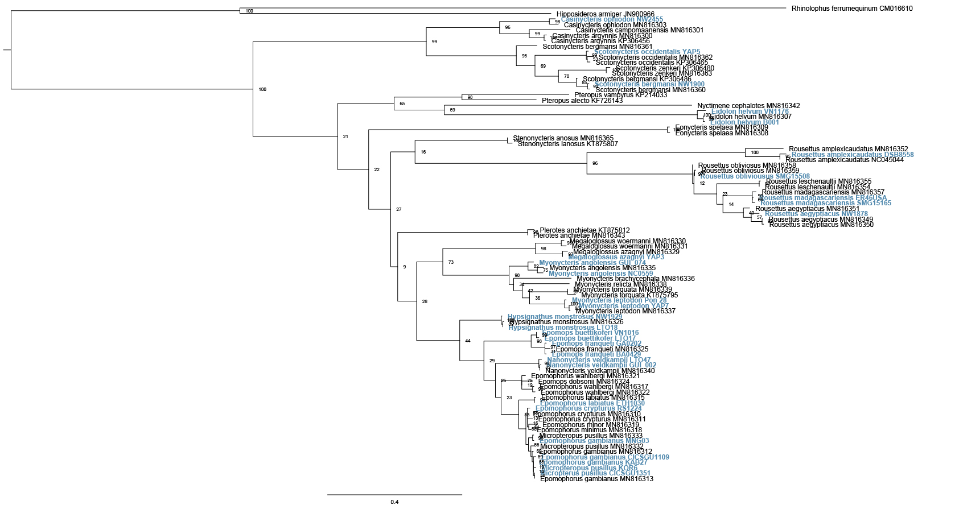
Supplementary Figure 2: Phylogenetic tree based on Cytb fragment under ML method (RaxML). New specimens added in this study are indicated in bleu.

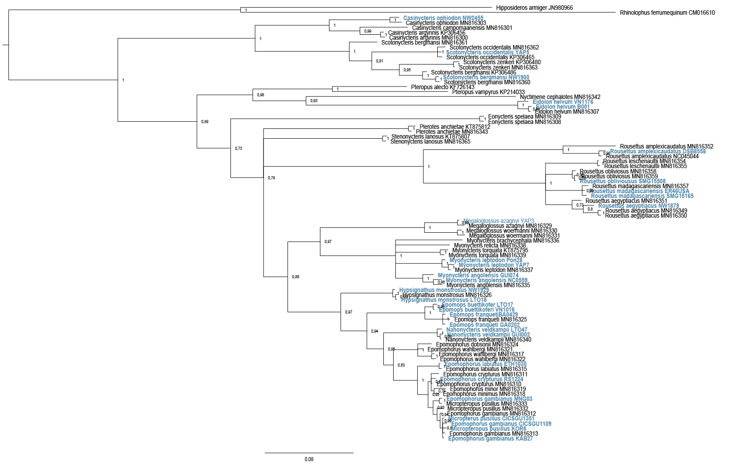
Supplementary Figure 3: Phylogenetic tree based on Cytb fragment under BI method (Mrbayes). New specimens added in this study are indicated in bleu.
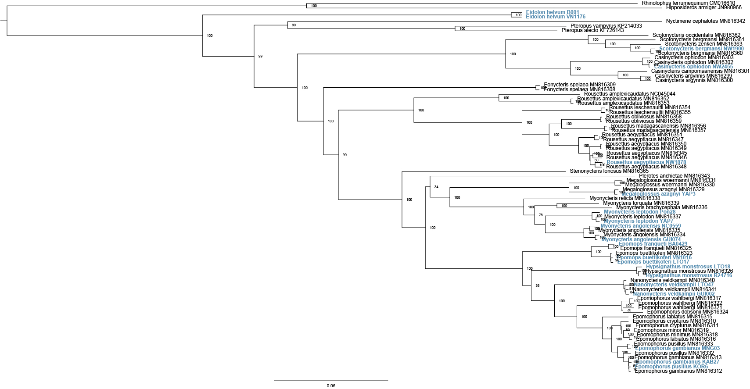
Supplementary Figure 4: Phylogenetic tree based on full mitochondrial genome minus de control region under ML method (RaxML). New specimens added in this study are indicated in bold (N = 20).

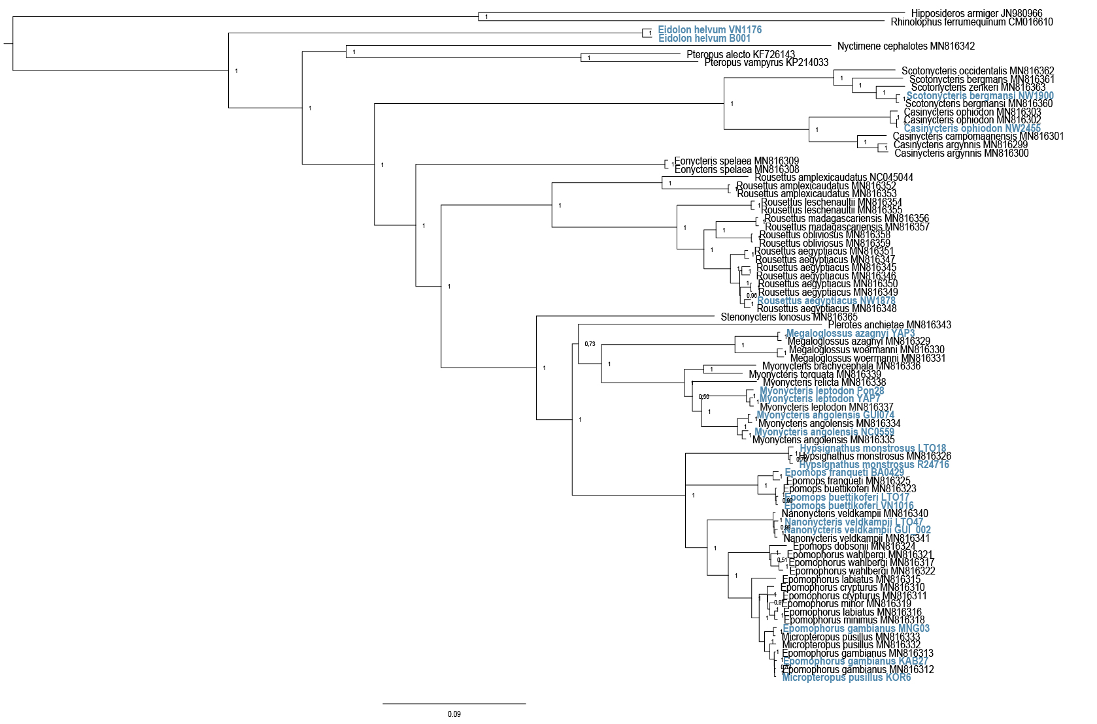
Supplementary Figure 5: Phylogenetic tree based on full mitochondrial genome minus de control region under BI method (Mrbayes). New specimens added in this study are indicated in bold (N = 20).
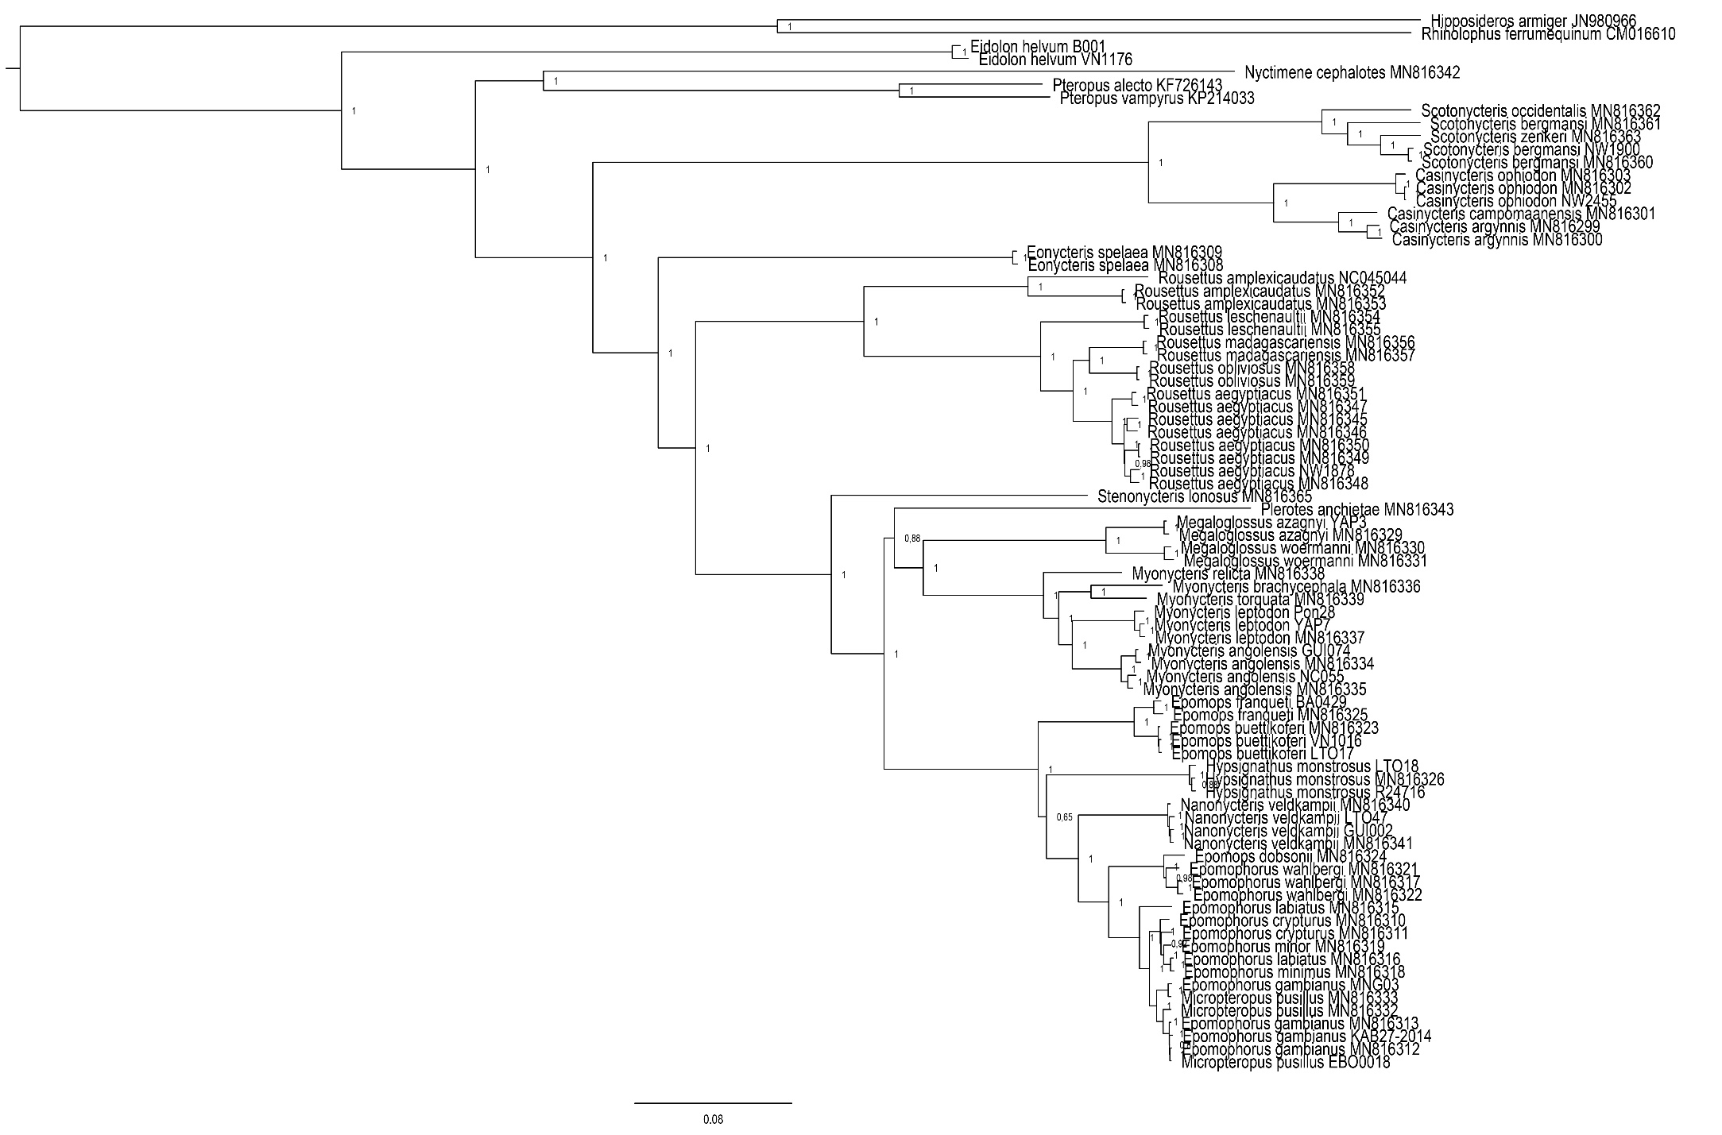

Supplementary Figure 6: Phylogenetic tree of mitochondrial genome based on the PCGs and the rRNAs under BI method (Mrbayes).
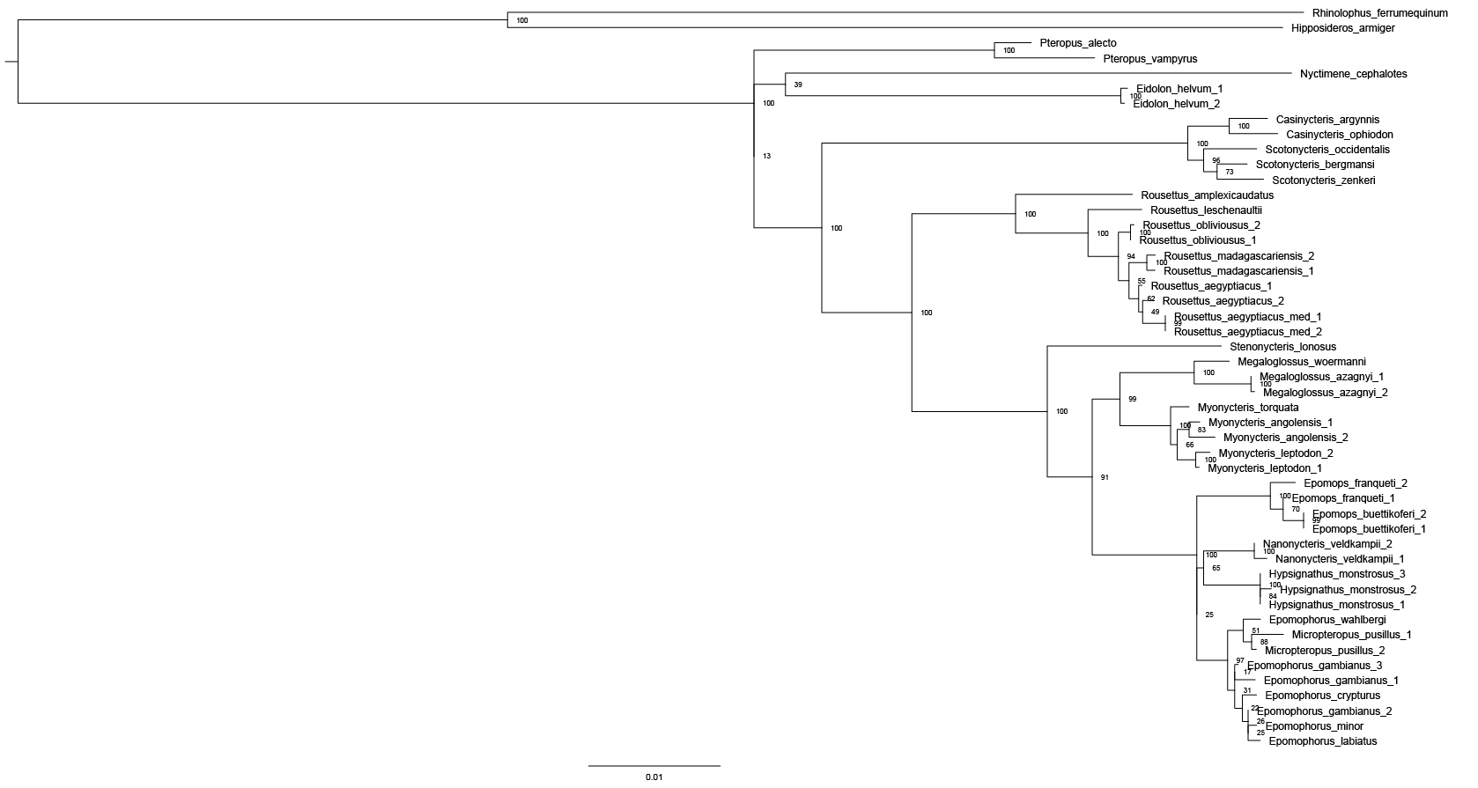

Supplementary Figure 7: Phylogenetic tree based on the concatenation of nuclear markers (BRCA1, FGB, RAG1, RAG2 and vWF) under ML method (RaxML).

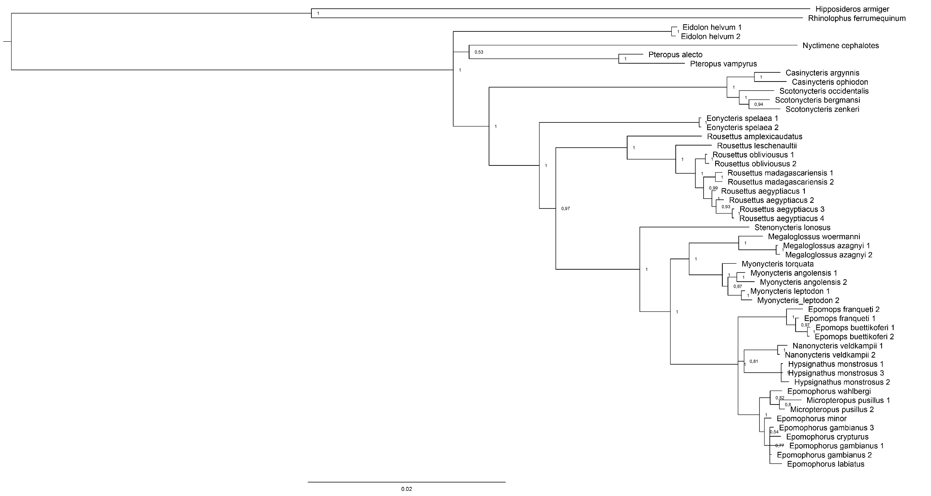
Supplementary Figure 8: Phylogenetic tree based on the concatenation of nuclear markers (BRCA1, FGB, RAG1, RAG2 and vWF) under BI method (Mrbayes).

Supplementary Figure 9: Phylogenetic tree based on the concatenation of the mitochondrial PCGs, the rRNA and nuclear markers (BRCA1, FGB, RAG1, RAG2 and vWF) under BI method (Mrbayes).
