Appendix
Table A1. Survey questions from the Cat Homing Behaviour Survey
Q | Question | Response type | Response options / scale
1 | Which best describes your cat at the time s/he went missing? | Multiple choice (select one) | Indoor-only cat (never been outside)  Indoor-only cat (some outside experience e.g. on-leash, in enclosure, or previous outdoor experience)  Outdoor-access cat (allowed outside unsupervised)  Outdoor-only cat (feral or barn cat)  Other (specify)
2 | Under what circumstances did your cat become lost? | Multiple choice (select one) | Recently moved and s/he went missing from new home  Lost in transit (e.g. from a car or airport)  Lost from a location away from home (e.g. vet's office, friend's house, while camping)  Accidentally or intentionally transported out of the area (e.g. climbed into a moving van)  Recently adopted and went missing from your home/yard  Other (specify)
3 | Where was your cat found? | Multiple choice (select one) | Returned home  Returned to a previous home  Other (specify)
4 | How long was your cat missing? | Open text (numeric) | Free text (duration)
5 | If possible, please provide an address (or intersection or nearby landmark) for the START and END of your cat's homing journey. Please include city, state/province, and country. Your address will remain confidential. | Open text | Free text (start address)  Free text (end address)
6 | How far did your cat travel? Please indicate whether this is straight-line distance, estimated distance actually travelled or distance by road. (You can skip if you answered Question 5) | Open text (numeric) | Free text (distance + unit)
7 | Is it likely that your cat travelled through or over any of the following? | Multiple choice (select all that apply) | Urban area (city)  Suburban area  Rural area (country)  Two-lane highway  Four-lane (or more) highway  Stream or river  Other (specify)
8 | How old was your cat at the time s/he went missing? | Multiple choice (select one) | Kitten (up to 6 months)  Young Adult (7 months to 2 years)  Adult (3 years to 10 years)  Senior (11 years to 15 years)  Advanced Senior (more than 15 years)
9 | Was your cat spayed or neutered when s/he went missing? | Multiple choice (select one) | Spayed Female  Unspayed Female  Neutered Male  Unneutered Male
10 | How old was your cat when you adopted him/her? | Open text (numeric) | Free text (age at adoption)
11 | How familiar was your cat with the location that s/he travelled back to? | Multiple choice (select one) | Not very familiar - lived there less than 1 month  Somewhat familiar - lived there less than 1 year  Familiar - lived there for several years (2-4 years)  Very familiar - lived there for many years (more than 5 years)  Other (specify)
12 | How would you rate your cat's personality, especially in response to strangers visiting your home? | Rating scale (1-5) | 1 - shy  2  3  4  5 - bold
13 | How does your cat behave in unfamiliar surroundings such as at the vet's office? For an escaped indoor-only cat, indicate how they behave when outdoors, if known. | Rating scale (1-5 + Unknown) | 1 - shy  2  3  4  5 - bold  Unknown

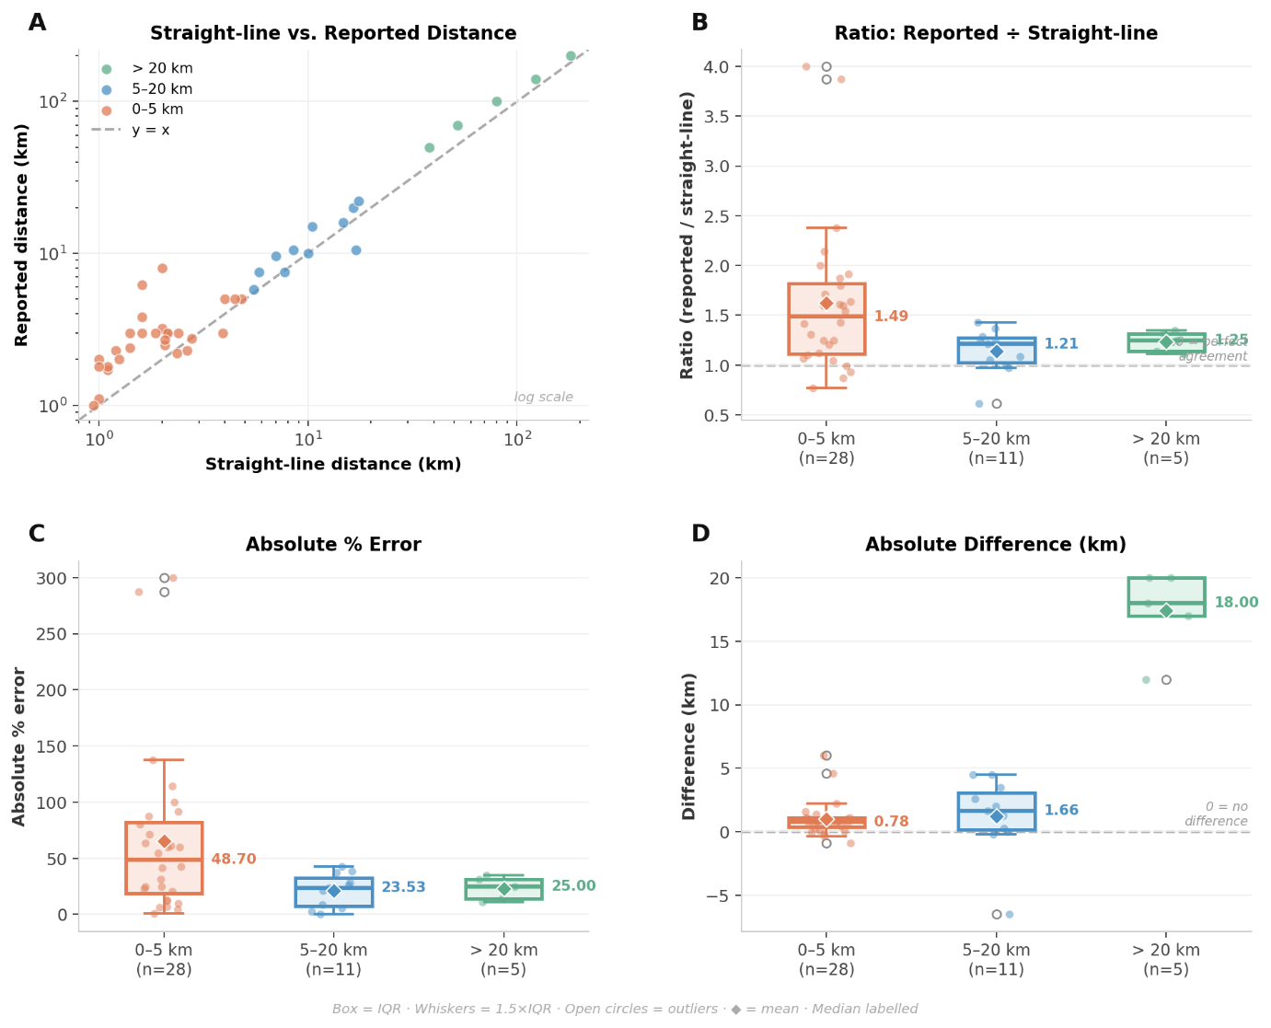
Figure A2. Comparison of owner-reported and straight-line (mapped) homing distances across three distance categories (0–5 km, n = 28; 5–20 km, n = 11; > 20 km, n = 5). (A) Log-scale scatter plot of straight-line against owner-reported distance; the dashed line indicates perfect agreement (y = x). Points above the line indicate over-reporting. (B) Ratio of reported to straight-line distance per category; the dashed reference line at 1.0 indicates perfect agreement. (C) Absolute percentage error (|reported − straight-line| / straight-line × 100) per category. (D) Absolute difference between reported and straight-line distance (km) per category; the dashed line at zero indicates no difference. In panels B–D, boxes represent the interquartile range (IQR), horizontal lines the median (labelled), whiskers extend to 1.5 × IQR, open circles denote outliers, and diamonds indicate the mean. Colours denote distance category: orange = 0–5 km, blue = 5–20 km, green = > 20 km

Table A3. GAMLSS model results for homing distance, time, and velocity
 |  | Distance (km) |  |  |  | Time (days) |  |  |  | Velocity (km/day)
Predictor |  | Inverse Gaussian |  |  |  | Log-Logistic |  |  |  | Log-Logistic
 |  | β (SE) | 95% CI | p | Ratio | β (SE) | 95% CI | p | Ratio | β (SE) | 95% CI | p | Ratio
Current age
Adult (reference) |  | — | — | — | 1.00 | — | — | — | 1.00 | — | — | — | 1.00
Young adult |  | 0.18 (0.25) | -0.31, 0.68 | 0.467 | 1.20 | 0.03 (0.30) | -0.56, 0.61 | 0.927 | 1.03 | -0.05 (0.24) | -0.52, 0.43 | 0.841 | 0.95
Senior |  | -0.32 (0.49) | -1.27, 0.64 | 0.514 | 0.73 | -0.03 (0.53) | -1.06, 1.00 | 0.958 | 0.97 | -0.07 (0.48) | -1.02, 0.87 | 0.882 | 0.93
Kitten |  | -0.34 (0.65) | -1.61, 0.93 | 0.603 | 0.71 | 0.78 (1.08) | -1.33, 2.89 | 0.469 | 2.18 | -1.06 (0.92) | -2.86, 0.73 | 0.245 | 0.35
Age at adoption
Kitten (reference) |  | — | — | — | 1.00 | — | — | — | 1.00 | — | — | — | 1.00
Young adult |  | -0.17 (0.38) | -0.91, 0.57 | 0.648 | 0.84 | -0.02 (0.37) | -0.75, 0.70 | 0.953 | 0.98 | 0.15 (0.32) | -0.48, 0.77 | 0.640 | 1.16
Adult |  | -0.10 (0.40) | -0.88, 0.68 | 0.810 | 0.91 | -0.40 (0.41) | -1.20, 0.40 | 0.330 | 0.67 | 0.32 (0.34) | -0.34, 0.99 | 0.343 | 1.38
Feral |  | 0.32 (0.58) | -0.81, 1.45 | 0.578 | 1.38 | -0.02 (0.48) | -0.95, 0.92 | 0.973 | 0.98 | 0.43 (0.41) | -0.38, 1.25 | 0.296 | 1.54
Continuous predictors
Familiarity |  | 0.09 (0.23) | -0.36, 0.54 | 0.694 | 1.09 | 0.20 (0.17) | -0.14, 0.53 | 0.250 | 1.22 | -0.13 (0.14) | -0.41, 0.15 | 0.351 | 0.88
Boldness |  | 0.00 (0.11) | -0.21, 0.22 | 0.972 | 1.00 | -0.24 (0.09)****** | -0.42, -0.07 | 0.006****** | 0.78 | 0.25 (0.07)****** | 0.11, 0.40 | 0.001****** | 1.29
Outdoor access type
Outdoor access (reference) |  | — | — | — | 1.00 | — | — | — | 1.00 | — | — | — | 1.00
Indoor only |  | 0.03 (0.50) | -0.95, 1.02 | 0.946 | 1.03 | 0.74 (0.57) | -0.38, 1.86 | 0.194 | 2.10 | -0.20 (0.54) | -1.25, 0.84 | 0.701 | 0.81
Outdoor only |  | -0.52 (0.35) | -1.21, 0.17 | 0.142 | 0.60 | -0.39 (0.31) | -1.00, 0.21 | 0.205 | 0.68 | 0.45 (0.25) | -0.04, 0.95 | 0.073 | 1.57
β = log-scale coefficient; SE = standard error; 95% CI = 95% confidence interval; Ratio = multiplicative effect (exp(β)) relative to reference category or per unit increase for continuous predictors. Highlighted rows (yellow) indicate p < 0.05. Significance codes: ***p < 0.001, **p < 0.01, *p < 0.05.

Table A4. Descriptive statistics of homing outcomes in domestic cats by categorical predictor
Predictor | Level | n | Distance mean (km) | Distance median (km) | Days lost mean | Days lost median | Velocity mean (km/day) | Velocity median (km/day)
Current age
 | Adult | 99 | 9.32 | 4.44 | 29.19 | 5.00 | 1.69 | 0.81
 | Young adult | 60 | 12.95 | 4.23 | 52.66 | 5.00 | 1.89 | 0.89
 | Senior | 9 | 7.21 | 4.83 | 18.00 | 7.00 | 1.43 | 0.69
 | Kitten | 3 | 5.64 | 5.64 | 153.33 | 6.00 | 0.45 | 0.40
Age at adoption
 | Kitten | 122 | 11.33 | 4.03 | 48.02 | 7.00 | 1.51 | 0.79
 | Young adult | 18 | 9.10 | 4.11 | 9.37 | 5.50 | 1.63 | 0.83
 | Adult | 16 | 6.27 | 4.56 | 17.81 | 4.50 | 1.17 | 0.97
 | Feral | 15 | 9.04 | 6.76 | 23.97 | 4.00 | 4.11 | 1.71
Outdoor access type
 | Outdoor access | 114 | 11.60 | 3.95 | 42.69 | 6.00 | 1.73 | 0.81
 | Indoor only | 9 | 12.24 | 6.44 | 110.56 | 15.00 | 1.54 | 0.93
 | Outdoor only | 48 | 7.26 | 5.23 | 16.87 | 5.00 | 1.74 | 1.05

