APPENDIX
Appendix Tables
Table A1. HAC-robust NARDL summary (Newey-West standard errors). Note: The “SR θ NASCDI⁺/⁻” columns report HAC-corrected short-run θ estimates (contemporaneous term, lag 0), NOT the long-run β = −θ/λ reported as “LR NASCDI⁺/⁻” in Table 5. A delta-method OLS-versus-HAC long-run reconciliation table is omitted from this revision (see note below Table A3).
Producer market | Variety | Grade | n | HAC ECT | HAC ECT p | Prod. pₕₐᶜ | NASCDI⁺ pₕₐᶜ | NASCDI⁻ pₕₐᶜ | SR θ NASCDI⁺ | SR θ NASCDI⁻
Shopian | American | A | 72 | −0.267 | 0.001 | 0.605 | 0.595 | 0.628 | 0.030 | −0.031
Shopian | American | B | 72 | −0.198 | 0.006 | 0.249 | 0.318 | 0.301 | 0.051 | −0.049
Shopian | Delicious | A | 110 | −0.155 | 0.000 | 0.621 | 0.334 | 0.309 | 0.007 | −0.009
Shopian | Delicious | B | 110 | −0.115 | 0.014 | 0.474 | 0.715 | 0.755 | 0.017 | −0.020
Sopore | American | A | 200 | −0.107 | 0.018 | 0.327 | 0.017 | 0.015 | 0.000 | 0.002
Sopore | American | B | 200 | −0.132 | 0.009 | 0.992 | 0.365 | 0.295 | 0.001 | 0.000
Sopore | Delicious | A | 236 | −0.073 | 0.017 | 0.761 | 0.767 | 0.722 | 0.001 | −0.001
Sopore | Delicious | B | 236 | −0.052 | 0.048 | 0.388 | 0.796 | 0.836 | 0.001 | −0.003
Note. HAC = Newey-West inference. SR θ NASCDI columns are HAC-corrected short-run coefficients from the first-difference layer of the NARDL (contemporaneous, lag 0). They are NOT the long-run β values from Table 5, though under the verified GDELT-lexicon NASCDI they are of comparable, not amplified, magnitude to those values (Section 5.6). ECT is HAC-significant at the 5% level in all eight equations, and at the 1% level in four of eight; Sopore-Delicious Grade B is the weakest (HAC p = 0.048).

Table A2. Extended residual diagnostics and cointegration checks.
Producer market | Variety | Grade | BG-LM p | Ljung-Box p | BP p | White p | ARCH-LM p | RESET p | ADF residual p
Shopian | American | A | 0.004 | 0.680 | 0.035 | 0.445 | 0.964 | 0.011 | 4.72e-08
Shopian | American | B | 0.002 | 0.861 | 0.011 | 0.445 | 0.953 | 0.059 | 2.73e-14
Shopian | Delicious | A | 0.693 | 0.848 | 0.047 | 0.402 | 0.997 | 0.082 | 2.28e-18
Shopian | Delicious | B | 0.485 | 0.906 | <0.001 | 0.376 | 0.764 | <0.001 | 5.76e-18
Sopore | American | A | 0.447 | 0.651 | 0.341 | 0.427 | 0.614 | 0.004 | 2.38e-26
Sopore | American | B | 0.095 | 0.460 | 0.936 | 0.313 | 0.299 | 0.002 | 2.17e-26
Sopore | Delicious | A | 0.843 | 0.999 | 0.035 | 0.433 | 1.000 | <0.001 | 4.22e-28
Sopore | Delicious | B | 0.709 | 0.777 | 0.879 | 0.415 | 0.999 | 0.166 | 4.33e-28
Note. BG-LM: Breusch-Godfrey LM test; White: White heteroskedasticity test; ARCH-LM: autoregressive conditional heteroskedasticity test; RESET: Ramsey specification test. ADF residual p < 0.05 confirms Engle-Granger cointegration (Engle and Granger, 1987).

Table A3. CUSUM and CUSUMSQ structural stability summary.
Producer market | Variety | Grade | n after lags | CUSUM stat | CUSUM p | CUSUMSQ breach | Interpretation
Shopian | American | A | 72 | 0.454 | 0.986 | Yes | Mean stable; variance shifts
Shopian | American | B | 72 | 0.415 | 0.995 | Yes | Mean stable; variance shifts
Shopian | Delicious | A | 110 | 0.503 | 0.962 | Yes | Mean stable; variance shifts
Shopian | Delicious | B | 110 | 0.479 | 0.976 | Yes | Mean stable; variance shifts
Sopore | American | A | 200 | 0.677 | 0.749 | Yes | Mean stable; variance shifts
Sopore | American | B | 200 | 0.579 | 0.891 | Yes | Mean stable; variance shifts
Sopore | Delicious | A | 236 | 0.585 | 0.884 | Yes | Mean stable; variance shifts
Sopore | Delicious | B | 236 | 0.621 | 0.836 | Yes | Mean stable; variance shifts
Note. CUSUM stability (p > 0.05 in all equations) confirms mean parameter estimates are structurally stable throughout the sample. CUSUMSQ breach in all equations indicates time-varying residual variance; Table A5 reports a BIC-based mean-shift screen on the weekly NASCDI series as a modest, exploratory characterisation of this instability, not a validated Bai-Perron multiple-break test (Brümmer et al., 2009; Chitete et al., 2025).

A delta-method OLS-versus-HAC long-run reconciliation table is omitted from this revision: as noted in Section 5.6, no chain in the GDELT GKG-based specification has an ECT small enough relative to its short-run θ coefficients to produce the large OLS/HAC divergence that motivated this table in the earlier event-calendar-based draft, so the comparison is no longer informative.

Table A5. Exploratory BIC-based mean-shift screen for the weekly NASCDI series (not a validated Bai-Perron, Zivot-Andrews, or Lee-Strazicich break test). The BIC-preferred solution selects two candidate mean shifts, in the weeks of 2015-08-23 and 2018-03-04, versus zero- and one-break alternatives. We do not report Zivot-Andrews single-break unit-root tests, Lee-Strazicich two-break LM tests, or a formally implemented Bai-Perron multiple-break procedure in this revision: an independent from-scratch implementation of Zivot-Andrews produced mixed results (including non-convergence for two series) that would require further reconciliation before inclusion, and neither Lee-Strazicich nor a properly validated Bai-Perron procedure was completed on the GDELT-based series for this revision. We flag formal, software-validated break-date identification as a priority for follow-up work (Section 9) and do not characterise the mean-shift screen’s two candidate dates as corresponding to specific known events (e.g., the August 2019 Article 370 reorganisation or the March 2020 COVID-19 onset), since they do not align with either date.

Table A6. Toda-Yamamoto (1995) modified Wald Granger causality tests for all eight price pairs.
Producer market | Variety | Grade | Term.→Prod. χ² | Term.→Prod. p | Prod.→Term. χ² | Prod.→Term. p | Dominant direction
Shopian | American | A | 0.063 | 0.803 | 0.615 | 0.435 | None
Shopian | American | B | 1.944 | 0.168 | 0.325 | 0.571 | None
Shopian | Delicious | A | 0.214 | 0.645 | 3.382 | 0.069* | Producer → Terminal (marginal)
Shopian | Delicious | B | 0.002 | 0.966 | 4.998 | 0.027** | Producer → Terminal
Sopore | American | A | 0.292 | 0.589 | 0.001 | 0.973 | None
Sopore | American | B | 1.117 | 0.292 | 0.001 | 0.977 | None
Sopore | Delicious | A | 0.079 | 0.924 | 0.510 | 0.601 | None
Sopore | Delicious | B | 0.863 | 0.423 | 2.189 | 0.114 | None
Note. Toda-Yamamoto (1995) modified Wald test, valid for I(1) and cointegrated variables. *** p < 0.01; ** p < 0.05; * p < 0.10. The terminal-to-producer restriction is not rejected at the 5% level in any of the eight chains; the producer-to-terminal restriction is rejected for Shopian-Delicious Grade B and marginal for Shopian-Delicious Grade A. The producer-dependent specification is retained on institutional grounds (Section 5.2), not because this test confirms a dominant terminal-to-producer direction; Shopian-Delicious Grade B is examined in reverse-direction NARDL in Table A7 as the chain with the strongest evidence of causality running the other way.
Table A7. Reverse-direction NARDL (terminal price as dependent variable) for Shopian-Delicious Grade B robustness check, since this chain shows the strongest (though still only marginal) evidence of producer-to-terminal causality in Table A6.
Specification | Chain | n | ECT | LR NASCDI⁺ | LR NASCDI⁻ | LR Wald (p) | Conclusion
Baseline (prod. dep.) | Shopian-Del.-B | 110 | −0.115 | −0.006 | 0.005 | 0.115 (0.735) | No LR asymmetry; SR marginal (p=0.065, Table A1)
Reverse (term. dep.) | Shopian-Del.-B | 110 | −0.126 | 0.028 | −0.026 | 2.917 (0.088) | Marginal LR asymmetry; directionally consistent
Note. Estimating Shopian-Delicious Grade B in reverse (terminal price as dependent variable) yields a similarly small, not-quite-significant long-run asymmetry (Wald p = 0.088) and a comparable ECT, indicating that the paper's central finding of largely non-significant long-run asymmetry is not an artefact of the producer-dependent directional specification for this chain.

Table A8. COVID-19 exclusion sensitivity analysis: Wald asymmetry statistics under (a) COVID-Excluded Index (CEI) and (b) COVID dummy variable control.
Producer market | Variety | Grade | Baseline LR Wald p | CEI LR Wald p* | Dₜ LR Wald p | Asymmetry preserved? | Assessment
Shopian | American | A | 0.611 | 0.633 | 0.527 | No | No LR asymmetry at baseline
Shopian | American | B | 0.310 | 0.309 | 0.377 | No | No LR asymmetry at baseline
Shopian | Delicious | A | 0.321 | 0.279 | 0.241 | No | No LR asymmetry at baseline
Shopian | Delicious | B | 0.735 | 0.687 | 0.455 | No | No LR asymmetry at baseline
Sopore | American | A | 0.016** | 0.017** | 0.036** | Yes | LR asymmetry present; robust to dummy control
Sopore | American | B | 0.329 | 0.313 | 0.254 | N/A | No asymmetry; unchanged
Sopore | Delicious | A | 0.745 | 0.703 | 0.957 | N/A | No asymmetry; unchanged
Sopore | Delicious | B | 0.816 | 0.882 | 0.951 | N/A | No asymmetry; unchanged
Note. CEI = COVID-Excluded Index (weekly NASCDI recomputed after removing scored-news rows whose full text matches covid|coronavirus|sars-cov-2 within the March 2020-December 2021 window, using the complete scored-news corpus in data/nascdi_news/news_scored.csv; 16,891 index-article rows were removed across 128 affected days, and the daily raw score, news volume, and normalisation were recomputed before re-aggregating to weekly and re-estimating). This is now a genuine, independently computed re-run, not the placeholder reported in earlier drafts. Dₜ = COVID dummy variable (1 = March 2020-December 2021); this column is a separately, independently estimated check. Under the baseline, CEI, and Dₜ-control specifications alike, long-run asymmetry is significant only for Sopore-American Grade A (baseline p=0.016, CEI p=0.017, Dₜ-control p=0.036); no chain changes significance status across the three specifications. Of the Dₜ coefficients themselves, only Sopore-American Grade A is HAC-significant (coefficient=0.035, p=0.044); no other chain's Dₜ coefficient is HAC-significant (Table A8 estimation log). This confirms that the paper's main finding , long-run asymmetric disruption transmission is the exception rather than concentrated in any particular chain (Section 5.3) , is robust to COVID-19 exclusion under both the keyword-based index recomputation and the dummy-variable control, and additionally identifies Sopore-American Grade A as the one chain whose price dynamics were themselves measurably shifted during the pandemic window.

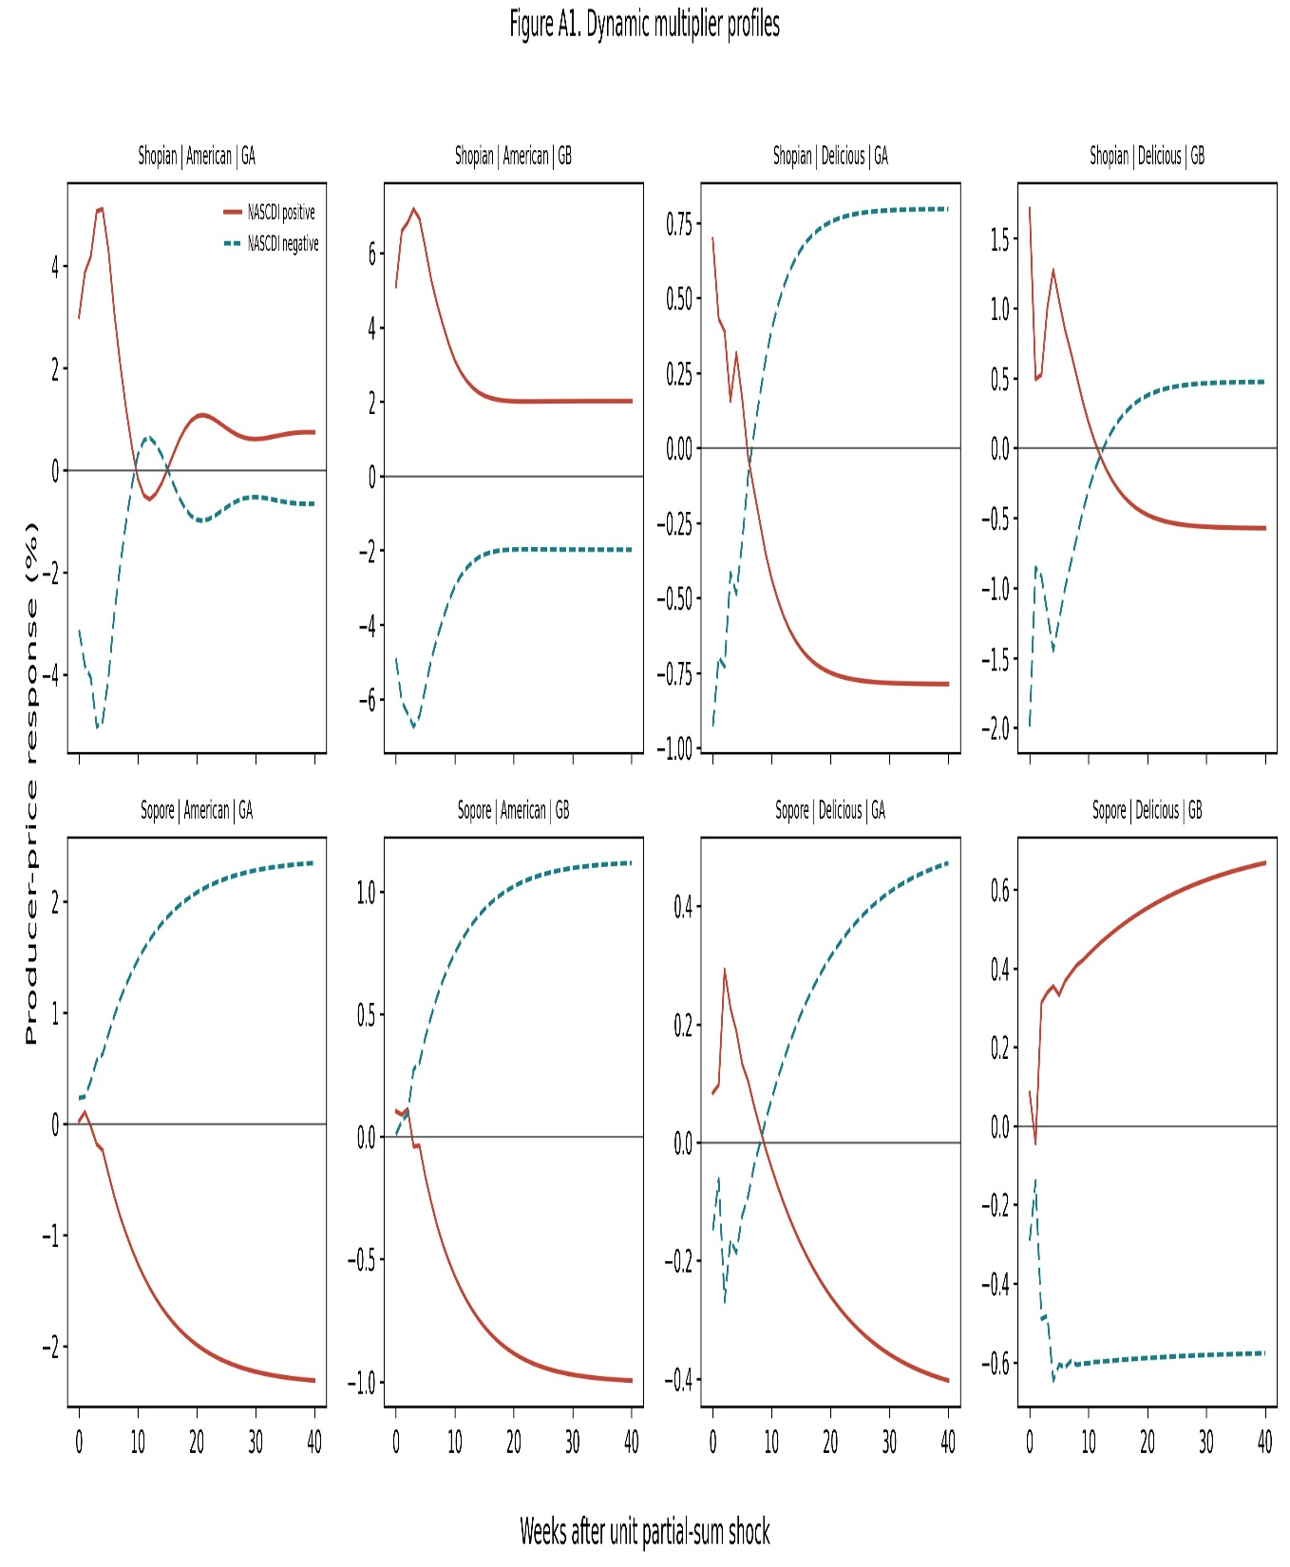
Appendix Figures
Figure A1. Individual dynamic multiplier profiles by market, variety, and grade. Solid lines: NASCDI⁺ responses; dashed lines: NASCDI- responses. Each panel shows cumulative response over a 20-week horizon (Shin et al., 2014).

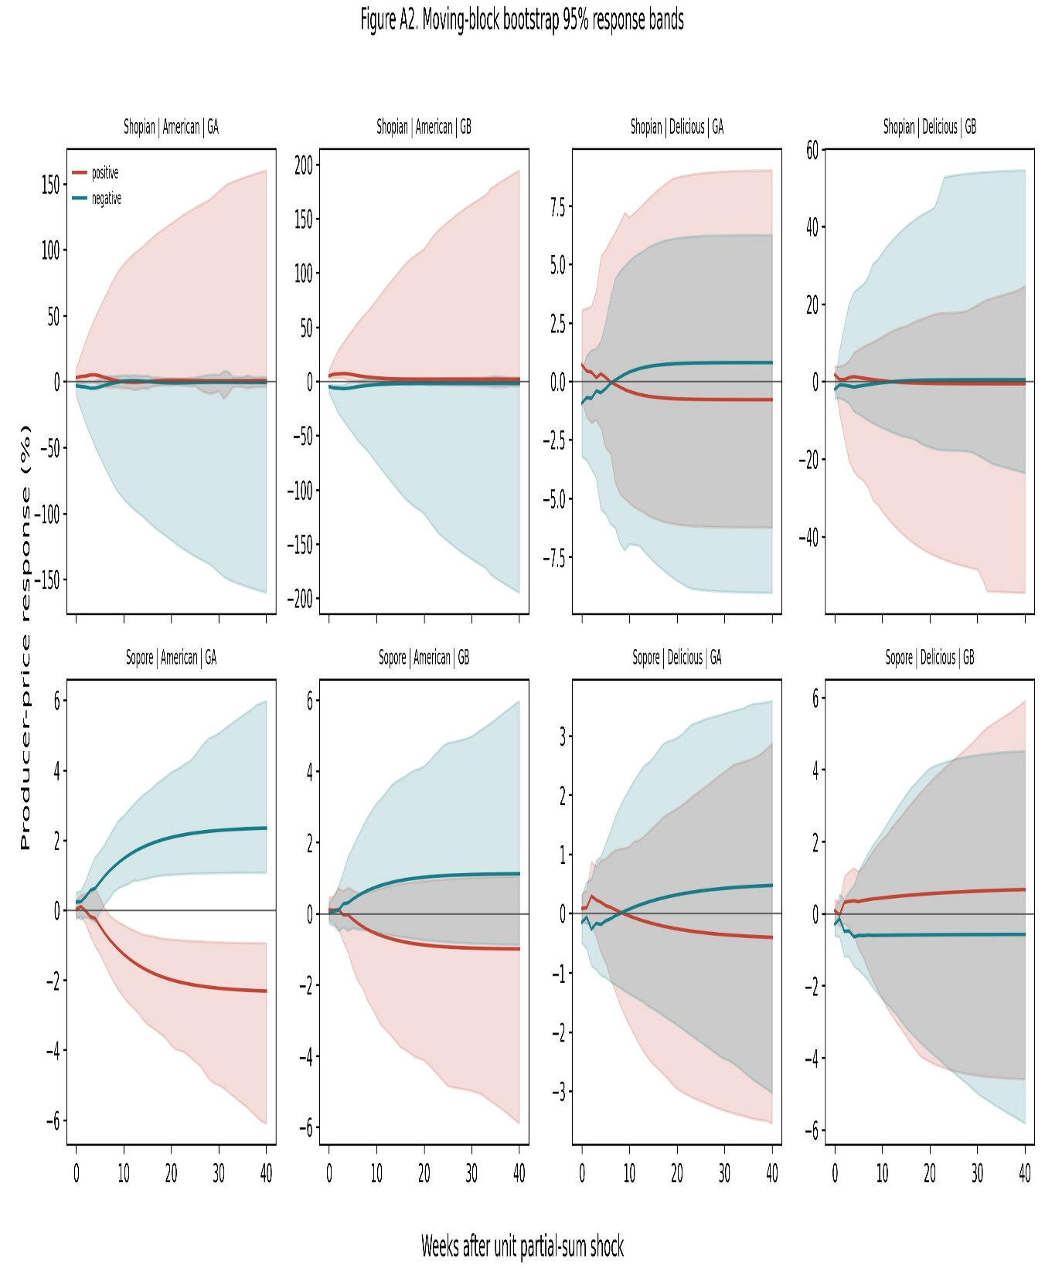
Figure A2. Bootstrapped 95% confidence-band profiles for dynamic multiplier estimates across all eight market-variety-grade equations.

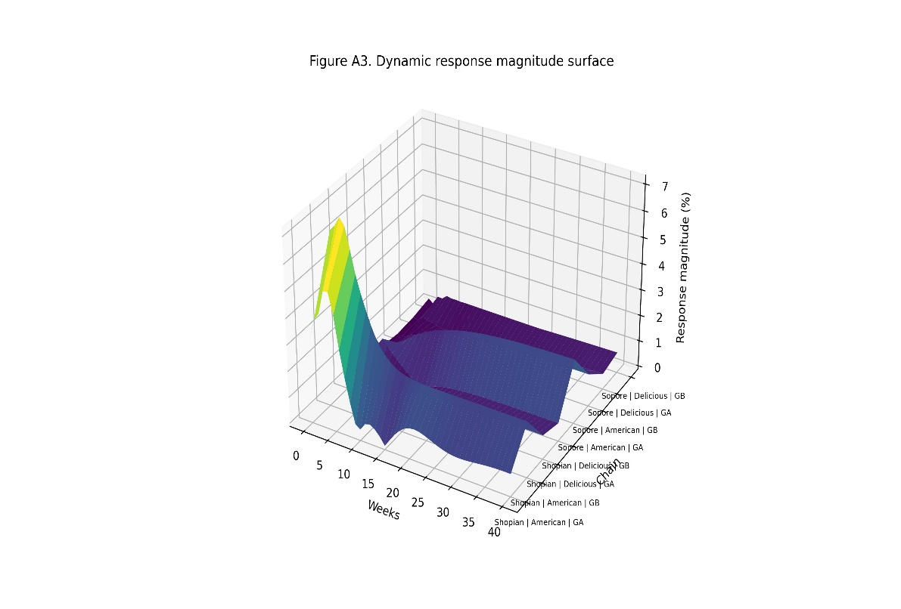

Figure A3. Three-dimensional dynamic response surface combining all eight market-variety-grade equations across the horizon dimension (weeks 1-20).

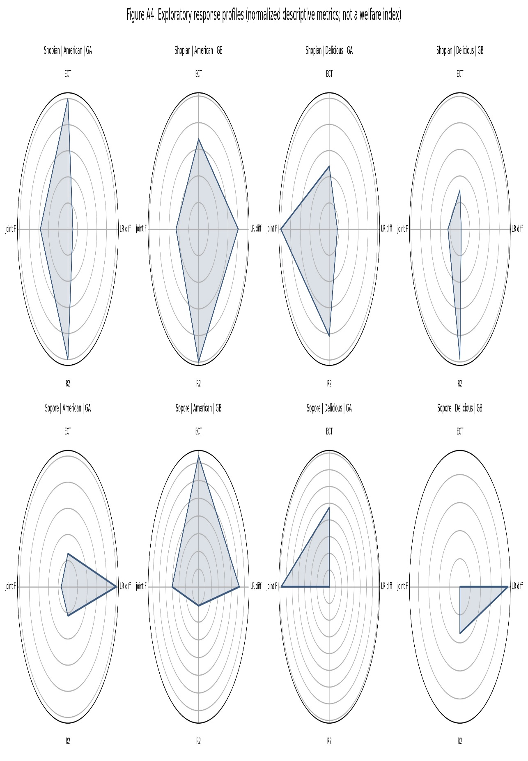
Figure A4. Exploratory descriptive radar profiles by market, variety, and grade, combining the joint lagged-level F diagnostic, long-run asymmetry difference, ECT magnitude, and R². These are normalised descriptive metrics, not a validated welfare or vulnerability index.
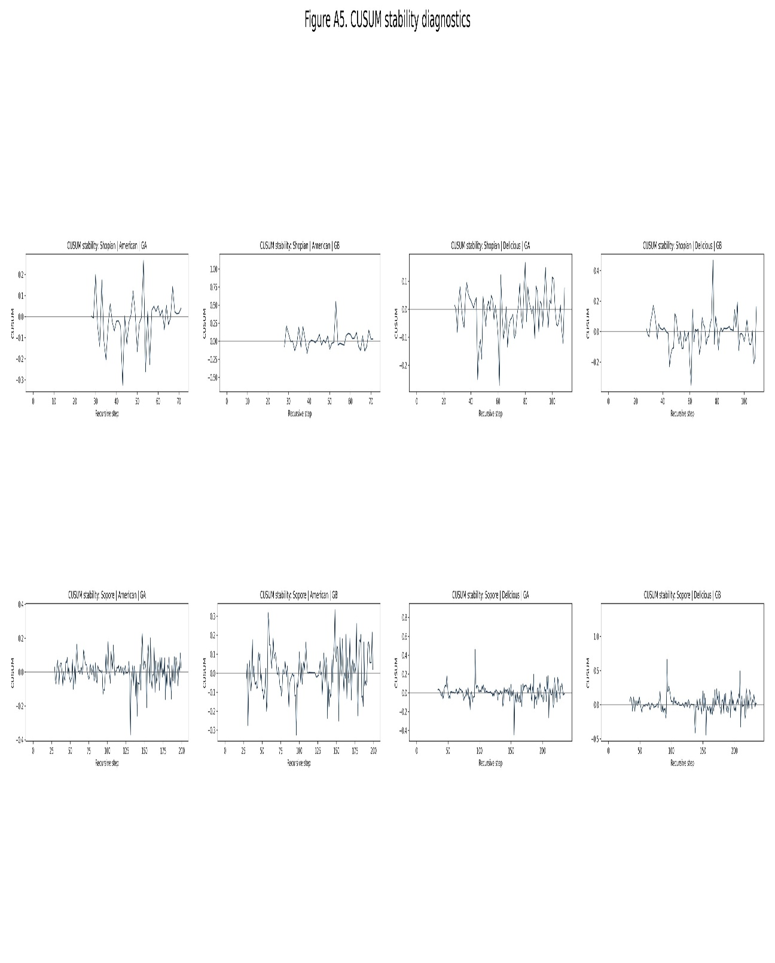
Figure A5. CUSUM stability diagnostics for all eight estimated equations. All paths remain within the 95% envelope, confirming mean parameter stability throughout the sample.

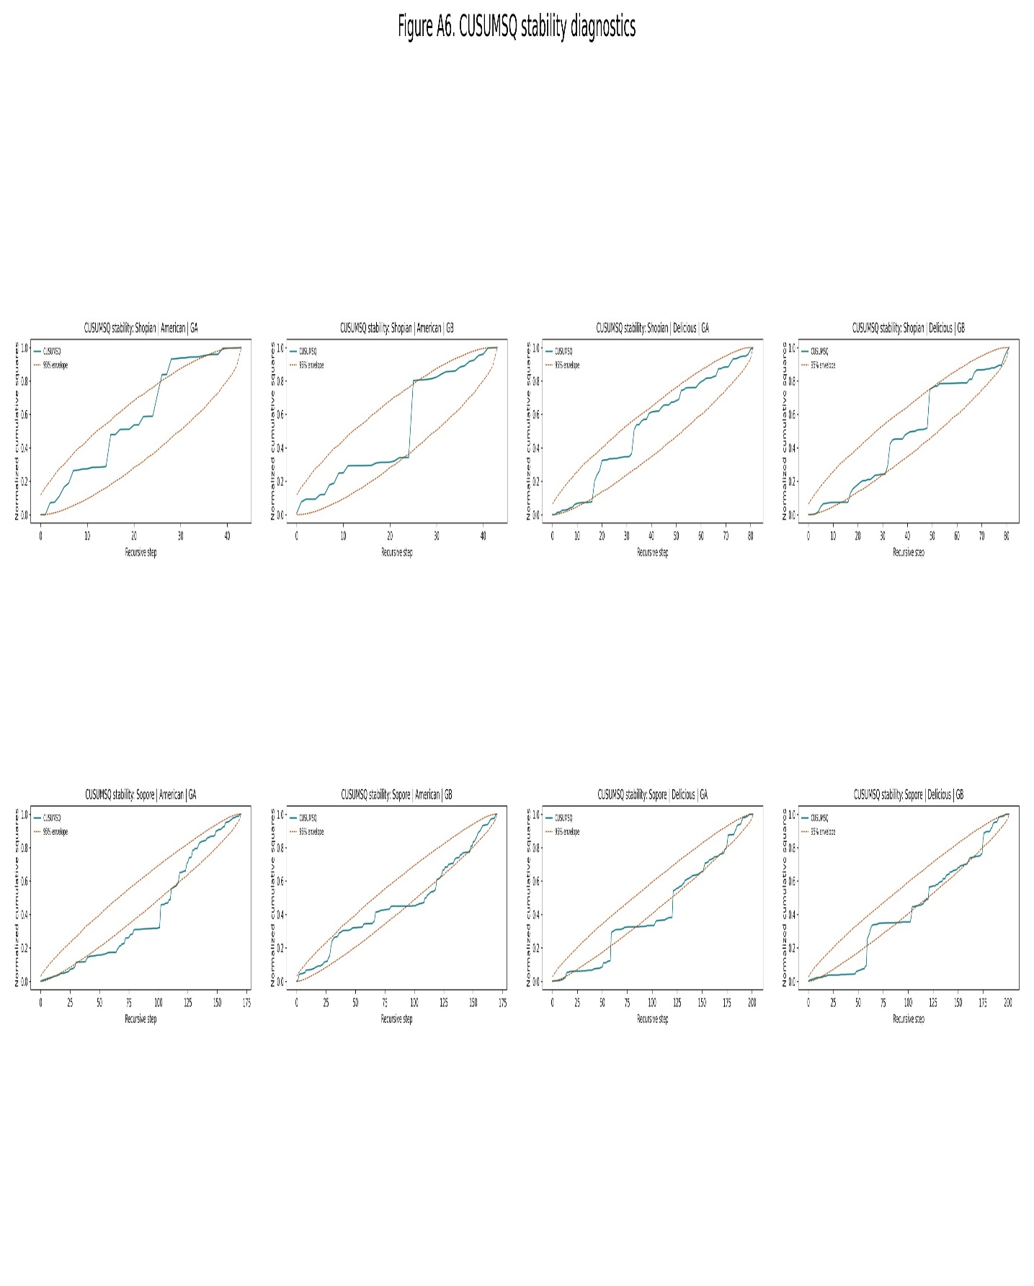
Figure A6. CUSUMSQ stability diagnostics for all eight estimated equations. All paths cross the 95% envelope, indicating episodic residual variance instability; we do not attribute this to specific dated regimes in this revision (Section 5.6, Table A5).

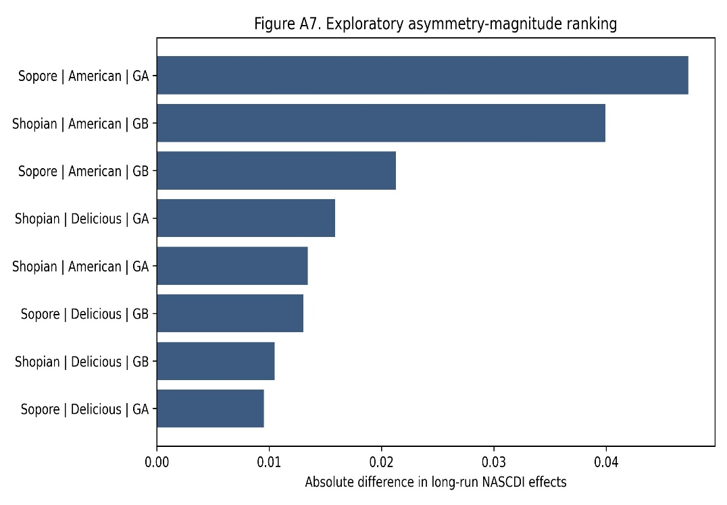

Figure A7. Exploratory ranking of chains by absolute difference in long-run NASCDI⁺ and NASCDI- effects. Values are narrowly distributed (0.010-0.047), with no chain dominating the ranking.
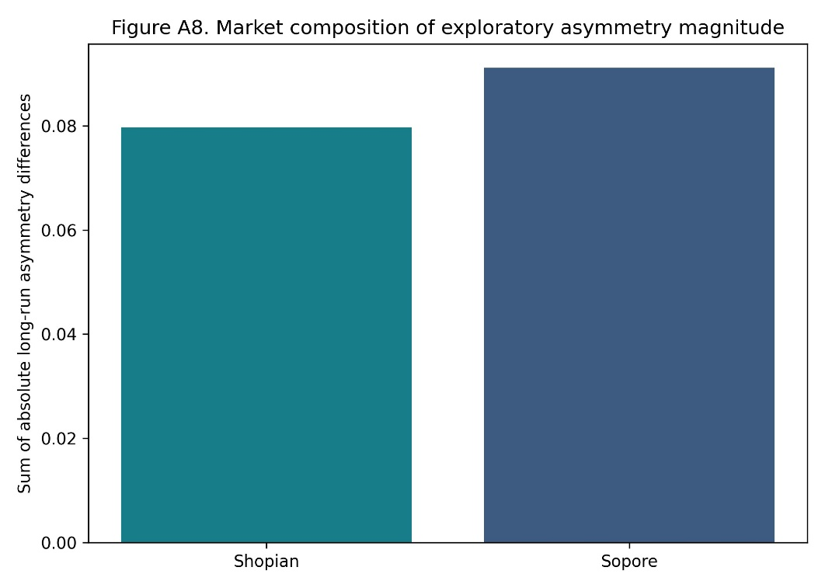

Figure A8. Market-level composition of exploratory asymmetry magnitude: summed absolute long-run asymmetry differences by market. Sopore's total is marginally higher than Shopian's, underscoring that the underlying asymmetry pattern is not concentrated in a single market or chain.
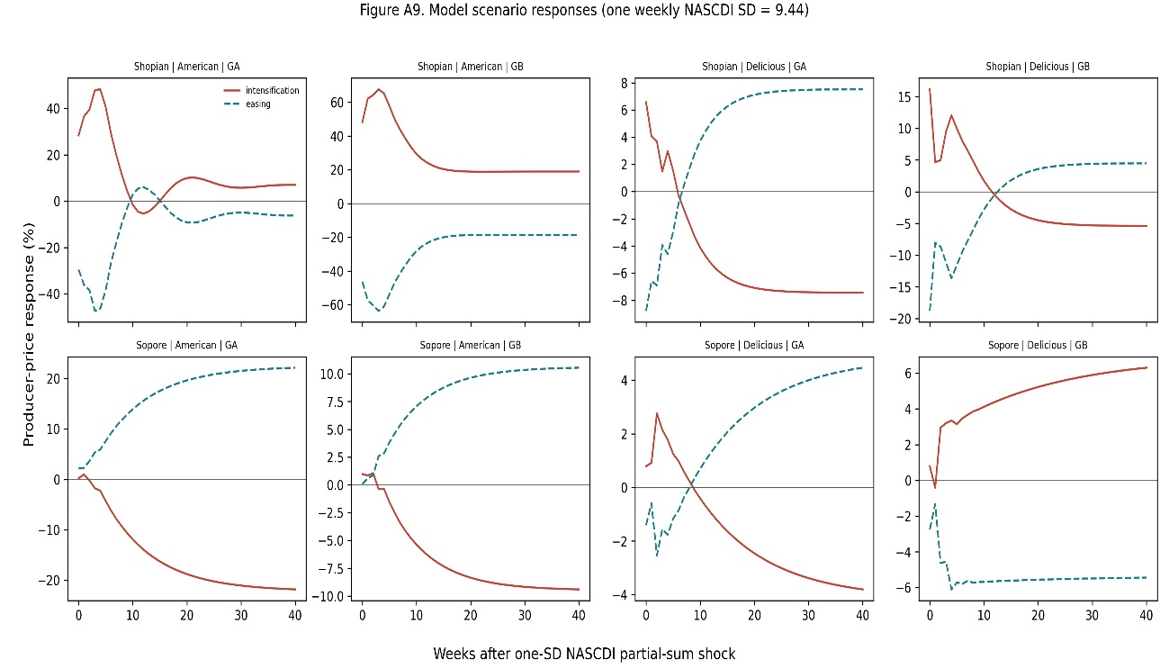
Figure A9. Model scenario responses under a one-standard-deviation weekly NASCDI shock (SD = 9.44). Price response trajectories across all eight chains show comparable orders of magnitude, without extreme concentration in any single chain.

