Supplementary material
The supplementary material is organised into six sections:
- Supplementary material 1: Age and depth information
- Supplementary material 2: Controls
- Supplementary material 3: Regression analysis of haptophytes and Bacillariophyta
- Supplementary material 4: Multiproxy evidence for high coccolithophore abundance during the Last Interglacial
- Supplementary material 5: Further characterisation of the unique ecological community composing the early phase of the Last Interglacial
- Supplementary material 6: Authentication of ancient DNA signal
- Supplementary material 7: Palaeoecological interpretations of taxa discussed in this study
- Supplementary material 8: List of Expedition 403 Scientists and affiliations

Supplementary material 1.
Age model for U1621
The tie points of the U1621 age model (Table S1, Figure S1) were selected based on visual correlation of the magnetic susceptibility spliced record of U1621 (on m CCSF-A, splice in Lucchi et al.¹) to the U1623 magnetic susceptibility time series (Gebhardt, De Schepper et al., submitted to Nature Communications) using PyAnalyseries (version 5.29).
U1621 and U1623 magnetic susceptibility data were collected onboard JOIDES Resolution¹.

Table S1. U1621 age model tie points
U1621 depth (m CCSF-A) | Age (ka)
20.14 | 67.2
22.90 | 90.3
24.53 | 103.0
25.37 | 109.5
28.09 | 128.6
29.53 | 135.0
29.77 | 136.7
30.96 | 140.7
31.83 | 144.0
32.39 | 146.7
33.51 | 150.1
34.12 | 151.3
36.13 | 159.8
36.85 | 162.5

Figure S1. Correlation of the U1621 and U1623 magnetic susceptibility record. Vertical lines indicate tie points.
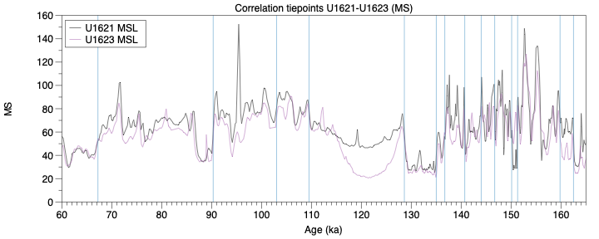

Age model for KH14
While there is an age model for KH14², here we chose to align the KH14 record with the reference time series of U1623, to ensure that our KH14, U1621 and U1623 time series are internally consistent and comparable.
The tie points of the KH14 age model (Table S2, Figure S2) were selected based on visual correlation of the KH14 magnetic susceptibility and XRF log(Ca/Ti) record to the U1623 magnetic susceptibility and XRF log(Ca/Ti) time series (Gebhardt, De Schepper et al., submitted to Nature Communications) using PyAnalyseries (version 5.29).
The resulting age model for KH14 aligns very well with the Steinsland et al.² age model, extends it and provides more detail (Figure S3).
The magnetic susceptibility for KH14 was measured on the whole round core using a 125 mm Bartington MS2C loop sensor of the GEOTEK multi-sensor core logger (MSCL-S) at EARTHLAB, University of Bergen. The raw data were cleaned by removing values that were affected by the absence of sediment, i.e. at the top and/or bottom of the sections. KH14 XRF data was collected by scanning a core half on the ITRAX X-Ray Fluorescence scanner at EARTHLAB, University of Bergen.

Table S2. KH14 age model tie points. For some tie points, the correlation is confirmed in both the magnetic susceptibility (MS) and XRF log(Ca/Ti) record.
CAGE19-3-KH14-GPC02 (m) | Age (ka) | Correlation tiepoint
0.09 | 17.1 | MS
2.83 | 56.8 | MS + log(Ca/Ti)
3.65 | 67.8 | MS
4.40 | 84.6 | MS + log(Ca/Ti)
5.39 | 115.2 | log(Ca/Ti)
5.52 | 124.4 | log(Ca/Ti)
5.75 | 128.9 | MS + log(Ca/Ti)
6.12 | 135.0 | MS + log(Ca/Ti)
6.34 | 136.7 | MS
7.30 | 152.3 | MS
7.61 | 162.3 | MS
8.80 | 180.5 | log(Ca/Ti)
9.15 | 189.9 | MS + log(Ca/Ti)
9.65 | 193.9 | MS + log(Ca/Ti)
10.15 | 196.7 | MS + log(Ca/Ti)
10.71 | 202.2 | MS + log(Ca/Ti)

Figure S2. Correlation of the KH14 and U1623 magnetic susceptibility and log(Ca/Ti) records. Vertical lines indicate tie points.
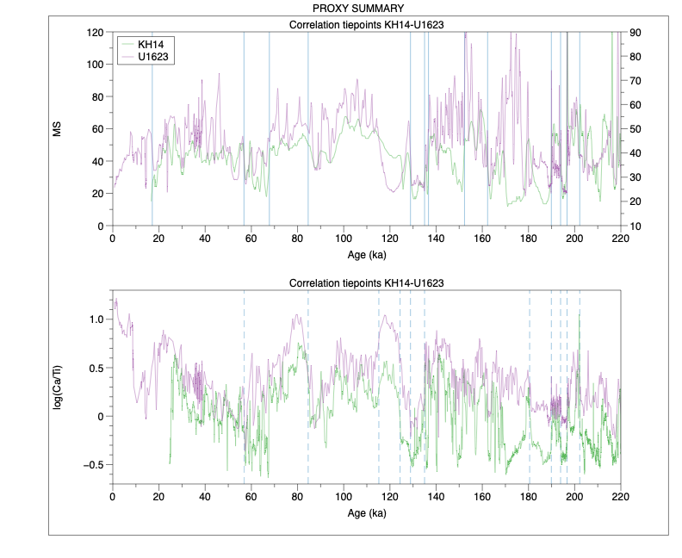

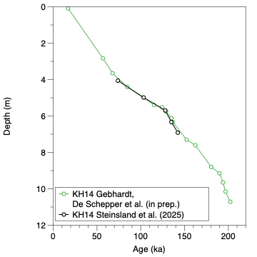
Figure S3. Comparison of the KH14 age model of this study (green) and Steinsland et al.² showing both align well.

Table S3. Samples collected for sedaDNA analysis for this study. Ages are presented to the nearest thousand years (ka). IMAS lab codes denote the batch in which the sample was processed; samples were randomly assigned batches. The prefix ‘S25’ means ‘sediment sample 2025’. The next number e.g. 12_13 means ‘extraction batch 12, sample 13’.
 | CSF-A (M) | CCSF (M) | AGE (KA) (Aug 2026) | IMAS LAB CODE | CORE | TYPE | SECT | SECT START (CM) | SECT END (CM)
1 | 19.455 | 20.438 | 70 | S2512_13 | 4 | H | 1 | 25 | 26
2 | 19.725 | 20.708 | 72 | S2512_14 | 4 | H | 1 | 52 | 53
3 | 20.055 | 21.038 | 75 | S2512_15 | 4 | H | 1 | 85 | 86
4 | 20.405 | 21.388 | 78 | S2512_16 | 4 | H | 1 | 120 | 121
5 | 20.845 | 21.828 | 81 | S2512_17 | 4 | H | 2 | 21 | 22
6 | 21.135 | 22.118 | 84 | S2510_5 | 4 | H | 2 | 50 | 51
7 | 21.555 | 22.538 | 87 | S2510_4 | 4 | H | 2 | 92 | 93
8 | 21.905 | 22.888 | 90 | S2512_6 | 4 | H | 2 | 127 | 128
9 | 22.215 | 23.198 | 93 | S2512_1 | 4 | H | 3 | 15 | 16
10 | 22.425 | 23.408 | 94 | S2510_17 | 4 | H | 3 | 36 | 37
11 | 22.795 | 23.778 | 97 | S2510_16 | 4 | H | 3 | 73 | 74
12 | 23.125 | 24.108 | 100 | S2511_11 | 4 | H | 3 | 106 | 107
13 | 23.665 | 24.648 | 104 | S2511_4 | 4 | H | 4 | 15 | 16
14 | 23.915 | 24.898 | 106 | S2512_8 | 4 | H | 4 | 40 | 41
15 | 24.135 | 25.118 | 108 | S258_1 | 4 | H | 4 | 62 | 63
16 | 24.435 | 25.418 | 110 | S2510_14 | 4 | H | 4 | 92 | 93
17 | 24.725 | 25.708 | 112 | S2512_7 | 4 | H | 4 | 121 | 122
18 | 25.105 | 26.088 | 115 | S2510_7 | 4 | H | 5 | 13 | 14
19 | 25.405 | 26.388 | 117 | S258_2 | 4 | H | 5 | 43 | 44
20 | 25.775 | 26.758 | 119 | S2512_3 | 4 | H | 5 | 80 | 81
21 | 26.025 | 27.008 | 121 | S258_3 | 4 | H | 5 | 105 | 106
22 | 26.255 | 27.238 | 123 | S2510_10 | 4 | H | 5 | 128 | 129
23 | 26.595 | 27.578 | 125 | S2511_14 | 4 | H | 6 | 17 | 18
24 | 26.845 | 27.828 | 127 | S2511_12 | 4 | H | 6 | 42 | 43
25 | 27.145 | 28.128 | 129 | S2510_8 | 4 | H | 6 | 72 | 73
26 | 27.415 | 28.398 | 130 | S2511_16 | 4 | H | 6 | 99 | 100
27 | 27.685 | 28.668 | 131 | S258_4 | 4 | H | 6 | 126 | 127
28 | 28.155 | 29.138 | 133 | S2511_10 | 4 | H | 7 | 27 | 28
29 | 28.435 | 29.418 | 135 | S2510_1 | 4 | H | 7 | 55 | 56
30 | 28.755 | 29.738 | 137 | S2510_2 | 4 | H | 7 | 87 | 88
31 | 28.945 | 29.938 | 137 | S2510_9 | 5 | H | 1 | 24 | 25
32 | 28.955 | 30.696 | 140 | S2512_5 | 4 | H | 7 | 107 | 108
33 | 29.335 | 31.086 | 141 | S2511_7 | 5 | H | 1 | 63 | 64
34 | 29.825 | 31.576 | 143 | S2510_6 | 5 | H | 1 | 112 | 113
35 | 30.325 | 32.076 | 145 | S2512_4 | 5 | H | 2 | 21 | 22
36 | 30.665 | 32.416 | 147 | S2511_9 | 5 | H | 2 | 55 | 56
37 | 31.195 | 32.946 | 148 | S2512_18 | 5 | H | 2 | 108 | 109
38 | 31.865 | 33.616 | 150 | S2512_19 | 5 | H | 3 | 34 | 35
39 | 32.215 | 33.966 | 151 | S2512_20 | 5 | H | 3 | 69 | 70
40 | 32.655 | 34.406 | 153 | S2512_21 | 5 | H | 3 | 113 | 114
Table S4. Stage boundaries for MIS 5e, termination II and the MIS 6 glacial maximum and their corresponding sample numbers for this study. Boundaries are harmonised with Gebhardt, De Schepper et al., submitted to Nature Communications.
Peak interglacial |  |  | Termination |  |  | Glacial Maximum
 | Age [ka] (duration) | Sample no. |  | Age [ka] (duration) | Sample no. |  | Age [ka] (duration) | Sample no.
MIS 5e | 115–127  (12) | 18-24 | T-II | 130–134.5  (4.5) | 26-29 | MIS 6 | 136–148  (12) | 30-37

Supplementary data 2.
Table S5. Negative biological controls used for subtractive filtering of the samples. Samples from U1621C presented in this study were processed with samples from U1618, therefore genera detected in the air control from U1618 were also subtracted. EBC = Extraction blank control.
Control type | IMAS lab codes | Location taken | Purpose
Shipboard air controls | S2511_5; S2510_11; S2512_11 | Core opening room during subsampling for U1618C and U1621C (1H-2H, 4H-5H); Microbiology lab clean hood during syringe cutting | Track biological contamination induced during the subsampling of the sediment cores
Extraction blank controls | EBC45; EBC46; EBC47; EBC49 | IMAS ancient DNA lab | Track bioloigcal contamination in the extraction and library preparation process
Drilling fluid control | S2511_17 | Shipboard | Track biological contamination that may be induced in the drilling process (contamination from the drill fluid was also tracked chemically – see Table S6)

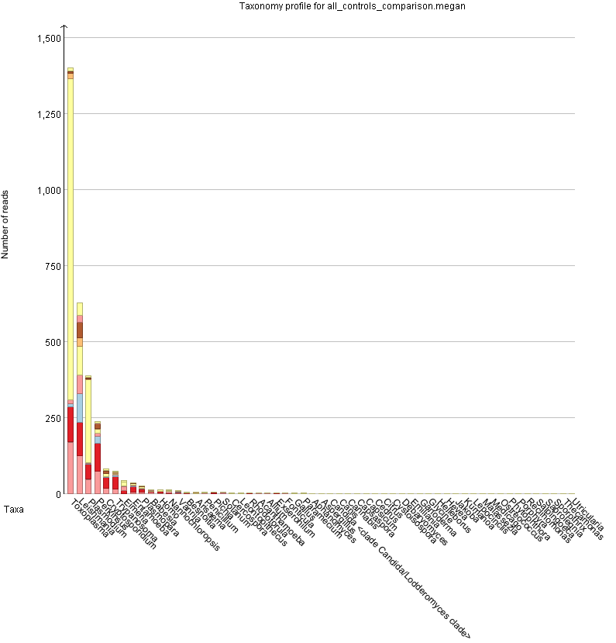
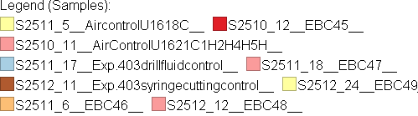
Figure S4. Read counts of the genera detected in the negative biological controls (extraction blank controls (EBCs), air controls during shipboard sediment subsampling and drilling fluid control). Figure produced in MEGAN6.

Table S6. Chemical tracer perfluorodecalin (PFD) concentrations for the sedaDNA samples in this study. Samples less than background (<0.007) are considered uncontaminated by drilling fluid.
 | CSF-A (M) | CCSF (M) | IMAS LAB CODE | CORE | TYPE | SECT | SECT START (CM) | SECT END (CM) | TRACER (PPB)
1 | 19.455 | 20.438 | S2512_13 | 4 | H | 1 | 25 | 26 | 0.001
2 | 19.725 | 20.708 | S2512_14 | 4 | H | 1 | 52 | 53 | 0.003
3 | 20.055 | 21.038 | S2512_15 | 4 | H | 1 | 85 | 86 | 0.002
4 | 20.405 | 21.388 | S2512_16 | 4 | H | 1 | 120 | 121 | 0.001
5 | 20.845 | 21.828 | S2512_17 | 4 | H | 2 | 21 | 22 | 0.001
6 | 21.135 | 22.118 | S2510_5 | 4 | H | 2 | 50 | 51 | 0
7 | 21.555 | 22.538 | S2510_4 | 4 | H | 2 | 92 | 93 | 0
8 | 21.905 | 22.888 | S2512_6 | 4 | H | 2 | 127 | 128 | 0.001
9 | 22.215 | 23.198 | S2512_1 | 4 | H | 3 | 15 | 16 | 0.001
10 | 22.425 | 23.408 | S2510_17 | 4 | H | 3 | 36 | 37 | 0.005
11 | 22.795 | 23.778 | S2510_16 | 4 | H | 3 | 73 | 74 | 0.001
12 | 23.125 | 24.108 | S2511_11 | 4 | H | 3 | 106 | 107 | 0.001
13 | 23.665 | 24.648 | S2511_4 | 4 | H | 4 | 15 | 16 | 0.001
14 | 23.915 | 24.898 | S2512_8 | 4 | H | 4 | 40 | 41 | 0.001
15 | 24.135 | 25.118 | S258_1 | 4 | H | 4 | 62 | 63 | 0.001
16 | 24.435 | 25.418 | S2510_14 | 4 | H | 4 | 92 | 93 | 0.001
17 | 24.725 | 25.708 | S2512_7 | 4 | H | 4 | 121 | 122 | 0.001
18 | 25.105 | 26.088 | S2510_7 | 4 | H | 5 | 13 | 14 | 0.001
19 | 25.405 | 26.388 | S258_2 | 4 | H | 5 | 43 | 44 | 0
20 | 25.775 | 26.758 | S2512_3 | 4 | H | 5 | 80 | 81 | 0
21 | 26.025 | 27.008 | S258_3 | 4 | H | 5 | 105 | 106 | 0.001
22 | 26.255 | 27.238 | S2510_10 | 4 | H | 5 | 128 | 129 | 0
23 | 26.595 | 27.578 | S2511_14 | 4 | H | 6 | 17 | 18 | 0.001
24 | 26.845 | 27.828 | S2511_12 | 4 | H | 6 | 42 | 43 | 0
25 | 27.145 | 28.128 | S2510_8 | 4 | H | 6 | 72 | 73 | 0.001
26 | 27.415 | 28.398 | S2511_16 | 4 | H | 6 | 99 | 100 | 0.001
27 | 27.685 | 28.668 | S258_4 | 4 | H | 6 | 126 | 127 | 0.001
28 | 28.155 | 29.138 | S2511_10 | 4 | H | 7 | 27 | 28 | 0.001
29 | 28.435 | 29.418 | S2510_1 | 4 | H | 7 | 55 | 56 | 0.001
30 | 28.755 | 29.738 | S2510_2 | 4 | H | 7 | 87 | 88 | 0.001
31 | 28.945 | 29.938 | S2510_9 | 5 | H | 1 | 24 | 25 | 0.004
32 | 28.955 | 30.696 | S2512_5 | 4 | H | 7 | 107 | 108 | 0
33 | 29.335 | 31.086 | S2511_7 | 5 | H | 1 | 63 | 64 | 0.001
34 | 29.825 | 31.576 | S2510_6 | 5 | H | 1 | 112 | 113 | 0.001
35 | 30.325 | 32.076 | S2512_4 | 5 | H | 2 | 21 | 22 | 0.001
36 | 30.665 | 32.416 | S2511_9 | 5 | H | 2 | 55 | 56 | 0.001
37 | 31.195 | 32.946 | S2512_18 | 5 | H | 2 | 108 | 109 | 0
38 | 31.865 | 33.616 | S2512_19 | 5 | H | 3 | 34 | 35 | 0.001
39 | 32.215 | 33.966 | S2512_20 | 5 | H | 3 | 69 | 70 | 0.001
40 | 32.655 | 34.406 | S2512_21 | 5 | H | 3 | 113 | 114 | 0.001

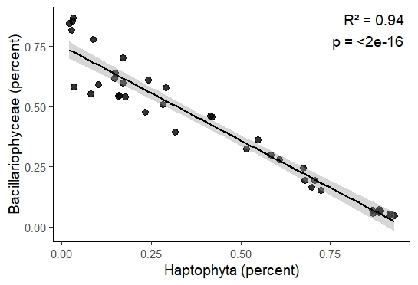
Supplementary data 3.

Figure S5. Linear regression between the relative abundances of Bacillariophyceae (diatoms) and Haptophyta showing a statistically significant strong positive correlation (R² = 0.94, p <2e-16).

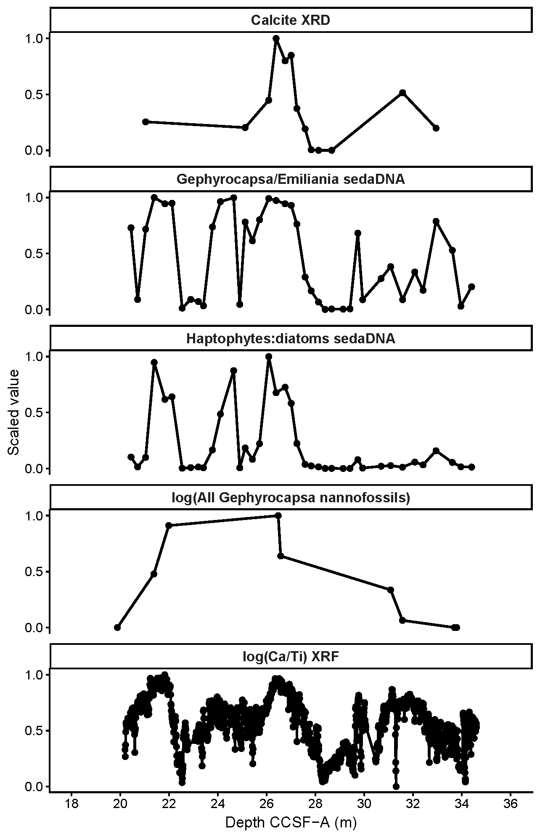
Supplementary data 4.

Figure S6. Comparison of carbonate, nannofossil and sedaDNA coccolithophore proxies across the Last Interglacial interval at Site U1621. Stacked depth profiles show scaled values for XRD calcite, Gephyrocapsa/Emiliania sedaDNA, haptophyte:diatom sedaDNA, log-transformed Gephyrocapsa nannofossil counts, and XRF log(Ca/Ti), plotted against depth on the CCSF-A (m) scale to allow comparison. The yellow shaded interval marks the Last Interglacial/MIS 5e. Peaks in calcite, XRF log(Ca/Ti), nannofossil Gephyrocapsa, and sedaDNA coccolithophore indicators broadly overlap within the highlighted interval, suggesting enhanced carbonate production and/or preservation associated with coccolithophore abundance during MIS 5e. The nannofossil data are from ³ and correspond to the identified nannofossil abundance event 2 (NA2).

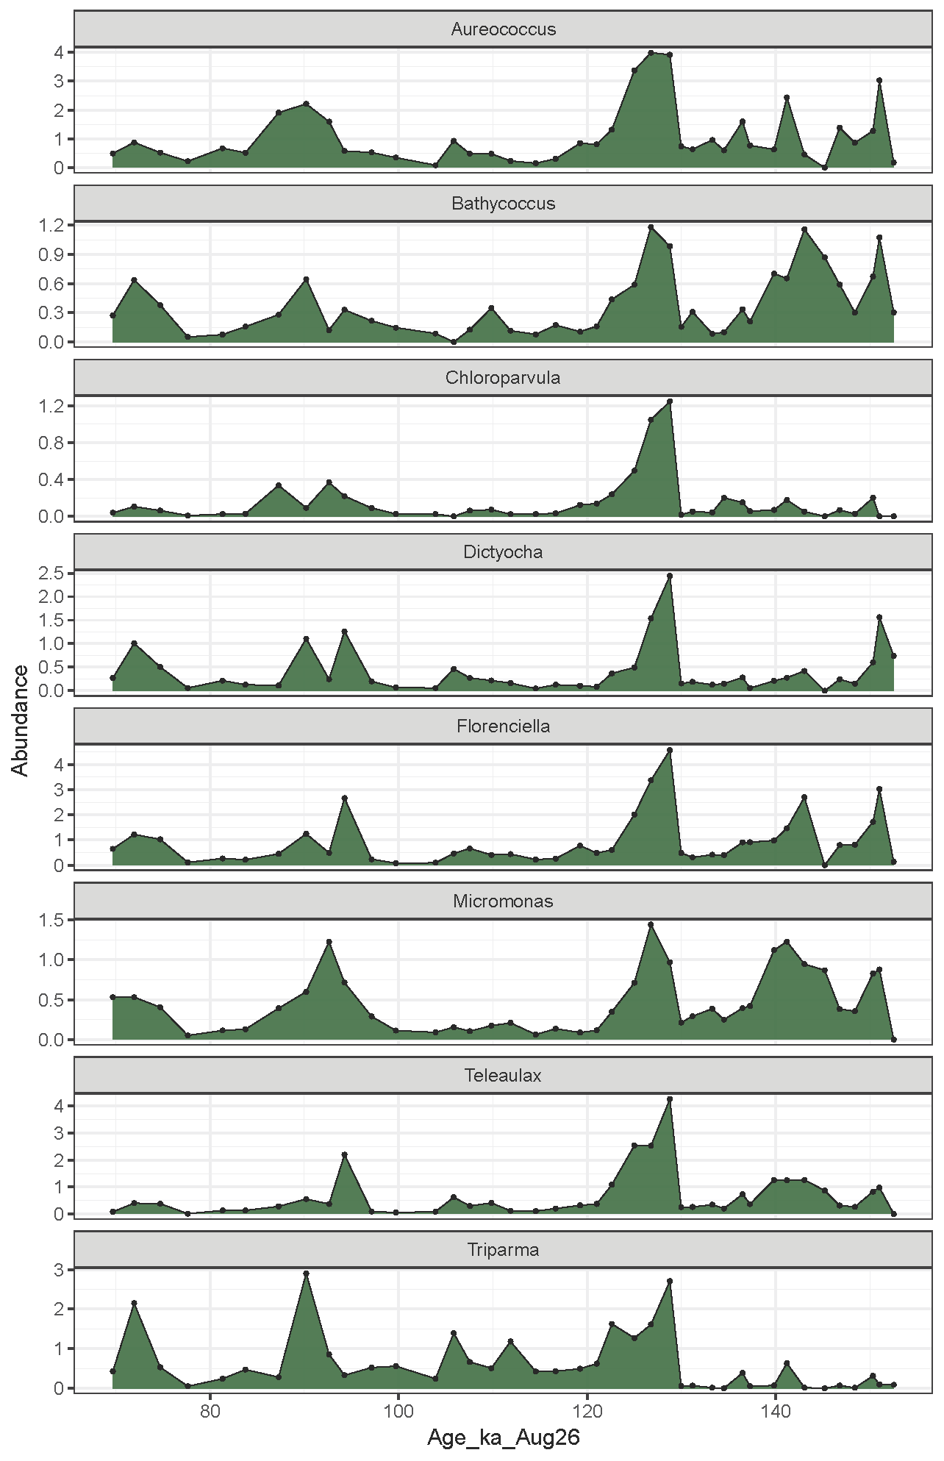
Supplementary data 5.

Figure S7. Genera with increased abundance in early MIS 5e.

Table S7. Ecological and functional characteristics of genera that increased in relative abundance during the early phase of the Last Interglacial. Taxa are classified by cell-size category (picoplankton, <2 μm; nanoplankton, 2-20 μm; microplankton, 20-200 μm), together with evidence for flagellation and mixotrophy. Where traits are uncertain, species dependent, or incompletely resolved, the most widely reported condition is indicated. Sources supporting size-class and trait assignments are provided for each genus.
Genus | Size class | Flagellate? | Mixotrophic? | Source
Florenciella | small nano | yes | yes | ⁴
Dictyocha | nano to micro | yes | yes | oceandatacenter.ucsc.edu/PhytoGallery/Other/dictyocha.html; ⁵
Micromonas | pico | yes | yes | ⁶
Chloroparvula | pico | no | no | ⁷
Bathycoccus | pico | no | no | ⁸
Aureococcus | pico | no known flagellar stage | potentially | marinespecies.org/aphia.php?p=taxdetails&id=375699; ⁹
Teleaulax | nano to micro | yes | yes | ¹⁰; ¹¹
Triparma | pico | sometimes | expected | ¹²; ¹³; ¹⁴; ¹⁵
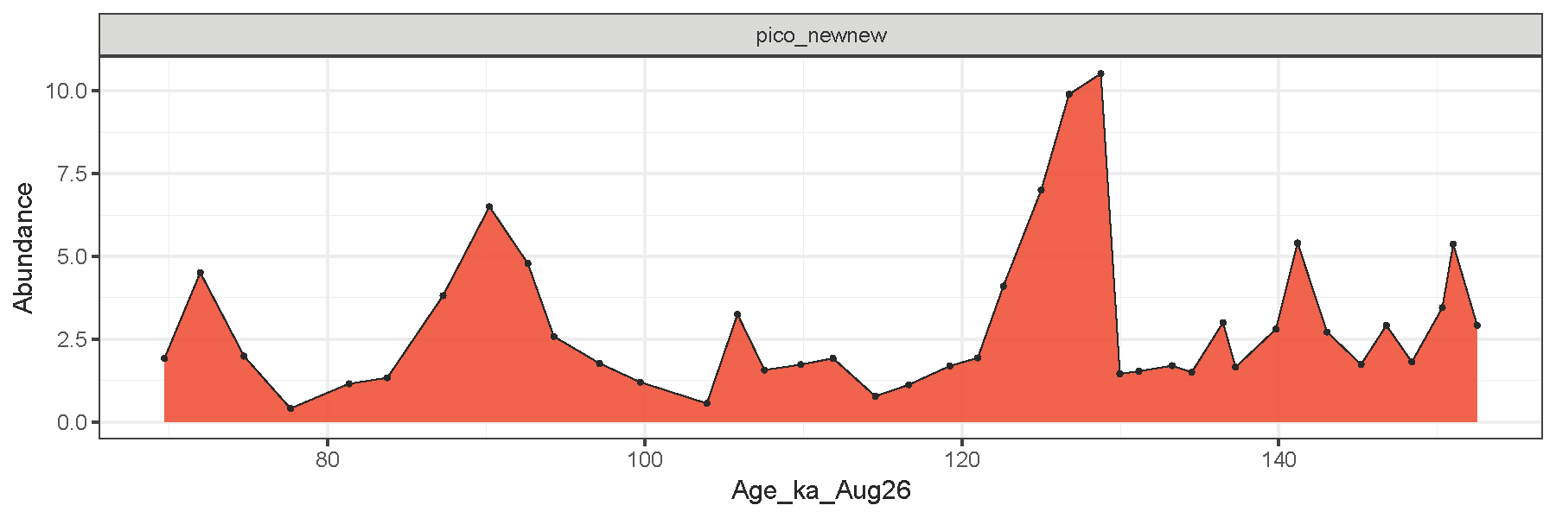
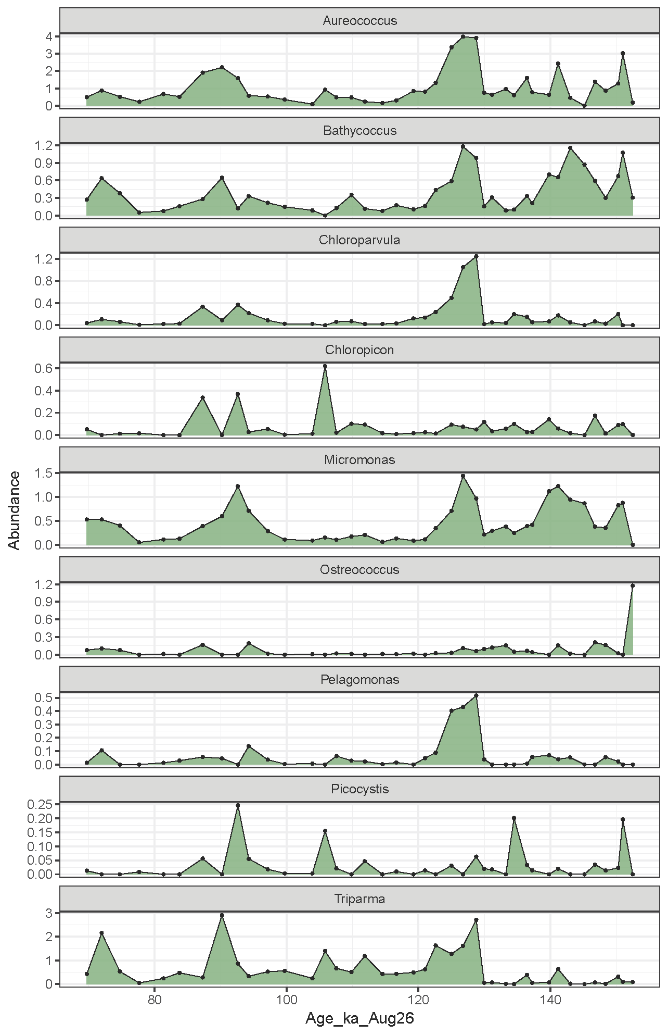
Figure S8. Relative abundances of the picoeukaryote genera through time. Red is the combined abundance of all picoeukaryote genera. Green are the individual genera.
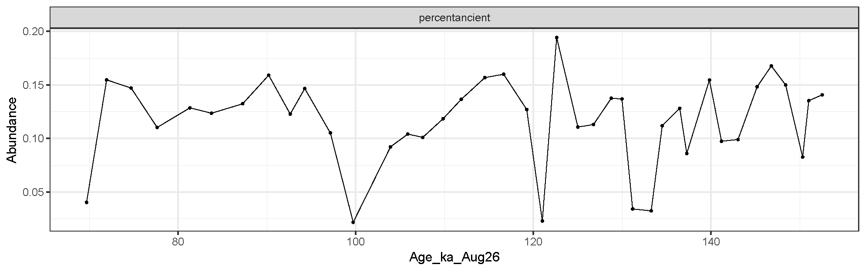
Supplementary material 6.
Figure S9. Ancient DNA authentication. Percent damage calculated using the program HOPS, (https://github.com/rhuebler/HOPS), calculated by finding the proportion of ‘ancient’ reads of the total reads ¹⁶.

Supplementary material 7
Table S8. Palaeoenvironmental interpretations of proxies used in this study.
Proxy | Reference | Interpretation
Haptophyte to diatom ratio | Krajewska, et al. ¹⁷, Weiß, et al. ¹⁸, Nöthig, et al. ¹⁹ | A proxy for warming in modern Svalbard fjord systems ¹⁷, associated with a temperature increase in an Antarctic marine sediment core ¹⁸ and also described in a compilation of modern observations of the summertime plankton ecology in the Fram Strait since 1991 ¹⁹
Fragilariopsis cylindrus | Oksman, et al. ²⁰ | A robust cold-water indicator, not necessarily associated with sea ice as has been previously thought
Gephyrocapsa/Emiliania huxleyi (coccolithophore) | Oziel, et al. ²¹; Gonzalez-Lanchas et al. (2026) | Modern observation suggest populations in the Arctic Ocean are bio-advected from lower latitudes with North Atlantic Water (the northward branch of the AMOC that bring salt and heat into the Arctic Ocean); associated with stratified warm waters; Enhanced nannofossil abundances co variant with sedimentary signatures indicative of enhanced pelagic production at the Bellsund Drift sediments (Fram Strait), indicative of NAW-driven interglacial ecologies.
Pseudo-nitzschia (diatom), chrysochromulina (prymnesiophyte) | Ardyna and Arrigo ²² | Blooms can be toxic or harmful; Predicted to be more likely to bloom from the shift to picoeukarytoic systems (often dominated by Micromonas polaris), a change induced by reduced sea ice in the modern day
Phaeocystis (prymnesiophyte) | Hegseth and Tverberg ²³, Ardyna and Arrigo ²² | A modern study of a Svalbard fjord found Phaeocystis pouchetii blooms to be associated with variability of North Atlantic inflow, i.e., bio-advected; High N; Low Si; Cold waters
Pennate to centric diatom ratio | Ardyna and Arrigo (2020), Zimmermann, et al. ²⁴ | Low light to high light; Tentative sea-ice proxy on a marine sediment record spanning the past 30,000 years in the northeastern Fram Strait. Higher proportions of pennate diatoms increased with higher IP₂₅ concentrations (an established sea ice proxy), however there was not statistically significant relationship between the two.
Triparma | Buchwald, et al. ²⁵, Ichinomiya, et al. ²⁶ | Occurs in modern day in western North Pacific at lower latitudes and optimally grows in surface waters between 5 and 10°C; Found in highest relative abundance during MIS 5e in a shotgun metagenomic record from the subarctic western Bering Sea
Attheyaceae, bacillariaceae, phaeocystaceae (diatoms) | Buchwald, et al. ²⁵ | Sea ice diatoms; These families show a decline in the shotgun metagenomic record from the subarctic western Bering Sea during MIS 5e
Attheya and Haslea | Buchwald, et al. ²⁵ | Sea ice diatoms; These genera completely drop out of the shotgun metagenomic record from the subarctic western Bering Sea at during MIS 5e

Supplementary material 8: List of Expedition 403 Scientists and affiliations
Gryphen Goss; Department of Earth and Planetary Sciences, Yale University, USA
Nicole M. Greco; National Center for Ecological Analysis and Synthesis, University of California Santa Barbara, USA
Jens Gruetzner; Department of Geosciences, Alfred Wegener Institute Helmholtz-Center for Polar and Marine Research, Germany
Aruggoda K.Isuri U. Kapuge; Department of Earth Sciences, University of Delaware, USA
Olga Libman-Roshal; Earth and Environmental Studies, Montclair State University, USA and Department of Earth and Planetary Sciences, Weizmann Institute of Science, Israel
Yanguang Liu; First Institute of Oceanography, Kay Laboratory of Marine Geology and Metallogeny, MNR, China
Lindsey Rose Monito; Department of Geological Sciences, University of Florida, USA
Brendan Thomas Reilly; Lamont-Doherty Earth Observatory, Columbia University, USA
Yuhi Sakai; Graduate School of Engineering, Kyoto University
Yi Zhong; Department of Ocean Science and Technology, Southern University of Science and Technology, China
Yusuke Suganuma; National Institute of Polar Research, Division for Advanced Research Promotion, Japan
Lauren Haygood; Boone Pickens School of Geology, Oklahoma State University, USA

References
1 Lucchi, R. et al. Sites U1621–U1623. Proceedings of the International Ocean Discovery Program Expedition reports 403 (2026).
2 Steinsland, K. et al. Sea ice variability from the penultimate glacial to the last interglacial in the eastern Fram Strait. Palaeogeography, Palaeoclimatology, Palaeoecology 663, 112779 (2025). https://doi.org/https://doi.org/10.1016/j.palaeo.2025.112779
3 González-Lanchas, A. et al. A paleoclimate reference record spanning the last 1 million years from the Fram Strait (Sites U1621 and U1623, IODP Expedition 403). Quaternary Science Reviews 377, 109838 (2026). https://doi.org/https://doi.org/10.1016/j.quascirev.2026.109838
4 Li, Q., Edwards, K. F., Schvarcz, C. R., Selph, K. E. & Steward, G. F. Plasticity in the grazing ecophysiology of Florenciella (Dichtyochophyceae), a mixotrophic nanoflagellate that consumes Prochlorococcus and other bacteria. Limnology and Oceanography 66, 47–60 (2021). https://doi.org/https://doi.org/10.1002/lno.11585
5 Gast, R. J., Fay, S. A. & Sanders, R. W. Mixotrophic Activity and Diversity of Antarctic Marine Protists in Austral Summer. Frontiers in Marine Science Volume 5 - 2018 (2018). https://doi.org/10.3389/fmars.2018.00013
6 Guo, X., Pang, M., Zheng, X. & Huang, L. Micromonas, a small pigmented flagellate, predominates the nanoflagellate and photosynthetic picoeukaryote communities in the northern South China Sea. Environmental Microbiology Reports 16, e13244 (2024). https://doi.org/https://doi.org/10.1111/1758-2229.13244
7 Lopes dos Santos, A. et al. Chloropicophyceae, a new class of picophytoplanktonic prasinophytes. Scientific Reports 7, 14019 (2017). https://doi.org/10.1038/s41598-017-12412-5
8 Vannier, T. et al. Survey of the green picoalga Bathycoccus genomes in the global ocean. Scientific Reports 6, 37900 (2016). https://doi.org/10.1038/srep37900
9 Sieburth, J. M., Johnson, P. W. & Hargraves, P. E. Ultrastructure and ecology of Aureococcus anophagefferens gen. et sp. nov. (Chrysophyceae): the dominant picoplankter during a bloom in Narragansett Bay, Rhode Island, summer 1985. Journal of Phycology 24, 416–425 (1988). https://doi.org/https://doi.org/10.1111/j.1529-8817.1988.tb04485.x
10 Altenburger, A. et al. Dimorphism in cryptophytes - The case of Teleaulax amphioxeia/Plagioselmis prolonga and its ecological implications. Science Advances 6, eabb1611 (2020). https://doi.org/doi:10.1126/sciadv.abb1611
11 Anschütz, A.-A., Flynn, K. J. & Mitra, A. Acquired Phototrophy and Its Implications for Bloom Dynamics of the Teleaulax-Mesodinium-Dinophysis-Complex. Frontiers in Marine Science Volume 8 - 2021 (2022). https://doi.org/10.3389/fmars.2021.799358
12 Yamada, K. et al. New clade of silicified bolidophytes that belong to Triparma (Bolidophyceae, Stramenopiles). Phycological Research 68, 178–182 (2020). https://doi.org/https://doi.org/10.1111/pre.12413
13 Ichinomiya, M. et al. Diversity and oceanic distribution of the Parmales (Bolidophyceae), a picoplanktonic group closely related to diatoms. The ISME Journal 10, 2419–2434 (2016). https://doi.org/10.1038/ismej.2016.38
14 Kuwata, A. et al. Bolidophyceae, a Sister Picoplanktonic Group of Diatoms – A Review. Frontiers in Marine Science Volume 5 - 2018 (2018). https://doi.org/10.3389/fmars.2018.00370
15 Ban, H. et al. Genome analysis of Parmales, the sister group of diatoms, reveals the evolutionary specialization of diatoms from phago-mixotrophs to photoautotrophs. Communications Biology 6 (2023). https://doi.org/10.1038/s42003-023-05002-x
16 Armbrecht, L., Hallegraeff, G., Bolch, C., Woodward, C. & Cooper, A. Hybridisation capture allows DNA damage analysis of ancient marine eukaryotes. Scientific reports 11, 1–14 (2021).
17 Krajewska, M., Szymczak-Żyła, M., Tylmann, W. & Kowalewska, G. Climate change impact on primary production and phytoplankton taxonomy in Western Spitsbergen fjords based on pigments in sediments. Global and Planetary Change 189, 103158 (2020). https://doi.org/https://doi.org/10.1016/j.gloplacha.2020.103158
18 Weiß, J. F. et al. Carbon drawdown by algal blooms during Antarctic Cold Reversal from sedimentary ancient DNA. Nature Geoscience 18, 901–908 (2025).
19 Nöthig, E.-M. et al. Summertime plankton ecology in Fram Strait—a compilation of long- and short-term observations. Polar Research 34, 23349 (2015). https://doi.org/10.3402/polar.v34.23349
20 Oksman, M., Juggins, S., Miettinen, A., Witkowski, A. & Weckström, K. The biogeography and ecology of common diatom species in the northern North Atlantic, and their implications for paleoceanographic reconstructions. Marine Micropaleontology 148, 1–28 (2019). https://doi.org/https://doi.org/10.1016/j.marmicro.2019.02.002
21 Oziel, L. et al. Faster Atlantic currents drive poleward expansion of temperate phytoplankton in the Arctic Ocean. Nature Communications 11 (2020). https://doi.org/10.1038/s41467-020-15485-5
22 Ardyna, M. & Arrigo, K. R. Phytoplankton dynamics in a changing Arctic Ocean. Nature Climate Change 10, 892–903 (2020). https://doi.org/10.1038/s41558-020-0905-y
23 Hegseth, E. N. & Tverberg, V. Effect of Atlantic water inflow on timing of the phytoplankton spring bloom in a high Arctic fjord (Kongsfjorden, Svalbard). Journal of Marine Systems 113-114, 94–105 (2013). https://doi.org/https://doi.org/10.1016/j.jmarsys.2013.01.003
24 Zimmermann, H. H. et al. Changes in the composition of marine and sea-ice diatoms derived from sedimentary ancient DNA of the eastern Fram Strait over the past 30 000 years. Ocean Science 16, 1017–1032 (2020). https://doi.org/10.5194/os-16-1017-2020
25 Buchwald, S. Z., Herzschuh, U., Nürnberg, D., Harms, L. & Stoof-Leichsenring, K. R. Plankton community changes during the last 124 000 years in the subarctic Bering Sea derived from sedimentary ancient DNA. The ISME Journal 18 (2024). https://doi.org/10.1093/ismejo/wrad006
26 Ichinomiya, M., Nakamachi, M., Shimizu, Y. & Kuwata, A. Growth characteristics and vertical distribution of Triparma laevis (Parmales) during summer in the Oyashio region, western North Pacific. Aquatic Microbial Ecology 68, 107–116 (2013).

