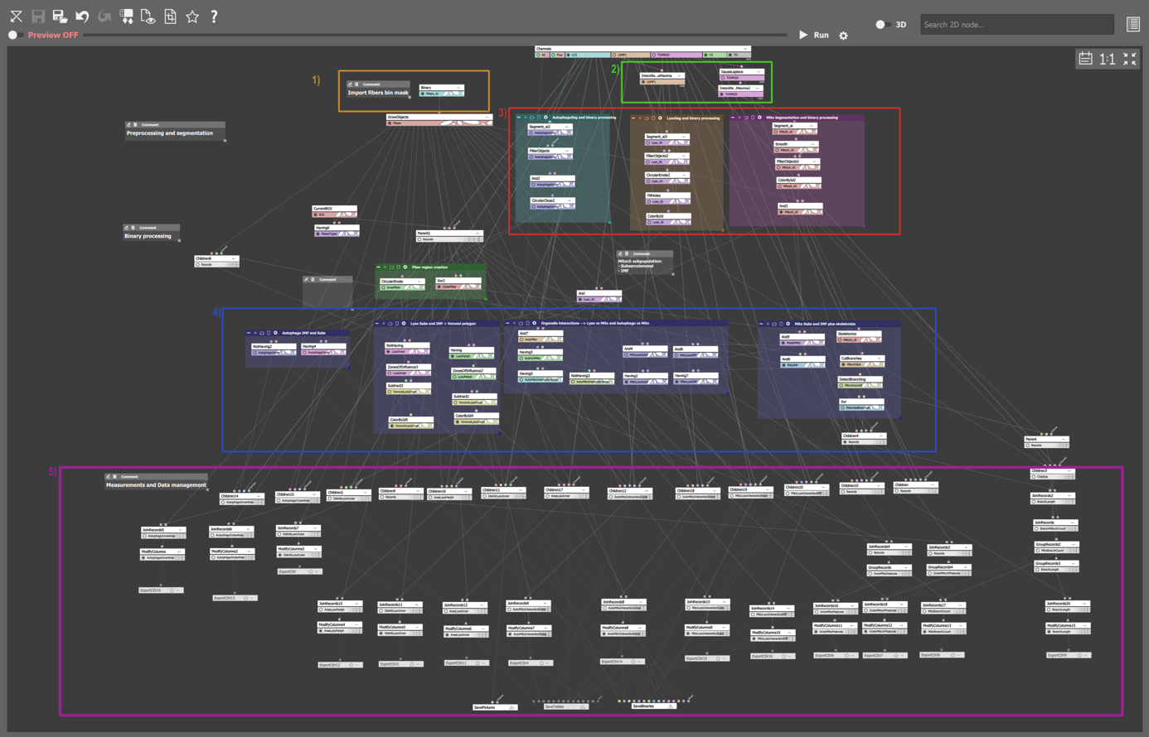
Supplemental Figures

Supplementary Figure 1 (Fig.S1). General Analysis 3 (GA3) pipeline for automated multi-organelle feature extraction. Detailed schematic of the GA3 analysis workflow developed in NIS-Elements for automated quantification of organelle morphometrics and physical interactions:1. Import and preprocessing (orange module): Binary masks of annotated muscle fibers were imported into the execution environment. 2. Contrast enhancement (green module): Local maxima contrast enhancement algorithms were applied to LAMP-1 and TOMM20 fluorescent channels to optimize organelle boundary detection. 3. Segmentation (red module): Three trained U-Net deep learning models ("Segment.ai") executed segmentation of autophagosomes, lysosomes, and mitochondria, followed by binary morphological smoothing. 4. Binary operations & spatial assignment (blue module): Myofibers were partitioned into subsarcolemmal (SS) and intermyofibrillar (IM) subregions using circular mask erosion. Organelles were assigned to their respective cellular compartments. Voronoi diagrams were constructed on lysosomal centroids to measure inter-lysosomal spatial spacing. Mitochondrial masks were skeletonized to calculate branch point density and branch length. Direct contact sites (<100 nm boundary proximity) between mitochondria and lysosomes/autophagosomes were mapped. 5. Quantifications (magenta module): Structural metrics (surface density, Feret diameter, branching density, branch length) and inter-organelle contact event counts were extracted per myofiber and subregion.

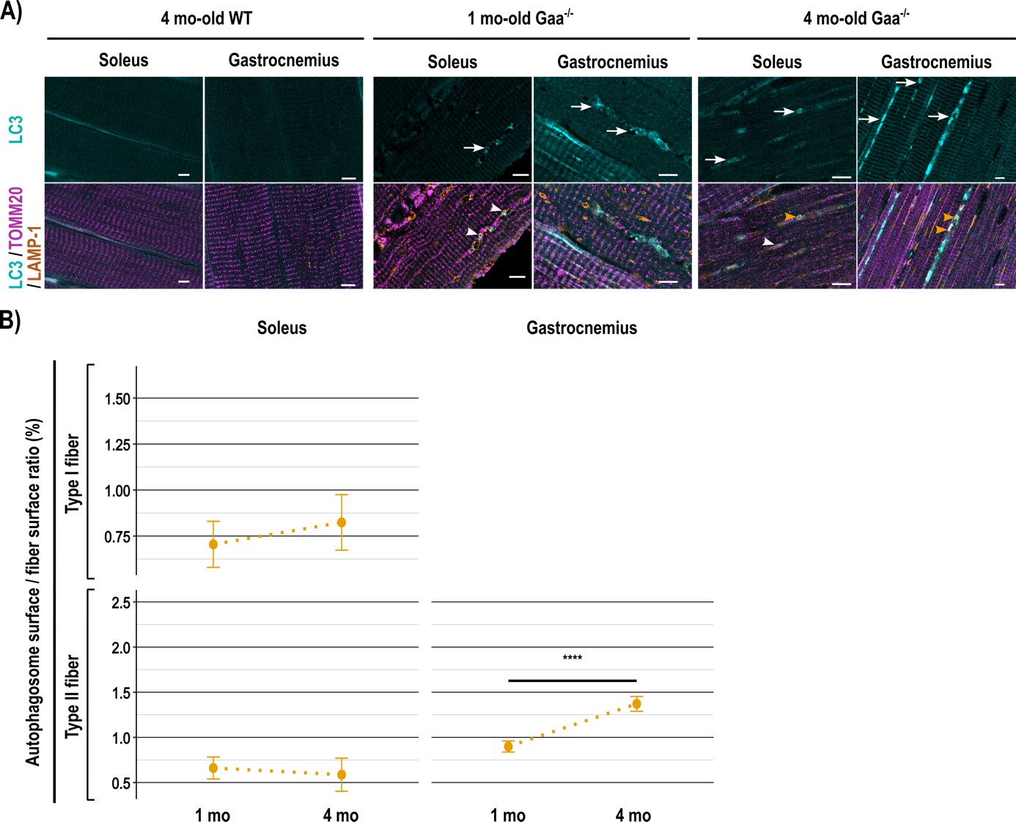

Supplementary Figure 2 (Fig.S2). Autophagosome distribution and fiber-type surface occupancy in Pompe disease muscle. (A) Representative super-resolution ISM images of autophagosomes in longitudinal muscle sections. Top row: single-channel LC3 (cyan); bottom row: triple overlay showing LC3 (cyan), LAMP-1 (lysosomes, orange), and TOMM20 (mitochondria, magenta). In Gaa⁻/⁻ muscle, autophagic buildup is evident (white arrows). Autophagosomes are frequently observed adjacent to lysosomes alone (orange arrowheads) or simultaneously contacting both lysosomes and mitochondria (white arrowheads). Scale bar = 5 µm. (B) Quantitative surface occupancy of autophagosomes (ratio of LC3-positive surface area to total myofiber area, %) in Soleus (Type I and Type II) and Gastrocnemius (Type II) fibers from 1- and 4-month-old Gaa⁻/⁻ mice. Data represent mean ± SEM (n = 4 animals per group). Statistical analysis was conducted using a linear mixed-effects model. *** p < 0.001.

