SUPPLEMENTARY INFORMATION

Interfacial Corrosion Protection of ST37 Steel by Borassus flabellifer Husk Extract in 1 M HCl: Effect of Inhibitor Concentration

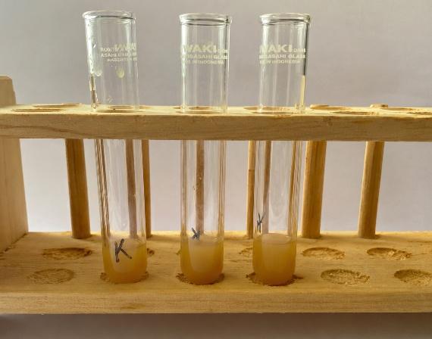 | 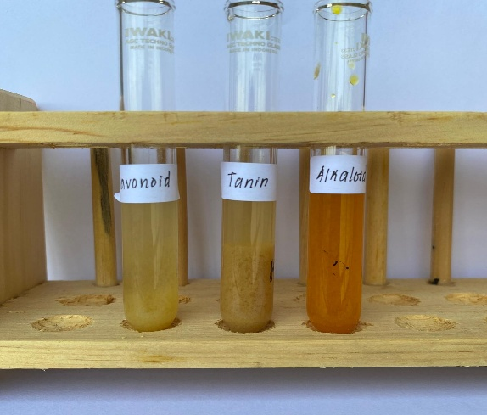
(a) | (b)
Fig S1. (a) Before phytochemical screening, (b) After phytochemical screening

Tabel 1. Phytochemical Screening Results of Borassus flabellifer Husk Extract
Compounds | Reagent | Observations | Identification
Flavonoid | NaOH 1% + HCl 1% | Yellow precipitate was formed | +
Tanin | Pb(CH₃COO)₂ 1% | Colour fading was observed | +
Alkaloid | HCl 1% + Dragendorff | Orange coloration was observed | +
*Remarks :
(+) : Present
(-) : Absent

Tabel 2. Corrosion Inhibition Efficiency of ST37 Steel at Different Concentrations of Borassus flabellifer Husk Extract
Concentrations (ppm) | No sampel | Initial weight (gr) | Final weight (gr) | Weight Loss (gr) | %IE | Average IE (%)
0 | 1 | 4.501 | 4.426 | 0.075 | - | -
0 | 2 | 5.13 | 5.048 | 0.082 | - | -
0 | 3 | 4.806 | 4.739 | 0.067 | - | -
50 | 1 | 4.501 | 4.479 | 0.022 | 70.55 | 73.23
50 | 2 | 4.587 | 4.566 | 0.021 | 71.89 | 73.23
50 | 3 | 4.531 | 4.514 | 0.017 | 77.24 | 73.23
100 | 1 | 4.745 | 4.734 | 0.011 | 85.27 | 88.40
100 | 2 | 4.958 | 4.952 | 0.006 | 91.97 | 88.40
100 | 3 | 5.204 | 5.195 | 0.009 | 87.95 | 88.40
150 | 1 | 4.854 | 4.851 | 0.003 | 95.98 | 87.06
150 | 2 | 4.614 | 4.590 | 0.024 | 67.87 | 87.06
150 | 3 | 4.630 | 4.628 | 0.002 | 97.32 | 87.06
200 | 1 | 4.938 | 4.914 | 0.024 | 67.87 | 77.69
200 | 2 | 4.684 | 4.669 | 0.015 | 79.92 | 77.69
200 | 3 | 4.388 | 4.377 | 0.011 | 85.27 | 77.69
250 | 1 | 4.635 | 4.610 | 0.025 | 66.53 | 81.25
250 | 2 | 4.246 | 4.238 | 0.008 | 89.29 | 81.25
250 | 3 | 4.377 | 4.368 | 0.009 | 87.95 | 81.25

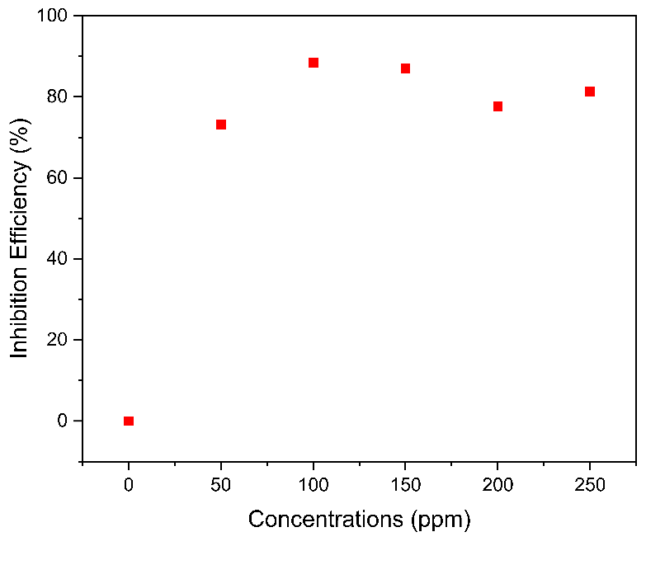
Fig S2. Effect of Borassus flabellifer Husk Extract Concentration on the Corrosion Inhibition Efficiency of ST37 Steel Based on Weight Loss Measurement

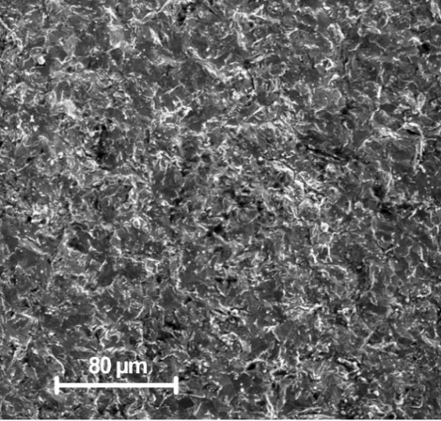
Fig S3. SEM of 50 ppm

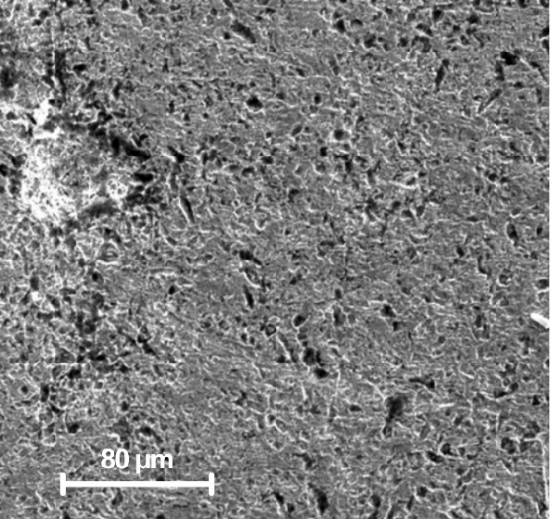
Fig S4. SEM of 150 ppm

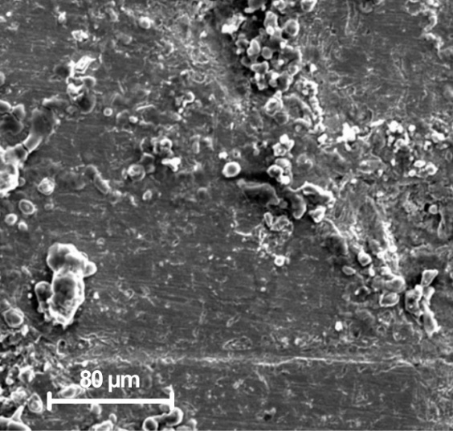
Fig S5. SEM of 200 ppm

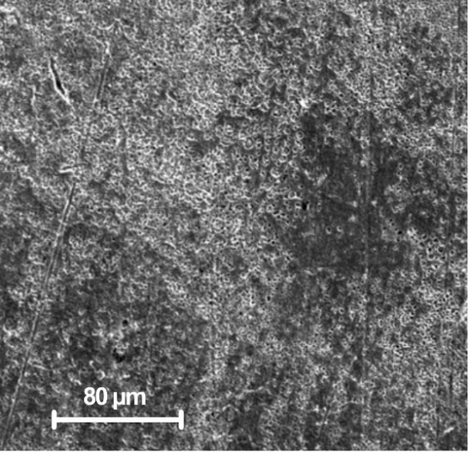
Fig S6. SEM of 250 ppm
Table S3. Surface elemental composition of ST37 steel determined by EDX analysis.
Sample | Fe (wt.%) | O (wt.%) | C (wt.%)
Bare | 98.75 | -ª | 0.49
Blank | 81.74 | 16.13 | 2.13
50 ppm | 90.11 | 6.45 | 3.44
100 ppm | 96.77 | 1.45 | 1.77
150 ppm | 90.22 | 7.06 | 2.72
200 ppm | 86.83 | 10.83 | 2.34
250 ppm | 84.21 | 1.17 | 0.61
ªOxygen was not included during EDX quantification of the bare specimen

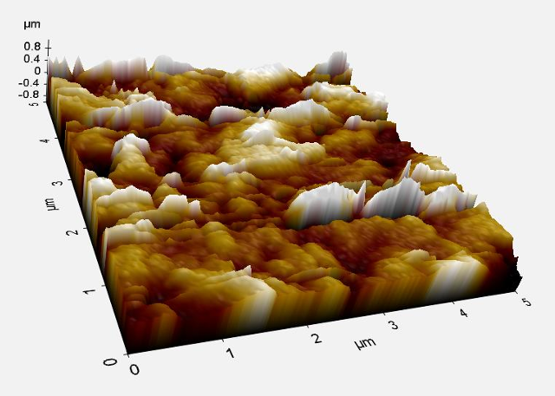  (a) | 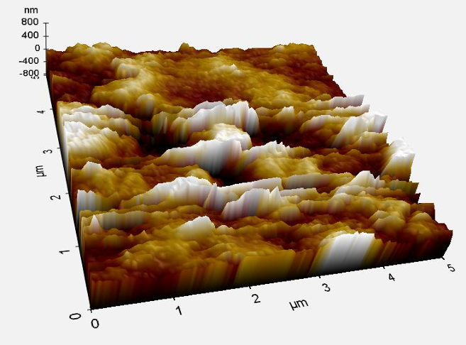  (b)
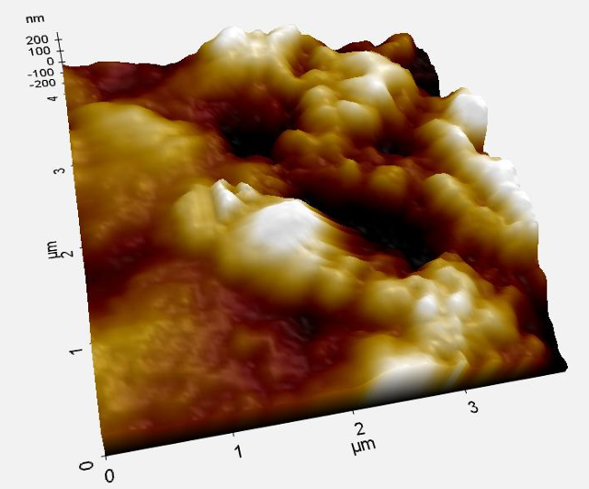  (c) | 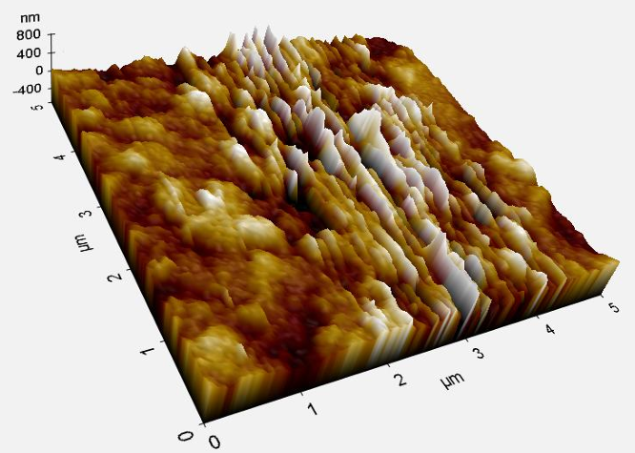  (d)
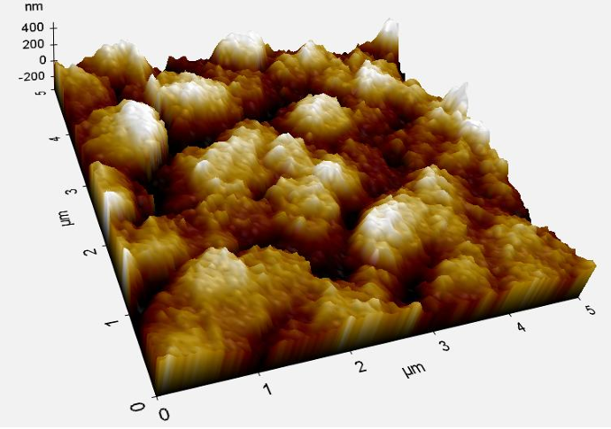  (e) | 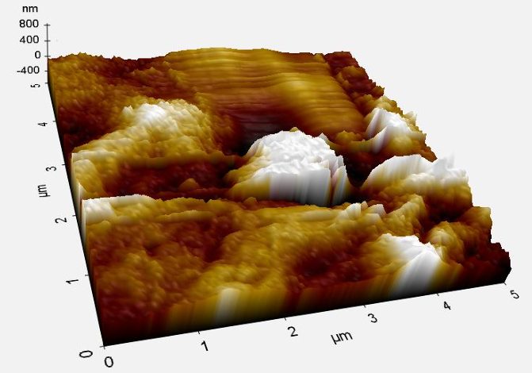  (f)
Fig S7. AFM of (a) blanko, (b) 50 ppm, (c) 100 ppm, (d) 150 ppm, (e) 200 ppm, (f) 250 ppm concentrations

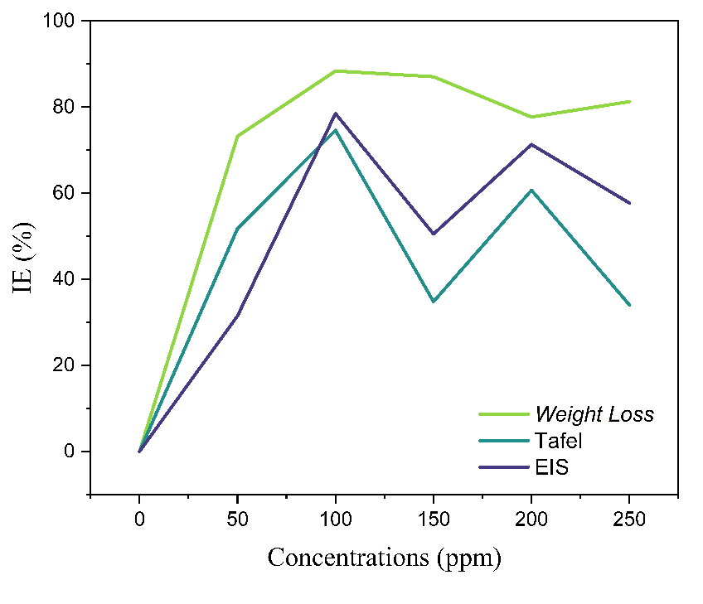
Fig S8. Comparison of inhibition efficiency (IE) determined by weight loss, Tafel polarization, and EIS measurements at different concentrations of palmyra fruit husk extract.

