Additional file 1

Three Birds with One Stone: Co-Encapsulation of Diclofenac and DL-Menthol for Realizing Enhanced Energy Deposition, Glycolysis Inhibition and Anti-Inflammation in HIFU Surgery

Haitao Wu^{1, †}, Hu Zhou^{2, †}, Wenjie Zhang¹, Ping Jin^{2,} *, Qianqian Shi¹, Zhaohua Miao¹, Hua Wang^{3,} * and Zhengbao Zha^{1,} *

¹ School of Instrument Science and Opto-Electronics Engineering, School of Food and Biological Engineering, Hefei University of Technology, Hefei, Anhui 230009, P. R. China.

*Correspondence: pingjin68@smu.edu.cn; wanghua@ahmu.edu.cn; zbzha@hfut.edu.cn.
†Haitao Wu, Zhou Hu contributed equally.

Experimental Section
Materials and regents
PLGA was gifted from Hefei Zhongren Technology Co., Ltd. Diclofenac (DC) was purchased from Tokyo Chemical Industry (TCI). Polyvinyl alcohol (PVA) was purchased from Alfa Aesar. _{DL}-Menthol was purchased from Sigma-Aldrich. All organic reagents including ethanol, DMSO and CH₂Cl₂ were purchased from Sinopharm Chemical Reagent Company. DMEM and RPMI 1640 cell culture medium were both obtained from HyClone Company. Methylthiazolyldiphenyl-tetrazolium bromide (MTT), Calcelin-AM and propidium iodide (PI) were supplied by Sigma-Aldrich. De-ionized (DI) water (18.2 MΩ/cm) used in the experiment was prepared by using a Milli-Q Gradient System.
Synthesis of DC/DLM@PLGA NPs
DC/DLM@PLGA NPs were synthesized by the typical oil-in-water emulsion method. Specifically, 0.8 mL DMSO with 20 mg of DC was firstly added into 4.0 mL CH₂Cl₂ in which 100 mg of PLGA and 50 mg of DL-Menthol are dissolved, and then the mixed solution was added into 20 mL PVA solution (2.0 wt%). Subsequently, under the continuous probe sonication (5 min), the above-mentioned immiscible mixtures formed a stable oil-in-water emulsion. Finally, the residual CH₂Cl₂ was evaporated by magnetic stirring at room temperature for 4 h. The preparation process of DLM@PLGA or PLGA NPs was basically the same as that of DC/DLM@PLGA NPs, the only difference is that DC or DLM was not added during the process of dissolving PLGA with CH₂Cl₂.
Characterization
The morphologies of as-prepared DC/DLM@PLGA NPs were observed by a scanning electron microscopy (SEM, Hitachi SU8020, Japan) and transmission electron microscope (JEM-1400ﬂash, 120 kV, Japan). The hydrodynamic diameter distribution and zeta potential of DC/DLM@PLGA NPs were acquired by Malvern Zetasizer Nano ZS 90 instrument (UK). Thermogravimetric analysis (TGA) was performed with a thermal analyzer (STA449F5 Jupiter, NETZSCH) at heating rate of 10 °C/min under nitrogen ﬂow. The optical property of diﬀerent samples were collected using spectrophotometer (U-5100, Hitachi). The temperature monitoring of different samples were recorded with an infrared thermal imager (Testo 865, Testo, German).
In vitro DC release performance from DC/DLM@PLGA NPs
20 mg DC/DLM@PLGA NPs was dispersed in 2.0 mL PBS solution and then packaged into a dialysis bag (Mw = 3000) which was immersed into a beaker containing 498 mL of PBS under magnetic stirring. 2.0 mL of PBS at predetermined time intervals was extracted from beaker to measure the UV−vis absorption. In addition, 2 mL of fresh PBS solution was added into the beaker to maintain a constant release volume. For investigating the influence of HIFU irradiation on DC release, the dialysis bag was irradiated 5 min with HIFU (25W, duty cycle:50%, HIFU ON 3S/OFF 3S), with the focus of HIFU (focal length: 16 mm) located in the dialysis bag containing the DC/DLM@PLGA. Under the same conditions, DLM@PLGA nanoparticles loaded with DC without HIFU irradiation served as a control.
In vitro ultrasound imaging
The synthesized DC/DLM@PLGA NPs (10 mg/mL) are packed into a rubber tube of 0.6 cm in diameter and immersed in a beaker containing 1.5 L of degassed water. Then, ultrasonic diagnostic detector (the frequency: 6.6 MHz; the frame frequency: 33 Hz) is fixed above the rubber tube to capture ultrasound images of DC/DLM@PLGA NPs at different time intervals (1, 5, 10, 20, 30 min). The total apparatus was placed on a heating stirrer which is setted as constant 60 °C. Degassed PBS buffer solution was used as a control.
In vitro cytotoxicity assays
HUVECs cells were used to evaluate the cytotoxicity of and DC/DLM@PLGA NPs. Cells were seeded in 96-well plates at a density of 5×10³ cells per well. After culturing for 24 h, the medium was replaced with fresh DMEM cell culture medium containing DC/DLM@PLGA NPs with gradient concentrations. The cytotoxicity of as-prepared NPs was then characterized by standard MTT or CCK-8 assay.
4T1 breast cells were used to evaluate the cell killing effect with/without HIFU irradiation. Cells with gradient concentrations of DC/DLM@PLGA NPs were then irradiated by HIFU (power: 25 W, irradiation time: 5 min, duty cycle: 50%) and another 2 min HIFU irradiation was enforced. After incubating for additional 24 h, the cell viabilities were then characterized through standard MTT and Live/Dead cell staining assays.
Determination of intracellular glucose level
To investigate the inhibition effect of DC on the glucose metabolism of tumor cells, 4T1 cells and HUVECs seeded in 6-well at a density of 5 × 10⁵ cells per well. After culturing for 24 h or 48h, cells were then treated with DC/DLM@PLGA NPs containing 0.4 mM DC (DC/DLM@PLGA NPs was irradiated by HIFU for 5 min). Subsequently, cells were lysed by ultrasound (200 W, 30 min) and boiled the cells in a boiling water bath for 10 minutes. After collecting the supernatant by centrifugation, the intracellular glucose level of the cells was detected using a glucose content assay kit (BC2500, Solarbio).
Evaluation of HIFU ex vivo ablation effect on pork livers
High intensity focused ultrasound ablation instrument (HaiYing Medical Technology Co., Ltd, Wuxi, China) was employed for ex vivo ablation on pork livers. The experimental steps were as follows, first, the HIFU transducer with focal length 16 mm, which was weared a plastic sleeve of diameter 21 mm, was filled with degassed water. Subsequently, 0.2 mL of PBS solution, PLGA NPs, DLM@PLGA NPs and DC/DLM@PLGA NPs in PBS (all 10 mg/mL) were injected into plastic sleeve, and then degassed pork livers were placed onto the plastic sleeve. After exposure of 3 min HIFU (25 W), pork livers were taken out and the extent of the coagulative necrosis area was measured. The necrotic volumes were calculated using the following equation (1):
$V=π×L×W^{2}/6$· (1)
Where V were necrotic volumes, L and W was maximum length of necrotic tissues and maximum width of necrotic tissues, respectively.
In vivo non-inﬂammatory HIFU ablation
All animal studies in accordance with the animal protocol approved by Ethics Committees of the Hefei University of Technology (No. HFUT20191015001) and all procedures were in accordance with the Guidelines of the Animal Care and Use Committee of Hefei University of Technology. Female BALB/c mice (4-6 weeks) were purchased from Jinan PengYue Laboratory Animal Breeding Co. Ltd.
To further evaluate the antitumor effect in vivo, forty-two 4T1 tumor-bearing nude mice were randomly divided into six groups: PBS, DLM/PLGA NPs, DC/DLM@PLGA NPs, PBS + HIFU, DLM/PLGA NPs + HIFU, DC/DLM@PLGA NPs + HIFU. After intratumoral injected with 0.2 mL of samples into the 4T1 tumor of mice (∼30 mm³) , the tumor tissue was HIFU irradiation (power: 25 W, focal legth: 16mm, duty cycle: 50% ) for 5 min . The relative tumor volume and body weight of treated mice were recored every other day. Tumor size was measured by a caliper, and tumor volume was calculated using the following formula (2):
$V=L×W^{2}/2$· (2)
Where V is tumor volume, L and W was tumor length and tumor width,respectively. Relative tumor volume was calculated as 100%×V/V₁ (where V₁ is the tumor volume before therapy). The tumor-bearing mice were weighed and tumor volume measured at specific time intervals. Simultaneously, tumor tissues, major organs (heart, liver, spleen, lung, and kidney) and serum after HIFU irradiation were collected and used for.H&E staining, immunoﬂuorescence staining and Ki67 staining to evaluate the antitumor mechanism. Moreover, after different treatments, the serum and tumor tissue of the mice were harvested for evaluation of level of inflammatory factors (TNF-α, IL-6, IL-1β) in mice with an ELISA kit (Wuhan Colorful-Gene Biological Technology, Wuhan, China) and the immunohistochemistry staining to confirm anti-inflammatory effect of prepared sample.
Female BALB/c mice (female, aged 4-6 weeks) as animal models were randomly divided into two groups: PBS and DC/DLM@PLGA NPs. The mice were sacrificed and blood was taken on the 7th and 21th days after intravenous injection of 0.2 mL of PBS or DC/DLM@PLGA NPs to perform blood biochemistry and blood routine measurement.
Statistical analysis
The data statistical analysis was carried out by using Student’s t-test model.

Additional file
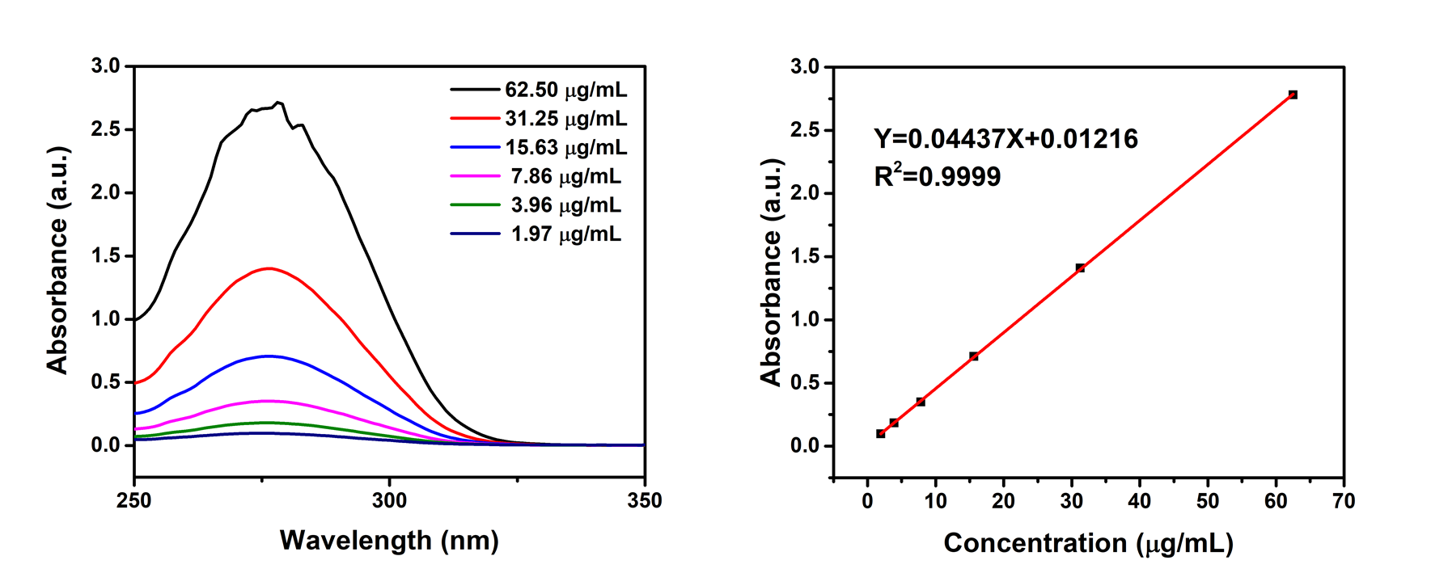
Fig. S1. The UV-Vis absorption spectrum and standard curve of DC.

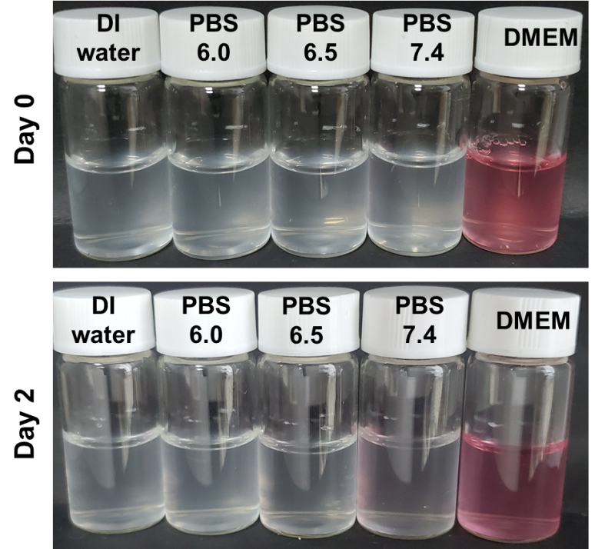
Fig. S2. Photographs of DC/DLM@PLGA nanoparticles dispersed in de-ionized water (DI water), PBS solution (pH 6.0, 6.5, 7.4) and DMEM culture medium.

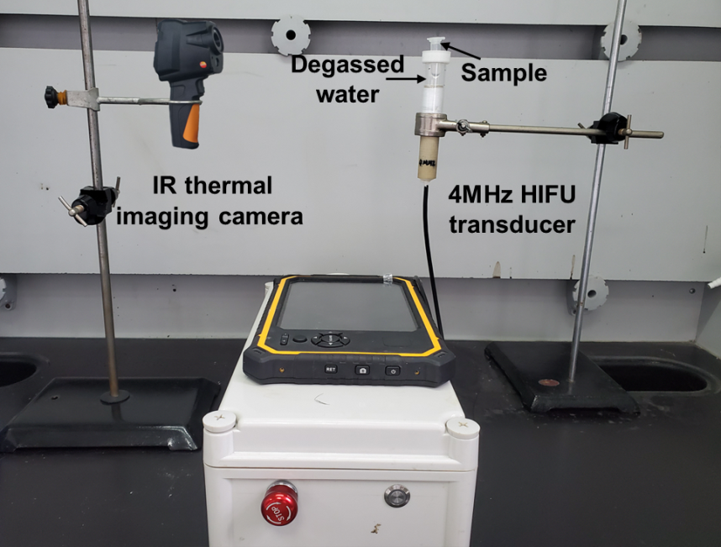
Fig. S3. Photographs of the device used to monitor the temperature changes of different dispersions (PLGA, DLM@PLGA, DC/DLM@PLGA) under HIFU irradiation.

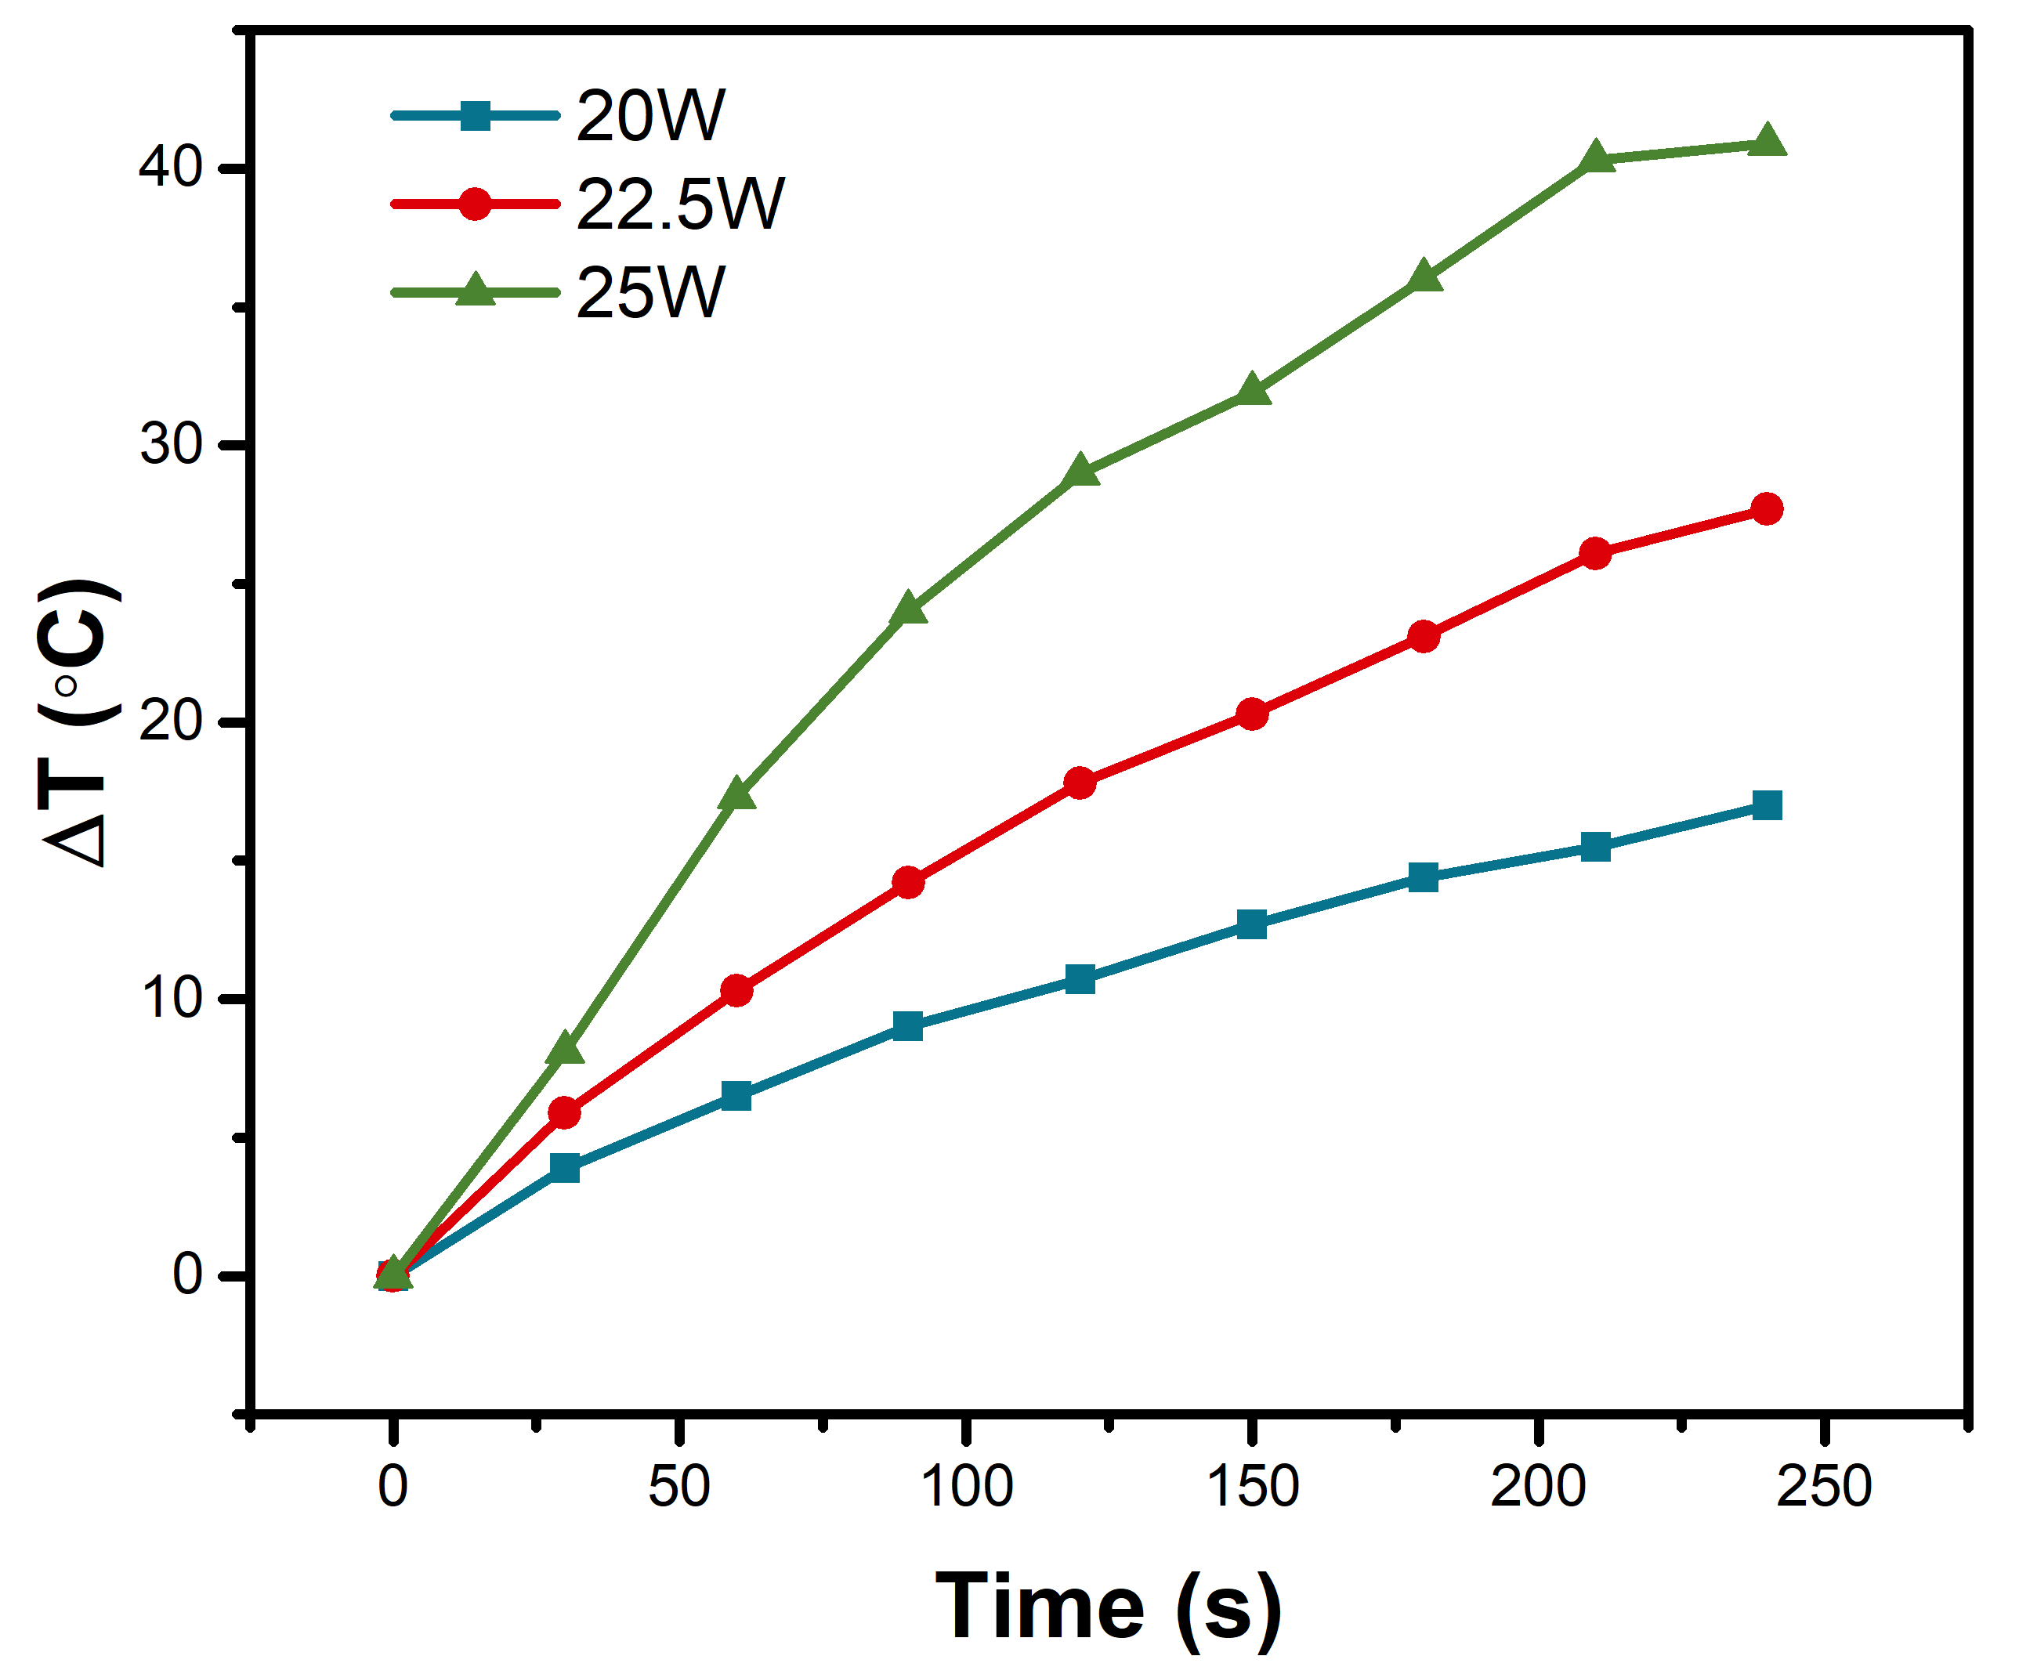
Fig. S4. The temperature variation profiles of PBS solution under different HIFU power.

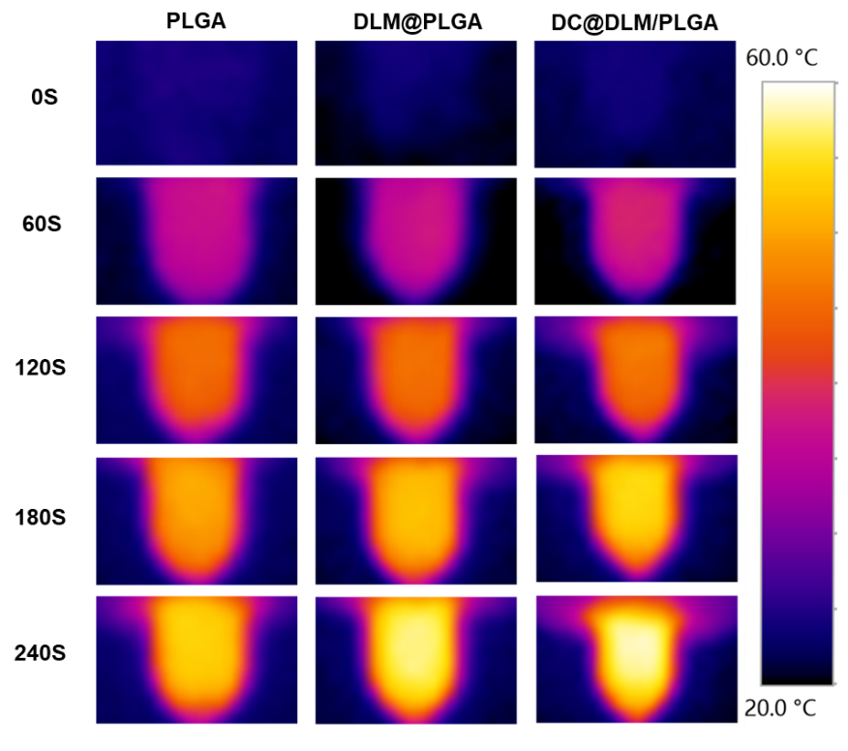
Fig. S5. In vitro thermal infrared images of PBS solution containing PLGA, DLM@PLGA or DC/DLM@PLGA after different HIFU irradiation times.

PBS
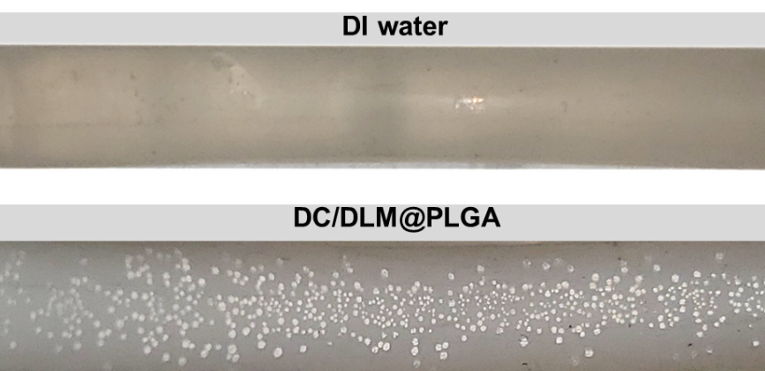
DC/DLM@PLGA

1 cm
Fig. S6. Photographs of a rubber tube containing PBS solution and DC/DLM@PLGA dispersion after 30 min in a 60 °C water bath.

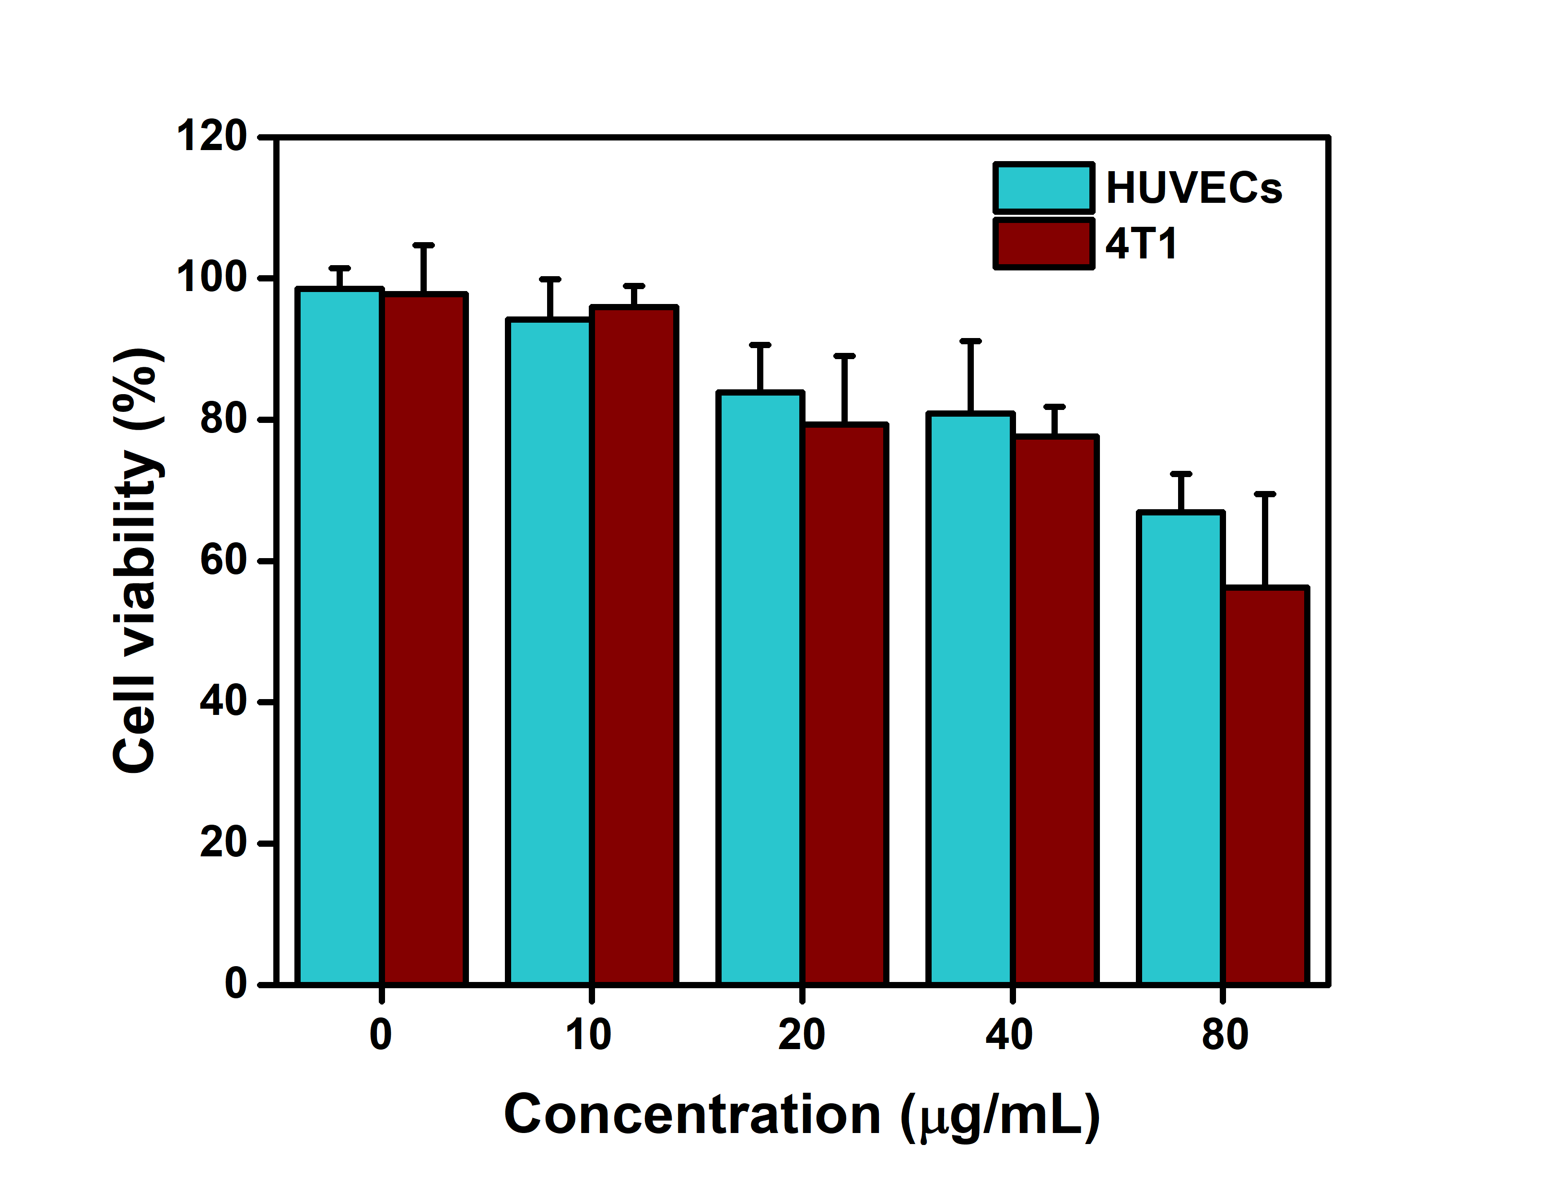
Fig. S7. Cytotoxicity of free DC with different concentrations to HUVECs and 4T1 cells.
Control
Pre-irradiation
120 s
60 s
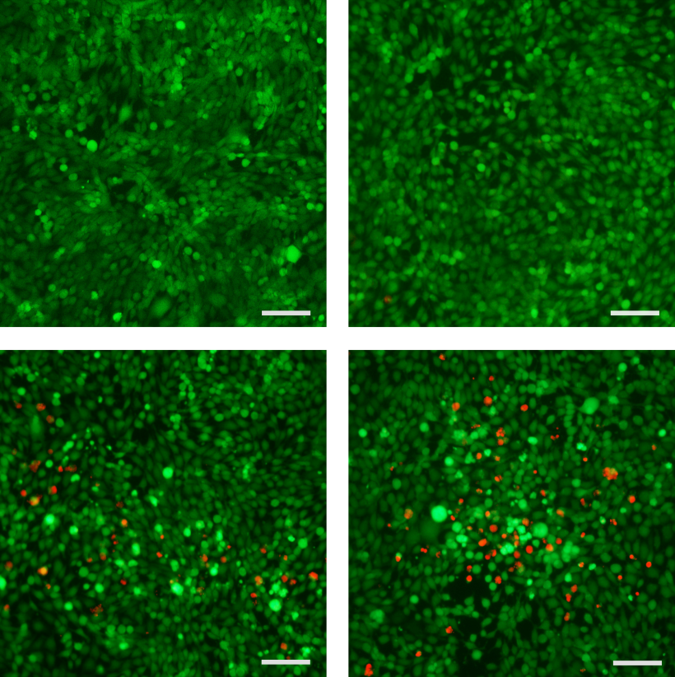
Fig. S8. Live/Dead staining imaging of 4T1 cells treated with PBS, DLM@PLGA, DLM@PLGA+HIFU (60 s) and DLM@PLGA+HIFU (120 s).
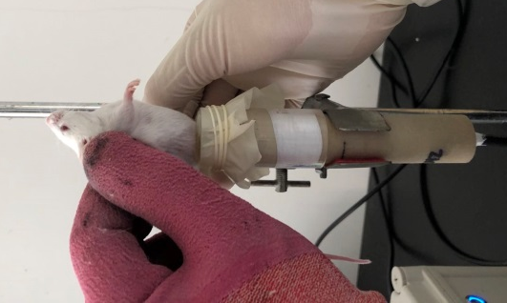
Fig. S9. Picture of the process of anti-tumor treatment of 4T1 tumor-bearing mice with DC/DLM@PLGA+HIFU irradiation.

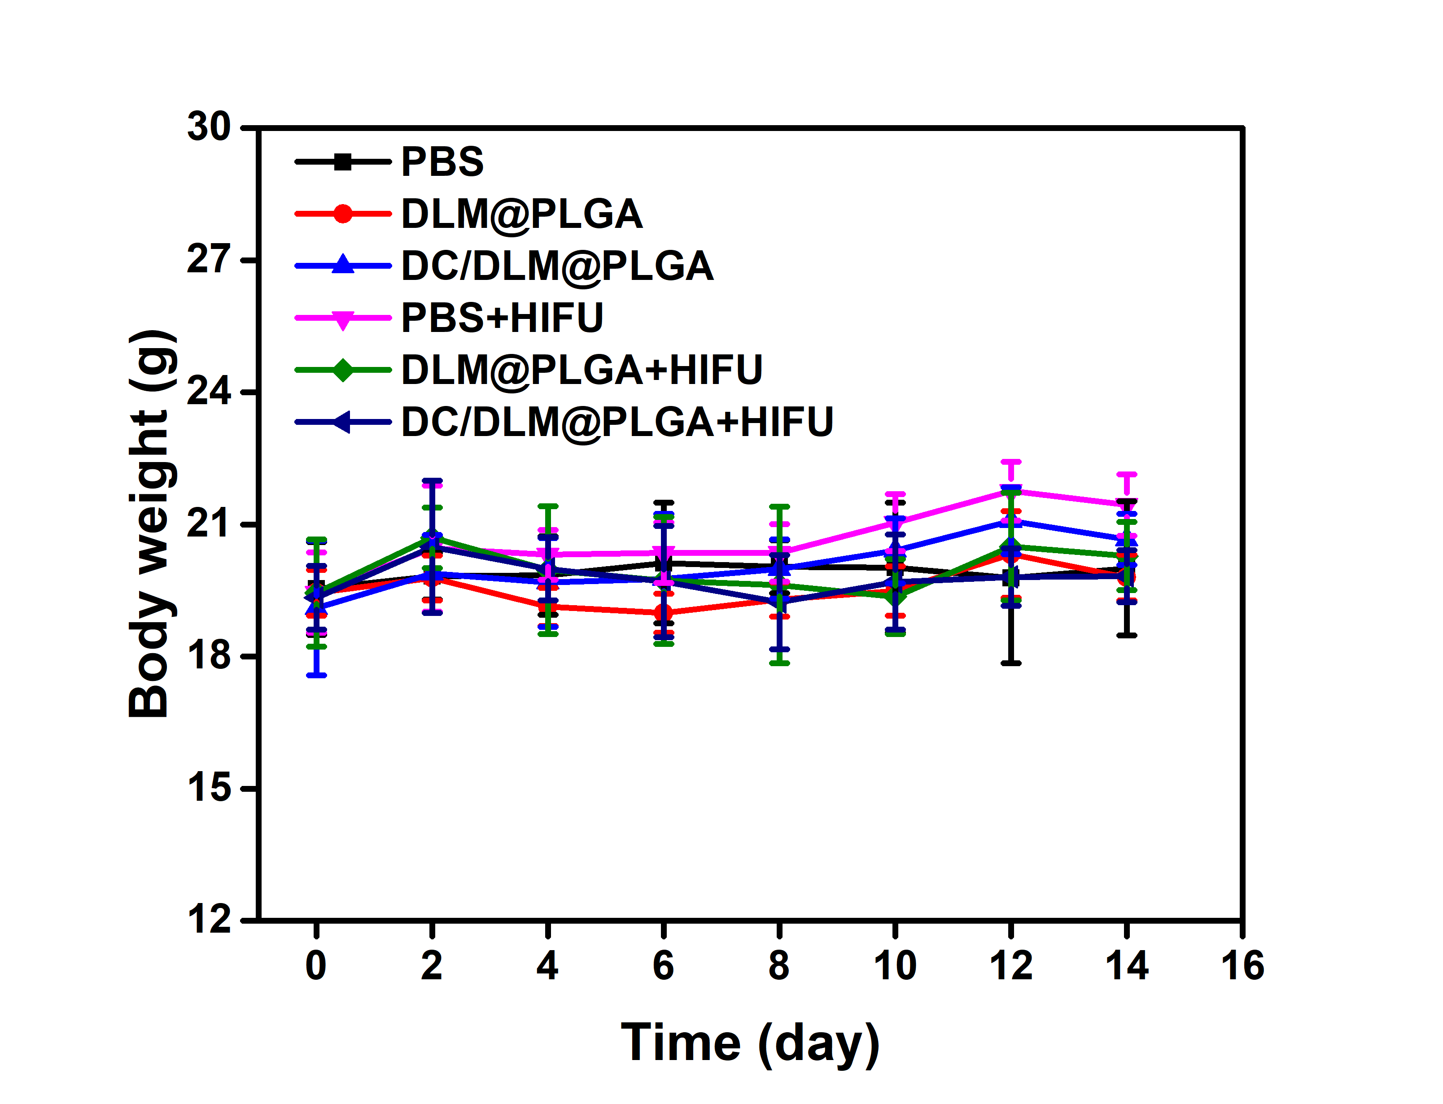
Fig. S10. Body weight change of 4T1 tumor-bearing mice after various treatments in 14 days.
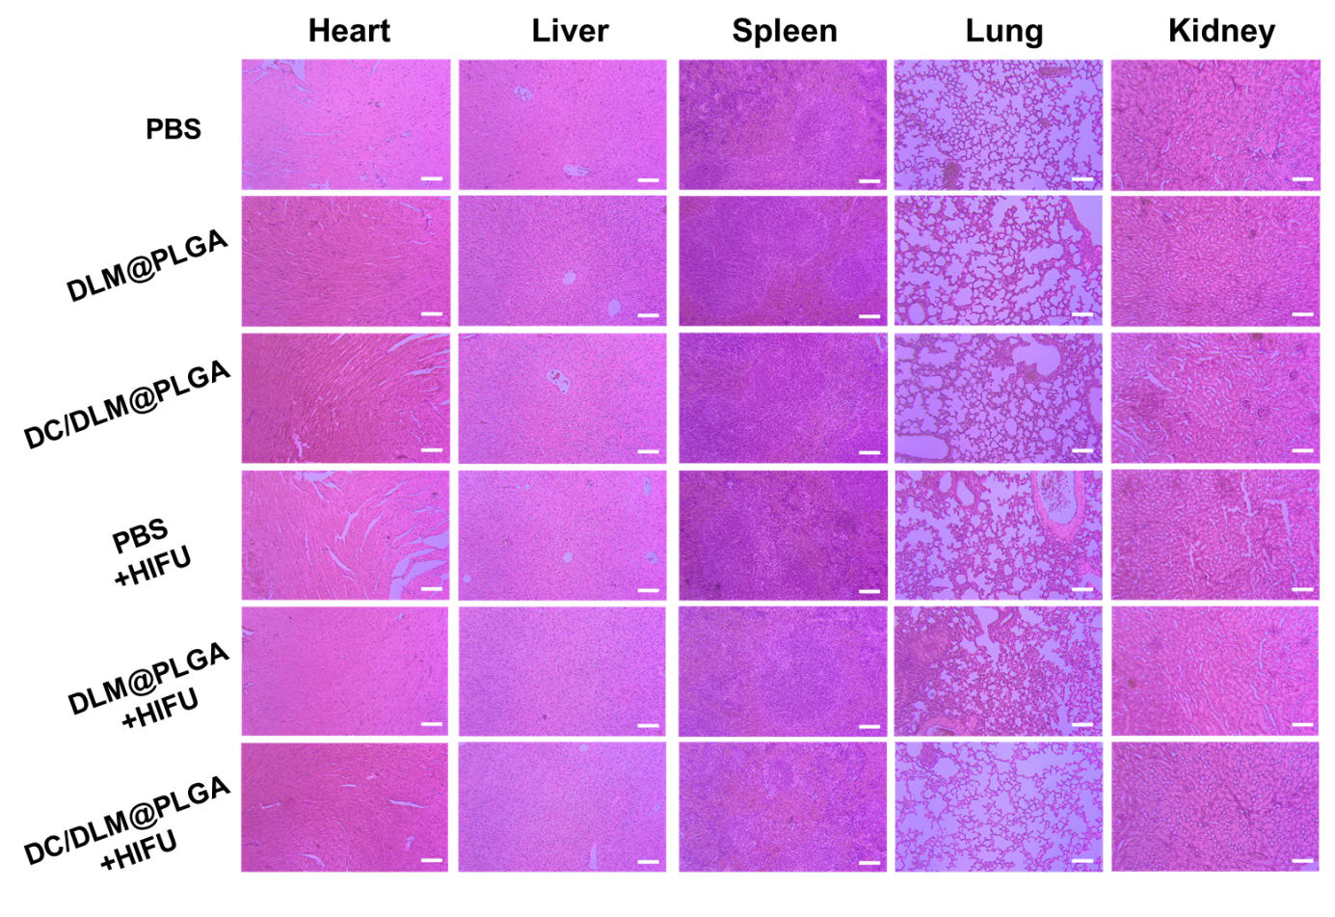
Fig. S11. H&E images of major organs extracted from different groups after treatments as indicated. Scale bar: 50 μm.

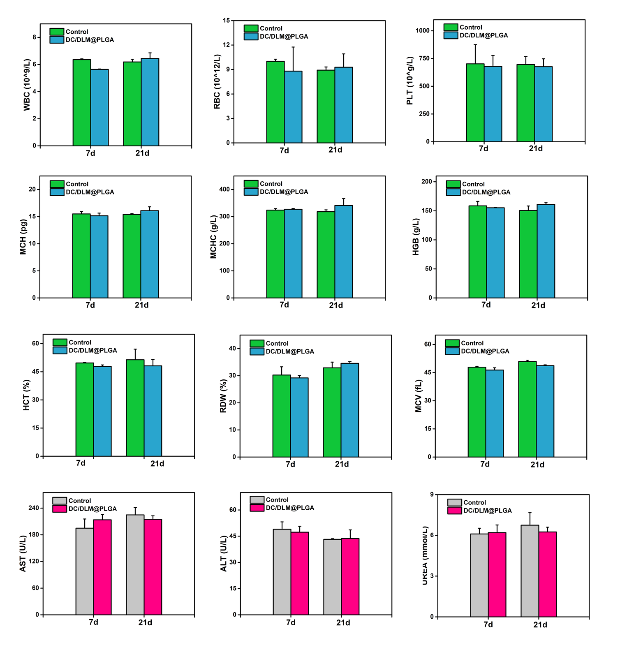
Fig. S12. Blood routine and blood biochemical indexes of mice treated with different treatments.

