Supplementary information
Light-Field-to-Bits Computing via an Online-Trainable Cascaded Optoelectronic Neural Network
Likuo Jia^{1#}, Hongqiang Zhou^{1#}, Tianlong Man¹, Xunbo Yu², Sheng Shen³，Liangcai Cao⁴, Yuhong Wan¹
- School of Physics and Optoelectronic Engineering, Beijing University of Technology, Beijing, 100124, China
- State Key Laboratory of Information Photonics and Optical Communications, Beijing University of Posts and Telecommunications (BUPT), Beijing, 100876, China
- China Mobile Group Design Institute Co., Ltd., Beijing, 100080, China
- State Key Laboratory of Precision Measurement Technology and instruments, Department of Precision instrument, Tsinghua University, Beijing, 100084, China
#Authors contributed equally to this work.

This supplementary material provides detailed computing model data mentioned in the main text.
Supplementary Note 1. Architecture of the physics-assisted surrogate model
The physics-assisted surrogate model was developed to approximate the input-dependent response of the physical free-space optical system while maintaining a differentiable physical propagation framework for end-to-end optimization. Instead of directly learning an unconstrained mapping from the input image to the camera intensity distribution, the model embeds learnable corrections into an analytical angular spectrum method (ASM) propagation framework. The detailed configurations and physical roles of the individual modules are summarized in Supplementary Table S1.
Let ($A_{in}\left(x,y\right)$) denote the input optical amplitude and ($ϕ_{1}\left(x,y\right)$) denote the phase pattern loaded onto the physical spatial light modulator (SLM). The input field is first numerically propagated over a distance of ($z_{0}=5cm$) to the SLM plane:
$U_{0}\left(x,y\right)=P_{z_{0}}\left[A_{in}\left(x,y\right)\right]$ (S1)
where ($P_{z}$) denotes ASM-based free-space propagation over a distance (z). The complex field ($U_{0}$) contains both the amplitude and phase accumulated during propagation from the input plane to the SLM plane.
Learnable SLM response correction
To account for deviations between the commanded SLM phase and the effective phase modulation produced by the physical device, a learnable pixel-wise response module was formulated to account for this nonlinear phase behavior of SLM. This module consists of two ($1×1$) convolutional layers with an intermediate Gaussian error linear unit (GELU) activation. It receives the commanded phase pattern ($ϕ_{cmd}$) and predicts a phase-dependent correction:
$Δϕ_{SLM}=f_{LUT}\left(ϕ_{cmd}\right)$ (S2)
where$f_{LUT}$ denotes the learnable SLM response module. The effective phase modulation is then expressed as
$ϕ_{eff}=ϕ_{cmd}+Δϕ_{SLM}$ (S3)
Because the ($1×1$) convolutions operate independently at each spatial location, this module acts as a differentiable approximation of the nonlinear phase response of the SLM.
Residual prediction of hardware-induced field distortions
The amplitude of the propagated field at the SLM plane, ($\left|U_{0}\right|$), is concatenated with the effective SLM phase ($ϕ_{eff}$) to form a two-channel feature tensor:
$X=\operatorname{Concat}\left(\left|U_{0}\right|,ϕ_{eff}\right)$ (S4)
The feature tensor is processed by a residual convolutional network. The first convolutional layer uses a ($3×3$) kernel to map the two input channels to 32 feature channels, followed by a ReLU activation. Three residual blocks are subsequently employed. Each residual block contains two ($3×3$) convolutional layers and an identity shortcut connection:
$F_{l+1}=F_{l}+\operatorname{Conv}{3×3}\left(\operatorname{ReLU}\left(\operatorname{Conv}{3×3}\left(F_{l}\right)\right)\right)$ (S5)
The residual structure enables the network to learn deviations from the ideal physical model rather than reconstructing the complete optical propagation process from data alone.

A final ($3×3$) convolutional layer maps the 32-channel feature representation to two output channels. The first channel predicts a spatial amplitude correction, whereas the second channel predicts a phase aberration:
$α\left(x,y\right)=\operatorname{sigmoid}\left(O_{1}\left(x,y\right)\right)$ (S6)
$Δϕ\left(x,y\right)=π\tanh\left(O_{2}\left(x,y\right)\right)$ (S7)
where ($O_{1}$) and ($O_{2}$) are the two output feature maps. The amplitude correction ($α$) describes spatially varying attenuation, while ($Δϕ$) represents hardware-induced phase aberrations and propagation errors.
The corrected complex field immediately after the physical phase layer is written as
${\overset{˜}{U}}_{1}\left(x,y\right)=α\left(x,y\right)U_{0}\left(x,y\right)\exp\left[iϕ_{eff}\left(x,y\right)\right]\exp\left[iΔϕ\left(x,y\right)\right]$ (S8)
The corrected field is then propagated over the physical distance ($z_{1}=20 cm$) from the phase SLM to the camera plane:
${\tilde{U}}_{cam}\left(x,y\right)=P_{z_{1}}\left[{\tilde{U}}_{1}\left(x,y\right)\right]$ (S9)
The surrogate-predicted camera intensity is finally obtained as
${\hat{I}}_{cam}\left(x,y\right)={\left|{\tilde{U}}_{cam}\left(x,y\right)\right|}^{2}$ (S10)
Therefore, the surrogate model retains the analytical structure of free-space diffraction while introducing only the learnable corrections required to describe the non-ideal physical hardware.
Offline initialization and online refinement
The training procedure consisted of an offline warm-start stage followed by online refinement. During the warm-start stage, the surrogate model was pretrained using experimentally acquired tuples containing the input amplitude, SLM phase pattern, and camera intensity. This initialization allowed the model to learn the dominant static characteristics of the optical system before joint optimization.
During online training, the current input amplitude and physical phase pattern were displayed on the experimental platform, and the corresponding intensity distribution was captured by the camera. The surrogate parameters were then updated to reduce the discrepancy between the predicted and measured intensities. When the diffractive phase parameters were subsequently optimized, the surrogate-model parameters were held fixed, while the task loss was backpropagated through the differentiable surrogate to the physical phase pattern.
This alternating optimization strategy allows the surrogate model to continuously track changes in the physical optical response while providing hardware-aware gradients for updating the diffractive network. Consequently, the optimized phase profiles are not restricted to an ideal numerical propagation model but are adapted to the actual operating condition of the experimental optoelectronic system.
Supplementary Note 2. Complete LFB conversion results and learned phase distributions
To provide a complete visualization of the LFB encoding behavior, Supplementary Fig. S1 presents the full qualitative conversion results for both tasks studied in this work, including the hexadecimal optical encoding task and the traffic-sign-based visual encoding task. For each task, all 16 input classes are shown together with the corresponding surrogate-simulated outputs and hybrid optoelectronic outputs. The decoded 4-bit codeword is annotated above each output, and the predefined differential ROIs are highlighted to indicate the physical intensity comparison used for binary readout.
In addition to the output intensity distributions, Supplementary Fig. S1 also shows the learned phase distributions of the two diffractive layers for the two tasks. The first phase distribution corresponds to the physical optical diffractive layer implemented on the phase-type SLM, whereas the second phase distribution corresponds to the electronic diffractive layer executed in the digital domain. The different optimized phase patterns obtained for the hexadecimal and traffic-sign tasks indicate that the proposed system establishes task-specific optical field modulation for different LFB mapping objectives.
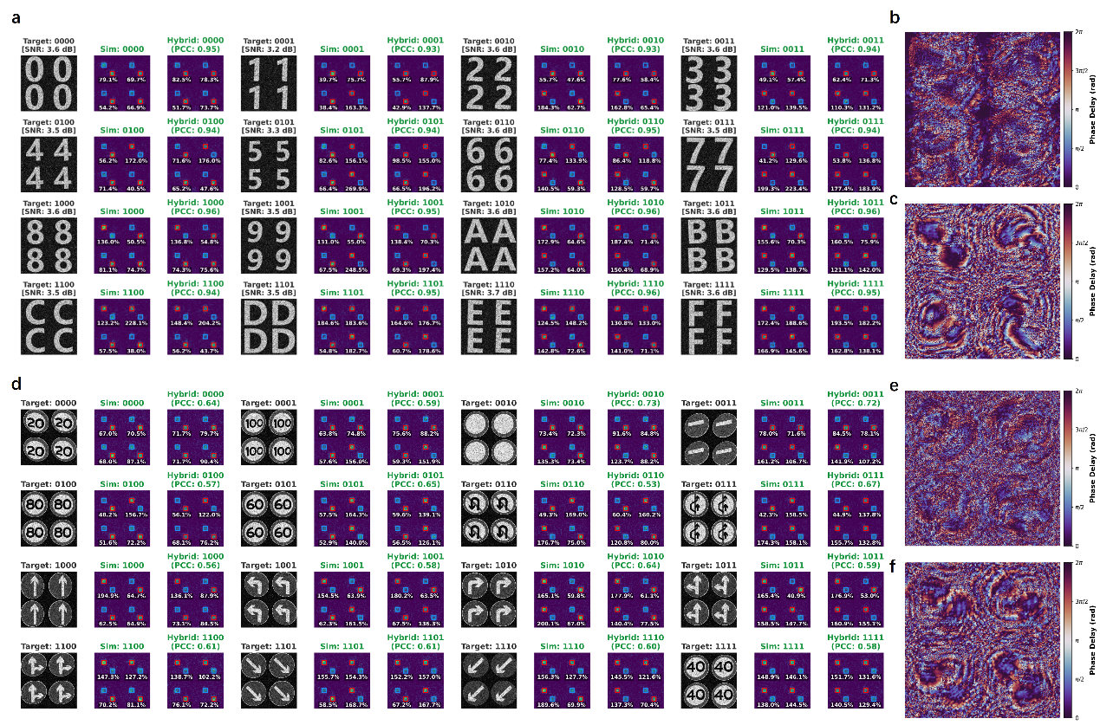
Supplementary Fig. S1 Complete LFB conversion results and learned phase distributions for the hexadecimal and traffic-sign tasks.
(a) Full qualitative conversion results for all 16 hexadecimal input classes. For each class, the target amplitude pattern, surrogate-simulated output, and hybrid optoelectronic output are shown together with the decoded 4-bit codeword. The red and blue boxes indicate the predefined differential ROI pairs used for binary readout. (b,c) Learned phase distributions of the two diffractive layers for the hexadecimal encoding task, where (b) corresponds to the physical optical diffractive layer and (c) corresponds to the electronic diffractive layer. (d) Full qualitative conversion results for all 16 traffic-sign input classes. Each traffic-sign class is assigned to a predefined 4-bit binary codeword, demonstrating the extension of the proposed LFB encoder from regular symbolic patterns to semantically distinct visual inputs. (e,f) Learned phase distributions of the two diffractive layers for the traffic-sign-based visual encoding task, where (e) corresponds to the physical optical diffractive layer and (f) corresponds to the electronic diffractive layer. PCC values quantify the global similarity between the surrogate-simulated and hybrid optoelectronic intensity distributions, whereas the decoded codewords are determined by the relative intensity ordering within the differential ROI pairs.
Supplementary Note 3 Ablation analysis of the physics-assisted surrogate model
To evaluate the contribution of the physics-assisted surrogate model, we performed a controlled ablation study using 256 input instances for each configuration. The test set consisted of 16 normal hexadecimal inputs and 240 augmented inputs. For each of the 16 classes, one unperturbed input and 15 augmented variants were included. The augmented inputs were generated by introducing random noise and geometric deformations to the original patterns.
Two sets of diffractive phase profiles were independently optimized before evaluation. The first set was trained using the ideal angular spectrum method (ASM) without hardware-aware correction, whereas the second set was trained using the physics-assisted surrogate model. During subsequent evaluation, all phase profiles were fixed, and no further parameter update or online refinement was performed. Four configurations were considered: numerical simulation without the surrogate model (Sim-NoProxy), numerical simulation with the surrogate model (Sim-WithProxy), physical hardware deployment without the surrogate model (Hardware-NoProxy), and physical hardware deployment with the surrogate model (Hardware-WithProxy). For brevity, the surrogate-assisted and non-surrogate configurations are denoted as WithProxy and NoProxy, respectively. The same predefined differential regions of interest (ROIs) and bit-decoding criterion were used for all configurations.
We first compared the physical hardware performance under normal and augmented input conditions. As shown in Supplementary Fig. S2a, the Hardware-NoProxy configuration achieved a complete 4-bit encoding accuracy of 68.75% for the 16 normal inputs. Its performance decreased to 45.42% for the 240 augmented inputs. In contrast, the Hardware-WithProxy configuration correctly decoded all normal inputs, achieving an accuracy of 100%, and maintained an accuracy of 95.00% under the augmented conditions. These results show that the phase profiles optimized with the physics-assisted surrogate are substantially more robust to input perturbations than those optimized using the ideal propagation model alone.
The corresponding bit error rates (BERs) are shown in Supplementary Fig. S2b. For the normal input subset, the BER decreased from 7.81% for Hardware-NoProxy to 0% for Hardware-WithProxy. Under augmented inputs, Hardware-NoProxy exhibited a BER of 17.40%, whereas Hardware-WithProxy maintained a low BER of only 1.25%. Therefore, surrogate-assisted optimization not only improves complete-codeword accuracy but also substantially suppresses bit-level errors under perturbed input conditions.
We further evaluated the overall hardware performance across all 256 test instances using multiple metrics, as summarized in Supplementary Fig. S2c. Without surrogate-assisted optimization, Hardware-NoProxy achieved a complete 4-bit encoding accuracy of 46.88% and a BER of 16.80%. After incorporating the physics-assisted surrogate model, the complete-codeword accuracy increased to 95.31%, while the BER decreased to 1.17%. In addition to the task-level decoding metrics, the ROI-level correlation between the target and measured optical responses increased from 0.6156 to 0.7938, while the ROI mean-squared error decreased from 0.1617 to 0.1010. These results indicate that the surrogate-assisted phase optimization improves both the binary decoding performance and the consistency of optical energy routing within the predefined readout regions.
For the Hardware-WithProxy configuration, 244 of the 256 input instances were correctly decoded, corresponding to a complete-codeword accuracy of 95.31%. The 16 normal inputs were all correctly decoded, whereas 228 of the 240 augmented inputs were correctly decoded, yielding an augmented-input accuracy of 95.00%. The remaining 12 codeword errors correspond to single-bit decoding errors in the final confusion matrix. Consequently, only 12 of the total 1024 output bits were incorrect, resulting in an overall BER of 1.17%. This distinction between complete-codeword accuracy and BER indicates that the remaining decoding errors are sparse at the bit level rather than involving large deviations across multiple bit channels.
Finally, we compared the overall complete-codeword accuracy of the four configurations, as shown in Supplementary Fig. S2d. Sim-NoProxy achieved an accuracy of 57.81%, whereas Hardware-NoProxy achieved 46.88%. The lower physical-hardware performance illustrates the degradation that occurs when phase profiles optimized without hardware-aware correction are transferred to the experimental system. After surrogate-assisted optimization, the numerical Sim-WithProxy configuration achieved 93.75% accuracy, while the physical Hardware-WithProxy configuration reached 95.31%. The substantial improvement observed in both simulation and hardware confirms that incorporating experimentally learned hardware deviations into the optimization process enables more reliable task-oriented optical energy routing.
Overall, the ablation results demonstrate that the physics-assisted surrogate model plays an important role in bridging the discrepancy between ideal numerical propagation and the actual optical hardware response. Across the 256-input test set, surrogate-assisted optimization increased the physical complete-codeword accuracy from 46.88% to 95.31% and reduced the BER from 16.80% to 1.17%. Under the more challenging augmented conditions, the encoding accuracy increased from 45.42% to 95.00%, while the BER decreased from 17.40% to 1.25%. Together with the improvements in ROI-level correlation and mean-squared error, these results demonstrate that the surrogate-assisted framework produces phase designs that are better adapted to the physical optical system and maintain reliable LFB encoding under input perturbations.
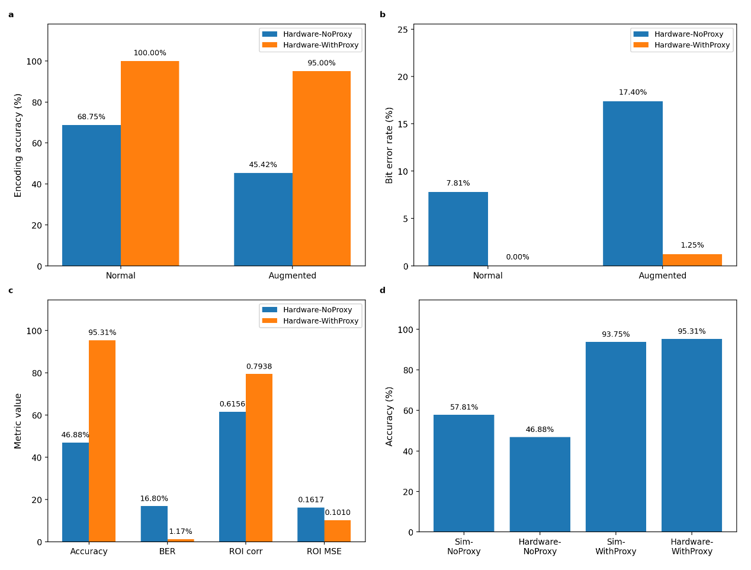
Supplementary Fig. S2 Ablation analysis of the physics-assisted surrogate model. (a) Hardware complete-codeword encoding accuracy for normal and augmented inputs, comparing Hardware-NoProxy and Hardware-WithProxy. The test set contains 16 normal inputs and 240 augmented inputs. (b) Corresponding bit error rate (BER) under normal and augmented conditions. (c) Overall hardware performance across all 256 test instances, including complete-codeword accuracy, BER, ROI-level correlation, and ROI mean-squared error. (d) Overall complete-codeword accuracy of the Sim-NoProxy, Hardware-NoProxy, Sim-WithProxy, and Hardware-WithProxy configurations. Surrogate-assisted optimization substantially improves both numerical and physical encoding performance, with the Hardware-WithProxy configuration achieving a final complete-codeword accuracy of 95.31%.

Supplementary Table S1 Layer-wise architecture and physical roles of the physics-assisted surrogate model.
Stage | Module | Architecture / Configuration | Physical Role and Output
Input propagation | Physical propagation I | Angular spectrum method (ASM), z₀ = 5 cm | Propagates the incident light field $A_{in}\left(x,y\right)$ to the SLM plane, producing $U₀\left(x,y\right)$.
SLM calibration | SLM response correction | 1×1 Conv → GELU → 1×1 Conv | Learns nonlinear deviations between commanded phase $Φ_{cmd}$ and effective phase, outputting $Φ_{eff}$.
Feature fusion | Input concatenation | Concatenate $A_{in}$ and $Φ_{eff}$ | Produces a 2-channel feature tensor containing amplitude and effective phase.
Feature extraction | Initial convolution | 3×3 Conv, 2→32 channels, ReLU | Maps 2-channel input to 32-channel feature representation for hardware-error modeling.
Residual correction | Residual backbone | 3 Residual Blocks (each 2×3×3 Conv + skip connection) | Extracts hardware-induced distortions.
Field-parameter prediction | Output convolution | 3×3 Conv, 32→2 channels | Produces amplitude and phase correction maps.
Physical modulation | Amplitude branch | Sigmoid activation | Outputs $α\left(x,y\right)$, the amplitude attenuation map.
Physical modulation | Phase branch | tanh × π | Outputs $ΔΦ\left(x,y\right)$, the phase perturbation map.
Complex-field assembly | Corrected light field | $${\tilde{U}}_{perturbed}\left(x,y\right)=α\left(x,y\right) A_{in}\left(x,y\right) e^{iΦ_{eff}\left(x,y\right)} e^{iΔΦ\left(x,y\right)}$$ | Combines amplitude, phase, and corrections into the reconstructed complex field.
Output propagation | Physical propagation II | ASM, z₁ = 20 cm | Propagates $Ũ_{perturbed}$ to camera plane, producing $Ũ_{cam}\left(x,y\right)$.
Intensity readout | Camera-plane intensity | $$\left|Î_{cam}\left(x,y\right)\right|²$$ | Predicted camera intensity for comparison with experimental measurements.
Supplementary Note 4: Modeling of optoelectronic hardware degradation
To evaluate the robustness of the proposed optoelectronic architecture under non-ideal readout conditions, we introduced a composite hardware degradation model that emulates two representative flaws in practical sensor-based systems: defective pixels and limited ADC precision.
For sensor defects, the captured intensity was degraded using a Bernoulli random mask. We model this spatial degradation using a Bernoulli masking matrix. Let $I\left(x,y\right)$ represent the ideal continuous intensity distribution at the focal plane, and $I'\left(x,y\right)$ represent the degraded captured intensity. The spatial masking is defined by the Hadamard product:
$I'\left(x,y\right)=M\left(x,y\right)⊙I\left(x,y\right)$ (S11)
where the mask $M\left(x,y\right)$ is composed of independent and identically distributed random variables following a Bernoulli distribution: $M\left(x,y\right)∼\text{Bernoulli}\left(1-p_{d}\right)$.Here, $p_{d}$ denotes the dead pixel ratio.
To further simulate the finite precision of sensor readout circuits, a uniform ADC quantization model was applied to the degraded intensity signal. For an ADC bit-width of b, the signal was discretized into $2^{b}$ levels within the full-scale range ($\left[V_{min},V_{max}\right]$). The quantization step was defined as
$Δ=\frac{V_{max}-V_{min}}{2^{b}-1}$ (S12)
This degradation model was used to examine whether the proposed ROI-based differential readout mechanism can preserve reliable classification performance under severe pixel loss and low-bit quantization.
Supplementary Note 5: Theoretical Evaluation of Computational Complexity and Throughput
To quantify the computational capacity of the proposed hybrid optoelectronic network, we evaluate the algorithmic complexity and equivalent operations of both the physical diffractive and digital electronic layers per forward pass. The primary physical optical layer executes high-dimensional feature extraction via free-space diffraction. Because the forward wave propagation maps each of the $N$ input spatial modes to all $M$ output modes on the intermediate sensor plane, this passive physical process is mathematically isomorphic to a fully connected matrix-vector multiplication (MVM). For an operational resolution of $400×400$ pixels ($N=M=160,000$), the single-layer physical diffractive modulation yields an equivalent computational workload defined as:
${\text{Ops}}_{\text{optical}}=2×N×M$ (S13)
This equates to approximately $51.2×{10}^{9}$ equivalent operations (OPs), or $25.6$ Giga-multiply-accumulate (GMAC) operations per inference, which are executed passively within a $∼1.16$ ns time-of-flight. Conversely, the secondary electronic layer performs spatial feature aggregation in the digital domain. To avoid the brute-force $O\left(N^{2}\right)$ computational overhead, this layer is implemented using the Fast Fourier Transform (FFT)-based angular spectrum method (ASM). The theoretical complexity is thereby constrained to $O\left(N\log_{2}{N}\right)$, requiring approximately $30.1$ Mega-FLOPs (MFLOPs) per digital inference. The effective system-level operational throughput (${\text{T}}_{\text{sys}}$) is determined by the frame rate ($f$) of the synchronized hardware pipeline, expressed as:
${\text{T}}_{\text{sys}}={\text{Ops}}_{\text{optical}}×f=2NM⋅f$ (S14)
Operating at a system refresh rate of $f=60$ Hz, which is governed by the macroscopic SLM-CMOS response, the practical operational throughput of the proof-of-concept prototype scales to approximately $3.07$ Tera-Operations Per Second (TOPS).

hhzhou@bjut.edu.cn
yuxunbo@126.com
yhongw@bjut.edu.cn

