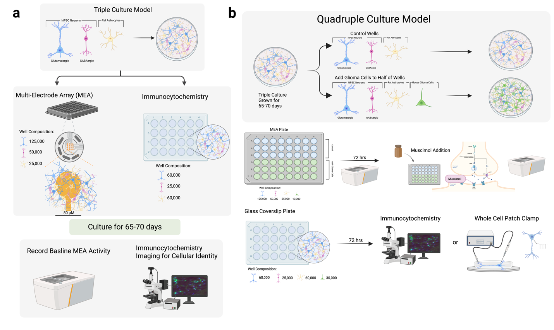
Supplementary Figure S1. Experimental workflow for the human iPSC-derived neuron–glioma culture model. (a) Human iPSC-derived glutamatergic and GABAergic neurons were cultured with rat astrocytes for 65–70 days to establish mature neuronal cultures for multi-electrode array (MEA) recordings and immunocytochemical characterization. (b) Following neuronal maturation, glioma cells were added to generate glioma-containing cultures alongside control neuronal cultures. MEA recordings were performed following glioma addition and GABAergic stimulation with muscimol. Parallel cultures grown on glass coverslips were used for immunocytochemistry and whole-cell patch-clamp electrophysiology [43].

