Supplementary Information for
Reactive-Intermediate Channelling from Interfacial Hydrogen Peroxide Generation to Confined Catalysis for Water Decontamination

Rongyao Wang^{a, b, 1*}, Weixin Li^{c, 1}, Haojing Yan^{b, 1}, Huabin Lianª, Xiaohua Ren^{b}, Feng Ru Fan^{c*}, Guo Zhu Chen^{a*}

a School of Chemistry and Chemical Engineering, University of Jinan, Jinan, Shandong 250022, PR China.
b School of Water Conservancy and Environment, University of Jinan, Jinan, Shandong 250022, PR China.
c State Key Laboratory of Physical Chemistry of Solid Surfaces, College of Chemistry and Chemical Engineering, Innovation Laboratory for Sciences and Technologies of Energy Materials of Fujian Province (IKKEM), Xiamen University, Xiamen 361005, China.

¹Rongyao Wang, Weixin Li and Haojing Yan contributed equally to this work.

*E-mail: stu_wangry@ujn.edu.cn
*E-mail: frfan@xmu.edu.cn
*E-mail: chm_chengz@ujn.edu.cn

Contents
Text S1. External H₂O₂ control experiments
Text S2. Analytical methods
Text S3. Operational quantification of H₂O₂ accumulation, background loss and pollutant-coupled consumption
Text S4. Fluoride determination
Text S5. Computational methods
Figure S1. N₂ adsorption–desorption isotherms (A) and pore size distributions (B) of different PTFE contents
Figure S2. EDS elemental mapping of (A) Cu/TS-1 and (B) PTFE@Cu/TS-1
Figure S3. iDPC-STEM images of (A) Cu/TS-1 and (B) PTFE@Cu/TS-1
Figure S4. ICP-MS analysis of Cu/TS-1 and PTFE@Cu/TS-1
Figure S5. FT-IR spectra of PTFE, Cu/TS-1, and 15wt%PTFE@Cu/TS-1
Figure S6. High-resolution XPS C 1s spectra of PTFE, Cu/TS-1, and PTFE@Cu/TS-1
Figure S7. High-resolution XPS (A) Ti 2p, (B) O 1s, (C) F 1s, and (D) Cu 2p spectra of PTFE, Cu/TS-1, and PTFE@Cu/TS-1
Figure S8. (A) Water contact angles and (B) images of PTFE, Cu/TS-1, and PTFE@Cu/TS-1 with different PTFE content
Figure S9. Surface potential changes of PTFE, PTFE@TS-1, and PTFE@Cu/TS-1 before and after the reaction
Figure S10. Information of MD models for PTFE+H₂O and PTFE+H₂O+H₂O₂ (The number of H₂O molecules is 50 and H₂O₂ is 1)
Figure S11. The MD simulation results at different times for PTFE+H₂O and PTFE+H₂O+H₂O₂ (The number of H₂O molecules is 50 and H₂O₂ is 1)
Figure S12. Radial distribution functions of interfacial water structures in PTFE–H₂O–HOOH
Figure S13. Charge redistribution analysis of the PTFE-water interface based on DFT calculations. The left panel displays the differential charge density map, visually indicating regions of electron gain (yellow) and loss (cyan)
Figure S14. DFT-calculated electrostatic potential profile of the PTFE-water interface
Figure S15. In situ ultrasonic ATR-FTIR spectra tracking the dynamic disruption of hydration networks and the generation of confined peroxide species in (A) Ti-free and (B) Ti-containing catalysts under ultrasonic excitation
Figure S16. N₂ adsorption–desorption isotherms (A) and pore size distributions (B) of Cu/TS-1 (fresh), TPABr treated Cu/TS-1, and thermal regenerated Cu/TS-1
Figure S17. XRD patterns of Cu/TS-1, TPABr treated Cu/TS-1, and thermal regenerated Cu/TS-1
Figure S18. N 1s XPS of TPABr treat Cu/TS-1
Figure S19. (A) C 1s, (B) Cu 2p, (C) O 1s, and (D) Ti 2p XPS of Cu/TS-1, TPABr treated Cu/TS-1, and thermal regenerated Cu/TS-1
Figure S20. Quasi-operando UV–vis diffuse reflectance spectra of TPABr-treated and thermally regenerated PTFE@Cu/TS-1 after ultrasonic activation
Figure S21. UV–vis diffuse reflectance spectra of PTFE@S-1 and PTFE@Cu/S-1 collected after ultrasonic stimulation
Figure S22. H₂O₂ generation and 2-FP removal for TPABr treated with different durations
Figure S23. MD simulations of H₂O₂ population evolution within different zeolitic frameworks over time
Figure S24. Effect of initial pollutant concentration. (A) Time-dependent degradation profiles of 2-FP at various initial concentrations and (B) the corresponding pseudo-first-order kinetic constants
Figure S25. Effect of ultrasonic power. (A) Time-dependent degradation profiles of 2-FP under varying ultrasonic powers and (B) the corresponding pseudo-first-order kinetic constant
Figure S26. Effect of catalyst dosage. (A) Time-dependent degradation profiles of 2-FP at different catalyst dosages and (B) the corresponding pseudo-first-order kinetic constants
Figure S27. Identification of 2-FP transformation products and their fragment ions by UPLC-QTOF-MS
Figure S28. (A) Optimized molecular structure and ESP distribution of 2-FP. (B) Frontier molecular orbitals, including HOMO and LUMO, of 2-FP. (C) Fukui function analysis of 2-FP, including electrophilic (f⁺), nucleophilic (f⁻), radical (f⁰) and dual descriptor (DD) distributions
Figure S29. Proposed degradation pathway of 2-FP during oxidation over PTFE@Cu/TS-1
Figure S30. Predicted (A) developmental toxicity, (B) mutagenicity, (C) bioconcentration factor and (D) acute aquatic toxicity (fathead minnow LC₅₀) of 2-FP and identified transformation products
Figure S31 Comparison of beans germination and early growth in 2-FP wastewater and treated water.
Figure S32. SEM images of PTFE@Cu/TS-1 (A) before and (B) after reaction
Figure S33. XRD patterns of PTFE@Cu/TS-1 before and after reaction
Figure S34 H₂O₂ concentration in the absence and presence of 2-FP through external H₂O₂ addition.
Figure S35. The effect of pre-adsorption time for 2-FP degradation
Figure S36. Time-resolved HPLC chromatograms of PMSO during reaction for probing oxygen-transfer activity
Figure S37. EPR spectra collected with DMPO spin trapping
Figure S38. (A) Ti 2p and (B) O 1s XPS of PTFE@Cu/TS-1 before and after reaction
Figure S39. Cu 2p XPS of PTFE@Cu/TS-1 before and after reaction
Figure S40. Spin-state evolution and orbital reorganization during the transformation from H₂O₂ to Ti–OOH and Ti–O–O–Cu intermediates
Figure S41. (A) Total spin-resolved PDOS of the Ti–O–O–Cu system. (B) Spin-resolved PDOS projected onto the peroxide O–O unit
Figure S42. (A) Total spin-resolved PDOS of the Ti–O–OH system. (B) Spin-resolved PDOS projected onto the peroxide O–O unit
Figure S43. Total spin-resolved PDOS of the Ti–O–OH–Cu system. (B) Spin-resolved PDOS projected onto the peroxide O–O unit
Figure S44. Orbital-resolved projected density of states of Cu–OOH and Ti–OOH
Figure S45. Orbital-resolved projected density of states of Ti–OO-Cu
Figure S46. Differential charge-density distributions of (A) Ti–OOH and (B) Cu–OOH intermediates
Figure S47. Differential charge-density distributions upon H₂O₂ coordination at Ti sites in (A) TS-1 and (B) Cu/TS-1
Figure S48. Optimized structures of reaction intermediates along the H₂O₂ activation pathway on TS-1
Figure S49. Optimized structures of reaction intermediates along the H₂O₂ activation pathway on Cu/TS-1
Figure S50. Illustration of the scaling-up process for a flow-through device
Text S1. External H₂O₂ control experiments
To distinguish peroxide accumulation from peroxide utilization, external H₂O₂ control experiments were performed under identical reaction conditions.
For externally supplied H₂O₂ experiments, H₂O₂ solution was added to the reaction suspension at a predetermined concentration (0.30 mmol/L unless otherwise stated). Reactions were conducted in the presence or absence of 2-FP under identical ultrasonic conditions.
Four paired systems were evaluated: (i) CEC-driven H₂O₂ accumulation without pollutant; (ii) CEC-driven oxidation with 2-FP; (iii) externally supplied H₂O₂ decay without pollutant; (iv) externally supplied H₂O₂ consumption during 2-FP oxidation.
These paired experiments were used to distinguish apparent H₂O₂ accumulation, background H₂O₂ loss, and pollutant-coupled H₂O₂ consumption.

Text S2. Analytical methods
Quantification of 2-FP. 2-FP concentrations were determined using a Shimadzu LC-20A HPLC system coupled with a QTRAP 3200 MS/MS (AB Sciex) equipped with an electrospray ionization source (ESI⁻). For HPLC separation, a 5 μL sample was loaded onto an Eclipse XDB C18 (2 μm, 2.1 × 100 mm) eluted with 0.3 mL min⁻¹ of 0.1% (v/v) acetic acid in water (A) and acetonitrile (B). The gradient program was: 0-2 min, 20-60% B; 2-6 min, 60-95% B; 6-10 min, hold at 95% B; 10-10.1 min, 95-20% B; 10.1-12 min, 20% B. MS parameters: curtain gas 30 psi, source temperature 350 °C, collision gas medium, GS1 = 50 psi, GS2 = 55 psi, and ion spray voltage –3500 V.
Quantification of H₂O₂. H₂O₂ concentrations were determined using a titanium sulfate colorimetric method. A hydrogen peroxide solution with a standard concentration of 1000 ppm was diluted to concentrations of 1.25, 2.5, 5, 10, and 20 ppm. To each 2 mL diluent, 1 mL of 0.1 M C₄H₂K₂O₁₀Ti solution was added. A 3 mL sample of the mixed solution was taken for UV-vis absorbance testing, with the absorbance at 385 nm used as the characteristic value. The standard curve was drawn based on the corresponding hydrogen peroxide concentrations.
Identification of intermediates. Intermediates were analyzed via ultraperformance liquid chromatography coupled with Quadrupole Time-of-Flight Mass Spectrometry (UPLC-QTOF MS, USA). The mobile phase comprised 5 mM ammonium acetate (Phase A) and methanol (Phase B), delivered at a flow rate of 0.2 mL min⁻¹. The gradient elution program initiated with a 3-minute hold at 95% Phase A, followed by a transition to 10% Phase A over 12 minutes and a subsequent 10-minute hold. The program then reverted to 95% Phase A within 5 minutes, with an additional 5-minute hold. MS analysis was performed in negative ion mode, scanning a mass-to-charge ratio (m/z) range of 50 to 1000. MS parameters: gas 1 = 55 psi, gas 2 = 55 psi, temperature 550 °C, voltage –4500 V, curtain gas 35 psi, declustering potential –100 V, collision energy –10 V.
TOC and fluoride analyses. Total organic carbon (TOC) was measured with a Shimadzu TOC-L CPH analyzer. Fluoride ion concentrations were determined as described in Test S7.
For mechanistic investigations, in situ ultrasonic attenuated total reflection Fourier transform infrared (ATR-FTIR) spectroscopy was performed on a Thermo Fisher Nicolet iS50 spectrometer equipped with a customized ultrasonic cell to track transient peroxide intermediates. In situ UV-vis diffuse reflectance spectroscopy (DRS) was conducted on a PerkinElmer Lambda 950 spectrophotometer. Electron paramagnetic resonance (EPR) spectroscopy (Bruker EMXplus) was employed to identify reactive oxygen species (ROS) with DMPO and TEMP as spin traps.

Text S3. Operational quantification of H₂O₂ accumulation, background loss and pollutant-coupled consumption
To evaluate peroxide utilization during oxidation, paired experiments were conducted under CEC and externally supplied H₂O₂ conditions.
The apparent H₂O₂ accumulation during CEC operation was defined as the bulk H₂O₂ concentration measured in the absence of pollutant:
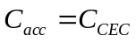
Where C_{CEC} represents the measurable H₂O₂ concentration accumulated in solution.
For externally supplied H₂O₂ systems, the initial H₂O₂ concentration (C₀) was partitioned into three operational fractions:
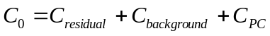
where: C_{residual} represents the remaining H₂O₂ concentration in bulk water after reaction; C_{background} represents H₂O₂ loss in the absence of pollutant; C_{PC} represents pollutant-coupled H₂O₂ consumption.
The background H₂O₂ loss was calculated as:
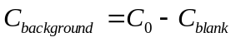
where C_{blank} is the residual H₂O₂ concentration measured without 2-FP.
The pollutant-coupled H₂O₂ consumption was calculated as:
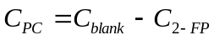
where C_{2-FP} is the residual H₂O₂ concentration measured in the presence of 2-FP.
To compare the coupling efficiency between peroxide consumption and contaminant transformation, an apparent H₂O₂ utilization index was defined:
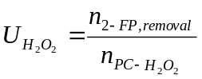
where n_{2-FP,removed} represents the amount of 2-FP removed and n_{PC-H2O2} represents the amount of pollutant-coupled H₂O₂ consumption. This index reflects the apparent efficiency with which consumed H₂O₂ contributes to pollutant transformation.

Text S4. Fluoride determination
Fluoride ion concentrations were measured using a fluoride ion-selective electrode (PXSJ-216F, INESA Scientific Instrument) with a total ionic strength adjustment buffer (TISAB).
TISAB was prepared by dissolving 85.0 g NaNO₃ and 58.5 g Na₃C₆H₅O₇‧3H₂O in deionized water and diluting to 1000 mL; the pH was adjusted to 5.5 with HCl.
For measurement, a 5 mL sample was mixed with 5 mL TISAB and diluted to 40 mL with Milli-Q water. The F⁻ concentration was then recorded using the ion-selective electrode.
Text S5. Computational methods
MD simulations of H₂O₂ transport in MFI frameworks. MD simulations were conducted using the LAMMPS software package for the Cu/TS-1, and Cu/S-1 systems. The simulations employed the UFF all-atom force field for cof, with water molecules described using the SPCE all-atom force field to model molecular interactions. The van der Waals interaction cutoff radius was set to 10 Å, and long-range electrostatic interactions were handled via the PPPM method. The systems were first equilibrated at 300 K in the NPT ensemble for 1 ns, followed by equilibration at 1 atm in the NVT ensemble for 1 ns, and finally subjected to 3 ns of NVT simulation with a time step of 1 fs. Temperature control was achieved using the Nosé–Hoover heat bath method, and pressure control was implemented using the Berendsen coupling method. Based on the simulation trajectories, we calculated the mean square displacement (MSD).
$$MSD\left(Δt\right)=〈{\left|\vec{Δr}\left(Δt\right)\right|}^{2}〉=\frac{1}{N}\sum_{i=1}^{N}{〈{\left|\vec{r_{i}}\left(t_{i}+Δt\right)−\vec{r_{i}}\left(t_{i}\right)\right|}^{2}〉}$$
where $t$ is time, $\vec{r}$ represents the position vector of each diffusing molecule, and all simulations were performed under periodic boundary conditions.
MD simulations of the PTFE–water interface. Classical molecular dynamics (MD) simulations of the MFI molecular sieve were performed using the Large-scale Atomic/Molecular Massively Parallel Simulator (LAMMPS 2024).^{[1]} The systems were described by the consistent valence force field (CVFF) in which the bonded interactions were represented by harmonic bond-stretching and angle-bending terms together with CVFF-type dihedral potentials, and the non-bonded interactions consisted of a 12-6 Lennard-Jones (LJ) term and Coulomb electrostatics. The data and force-field files were generated with Moltemplate.^{[2]} The LJ interactions were combined using geometric mixing rules and truncated at a cutoff of 10 Å, while the long-range electrostatic interactions were evaluated with the particle–particle particle–mesh (PPPM) solver at a relative accuracy of 1×10⁻⁴.^{[3]}
Each MFI system was first relaxed by conjugate-gradient energy minimization to remove close atomic contacts. The equilibration then proceeded through a 200 ps NVT stage, followed by a 1 ns NPT stage at 300 K and 1 atm to obtain the equilibrium density, after which a 5 ns NVT production run was carried out with configurations recorded every 2 ps. A timestep of 1 fs was used throughout, and the temperature and pressure were controlled by the Nosé–Hoover thermostat and barostat ^{[4,5]} with damping constants of 100 fs and 1000 fs, respectively.
DFT calculations. All calculations were performed using the spin-polarized density functional theory (DFT) method using the Vienna Ab initio Simulation Package (VASP). ^{[6,7]} Generalized gradient approximation (GGA) of Perdew-Burke-Ernzerhof (PBE) was adopted to describe the exchange correlation interaction. ^{[8]} The ion-electron interaction was treated using the projector augmented wave (PAW) technique. ^{[9]} The plane-wave cutoff energy of 450 eV was employed. The Brillouin zone of the MFI framework, in which three framework Si atoms were substituted by Ti and one Cu atom was introduced, was sampled with a k-point mesh of 2×2×2 in the Γ-centered grid. Gaussian smearing with a width of 0.05 eV was applied, and the electronic convergence criterion was set to 1×10⁻⁵ eV. During the relaxation, the zeolite framework was held fixed and only the adsorbed oxygen-containing intermediates (H₂O₂, *OOH*, *OO*, *O) species together with its coordinating metal sites were allowed to relax, so that the two models are compared within an identical framework. Based on the relaxed geometries, a single-point calculation was subsequently carried out with PREC = Accurate, from which the spin-polarized density of states (DOS), differential charge density (DCD), and the all-electron charge density were obtained.
Bader charge analysis was performed with the Henkelman code using the all-electron density reconstructed from the core and valence charge files, ^{[10,11]} and the net atomic charge was defined as the number of valence electrons minus the electron count within the Bader volume, so that a positive value denotes electron loss.
The adsorption energies of oxygen intermediate (H₂O₂, *OOH*, *OO*, *O) on the MFI framework were calculated using the equation:
𝐸_{𝐴𝑑𝑠} = 𝐸_{𝑇𝑜𝑡𝑎𝑙}−𝐸_{MFI} − 𝐸_{H2O2}
Where 𝐸_{𝐴𝑑𝑠} is the total energy the H₂O₂-adsorbed MFI model, 𝐸_{MFI} is the energy of the corresponding clean MFI model, and 𝐸_{H2O2} is the energy of an isolated H₂O₂ molecule. A more negative value indicates a stronger, more exothermic adsorption.

Fig. S1 N₂ adsorption–desorption isotherms (A) and pore size distributions (B) of different PTFE loadings.

Fig. S2 EDS elemental mapping of (A) Cu/TS-1 and (B) PTFE@Cu/TS-1.

Fig. S3 iDPC-STEM images of (A) Cu/TS-1 and (B) PTFE@Cu/TS-1.

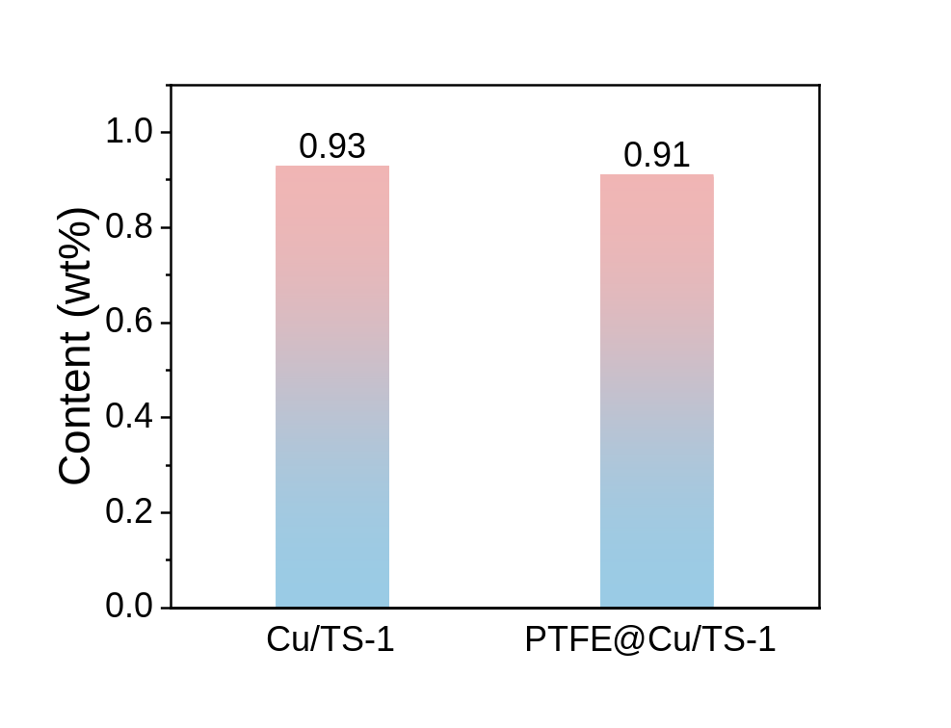
Fig. S4 ICP-MS analysis of Cu/TS-1 and PTFE@Cu/TS-1.

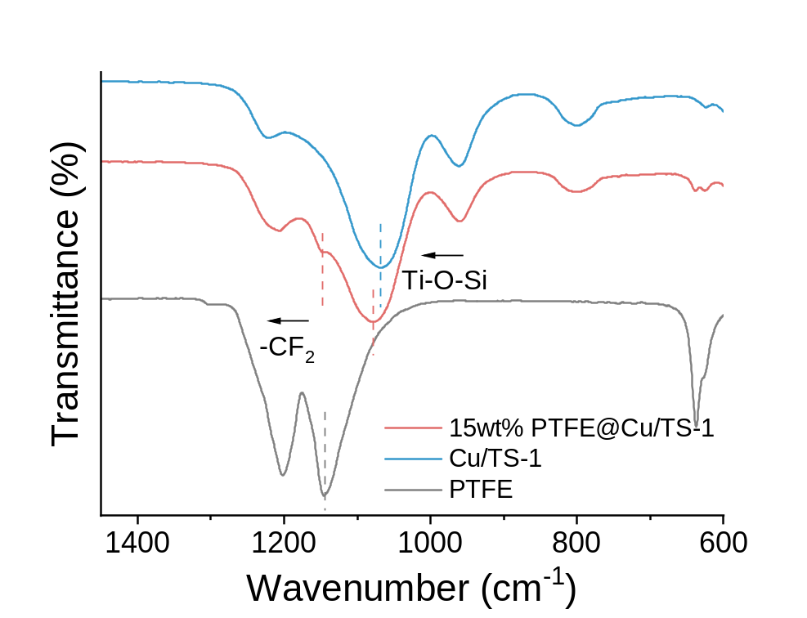
Fig. S5 FT-IR spectra of PTFE, Cu/TS-1, and 15wt%PTFE@Cu/TS-1.
Note: A higher PTFE loading of 15 wt% was used only for FTIR characterization to enhance the PTFE-associated vibrational signal.

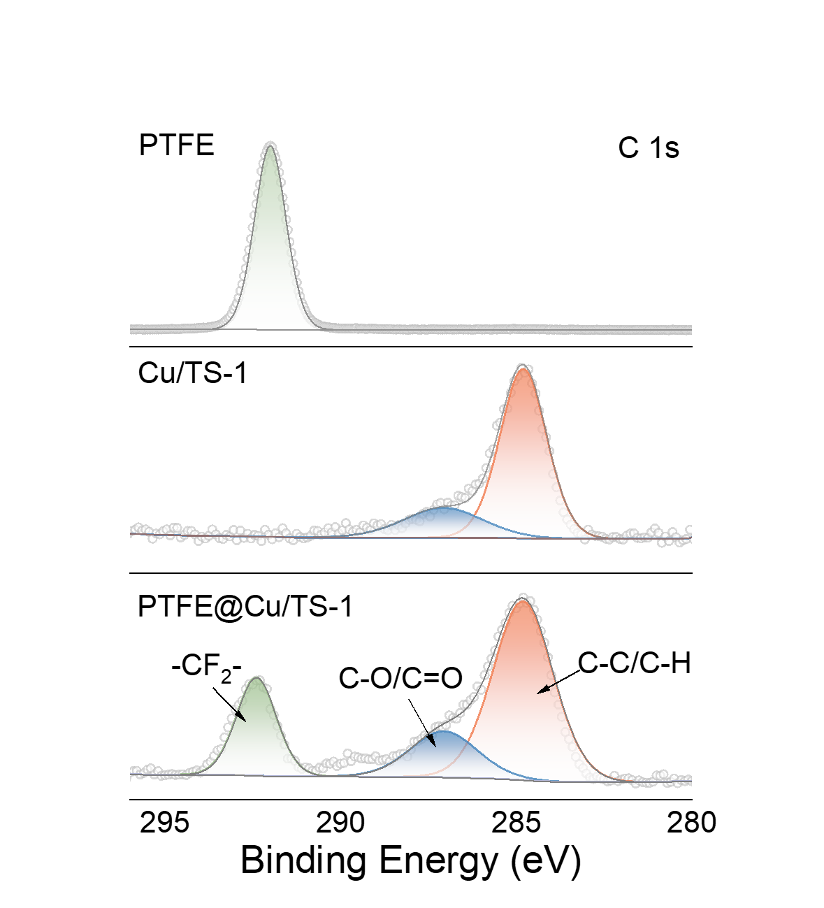
Fig. S6 High-resolution XPS C 1s spectra of PTFE, Cu/TS-1, and PTFE@Cu/TS-1.

Fig. S7 High-resolution XPS (A) Ti 2p, (B) O 1s, (C) F 1s, and (D) Cu 2p spectra of PTFE, Cu/TS-1, and PTFE@Cu/TS-1.

Fig. S8 (A) Water contact angles and (B) images of PTFE, Cu/TS-1, and PTFE@Cu/TS-1 with different PTFE content.

Fig. S9 Surface potential changes of PTFE, PTFE@TS-1, and PTFE@Cu/TS-1 before and after the ultrasonic excitation.

Fig. S10 Information of MD models for PTFE+H₂O and PTFE+H₂O+H₂O₂ (The number of H₂O molecules is 50 and H₂O₂ is 1).

Fig. S11 MD snapshots at different simulation times for PTFE+H₂O and PTFE+H₂O+H₂O₂ (The number of H₂O molecules is 50 and H₂O₂ is 1).

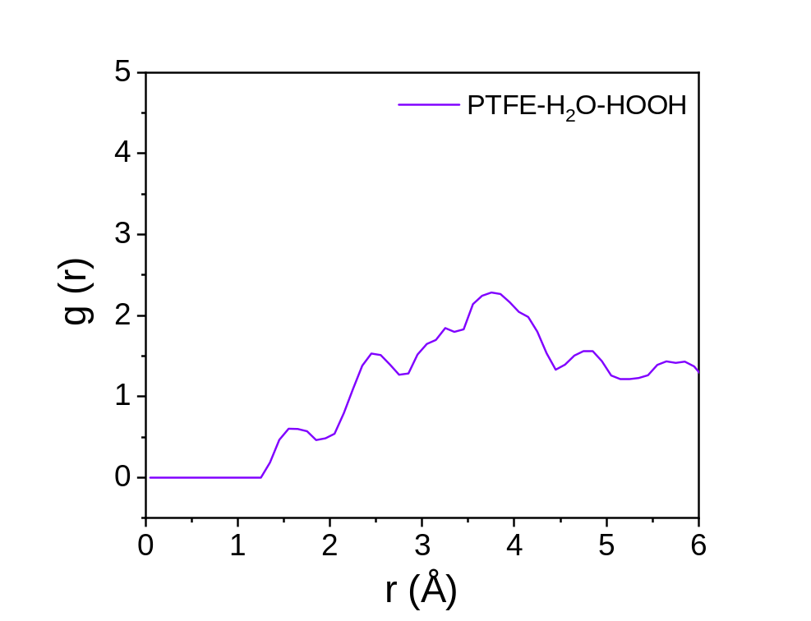
Fig. S12 Radial distribution functions of interfacial water structures in PTFE–H₂O–HOOH.

Fig. S13 Charge redistribution analysis of the PTFE-water interface based on DFT calculations. The left panel displays the differential charge density map, visually indicating regions of electron gain (yellow) and loss (cyan). The right panel shows the planar average charge density difference along the z-axis, quantifying the extent of electrostatic fluctuation and interfacial polarization.

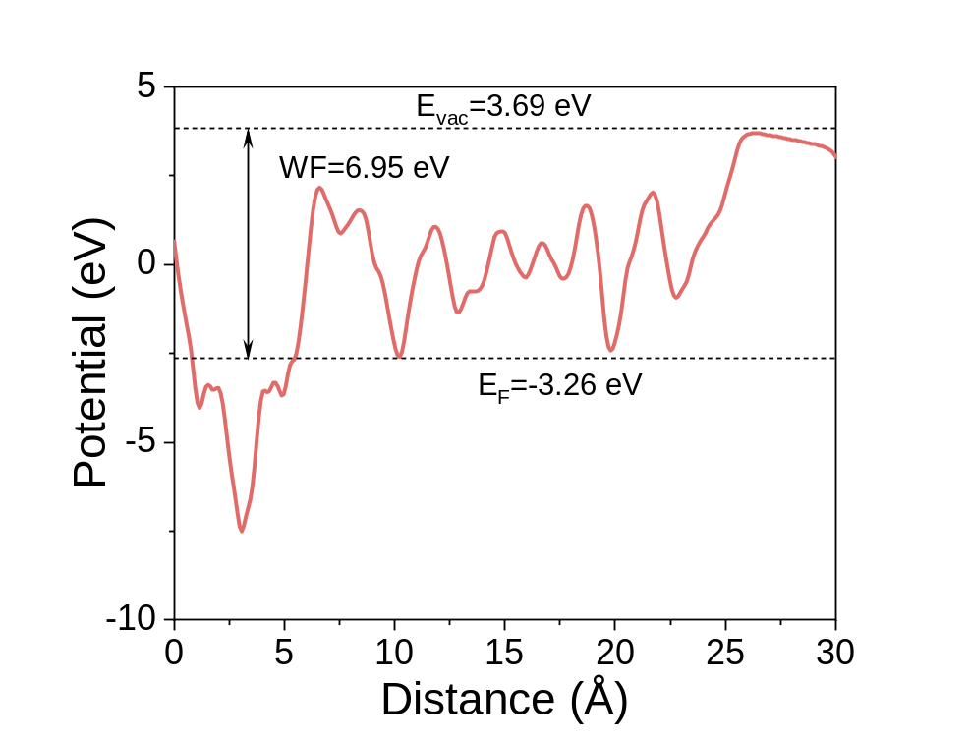
Fig. S14 DFT-calculated electrostatic potential profile of the PTFE-water interface.

Fig. S15 In situ ultrasonic ATR-FTIR spectra tracking hydration-network perturbation and peroxide-associated species in (A) Ti-free and (B) Ti-containing catalysts under ultrasonic excitation.

Fig. S16 N₂ adsorption–desorption isotherms (A) and pore size distributions (B) of Cu/TS-1 (fresh), TPABr treated Cu/TS-1, and thermal regenerated Cu/TS-1.

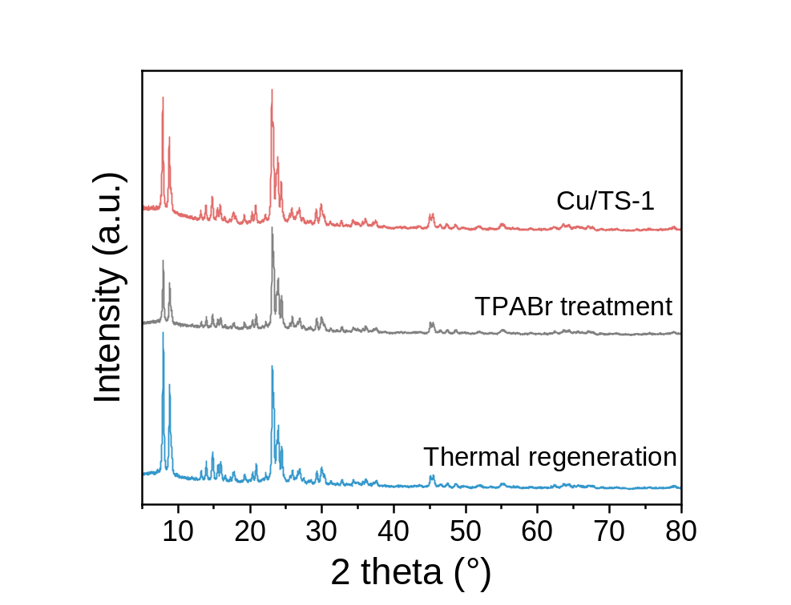
Fig. S17 XRD patterns of Cu/TS-1, TPABr treated Cu/TS-1, and thermal regenerated Cu/TS-1.

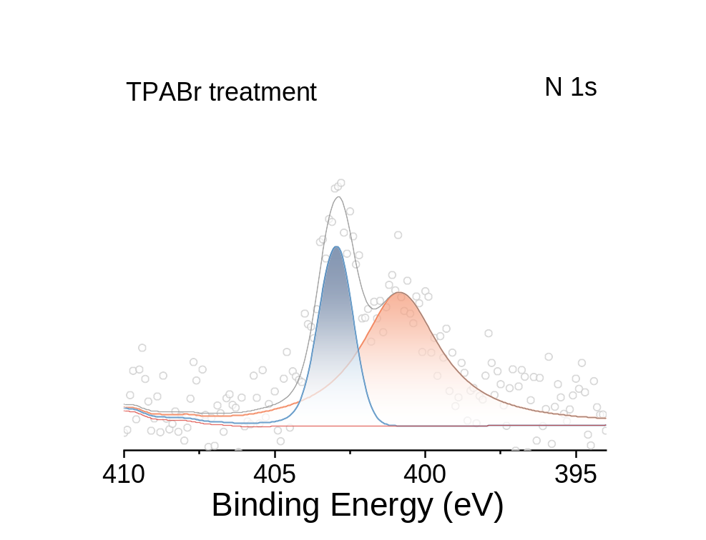
Fig. S18 N 1s XPS of TPABr treat Cu/TS-1.

Fig. S19 (A) C 1s, (B) Cu 2p, (C) O 1s, and (D) Ti 2p XPS of Cu/TS-1, TPABr treated Cu/TS-1, and thermal regenerated Cu/TS-1.
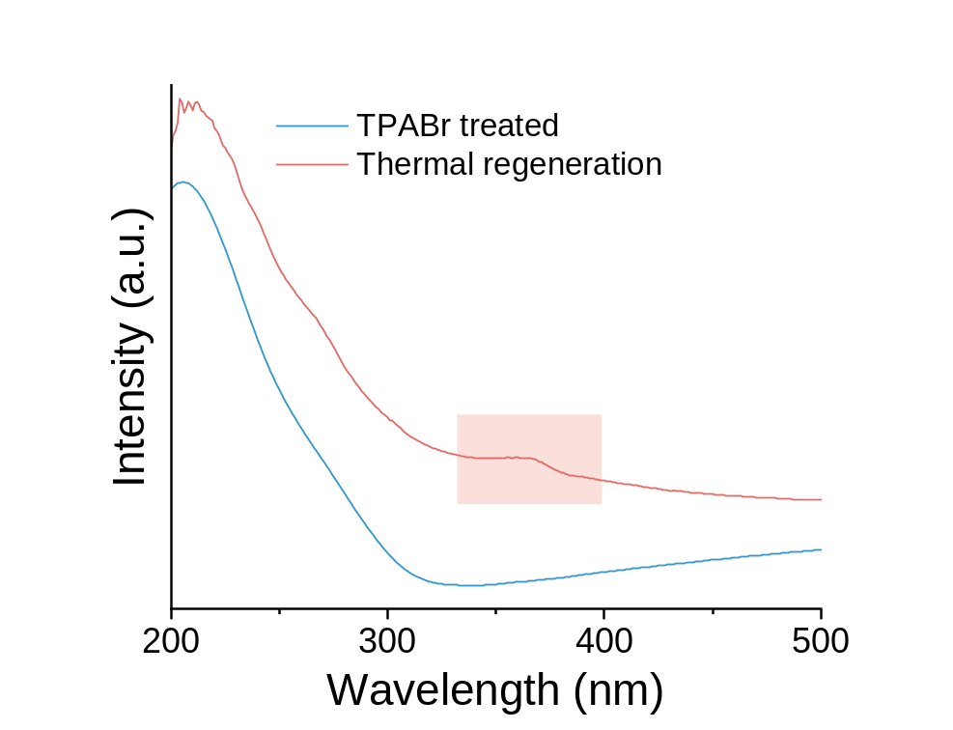
Fig. S20 Quasi-operando UV-vis diffuse reflectance spectra of TPABr-treated and thermally regenerated PTFE@Cu/TS-1 after ultrasonic activation.

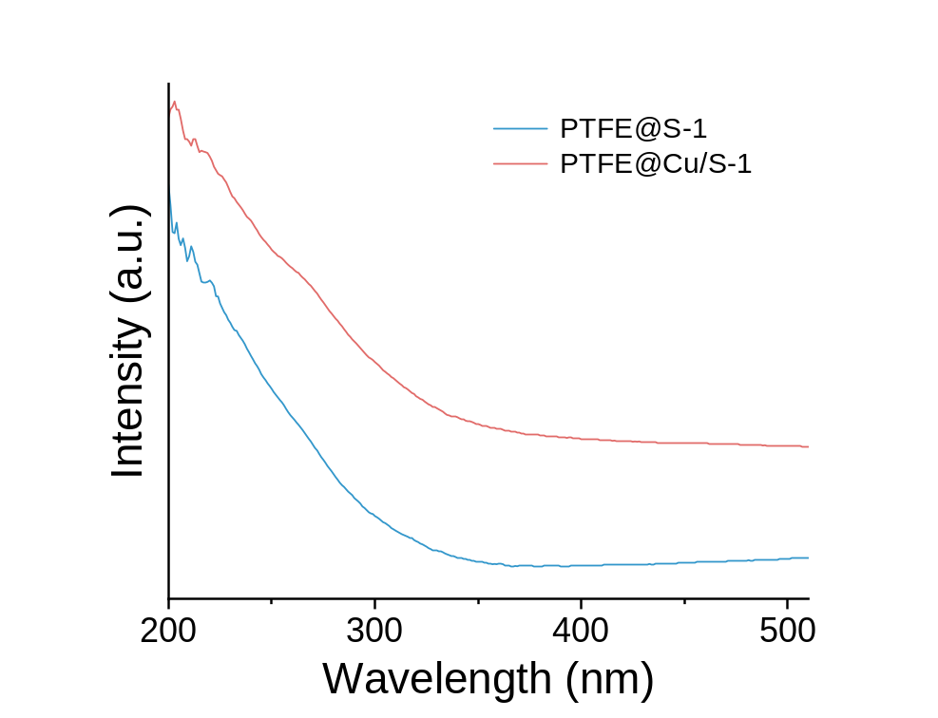
Fig. S21 UV–vis diffuse reflectance spectra of PTFE@S-1 and PTFE@Cu/S-1 collected after ultrasonic stimulation.

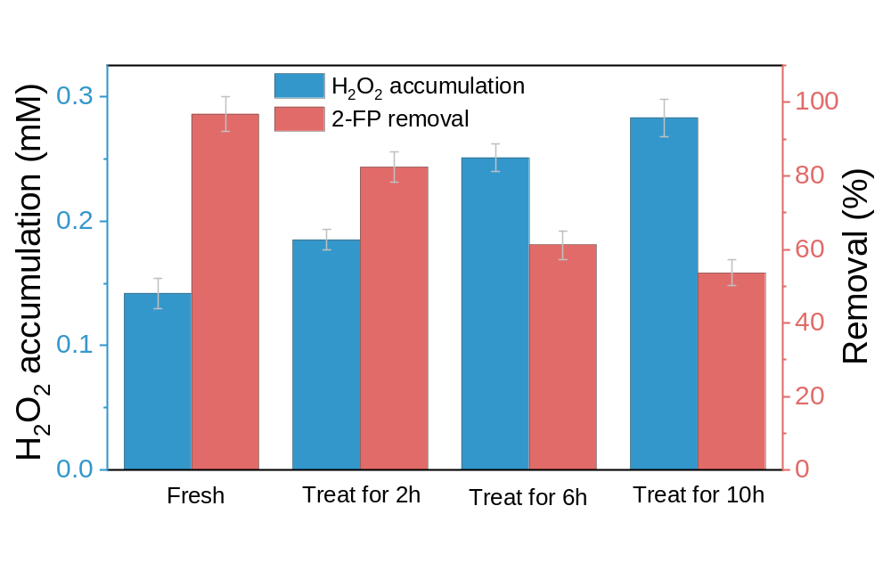
Fig. S22 Bulk H₂O₂ accumulation and 2-FP removal over samples subjected to different TPABr treatment durations.

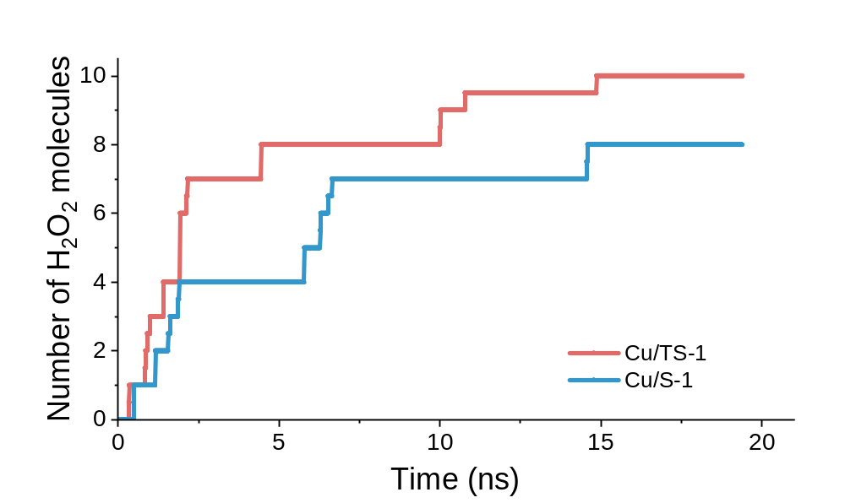
Fig. S23 MD simulations of H₂O₂ population evolution within different zeolitic frameworks over time.

Fig. S24 Effect of initial pollutant concentration. (A) Time-dependent degradation profiles of 2-FP at various initial concentrations and (B) the corresponding pseudo-first-order kinetic constants.

Fig. S25 Effect of ultrasonic power. (A) Time-dependent degradation profiles of 2-FP under varying ultrasonic powers and (B) the corresponding pseudo-first-order kinetic constants.

Fig. S26 Effect of catalyst dosage. (A) Time-dependent degradation profiles of 2-FP at different catalyst dosages and (B) the corresponding pseudo-first-order kinetic constants.

Fig. S27 Identification of 2-FP transformation products and their fragment ions by UPLC-QTOF-MS.

Fig. S28 (A) Optimized molecular structure and ESP distribution of 2-FP. (B) Frontier molecular orbitals, including HOMO and LUMO, of 2-FP. (C) Fukui function analysis of 2-FP, including electrophilic (f⁺), nucleophilic (f⁻), radical (f⁰) and dual descriptor (DD) distributions.
To understand the intrinsic electronic properties of 2-FP and identify the preferential oxidation sites, DFT calculations were performed. The optimized molecular structure and electrostatic potential (ESP) distribution show an uneven charge distribution across the aromatic framework, with electron-rich regions localized mainly around the phenolic oxygen and the aromatic π-system (Fig. S28A). This polarization suggests that electron transfer or electrophilic attack can preferentially occur at specific positions rather than uniformly across the molecule.
Frontier molecular orbital analysis further reveals that the highest occupied molecular orbital (HOMO) is mainly distributed over the aromatic ring and phenolic oxygen, whereas the lowest unoccupied molecular orbital (LUMO) is localized at complementary regions of the molecular framework (Fig. S28B). This spatial separation indicates potential pathways for interfacial charge transfer during oxidation.
Fukui function analysis was subsequently employed to evaluate the local chemical reactivity of 2-FP. The calculated electrophilic and nucleophilic Fukui indices (f⁺, f⁻ and f⁰) identify the carbon atoms adjacent to the hydroxyl and fluorine substituents as electronically susceptible sites (Fig. S28C), suggesting that these positions are preferentially involved in initial oxidation and subsequent C–F bond transformation.
These theoretical results indicate that 2-FP possesses intrinsic electronic asymmetry, providing a molecular basis for selective oxidation and defluorination during confined peroxide activation

Fig. S29 Proposed degradation pathway of 2-FP during oxidation over PTFE@Cu/TS-1.
The transformation pathway of 2-FP during oxidation was elucidated by LC–TOF–MS analysis combined with theoretical prediction of reactive sites. The detected intermediates indicate a sequential oxidation process involving aromatic hydroxylation, ring oxidation and progressive fragmentation.
The initial transformation is proposed to involve oxidation of the aromatic framework, producing hydroxylated fluorophenol or phenoxy-type intermediates. Subsequent oxidative ring-opening reactions generate oxygenated fluorinated intermediates, including dihydroxymuconic-acid-type and hydroxy-hexenedioic-acid-type products.
Further oxidation leads to progressive C–C bond cleavage and shortening of fluorinated carbon fragments, producing low-molecular-weight oxygenated species. Continued oxidation promotes further defluorination and mineralization, with CO₂, H₂O and inorganic fluoride representing the expected terminal products.
The lack of major accumulation of persistent fluorinated intermediates under the investigated conditions suggests that the confined peroxide activation pathway promotes continuous oxidative transformation rather than accumulation of stable partially oxidized products.
Fig. S30 Predicted (A) developmental toxicity, (B) mutagenicity, (C) bioconcentration factor and (D) acute aquatic toxicity (fathead minnow LC₅₀) of 2-FP and identified transformation products.
To evaluate the potential ecological implications of 2-FP transformation, toxicity prediction was performed using the Toxicity Estimation Software Tool (TEST). The predicted developmental toxicity, mutagenicity, bioconcentration factor and acute aquatic toxicity were compared between 2-FP and the identified transformation products (Fig. S30).
Compared with the parent 2-FP molecule, most transformation products exhibited reduced predicted bioconcentration potential and lower acute aquatic toxicity, consistent with the progressive conversion of hydrophobic fluorinated aromatic structures into smaller oxygenated intermediates.
The reduction in predicted environmental risk parameters accompanies the observed defluorination and carbon-fragment degradation, suggesting that the confined oxidation pathway not only removes the parent contaminant but also promotes transformation toward less persistent products.
Fig. S31 Comparison of bean germination and early growth in 2-FP-containing water and treated water.
Fig. S32 SEM images and corresponding EDS elemental maps of PTFE@Cu/TS-1 (A) before and (B) after reaction.

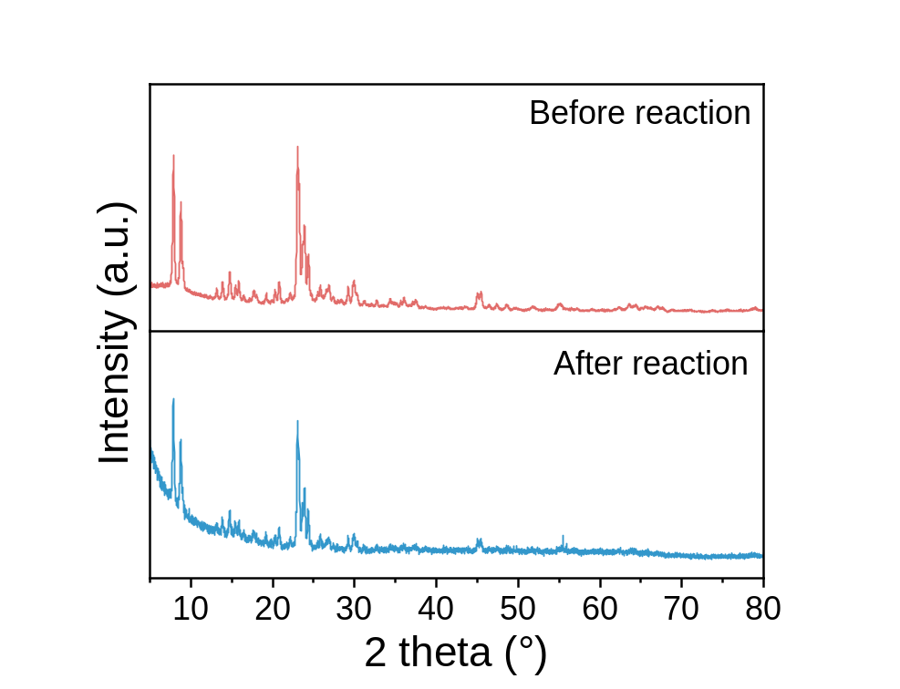
Fig. S33 XRD patterns of PTFE@Cu/TS-1 before and after reaction.

Fig. S34 H₂O₂ concentration in the absence and presence of 2-FP under externally supplied H₂O₂ conditions.

Fig. S35 The effect of pre-adsorption time for 2-FP degradation.

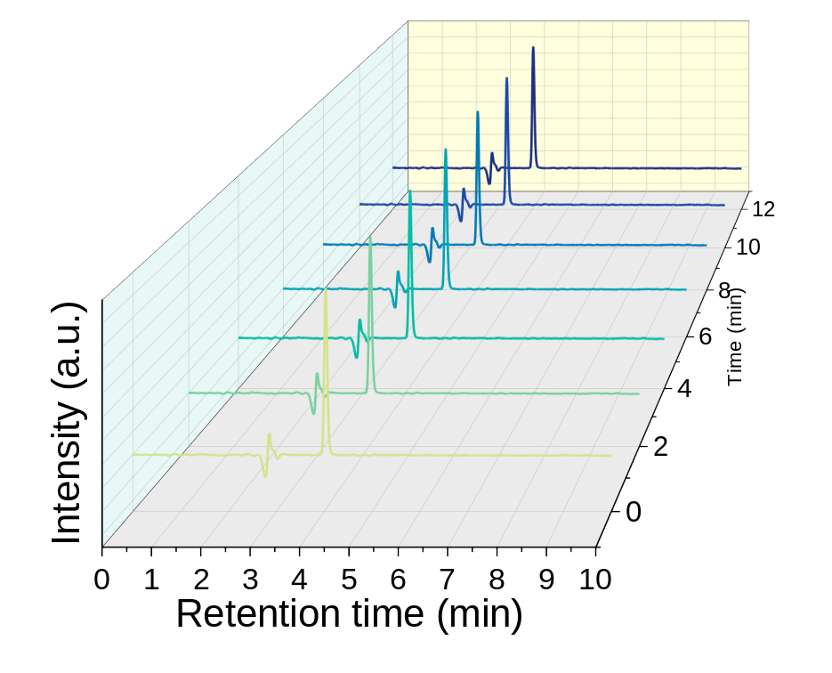
Fig. S36 Time-resolved HPLC chromatograms of PMSO during reaction for probing oxygen-transfer activity.

Fig. S37 EPR spectra collected with DMPO spin trapping.

Fig. S38 (A) Ti 2p and (B) O 1s XPS of PTFE@Cu/TS-1 before and after reaction.

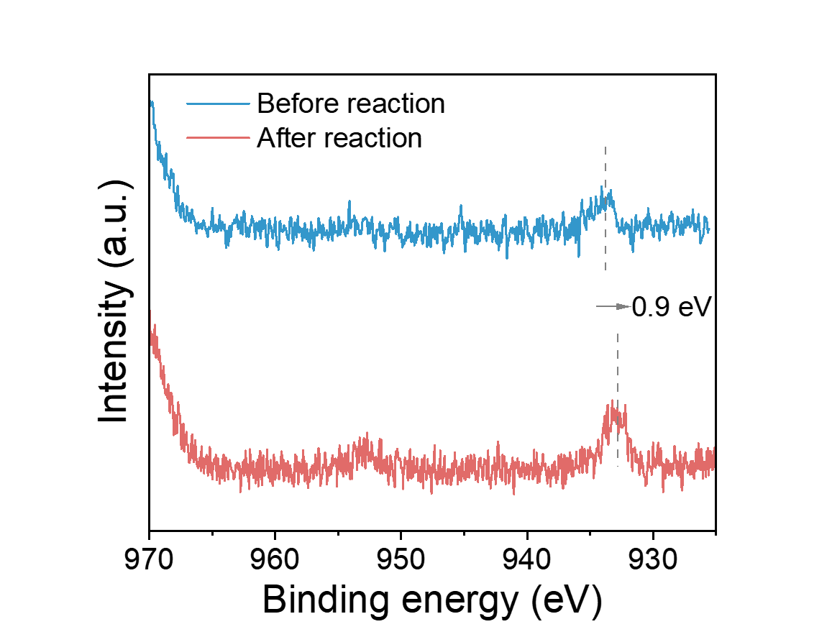
Fig. S39 Cu 2p XPS of PTFE@Cu/TS-1 before and after reaction.

Fig. S40 Spin-state evolution and orbital reorganization during the transformation from H₂O₂ to Ti–OOH and Ti–O–O–Cu intermediates.

Fig. S41 (A) Total spin-resolved PDOS of the Ti–O–O–Cu system. (B) Spin-resolved PDOS projected onto the peroxide O–O unit.
Fig. S42 (A) Total spin-resolved PDOS of the Ti–O–OH system. (B) Spin-resolved PDOS projected onto the peroxide O–O unit.
Fig. S43 (A) Total spin-resolved PDOS of the Ti–O–OH–Cu system. (B) Spin-resolved PDOS projected onto the peroxide O–O unit.
Fig. S44 Orbital-resolved projected density of states of Cu–OOH and Ti-OOH.

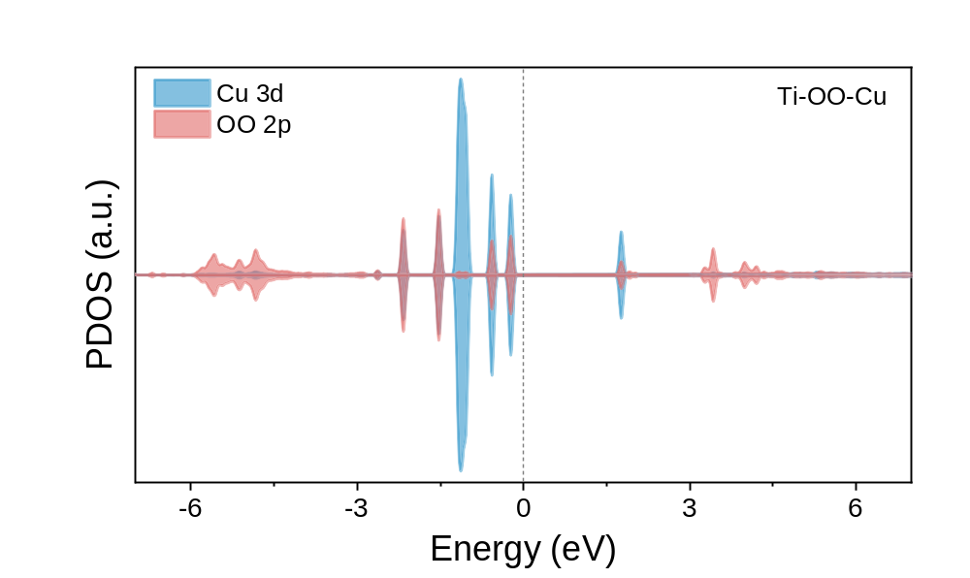
Fig. S45 Orbital-resolved projected density of states of Ti–OO-Cu.

Fig. S46 Differential charge-density distributions of (A) Ti–OOH and (B) Cu–OOH intermediates (yellow/cyan = electron accumulation/depletion).

Fig. S47 Differential charge-density distributions upon H₂O₂ coordination at Ti sites in (A) TS-1 and (B) Cu/TS-1 (yellow/cyan = electron accumulation/depletion).

Fig. S48 Optimized structures of reaction intermediates along the H₂O₂ activation pathway on TS-1.

Fig. S49 Optimized structures of reaction intermediates along H₂O₂ activation pathway on Cu/TS-1.

Fig. S50 Illustration of the scaling-up process for a flow-through device.

Table S1. N₂ adsorption–desorption parameters of Cu/TS-1 and PTFE@Cu/TS-1 samples
Entry | Samples | PTFE loading（wt%） | BET surface area  （m²/g） | V_{t}  （cm³/g） | d_{BJH}  （nm）
1 | Cu/TS-1 | 0 | 404.3 | 0.54 | 12.7
2 | 0.5 wt%PTFE@Cu/TS-1 | 0.5 | 412.6 | 0.54 | 13.3
3 | 2.5 wt%PTFE@Cu/TS-1 | 2.5 | 399.6 | 0.52 | 13.4
4 | 5.0 wt%PTFE@Cu/TS-1 | 5.0 | 380.7 | 0.51 | 13.3

Table S2. EXAFS fitting parameters at the Cu K-edge for various samples. (Ѕ₀²=0.86)
Sample | Shell | CNª | R(Å)^{b} | σ2(Å²)^{c} | ΔE0(eV)^{d} | K-range/Å⁻¹ | R-range/Å | R factor
Cu foil | Cu-Cu | 12* | 2.54±0.01 | 0.0088 | 4.5±0.6 | 3.0-12.1 | 1.0-3.0 | 0.0029
sample-Cu | Cu-O | 4.9±0.3 | 1.92±0.01 | 0.0075 | -3.0±1.8 | 3.0-10.6 | 1.0-2.5 | 0.0080
sample-Cu | Cu-Cu | 0.5±0.1 | 2.69±0.02 | 0.0002
ªN: coordination numbers; ^{b}R: bond distance; ^{c}σ²: Debye-Waller factors; ^{d} ΔE₀: the inner potential correction. R factor: goodness of fit.

Table S3. Spin-resolved magnetic moments of peroxide intermediates obtained from DFT calculations.
Intermediate | O(1) local magnetic moment  (μB) | O(2) local magnetic moment  (μB) | Total magnetic moment of O–O unit  (μB) | Total magnetic moment of system  (μB) | Contribution of O–O unit  (%)
Ti–OOH | 0.000 | 0.000 | −0.000 | 0.000 | 0
Ti–O–O–Cu | +0.374 | +0.364 | +0.738 | +1.00 | 74

References
[1] A. P. Thompson, H. M. Aktulga, R. Berger, D. S. Bolintineanu, W. M. Brown, P. S. Crozier, P. J. in 't Veld, A. Kohlmeyer, S. G. Moore, T. D. Nguyen, R. Shan, M. J. Stevens, J. Tranchida, C. Trott, S. J. Plimpton, Comput. Phys. Commun. 2022, 271, 108171.
[2] A. I. Jewett, D. Stelter, J. Lambert, S. M. Saladi, O. M. Roscioni, M. Ricci, L. Autin, M. Maritan, S. M. Bashusqeh, T. Keyes, R. T. Dame, J.-E. Shea, G. J. Jensen, D. S. Goodsell, J. Mol. Biol. 2021, 433, 166841.
[3] R. W. Hockney, J. W. Eastwood, Computer Simulation Using Particles, Adam Hilger, Bristol, UK 1988.
[4] S. Nosé, J. Chem. Phys. 1984, 81, 511.
[5] W. G. Hoover, Phys. Rev. A 1985, 31, 1695.
[6] Kresse, G.; Hafner, J. Ab Initio Molecular Dynamics for OpenShell Transition Metals. Phys. Rev. B 1993, 48 (17), 13115−13118.
[7] Kresse, G.; Hafner, J. Ab Initio Molecular Dynamics for Liquid Metals. Phys. Rev. B 1993, 47 (1), 558−561.
[8] Perdew, J. P.; Burke, K.; Ernzerhof, M. Generalized Gradient Approximation Made Simple. Phys. Rev. Lett. 1996, 77 (18), 3865−3868.
[9] Kresse, G.; Joubert, D. From Ultrasoft Pseudopotentials to the Projector Augmented-Wave Method. Phys. Rev. B 1999, 59 (3), 1758−1775.
[10] Henkelman, G.; Arnaldsson, A.; Jónsson, H. A Fast and Robust Algorithm for Bader Decomposition of Charge Density. Comput. Mater. Sci. 2006, 36 (3), 354−360.
[11] Tang, W.; Sanville, E.; Henkelman, G. A Grid-Based Bader Analysis Algorithm without Lattice Bias. J. Phys.: Condens. Matter 2009, 21 (8), 084204.

